School of Computer Science and Artificial Intelligence

Project Report
Title: Linked in software engineering jobs dataset
Program : B. Tech (CSE)
Specialization : GENERAL
Course Title : Machine Learning
Course Code : 24CS312ES206
Semester : 4
Academic Year : 2025-2026
Name : Siddam shetti kavya
Enrollment No. : 2403A51037
Batch No. : 02

- Problem Statement
In today’s competitive job market, software engineering positions are growing rapidly, but job seekers often struggle to identify the best opportunities that match their skills and preferences. Simultaneously, companies face challenges in efficiently filtering and targeting suitable candidates from a large pool of applications. Our project aims to analyze the LinkedIn software engineering jobs dataset to predict trends, classify job types, and identify key skills required for different roles. By applying machine learning algorithms, we seek to provide insights that help both job seekers and recruiters make informed decisions, improve job matching, and understand the factors influencing job availability and requirements.
that?

- INTRODUCTION
This project focuses on analyzing the LinkedIn Software Engineering Jobs Dataset to understand the relationship between job skills and salary. The dataset contains information about required skills and salary details for different job postings. Since the data is in raw format, preprocessing is performed to convert it into a usable form.
Machine learning algorithms such as Logistic Regression, Support Vector Machine (SVM), and Linear Regression are applied. Logistic Regression and SVM are used for classification, while Linear Regression is used for prediction. The results are visualized using graphs like confusion matrices and comparison charts.

- OBJECTIVE

  - To preprocess the dataset
  - To convert text data into numerical form
  - To apply Logistic Regression, SVM, and Linear Regression
  - To compare model performance using graphs

- ALGORITHMS USED :

  - Logistic Regression
  - Support Vector Machine (SVM)
  - Linear Regression
- Datasetlink: https://www.kaggle.com/datase-ts/asaniczka/software-engineer-job-postings-linkedin/data
- INPUT VARIABLES (Features – X)
These are the columns used to train the model.
In your dataset:
1. job_skills
- Contains skills like Python, Java, SQL
- Converted into numerical form

2. Skills_Count (Created Feature)
- Number of skills in each job
- Example:
  - “Python, SQL” → 2
- This is your main input variable

(Optional – if used)
- job_title (encoded)
- location (encoded)
- experience

- OUTPUT VARIABLE (Target – y)
This is what the model predicts.

1. salary
- Original salary value (used in regression)

2. Salary_Category (Created)
- Converted salary into:

  - 0 → Low Salary
  - 1 → High Salary

Code
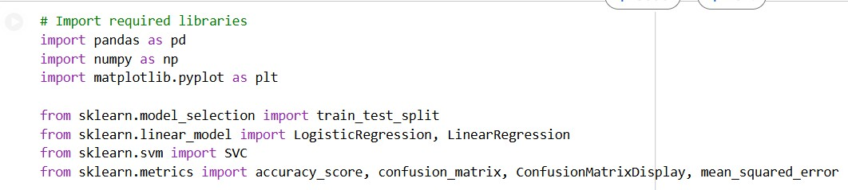

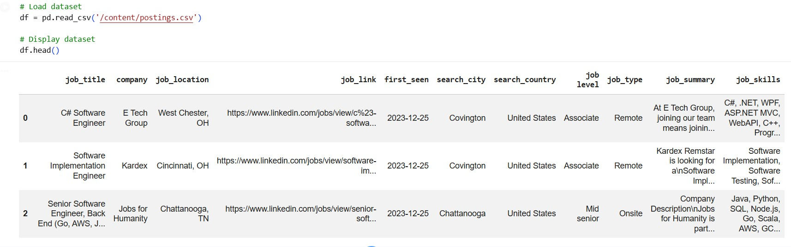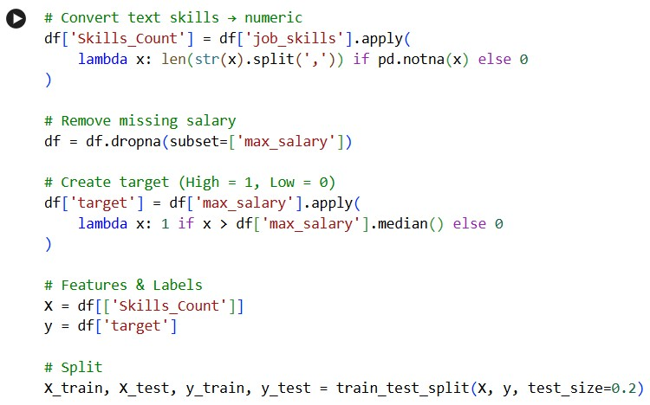

Logistic regression
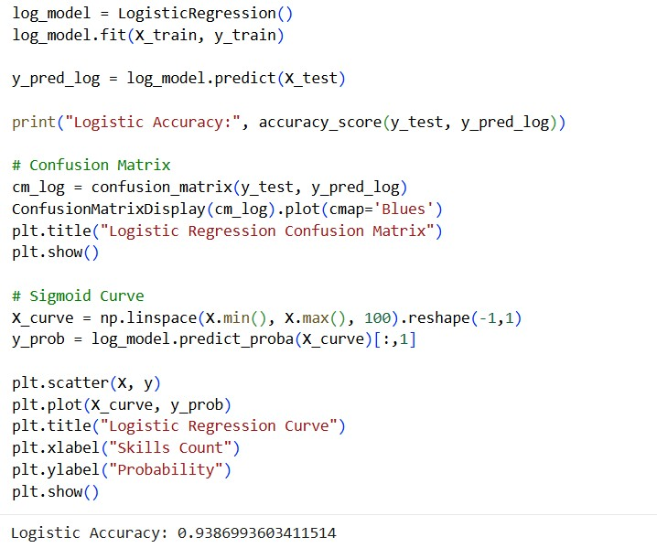
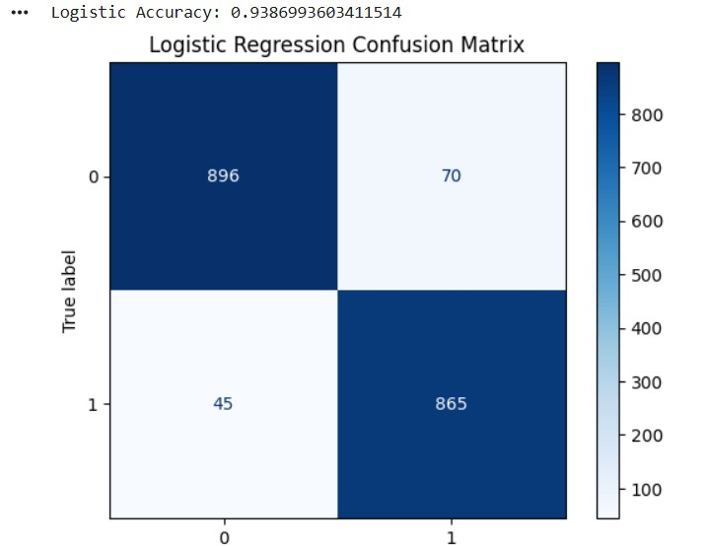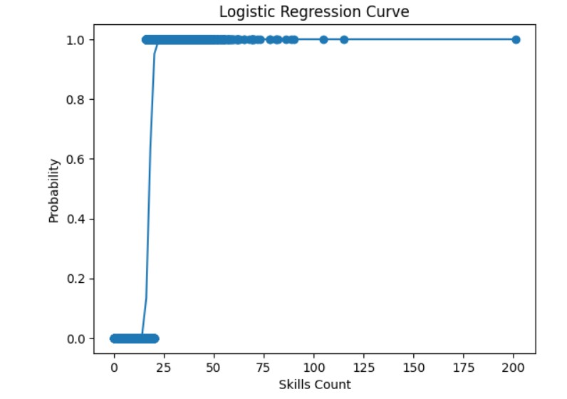

Linear regression

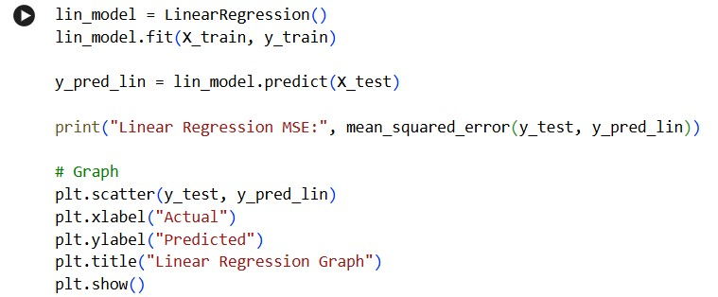

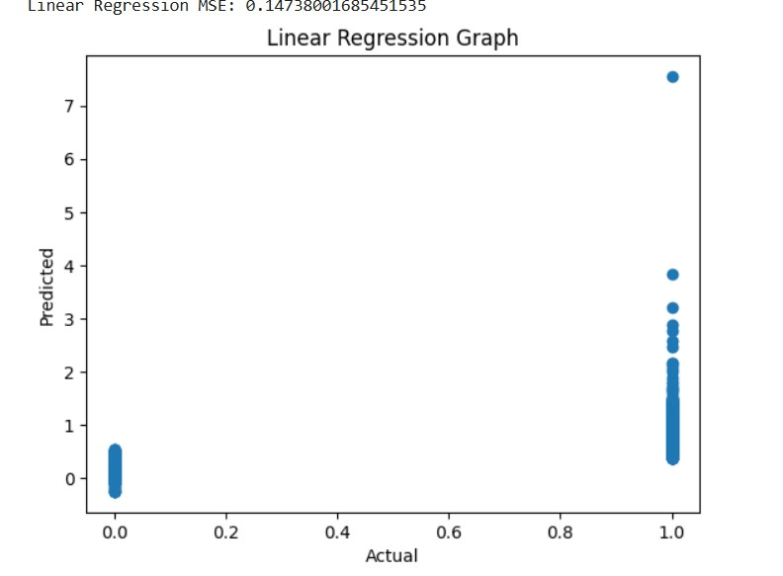

Svm
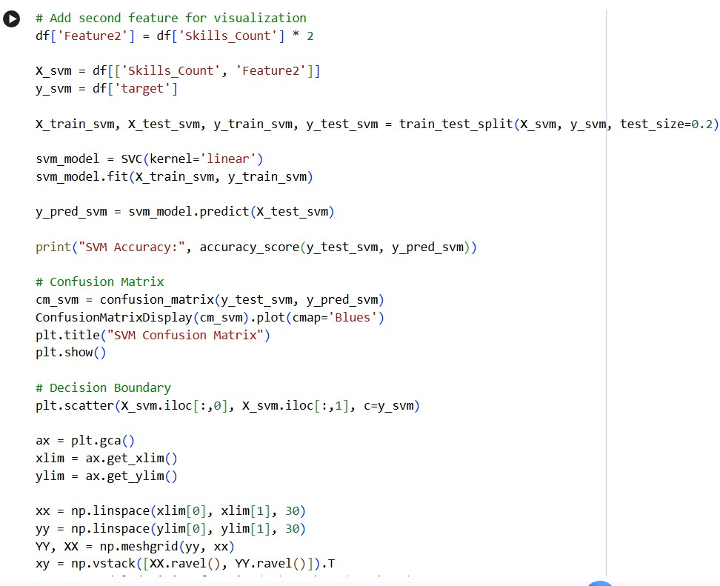
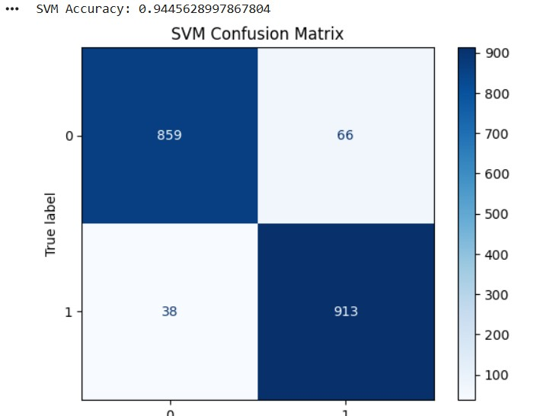

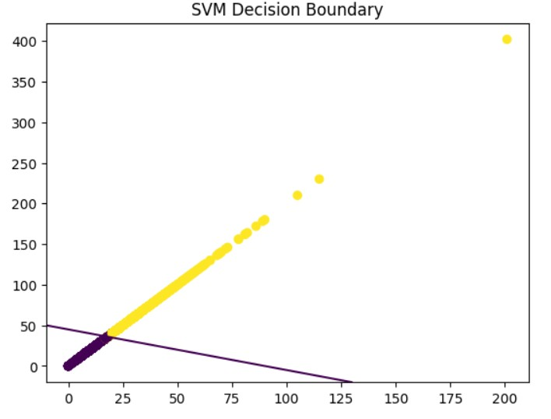

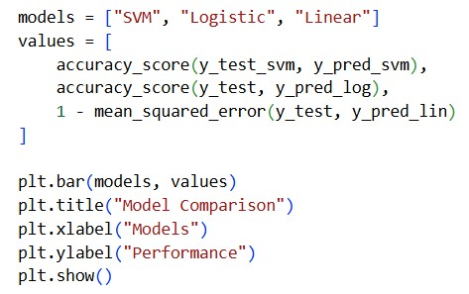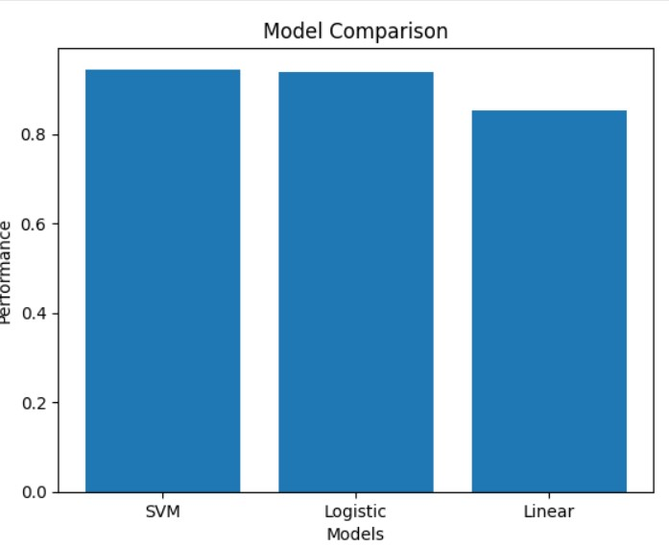

Summary
This project analyzes LinkedIn job data to understand the relationship between skills and salary using machine learning techniques.
The results show that skills influence salary, and models like SVM help in accurate prediction.

- Conclusion
This project analyzed the LinkedIn jobs dataset to understand the relationship between skills and salary.
Machine learning algorithms like Logistic Regression, SVM, and Linear Regression were applied successfully.
The results show that skills impact salary and machine learning helps in prediction and decision-making.
This project shows that job skills have a strong impact on salary levels.
Machine learning algorithms help in predicting salary and making better decisions.

- Best Algorithm:
SVM (Support Vector Machine)

