Buck DC-DC Converter

# Name :Siddam Vinay

# Roll number :184157

# Btech 2nd year

# Ece-A

Introduction :

The dc-dc converters have a wide range of applications in industry, electric machines control, aviation, as interface in distributed generation, portable devices and also power factor correction.

A **buck converter** (**step-down converter**) is a [DC-to-DC power converter](https://en.wikipedia.org/wiki/DC-to-DC_converter) which steps down voltage from its input to its output . It is a class of [switched-mode power supply](https://en.wikipedia.org/wiki/Switched-mode_power_supply) (SMPS) typically containing at least two semiconductors and at least one energy storage element, a [capacitor](https://en.wikipedia.org/wiki/Capacitor), [inductor](https://en.wikipedia.org/wiki/Inductor), or the two in combination.

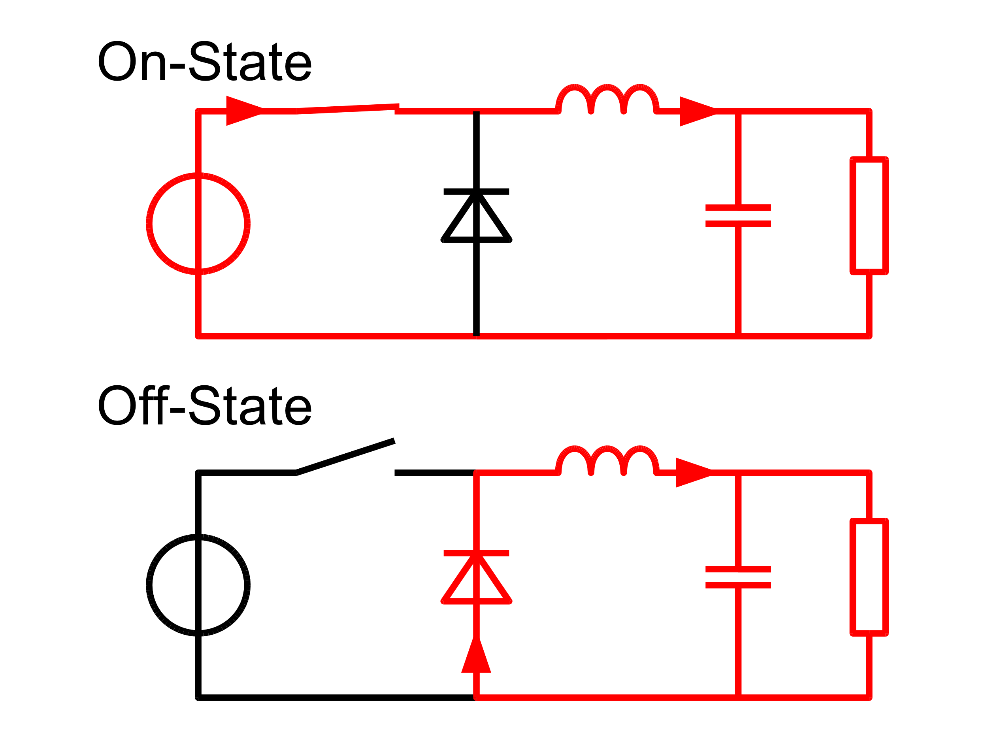

The conceptual model of the buck converter is best understood in terms of the relation between current and voltage of the inductor. Beginning with the switch open (off-state), the current in the circuit is zero. When the switch is first closed (on-state), the current will begin to increase, and the inductor will produce an opposing voltage across its terminals in response to the changing current. This voltage drop counteracts the voltage of the source and therefore reduces the net voltage across the load. Over time, the rate of change of current decreases, and the voltage across the inductor also then decreases, increasing the voltage at the load. During this time, the inductor stores energy in the form of a [magnetic field](https://en.wikipedia.org/wiki/Magnetic_field). If the switch is opened while the current is still changing, then there will always be a voltage drop across the inductor, so the net voltage at the load will always be less than the input voltage source. When the switch is opened again (off-state), the voltage source will be removed from the circuit, and the current will decrease. The decreasing current will produce a voltage drop across the inductor (opposite to the drop at on-state), and now the inductor becomes a Current Source. The stored energy in the inductor's magnetic field supports the current flow through the load. This current, flowing while the input voltage source is disconnected, when concatenated with the current flowing during on-state, totals to current greater than the average input current (being zero during off-state). The "increase" in average current makes up for the reduction in voltage, and ideally preserves the power provided to the load. During the off-state, the inductor is discharging its stored energy into the rest of the circuit. If the switch is closed again before the inductor fully discharges (on-state), the voltage at the load will always be greater than zero.

Mathematical Modelling :

In the given fig1 shows the circuit configuration of a buck dc-dc converter.

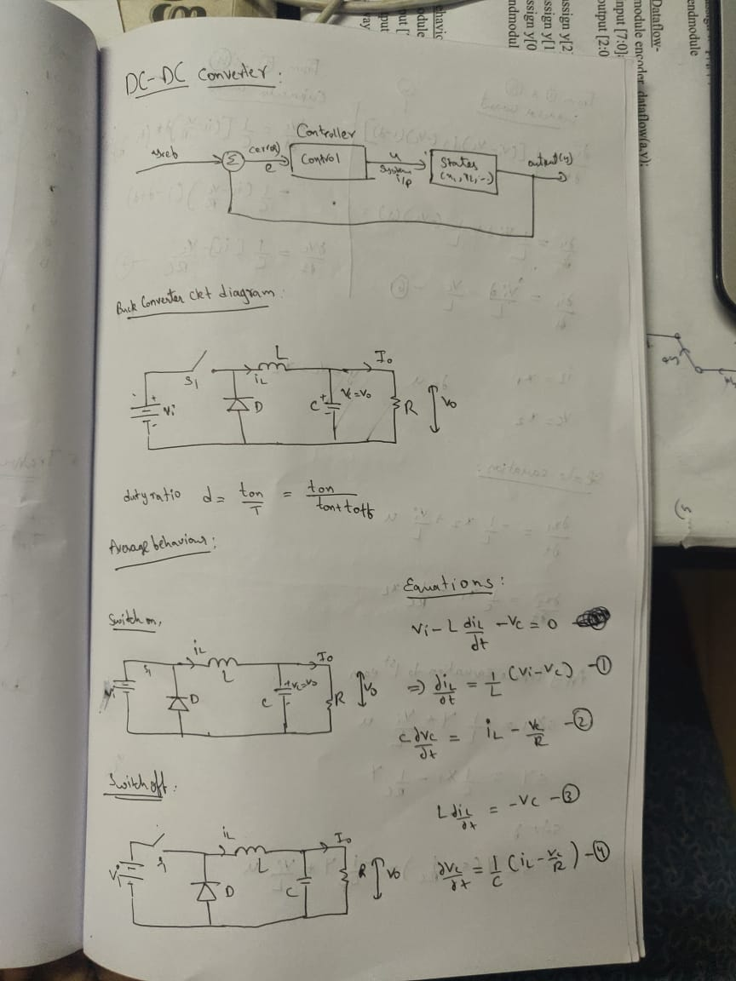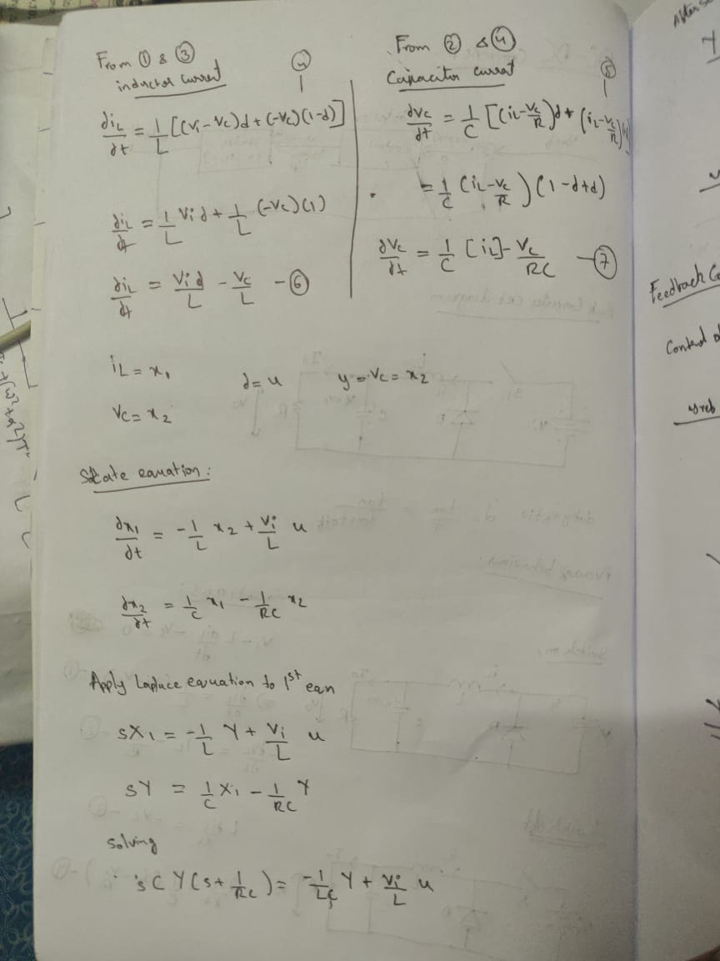

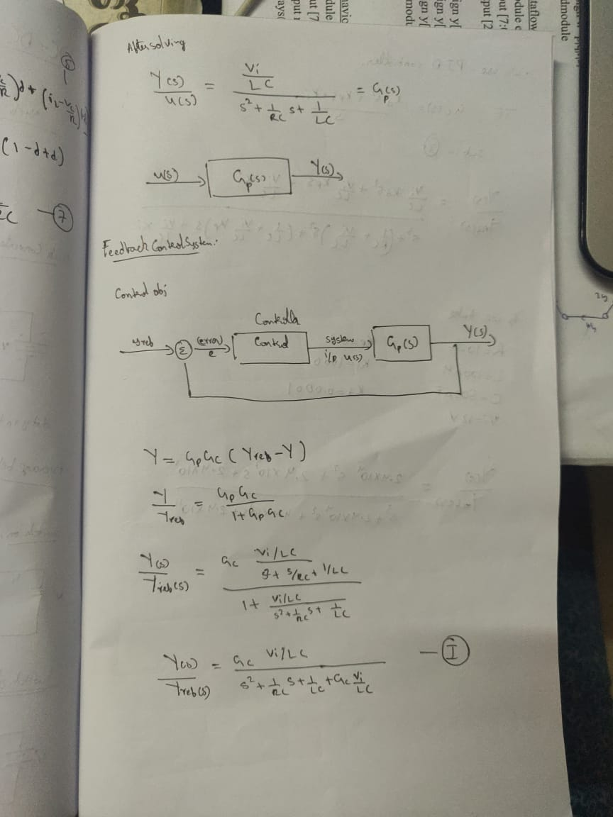

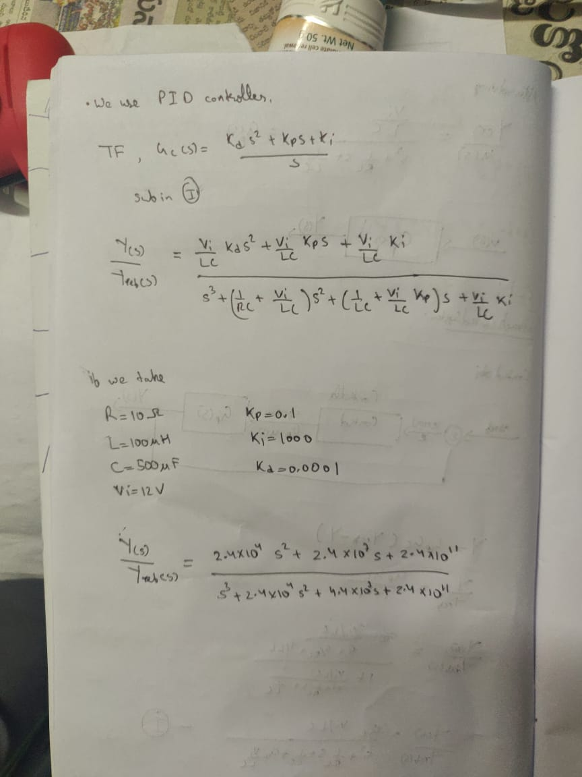

Matlab Code:



**Time response Analysis :**

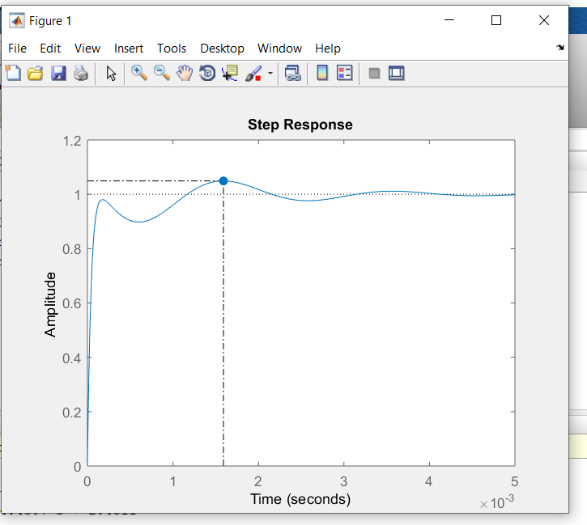

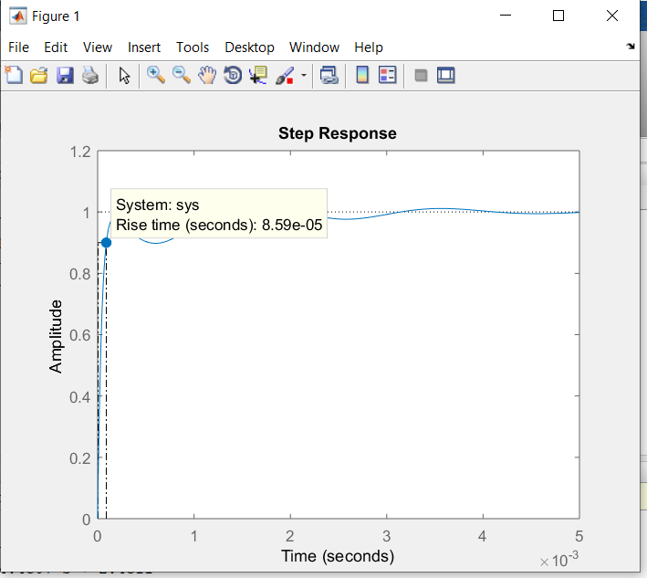

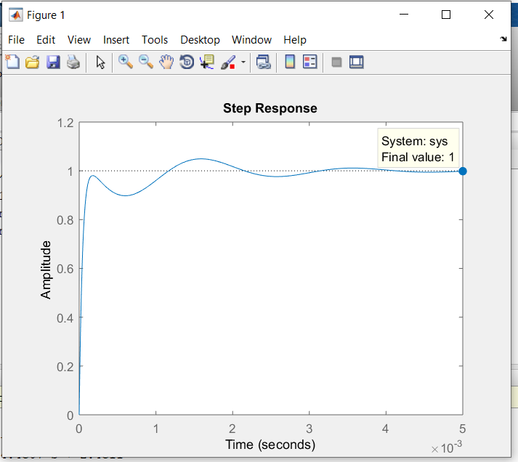

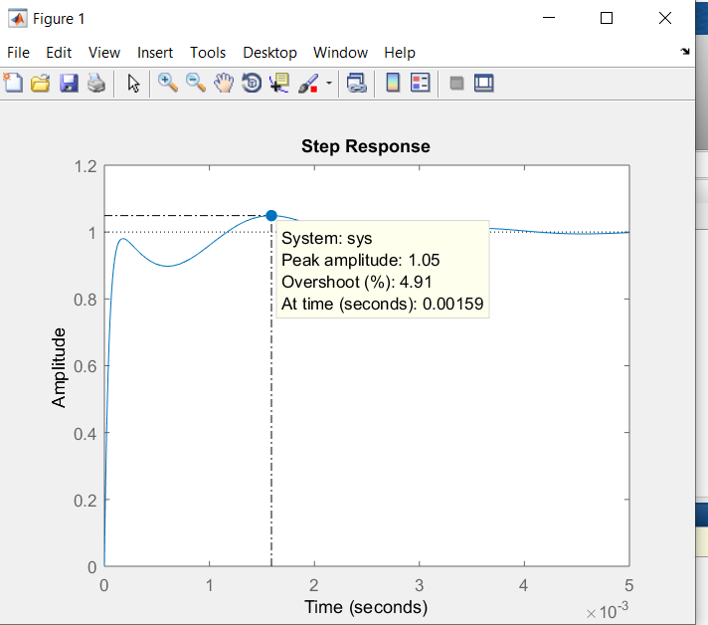

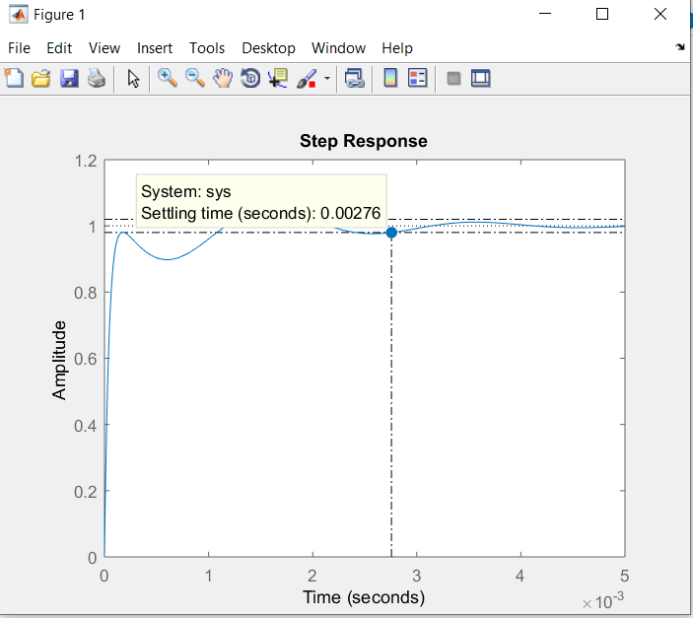

Reference:

Fudamentals ofPower Electronice EE404 by Katkimshow(https://www.youtube.com/playlist?list=PLmK1EnKxphikP6c9Yc9kGYO0kvrbEoWN8).