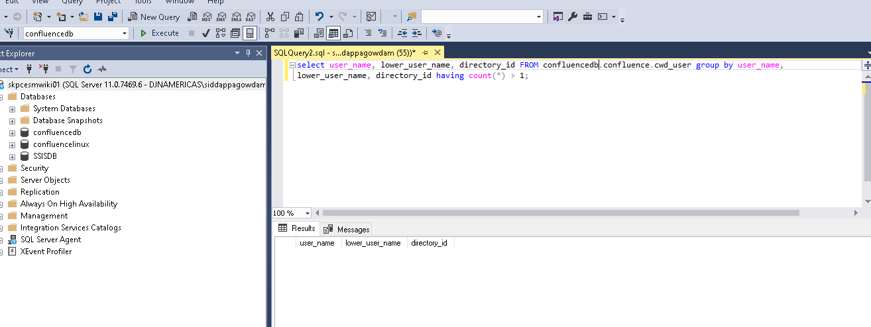

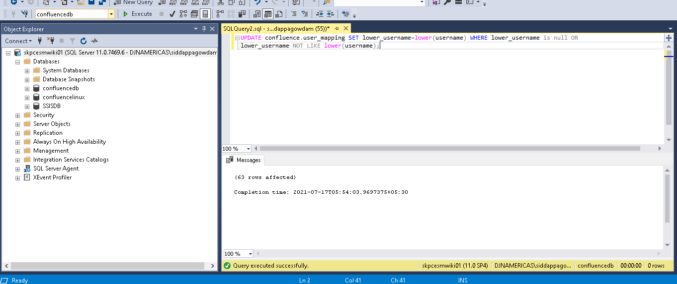

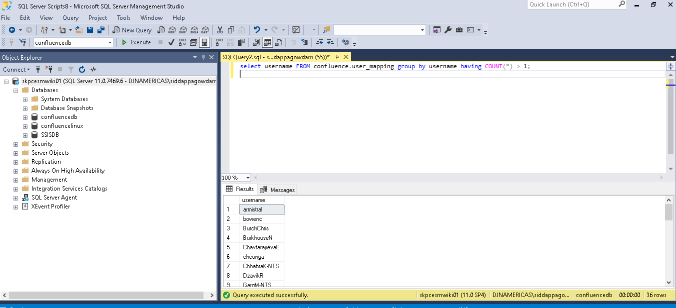

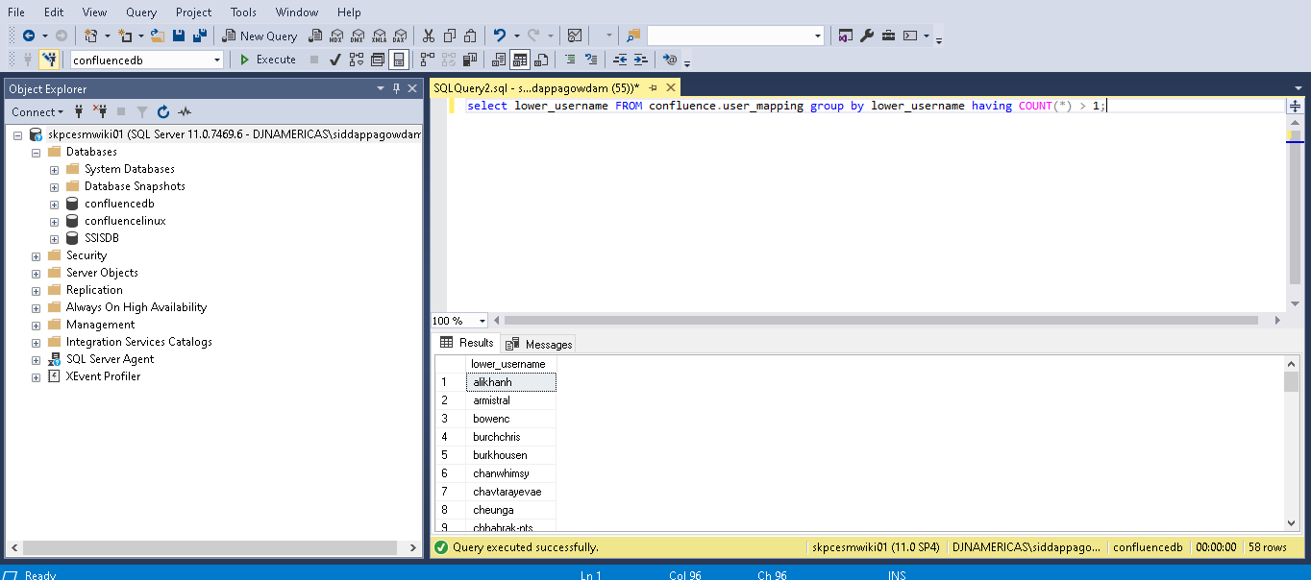

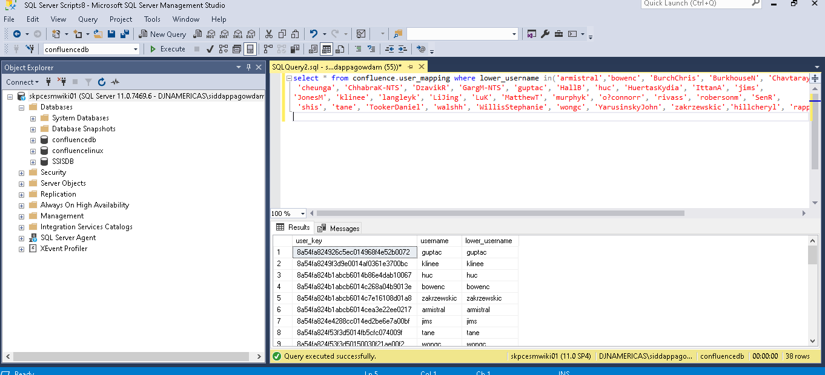

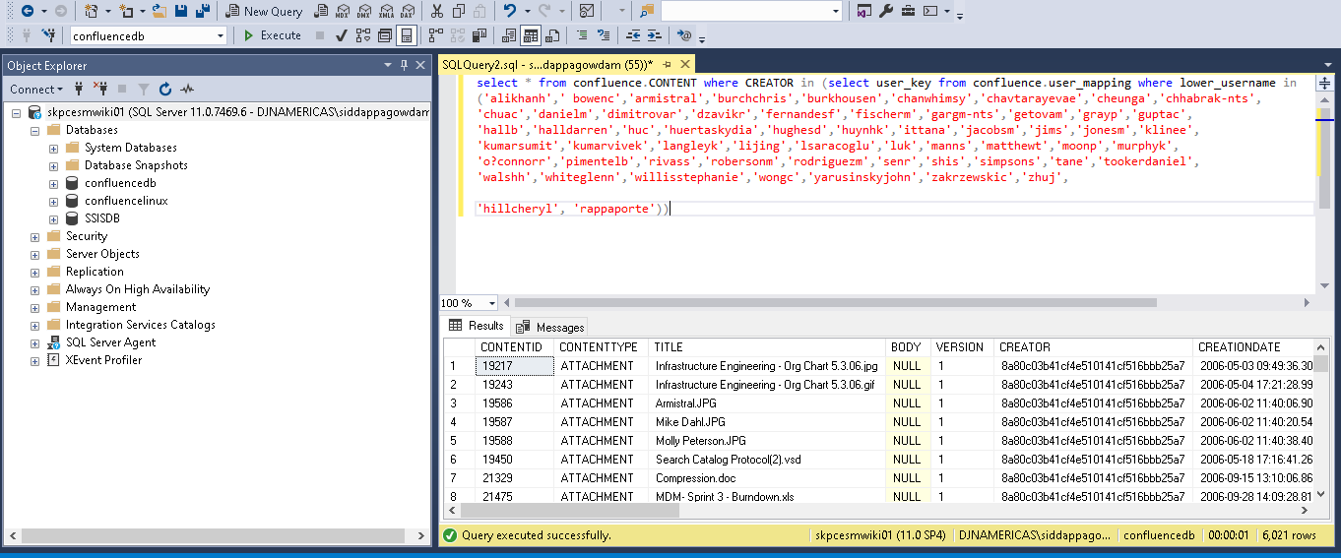

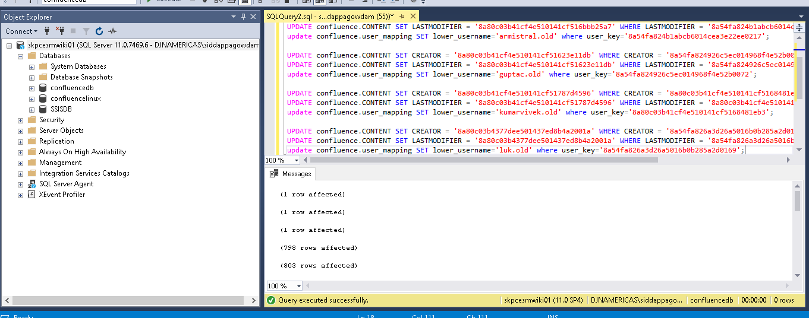

(1 row affected)

(1 row affected)

(1 row affected)

(798 rows affected)

(803 rows affected)

(1 row affected)

(1 row affected)

(1 row affected)

(1 row affected)

(49 rows affected)

(54 rows affected)

(1 row affected)

(207 rows affected)

(208 rows affected)

(1 row affected)

Completion time: 2021-07-17T05:58:15.7772311+05:30

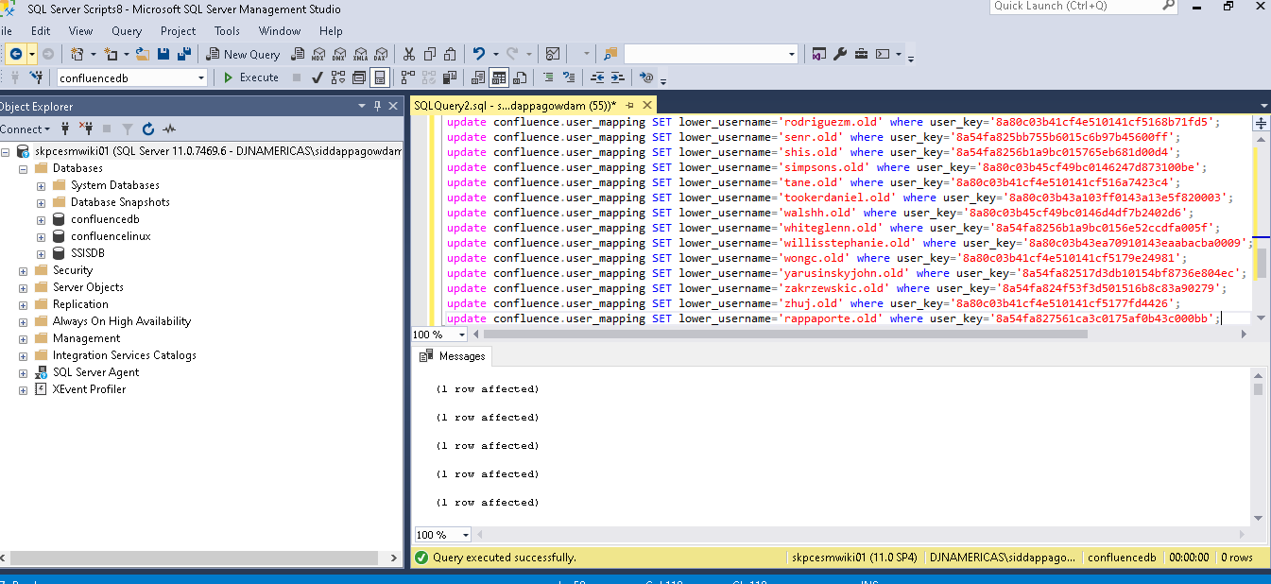

(1 row affected)

(1 row affected)

(1 row affected)

(1 row affected)

(1 row affected)

(1 row affected)

(1 row affected)

(1 row affected)

(1 row affected)

(1 row affected)

(1 row affected)

(1 row affected)

(1 row affected)

(1 row affected)

(1 row affected)

(1 row affected)

(1 row affected)

(1 row affected)

(1 row affected)

(1 row affected)

(1 row affected)

(1 row affected)

(1 row affected)

(1 row affected)

(1 row affected)

(1 row affected)

(1 row affected)

(1 row affected)

(0 rows affected)

(1 row affected)

(1 row affected)

(1 row affected)

(1 row affected)

(0 rows affected)

(1 row affected)

(1 row affected)

(1 row affected)

(1 row affected)

(1 row affected)

(1 row affected)

(1 row affected)

(1 row affected)

(1 row affected)

(1 row affected)

(1 row affected)

(1 row affected)

(1 row affected)

(1 row affected)

(1 row affected)

(1 row affected)

(1 row affected)

(1 row affected)

(1 row affected)

(1 row affected)

(1 row affected)

(1 row affected)

Completion time: 2021-07-17T05:59:23.5892649+05:30

