Benefits of Hydroponics System using IoT

Shubham S
Centre for Internet of Things(C- IoT)
PES University
Bengaluru, India
shubhamsbhatt@gmail.com
Siddarth M
Centre for Internet of Things(C- IoT)
PES University
Bengaluru, India
smrch003@gmail.com
Shuchith B U
Centre for Internet of Things(C- IoT)
PES University
Bengaluru, India
shuchithbu@gmail.com
Revathi G P
Centre for Internet of Things(C- IoT)
PES University
Bengaluru, India
revathigp@pes.edu
Siddarth M P
Centre for Internet of Things(C- IoT)
PES University
Bengaluru, India
siddump2002@gmail.com
Prasad B Honnavalli
Centre for Internet of Things(C- IoT)
PES University
Bengaluru, India
prasadhb@pes.edu

Abstract— Global population growth has increased the demand for agricultural products and, consequently, the need for new methods of production. The proportion of available fertile land is at its lowest point. This is where the usage of hydroponics can be put to use to address majority of the current issues in agriculture, home gardening, and green city applications. Using nutrient solutions necessary for the growth of a particular plant directly, hydroponics is a method of growing plants without the use of soil.
A hydroponic system offers a favorable environment for plant growth while significantly reducing the amount of water consumed. The plants grown hydroponically are not subject to soil-borne illnesses or pest attacks. All around the world, there are fewer locations with access to clean water and food. Hydroponics offers a solution to all of these issues. Agriculture's most likely future is hydroponics, which can be done effectively with the aid of IoT.
Keywords— Hydroponics, Internet of Things, Thingspeak, Blynk, ESP32, MatLab

Introduction
Hydroponic farming is simple and straightforward. On the health of the soil, traditional farming has several negative repercussions. In India and many other nations, soil health has been steadily deteriorating. Since hydroponics can better handle this issue of soil health than most other agricultural methods, it is an excellent alternative to traditional farming. Hydroponic crops grow more quickly, better, and healthier since they use less water, less space, and no pests or weeds. Irrigation is a time-consuming task for farmers. IoT technology would assist in lowering the demand for land, saving time, water, and human labor.
A bigger field and careful plant maintenance are necessary in a typical agricultural approach. Farm management requires greater time and effort from farmers. Agriculture has historically required a lot of physical labor. The management of an automated hydroponic system involves very little physical effort and is not labor intensive.
When a hydroponic system is used in a terrace garden or a back garden, far more vegetation may be grown in the same amount of area, which makes traditional house gardening appear to be very inefficient in terms of land utilization. Given that an IoT hydroponic system is automated and perceived as more aesthetically pleasing and sophisticated than a regular garden, more homes are likely to opt for one in the future.

Related Works
The Internet of Things, or IoT, is now widely used in agriculture, and numerous studies have shown that using technology to help with agriculture may increase comfort and productivity. By incorporating IoT technology and the required sensors, the system in [6] was able to handle external conditions. The Titan Smartponics system's online interface allowed for parameter control, and the outcomes demonstrated that the plants produced in the control system outperformed the external system.
The study in [7] primarily focuses on employing more simpler methods to achieve optimum productivity. Analysis was conducted on a single plant utilizing a system
consisting of pHarmbot and hydrobot to manage specific parameters as a simpler way to apply the Internet of Things concept to the traditional hydroponics system. The project described in [9] primarily focuses on maximizing power and water usage, employing soil moisture and a DHT11 sensor, storing the acquired data in a server database, and constructing front-end web apps to retrieve the data that is more suitable for a particular sapling's growth.
Reference [11] focuses on research that primarily addresses the issue of greenhouse climate change and seeks to maximize findings by using several sensors while modifying the environment, nutrient solution, and other parameters. The research done in [15] attempts to use the ideas of Big Data and improve their model by changing the quantity of the nutrient solution and monitoring them to obtain the maximum yield.

OBJECTIVE OF THE STUDY
The primary objectives of this project are to develop an automated hydroponic system that may be used for a variety of applications, including small-scale home gardens, commercial farming, and large-scale city planning models [6]. Additionally, to evaluate the pace of growth between plants cultivated hydroponically and conventionally.
Installed sensors communicate data continuously and notify the mobile application whenever the water supply runs low, updating users on the situation and providing status in real-time. It is also far less wasteful as the excess nutrient solution can be made to return to the supply,(also known as drip-system) bringing such concepts together with the hydroponics system can create a revolution in the field of the agricultural industry.

METHODOLOGY

Hardware
DHT11 sensor: A temperature and humidity sensor as shown in (Fig 1.) which measures the temperature and outputs temperature and humidity as the output [1][5]. The sensor works on a range of 3V to 5V voltage. Light sensors are used to measure ambient light levels [14]. For crops, light is the primary energy source for photosynthesis. When using a Light Dependent Resistor (LDR), remember that resistivity drops as the light intensity rises and vice versa. The voltage divider circuit is made to detect resistance as a result of changes in light intensity. With a rise in light intensity, the voltage level rises. On the board, the analog reading is taken. It is suitable for use in greenhouses [11] when artificial lighting is provided by any incandescent lamp [9].
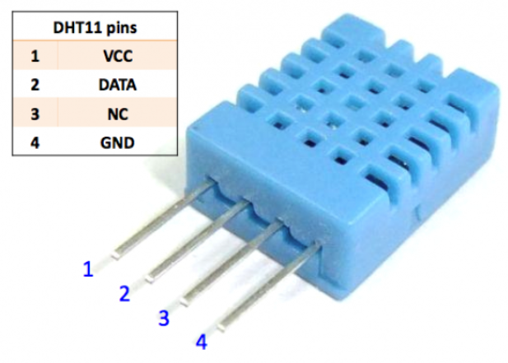
Fig. 1. DHT11 Sensor
pH sensor: A sensor that measures the hydrogen ion concentration [1][7] in the water according to equation (1) [11].
Water level depth sensor: A high-level or drop recognition sensor that measures the volume of water (in cm3) in order to determine the depth or the water level, helps to determine the amount of water still in the storage container, and provides accurate reports to prevent empty water containers, which will lead to hydroponic plants that lack water, [11] and helps to find out how much water is still there.
Water pump (5V DC pump): Solenoid 2-valve water pump which pumps the water into the system when the depth of water reaches below a specified threshold value [1].
Relay: A electromechanical switch that is used to control the water pump [1] and controls the movement of the fan which is done through voltage switching [14]. The relay module is the electrical switch for mains voltage to turn on or off or let the current go through or not [9] and can be connected to the ESP32 board as shown in (Fig. 2.)
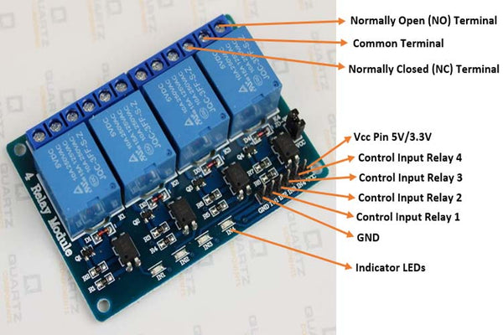
Fig. 2. 4-Channel Relay module
Fan: A device that works under a relay that helps in regulating the temperature of the system [13].
Strip LED: An electronic device producing artificial light [3].
Soil moisture sensor: A device that passes an electric current through the soil and observes resistance to measure the volumetric content of water [2][9].
ESP32 microcontroller: It is one of the development boards of the Esp32 series [13]. The module is shown in (Fig. 3.) which has built-in Wi-Fi connectivity and the ability to drive the entire system through power allocation and is involved in sending data continuously [10]. Other microcontroller boards such as Raspberry Pi can be used to store data in a cloud. Through IP address, the stored data can be accessed efficiently [15].
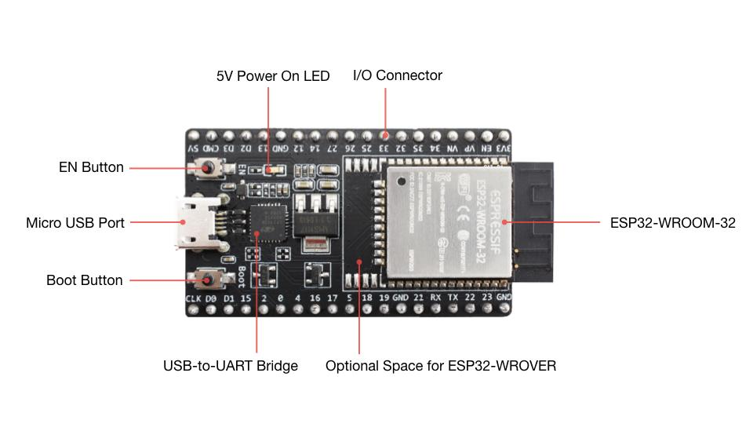
Fig. 3. ESP32 Devkit Module

Software
In order to enable functionality and resource heterogeneity, the suggested IoT software architecture must perform satisfactorily. Various software and application designs to perform analysis or to inform updates to users include the ones listed below:
Arduino IDE: It is an open-source application that allows to code programs to ESP32 board and it runs on Windows, Mac OS X, and Linux [10]. The ESP32 board with several data pins is easy for connecting various accessories.
Thingspeak: A cloud platform that helps in remote monitoring of applications built over IoT and builds MatLab models to perform analysis of the data [4].
Blynk IoT: A mobile application that used control applications built over IOT via Internet [1][4]. Provides the user with the desired information through a graphical user interface or human-machine interface [16].

Block Diagram
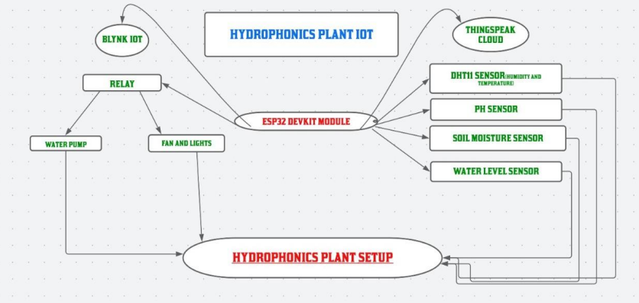
Fig. 4.4. Work-flow of the Model

Approach
In the flow chart mentioned above (Fig. 4), It is evident that a set of sensors are connected to the ESP32 microcontroller through which data and analog pins are connected. 2 breadboards have been used in this system which is powered by ESP32 boards (Fig. 3) positive, and negative terminals, and these breadboards are used in turn to power up the sensors.
The compiled code will initially be run via uploading it to the ESP32 which is powered by a 12V battery or mains power source, which also powers on all of the sensors and causes them to begin reading data from their interfaces and loading it into ESP32. The water level depth sensor is used in the first step of the process, reading the amount of water in the pipe (in cm3) and sending data back to the ESP32 [10], where the received value is compared with the threshold value that is given in the code. The motor is set to be switched ON through the relay if the value is less than the threshold., in which for every 2 seconds, it checks the status of the flag in the code and works accordingly [16], the same principle applies to the temperature sensor (DHT11), which measures temperature in Celsius and compares it to a predetermined threshold value. If the ambient temperature exceeds the threshold, the other relay condition is set to high, and the fan motor is switched on as a result (this comparison is made every two seconds). Using the ESP32's built-in Wi-Fi function, it is able to upload data from these sensors to the Thingspeak cloud, where analyses were carried out and graphs were created to collect more information and crucial data that facilitated the plant's rapid growth. Despite the fact that any application can be created with enough technology, connecting to Blynk-IoT was done in order to send data. Thanks to the Bluetooth functionality of the ESP32, any application can be developed with an appropriate front-end [9], and for some sensors, users were able to remotely control the system's functioning with a stable network connection [6]. Certain notifications were sent to users' mobile devices.

APPLICATIONS
Smart hydroponic systems can be used for many different things. They can be used for a variety of tasks, like collecting plants from the earth and cultivating them in space stations. The well-known ideas of the Internet of Things can be combined with traditional farming methods to build smart systems. Organic farming has received a lot of attention recently. Restaurants grew their meals using hydroponics in the subway networks of several southeast Asian nations [17]. Terrace farming, which can be employed on space stations where the grown food can serve as an astronaut food source because it takes up little space and guarantees a healthy atmosphere, can be used to use it in a range of constructions [16].

Results And Discussions
The complete project Model was created using the earlier discussed methodology, which used a drip system to deliver solutions effectively [7]. For Comparative analysis, the experiment was carried out using two sets of plants to evaluate the concept [6]. One of the sets contained a few of the plants such as tomato, coriander, and lettuce [7], and allowed the same to grow hydroponically. The second set included identical plants that were raised in a typical habitat (without utilizing a created system). With the help of characteristics like temperature variation, water use, etc., some interesting graphs were created utilizing the data that was collected in Thingspeak. For roughly a week, the model was left to run on its own. During that time, it was able to record the plant's daily growth height, and the MatLab Analysis Tool was used to do the following analysis.

Discrete sequence Plots

Variation in solution’s pH:
Different nutrient solutions are more effective in certain hydroponics systems. On the other hand, because different nutrient solutions break down into ions in ions, they give varied conductivity values. The ability of plants to absorb solutions typically depends on the pH of the solution [1][7]. Plants absorb nutritional solutions through their roots. Acid solutions, for instance, encourage the absorption of hydrogen, the pH value can be found as mentioned in equation (1) [11].
pH = -log[(H₃O+)] (1)
From point of Analysis, keen observational analysis were performed on the data that was collected from the Thingspeak cloud which contained 4000 data points taken across 2 days. At first, the solution will be acidic because of the presence of Nitrogen, Phosphorous, and Sodium (also known as NPK). At first, as the water supply starts water tries to neutralize the solution hence the value of pH goes on increasing because of more water content [6]. After a Certain Point when the threshold value is reached, supply stops and that’s where a gap can be observed in (Fig. 5) in the graph, later when plants start to absorb the solution and hence water content goes on decreasing, the presence of NPK dominates so pH gradually decreases. And this process goes on as and when water needs to be pumped
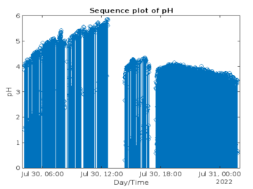
Fig. 4. Sequence Plot of pH

Variation in Water Level
It was one of the base conditions for maintaining a supply of the nutrient solution. Initially, the threshold was set to 2500 cm³ So whenever the water supply reached the threshold value [12], the supply stops by turning the motor off, and when water was being consumed (level goes down), the water supply began by turning the motor on, thereby maintaining an average threshold [4]. The same can be seen in (Fig. 5.) where alternate data points are observed going in alternating up and down trends.
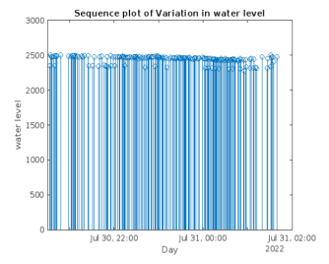
Fig. 5. Sequence plot of water level (in cm³)

Histograms

Temperature variation:
The graph (Fig. 7) showcases a plot of a histogram wherein data taken over 72 hours is been depicted on the y-axis (across 3 days) [12], and the temperature scale is depicted on the x-axis, It is evident that in the first 10 hours maximum temperature of 26 degrees was observed and in the next 10 hours, it has increased to 26.5 degrees on average and so on [4].
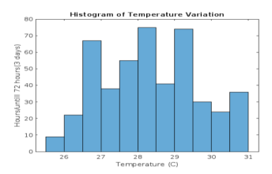
Fig. 6. Variation in Temperature (C)

Variation in Soil moisture:
The graph (Fig. 8) showcases a plot of a histogram that depicts data that was collected for around 83 hours (3+ days). Although soil is not used in the project, the cocopeat soil was used only to give support for the growth of plants. Hence when the presence of solution in the tank, interacts with this soil, soil moisture data was recorded. One can observe an upward/downward trend which depicts the usage of the nutrient solution by plants every now and then.
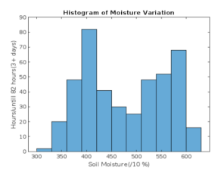
Fig. 7. Variation in Soil moisture (in relative %)

Two Y-Axes Plot
These plots help identify underlying relationships, and patterns observed among any 2 given parameters.

Temperature against pH:
From the graph (Fig. 8.) It is evident that, initially, whenever the temperature (represented in blue color) was observed to be more, plants consumed more of the solution, and a bit of evaporation in the solution can be expected, and hence the value of the solution’s pH (represented in red color) can be observed to be a bit higher [6], this can be attributed due to the fact that more of water content was consumed leaving NPK behind and resulting in a solution which is highly acidic nature.
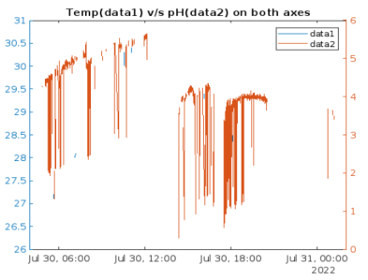
Fig. 8. Temperature v/s pH (Temperature, C)

pH
Graph (Fig. 9.) indicates that initially on providing the solution, water content gradually increases. Hence an increase in pH is observed as the presence of NPK is neutralized, later as the solution is consumed by plants, pH gradually decreases, this can be attributed due to low watery content and higher nutrient concentration (NPK), hence the solution is more acidic which indicates less pH value observed in Right-hand side of the graph (Fig. 9.).
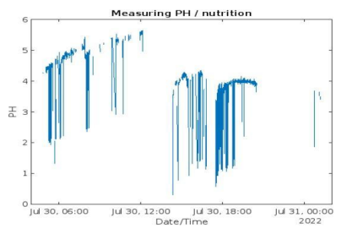
Fig. 9. Variation in pH across two days

Growth Rate Comparison Results
From the growth chart (Fig. 11) and (Fig. 12) it is evident that by applying principles of IoT one can expect a good, fast yield compared to the traditional approach. By automizing the entire process not only can one reduce human involvement but also can get the expected product in a much easier, faster way [13]. In these charts, a linear growth trend can be observed across 7 days [4], The red line indicates the Growth rate of the plant using 1st sample which had plants that were grown in the hydroponic system and the blue line indicates those plants that were grown in the traditional approach. Here plant’s height versus time has been considered as one of the qualitative measurements which determine the successful growth of a plant.
Under varied conditions, plants were hydroponically cultivated, and some of the morphological data were measured and analyzed. the usage of blue light LED-treated plants resulted in a greater accumulation of biomass, leaf density, leaf area, and pigment content were the results of additional LED light [17].

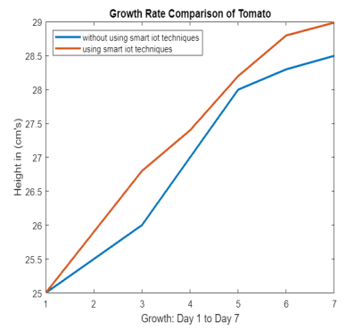
Fig. 10. Growth rate of Tomato (in cm)
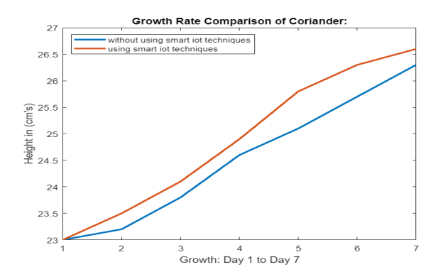
Fig. 11. Growth rate of Coriander (in cm)

TABLE I. Growth rate Comparison of Plants with and without using IoT Techniques
Plants | Height With non-IoT approach In 7 days  (in cm) | pH Range | Temp  Range | Height achieved using IoT approach In 7 days  (in cm)
tomato | 28.6 | 4.9-5.6 | 21-26°C | 29
lettuce | 18.5 | 5.2-6 | 21-24°C | 18.8
coriander | 26.2 | 4.9-6.3 | 25-30°C | 26.6
From the above growth comparison of various plants (TABLE I.), It is evident that, by using the smart Hydroponics system, the yield of plants increases when compared to the conventional method of growing Plants. This Table (TABLE I.) also shows the optimal conditions of growing plants (parameters like temperature) [16] (like lettuce, tomato coriander) which have been identified as factors for fast/successful growth under this system. One can also observe that for that particular range of pH, and temperature [9], variation in height of the plants can be seen. Circuit implementation is shown in (Fig. 12.) and the project is shown in (Fig. 13.)

Mobile Application
Since the system uses ESP32-Devkit which has a built-in Wi-Fi module, it is possible to send the status of the system and necessary data into the Thingspeak cloud as well as the Blynk-IoT mobile application [1][3][9][12][16] wherein the user is notified with appropriate messages and also notifies about the actions that need to be taken [13][14]. For example, the below table (TABLE II) shows some notifications that were obtained while experimenting according to the scenario of the system. The mobile interface is shown in (Fig. 14.)
TABLE II. User Notifications
Condition/status of the system | Notification through App
Water level (<2500) | Low Plant Water level
Temperature (>25 degrees) | Fan turned ON.
the Motor is ON/OFF | Motor ON / OFF
The Ph of supply below a set threshold | Supply Improper

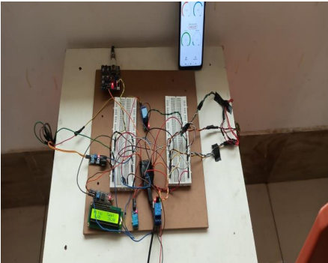
Fig. 12. Implemented Circuit
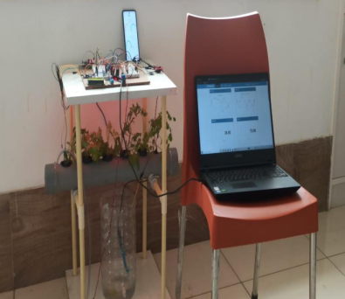
Fig. 13. Complete Developed Project
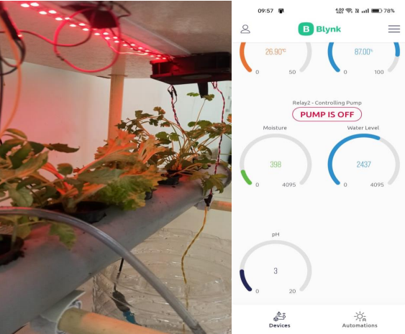
Fig. 14. Plants (on the left) and Mobile Interface (on the right)

Future Scope
IoT will play a major role in the development of the hydroponic way of growing plants. Automation using IOT along with the advancement in technology, interaction of farmers with the plant system can be minimized. With the help of the sensor bulk amount of data can be collected and various sorts of analyses can be done to bring out results and parameters which can improve the conditions and production of the hydroponic system by monitoring the system by knowing the IP address to access the Dashboard [15]. In the mindset of the growing population, the self-sufficient system can be introduced to create a hydroponics farm system to cover all the waste place in creating a local hydroponic environment which reduces the dependence on other systems. Moving further, Ultra-Violet (UV) based LED lights can be used to harness an adequate amount of light energy being supplied to plants appropriately [17]. Installation of insecticide solution spray can be included right above the plants to ensure the quality of yield. One can even ensure that more carbon dioxide can be supplied to the plants by passing through various filter membranes, which can act as Air-Filter A system of sensors along with working mechanical models can be used farm over the hydroponic system to avoid human interaction. With a large amount of data being gathered Certain concepts of big data [5][8][15] can be applied to process these and concepts of Machine Intelligence can be applied to know the quality, and quantity of yield. In the development of hydroponics, a hybrid system of water and soil can be introduced to generate a more approachable and economical way. An Aquaponic system can be implemented

CONCLUSION
Hydroponics is trending around the world as a viable and feasible alternative to various other techniques of growing plants for all the right reasons. The better yield of plants is a very attractive feature for farmers around the globe to implement this system. Soilless cultivation of plants is extremely useful in urban household gardens and other places where land is scarce. Applying IoT principles to hydroponics amplifies the impact of these benefits and offers a user-friendly interface for viewing and managing the system with minimal human involvement. Solar energy can be used to power the automated system created in this way, allowing one to conserve natural resources and make the system environmentally friendly. In locations where gardening is not feasible, soilless culture and vertical hydroponics can be employed to provide proper food and air quality. Chlorophyll-enriched plants can be cultivated with the help of the right LEDs, which would result in improved growth and higher light absorption for photosynthesis.
By constantly monitoring the system, one can have complete control over the nutrients while also using 15% less area to develop. It is possible to use cultivation and drip watering. It is possible to use a hydroponic system that conserves resources and water. The growth rate of the plant increases quickly in comparison to a conventional strategy since the roots of plants will always be in contact with nutrient solution. The system created is user-friendly and doesn't require any prior system expertise. Hydroponic farming would be beneficial in a difficult environment since plants may grow quickly in isolated places like an arid desert or underwater (oceanic farming). Data is kept on the cloud, so analysis can be done there.

References
- Kanhekar, Vaibhav, Tejas Deshbhratar, Yogeshwari Matey, Kamlesh Kalbande, and Atul Deshmukh. "Hydroponic Farming using IoT." In 2022 International Conference on Edge Computing and Applications (ICECAA), pp. 583-586. IEEE, 2022.
- Joshitha, C., P. Kanakaraja, Kovur Sarath Kumar, Polavarapu Akanksha, and Guduru Satish. "An eye on hydroponics: The IoT initiative." In 2021 7th International Conference on Electrical Energy Systems (ICEES), pp. 553-557. IEEE, 2021.
- Pawar, Smita, Shreya Tembe, Rujuta Acharekar, Sahar Khan, and Sheetal Yadav. "Design of an IoT-enabled Automated Hydroponics system using NodeMCU and Blynk." In 2019 IEEE 5th International Conference for Convergence in Technology (I2CT), pp. 1-6. IEEE, 2019.
- Boonnam, Nathaphon, Jumras Pitakphongmetha, Siriwan Kajornkasirat, Teerayut Horanont, Deeprom Somkiadcharoen, and Jiranuwat Prapakornpilai. "Optimal plant growth in smart farm hydroponics system using the integration of wireless sensor networks into the internet of things." Adv. Sci. Technol. Eng. Syst. J 2, no. 3 (2017): 1006-1012
- Munandar, Aris, Hanif Fakhrurroja, Irfan FA Anto, Rian Putra Pratama, Joni Winaryo Wibowo, Taufik Ibnu Salim, and Muhammad Ilham Rizqyawan. "Design and development of an IoT-based smart hydroponic system." In 2018 international seminar on the research of information technology and intelligent systems (ISRITI), pp. 582-586. IEEE, 2018.
- Palande, Vaibhav, Adam Zaheer, and Kiran George. "Fully automated hydroponic system for indoor plant growth." Procedia Computer Science 129 (2018):482-488.
- Bakhtar, Nikita, Varsha Chhabria, Iptisaam Chougle, Harsha Vidhrani, and Rupali Hande. "IoT based hydroponic farm." In 2018 International Conference on Smart Systems and Inventive Technology (ICSSIT), pp. 205-209. IEEE, 2018.
- Kularbphettong, Kunyanuth, Udomlux Ampant, and Nutthaphol Kongrodj. "An automated hydroponics system based on mobile application." International Journal of Information and Education Technology 9.8 (2019): 548-552.
- P. Rajalakshmi and S. Devi Mahalakshmi, "IOT based crop-field monitoring and irrigation automation," 2016 10th International Conference on Intelligent Systems and Control (ISCO), 2016, pp. 1-6, doi: 10.1109/ISCO.2016.7726900.
- Babiuch, Marek, Petr Foltýnek, and Pavel Smutný. "Using the ESP32 microcontroller for data processing." 2019 20th International Carpathian Control Conference (ICCC). IEEE, 2019.
- R. Perwiratama, Y. K. Setiadi and Suyoto, "Smart hydroponic farming with IoT-based climate and nutrient manipulation system," 2019 International Conference of Artificial Intelligence and Information Technology (ICAIIT), 2019, pp. 129-132, doi: 10.1109/ICAIIT.2019.8834533.
- Pitakphongmetha, Jumras, Nathaphon Boonnam, Siriwan Wongkoon, Teerayut Horanont, Deeprom Somkiadcharoen, and Jiranuwat Prapakornpilai. "Internet of things for planting in smart farm hydroponics style." In 2016 International Computer Science and Engineering Conference (ICSEC), pp. 1-5. IEEE, 2016.
- Ullah, Ahsan, Sadia Aktar, Nipa Sutar, Rafsan Kabir, and Afzal Hossain. "Cost effective smart hydroponic monitoring and controlling system using IoT." Intelligent Control and Automation 10, no. 04 (2019): 142.
- Kularbphettong, Kunyanuth, Udomlux Ampant, and Nutthaphol Kongrodj. "An automated hydroponics system based on mobile application." International Journal of Information and Education Technology 9, no. 8 (2019): 548-552.
- Ani, Akhil, and Prakash Gopalakirishnan. "Automated Hydroponic Drip Irrigation Using Big Data." 2020 Second International Conference on Inventive Research in Computing Applications (ICIRCA). IEEE, 2020.
- Wan Azhar, Wan Ahmad Firdaus, et al. "Realtime control and monitoring aquaponic system via Blynk." Journal of Electrical and Electronic Systems Research (JEESR) 16 (2020): 73-80..
- Namgyel, T., et al. "IoT based hydroponic system with supplementary LED light for smart home farming of lettuce." 2018 15th International Conference on Electrical Engineering/Electronics, Computer, Telecommunications and Information Technology (ECTI-CON). IEEE, 2018.

