AI LinkedIn Post Generator - Interview Revision Notes
This document is designed as a quick revision guide. It summarizes the complete project so that even after a long gap, you can review it in 20–30 minutes and confidently explain the project during interviews.

1. Project Introduction
Problem:
Generic LLMs can generate LinkedIn posts, but they do not naturally imitate a specific creator's writing style.
Solution:
This project generates LinkedIn posts by retrieving similar examples from an existing dataset and supplying them as Few-Shot examples to the LLM.
Why this project : for content creators/influencers, with help of AI,improve their writing
Why Few-Shot instead of Fine-Tuning?
• No training cost.
• Easier to update with new posts.
• Faster development.
• Suitable for small datasets.
Tech Stack:
Python, LangChain, Groq (Llama), Streamlit, Pandas, JSON.

2. High-Level Architecture
Phase 1 (Offline)
raw_posts.json
↓
preprocess.py
↓
Metadata Extraction
↓
Tag Normalization
↓
processed_posts.json
Phase 2 (Runtime)
Streamlit UI
↓
FewShotPosts
↓
Retrieve Similar Posts
↓
Prompt Builder
↓
Groq LLM
↓
Generated LinkedIn Post

3. Phase 1 - Preprocessing
Goal:
Convert raw posts into structured posts that can later be searched efficiently.
Input:
{text, engagement}
Output:
{text, engagement, language, line_count, tags}
Reason:
The runtime should not repeatedly ask the LLM to extract metadata.

Preprocess.py :
Sample:
Input:
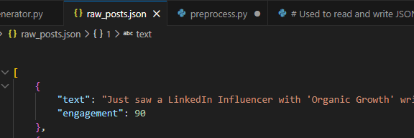
Output:
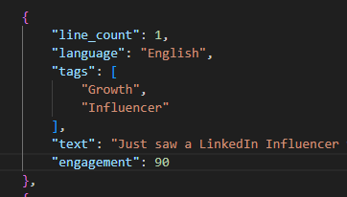
- Obtain the post in form of json,load it ,send it to extract metadata :
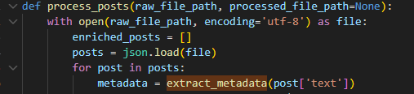
2) so create a prompt saying generate (tag,line_count,language) mdt for each post , create a prompt, pass it to llm model using pipe operator langchain,then obtain response content in form of dictionary :
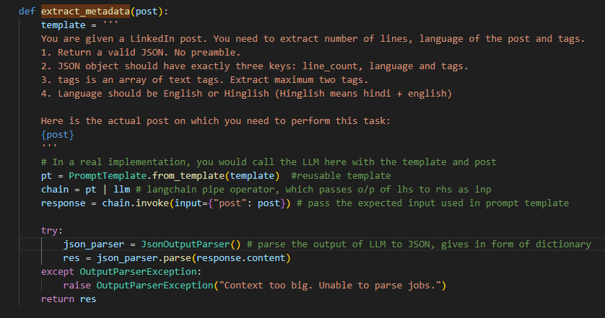
- Now merge this metadata with actual post using pipe operator of dictionary 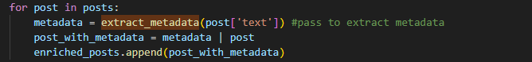
- now problem of this output is it can store multiple tags of same meaning,like Job hunting,job seeker,job search, they all point to Job search tag,so unify it using llm
so send a prompt for that again : 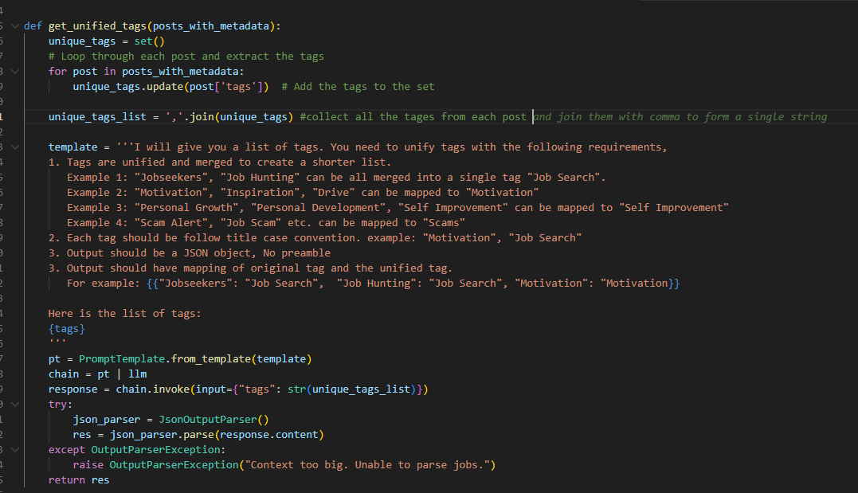
next once we have updated generalised tags its like dictionary like :
{ ‘Job hunting’ -> ‘Job Search’ , ‘Job seeker’ -> ‘Job Search’}
so for our current post tags, pick our generalised one:
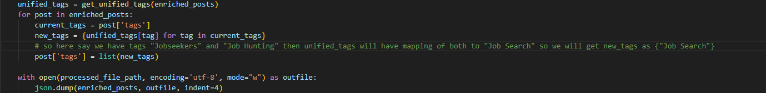

8. Phase 2 - Runtime
Goal:
Use the processed dataset to retrieve similar examples and generate a new LinkedIn post matching the user's request.

FewShotPosts.py :
Responsibilities:
• Read processed_posts.json
• Convert JSON into a Pandas DataFrame
• Categorize post length
• Extract unique tags
• Filter matching examples
In Constructor , we will just open the file, convert json data to dataframe,(easy to have in form of columns, coz its needed for streamlit),. So 2 things :
1)User enters just small,M,L , we need to encode it to number of lines like this :
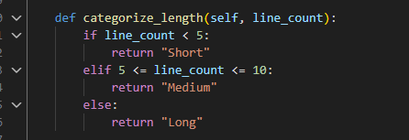
2) In order to display topics we need to have all tags in a column so build that
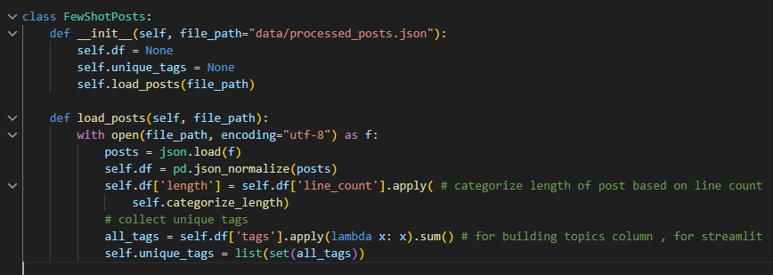
3) Now we have actual function that filters tags,language,length against user entries 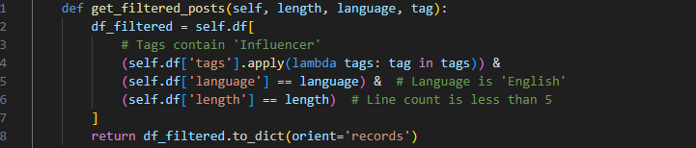

Post_generator.py:

so here mainly we are taking user input ,making prompt out of it
example is from few shot->actual matching response if we obtain, then only it will use as an example, this is the one that adds writer’s essence ,

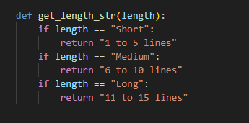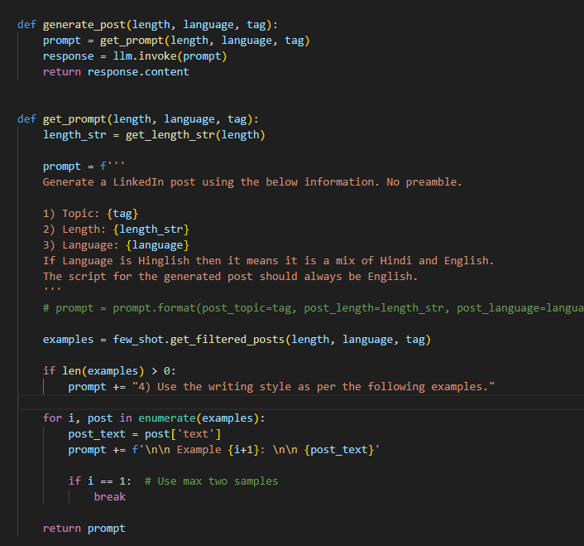

Llm helper :
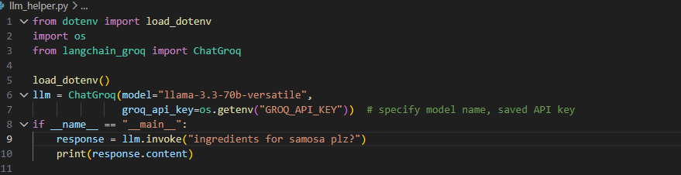
Streamlit/Main.py :
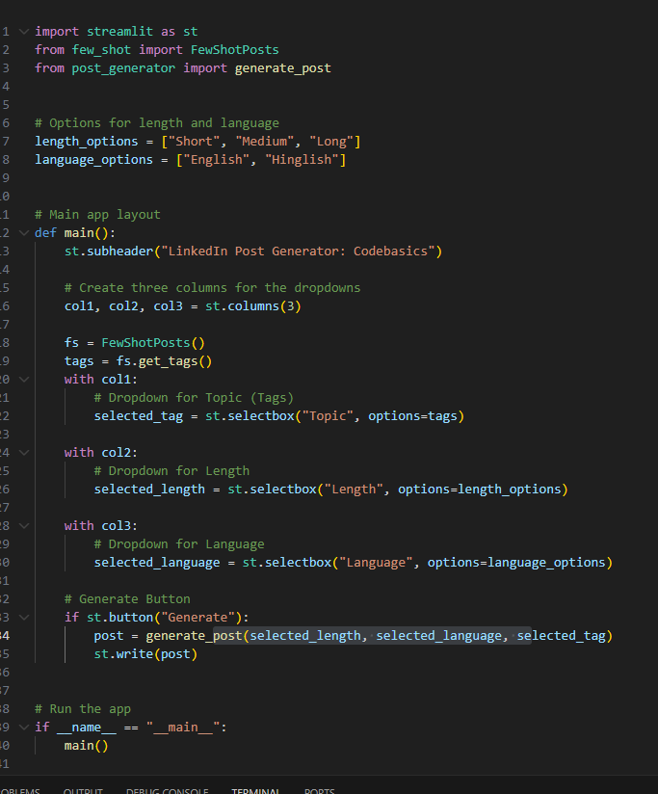
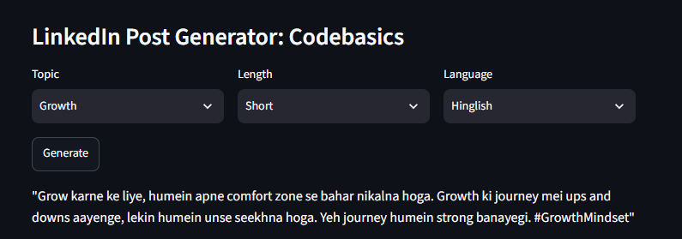

11. User Input
Streamlit displays:
Topic
Length
Language
Example:
Topic = Job Search
Length = Short
Language = English
User clicks Generate.

12. Filtering Examples
DataFrame is filtered using:
• Tag
• Language
• Length
Example:
Row1 -> Social Media ❌
Row2 -> Job Search + English + Short ✅
Row3 -> Job Search + English + Medium ❌
Only matching rows are returned as Few-Shot examples.

13. Prompt Building
Prompt initially contains:
• Topic
• Length
• Language
Then matching examples are appended.
Final Prompt:
Generate LinkedIn post
Topic: Job Search
Length: 1-5 lines
Language: English
Example 1:
...
Example 2:
...

14. LLM Generation
llm.invoke(prompt)
The LLM receives:
• User requirements
• Two similar examples
Because of the examples, it imitates the writing style instead of generating a generic post.

15. Final Output
generate_post()
↓
response.content
↓
main.py
↓
st.write(post)
The generated LinkedIn post is displayed in the browser.

16. End-to-End Dry Run
raw_posts.json
↓
preprocess.py
↓
Metadata Extraction
↓
Tag Normalization
↓
processed_posts.json
↓
FewShotPosts
↓
Load DataFrame
↓
User selects Topic + Length + Language
↓
Filter Matching Posts
↓
Build Prompt
↓
Append Examples
↓
Groq LLM
↓
Generated LinkedIn Post

17. Important Concepts
PromptTemplate - Creates reusable prompts.
Pipe Operator (|) - Connects LangChain components.
invoke() - Executes the chain/LLM.
JsonOutputParser - Converts JSON string into Python dictionary.
Pandas DataFrame - Makes filtering simple.
Few-Shot Learning - Teaches the LLM the desired writing style using examples.

18. Interview Cheat Sheet
Be ready to answer:
• Explain the project architecture.
• Why preprocessing?
• Why store metadata?
• Why normalize tags?
• Why Pandas?
• How does filtering work?
• Why Few-Shot instead of Fine-Tuning?
• How is the prompt constructed?
• What does llm.invoke() do?
• How would you improve this project? (Embeddings, Vector DB, FAISS, RAG)

