1. System Architecture The project follows a Client-Server Architecture.
- Frontend (User Interface): Built using HTML5 and CSS3. It captures user inputs and displays the prediction result.
- Backend (Server): A Flask application running on Python. It acts as the bridge between the UI and the Machine Learning model.
- Model Layer: The XGBoost Classifier. The model is loaded into the server's memory using joblib.
2. Component Interaction
- The user submits data via the Web Form.
- Flask receives the data and applies scaling using the StandardScaler object.
- The scaled data is sent to the XGBoost model.
- The model returns a prediction, which Flask uses to redirect the user to the correct outcome page.

User Interface Design
1. Design Principles
- Simplicity: Minimalist layout for ease of use by non-technical users.
- Clarity: Uses color-coding (Red for Alert, Green for Safe) to communicate risk instantly.
2. Page Structure
- Home Page (home.html): Introduction to the flood prediction system.
- 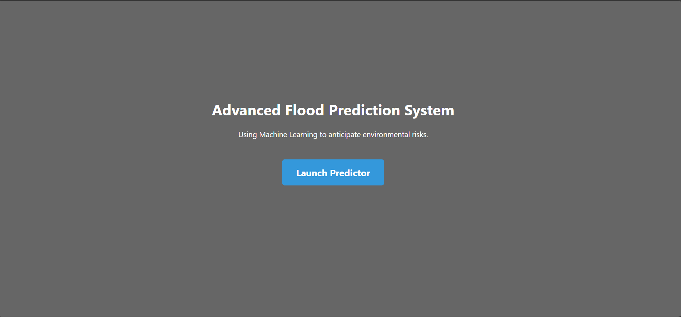
- Input Page (index.html): Form containing five numeric input fields.
- 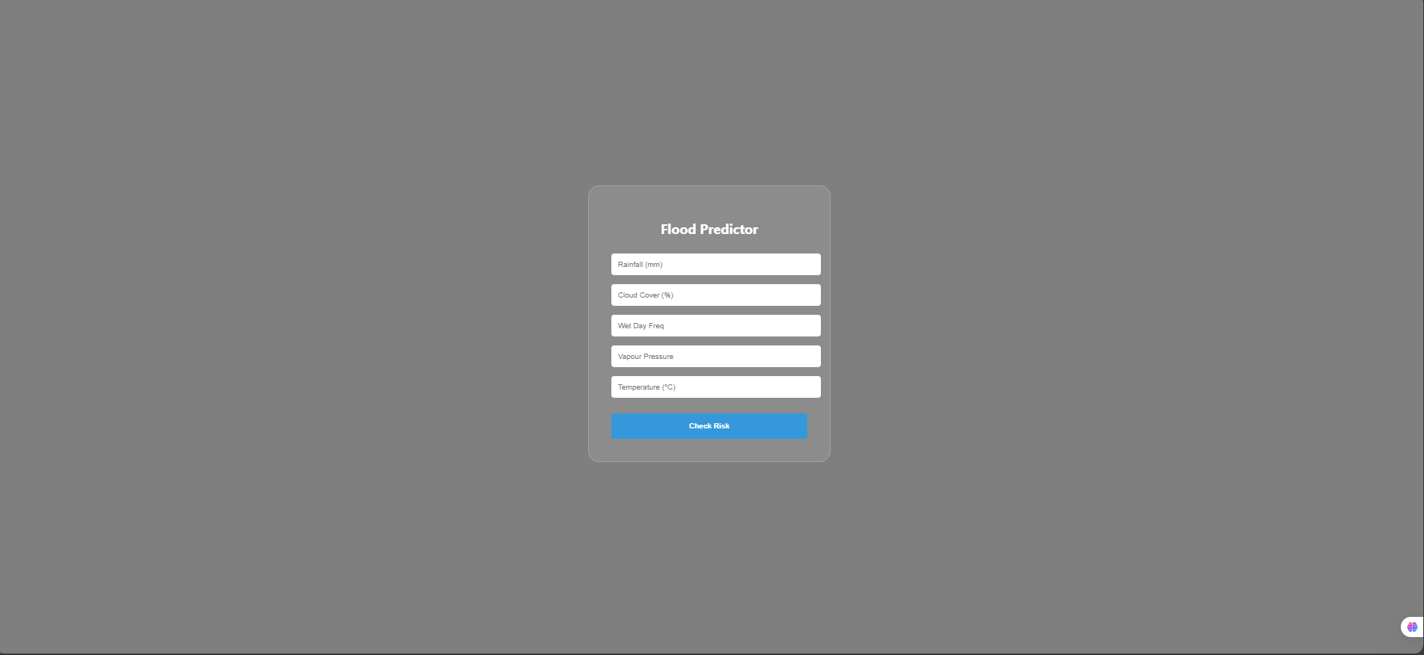
- High Risk Page (chance.html): Red-themed alert indicating flood probability.
- 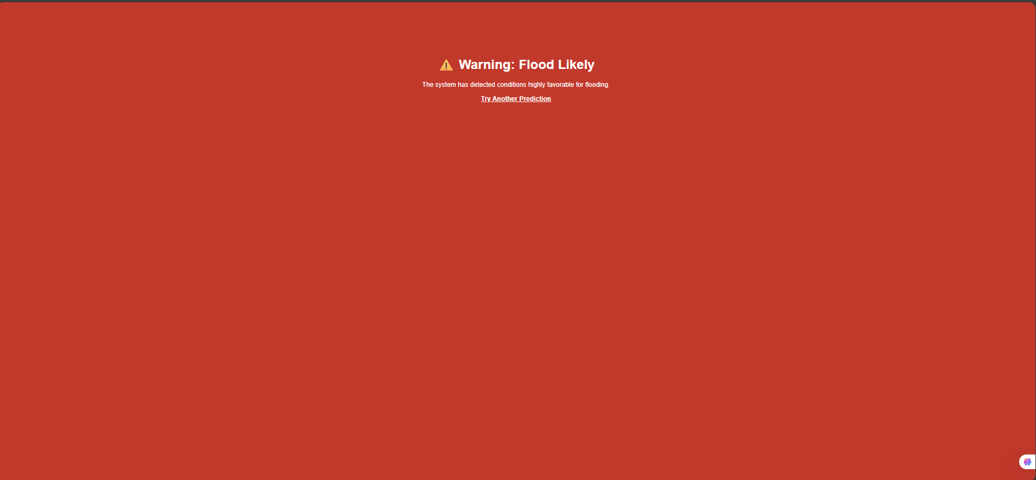
- Safe Page (no_chance.html): Green-themed notification indicating no flood risk.
- 