PHD Report
Demographics Data :
•
CustomerID : Customer ID
•
InsuredAge : age
•
InsuredZipCode : Zip Code
•
InsuredGender : Gender
-
the missing value is represented as “NA”
•
InsuredEducationLevel : Education
•
InsuredOccupati
on : Occupation
•
InsuredHobbies : Hobbies
•
CapitalGains : Capital gains(Financial Status)
•
CapitalLoss : capital loss(Financial Status)
•
Country : Country
Policy Information :
•
CustomerID : Customer ID
•
CustomerLoyaltyPeriod : Duration of
customer relationship
•
InsurancePolicyNumber : policy number
•
DateOfPolicyCoverage : policy commencement date
•
InsurancePolicyState : Policy location (State)
•
Policy_CombinedSingleLimit : Split Limit and Combined Single Limit
•
Policy_Deductible :
Deductible amount
•
PolicyAnnualPremium : Annual Premium
–
the missing value is represented as “
-
1”
•
UmbrellaLimit : Umbrella Limit amount
•
InsuredRelationship : Realtionship
•
TotalCharges : Customer account information (Total). ( For this attribute,
missing values are denoted as “MISSINGVAL” also)
•
DOE : Date of entry as customer
•
ElectronicBilling : Customer account information
-
whether electronic
billing
•
Cont
ractType : Contract type ( For this attribute,
missing values are
denoted as “NA”)
•
PaymentMethod : payment method
Claim Information :
•
CustomerID : Customer ID
•
DateOfIncident : Date of incident
•
TypeOfIncident : Type of incident
•
TypeOfCollission : Type of Collision
-
“?” is the missing value
•
SeverityOfIncident : Collision severity
•
AuthoritiesContacted : Which authorities are contacted
•
IncidentState : Incident location (State)
•
IncidentCity : Incident location (City)
•
IncidentAddress : Incident location (address)
•
IncidentTime : time of incident
–
Hour of the day
-
the missing value is represented
as “
-
5”
•
NumberOfVehicles : Number of vehicles involved
•
PropertyDamage : If property damage is there
-
“?” is the
missing value
•
BodilyInjuries : Number of bodily injuries
•
Witnesses : Number of witnesses
-
missing value is represented as
"MISSINGVALUE"
•
PoliceReport : If police report available
-
“?” is the missing value
•
AmountOfTotalClaim : Total cl
aim amount
-
the missing value is
represented as
“MISSEDDATA”
•
AmountOfInjuryClaim : Claim for injury
•
AmountOfPropertyClaim : claim for property damage
•
AmountOfVehicleDamage : claim for vehicle damage
Data of Vehicle:
•
CustomerID : Customer
ID
•
VehicleAttribute : Service signed for
•
VehicleAttributeDetails : Value of the vehicle attribute
-
the missing value is
represented as “???”
Churn Data :
•
CustomerID : Customer ID
•
ReportedFraud : Fraud or not
–
Targe
Demographics Data :
•
CustomerID : Customer ID
•
InsuredAge : age
•
InsuredZipCode : Zip Code
•
InsuredGender : Gender
-
the missing value is represented as “NA”
•
InsuredEducationLevel : Education
•
InsuredOccupati
on : Occupation
•
InsuredHobbies : Hobbies
•
CapitalGains : Capital gains(Financial Status)
•
CapitalLoss : capital loss(Financial Status)
•
Country : Country
Policy Information :
•
CustomerID : Customer ID
•
CustomerLoyaltyPeriod : Duration of
customer relationship
•
InsurancePolicyNumber : policy number
•
DateOfPolicyCoverage : policy commencement date
•
InsurancePolicyState : Policy location (State)
•
Policy_CombinedSingleLimit : Split Limit and Combined Single Limit
•
Policy_Deductible :
Deductible amount
•
PolicyAnnualPremium : Annual Premium
–
the missing value is represented as “
-
1”
•
UmbrellaLimit : Umbrella Limit amount
•
InsuredRelationship : Realtionship
•
TotalCharges : Customer account information (Total). ( For this attribute,
missing values are denoted as “MISSINGVAL” also)
•
DOE : Date of entry as customer
•
ElectronicBilling : Customer account information
-
whether electronic
billing
•
Cont
ractType : Contract type ( For this attribute,
missing values are
denoted as “NA”)
•
PaymentMethod : payment method
Claim Information :
•
CustomerID : Customer ID
•
DateOfIncident : Date of incident
•
TypeOfIncident : Type of incident
•
TypeOfCollission : Type of Collision
-
“?” is the missing value
•
SeverityOfIncident : Collision severity
•
AuthoritiesContacted : Which authorities are contacted
•
IncidentState : Incident location (State)
•
IncidentCity : Incident location (City)
•
IncidentAddress : Incident location (address)
•
IncidentTime : time of incident
–
Hour of the day
-
the missing value is represented
as “
-
5”
•
NumberOfVehicles : Number of vehicles involved
•
PropertyDamage : If property damage is there
-
“?” is the
missing value
•
BodilyInjuries : Number of bodily injuries
•
Witnesses : Number of witnesses
-
missing value is represented as
"MISSINGVALUE"
•
PoliceReport : If police report available
-
“?” is the missing value
•
AmountOfTotalClaim : Total cl
aim amount
-
the missing value is
represented as
“MISSEDDATA”
•
AmountOfInjuryClaim : Claim for injury
•
AmountOfPropertyClaim : claim for property damage
•
AmountOfVehicleDamage : claim for vehicle damage
Data of Vehicle:
•
CustomerID : Customer
ID
•
VehicleAttribute : Service signed for
•
VehicleAttributeDetails : Value of the vehicle attribute
-
the missing value is
represented as “???”
Churn Data :
•
CustomerID : Customer ID
•
ReportedFraud : Fraud or not
–
Targe
Claim Information :
•
CustomerID : Customer ID
•
DateOfIncident : Date of incident
•
TypeOfIncident : Type of incident
•
TypeOfCollission : Type of Collision
-
“?” is the missing value
•
SeverityOfIncident : Collision severity
•
AuthoritiesContacted : Which authorities are contacted
•
IncidentState : Incident location (State)
•
IncidentCity : Incident location (City)
•
IncidentAddress : Incident location (address)
•
IncidentTime : time of incident
–
Hour of the day
-
the missing value is represented
as “
-
5”
•
NumberOfVehicles : Number of vehicles involved
•
PropertyDamage : If property damage is there
-
“?” is the
missing value
•
BodilyInjuries : Number of bodily injuries
•
Witnesses : Number of witnesses
-
missing value is represented as
"MISSINGVALUE"
•
PoliceReport : If police report available
-
“?” is the missing value
•
AmountOfTotalClaim : Total cl
aim amount
-
the missing value is
represented as
“MISSEDDATA”
•
AmountOfInjuryClaim : Claim for injury
•
AmountOfPropertyClaim : claim for property damage
•
AmountOfVehicleDamage : claim for vehicle damage
Claim Information :
•
CustomerID : Customer ID
•
DateOfIncident : Date of incident
•
TypeOfIncident : Type of incident
•
TypeOfCollission : Type of Collision
-
“?” is the missing value
•
SeverityOfIncident : Collision severity
•
AuthoritiesContacted : Which authorities are contacted
•
IncidentState : Incident location (State)
•
IncidentCity : Incident location (City)
•
IncidentAddress : Incident location (address)
•
IncidentTime : time of incident
–
Hour of the day
-
the missing value is represented
as “
-
5”

PHD Report

Predicting the “Fraud in auto insurance claims”

Submitted By:
Siddarth.B
Batch 32 - INSOFE, Bengaluru

International School of Engineering, Bengaluru

9th Februaury, 2018

Predicting the “Fraud in auto insurance claims”

Submitted By:
Siddarth.B
Batch 32 - INSOFE, Bengaluru



International School of Engineering, Bengaluru

9th February, 2018

Contents

Abstract

1 . Introducion
1.1 Problem Statement
1.2 Data Description

2.Exploratory Data Analysis
2.1 Data Merging
2.2 Handle Missing Data
2.3 Outlier treatment
2.4 Correlation Values
2.5 Feature Engineering
2.6 Data Splitting

3. Models Building and Evaluation
3.1 Naive Bayes Model
3.2 Random Forest Model
3.3 XGBOOST Model
3.4 GBM Model
3.5 Stacking

Conclusion

Reference

Abstract

The purpose of this project is to predict the Fraud cases in vehicles insurance claims .A major general insurance company has a business problem with significant number of claims being reported are fraudulent in nature and it is leading to leakages.So, the Insurer decided to predict the fraudulent onesbefore even processing the claims to allocate costs appropriately, to keep the thorough investigation process in place and to design proper action plan for the claims etc.

1.Introduction

1.1Problem Statement
Insurance fraud refers toany claim with the intent to obtain an improper payment from an insurer.Motor and health insurance are the two prominent segments that have seen a spurt in fraud. Fraudscan be classified from source and/or nature point of view . Sources can be policyholder, intermediary and/or internal with the latter two being more critical from internal control framework point of view.Frauds can be classified into nature wise, for example, application, inflation, identity, fabrication, staged/contrived/induced accidents etc. Fraud affects the lives of innocent people as well as the insurance industry and thus it may be of interest for the health of the Insurance Industry and Society . In fact, Insurers report certain classified cases to Regulator and Law enforcement agencies like Police, Crime Bureaus and others as mandated by the Regulators/Government and required by Law.
With the advent of organised gangs and/or collusion, the problem has become more complex and sophisticated and the frauds have been difficult to detect and to prove, if detected . The framework of prediction of fraud and pattern extraction wil be useful for the insurance companies, regulatory body, intelligence department etc.Prediction at the time of processing claims will reduce costs and minimize losses.The intelligence arising out of ever improving prediction algorithms will help retrofitting in terms of improvement of the underwriting process, exercise of good selection of policyholders based on identified profile attributes, strengthening of internal risk management mechanisms and finally,a clear
guidance and communication to employees and other stakeholders involved.At the Industry level, the shared aggregate information helps build appropriate intelligence and resilience while paving the way for collective effort for prevention as well as minimizing losses and to match the efforts of perpetrators.At the Regulator and Law enforcement level, the intelligence arising out of prediction will help revamp the Regulations/Laws and plan not only enforcement but Industry based initiatives/systems for resilience and to share informationfor consumption of the Industry and the Society.Prediction at the time of processing claims will reduce costs and minimize losses for the insurance company. Hence, prediction of fraud plays very important role in auto insurance claims. The companywants to understand the hidden patterns in the data which lead to construction of investigation process as well as claim settlement decision.

1.2 Data Description

Total records in Train = 28836 No. Of Reported Fraud in train data
Total record in Test =9662
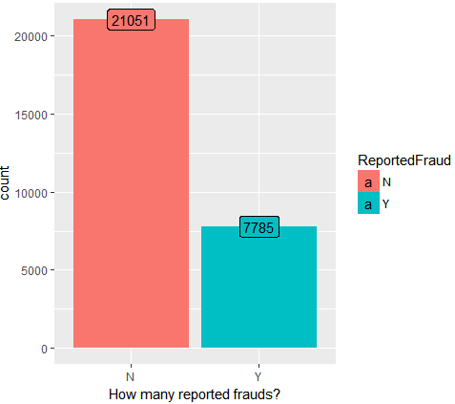
Demographics Data : • InsuredAge : age
•InsuredZipCode : Zip Code
•InsuredGender : Gender
•InsuredEducationLevel : Education
•InsuredOccupation : Occupation
•InsuredHobbies : Hobbies
•CapitalGains : Capital gains(Financial Status)
•CapitalLoss : capital loss(Financial Status)
•Country : Country

Policy Information :
• CustomerLoyaltyPeriod : Duration of customer relationship
•InsurancePolicyNumber : policy number
•DateOfPolicyCoverage : policy commencement date
•InsurancePolicyState : Policy location (State)
•Policy_CombinedSingleLimit : Split Limit and Combined Single Limit
•PolicyAnnualPremium : Annual Premium
•UmbrellaLimit : Umbrella Limit amount
•InsuredRelationship : Realtionship
•TotalCharges : Customer account information (Total).
•DOE : Date of entry as customer

Claim Information :
• DateOfIncident : Date of incident
•TypeOfIncident : Type of incident
•TypeOfCollission : Type of Collision
•SeverityOfIncident : Collision severity
•AuthoritiesContacted : Which authorities are contacted
•IncidentState : Incident location (State)
•IncidentCity : Incident location (City)
•IncidentAddress : Incident location (address)
•IncidentTime : time of incident –Hour of the day
•NumberOfVehicles : Number of vehicles involved
•PropertyDamage : If property damage is there
•BodilyInjuries : Number of bodily injuries
•Witnesses : Number of witnesses
-•PoliceReport : If police report available
•AmountOfTotalClaim : Total claim amount
•AmountOfInjuryClaim : Claim for injury
•AmountOfPropertyClaim : claim for property damage
•AmountOfVehicleDamage : claim for vehicle damage

Data of Vehicle:
•CustomerID : CustomerID
•VehicleAttribute : Service signed for
•VehicleAttributeDetails : Value of the vehicle attribute

Churn Data :
•CustomerID : Customer ID
•ReportedFraud : Fraud or not –Target

2 .Exploratory Data Analysis

2.1 Reading the Data And Merging

I. Combining the dataset of train and test into one file
We combine similar datasets of the train and test data into one file each , wrt to the rows

II . Splitting the data in “Data of vehicle” by Vehicle Attribute
The Train and Test data are given in 5 different .CSV files with the above given data fields.
We convert the following symbols of missing values in the respective data into NA’s .
The number of rows in the csv containing “Data of Vehicle” contains 4X number of rows as the other data . The reason being the vehicle attributes which contains 4 different fields in it which are corresponding to the costumer.
So we split the data of vehicle based on the vehicle attributes into 4 columns thereby converting them into 28836 rows.

III. Merging all the data By customer ID
Now after splitting the data in “Data of Vehicle” we merge all the attributes leaving out Vechicle ID as it contains no pattern. After this we merge all the remaining of the csv files with this into 1 csv file

2.2 Handle Missing Data

I. Filling NA's of insured gender using insured relationship
Some of the missing values in gender can be filled up by the relationship status .
i.e if relationship status is “wife” the gender is obviously Male
sameway if the relationship status is “Husband” the gender is Female

II. Imputing police report
For police report we consider the fields "Witnesses","Authorities Contacted","Property Damage" as they help in guessing whether a police report was filed or not.
Then , I split the data into test and train depending on the missing values in police report and used H2o.random forest to predict the missing values of police reported

III. Imputing TypeOfCollission
For police report we consider the fields "Number Of Vehicles","Type Of Incident","Property Damage" as they help in guessing whether a police report was filed or not.
Then , I split the data into test and train depending on the missing values in police report and used H2o.random forest to predict the missing values of police reported

IV. Imputing property damage
For police report we consider the fields "Type Of Collission","Amount Of PropertyClaim","Number Of Vehicles","Type Of Collission" as they help in guessing whether a police report was filed or not.
Then , I split the data into test and train depending on the missing values in police report and used H2o.random forest to predict the missing values of police reported

2.3 Outlier Detection

Box Plot: A box plot is a graphical rendition of statistical data based on the minimum, first quartile, median, third quartile, and maximum . The top of the rectangle indicates the third quartile, a horizontal line near the middle of the rectangle indicates the median, and the bottom of the rectangle indicates the first quartile. A vertical line extends from the top of the rectangle to indicate the maximum value, and another vertical line extends from the bottom of the rectangle to indicate the minimum value. Bubbles in box-plot show the outliers.

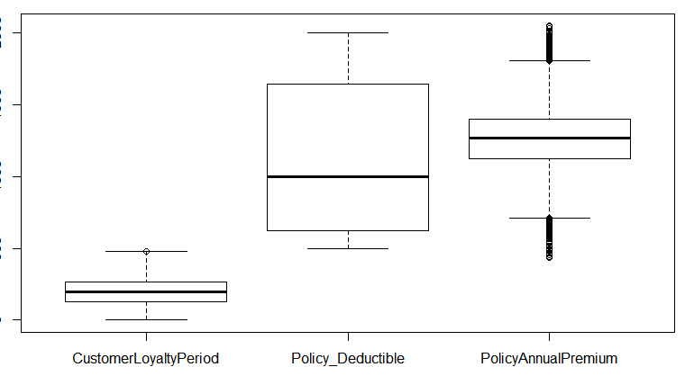
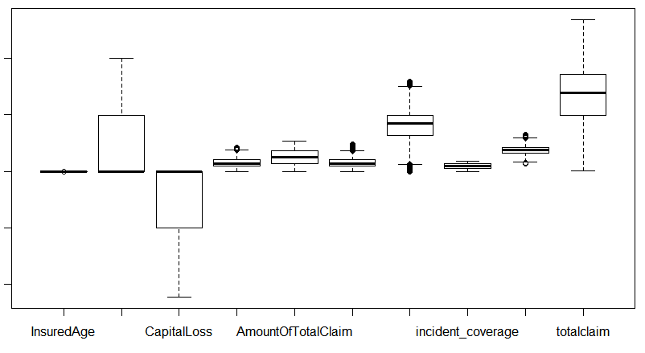

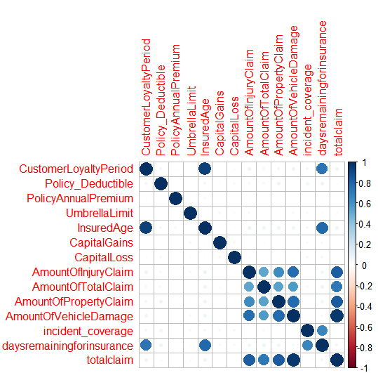
We can see here that Policy Annual Premium ,amount property claim and amount vehicle damage have many values out of the inter quantile range, so i took out those 3 fields and Capped the value down to 1.5*IQR value, so as to reduce their influence.

2.4 Correlation Plot

correlation plot t: this plots showing correlations
among pairs of variables in X. Through this we try
to explore the relationship (linear association)
among features.
All correlations have two properties: strength and
direction
2.5 Feature Engineering

I. Removing unnecessary features
we can remove Insurance Policy Number And country as they are reduntant fields

II. Zipcode
We divide the zipcode by 10 as to reduce the number of factors and also it would empahasize a particular region more . As we know the first 2 digits of a zipcode represents the region

III. Age of the customer during the incident
We introduce a new variable i.e is the age of the customer during the accident , so for this we take the difference of the data of the incident and the commencement of the insurance , to which we add the insured age of the customer.

IV. Weekend or weekday
We create a new variable which represents whether the day of the incident is a weekend or weekday.

V. Total claim
We add the claims from injury , property , vehicles damage and the amount of total claim.

VI. Converting the fields into categorical and numerical attributes
Now we convert the fields into numerical attributes or categorical attributes

VII. Storing the order of original customer ID
Its important to store the order of the customer ID as while merging the rows get scrambled and might not match the same order. After that we can remove the customer ID field.

2.7 Data splitting
Split the data into train and test. For this use stratified sampling which take care the proportions. As there are 2 classes and there proportion is as follows:

No : 73%
Yes :27%

So, we use createdatapartition for stratified sampling as the classes are unbalanced.
The split i’ve used here 80:20.

3. Models Building and Evaluation

3.1 Naive Bayes Model:
Naive Bayes Model for discrete predictors. Bayesian classification can predict class membership probabilities. The effect of an attribute value on a given class is independent of the value of the other attributes is assumed by the Naive Bayes algorithm . The Naive Bayes algorithm scales continuously in the number of predictors and rows and builds models , Naive Bayes algorithm derives the probability of a predictions
The probability of event X occurring given that event Y has occurred (P(X|Y)) is proportional to the probability of event Y occurring given that event X has occurred multiplied by the probability of event X occurring ((P(Y|X)P(X)).

Table: Naive Bayes Model Results

Reference
Prediction N Y
N 10080 619
Y 445 3273

Accuracy : 0.9262
95% CI : (0.9218, 0.9304)
No Information Rate : 0.73
P-Value [Acc > NIR] : < 2.2e-16

Kappa : 0.8101
Mcnemar's Test P-Value : 1.135e-07

Sensitivity : 0.9577
Specificity : 0.8410
Pos Pred Value : 0.9421
Neg Pred Value : 0.8803
Prevalence : 0.7300
Detection Rate : 0.6992
Detection Prevalence : 0.7421
Balanced Accuracy : 0.8993
'Positive' Class : N

3.2 H2o. Random Forest Model:
Random forest is like bootstrapping algorithm with Decision tree (CART) model. Say, we have 1000 observation in the complete population with 10 variables. Random forest tries to build multiple CART model with different sample and different initial variables. For instance, it will take a random sample of 100 observation and 5 randomly chosen initial variables to build a CART model. It will repeat the process (say) 10 times and then make a final prediction on each observation. Final prediction is a function of each prediction. This final prediction can simply be the mean of each prediction.

Table: Random Forest Model Results

Reference
Prediction N Y
N 4118 253
Y 92 1304

Accuracy : 0.9402
95% CI : (0.9337, 0.9462)
No Information Rate : 0.73
P-Value [Acc > NIR] : < 2.2e-16

Kappa : 0.8431
Mcnemar's Test P-Value : < 2.2e-16

Sensitivity : 0.9781
Specificity : 0.8375
Pos Pred Value : 0.9421
Neg Pred Value : 0.9341
Prevalence : 0.7300
Detection Rate : 0.7141
Detection Prevalence : 0.7579
Balanced Accuracy : 0.9078
'Positive' Class : N

3.3 H2o. GBM Model:

Parameters of GBM model

gbm.model <- h2o.gbm(y=y.dep, x=x.indep, training_frame = finaltrain.h2o, ntrees = 251, max_depth = 6, learn_rate = 0.11, seed = 1122,sample_rate = 1,col_sample_rate=1,min_split_improvement=1e-5)

Table: GBM Model Results
Reference
Prediction N Y
N 4068 282
Y 142 1275

Accuracy : 0.9265
95% CI : (0.9194, 0.9331)
No Information Rate : 0.73
P-Value [Acc > NIR] : < 2.2e-16
Kappa : 0.808
Mcnemar's Test P-Value : 1.474e-11
Sensitivity : 0.9663
Specificity : 0.8189
Pos Pred Value : 0.9352
Neg Pred Value : 0.8998
Prevalence : 0.7300
Detection Rate : 0.7054
Detection Prevalence : 0.7543
Balanced Accuracy : 0.8926
'Positive' Class : N

3.4 XGBOOST Model:

Parameters of XGBOOST model
xgb.model.speed <- xgb.train(data = xgb.data.train
, params = list( booster="gbtree",objective = "binary:logistic, eta = 0.05 , max.depth = 3, min_child_weight = 5 , subsample = 0.9, colsample_bytree = 0.6 , nthread = 2 ,nfolds=3, eval_metric = "auc")
, watchlist = list(test = xgb.data.test)
, nrounds = 5000
, early_stopping_rounds = 400
, print_every_n = 20
)

F1 score in XGBOOST is : 84%

3.5 Stacking:

We take the Prediction of the 4 models on the train data and stack them together as input for the stacking train data.
Then i used H2o. Randomforest on the train data training against the original output to build our model for the stacking.
This we take the prediction of the 4 models on the test data and stack them together as the fields for the test data and used the previous model built to predict our final output.

# Combining the predictions of the train data as input for stacking
train_Pred_All_Models = data.frame(nb = prednb_train,
xgb = pred_train,
rf = predict.dl2_random_train[,1],
gbm=predict.dl2_train[,1])
train_Pred_All_Models = data.frame(sapply(train_Pred_All_Models,
as.factor))

#Building model on the predictions on the train data
ensemble_Model=h2o.randomForest(y=y.dep, x=x.indep, training_frame = ensemble.h2o, ntrees = 151, max_depth = 3, seed = 1122,col_sample_rate_per_tree = 0.75)

#Combining the predictions of the test data as the fields for stacking
test_Pred_All_Models = data.frame(nb = prednb[,1],
xgb = pred[,1],
rf = predict.dl2_random[,1],
gbm=predict.dl2[,1])
test_Pred_All_Models = data.frame(sapply(test_Pred_All_Models, as.factor))
F1 Score : 89.1% we got the highest F1 score by stacking the 4 models
3.6 Feature Importance:
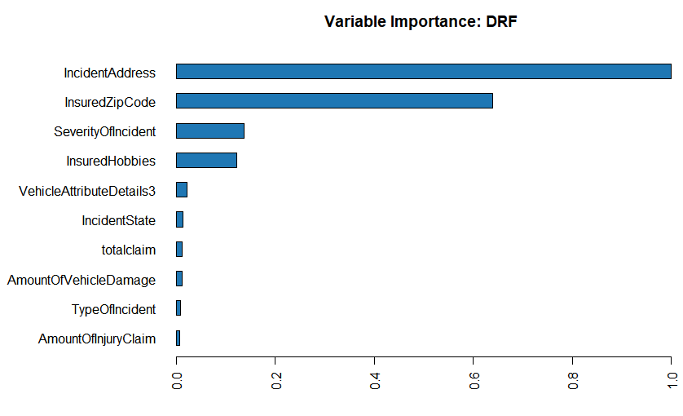

Conclusion

We can see that the place of the Incident and the zipcode of the insured vehicle have huge influence on the reported fraud . Also the severity of the frauds have a huge impact on the frauds reported .
The total claim which we derived also has a impact on fraud cases. Also we can say that people with hobbies as chess and cross fit tend to have more fraud cases . The gender plays almost no role in identifying the fraud cases

References

1.Strategies for detecting fraudulent claims in the automobile insurance industry, Stijn Viaene,Mercedes Ayuso, Montserrat Guillenb,Dirk Van Gheel, Guido Dedene,

2.Artıs, M., Ayuso, M., Guillen, M., 1999. Modelling differentypes of automobile insurance fraud behaviour in theSpanish market. Insurance: Mathematics and Economics

3.Artıs, M., Ayuso, M., Guillen, M., 2002. Detection of automobile insurance fraud with discrete choice models and misclassified claims. Journal of Risk and Insurance

4.Belhadji, E.B., Dionne, G., Tarkhani, F. 2000. A model for the detection of insurance fraud.Geneva Papers on Risk and Insurance

