Pre Processing And Data visualistaion

By: Siddarth.B
Batch:32

#1 Divided the data of Train_vehicle based on their factor/class.

#2 Merged all the columns from the 5 datasets given.

#3 Converted all the missing value to NA occordingly. As given below

#for Data of Vehicle
five$VehicleAttributeDetails=as.factor(ifelse(five$VehicleAttributeDetails=="???",NA,five$VehicleAttributeDetails))

#for Claim INformation
two$TypeOfCollission=as.factor(ifelse(two$TypeOfCollission=="?",NA,two$TypeOfCollission))
two$IncidentTime=as.factor(ifelse(two$IncidentTime=="-5",NA,two$IncidentTime))
two$PropertyDamage=as.factor(ifelse(two$PropertyDamage=="?",NA,two$PropertyDamage))
two$Witnesses=as.factor(ifelse(two$Witnesses=="MISSINGVALUE",NA,two$Witnesses))
two$PoliceReport=as.factor(ifelse(two$PoliceReport=="?",NA,two$PoliceReport))
two$AmountOfTotalClaim=(ifelse(two$AmountOfTotalClaim=="MISSEDDATA",NA,two$AmountOfTotalClaim))

#for policy INFORMATIOn
four$PolicyAnnualPremium=(ifelse(four$PolicyAnnualPremium=="-1",NA,four$PolicyAnnualPremium))

#4 Filling the missing values
# I Filled NA's of insured gender using insured relationship
i.e if insured relationship==WIFE gender will be MALE.

# II Filling NA's in type of collision by plotting against TypeOfIncident and SeverityOfIncident

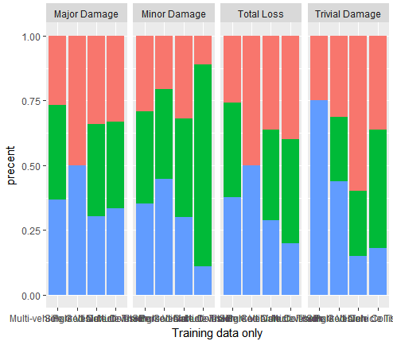

# III Filling NA's in property damage by plotting against AmountOfPropertyClaim and SeverityOfIncident
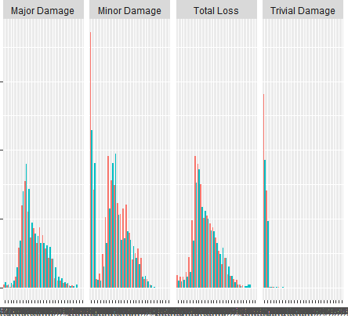

# IV Filling amountoftotalclaim has correlation of 0.5 with propertyclaim and injuryclaim

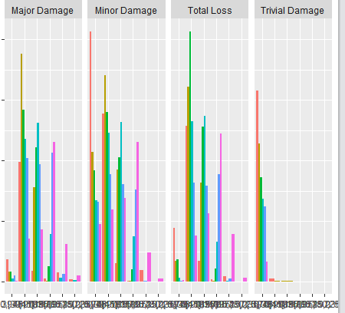

#data visualisation

#plotting the number of yes and no's of reported frauds

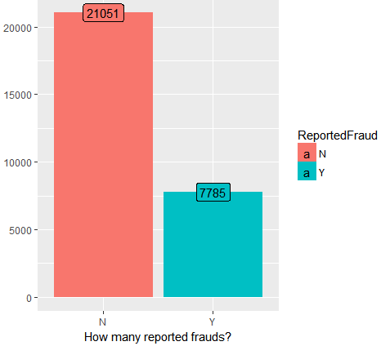

#checking for percentage of men and women who default
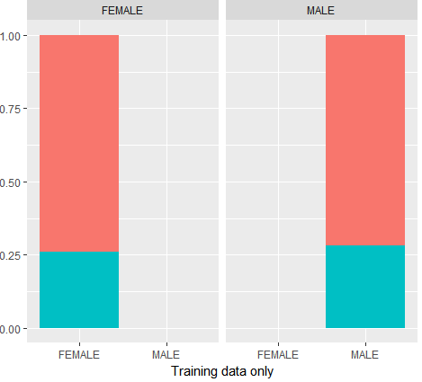
We can see that
gender doesnt play much role in deciding of YES and NO, so its more or less useless.

#Insurance policy state
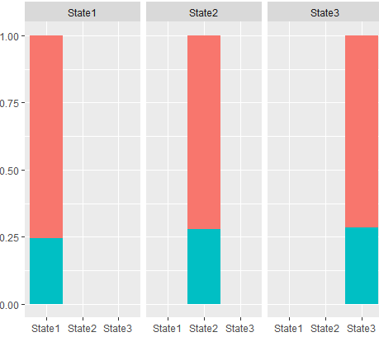
We notice that even the states dont have much impact on the result of yes or no

#InsuredHobbies
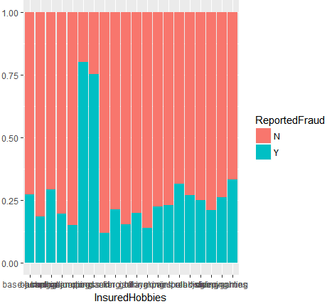
We can clearly see that (when zoomed),
That people with hobbies as Chess and Cross Fit have high fraud rates than other hobbies

#number of vehicles
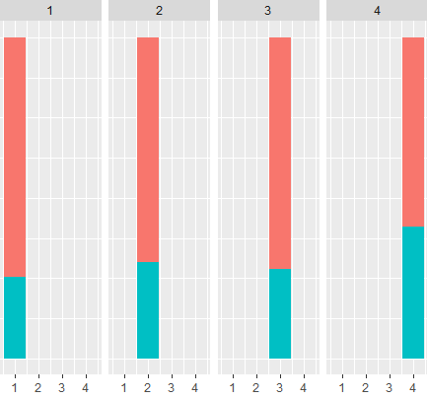
When number of vehicles involved are 2 or 4 the fraud cases are higher

#DateOfIncident
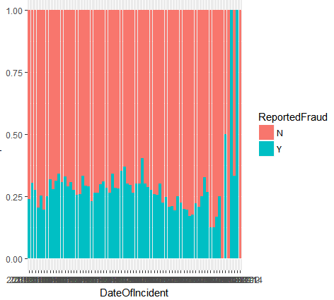

Certain dates have higher chances of fraud rate

##Derived variables

Days from commencement of insurance to incident =DateOfIncident-DateOfPolicyCoverage

Days remaining for insurance from incident = InsuredAge*365-
incident_coverage

#Percentage of influence Days remaining for insurance

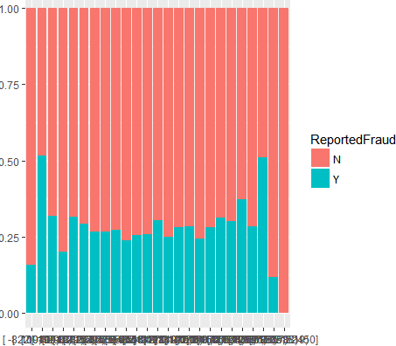
Few Bins after the start of insurance and before the end of insurance have a higher chance of fraud rate

#Checking the percentage witnesses value
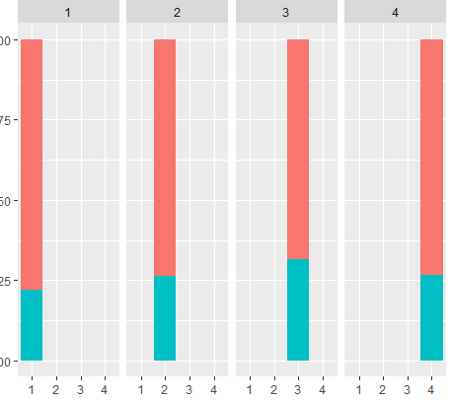
We see that when witness numbers are around 3 the percentage of Yes is slightly higher.

#IncidentAddress
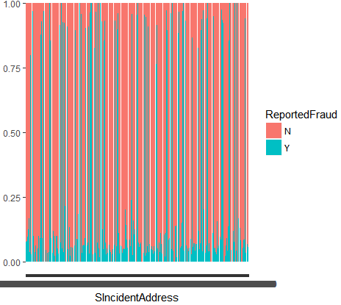
Some of the address as shown have very high chance of fraud cases than other.

Thereby the zipcode also would have high impact

#zipcode where the accidents occur usually
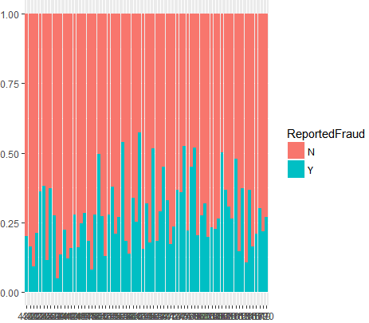

#umbrella limit discretized into 20 categories
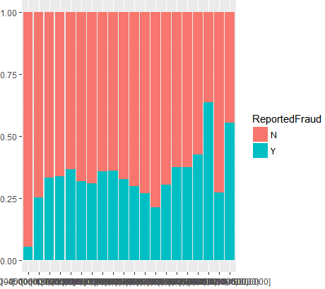

some of the higher values of imbrella limit have more influence in fraud cases .

#insured relationship
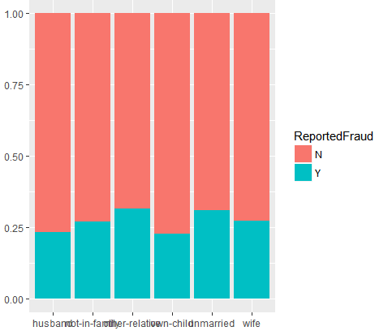

We notice that other relatives, not in family and unmarried have higher chances of fraud then the other relations.

#Density plot of annualPremium
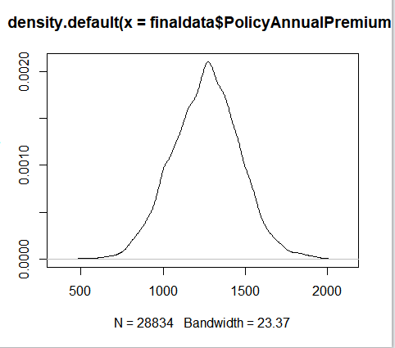

It follows an almost gaussian curve with a bit of skewness

#Density plot of UmbrellaLimit
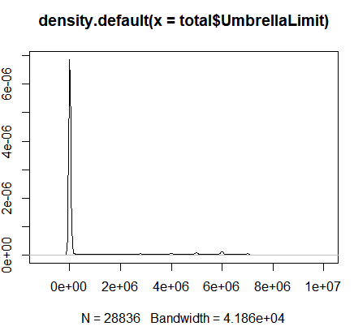

We can see that umbrella Limit is highly skewed and can be transformed with log to reduce its skewness

#Amount of Total Claim
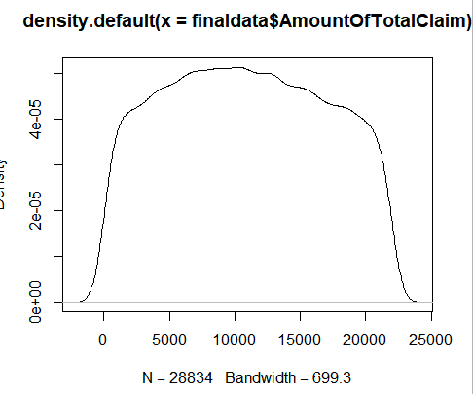
It follows an almost rectangular type distribution

#Insured Age is almost similar as it follows a gaussian distribution
