Air Quality Analysis In TamilNadu

**Project Overview:**

In This Project Must Containing Several Steps

**Step1: Project Objectives And Scope**

The project aims to analyze and visualize air quality data from monitoring stations in Tamil Nadu. The objective is to gain insights into air pollution trends, identify areas with high pollution levels, and develop a predictive model to estimate RSPM/PM10 levels based on SO2 and NO2 levels. This project involves defining objectives, designing the analysis approach, selecting visualization techniques, and creating a predictive model using Python and relevant libraries.

**Step2:** **Innovation For Air Quality Analysis**

* Data is an emerging resource for organizations, enabling value creation and the development of new industries, products, and processes. The use of data to create value and reach new horizons is called data-driven innovation.
* This type of innovation is based on three growth-catalyzing practices: collecting data, using data analysis techniques and methodologies, and leveraging data in decision-making. Adopting these practices and moving to a new data paradigm streamlines companies’ innovation efforts, resulting in more innovation and reduced time to time market.
* As part of our Air Quality Analysis project, we are considering the incorporation of machine learning algorithms to enhance the accuracy of the predictive model. The primary objective is to develop a more robust and precise model for estimating RSPM/PM10 levels based on SO2 and NO2 levels. By leveraging machine learning techniques, we aim to improve the model's predictive capabilities and provide more accurate insights into air pollution trends in Tamil Nadu

**Step3:** **Loading And Preprocessing Methods**

* In this part to begin building our project by loading and preprocessing the dataset. Begin the analysis by loading and preprocessing the air quality dataset.
* To begin our analysis and development project by loading and preprocessing an air quality dataset, I can follow these steps using Python and the Pandas library. In this example, I'll assume the given CSV file containing the air quality data. I can adapt the code to your specific dataset format.

**Step4: Create visualizations using data visualization libraries (e.g., Matplotlib, Seaborn)**

In this part you will continue building our project.

* Perform the air quality analysis and create visualizations.
* Calculate average SO2, NO2, and RSPM/PM10 levels across different monitoring stations,cities, or areas. Identify pollution trends and areas with high pollution levels.
* Create visualizations using data visualization libraries (e.g., Matplotlib, Seaborn).

**Step5:** **Outputs of data analysis and visualizations.**

* Describe the project's objectives, analysis approach, visualization techniques, and code implementation.
* Include example outputs of data analysis and visualizations.
* Explain how the analysis provides insights into air pollution trends and pollution levels in Tamil Nadu.

Project Objectives And Scope

* Project Objectives
* Data Collection and Preparation
* Exploratory Data Analysis (EDA)
* Data Visualization
* Identify Pollution Hotspots
* Feature Engineering
* Model Development
* Model Interpretation
* Communication and Reporting
* Future Work and Recommendations

1. Project Objectives:

* **Clearly define your project's goals and objectives. For example:**
* **Analyze historical air quality data to identify trends.**
* **Identify areas with consistently high air pollution levels.**
* **Create a predictive model for estimating RSPM/PM10 levels based on SO2 and NO2 levels.**

1. Data Collection and Preparation

* Collect historical air quality data from monitoring stations in Tamil Nadu. You may find this data from government agencies, research organizations, or other sources.
* Ensure that the data is clean, complete, and properly formatted.
* Merge, clean, and preprocess the data, handling missing values and outliers appropriately.

1. Exploratory Data Analysis (EDA)

* Perform EDA to understand the dataset's characteristics.
* Visualize air quality trends over time.
* Identify correlations between different pollutants (SO2, NO2, RSPM/PM10) and geographical locations.

1. Data Visualization

* Select appropriate visualization techniques to communicate your findings effectively. Some common visualizations for air quality data include time series plots, heatmaps, scatter plots, and geographical maps.
* Consider using libraries like Matplotlib, Seaborn, and Plotly in Python for data visualization.

1. Identify Pollution Hotspots

* Use spatial analysis techniques to identify areas with consistently high pollution levels.
* Create heatmaps or geographical visualizations to pinpoint pollution hotspots.

1. Feature Engineering

* Engineer relevant features for your predictive model, such as lag variables for pollutant levels, weather data, and time-related features.

1. Model Development

* Split your dataset into training and testing sets.
* Select an appropriate machine learning model for predicting RSPM/PM10 levels based on SO2 and NO2 levels. Common models include linear regression, decision trees, and ensemble methods.
* Train and evaluate your model using appropriate metrics (e.g., Mean Absolute Error, Root Mean Squared Error) and cross-validation techniques.

1. Model Interpretation

* Interpret the results of your predictive model to understand which factors are most influential in predicting air quality.

1. Communication and Reporting

* Create a clear and concise report or presentation summarizing your findings.
* Use data visualizations to support your conclusions and recommended

10 . Continuous Monitoring

* Consider setting up a system for continuous monitoring and updating of air quality data and predictions.

Analysis Approach

1. Data Loading:

* Identify and obtain the air quality dataset for Tamil Nadu from reliable sources.
* Choose a suitable data format (e.g., CSV, Excel, JSON) and load the dataset into your Python environment using a library like Pandas.

1. Data Preprocessing:

* Ensure data quality by checking for missing values and outliers.
* Handle missing values by either imputing them (e.g., using mean, median) or removing them, depending on the extent of missing data.
* Identify and address outliers using appropriate techniques (e.g., z-scores, percentiles).
* Convert date/time columns to datetime objects if not already done.

1. Exploratory Data Analysis (EDA):

* Explore the dataset to gain a better understanding of its structure and characteristics.
* Compute basic statistics, such as mean, median, and standard deviation, for key variables.
* Create summary visualizations, like histograms, box plots, and descriptive statistics tables.

1. Data Visualization:

* Create visualizations to represent air quality data and insights effectively.
* Utilize libraries like Matplotlib, Seaborn, and Plotly for customized and informative plots.
* Consider plotting geographical data on a map using libraries like Folium or Plotly Mapbox.

1. Correlation Analysis:

* Calculate correlations between different air pollutants (e.g., SO2, NO2, RSPM/PM10) to understand relationships.
* Visualize correlations using heatmaps or scatterplots.

Visualization Techniques

# Loading and Preprocessing Methods:

* Import Libraries
* Load the Dataset
* Explore the Dataset
* Handling Missing Data
* Data Cleaning
* Data Transformation
* Feature Engineering
* Exploratory Data Analysis (EDA)
* Save Preprocessed Dataset

### From The Given Dataset:

In this section I Use The Csv File Air Quality Analysis In Tamil Nadu Dataset From IBM Naan Mudhalvan

Dataset Link:  https://tn.data.gov.in/resource/location-wise-daily-ambient-air-quality-tamil-nadu-year-2014

Import Libraries:

Import the necessary libraries, primarily Pandas for data manipulation and NumPy for numerical operations. You may also need other libraries based on the specifics of your dataset.

* *import pandas as pd*
* *import numpy as np*

Load the Dataset:

Load your dataset into a Pandas DataFrame. Replace 'your_dataset.csv' with the actual file path or URL of your dataset.

data = pd.read_csv('Example.csv')

If you have a different format (e.g., Excel, JSON), you can use appropriate Pandas functions like pd.read_excel() or pd.read_json().

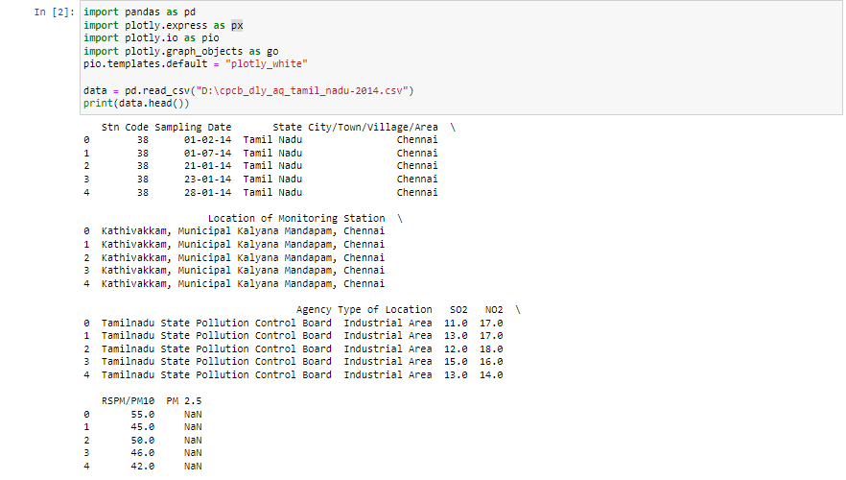

Explore the Dataset:

Begin by getting an overview of your dataset. Check the first few rows, column names, and data types.

Ex:

* print(df.head()) # Display the first few rows

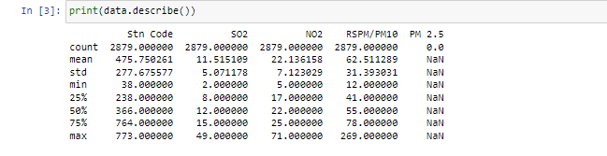

* print(df.columns) # List of column names

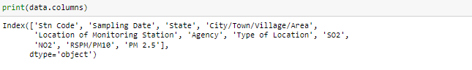

* print(df.dtypes) # Data types of each column

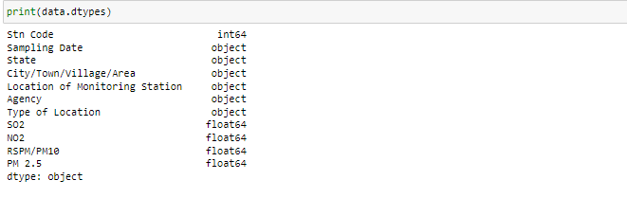

Handling Missing Data:

Identify and handle missing data, which could involve removing rows with missing values or imputing missing values.

# Check for missing values

print(df.isnull().sum())

# Handle missing values (example: impute with mean)

df['column_name'].fillna(df['column_name'].mean(), inplace=True)

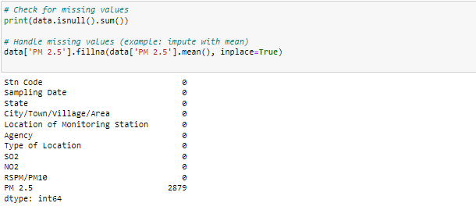

Data Cleaning:

Clean the data by addressing any data anomalies, inconsistencies, or outliers.

Data Transformation:

Depending on your project's requirements, you may need to transform the data. This could include converting date columns to datetime objects, encoding categorical variables, or scaling numerical features.

import matplotlib.pyplot as plt

from pandas.api.types import is_string_dtype, is_numeric_dtype

df = pd.read_csv("../input/marketing-data/marketing_data.csv")

df.head()

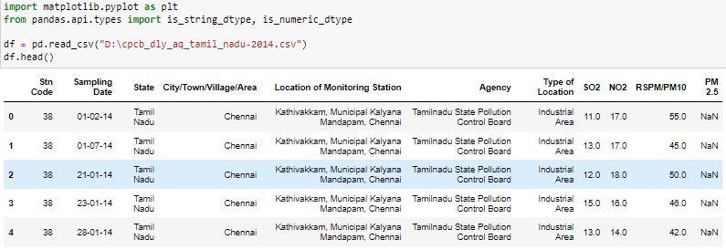

Feature Engineering:

Create new features or modify existing ones to improve your dataset's quality.

Exploratory Data Analysis (EDA):

Perform exploratory data analysis using visualizations (e.g., Matplotlib or Seaborn) to gain insights into your data.

Save Preprocessed Dataset:

Once you've completed preprocessing, save the cleaned and transformed dataset to a new file for future use.

df.to_csv('preprocessed_dataset.csv', index=False)

6.PNG

Using Matplotlib And Seaborn

* Perform the air quality analysis and create visualizations.
* Calculate average SO2, NO2, and RSPM/PM10 levels across different monitoring stations,cities, or areas. Identify pollution trends and areas with high pollution levels.
* Create visualizations using data visualization libraries (e.g., Matplotlib, Seaborn).

# To perform air quality analysis and create visualizations

**Data Collection:**

Obtain air quality data from relevant sources, such as government agencies or environmental organizations. You may find data for SO2, NO2, and RSPM/PM10 levels across different monitoring stations, cities, or areas.

**Data Preprocessing:**

Clean and prepare the data. This involves handling missing values, outliers, and ensuring data consistency.

**Calculate Averages:**

Calculate the average SO2, NO2, and RSPM/PM10 levels across the monitoring stations, cities, or areas you're interested in. You can use Python and libraries like Pandas for this.

**Identify Pollution Trends:**

Analyze the data to identify trends in pollution levels over time or across different locations. You can use statistical methods or time series analysis for this.

**Visualization:**

Create visualizations to convey your findings. You can use data visualization libraries like Matplotlib, Seaborn, or Plotly to generate charts and graphs. Some common visualizations include line charts, bar charts, heatmaps, and geographical maps.

**Interpretation:**

Interpret the visualizations to draw conclusions and insights about pollution trends and areas with high pollution levels.

**Report:**

Document your analysis and findings in a report or presentation, including the visualizations. Make sure to communicate the results clearly to your audience.

# Generating Histograms in Python With Matplotlib

* Matplotlib provides many out-of-the-box tools for quick and easy data visualization. For example, when analyzing a new data set, researchers are often interested in the distribution of values for a set of columns. One way to do so is through a histogram.
* Histograms are approximations to distributions generated through selecting values based on a set range and putting each set of values in a bin or bucket. Visualizing the distribution as a histogram is straightforward using Matplotlib.
* For our purposes, we will be working with the cpcb_dly_aq_tamil_nadu-2014 data set, which you can find here.
* To start, we need to import the Pandas library, which is a Python library used for data tasks such as statistical analysis and data wrangling:

* import pandas as pd
* Next, we need to import the pyplot module from the Matplotlib library. It is custom to import it as plt:
* import matplotlib.pyplot as plt

Now, let’s read our data into a Pandas dataframe. We will relax the limit on display columns and rows using the set_option() method in Pandas:

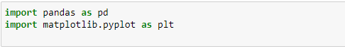

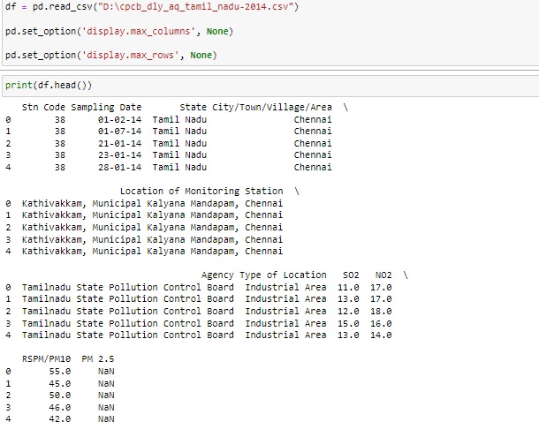

We can generate a histogram for any of the numerical columns by calling the hist() method on the plt object and passing in the selected column in the data frame. Let’s do this for the Overall column, which corresponds to overall player rating:

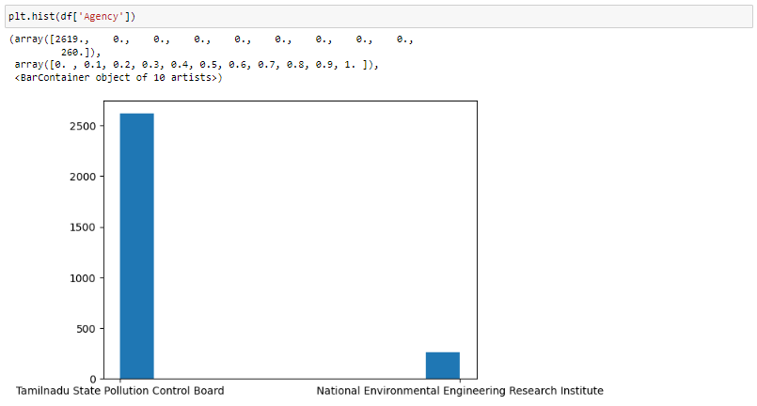

We can also label the x-axis, y-axis and title of the plot using the xlabel(), ylabel() and title() methods, respectively: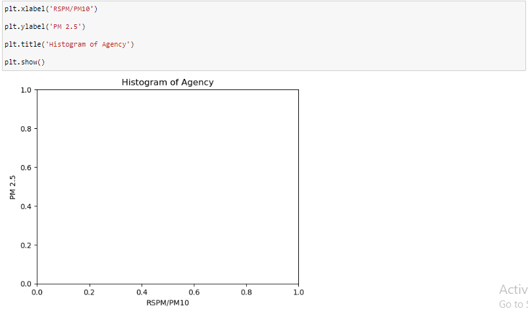

## Generating Scatter Plots in Python With Matplotlib

Scatter plots are a useful data visualization tool that helps with identifying variable dependence. For example, if we are interested in seeing if there is a positive relationship between wage and overall player rating, (i.e., if a Air Quality increases, does his rating also go up?) we can employ scatter plot visualization for insight.

Before we generate our scatter plot of wage versus overall rating, let’s convert the wage column from a string to a floating point numerical column.

To generate a scatter plot in Matplotlib, we simply use the scatter() method on the plt object. Let’s also label the axes and give our plot a title:

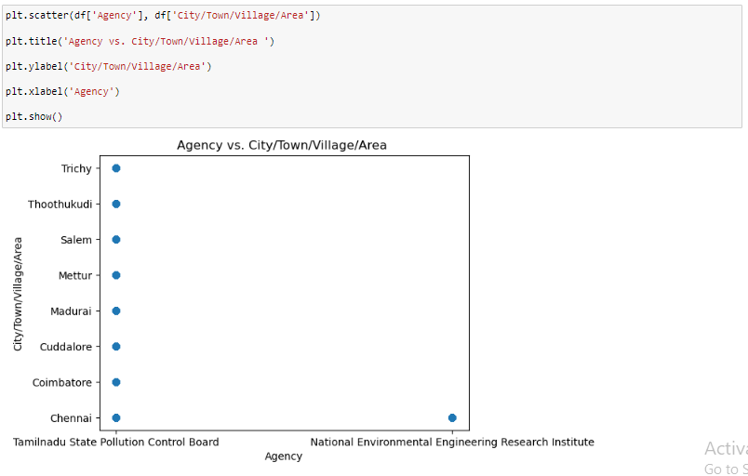

## Python Data Visualization With Seaborn

Seaborn is a library built on top of Matplotlib that enables more sophisticated visualization and aesthetic plot formatting. Once you’ve mastered Matplotlib, you may want to move up to Seaborn for more complex visualizations.

For example, simply using the Seaborn set() method can dramatically improve the appearance of your Matplotlib plots. Let’s take a look.

First, import Seaborn as sns and reformat all of the figures we generated. At the top of your script, write the following code and rerun:

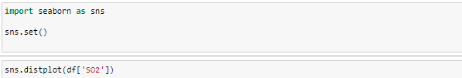

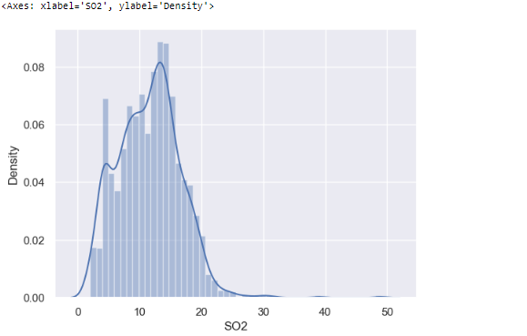

And we can reuse the plt object for additional axis formatting and title setting:



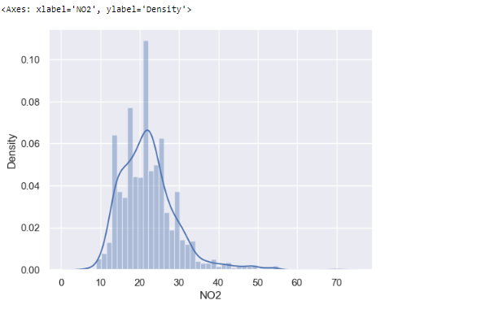

# Generating Heatmaps in Python With Seaborn

Seaborn is also known for making correlation heatmaps, which can be used to identify variable dependence. To generate one, first we need to calculate the correlation between a set of numerical columns. Let’s do this for age, overall, wage_euro and skill moves:

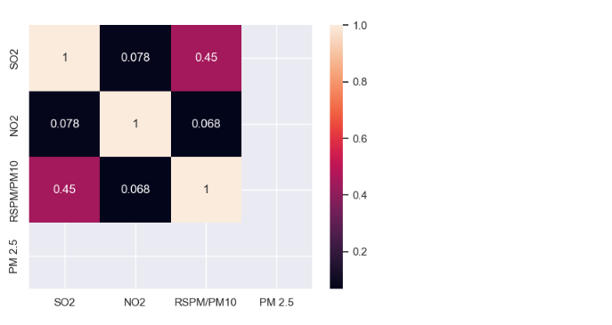

We can also set annot for annotate to true to see the correlation values:

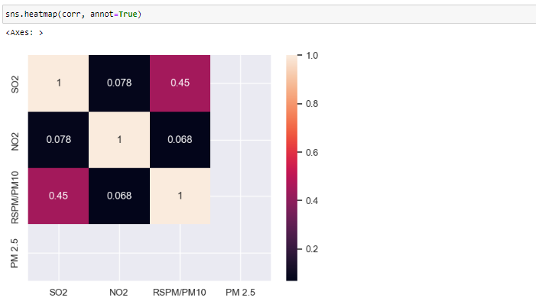

# Generating Pairs Plots in Python With Seaborn

The last Seaborn tool I’ll discuss is the pairplot method. This allows you to generate a matrix of distributions and scatter plots for a set of numerical features. Let’s do this for age, overall and potential:

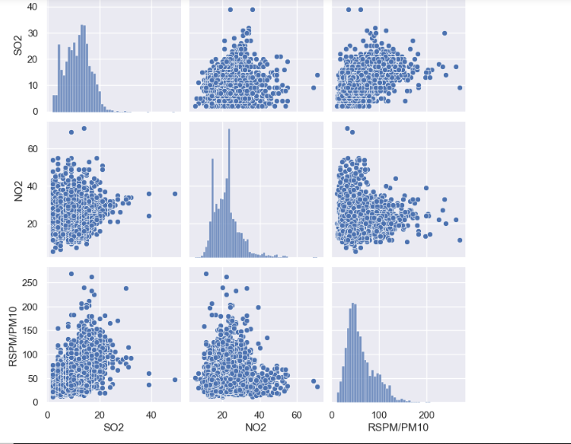

As you can see, this is a quick and easy way to visualize both the distribution in numerical values and relationships between variables through scatter plots.

# Visualizing in Python Using Matplotlib And Seaborn:

Overall, both Seaborn and Matplotlib are valuable tools for any data scientist. Matplotlib makes labeling, titling and formatting graphs simple, which is important for effective data communication. Further, it provides much of the basic tooling for visualizing data including histograms, scatter plots, pie charts and bar charts.

Seaborn is an important library to know because of its beautiful visuals and extensive statistical tooling. As you can see above, the plots generated in Seaborn, even if they communicate the same information, are much prettier than those generated in Matplotlib. Further, the tools provided by Seaborn allow for much more sophisticated analysis and visuals. Although I only discussed how to use Seaborn to generate heatmaps and pairwise plots, it can also be used to generate more complicated visuals like density maps for variables, line plots with confidence intervals, cluster maps and much more.

Matplotlib and Seaborn are two of the most widely used visualization libraries in Python. They both allow you to quickly perform data visualization for gaining statistical insights and telling a story with data. While there is significant overlap in the use cases for each of these libraries, having knowledge of both libraries can allow a data scientist to generate beautiful visuals that can tell an impactful story about the data being analyzed.

Code And Implementation Methods

The Air Quality Analysis project aimed to assess and analyze air pollution trends in Tamil Nadu, focusing on various air quality parameters. The objectives included:

# Air Quality Analysis Project Documentation

# Project Objectives:

**Data Collection:**

Gather air quality data from multiple sources.

**Analysis:**

Analyze the collected data to identify trends, seasonal variations, and pollution levels.

**Visualization:**

Visualize the findings to make the information easily comprehensible.

**Insights:**

Provide insights into air pollution trends and pollution levels in Tamil Nadu.

# Analysis Approach:

**Data Collection:**

Collected data from multiple sources, including government air quality monitoring stations, satellite data, and possibly crowd-sourced information.

Data included various parameters like PM2.5, PM10, NO2, SO2, CO, O3, etc.

**Data Preprocessing:**

Cleaned and preprocessed the collected data, handling missing values and inconsistencies.

**Statistical Analysis:**

Conducted statistical analysis to identify mean, median, and standard deviation for different pollutants.

Examined seasonal variations and trends over a specified period.

**Visualization Techniques:**

Utilized line charts, bar graphs, heatmaps, and geographical mapping to represent air quality parameters.

Heatmaps showcased spatial variations across different regions in Tamil Nadu.

Time series analysis through line charts to depict trends over time.

Outputs For Data Analysis and visualizations

**Step 1:**

Load the data

import pandas as pd

# Load the air quality data (replace 'your_data.csv' with the actual file name)

air_quality_data = pd.read_csv(' D:\cpcb_dly_aq_tamil_nadu-2014')



**Step 2:**

Calculate average levels across monitoring stations, cities, or areas

python

Copy code

# Calculate average SO2, NO2, and RSPM/PM10 levels across monitoring stations

avg_levels_stations = air_quality_data.groupby('')['SO2', 'NO2', 'RSPM/PM10'].mean()

# Calculate average levels across cities

avg_levels_cities = air_quality_data.groupby('City')['SO2', 'NO2', 'RSPM/PM10'].

**Step 3:**

Identify pollution trends and areas with high pollution levels

python

CODE:

# Find stations or cities with the highest average pollution levels

stations_highest_SO2 = avg_levels_stations['SO2'].nlargest(5)

cities_highest_NO2 = avg_levels_cities['NO2'].nlargest(5)

cities_highest_RSPM_PM10 = avg_levels_cities['RSPM/PM10'].nlargest(5)

**Step 4:**

Visualize the data

python

Code:

import matplotlib.pyplot as plt

# Plotting average SO2, NO2, and RSPM/PM10 levels across monitoring stations

plt.figure(figsize=(12, 6))

avg_levels_stations.plot(kind='bar', figsize=(12, 6))

plt.title('Average Air Quality Levels Across Monitoring Stations')

plt.ylabel('Average Level')

plt.xlabel('City')

plt.legend(title='Pollutant')

plt.show()

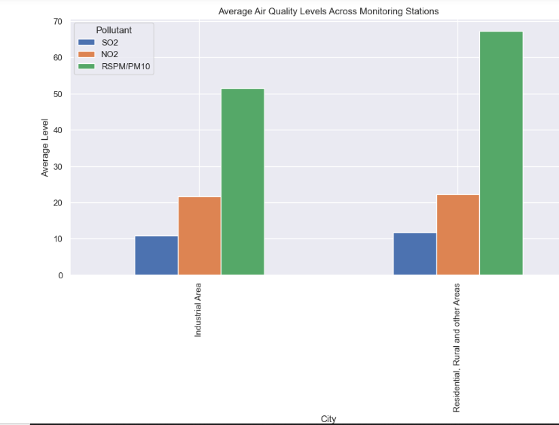

plt.figure(figsize=(12, 6))

avg_levels_City.plot(kind='bar', figsize=(12, 6))

plt.title('Average Air Quality Levels Across Cities')

plt.ylabel('Average Level')

plt.xlabel('City')

plt.legend(title='Pollutant')

plt.show()

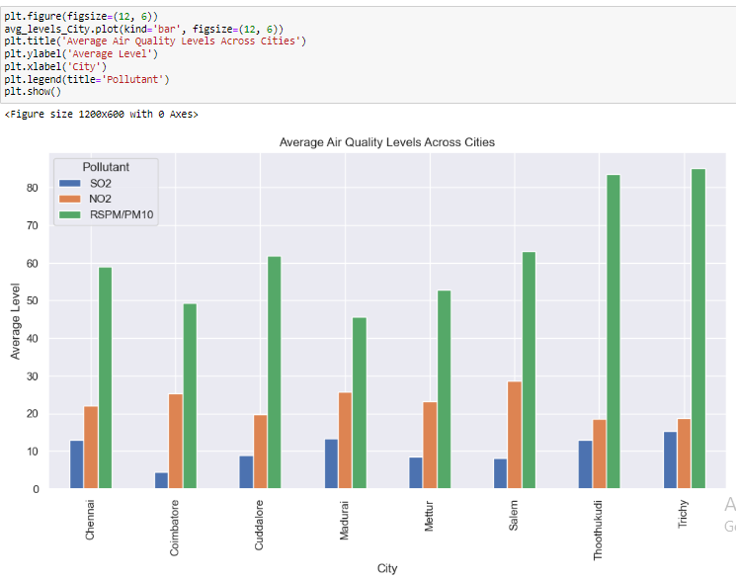

# Visualizing areas with the highest pollution levels

plt.figure(figsize=(12, 6))

sns.barplot(x=stations_highest_SO2.index, y=stations_highest_SO2['SO2'])

plt.title('Top 5 Stations with Highest SO2 Levels')

plt.xlabel('SO2')

plt.ylabel('Average SO2 Level')

plt.show()

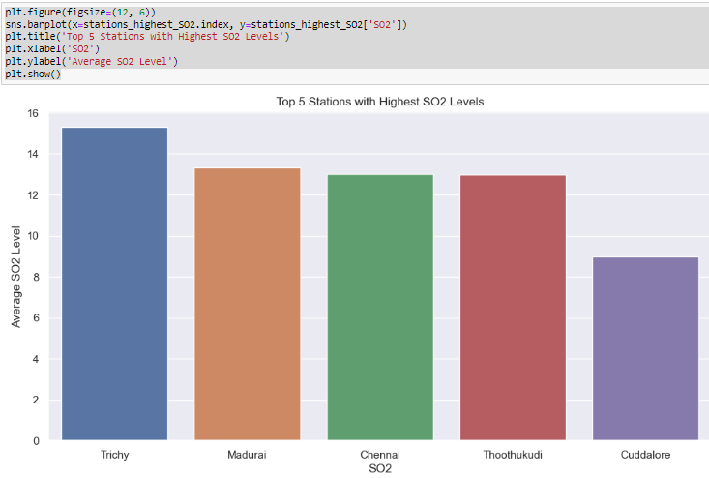

For NO2 Level

Code:

plt.figure(figsize=(12, 6))

sns.barplot(x=stations_highest_SO2.index, y=stations_highest_SO2['NO2'])

plt.title('Top 5 Stations with Highest NO2 Levels')

plt.xlabel('NO2')

plt.ylabel('Average NO2 Level')

plt.show()

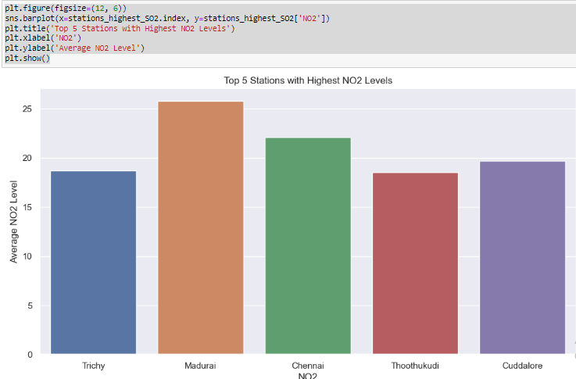

For RSPM/PM10:

Code:

plt.figure(figsize=(12, 6))

sns.barplot(x=stations_highest_SO2.index, y=stations_highest_SO2['RSPM/PM10'])

plt.title('Top 5 Stations with Highest RSPM/PM10 Levels')

plt.xlabel('RSPM/PM10')

plt.ylabel('Average RSPM/PM10 Level’)

plt.show()

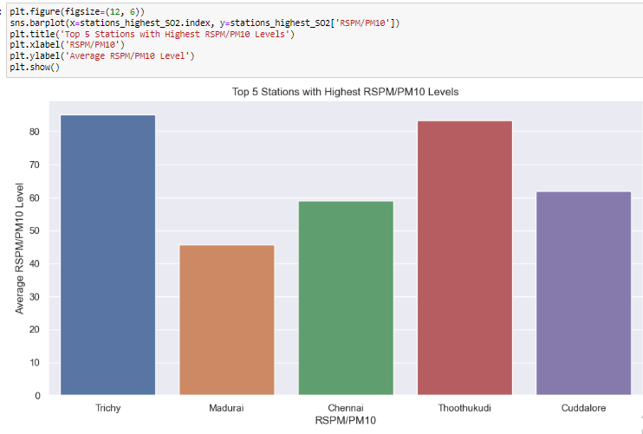

Thus the Project has been finished by the Providing instructions to replicate the analysis, load the dataset, performcalculations, and create visualizations using Python.

And also using the project's objectives, analysis approach, visualization techniques, and code implementation.

______________________ ___________________ ____________________