APPENDIX 1

**RAILWAY RESERVATION SYSTEM**

**END TERM REPORT**

***by***

**Name of The Candidate Roll number Section**

**DEVRAJ 19 K19KK**

**A.SAI DINESH 20 K19KK**

**SIDDARTHA ROY 21 K19KK**



**Department of Intelligent Systems**

**School of Computer Science Engineering**

**Lovely Professional University, Jalandhar**

**April - 2020**

APPENDIX 2

**Student Declaration**

This is to declare that this report has been written by us. No part of the report is copied from other sources. All information included from other sources have been duly acknowledged. we ever that if any part of the report is found to be copied ,we shall take full responsibility for it.

Signature :

**DEVRAJ**

**Roll number:19**

Signature :

1. **SAI DINESH**

**Roll number:20**

Signature :

**SIDDARTHA ROY**

**Roll number:21**

**Place:Jalandhar**

**Date : 10/04/2020**

APPENDIX 3

**TABLE OF CONTENTS**

**TITLE PAGE NUMBER**

**1.Background and objectives of project assigned 1**

**1.1 …………………………………………………… 1**

**1.2 ……………………………………………………. 2**

**1.3 ……………………………………………………. 3**

**1.4 ……………………………………………………. 4**

**2.Description of project ( INTRODUCTION ) 5**

**3.Description of Work Division 6**

**4.Implimentation of project 7**

**5.Screenshots of web pages 7-14**

**6.CONCLUSION 15**

APPENDIX 4

**BONAFIED CERTIFICATE**

Certified that this project report “RAILWAY RESERVATION SYSTEM” is the bonafied work of DEVRAJ, A.SAI DINESH, SIDDARTHA ROY” who carried out the project work under my supervision.

Report Submitted to

Mrs.POOJA RANA

<<Signature of the supervisor >>

<< name of supervisor>>

<<Academic Designation >>

<< ID of supervisor >>

<< Department of supervisor >>

**INTRODUCTION :**

**CONTENTS OF PROJECT :**

**1.HOME**

**2.BOOKING FORM**

**3.ABOUT US**

**4.OFFERS**

**5.MEALS**

**6.CONTACT US**

**7.TRAIN TIMETABLE**

**DESCRIPTION OF WORK DIVISION**

**Description of Work division in terms of roles among students**

1. SIDDARTHA ROY **– HOME PAGE, CONTACT US, OFFERS**

**2.** SAI DINESH - **BOOKING FORM, MEALS, TRAINS TIME TABLE**

**3.** DEVRAJ **- ABOUT US.**

**IMPLIMENTATION OF PROJECT :**

**\*HOME :**

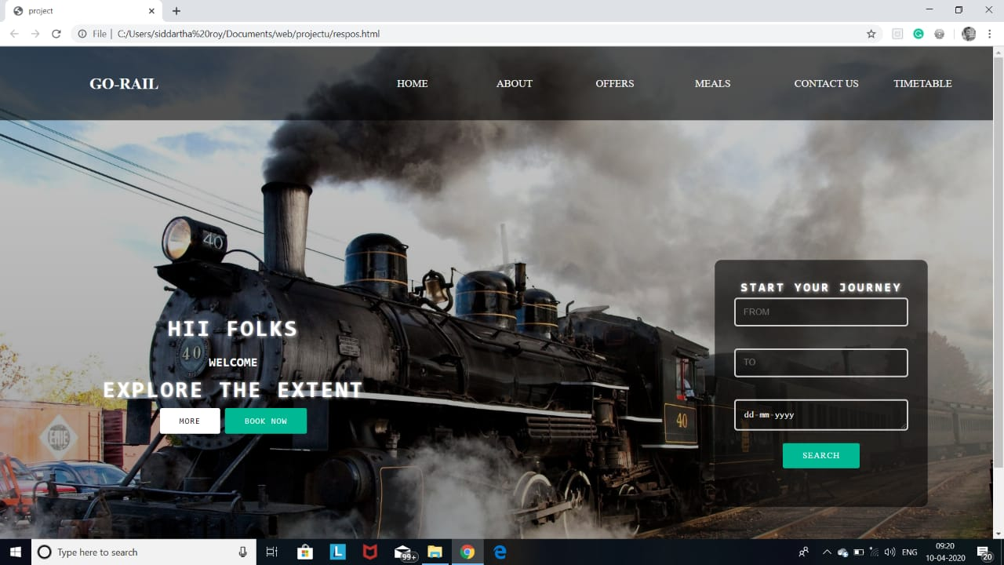

This is the main page of our project. I have made the homepage design in many divisions and each design will showcase each speciality of this website

These divisions are positioned absolutely using position: absolute attribute of css

In this home page we have subpages such as train logo, about us ,booking form, offers, meals, contact us , timetable….

we have many contents in this page such as MORE, SIGN UP ……

**\*BOOKING FORM :**

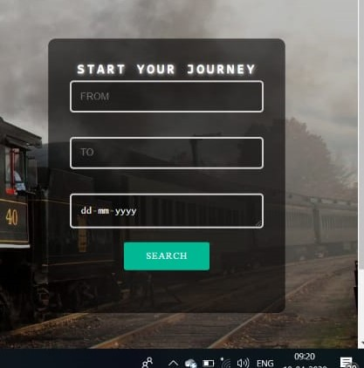

In this form includes journey date, departure and arrival of trains , and this form takes us to the trains list.

\***ABOUT US :**

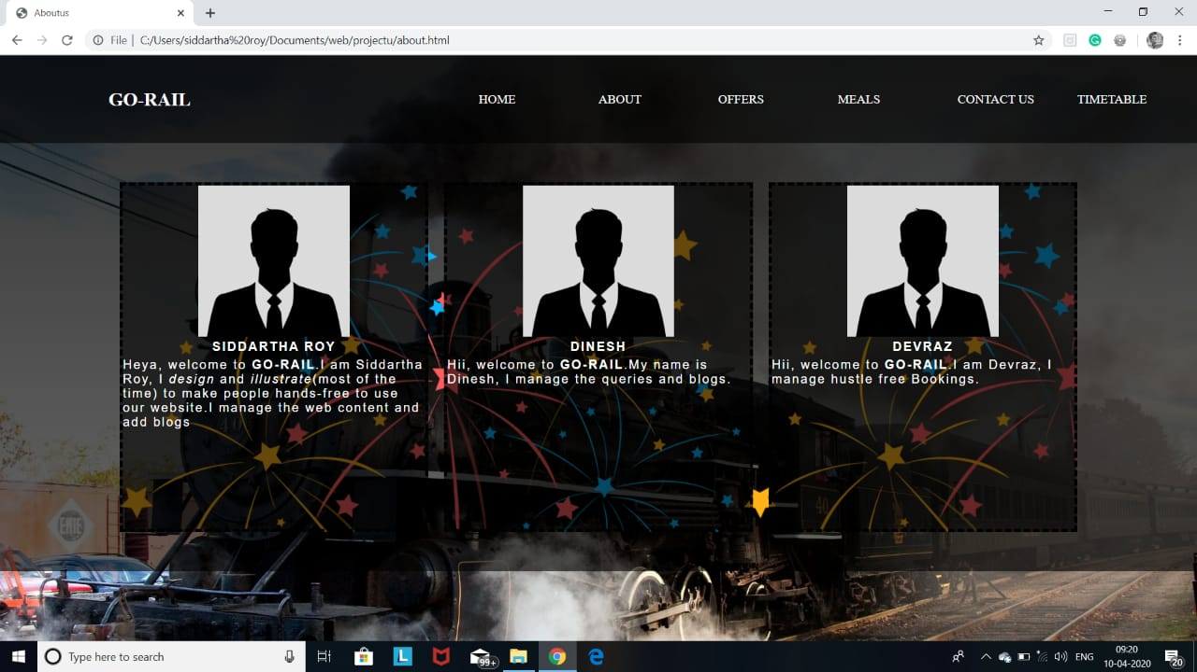

In this about us page u can get information about our website, information about our services and u can get some information about founders

**\*OFFERS :**

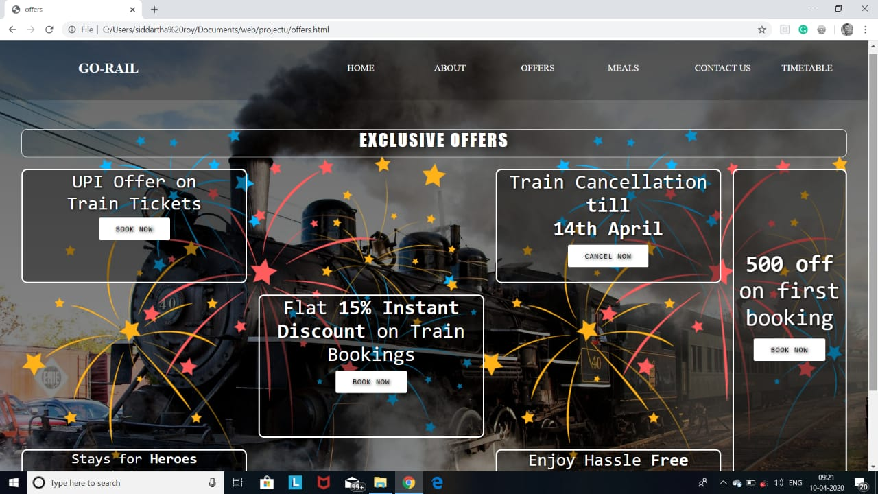

In this page we shows the available offers and best packages to the users as u can see from above picture.

**\*CONTACT US THROUGH EMAIL :**

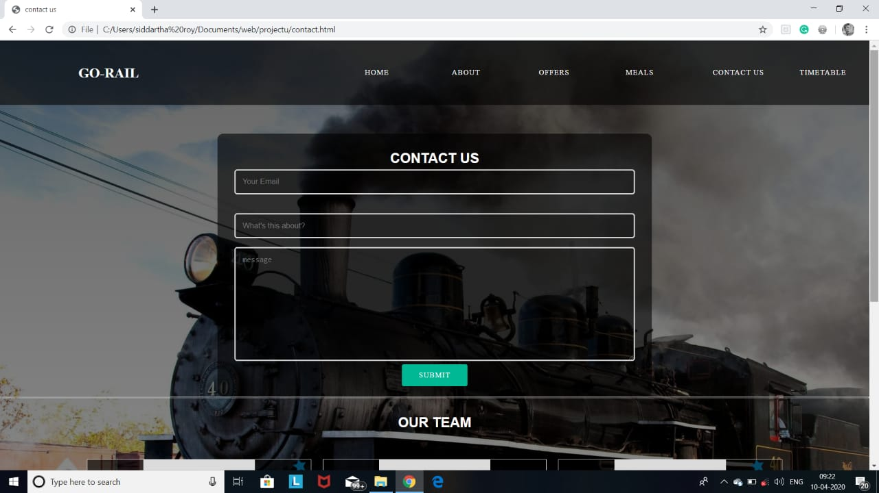

In this slot u can share your email and your quires regarding to the issue and we can find a solutions to your quires.

**\*CONTACT US THROUGH MOBILE NUMBER :** 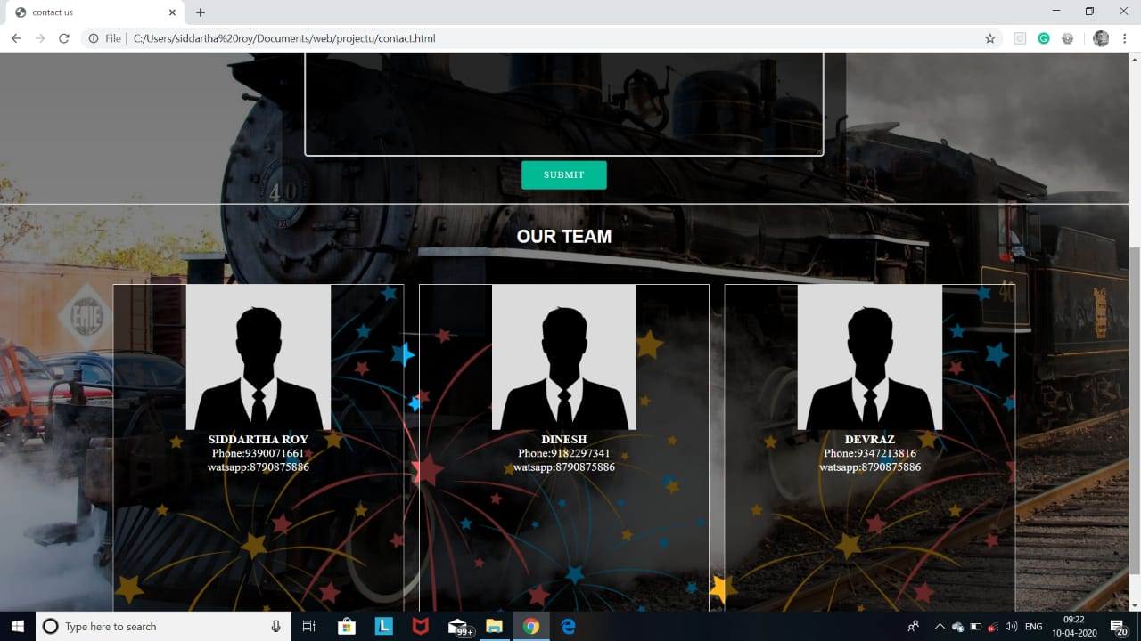

IF u wants to contact us then we have provided our mobile numbers .

\***MEALS :**

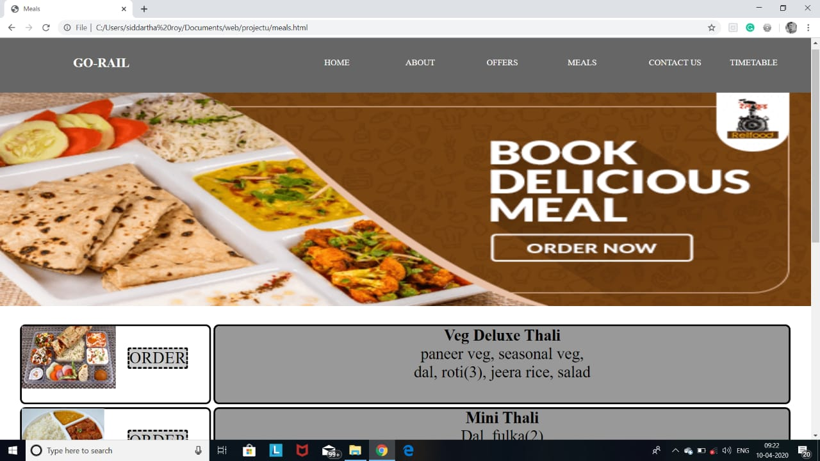

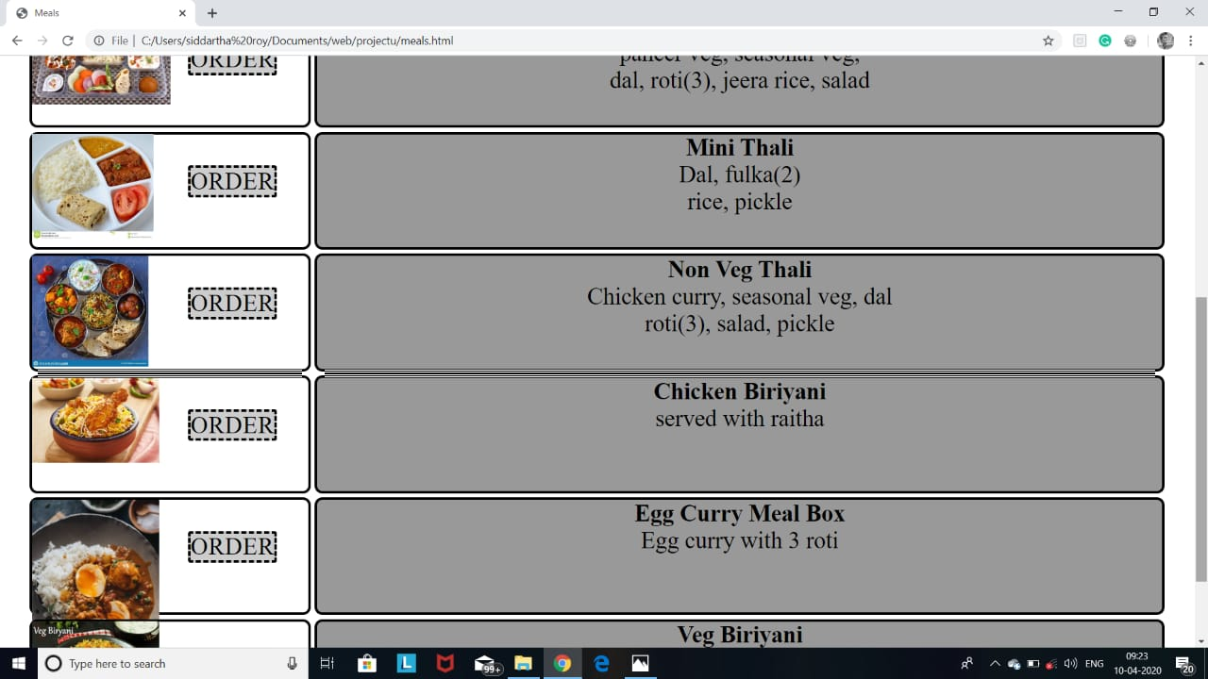

Here u can find various dishes that u can order through our website.

**\*TRAIN TIMETABLE :**

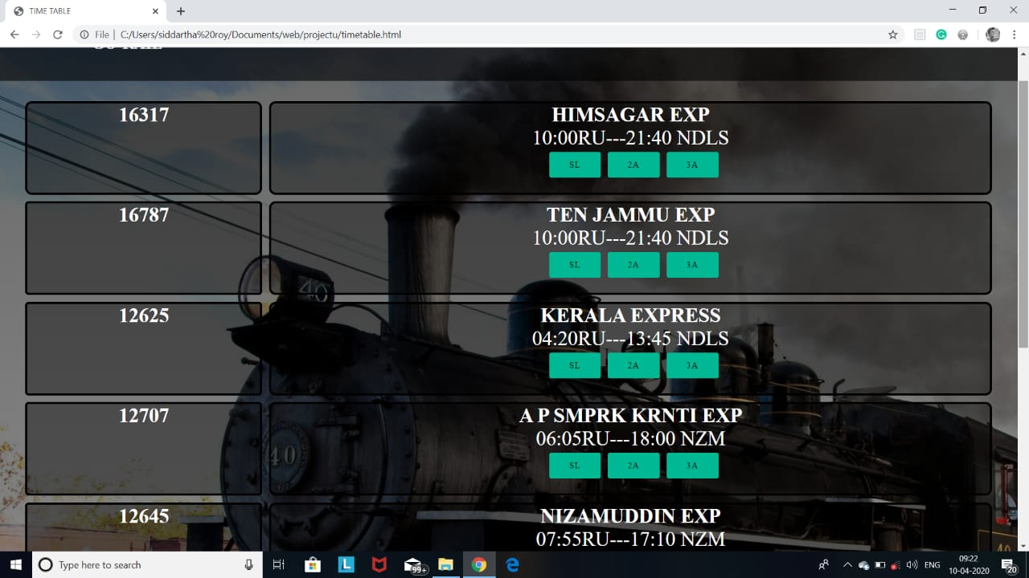

This page shows all the available trains on a particular time and particular states.

**\*CONCLUSION :**

**With this, our**

**website report finishes. Everyone in the group had participated and worked hard equally .They helped each other for their parts of website.We all got lots of knowledge and experience on html, css and java script.**

**THANK YOU**