ASSIGNMENT9.1

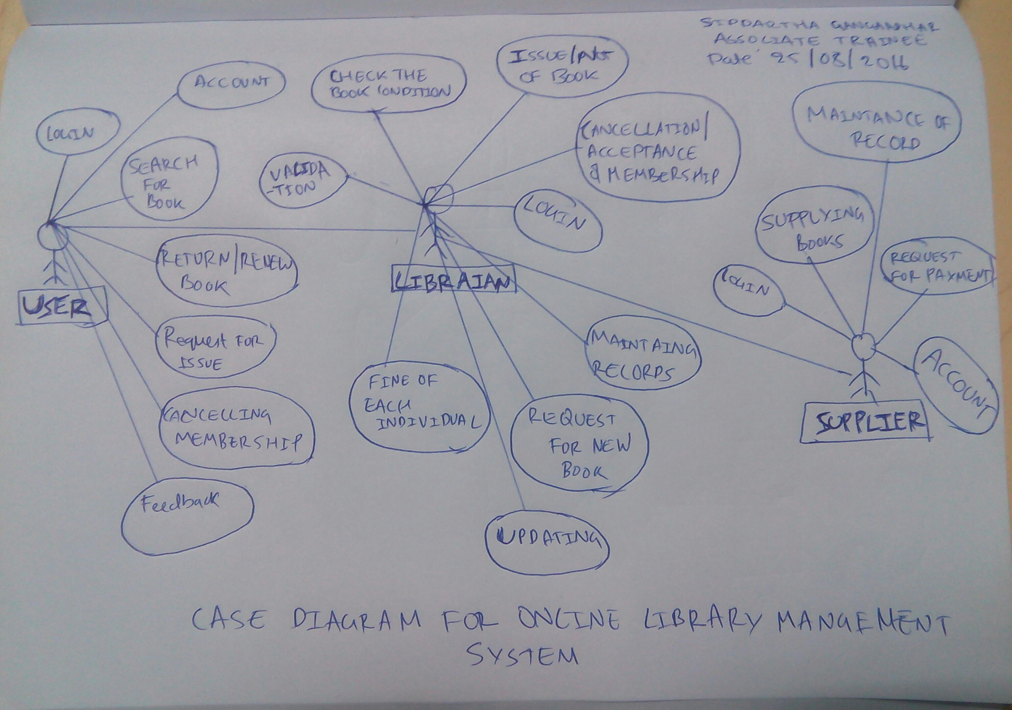
1.Draw a Use Case Diagram for an online Library Management System

2.List down the best practices from Agile/Scrum methodology
one can ensure success in agile project by following below mentioned practices
Design:In this process one ensures
- architecture envisioning (high level design and critical level issues are concerned)
- model storming(one minute session defines teams stratergy)
- test driven design(prototype is tested and minor changes are made to improve quality)
- integration is done using automatically generated tools.Test, compiled and validated and changes are welcomed.

Collaboration:it is most required criteria for agile where one has to works as team.In agile/scrum as everyone is self organised ,it is necessary that they should have daily scrum meetings and inter scrum meeting helps everyone to know what is going and how to proceed next.In agile as requirement changes, it is very necessary to have co-relation between the employees.

Development: which includes SDLC where the potential project is selected prioritized,intializing requirements,defining of scope,monitering,transition, meeting the acceptence criteria,support and maintance,even migration to new product is also entertained.

3.Collaboration
a.How does collaboration help agile development?
As agile development is incremental and requirement instabilty arises ,team must be ready to accept risk and changes,all individual
work are inter related.
Thus if they collabrated one can ensure the success of project.
Thus it is very much neccesary for a self organised team to have collaboration so that final product can be delivered in time.
b.What if the team is distributed and can you achieve the same
productivity?
As a scrum team it is very much neccesary to have colocation of resources to increase the productivity.
Collaboration is a key for agile,which would be achieved if they are working under the same roof,though probability of high productive is more if they are colocated there is still chance of getting good productivity if they are collaborated.
Thus productivity is less when they are distributed compare to co-located.

c.What would you do to achieve the productivity for a distributed
team?
Agile success depends on collaboration and hence they should be co-located,but if resources are distributed and co-location is impossible ,one must ensure that they have frequent communication through online,meetings including video calls and change in scope must be docuimented and mailed.
Scrum master should take extra effort to train and moniter the project so that everything is going according to requirements.

4.What is Sprint Zero in Agile?Describe the activities that are done in Sprint Zero.
Sprint zero is the initiation phase which is the skelton of the project in which iteration are in days.Includes intial Requirement envisioning & architectural envisioning.
Activities
- requirement gathering
- defining high level scope
- meetings with stakeholder and invovling them
- making the case diagram
- data flow diagram
- risk assessment
- estimation of cost and funding required
- setting up of environoment

