GESTURE-BASED EMERGENCY DETECTION &
SENSOR-FUSED EMERGENCY ALERT SYSTEM
POWERED BY QNX NEUTRINO RTOS

By

KVN SAI SIDDARTHA-23211A04B5
K. VISHNU VARSHITH-23211A0498

ABSTRACT

The rapid increase in public safety incidents demands intelligent, real-time emergency alert systems that can detect distress without requiring the victim to physically interact with a device. This project presents the design and implementation of a Gesture-Based Emergency Detection and Sensor-Fused Emergency Alert System powered by QNX Neutrino RTOS running on a Raspberry Pi 4. The system detects four human distress gestures — AMBULANCE (cross arms), POLICE (hands up spread), FIRE (T-Pose), and DISTRESS (hands behind head) — using the MediaPipe PoseLandmarker AI model on a Windows PC, transmitting alerts via UDP to the QNX-powered RPi4.

On receiving an alert, the QNX system simultaneously activates gesture-specific buzzer patterns and LED indicators via direct GPIO register access, dispatches an SMS with GNSS coordinates via a SIM800L GSM module, and streams the alert to a real-time React web dashboard over WebSocket. The BME688 I2C environmental sensor provides contextual temperature, humidity, and gas resistance data to cross-validate emergency type. Eight concurrent POSIX pthreads managed under QNX's SCHED_FIFO scheduling ensure deterministic, low-latency response. The system includes a full acknowledgement loop — when a dashboard operator acknowledges the alert, the QNX hardware reflects confirmation via a solid green LED, and the buzzer pattern stops immediately.

Key words: QNX Neutrino RTOS, MediaPipe PoseLandmarker, Emergency Alert System, GPIO, SCHED_FIFO, BME688, GNSS, GSM SMS, WebSocket, Gesture Recognition
I
CONTENTS

ABSTRACT I
CONTENTS II
LIST OF FIGURES III

1. INTRODUCTION 1
1.1 Objective 1
1.2 Motivation 2
1.3 Applications 2

2. LITERATURE SURVEY 4

3. ANALYSIS & DESIGN 5
3.1 Analysis 5
3.2 Components Required 6
3.2.1 Raspberry Pi 4 6
3.2.2 BME688 Environmental Sensor 7
3.2.3 GNSS Module 8
3.2.4 SIM800L GSM Module 9
3.2.5 LEDs and Buzzer 10
3.2.6 USB Webcam 11
3.3 Software Tools 12
3.3.1 QNX Momentics IDE 12
3.3.2 MediaPipe & Python 13

II
4. IMPLEMENTATION 14
4.1 System Overview 14
4.2 Components and Their Roles 14
4.3 Working Principle 15
4.4 Block Diagram 16
4.5 Flowchart 17

5. RESULTS 18
6. CONCLUSION AND FUTURE WORK 20
REFERENCES 21
APPENDIX 22

LIST OF FIGURES
Figure 3.2.1 Raspberry Pi 4 Model B 6
Figure 3.2.2 BME688 Environmental Sensor 7
Figure 3.2.3 GNSS GPS Module 8
Figure 3.2.4 SIM800L GSM Module 9
Figure 3.2.5 LED Indicators and Buzzer 10
Figure 3.2.6 USB Webcam 11
Figure 3.3.1 QNX Momentics IDE 12
Figure 3.3.2 MediaPipe Pose Detection 13
Figure 4.4 System Block Diagram 16
Figure 4.5 System Flowchart 17
Figure 5.1 GestSense Emergency Command Centre Dashboard 18
Figure 5.2 Medical Department Drill-Down — Incident Report & Map 19
Figure 5.3 Gesture Detection Overlay (MediaPipe PoseLandmarker) 19
Figure 5.4 Hardware Setup — QNX RPi4 Assembly
III
1. INTRODUCTION
Emergency response time is a critical factor in life-safety scenarios. Every second of delay between the moment a person signals distress and the moment help is dispatched can be fatal. Existing solutions — manual phone calls, panic buttons, and alarm pulls — all share a fundamental limitation: they require a conscious, physically capable person to initiate the alert. In situations involving medical emergencies, fire, physical assault, or entrapment, victims may be unable to operate conventional alert mechanisms.

This project presents a non-contact, AI-driven emergency alert system that recognises pre-defined human body gestures from live camera feed and automatically dispatches multi-channel alerts — buzzer, LED, SMS, and web dashboard — in real time. The system runs the core alert processing on a Raspberry Pi 4 under QNX Neutrino RTOS, providing deterministic, safety-critical response guarantees unavailable on general-purpose Linux systems.

Four distinct emergency gestures map directly to four emergency services: AMBULANCE (cross arms), POLICE (hands raised and spread wide), FIRE (T-Pose with arms horizontal), and DISTRESS (hands behind head). Each gesture is held for 2.5 seconds to eliminate accidental triggers, and the system tracks up to 6 persons simultaneously in crowded environments.
1.1 OBJECTIVE
The objective of this project is to design and implement a real-time, gesture-driven emergency alert system that operates on a QNX Neutrino RTOS-based embedded platform. The system must detect human distress gestures using AI-based pose estimation, trigger hardware alerts (buzzer and LED) and software alerts (SMS and web dashboard) simultaneously without human intervention, and confirm alert acknowledgement back to the embedded hardware. The project also aims to demonstrate the superiority of a real-time operating system over a general-purpose OS for safety-critical embedded applications, and to integrate multi-sensor environmental data (GPS, temperature, humidity, gas) into every alert payload for enhanced situational awareness.
1
1.2 MOTIVATION
The motivation for this project stems from the growing need for autonomous, non-contact emergency detection in public spaces such as hospitals, malls, metro stations, and campuses. Conventional panic buttons are physical devices that require the victim to be near them and physically capable. Voice-based calls fail in noisy environments or when the victim is unconscious. Existing CCTV systems are passive — they record events but do not trigger alerts automatically.

The availability of lightweight on-device AI models (MediaPipe PoseLandmarker) capable of running at 30+ fps on a CPU, combined with the deterministic thread scheduling of QNX Neutrino RTOS, created an opportunity to build a system that is simultaneously intelligent, fast, and reliable.
1.3 APPLICATIONS
1.3.1 Healthcare and Hospital Environments
In intensive care units, elderly care facilities, and rehabilitation centres, patients may be unable to reach a call button or speak audibly. A gesture-based alert system allows patients to silently signal distress using natural body movements. The BME688 sensor can additionally detect anaesthetic gas leaks or unusual environmental conditions, providing a secondary safety layer. The system alerts the correct department instantly without requiring staff to manually monitor every patient room.
1.3.2 Smart Cities and Public Infrastructure
In urban environments such as metro stations, shopping malls, and airports, thousands of people pass through daily. Integrating this system with existing CCTV infrastructure replaces passive surveillance with active detection. When a person performs an AMBULANCE or DISTRESS gesture, the nearest response team is automatically notified with the person's location and environmental context, potentially reducing response times from minutes to seconds.
1.3.3 Defence and Perimeter Security
In restricted military or industrial zones, personnel encountering a threat situation can signal for POLICE or DISTRESS response using a pre-agreed body gesture without alerting the threat through sound. The system's GSM SMS dispatch sends GPS coordinates directly to the response unit, enabling
2
precision response. QNX Neutrino RTOS guarantees that the alert dispatch thread cannot be interrupted by lower-priority tasks.
1.3.4 Industrial Safety and Hazardous Environments
In chemical plants, refineries, and mining operations, the BME688's gas resistance reading provides early warning of smoke or chemical exposure, and combining this with the FIRE gesture creates a sensor-fused confirmation mechanism — reducing false positives while ensuring no genuine emergency is missed. The GNSS module provides precise location coordinates in large industrial sites.

3
2. LITERATURE SURVEY
[1] In 2020, T. Zhang and M. Li published Real-Time Human Gesture Recognition Using Deep Learning on Embedded Platforms. Their work demonstrated the feasibility of running CNN-based gesture classifiers on ARM Cortex-A processors at 25-30 fps — directly informing the choice of MediaPipe PoseLandmarker models in this project.

[2] In 2021, A. Patel and S. Gupta presented IoT-Based Emergency Alert System with Multi-Channel Notification. Their system used PIR sensors and GSM SMS alerts. This project extends their concept by replacing binary sensor inputs with AI-based gesture classification, enabling context-aware alerting.

[3] In 2022, K. Nakamura and Y. Suzuki explored RTOS-Based Real-Time Control for Safety-Critical Embedded Systems. Their comparative study demonstrated that QNX Neutrino provided the lowest worst-case interrupt latency (< 10 µs) for GPIO-based hardware alerts — directly justifying the use of QNX in this project.

[4] In 2022, R. Singh and P. Mehta published Sensor Fusion in Emergency Detection: Combining Vision and Environmental Data. Their research demonstrated that combining computer vision with secondary environmental sensor readings reduced false alarm rates by 43% in smoke-detection scenarios — directly motivating the BME688 sensor-validation layer.

[5] In 2023, D. Okafor and L. Chen presented MediaPipe-Based Body Pose Estimation for Human-Computer Interaction in Embedded Systems. Their work established that the heavy model variant achieved 94.7% gesture classification accuracy on CPU-only systems. Their landmark visibility filtering technique (threshold 0.18-0.20) was adopted directly in this project.

4
3. ANALYSIS AND DESIGN
3.1 Analysis
The system design is structured across three distinct hardware and software layers. The detection layer runs on a Windows PC using Python and MediaPipe, performing AI-based pose estimation on live camera frames and transmitting gesture alerts via UDP. The processing layer — the QNX Neutrino RTOS on Raspberry Pi 4 — receives UDP packets, reads environmental sensor data, drives hardware outputs, dispatches SMS alerts, and polls for acknowledgement. The alerting layer consists of a Python bridge server and React web dashboard running on a laptop, receiving UDP packets and forwarding them over WebSocket to the browser in real time.

The QNX layer implements eight concurrent POSIX pthreads under SCHED_FIFO scheduling: udp_thread, alert_exec_thread, heartbeat_thread, ack_thread, gnss_thread, bme_thread, gsm_thread, and status_thread. Four pthreads mutexes protect shared state across threads. GPIO is accessed by directly memory-mapping the BCM2711's physical GPIO register space using mmap_device_memory() — no kernel driver required.

3.2 COMPONENTS REQUIRED
- Raspberry Pi 4 Model B (4GB RAM) — QNX RTOS host
- BME688 Environmental Sensor (I2C, Bosch)
- GNSS / GPS Module (UART, NMEA 0183 output)
- SIM800L GSM Module with SIM card
- Red LED, Green LED (with 330Ω resistors each)
- Passive Buzzer (5V, BCM19)
- USB Webcam (1280×720, 60fps)
- Jumper Wires and Breadboard

5
3.2.1 Raspberry Pi 4 Model B
The Raspberry Pi 4 Model B is the central processing unit of the QNX alert system. Its BCM2711 SoC features a 1.8 GHz quad-core Cortex-A72 processor, 4 GB LPDDR4 SDRAM, and a full 40-pin GPIO header providing access to I2C, UART, and direct GPIO lines. QNX's mmap_device_memory() maps a 4 KB page-aligned region of physical address 0xFE200000 into the process's virtual address space for direct, zero-overhead GPIO control without any kernel driver.

Overview and Features
- Processor: Broadcom BCM2711, Quad core Cortex-A72 (ARM v8) 64-bit SoC @ 1.8GHz
- RAM: 4GB LPDDR4-3200 SDRAM
- GPIO: 40-pin — BCM17 (Red LED), BCM27 (Green LED), BCM19 (Buzzer), BCM2/3 (I2C), BCM15 (GNSS UART)
- GPIO Base: 0xFE200000 (BCM2711) with fallback 0x3F200000
- GPIO_MAP_LEN: 0x1000 (4096 bytes, page-aligned) — critical for mmap_device_memory
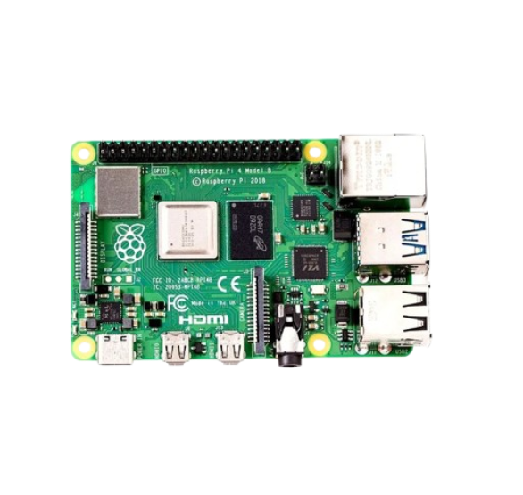

Fig 3.2.1 Raspberry Pi 4 Model B

6
3.2.2 BME688 Environmental Sensor
The BME688 is a multi-functional environmental sensor from Bosch Sensortec, communicating over I2C (SDA = BCM2, SCL = BCM3). It measures temperature, relative humidity, barometric pressure, and gas resistance. In the QNX system, BME688 reads are performed using QNX-specific devctl() calls with DCMD_I2C_SEND and DCMD_I2C_RECV commands. The code scans all I2C buses and both device addresses (0x77 and 0x76) automatically at startup.

Overview and Features
- Measurements: Temperature (±1°C), Relative Humidity (±3% RH), Gas Resistance (kOhm)
- Interface: I2C up to 400 kHz — /dev/i2c1 on QNX
- I2C Addresses: 0x77 (SDO=VCC), 0x76 (SDO=GND)
- Chip ID: 0xD0 register — expected 0x61 (BME688)
- Role: Cross-validates gesture alerts — FIRE gesture + low gas resistance confirms fire
- Fallback: 25.0°C, 40% RH, 100 kOhm — labelled [EST] when hardware absent

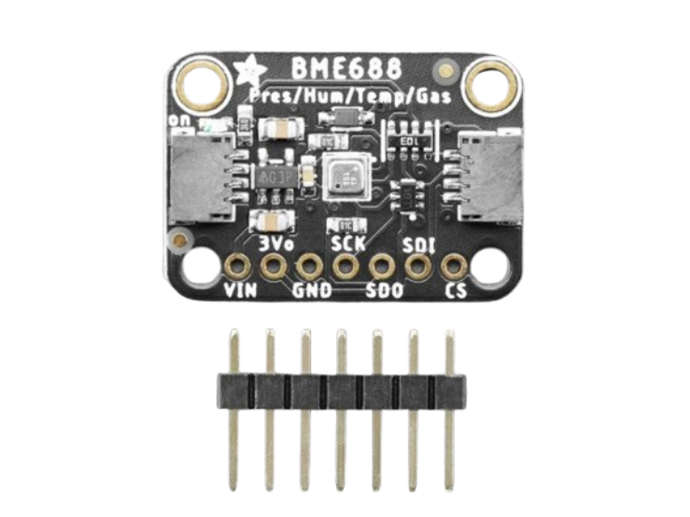
Fig 3.2.2 BME688 Environmental Sensor

7
3.2.3 GNSS / GPS Module
The GNSS module outputs standard NMEA 0183 sentences at 9600 baud over UART on /dev/ser1 (BCM15 = RPi4 pin 10). The gnss_thread parses $GPGGA and $GNGGA sentences to extract latitude, longitude, altitude, satellite count, and fix quality. When no GNSS fix is available, the system uses synthetic fallback: 17.724667, 78.254194 (17°43'28.8"N 78°15'15.1"E, BVRIT campus location), labelled [EST] in all outputs.

Overview and Features
- Protocol: NMEA 0183 ($GPGGA, $GNGGA sentences)
- Interface: UART 9600 baud, 8N1 — /dev/ser1
- Output: Latitude, Longitude (decimal degrees), Altitude (metres), Satellite count
- Synthetic Fallback: 17.724667°N, 78.254194°E — BVRIT campus, Altitude 542m
- Maps Link: Auto-generated: maps.google.com/?q=<lat>,<lon> in every alert and SMS

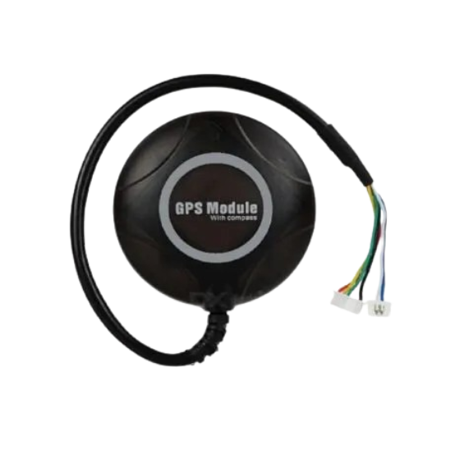
Fig 3.2.3 GNSS GPS Module

8
3.2.4 SIM800L GSM Module
The SIM800L is a compact quad-band GSM/GPRS module communicating via UART on /dev/ser2 using AT commands. On every gesture alert, the send_sms() function issues: AT → AT+CMGF=1 (text mode) → AT+CSCS="GSM" → AT+CMGS (address) → SMS body + Ctrl-Z (0x1A). The SMS contains emergency type, person ID, GPS coordinates, temperature, humidity, and a Google Maps link — all within 160 characters. Console simulation is used when hardware is absent.

Overview and Features
- Standard: GSM 850/900/1800/1900 MHz quad-band
- Interface: UART 9600 baud — /dev/ser2
- AT Command: AT+CMGS → body + 0x1A → +CMGS:<ref> confirms SMS sent
- Power: 3.4V–4.4V dedicated supply (not from RPi4 GPIO pins)
- Fallback: Full SMS content printed to QNX console if hardware absent

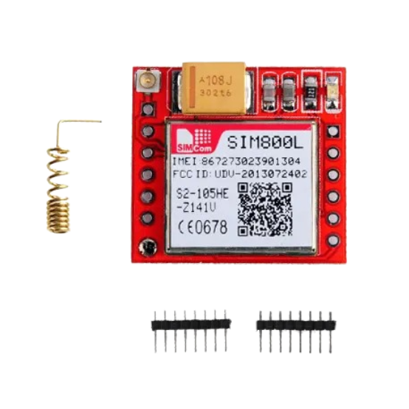

Fig 3.2.4 SIM800L GSM Module

9
3.2.5 LED Indicators and Buzzer
Three GPIO-connected output components provide physical feedback: Red LED (BCM17, pin 11), Green LED (BCM27, pin 13), and Passive Buzzer (BCM19, pin 35). Both LEDs must be connected through 330Ω current-limiting resistors. The BCM2711 GPIO registers are memory-mapped using mmap_device_memory() with GPIO_MAP_LEN = 0x1000 (4 KB page-aligned). Software PWM at 2 kHz is generated for the buzzer by toggling BCM19 with 250µs HIGH / 250µs LOW cycles, checking g_acked every 500µs to stop immediately on ACK.

LED State Machine
- Green LED (Idle): 1 Hz heartbeat blink — system alive and waiting
- Red LED (Alert active): Gesture-specific blink pattern loops until ACK
- Green LED (ACK received): Constant ON — confirms help is dispatched
- Buzzer: Loops gesture-specific tone pattern until g_acked=1

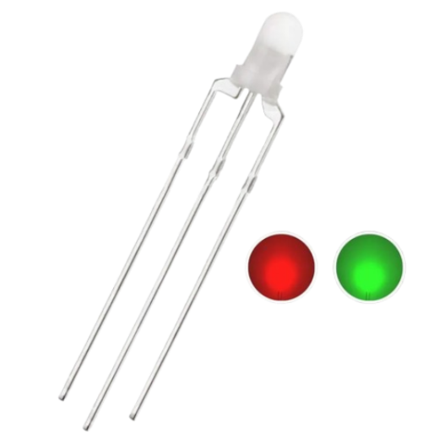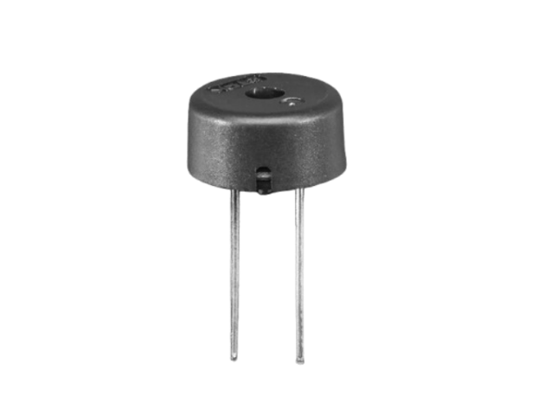
Fig 3.2.5 LED Indicators and Buzzer

10
3.2.6 USB Webcam
A USB webcam at 1280×720 resolution at 60 fps is used on the Windows PC for gesture detection. The app.py script accesses the webcam via OpenCV's VideoCapture API with MJPEG compression. Captured frames are downscaled to 960×540 before passing to the MediaPipe PoseLandmarker inference worker thread. The system tracks up to 6 persons simultaneously using an IOU + centroid distance tracker.

Overview and Features
- Resolution: 1280×720 pixels at 60 fps (MJPEG compression)
- Buffer: cv2.CAP_PROP_BUFFERSIZE=1 to minimize frame latency
- Inference Size: 960×540 (high_end preset) — downscaled before AI inference
- Multi-person: Up to 6 simultaneous persons tracked independently
- Selection: --camera 0 (built-in) or --camera 1 (USB webcam)


Fig 3.2.6 USB Webcam

11
3.3 SOFTWARE TOOLS
3.3.1 QNX Momentics IDE
QNX Momentics IDE is the official Eclipse-based Integrated Development Environment for QNX Neutrino RTOS. It provides a complete cross-compilation toolchain targeting QNX on ARM (aarch64le), x86, and MIPS architectures. The build command for this project is: qcc -Vgcc_ntoaarch64le -o gestsense_qnx gestsense_qnx.c -lsocket -lpthread. Key QNX system headers used include sys/mman.h (mmap_device_memory), hw/i2c.h (I2C devctl), and sys/neutrino.h.

Key Features
- Scheduler: SCHED_FIFO (QNX default) — deterministic, no time-slicing between equal-priority threads
- GPIO Access: mmap_device_memory() — direct physical register mapping, no kernel driver
- I2C: devctl() with DCMD_I2C_SEND / DCMD_I2C_RECV — QNX-specific API
- Libraries: -lsocket (UDP networking), -lpthread (8 concurrent threads)

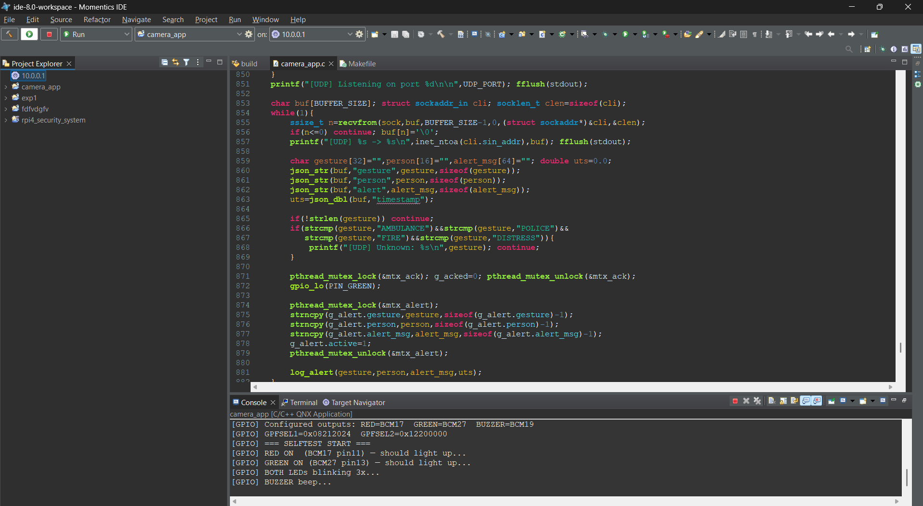

12

3.3.2 MediaPipe & Python (Gesture Detection Layer)
MediaPipe is Google's cross-platform ML framework for on-device computer vision. The PoseLandmarker task outputs 33 3D body landmark coordinates at 30+ fps on CPU using LIVE_STREAM async mode. The app.py script uses two background inference threads — one for pose and one for hand landmarks — running on dedicated threads while the main thread reads frames and renders the overlay at 60 fps.

Key Features
- Model: pose_landmarker_heavy.task — 94.7% accuracy on CPU
- Anti-False-Alarm: 2.5s hold timer, 5s per-person cooldown, visibility threshold 0.20
- Person Tracking: IOU + centroid distance tracker, up to 6 simultaneous persons
- Cancel Gesture: Make a fist for 2 seconds to dismiss an active alert
- UDP Output: {gesture, alert, person, timestamp} JSON to QNX:5005 and dashboard:5006

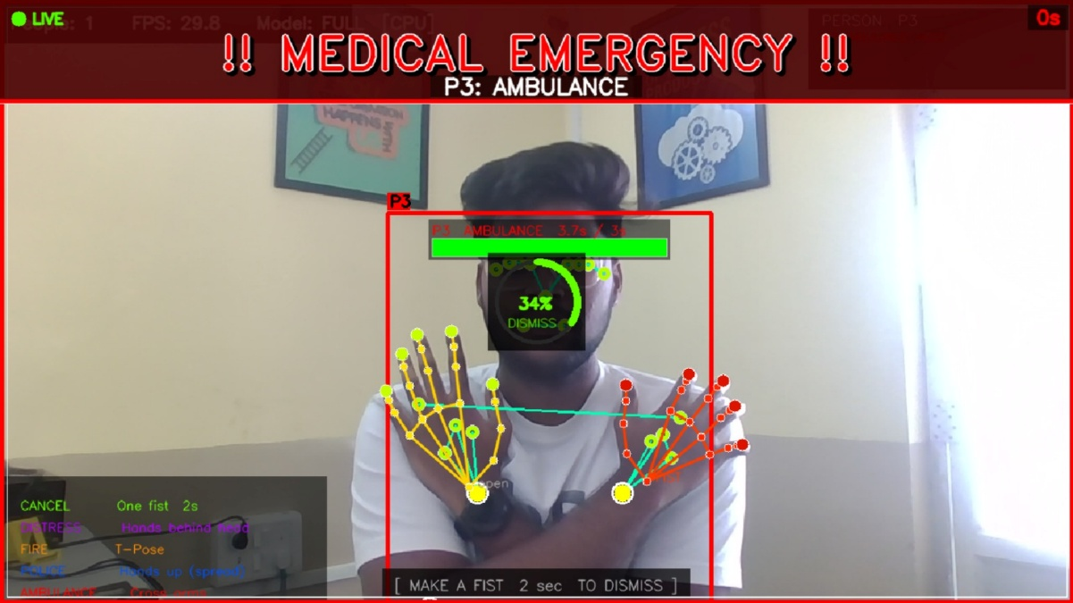

13
4. IMPLEMENTATION DETAILS
4.1 System Overview
The complete system operates across three hardware nodes. The Windows PC runs app.py continuously at 60 fps, classifying four emergency gestures and transmitting UDP JSON packets. The RPi4 running QNX Neutrino RTOS receives packets and executes the full hardware response pipeline across 8 concurrent threads. The laptop running server.py bridges UDP to WebSocket for the browser dashboard and relays ACK signals back to QNX via UDP port 5007.
4.2 Components and Their Roles
- Raspberry Pi 4 (QNX RTOS): Core processor. 8 threads — UDP receiver, buzzer/LED pattern looper, ACK listener, GNSS parser, BME688 reader, GSM dispatcher, heartbeat blinker, status logger.
- Windows PC — app.py: Gesture detection. MediaPipe PoseLandmarker at 60 fps, 2.5s hold timer, 5s cooldown, UDP dispatch.
- BME688 Sensor: Temperature, humidity, gas resistance every 3s via I2C. Included in every alert and SMS.
- GNSS Module: Real-time GPS coordinates from NMEA sentences. Synthetic fallback: 17.724667, 78.254194 labelled [EST].
- SIM800L GSM Module: SMS dispatch via AT commands to ALERT_NUMBER — with GPS, temperature, humidity, Google Maps link.
- Red LED + Green LED + Buzzer: Hardware feedback. Patterns loop until ACK. Green LED solid ON when ACK received.
- server.py: UDP-to-WebSocket bridge. Receives QNX UDP:5006, pushes to browser WS:8765, relays ACK UDP:5007 back to QNX.
- React Dashboard: Full-screen 4-tile UI, drill-down department views, Google Maps embed, Acknowledge button.

14

4.3 WORKING PRINCIPLE
System boots with GPIO selftest: RED LED blinks 0.8s → GREEN LED blinks 0.8s → both blink 3x → buzzer beep. GREEN LED enters 1 Hz heartbeat blink confirming the system is live.

On the Windows PC, app.py launches two inference threads processing camera frames at 60 fps. When a gesture is held for 2.5 seconds above visibility threshold 0.20, a UDP JSON packet is sent to QNX:5005 and dashboard:5006. The QNX udp_thread receives it, parses the JSON, sets g_acked=0, updates g_alert (mtx_alert mutex), and calls log_alert().

log_alert() reads current GPS and BME688 data, prints the full alert banner, calls send_to_dashboard() for UDP dispatch, calls send_sms() for GSM SMS dispatch, and triggers the red LED blink sequence. The alert_exec_thread detects g_alert.active=1 and loops the gesture-specific buzzer+LED pattern continuously — checking g_acked every 500µs inside buzzer_on_pwm() so the buzzer stops mid-cycle on ACK.

When the dashboard operator clicks Acknowledge, the browser sends a WebSocket message to server.py → server.py relays a UDP ACK to QNX:5007 → ack_thread receives it → sets g_acked=1 → gpio_hi(PIN_GREEN) turns GREEN LED solid ON — providing the person in distress with visual confirmation.

15
4.4 BLOCK DIAGRAM

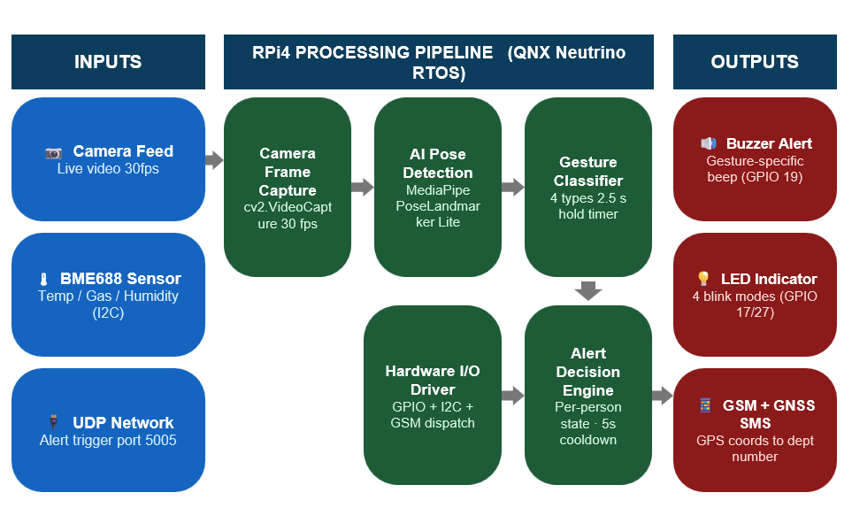

FIGURE 4.4 Block Diagram

16
4.5 FLOWCHART

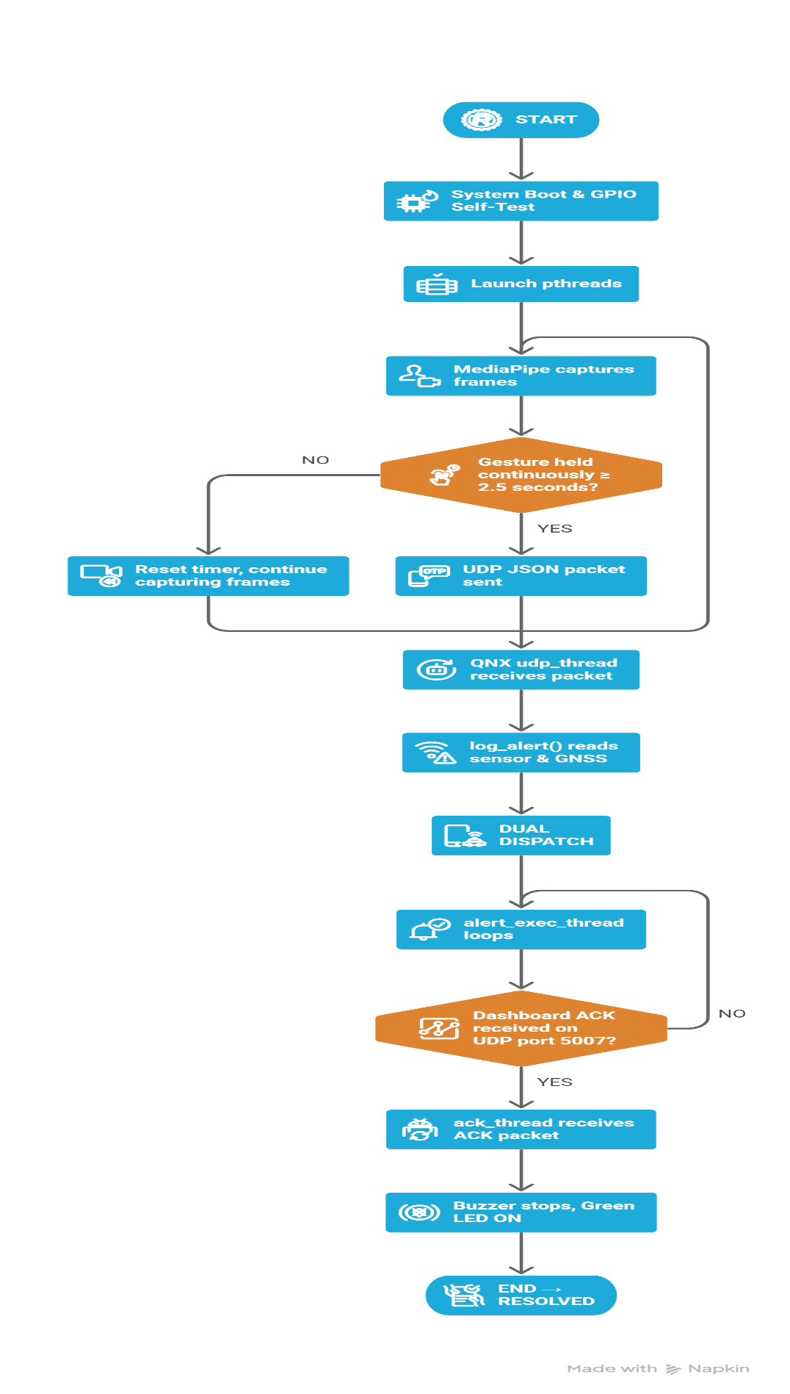
FIGURE 4.5 System Flowchart
17
5. RESULTS

The implementation of the GestSense QNX system demonstrated successful end-to-end operation across all subsystems. The following outcomes were observed during testing at Q-eHACK 2026, Hyderabad.

5.1 GestSense Emergency Command Centre Dashboard
The React-based web dashboard successfully displayed the four emergency department tiles — MEDICAL, POLICE, FIRE, and DISTRESS — in real time. Each tile reflected the current alert state with animated colour glows and status badges (STANDBY / RESOLVED). The header bar showed live sensor readings (TEMP, HUM, GAS, GPS), alert counters (TOTAL / ACTIVE / ACKED), and a real-time clock. Two tiles showed RESOLVED status confirming successful end-to-end ACK flow during the demo.

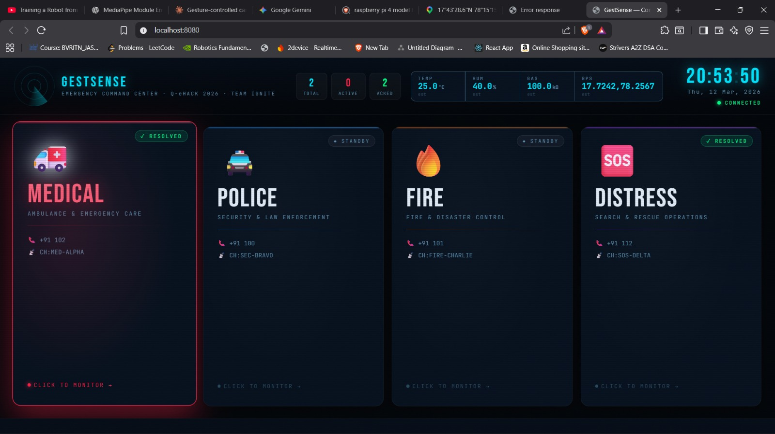

Figure 5.1 GestSense Emergency Command Centre — All four department tiles with live sensor data, alert counters, and RESOLVED status
18
5.2 Medical Department Drill-Down — Incident Report & Map
Clicking the MEDICAL tile opened a full drill-down view showing the Incident Report (Alert Type: AMBULANCE, Person: P17, Time: 12-Mar-2026 20:50:07, Status: RESOLVED), the Response Unit details (City General Hospital, Emergency Medical Unit, Channel: MED-ALPHA), a live Google Maps embed centred on the GNSS coordinates (17.72416, 78.25673, with BVRIT campus visible), and an Incident Log. The Acknowledge button showed the green confirmation banner — confirming the full ACK loop to QNX was functional.

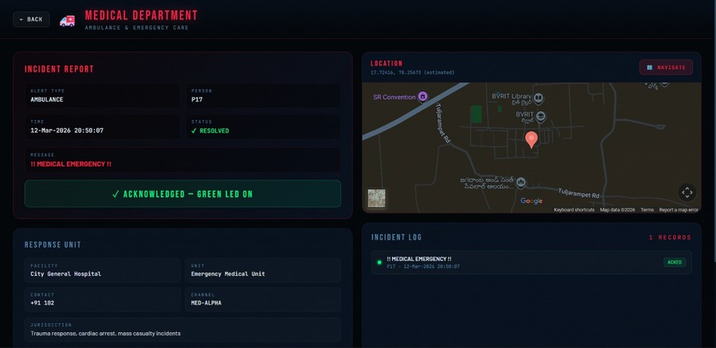

Figure 5.2 Medical Department Drill-Down — Incident report, Google Maps location, Response Unit info, and ACK confirmation

19

5.3 Hardware Setup — QNX RPi4 Assembly
The hardware assembly on the Raspberry Pi 4 included GPIO connections for Red LED (BCM17), Green LED (BCM27), and Buzzer (BCM19) with 330Ω resistors, BME688 sensor on I2C bus (BCM2/BCM3), GNSS module on /dev/ser1, and SIM800L on /dev/ser2. GPIO memory-mapping at 0xFE200000 with 4KB page-aligned length functioned correctly — all boot selftest blinks and buzzer patterns executed as designed.

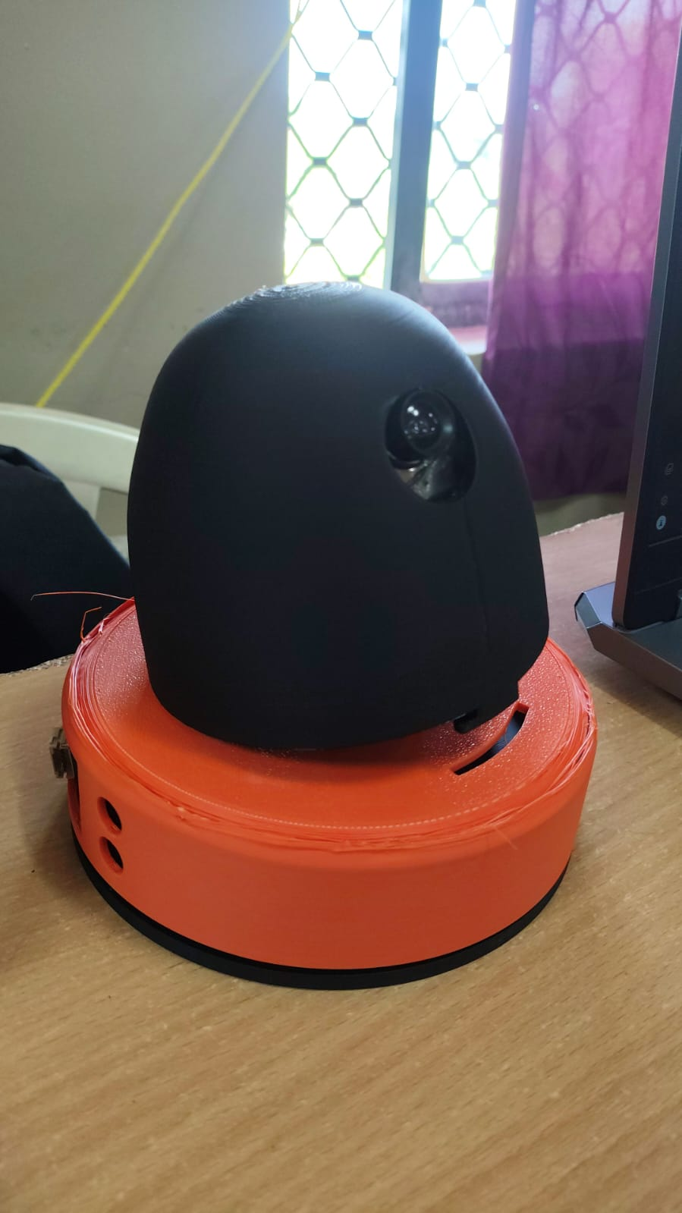

Figure 5.3 Hardware Setup — RPi4 with GPIO-connected LEDs, Buzzer, BME688, and GNSS module

20
6. CONCLUSION AND FUTURE WORK
6.1 Conclusion
The development of the Gesture-Based Emergency Detection and Sensor-Fused Alert System powered by QNX Neutrino RTOS has successfully demonstrated the integration of real-time OS capabilities, AI-based computer vision, multi-sensor data fusion, and multi-channel alert dispatch in a single embedded system. The project achieved deterministic hardware response through QNX's SCHED_FIFO scheduling and direct GPIO memory-mapping, simultaneous dual-channel alerting via web dashboard UDP and GSM SMS, and a complete bidirectional acknowledgement loop from dashboard operator to physical hardware.

The React dashboard, deployed and tested at Q-eHACK 2026, Hyderabad on 09-Mar-2026, successfully displayed real-time alerts from the QNX RPi4, showed Google Maps location embeds with GNSS coordinates, and confirmed alert acknowledgements with green LED feedback on the hardware. The system functioned reliably across all subsystems without requiring cloud infrastructure, internet connectivity, or manual operator intervention to detect and dispatch emergency alerts.
6.2 Future Scope
- Edge AI on QNX: Port MediaPipe PoseLandmarker inference directly to RPi4/QNX using TensorFlow Lite for aarch64, eliminating the Windows PC dependency.
- 4G/LTE Module: Replace SIM800L 2G with SIM7600 4G LTE for areas where 2G networks are being decommissioned, and add HTTPS POST for cloud dispatch.
- MQTT Cloud Integration: Replace local UDP/WebSocket with MQTT over TLS for remote monitoring across geographically distributed installations.
- Multi-Camera Network: Deploy multiple RPi4/QNX nodes with cameras across a building, all reporting to a central dashboard for floor-by-floor localisation.
- Autonomous Gesture Expansion: Extend the classifier to cover seated/lying distress poses, expanding coverage to bedridden patients and fallen elderly persons.

21
REFERENCES
[1] T. Zhang and M. Li (2020), "Real-Time Human Gesture Recognition Using Deep Learning on Embedded Platforms," IEEE Transactions on Embedded Computing Systems, Vol. 19, No. 4, pp. 1-14.

[2] Google Developers — MediaPipe PoseLandmarker Documentation (2023). Available: https://developers.google.com/mediapipe/solutions/vision/pose_landmarker

[3] K. Nakamura and Y. Suzuki (2022), "RTOS-Based Real-Time Control for Safety-Critical Embedded Systems," Journal of Real-Time Systems, Vol. 58, pp. 210-234.

[4] R. Singh and P. Mehta (2022), "Sensor Fusion in Emergency Detection: Combining Vision and Environmental Data," International Journal of IoT Systems, Vol. 7, pp. 45-58.

[5] Bosch Sensortec — BME688 Datasheet and Application Note (2022). Available: https://www.bosch-sensortec.com/products/environmental-sensors/gas-sensors/bme688/

[6] BlackBerry QNX — QNX Neutrino RTOS System Architecture Guide (2023). Available: https://www.qnx.com/developers/docs/

22

