1. Create a HTML static web page which shows the use different controls.

Basic Controls.html
<html>
<frameset rows="20%,50%">
<frame src="bpibs.html" />
<frameset cols="25%,75%">
<frame src="ALLLINKS.HTML" />
<frame src="TABLE.HTML" />
</frameset>
</frameset>
</html>

Bpibs.html
<html>
<h1><font size="72" color ="red">BPIBS<h1>
</html>

Alllinks.html
<html>
<body>
<a href="hello.html">MCA</a> <br/>
<a href="hello.html">MBA</a> <br/>
<a href="hello.html">BBA</a> <br/>
<a href="hello.html">MOP</a> <br/>
</body>
</html>

Table.html
<html>
<body>
<h4>COURSES</h4>
<table border="1">
<tr>
<th>S no</th>
<th>Name Of The Course</th>
</tr>
<tr>
<td>1</td>
<td>MCA</td>
</tr>
<tr>
<td>2</td>
<td>MBA</td>
</tr>
<tr>
<td>3</td>
<td>BBA</td>
</tr>
<tr>
<td>4</td>
<td>MOP</td>
</tr>
</table></body>
</html>

2. Create a HTML form which display some validation in text box using java script .

Textbox Validation.html

<html>
<head>
<script type="text/javascript">
function validateForm()
{
var x=document.forms.myForm.fname.value;
var y=document.forms.myForm.lname.value;
if (x==null || x=="" || y==null || y=="")
{
alert("name must be filled out");
return false;
}
}
</script>
</head>
<body>
<table width="100%" height="100%" border="0">

<tr>
<td colspan="2" style="background-color:LavenderBlush;">
<h1>BPIBS</h1>
</td>
</tr>

<tr valign="top">
<td style="background-color:FloralWhite;text-align:top;">
<b>Menu</b><br />
<a href="p_html.htm">
HTML</a><br />
<a href="p_css.htm">CSS</a><br />
<a href="p_js.htm">JavaScript</a>
</td>

<td style="background-color:PapayaWhip;text-align:top;">
Content

<form name="myForm" action="DATALINK.HTML" onsubmit="return validateForm()">
First name: <input type="text" name="fname" value="" /><br />
Last name: <input type="text" name="lname" value="" /><br />
<input type="submit" value="Submit" />
<input type="Reset" value="Reset" />
</form>

<p>Create a link of an image:

<a href="Hello.html">
<img src="smiley.gif" alt="HTML tutorial" width="32" height="32" />
</a></p>

</td>
</tr>

<tr>
<td colspan="2" style="background-color:NavajoWhite;text-align:center;">
sid</td>
</tr>

</table>
</body>
</html>

Hello.html

<html>

<body>
<h1>HELLO</h1>
</body>

</html>

3. Create a HTML page and use Cascading Style Sheets.

Css.html

<html>
<head>
<style type="text/css">
a:link {color:#FF0000;} /* unvisited link */
a:visited {color:black;} /* visited link */
a:hover {color:black;} /* mouse over link */
a:active {color:#0000FF;} /* selected link */
</style>
</head>

<body>
<h1>CASCADING STYLE SHEETS</h1>
<HR/>
<p><b><a href="default.asp" target="_blank">Google</a></b></p>

</body>
</html>

4. Create a ASP.NET which show the employee registration form. Form should receive the name, age, sex, hobbies, date of birth employee number auto generated and a submit and cancel button.

Code:-
<%@ Page Language="C#" AutoEventWireup="true" CodeFile="Default.aspx.cs" Inherits="_Default" %>
<!DOCTYPE html PUBLIC "-//W3C//DTD XHTML 1.0 Transitional//EN" "http://www.w3.org/TR/xhtml1/DTD/xhtml1-transitional.dtd">
<html xmlns="http://www.w3.org/1999/xhtml">
<head runat="server">
<title></title>
</head>
<body>
<form id="form1" runat="server">
<div>
<h1>Personal Information</h1>
<br />
<asp:Label ID="Label90" runat=server>Employee Id</asp:Label>&nbsp;&nbsp;&nbsp;&nbsp;&nbsp;&nbsp;&nbsp;&nbsp;&nbsp;&nbsp;&nbsp;&nbsp;&nbsp;
<asp:Label ID="Label9" runat=server><script language=javascript>document.write(Math.round(Math.random()) * 120)</script></asp:Label>
<br />
<asp:Label ID="Label1" runat=server>First Name</asp:Label>&nbsp;&nbsp;&nbsp;&nbsp;&nbsp;&nbsp;&nbsp;&nbsp;&nbsp;&nbsp;&nbsp;&nbsp;&nbsp;&nbsp;&nbsp;
<asp:TextBox runat=server Width="188px"></asp:TextBox>
<br />
<asp:Label ID="Label2" runat=server>Middle Name</asp:Label>&nbsp;&nbsp;&nbsp;&nbsp;&nbsp;&nbsp;&nbsp;&nbsp;&nbsp;&nbsp;&nbsp;
<asp:TextBox ID="TextBox2" runat=server Width="188px"></asp:TextBox>
<br />
<asp:Label ID="Label3" runat=server>Last Name</asp:Label>&nbsp;&nbsp;&nbsp;&nbsp;&nbsp;&nbsp;&nbsp;&nbsp;&nbsp;&nbsp;&nbsp;&nbsp;&nbsp;&nbsp;&nbsp; <asp:TextBox ID="TextBox1" runat=server Width="188px"></asp:TextBox>
<br />
<asp:Label ID="Label4" runat=server>Age</asp:Label>&nbsp;&nbsp;&nbsp;&nbsp;&nbsp;&nbsp;&nbsp;&nbsp;&nbsp;&nbsp;&nbsp;&nbsp;&nbsp;&nbsp;&nbsp;&nbsp;&nbsp;&nbsp;&nbsp;&nbsp; &nbsp;&nbsp;&nbsp;&nbsp; <asp:TextBox ID="TextBox3" runat=server Width="188px"></asp:TextBox>
<br />
<asp:Label ID="Label5" runat=server>Contact Number</asp:Label>&nbsp;&nbsp;&nbsp;&nbsp;&nbsp;&nbsp; <asp:TextBox ID="TextBox4" runat=server Width="188px"></asp:TextBox>
<br />
<asp:Label ID="Label6" runat=server>Email</asp:Label>&nbsp;&nbsp;&nbsp;&nbsp;&nbsp;&nbsp;&nbsp;&nbsp;&nbsp;&nbsp;&nbsp;&nbsp;&nbsp;&nbsp;&nbsp;&nbsp;&nbsp;&nbsp;&nbsp;&nbsp;&nbsp;&nbsp;&nbsp; <asp:TextBox ID="TextBox5" runat=server Width="188px"></asp:TextBox>
<br />
<asp:Label ID="Label7" runat=server>Sex</asp:Label>
&nbsp;&nbsp;&nbsp;&nbsp;&nbsp;&nbsp;&nbsp;&nbsp;&nbsp;&nbsp;&nbsp;&nbsp;&nbsp;&nbsp;&nbsp;&nbsp;&nbsp;&nbsp;&nbsp;&nbsp;&nbsp;&nbsp;&nbsp;
<asp:RadioButton Text="Male" runat=server GroupName="sex"/>
<asp:RadioButton Text="Female" runat=server GroupName="sex"/>
<br />
<asp:Label runat=server>Date Of Birth <asp:Calendar ID=Calendar runat=server></asp:Calendar> </asp:Label>
</div>
<div>
<h1>Hobbies</h1>
<table>
<tr>
<td><asp:CheckBox ID="CheckBox1" runat=server Text="Reading"/></td>
<td><asp:CheckBox ID="CheckBox2" runat=server Text="Writing"/></td>
<td><asp:CheckBox ID="CheckBox3" runat=server Text="Chatting"/></td>
<td><asp:CheckBox ID="CheckBox4" runat=server Text="Music"/></td>
</tr>
<tr>
<td><asp:CheckBox ID="CheckBox5" runat=server Text="Cricker"/></td>
<td><asp:CheckBox ID="CheckBox6" runat=server Text="Movies"/></td>
<td><asp:CheckBox ID="CheckBox7" runat=server Text="Hockey"/></td>
<td><asp:CheckBox ID="CheckBox8" runat=server Text="Football"/></td>
</tr>
<tr>
<td><asp:CheckBox ID="CheckBox9" runat=server Text="Working" Width=90px/></td>
<td><asp:CheckBox ID="CheckBox10" runat=server Text="Drawing" Width=90px/></td>
<td><asp:CheckBox ID="CheckBox11" runat=server Text="Flerting" Width=90px/></td>
<td><asp:CheckBox ID="CheckBox12" runat=server Text="Eating" Width=90px/></td>
</tr>
</table>
</div>
<div>
<br /><br />
<asp:Button ID="Button1" Text="Submit" runat=server/>
<asp:Button ID="Button2" Text="Cancel" runat=server />
</div>
</form>
</body>
</html>

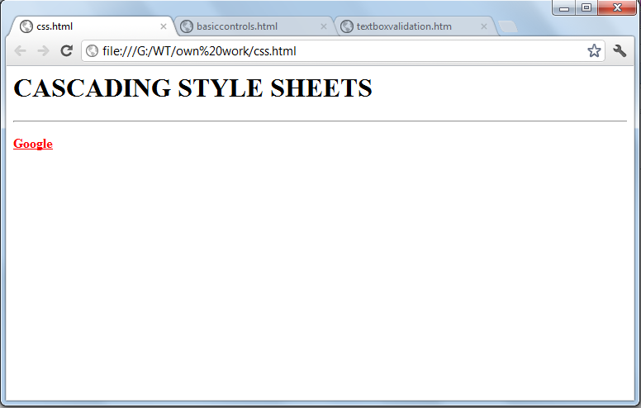

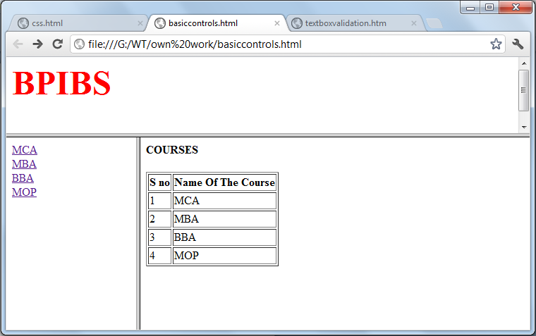

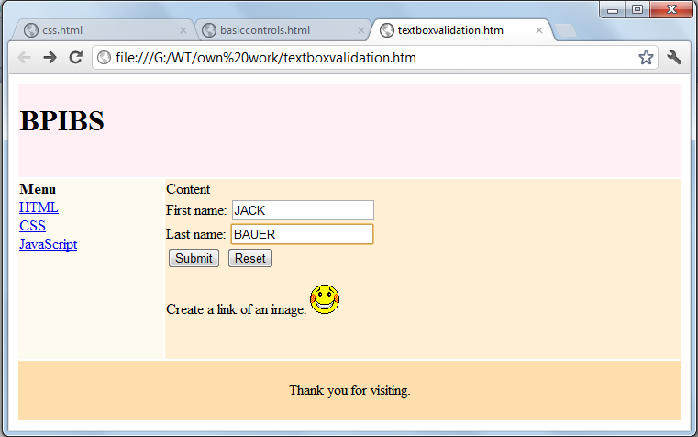

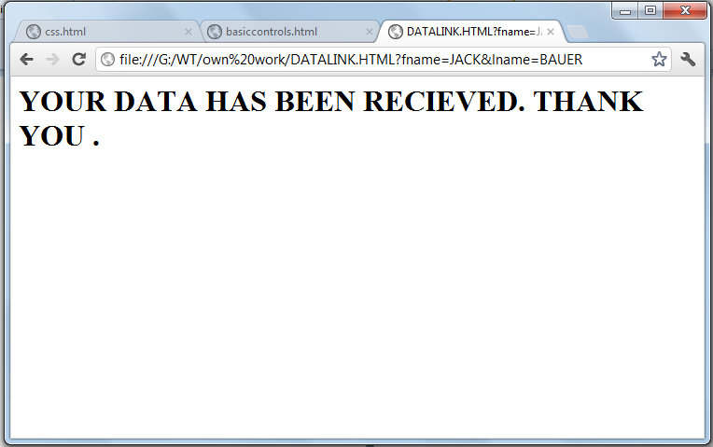

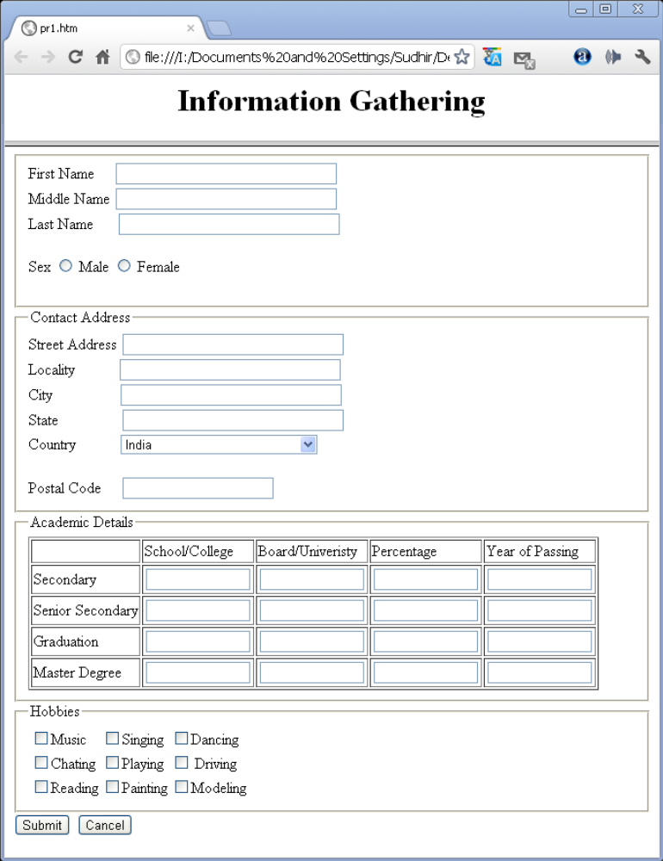

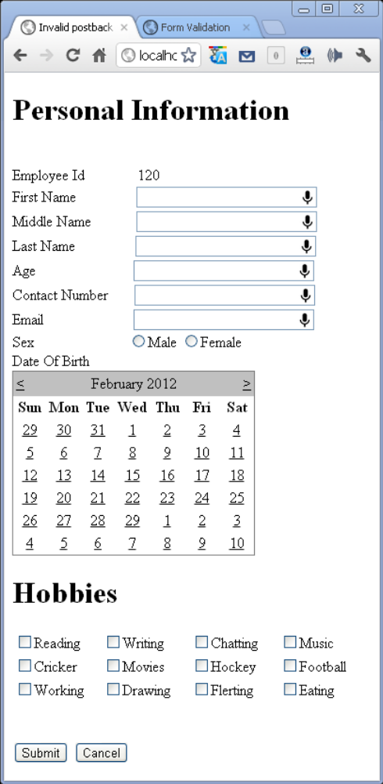

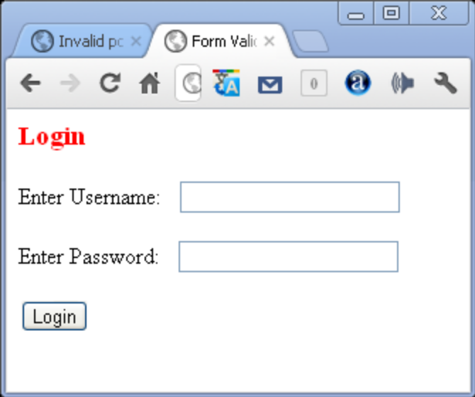

Create a web page with the help of ASP.NET and put some server control.
<%@ Page Language="VB" AutoEventWireup="false" CodeFile="Default.aspx.vb" Inherits="_Default" %>

<!DOCTYPE html PUBLIC "-//W3C//DTD XHTML 1.0 Transitional//EN" "http://www.w3.org/TR/xhtml1/DTD/xhtml1-transitional.dtd">
<html>
<head>
</head>
<body>
<form id=FORM1 method=post runat="server">
<table style="LEFT: 122px; POSITION: absolute; TOP: 106px" height=137 cellSpacing=1 cellPadding=1 width=474 bgColor=#ffffcc border=1>
<tr>
<td colSpan=2><asp:label id=Label1 runat="server" Width="127" Height="18"
fontsize="Small" font-bold="True" font-names="Verdana" bordercolor="Transparent"
borderstyle="None" backcolor="#FFFFC0">User Name:</asp:label><asp:textbox
id=txtUserName runat="server"></asp:textbox>
</td>
</tr>
<tr>
<td colSpan=2>
<asp:label id=Label2 runat="server" Width="127" Height="18"
font-size="Small" font-bold="True" font-names="Verdana"
bordercolor="Transparent" borderstyle="None" backcolor="#FFFFC0">
Password:
</asp:label>
<asp:textbox id=txtPassword runat="server" textmode="Password">
</asp:textbox>
</td>
</tr>
<tr>
<td>
<asp:RadioButton ID="Admin" runat="server" GroupName="user" Text="Admin" /></td>
<td><asp:RadioButton ID="Cust" runat="server" GroupName="user" Text="Employee" /></td>
</tr>
<tr>
<td> <asp:CheckBox ID="Buy" runat="server" Text="Buy" /> </td>
<td> <asp:CheckBox ID="Sell" runat="server" Text="Sell" /> </td>
</tr>
<tr> <td>
<asp:Label ID="Label3" runat="server" Text="Website"></asp:Label></td>
<td>
<asp:LinkButton ID="LinkButton1" runat="server"
OnClientClick="google.com" Text="www.google.com"></asp:LinkButton></td>
</tr>
<tr>
<td>
<asp:Label ID="Label4" runat="server" Text="State"></asp:Label></td>
<td>
<asp:DropDownList ID="DropDownList1" runat="server">
<asp:ListItem>noida</asp:ListItem>
<asp:ListItem>delhi</asp:ListItem>
<asp:ListItem>haryana</asp:ListItem>
<asp:ListItem>Uttar pradesh</asp:ListItem>
</asp:DropDownList> </td>
</tr>
<tr>
<td align=middle class="style1">
<asp:button id=cmdCancel runat="server" Text="Cancel"
font-bold="True" font-names="Verdana" commandname="cmdCancel"
height="24" width="104"></asp:button>
</td>
<td align=middle width=200>
<asp:button id=cmdOK runat="server" Text="OK" font-bold="True"
font-names="Verdana" commandname="cmdOK" height="25"
width="101"></asp:button>
</td>
</tr>
</table>
</form>
</body>
</html>

OUTPUT
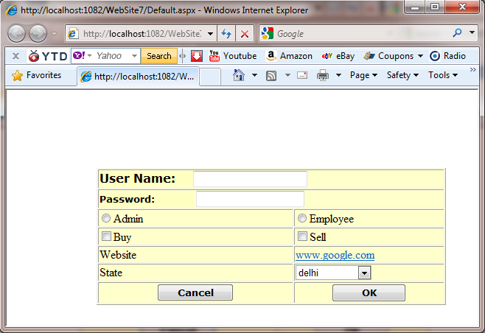

Create a web page using ASP.NET with proper validation on each components.

<%@ Page Language="C#" AutoEventWireup="true" CodeFile="Default.aspx.cs" Inherits="_Default" %>

<!DOCTYPE html PUBLIC "-//W3C//DTD XHTML 1.0 Transitional//EN" "http://www.w3.org/TR/xhtml1/DTD/xhtml1-transitional.dtd">

<html xmlns="http://www.w3.org/1999/xhtml">
<head runat="server">
<title></title>
</head>
<body>
<form id="form1" runat="server">
<div style="height: 390px">
Name&nbsp;&nbsp;&nbsp;&nbsp;&nbsp;&nbsp;&nbsp;&nbsp;&nbsp;&nbsp;&nbsp;&nbsp;&nbsp;&nbsp;&nbsp;&nbsp;&nbsp;&nbsp;&nbsp;&nbsp;&nbsp;&nbsp;&nbsp;&nbsp;&nbsp;
<asp:TextBox ID="TextBox1" runat="server" ></asp:TextBox>

<asp:RequiredFieldValidator ID="RequiredFieldValidator1" runat="server"
ControlToValidate="TextBox1" ErrorMessage="*"></asp:RequiredFieldValidator>
&nbsp;&nbsp;&nbsp;&nbsp;&nbsp;&nbsp;&nbsp;&nbsp;&nbsp;&nbsp;&nbsp;&nbsp;&nbsp;&nbsp;&nbsp;&nbsp;&nbsp;&nbsp;&nbsp;&nbsp;&nbsp;&nbsp;&nbsp;&nbsp;&nbsp;&nbsp;&nbsp;&nbsp;&nbsp;&nbsp;&nbsp;&nbsp;&nbsp;&nbsp;&nbsp;&nbsp;&nbsp;&nbsp;&nbsp;&nbsp;&nbsp;
<br />
<br />
Password&nbsp;&nbsp;&nbsp;&nbsp;&nbsp;&nbsp;&nbsp;&nbsp;&nbsp;&nbsp;&nbsp;&nbsp;&nbsp;&nbsp;&nbsp;&nbsp;&nbsp;&nbsp;&nbsp;
<asp:TextBox ID="TextBox2" runat="server"></asp:TextBox>
<asp:RequiredFieldValidator ID="RequiredFieldValidator2" runat="server"
ControlToValidate="TextBox2" ErrorMessage="*"></asp:RequiredFieldValidator>
<br />
<br />
Confirm password&nbsp;&nbsp;&nbsp;&nbsp;&nbsp;&nbsp;&nbsp;
<asp:TextBox ID="TextBox3" runat="server"></asp:TextBox>
<asp:CompareValidator ID="CompareValidator1" runat="server"
ControlToCompare="TextBox2" ControlToValidate="TextBox3"
ErrorMessage="Password mismatch"></asp:CompareValidator>
<br />
<br />
Age&nbsp;&nbsp;&nbsp;&nbsp;&nbsp;&nbsp;&nbsp;&nbsp;&nbsp;&nbsp;&nbsp;&nbsp;&nbsp;&nbsp;&nbsp;&nbsp;&nbsp;&nbsp;&nbsp;&nbsp;&nbsp;&nbsp;&nbsp;&nbsp;&nbsp;&nbsp;&nbsp;
<asp:TextBox ID="TextBox4" runat="server" Width="39px" AutoPostBack="True"
CausesValidation="True"></asp:TextBox>
&nbsp;&nbsp;&nbsp;&nbsp;&nbsp;&nbsp;&nbsp;
<asp:RangeValidator ID="RangeValidator1" runat="server"
ControlToValidate="TextBox4" ErrorMessage="18&gt;age&lt;50" MaximumValue="50"
MinimumValue="10" Type="Integer"></asp:RangeValidator>
&nbsp;&nbsp;&nbsp;&nbsp;&nbsp;&nbsp;&nbsp;&nbsp;&nbsp;
<br />
<br />
E-mail&nbsp;&nbsp;&nbsp;&nbsp;&nbsp;&nbsp;&nbsp;&nbsp;&nbsp;&nbsp;&nbsp;&nbsp;&nbsp;&nbsp;&nbsp;&nbsp;&nbsp;&nbsp;&nbsp;&nbsp;&nbsp;&nbsp;
<asp:TextBox ID="TextBox5" runat="server" AutoPostBack="True" CausesValidation="True"></asp:TextBox>
<asp:RegularExpressionValidator ID="RegularExpressionValidator1" runat="server"
ControlToValidate="TextBox5" ErrorMessage="Should include @ and ."
ValidationExpression="\w+([-+.']\w+)*@\w+([-.]\w+)*\.\w+([-.]\w+)*"></asp:RegularExpressionValidator>
<br />
&nbsp;<br />
&nbsp;&nbsp;&nbsp;&nbsp;&nbsp;&nbsp;&nbsp;&nbsp;&nbsp;&nbsp;&nbsp;&nbsp;&nbsp;&nbsp;&nbsp;&nbsp;&nbsp;&nbsp;
<asp:Button ID="Button1" runat="server" Text="Submit" />
<br />

</div>
</form>
</body>
</html>

OUTPUT

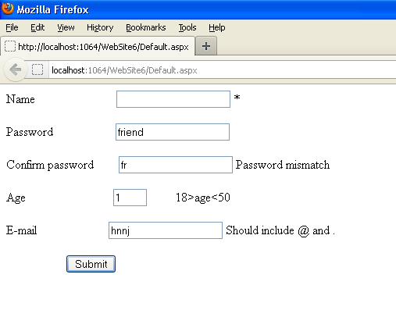

Create a web page with the use of data grid linked with database.

<%@ Page Language="VB" AutoEventWireup="false" CodeFile="Default.aspx.vb" Inherits="_Default" %>

<!DOCTYPE html PUBLIC "-//W3C//DTD XHTML 1.0 Transitional//EN" "http://www.w3.org/TR/xhtml1/DTD/xhtml1-transitional.dtd">

<html xmlns="http://www.w3.org/1999/xhtml">
<head runat="server">
<title></title>
</head>
<body>
<form id="form1" runat="server">
<div>

<asp:GridView ID="GridView1" runat="server" AllowPaging="True"
AutoGenerateColumns="False" DataKeyNames="Subjectcode"
DataSourceID="AccessDataSource1">
<Columns>
<asp:BoundField DataField="Subjectcode" HeaderText="Subjectcode"
ReadOnly="True" SortExpression="Subjectcode" />
<asp:BoundField DataField="Subjectname" HeaderText="Subjectname"
SortExpression="Subjectname" />
<asp:BoundField DataField="CreditMark" HeaderText="CreditMark"
SortExpression="CreditMark" />
<asp:BoundField DataField="MaxMark" HeaderText="MaxMark"
SortExpression="MaxMark" />
<asp:BoundField DataField="Type" HeaderText="Type" SortExpression="Type" />
<asp:BoundField DataField="Practical" HeaderText="Practical"
SortExpression="Practical" />
</Columns>
</asp:GridView>
<asp:AccessDataSource ID="AccessDataSource1" runat="server"
DataFile="~/student.mdb" SelectCommand="SELECT * FROM [subject]">
</asp:AccessDataSource>

</div>
</form>
</body>
</html>

OUTPUT

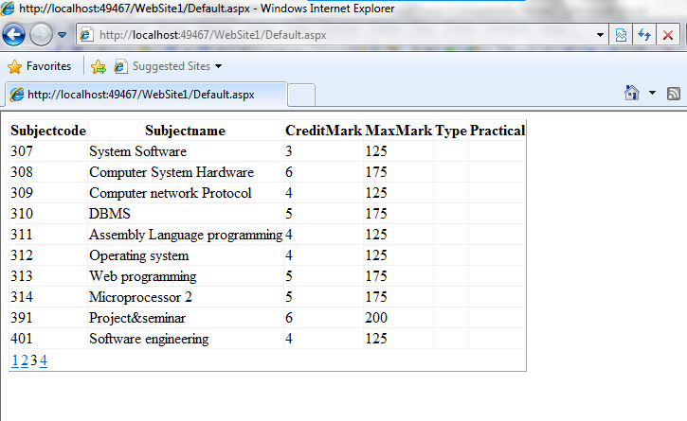

Create a website which accept a feedback form, all the fields should be connected through ADO.net.
<%@ Page Language="VB" AutoEventWireup="false" CodeFile="Default3.aspx.vb" Inherits="Default3" %>
<!DOCTYPE html PUBLIC "-//W3C//DTD XHTML 1.0 Transitional//EN" "http://www.w3.org/TR/xhtml1/DTD/xhtml1-transitional.dtd">
<%@ Import Namespace="System.Data.OleDb"%>
<html><head><title></title></head>
<script language="VB" runat="server">
Sub Insert_Click(Src As Object, E As EventArgs)
' Connect to Database
Dim cnAccess As New OleDbConnection("Provider=Microsoft.Jet.OLEDB.4.0;Data Source=E:\ADODemo\Employee.mdb")
cnAccess.Open()
Dim sID, sFName, sLName, sAge, sInsertSQL As String
sID = eID.Text
sFName = FName.Text
sLName = LName.Text
sAge = Age.Text
'Make the insert statement
sInsertSQL = "insert into employees values(" & sID & ",'" &
sFName & "','" & sLName & "'," & sAge & ")"
'Make the OleDbCommand object
Dim cmdInsert As New OleDbCommand(sInsertSQL, cnAccess)
' This not a query so we do not expect any return data so use
' the ExecuteNonQuery method
cmdInsert.ExecuteNonQuery()
Response.Write("Data recorded!")
End Sub

Sub show_Click()
' Connect to Database
Dim cnAccess As New OleDbConnection("Provider=Microsoft.Jet.OLEDB.4.0;Data Source=E:\ADODemo\Employee.mdb")
cnAccess.Open()
Dim sSelectSQL As String
'Make the select statement
sSelectSQL = "select * from employees"
'Make the OleDbCommand object
Dim cmdSelect As New OleDbCommand(sSelectSQL, cnAccess)
' This query should return an OleDbDataReader so we use the
' ExecuteReader method
Dim drEmp As OleDbDataReader, sbResults As New StringBuilder()
drEmp = cmdSelect.ExecuteReader()
sbResults.Append("<Table>")
Do While drEmp.Read()
sbResults.Append("<TR><TD>")
sbResults.Append(drEmp.GetInt32(0).ToString())
sbResults.Append("</TD><TD>")
sbResults.Append(drEmp.GetString(1))
sbResults.Append("</TD><TD>")
sbResults.Append(drEmp.GetString(2))
sbResults.Append("</TD><TD>")
sbResults.Append(drEmp.GetInt32(3).ToString())
sbResults.Append("</TD><TR>")
Loop
sbResults.Append("</Table>")
lblResult.Text = sbResults.ToString()
End Sub

</script>
<body>
<form id = "form1" runat="server">
<h3><font face="Verdana">Enter Employee Details</font></h3>
<table>
<tr>
<td>ID:</td>
<td><asp:textbox id="eID" runat="server"/></td>
</tr>
<tr>
<td>First Name:</td>
<td><asp:textbox id="FName" runat="server"/></td>
</tr>
<tr>
<td>Last Name:</td>
<td><asp:textbox id="LName" runat="server"/></td>
</tr>
<tr>
<td>Age:</td>
<td><asp:textbox id="Age" runat="server"/></td>
</tr>
</table>
<asp:button ID="Button1" text="Insert" OnClick="Insert_Click" runat="server"/>

<asp:Label id="Msg" ForeColor="red" Font-Name="Verdana" Font-Size="10" runat="server" />
<hr />
<h3><font face="Verdana">Employee Details</font></h3>
<asp:button ID="Button2" text="Show Records" OnClick="show_Click" runat="server"/>
<asp:label id="lblResult" runat="server" text=""/>

</body>
</form>
</body>
</html>
OUTPUT

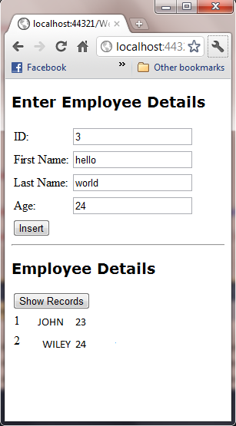

Create a web page using ASP.NET and show the use of session in it.
PAGE- DEFAULT 6
<%@ Page Language="VB" AutoEventWireup="false" CodeFile="Default6.aspx.vb" Inherits="Default6" %>

<!DOCTYPE html PUBLIC "-//W3C//DTD XHTML 1.0 Transitional//EN" "http://www.w3.org/TR/xhtml1/DTD/xhtml1-transitional.dtd">
<html xmlns="http://www.w3.org/1999/xhtml">
<head runat="server">
<title></title>
<script runat ="server">
Protected Sub Page_Load(ByVal sender As Object, ByVal e As System.EventArgs) Handles Me.Load
Dim userid As String
Dim pass As String
userid = Session("userid")
pass = Session("pass")
If userid = "" Or pass = "" Or Session("admin") = "" Then
Response.Redirect("Default5.aspx")
End If
Label1.Text = "Administrator : " & UCase(userid)
End Sub
</script>
</head>
<body>
<form id="form1" runat="server">
<div>
</div>
<asp:Label ID="Label1" runat="server" Text="Label"></asp:Label>
</form>
</body>
</html>
PAGE- DEFAULT 5

<%@ Page Language="VB" AutoEventWireup="false" CodeFile="Default5.aspx.vb" Inherits="Default5" %>

<!DOCTYPE html PUBLIC "-//W3C//DTD XHTML 1.0 Transitional//EN" "http://www.w3.org/TR/xhtml1/DTD/xhtml1-transitional.dtd">
<%@ Import Namespace ="System.Data.SqlClient" %>
<%@ Import Namespace ="System.Web" %>

<html xmlns="http://www.w3.org/1999/xhtml">
<head runat="server">
<title></title>
<script runat ="server">

Protected Sub logins_Click(ByVal sender As Object, ByVal e As System.EventArgs) Handles logins.Click
If uid.Text = "" Then
Label3.Text = "Please Fill All the Fields"
ElseIf password.Text = "" Then
Label3.Text = "Please Fill All the Fields"
End If

Dim con As SqlConnection
Dim str As String
Dim cmd As SqlCommand
Dim dr As SqlDataReader
Dim userid As String
Dim pass As String
con = New SqlConnection("Data Source=localhost\SQLEXPRESS;AttachDbFilename=E:\my asp net project\database.mdf;Integrated Security=True")
con.Open()
str = "select * from admin_login"
cmd = New SqlCommand(str, con)
dr = cmd.ExecuteReader
While dr.Read() = True

If uid.Text = dr(0) And password.Text = dr(1) Then
userid = dr(0)
pass = dr(1)
Session("userid") = userid
Session("pass") = pass
Session("admin") = "admin"
Response.Redirect("Default6.aspx")
Else
Label3.Text = "Username Or Password Is Incorrect"
End If
End While
End Sub
</script>

</head>
<body>
<form id="form1" runat="server">
<div>
<table>
<tr>
<td>
<asp:Label ID="Label1" runat="server" Text="User ID"></asp:Label></td>
<td>
<asp:TextBox ID="uid" runat="server"></asp:TextBox></td>
</tr>
<tr>
<td class="style1">
<asp:Label ID="Label2" runat="server" Text="Password"></asp:Label></td>
<td class="style1">
<asp:TextBox ID="password" runat="server" TextMode="Password"></asp:TextBox></td>
</tr>
</table>
<center><asp:Button ID="logins" runat="server" Text="Login"/><br />
<asp:Label ID="Label3" runat="server"></asp:Label></center>
</div>
</form>
</body>
</html>

OUTPUT

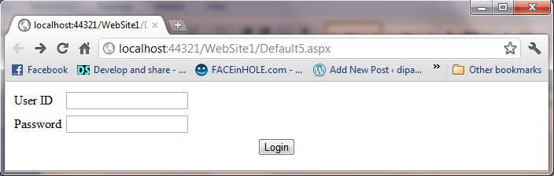

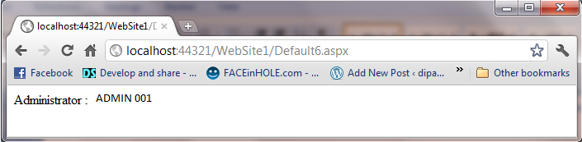

Create a web service in ASP.NET which run a specific application.
FirstService.asmx

<%@ WebService language="C#" class="FirstService" %>

using System;
using System.Web.Services;
using System.Xml.Serialization;

[WebService(Namespace="http://localhost/MyWebServices/")]
public class FirstService : WebService
{
[WebMethod]
public int Add(int a, int b)
{
return a + b;
}

[WebMethod]
public String SayHello()
{
return "Hello World";
}
}

WebApp.aspx

<%@ Page Language="C#" %>
<script runat="server">
void runSrvice_Click(Object sender, EventArgs e)
{
FirstService mySvc = new FirstService();
Label1.Text = mySvc.SayHello();
Label2.Text = mySvc.Add(Int32.Parse(txtNum1.Text), Int32.Parse(txtNum2.Text)).ToString();
}
</script>
<html>
<head>
</head>
<body>
<form runat="server">
<p>
<em>First Number to Add </em>:
<asp:TextBox id="txtNum1" runat="server" Width="43px">4</asp:TextBox>
</p>
<p>
<em>Second Number To Add </em>:
<asp:TextBox id="txtNum2" runat="server" Width="44px">5</asp:TextBox>
</p>
<p>
<strong><u>Web Service Result -</u></strong>
</p>
<p>
<em>Hello world Service</em> :
<asp:Label id="Label1" runat="server" Font-Underline="True">Label</asp:Label>
</p>
<p>
<em>Add Service</em> :
&nbsp;<asp:Label id="Label2" runat="server" Font-Underline="True">Label</asp:Label>
</p>
<p align="left">
<asp:Button id="runSrvice" onclick="runSrvice_Click" runat="server" Text="Execute"></asp:Button>
</p>
</form>
</body>
</html>

OUTPUT
