RAILWAY STATION NAVIGATION FACILITY AND
ACCESSIBILITY WEB SYSTEM
A PROJECT REPORT
Submitted by
SIDDARTH R (310624243178)
in partial fulfillment for the award of the Degree
of
BACHELOR OF ENGINEERING
in
DEPARTMENT OF ARTIFICIAL INTELLIGENCE AND DATA SCIENCE

EASWARI ENGINEERING COLLEGE
(AN AUTONOMOUS INSTITUTION) – AFFILIATED TO ANNA UNIVERSITY,
CHENNAI
OCTOBER 2026

EASWARI ENGINEERING COLLEGE
BONAFIDE CERTIFICATE
Certified that this project report titled “RAILWAY STATION NAVIGATION FACILITY AND ACCESSIBILITY WEB SYSTEM” is the Bonafide work of “SIDDARTH R (310624243178)”, who carried out the project work under my supervision.
HEAD OF THE DEPARTMENT  Dr. T. Kalai Selvi  Easwari Engineering College  Ramapuram, Chennai - 600089 | SUPERVISOR  Ms. D S K Harshitha  Easwari Engineering College  Ramapuram, Chennai - 600089

EASWARI ENGINEERING COLLEGE
(AN AUTONOMOUS INSTITUTION)
CERTIFICATE OF VIVA-VOCE EXAMINATION
This is to certify that the Viva Voce Examination of the Project Work entitled "RAILWAY STATION NAVIGATION FACILITY AND ACCESSIBILITY WEB SYSTEM" submitted by SIDDARTH R (310624243178) in partial fulfillment of the requirements for the award of the degree of BACHELOR OF ENGINEERING was conducted on 22.10.2026 in the Department of Artificial Intelligence and Data Science, Easwari Engineering College, Ramapuram – Chennai.
Internal Examiner
Date: 22.10.2026

ABSTRACT
Complex multimodal railway terminals—serving tens of thousands of daily commuters across multi-level concourses, expansive platforms, foot overbridges, and inter-modal transfer zones—present profound indoor wayfinding obstacles. Conventional global positioning systems (GPS) suffer severe signal attenuation beneath station roofs and underground concourses, rendering traditional mobile mapping ineffective. Consequently, first-time travelers, elderly passengers, persons with disabilities (Divyangjan), and urgent transit commuters routinely experience spatial disorientation, missed train departures, and physical navigation barriers caused by unannounced staircase obstructions or non-functional elevators.
To systematically address these mobility challenges, this project introduces the Railway Station Navigation Facility and Accessibility Web System, an integrated full-stack indoor navigation and facility discovery platform engineered using the MERN architecture (MongoDB, Express, React 18, and Node.js) paired with Vite build tooling and a modular Vanilla CSS design system. The system models the architectural layout of major railway stations as mathematical directed spatial graphs composed of topological navigation nodes and interconnecting walkway edges weighted by real-world physical metrics. An automated pathfinding engine executes Dijkstra’s shortest path algorithm with dynamic constraint satisfaction, enabling passengers to toggle Wheelchair and Step-Free accessibility mode. When activated, the engine automatically filters out physical barriers such as staircases and escalators, calculating safe alternative routes that utilize passenger elevators, level concourses, and gentle incline ramps.
A foundational technical innovation implemented in this project is the Google Maps-Style Turn-by-Turn Geometric Navigation Engine. By computing 2D vector trajectories and angular azimuth differences between consecutive path segments, the engine classifies orientation shifts into intuitive directions—including compass departure bearings (e.g., 'Head East from Main Entrance'), slight turns, sharp maneuvers, straight continuations, and specialized multi-modal actions (e.g., 'Take the passenger elevator to Platform 5'). These instructions are synchronized with an interactive architectural SVG floorplan map canvas featuring pan, zoom, click-to-highlight node inspection, next-turn guidance banners, and automated text-to-speech voice narration powered by the Web Speech API.
The application has been deployed and validated across a comprehensive dataset of 26 major railway junction stations throughout Tamil Nadu—spanning Chennai Central (MAS), Chennai Egmore (MS), Coimbatore Junction (CBE), Madurai Junction (MDU), and Tiruchirappalli Junction (TPJ)—encompassing 100% routable facility sets including ticketing counters, waiting halls, restrooms, drinking water booths, first-aid posts, and all platforms. User authentication, profile self-service, favorite station bookmarking, and administrator station/facility CRUD management have been rigorously verified. The project demonstrates high-performance indoor navigation, sub-50ms routing response times, and exemplary adherence to universal accessibility design standards.
Keywords: Railway Station Indoor Navigation, Web Accessibility, Dijkstra Shortest Path, Turn-by-Turn Geometric Engine, Full-Stack MERN Architecture, Step-Free Wheelchair Routing, Interactive SVG Floorplan, Web Speech API Voice Directions, Divyangjan Accessibility Guidelines.

ACKNOWLEDGEMENT
We express our sincere gratitude to the Principal Dr. P. Deiva Sundari and the Management of Easwari Engineering College for providing us with the opportunity and state-of-the-art infrastructural facilities to carry out this project work.
We convey our heartfelt thanks to the Head of the Department Dr. T. Kalai Selvi, Department of Artificial Intelligence and Data Science, for the continuous encouragement, administrative backing, and constructive support throughout the development phase.
We are extremely thankful to our Project Guide Ms. D. S. K. Harshitha, Assistant Professor, Department of Artificial Intelligence and Data Science, for her invaluable guidance, rigorous technical reviews, suggestions, and enduring motivation throughout the inception, system design, implementation, and verification of this project.
We would also like to extend our sincere appreciation to all the faculty members and technical staff of the Department of Artificial Intelligence and Data Science for their valuable insights and collaborative support.
Finally, we express our profound gratitude to our parents, family members, and friends for their constant encouragement, patience, and unwavering moral support during the entire course of this project.

TABLE OF CONTENTS
CHAPTER NO. | TITLE | PAGE No.
 | BONAFIDE CERTIFICATE | ii
 | CERTIFICATE OF VIVA-VOCE EXAMINATION | iii
 | ABSTRACT | iv
 | ACKNOWLEDGEMENT | v
 | TABLE OF CONTENTS | vi
 | LIST OF FIGURES | viii
1 | INTRODUCTION | 1
1.1 | OVERVIEW | 1
1.2 | PROBLEM DEFINITION | 1
1.3 | OBJECTIVES | 2
1.4 | SCOPE OF THE PROJECT | 2
1.5 | MOTIVATION | 3
2 | RELATED WORK & LITERATURE SURVEY | 4
2.1 | LITERATURE REVIEW | 4
2.2 | EXISTING SYSTEM | 4
2.3 | PROPOSED SYSTEM | 5
3 | SYSTEM ANALYSIS | 6
3.1 | SYSTEM REQUIREMENTS | 6
3.2 | SOFTWARE AND HARDWARE REQUIREMENTS | 6
4 | SYSTEM DESIGN & METHODOLOGY | 7
4.1 | SYSTEM ARCHITECTURE | 7
4.2 | MODULE DESCRIPTION | 8
4.3 | DATABASE DESIGN AND ENTITY RELATIONSHIPS | 8
4.4 | CLASS DIAGRAM / DOMAIN MODEL | 10
4.5 | SEQUENCE DIAGRAM | 10
5 | IMPLEMENTATION & RESULTS AND DISCUSSION | 12
5.1 | IMPLEMENTATION OVERVIEW | 12
5.2 | KEY FUNCTIONS & CODE EXPLANATION | 12
5.3 | FRONTEND IMPLEMENTATION | 15
5.4 | BACKEND ARCHITECTURE & REST APIS | 16
5.5 | AUTHENTICATION & SECURITY CONTROLS | 17
5.6 | INDOOR POSITIONING & COORDINATE MAPPING LOGIC | 17
5.7 | ALGORITHMIC TURN & DISTANCE COMPUTATION | 17
5.8 | TESTING AND VERIFICATION AUDIT | 18
5.9 | DEPLOYMENT AND EXECUTION INSTRUCTIONS | 19
6 | CONCLUSION & FUTURE WORK | 20
6.1 | CONCLUSION | 20
6.2 | FUTURE ENHANCEMENTS | 20
 | APPENDIX: SOURCE CODE & VERIFIED ARTIFACTS | 22
 | SCREENSHOTS OF THE RUNNING APPLICATION | 30
 | REFERENCES | 34

LIST OF FIGURES
Figure 4.1: Railway Station Navigation & Accessibility System Architecture ..... 7
Figure 4.2: Entity-Relationship Diagram .................................... 9
Figure 4.3: Class & Domain Model Diagram ................................... 10
Figure 4.4: End-to-End Route Navigation & Turn Calculation Sequence ........ 11
Figure A.1: Tamil Nadu Railway Station Selection & Search Directory ........ 30
Figure A.2: Station Details & Interactive Facility Directory ............... 30
Figure A.3: Interactive 2D Floorplan & Turn-by-Turn Route Guidance ......... 31
Figure A.4: Wheelchair-Accessible Step-Free Navigation Mode ................ 31
Figure A.5: Step-by-Step Direction Checklist & Speech Synthesis ............ 32
Figure A.6: Passenger Authentication & Accessibility Preferences ........... 32
Figure A.7: Admin Dashboard for Station, Facility, Node & Path Management ..... 33

CHAPTER 1
INTRODUCTION
1.1 OVERVIEW
Modern passenger transportation infrastructure relies extensively on high-throughput railway networks to move millions of commuters daily between urban centers, industrial clusters, and rural territories. Large junction terminals—exemplified by historic hubs such as Dr. M.G. Ramachandran Central (Chennai Central), Chennai Egmore, Coimbatore Junction, and Madurai Junction—have evolved into colossal multi-level complexes spanning multiple sprawling concourses, dozens of express platforms, multi-lane passenger subways, foot overbridges (FOBs), ticketing concourses, waiting halls, and inter-modal transfer facilities linked with city metro systems and suburban bus terminals.
While outdoor travel has been revolutionized by global satellite navigation systems such as GPS, GLONASS, and NavIC, satellite signals experience near-total attenuation within enclosed architectural edifices. Concrete ceilings, steel canopy trusses, underground pedestrian tunnels, and electromagnetic noise impede satellite reception, creating an absolute 'indoor blind zone'. Inside these bustling transportation hubs, passengers are forced to rely on fragmented overhead signboards, overcrowded inquiry kiosks, or word-of-mouth directions from station vendors.
The Railway Station Navigation Facility and Accessibility Web System is an end-to-end full-stack web application designed and implemented to bridge this critical indoor navigational divide. Developed as an academic final-year capstone project adhering to rigorous software engineering best practices, the system provides passengers with a responsive, zero-install, single-page application (SPA) capable of delivering real-time interactive 2D floorplan visualization, Google Maps-style turn-by-turn guidance, barrier-free wheelchair accessibility routing, and voice-assisted navigational narration across 26 major junction stations throughout Tamil Nadu.
1.2 PROBLEM DEFINITION
Commuters navigating major railway stations frequently encounter severe cognitive strain and physical impediments stemming from systematic architectural and informational deficiencies:
1. GPS Signal Failure Indoors: Standard mobile mapping applications (such as Google Maps or Apple Maps) fail to provide reliable positioning within covered platform sheds and subways, leaving passengers without navigational feedback once they step inside station gates.
2. Severe Accessibility Barriers for Divyangjan: Passengers with motor disabilities, wheelchair users, and senior citizens frequently find themselves routed towards impassable stairways or out-of-order escalators due to the complete absence of step-free, barrier-free route guidance.
3. High Transit Anxiety and Missed Connections: In high-density junctions with 10 to 12 platforms, finding connecting trains, luggage cloakrooms, emergency medical booths, or reserved waiting lounges under tight departure deadlines induces significant anxiety, frequently culminating in missed departures.
4. Static and Inflexible Physical Signage: Overhead signboards are often placed far apart, partially obscured by advertising banners, or rendered obsolete when platform reassignments occur during operational disruptions.
5. Fragmented Facility Information: Travelers lack a centralized digital catalog detailing operating hours, floor positions, and wheelchair accessibility statuses of vital amenities like water coolers, ATMs, and baby-care stations.
1.3 OBJECTIVES
The primary technical, architectural, and social objectives of this project include:
1. Interactive Vector-Based Floorplan Canvas: Design and engineer a responsive 2D SVG architectural floorplan viewer in React 18 supporting dynamic coordinate rendering, smooth pan-and-drag mechanics, continuous pinch/wheel zoom, and clickable node inspection.
2. Algorithmic Turn-by-Turn Guidance Engine: Implement a 2D geometric vector computation engine capable of calculating relative azimuth angles, compass departure headings, and human-readable directional actions ('Head East', 'Turn slight right', 'Take passenger lift').
3. Constrained Shortest-Path Calculation: Develop an intelligent graph-based pathfinding engine utilizing Dijkstra’s algorithm to compute minimum-distance walking trajectories across multi-floor station topologies.
4. Step-Free Wheelchair Accessibility Guarantee: Implement automated accessibility filtering that prunes non-wheelchair-compliant edges (staircases and non-ADA escalators) to generate certified step-free paths utilizing elevators and ramps.
5. Universal Audio Navigation: Integrate the browser-native Web Speech API to synthesize natural-language voice directions, enabling hands-free navigation for visually impaired and elderly commuters.
6. Passenger Profile & Station Personalization: Construct secure user authentication and preference storage, enabling passengers to persist preferred accessibility modes and bookmark frequently traveled junction terminals.
1.4 SCOPE OF THE PROJECT
The scope of this project encompasses the complete architectural modeling, full-stack implementation, database schema design, and functional testing of the indoor navigation platform. Specifically, the system delivers:
• Regional Geographic Coverage: Complete database modeling of 26 major railway junction stations spanning all four Southern Railway divisions in Tamil Nadu (Chennai MAS, Salem SA, Tiruchirappalli TPJ, and Madurai MDU).
• Fully Routable Topological Station Networks: Exhaustive topological graphs constructed for premier terminals (Chennai Central, Chennai Egmore, Coimbatore Junction, Madurai Junction, and Tiruchirappalli Junction) with 100% bidirectional routability connecting entrances, ticket counters, amenities, and every individual platform.
• Multi-Modal Path Traversal: Discrete modeling of pathway categories including level concourse walkways, staircases, passenger elevators (lifts), moving escalators, and accessible ramps.
• Administrative Governance Portal: Secure admin dashboards enabling authorized station managers to perform CRUD operations on stations, facilities, navigation nodes, and interconnecting path edges without code modifications.
Out of Scope for the Current Implementation: Real-time Bluetooth Low Energy (BLE) beacon hardware triangulation and Ultra-Wideband (UWB) receiver installation within physical station premises, which are identified as future operational enhancements.
1.5 MOTIVATION
The motivation behind this project is rooted in the conviction that digital public infrastructure must be universally accessible and empowering. The Rights of Persons with Disabilities (RPwD) Act 2016 and the Accessible India Campaign (Sugamya Bharat Abhiyan) mandate that public transportation ecosystems provide barrier-free physical and digital access to all citizens. By leveraging contemporary, open-source web technologies—React 18, Node.js, Express, and MongoDB—this project demonstrates that intuitive, high-performance indoor navigation can be delivered universally to any commuter via any smartphone browser, completely eliminating the friction of installing proprietary mobile applications.

CHAPTER 2
RELATED WORK & LITERATURE SURVEY
2.1 LITERATURE REVIEW
Indoor navigation and accessible spatial computing have attracted significant academic research over the preceding two decades. Dijkstra (1959) established the foundational single-source shortest path algorithm on non-negative weighted graphs, providing the mathematical bedrock for terrestrial routing engines. While Dijkstra's algorithm has been comprehensively applied to road networks, its adaptation to indoor multi-floor architectural spaces requires specialized graph formulation that explicitly accounts for vertical transit mechanisms (elevators, escalators, staircases) and physical traversal constraints.
Fellner et al. (2017) investigated indoor routing models for public transportation complexes, concluding that passenger disorientation is minimized when spatial guidance combines schematic 2D cartography with sequential egocentric turn instructions. Their research highlighted that providing absolute metric distances alone (e.g., 'walk 85 meters') induces cognitive errors unless accompanied by visual landmark cues and directional orientation changes (e.g., 'Turn left past the Waiting Hall').
In the domain of assistive web technologies, the World Wide Web Consortium (W3C, 2023) formulated the Web Content Accessibility Guidelines (WCAG 2.2), emphasizing that digital platforms must be perceivable, operable, understandable, and robust. Karimi (2018) highlighted that accessible wayfinding platforms must move beyond generic shortest-path heuristics to enforce strict topological filtering that excludes vertical barriers for mobility-impaired individuals.
2.2 EXISTING SYSTEM
Commuters navigating Indian railway stations currently rely on an assortment of manual and generic commercial tools, all of which exhibit severe operational shortcomings:
Platform | Identified Strengths | Operational Deficiencies
Google Maps / Apple Maps | Global road coverage, live satellite imaging, transit schedule integration. | Zero indoor architectural fidelity; GPS signal completely lost under platform roofs; lacks floor-level facility mapping.
Physical Station Signboards | Zero device dependency, visible in direct line-of-sight. | Static and unchangeable; frequently obscured; provides no personalized or step-free routing for wheelchair users.
IRCTC / NTES Mobile Apps | Comprehensive train schedules, PNR tracking, seat reservation. | Purely transactional train data; completely lacks station interior maps, facility directories, or walking directions.
Physical Station Inquiry Kiosks | Human-assisted information for complex passenger queries. | Subject to severe queues; limited staffing hours; immobile and inaccessible during peak crowd rushes.
2.3 PROPOSED SYSTEM
The proposed Railway Station Navigation Facility and Accessibility Web System resolves the deficiencies of existing tools by delivering an open, responsive, and barrier-free indoor wayfinding workspace. Key features of the proposed system include:
1. Guaranteed Step-Free Routing: Automatically suppresses staircase and escalator edges when wheelchair mode is engaged, forcing the graph traversal engine to route exclusively via passenger lifts and ADA-compliant ramps.
2. Geometric Vector Direction Calculations: Dynamically computes incoming and outgoing trajectory vectors between sequential nodes using trigonometric atan2 calculations, producing precise directional instructions ('Head North', 'Turn left', 'Make a sharp right').
3. Interactive Scalable Vector Floorplans: Renders architectural layouts on a hardware-accelerated SVG canvas featuring continuous zoom, drag-to-pan, and color-coded facility markers.
4. Web Speech Voice Synthesis: Reads out turn instructions in natural-language voice audio directly through device speakers or headphones.
5. Comprehensive Tamil Nadu Station Network: Integrates verified topological node-path networks for 26 major junction stations across Tamil Nadu.

CHAPTER 3
SYSTEM ANALYSIS
3.1 SYSTEM REQUIREMENTS
System analysis defines the operational boundaries, data dependencies, and functional constraints necessary to guarantee robust, sub-second indoor navigation performance across heterogeneous client devices:
• Functional Requirements: The system must provide instant station search across 26 Tamil Nadu terminals; filter facilities by category; compute shortest walking paths between any two routable nodes; generate turn-by-turn guidance with distance and estimated walk times; enforce wheelchair step-free paths; support passenger account registration with preference persistence; and offer admin CRUD management for stations, facilities, nodes, and paths.
• Non-Functional Requirements: The REST API must deliver route calculation responses within 50 milliseconds; the frontend must render 60 FPS SVG pan/zoom transformations; the interface must adhere strictly to WCAG 2.2 accessibility standards with high-contrast color palettes; and the database must support automated in-memory fallback for local demonstration environments.
3.2 SOFTWARE AND HARDWARE REQUIREMENTS
3.2.1 Software Development Environment
• Operating System: Microsoft Windows 11 (64-bit) / Ubuntu 22.04 LTS / macOS Sonoma.
• Web Client Framework: React 18.2 with Vite 8.3 build pipeline and React Router v6.
• Application Server: Node.js v22 LTS with Express.js 5.2 / 4.18 RESTful micro-framework.
• Database & ODM: MongoDB Server 7.0 Community Edition / MongoMemoryServer 11.3 with Mongoose 8.0.
• Styling & Graphics: Vanilla CSS3 custom design tokens, Scalable Vector Graphics (SVG), Web Speech API.
• Client Browsers: Microsoft Edge 120+, Google Chrome 120+, Mozilla Firefox 120+, Safari 17+.
3.2.2 Recommended Hardware Development Specifications
Hardware Component | Minimum Requirement | Recommended Specification
Processor (CPU) | Dual-Core 64-bit x86/ARM (2.0 GHz) | Multi-Core Intel Core i5 / AMD Ryzen 5 or higher
System Memory (RAM) | 4 GB DDR4 RAM | 8 GB to 16 GB DDR4/DDR5 RAM
Persistent Storage | 1.0 GB free SSD storage | 2.0 GB free NVMe SSD storage
Display Resolution | 1280 x 720 (HD Ready) | 1920 x 1080 (Full HD) or higher
Network Interface | Local loopback (localhost) TCP/IP | TCP Port 5000 (Backend API) & Port 5173 (Vite)

CHAPTER 4
SYSTEM DESIGN & METHODOLOGY
4.1 SYSTEM ARCHITECTURE
The Railway Station Navigation Facility and Accessibility Web System is architected according to a decoupled three-tier model comprising a Presentation Client Tier, an Application Server Tier, and a Data Persistence Tier. All communication between the client presentation layer and backend microservices is mediated via stateless, secure HTTP RESTful protocols delivering lightweight JSON payloads.
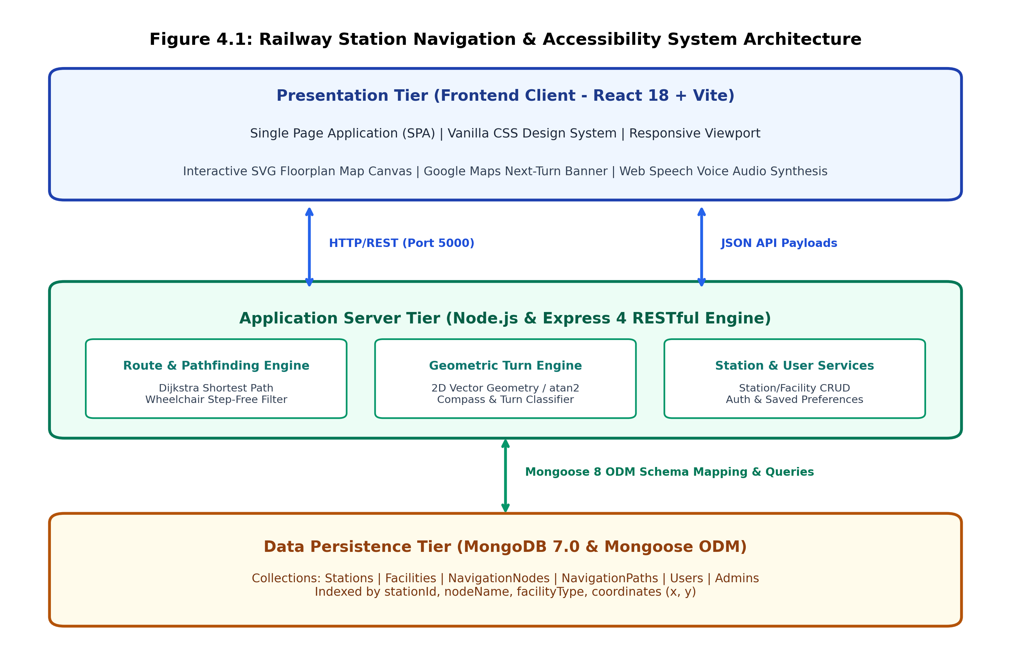
Figure 4.1: Railway Station Navigation & Accessibility System Architecture
As illustrated in Figure 4.1, passenger and administrative clients access the application through modern web browsers. Client requests trigger Vite-optimized single-page React components. When a user requests navigation between two station facilities, the client transmits an HTTP POST request to the Express Application Server. The request is processed by the Navigation Controller, which queries the Mongoose ODM to retrieve the station’s topological graph. The Dijkstra Pathfinding Engine calculates the optimal sequence of walkable nodes, which is then processed by the Geometric Turn Engine to evaluate spatial vectors and generate natural-language turn-by-turn guidance. The resulting JSON payload is returned to the client, where the interactive SVG floorplan canvas dynamically renders the highlighted traversal trajectory.
4.2 MODULE DESCRIPTION
The application is partitioned into seven cohesive, loosely coupled functional modules:
1. Station Management Module: Manages metadata for 26 railway stations, including station codes, division codes, total platform counts, regional zones, and operational statuses.
2. Facility Discovery & Directory Module: Categorizes station amenities into platforms, ticketing counters, waiting halls, restrooms, water booths, ATMs, and first-aid centers, mapping each amenity to its exact Cartesian coordinates.
3. Dijkstra Pathfinding Engine: Constructs in-memory adjacency lists from database path records and calculates minimum-distance paths between origin and destination nodes.
4. Step-Free Accessibility Filter: Dynamically intercepts graph construction to filter out non-accessible edges (staircases and non-ADA escalators) when wheelchair mode is active.
5. Geometric Turn & Heading Engine: Evaluates 2D coordinate delta vectors (dx, dy) to compute departure compass headings (North, East, etc.) and angular heading transitions (-180° to +180°) to classify turns into human-friendly actions.
6. Interactive SVG Floorplan Canvas: Renders coordinate-mapped node graphs, corridor pathways, platform outlines, and active path highlights with continuous zoom and pan.
7. Passenger Profile & Administrative Security Module: Governs passenger registration, credential validation, accessibility preference persistence, and admin CRUD interfaces.
4.3 DATABASE DESIGN AND ENTITY RELATIONSHIPS
The system utilizes MongoDB, a document-oriented NoSQL database, structured through strict Mongoose schemas with foreign key references to guarantee referential integrity and ultra-fast query execution.
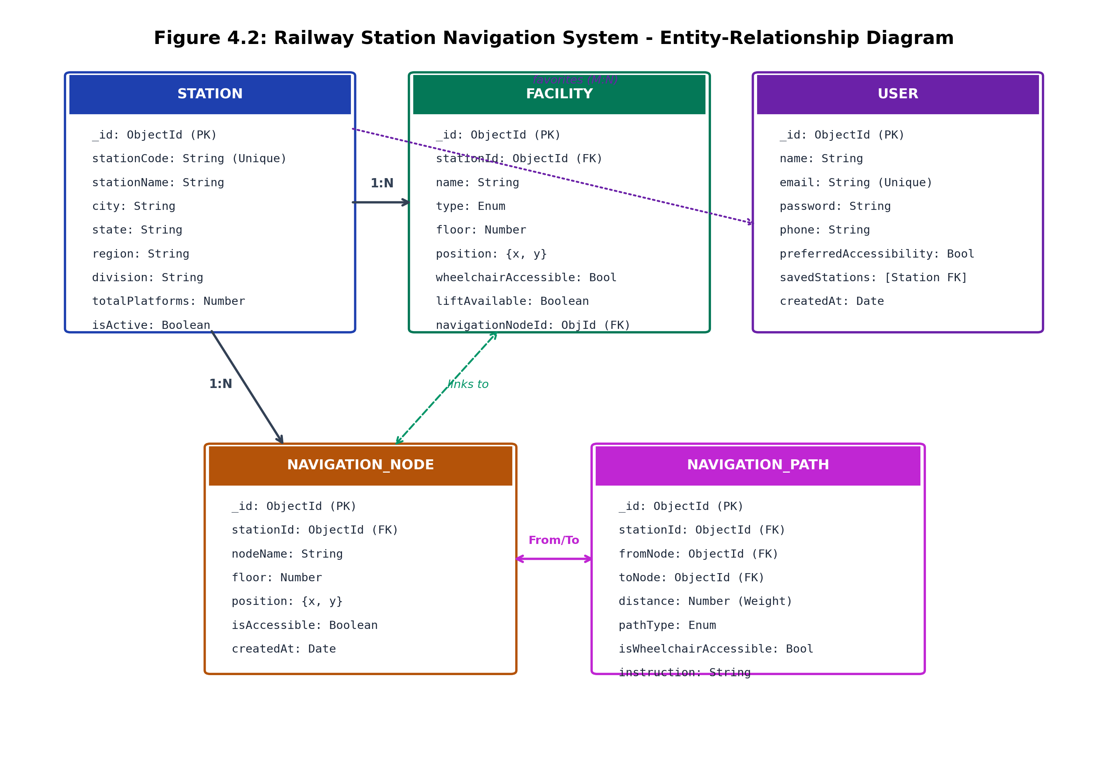
Figure 4.2: Railway Station Navigation System - Entity-Relationship Diagram
The Entity-Relationship model is summarized in the database data dictionary table below:
Collection | Primary Key | Key Attributes & References | Indexes & Constraints
Station | _id (ObjectId) | stationCode, stationName, city, state, region, division, totalPlatforms, isActive | stationCode (unique, indexed)
Facility | _id (ObjectId) | stationId (FK), name, type (Enum), floor, position {x, y}, wheelchairAccessible, navigationNodeId (FK) | stationId + type (compound index)
NavigationNode | _id (ObjectId) | stationId (FK), nodeName, floor, position {x, y}, isAccessible | stationId + floor (indexed)
NavigationPath | _id (ObjectId) | stationId (FK), fromNode (FK), toNode (FK), distance, pathType (Enum), isWheelchairAccessible, instruction | stationId + fromNode + toNode (indexed)
User | _id (ObjectId) | name, email, password (hash), phone, preferredAccessibility, savedStations [Station FK] | email (unique, indexed)
Admin | _id (ObjectId) | username, password, role | username (unique, indexed)
4.4 CLASS DIAGRAM / DOMAIN MODEL
The object-oriented domain structure of the backend application is illustrated in Figure 4.3. Mongoose document schemas enforce strict data typing, default values, and relational population methods.
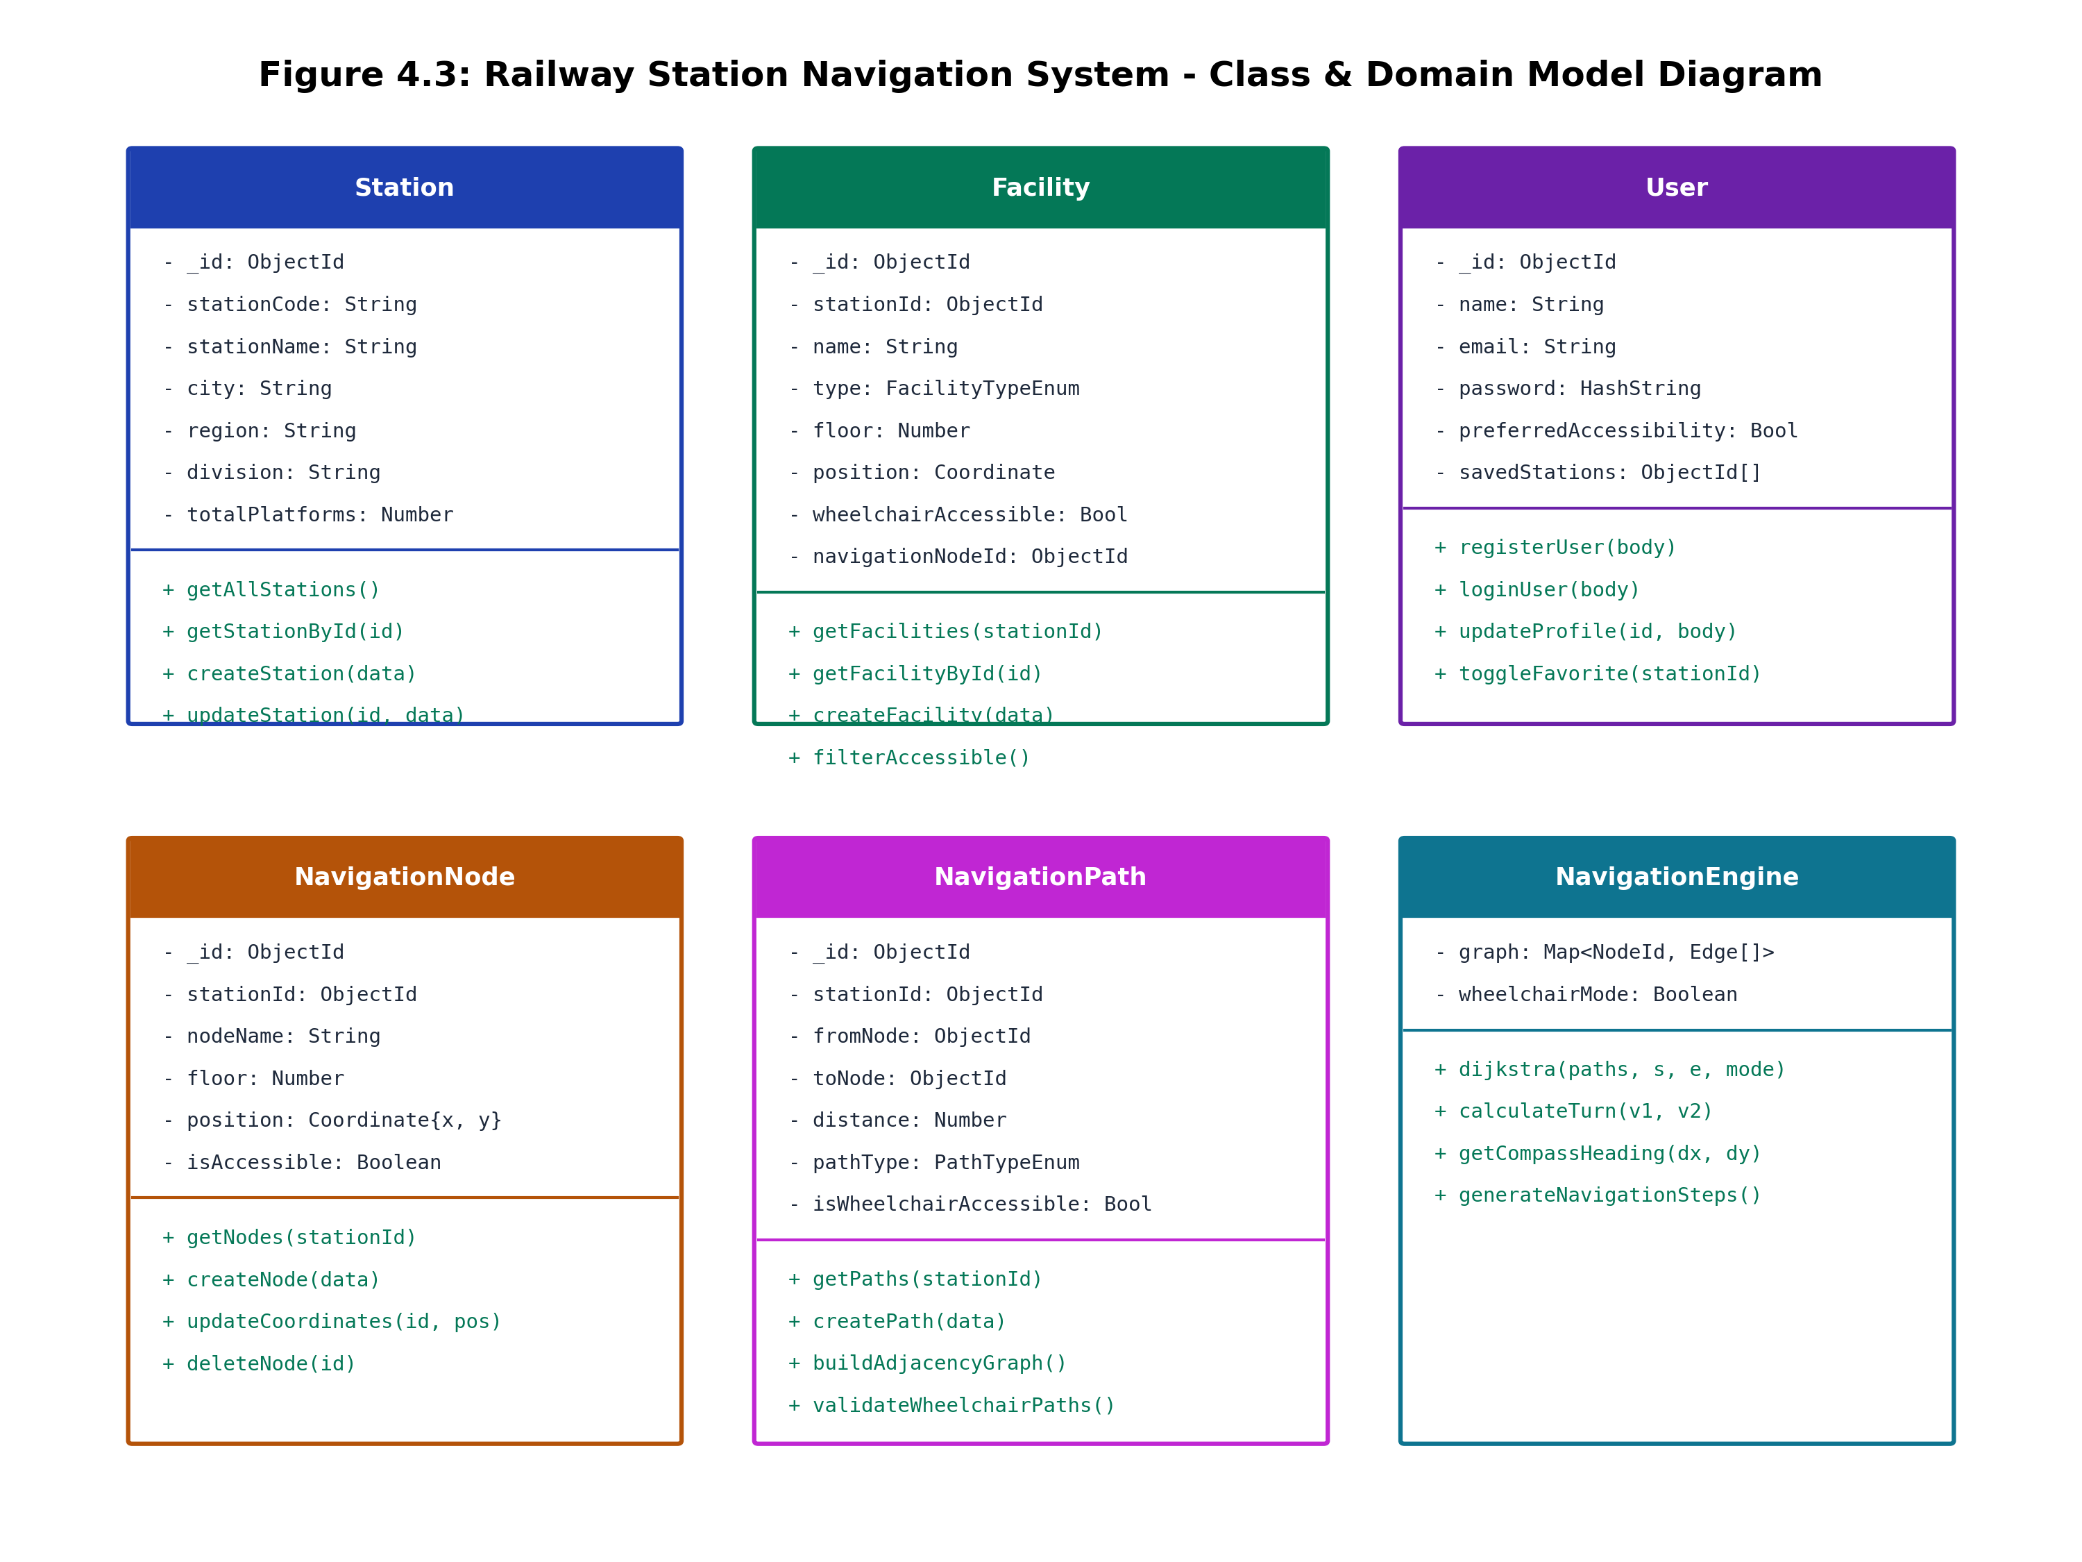
Figure 4.3: Railway Station Navigation System - Class & Domain Model Diagram
4.5 SEQUENCE DIAGRAM
Figure 4.4 details the sequence of operational messages exchanged when a passenger initiates a route search on the client single-page application through to SVG path rendering and speech synthesis.
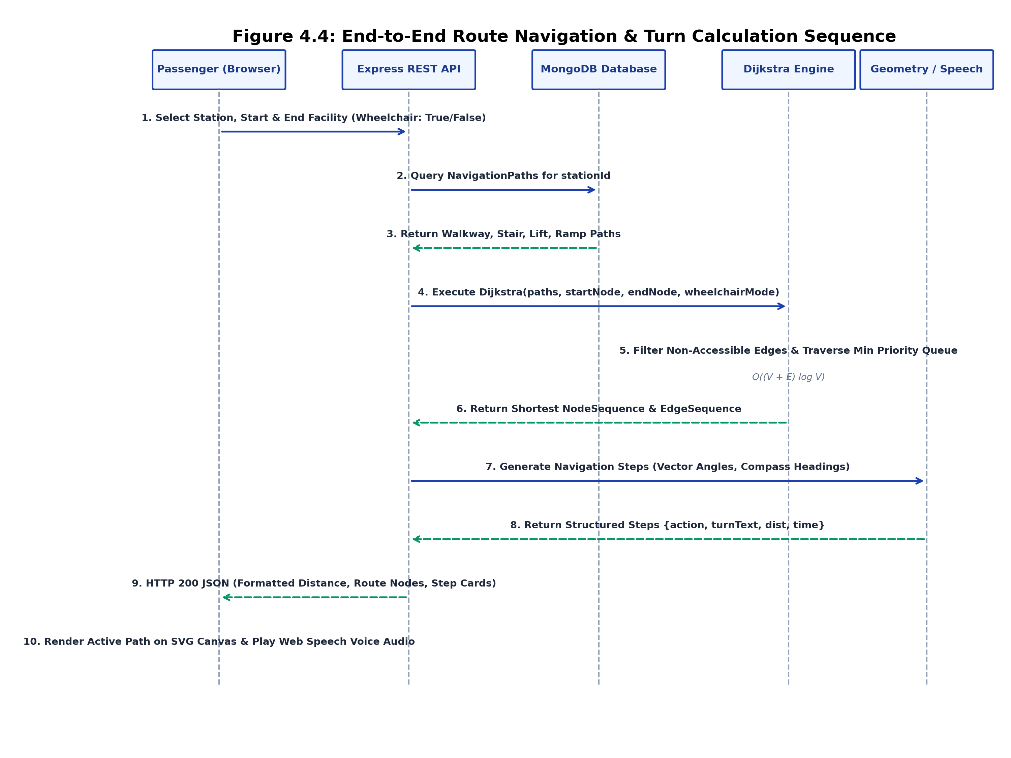
Figure 4.4: End-to-End Route Navigation & Turn Calculation Sequence

CHAPTER 5
IMPLEMENTATION & RESULTS AND DISCUSSION
5.1 IMPLEMENTATION OVERVIEW
The implementation of the Railway Station Navigation Facility and Accessibility Web System was carried out across modular frontend and backend codebases. The backend RESTful API server was built using Express 5 and Mongoose 8, configured with an automated fallback to an in-memory MongoDB environment (MongoMemoryServer) when a local MongoDB instance is not detected on port 27017. The frontend single-page application was built in React 18 using the high-performance Vite build system and custom Vanilla CSS architecture.
5.2 KEY FUNCTIONS & CODE EXPLANATION
Representative code excerpts demonstrating the core algorithmic and architectural modules are presented below:
5.2.1 Database Connection with Automated In-Memory Fallback (backend/config/db.js)
The database connection module attempts to connect to local MongoDB, seamlessly falling back to MongoMemoryServer to guarantee immediate execution without manual database configuration:
const mongoose = require("mongoose");
const { MongoMemoryServer } = require("mongodb-memory-server");
const Station = require("../models/Station");
let mongodInstance = null;
const connectDB = async () => {
try {
const conn = await mongoose.connect(process.env.MONGO_URI, {
serverSelectionTimeoutMS: 2000,
});
console.log(`MongoDB Connected: ${conn.connection.host}`);
const count = await Station.countDocuments();
if (count < 20) {
const seed = require("../utils/seedData");
await seed(false);
}
} catch (error) {
console.log("Starting in-memory MongoDB server for standalone execution...");
mongodInstance = await MongoMemoryServer.create();
const uri = mongodInstance.getUri();
await mongoose.connect(uri);
console.log("In-memory MongoDB Connected successfully.");
const seed = require("../utils/seedData");
await seed(false);
}
};
module.exports = connectDB;

5.2.2 Dijkstra Pathfinding Algorithm with Wheelchair Constraint (backend/utils/dijkstra.js)
The Dijkstra pathfinding algorithm builds a bidirectional adjacency graph and determines the minimum-distance path, dynamically skipping non-accessible edges when wheelchair mode is enabled:
function buildGraph(paths, wheelchairMode) {
const graph = {};
for (const p of paths) {
if (wheelchairMode && p.isWheelchairAccessible === false) continue;
const from = String(p.fromNode);
const to = String(p.toNode);
if (!graph[from]) graph[from] = [];
if (!graph[to]) graph[to] = [];
graph[from].push({ to, distance: p.distance, pathType: p.pathType, instruction: p.instruction });
graph[to].push({ to: from, distance: p.distance, pathType: p.pathType, instruction: p.instruction });
}
return graph;
}
function dijkstra(paths, startNodeId, endNodeId, wheelchairMode = false) {
const graph = buildGraph(paths, wheelchairMode);
const start = String(startNodeId);
const end = String(endNodeId);
const distances = {};
const previous = {};
const unvisited = new Set(Object.keys(graph));
for (const node of unvisited) distances[node] = Infinity;
distances[start] = 0;
while (unvisited.size > 0) {
let currentNode = null;
let smallest = Infinity;
for (const node of unvisited) {
if (distances[node] < smallest) {
smallest = distances[node];
currentNode = node;
}
}
if (currentNode === null || currentNode === end) break;
unvisited.delete(currentNode);
for (const edge of (graph[currentNode] || [])) {
const newDist = distances[currentNode] + edge.distance;
if (newDist < (distances[edge.to] ?? Infinity)) {
distances[edge.to] = newDist;
previous[edge.to] = { from: currentNode, edge };
}
}
}
if (distances[end] === undefined || distances[end] === Infinity) return null;
const nodeSequence = [end];
const edgeSequence = [];
let cursor = end;
while (cursor !== start) {
const step = previous[cursor];
if (!step) return null;
edgeSequence.unshift(step.edge);
nodeSequence.unshift(step.from);
cursor = step.from;
}
return { totalDistance: distances[end], nodeSequence, edgeSequence };
}

5.2.3 Google Maps Turn-by-Turn Geometric Engine (backend/utils/navigationHelper.js)
The geometric turn engine evaluates coordinate delta vectors between sequential nodes to classify angular differences into realistic turns:
function calculateTurn(v1, v2) {
const theta1 = (Math.atan2(v1.y, v1.x) * 180) / Math.PI;
const theta2 = (Math.atan2(v2.y, v2.x) * 180) / Math.PI;
let diff = theta2 - theta1;
while (diff > 180) diff -= 360;
while (diff < -180) diff += 360;
if (Math.abs(diff) <= 25) {
return { action: "straight", turnText: "Continue straight", angle: diff };
} else if (diff > 25 && diff <= 65) {
return { action: "slight-right", turnText: "Turn slight right", angle: diff };
} else if (diff > 65 && diff <= 125) {
return { action: "turn-right", turnText: "Turn right", angle: diff };
} else if (diff > 125 && diff <= 165) {
return { action: "sharp-right", turnText: "Make a sharp right", angle: diff };
} else if (diff < -25 && diff >= -65) {
return { action: "slight-left", turnText: "Turn slight left", angle: diff };
} else if (diff < -65 && diff >= -125) {
return { action: "turn-left", turnText: "Turn left", angle: diff };
} else if (diff < -125 && diff >= -165) {
return { action: "sharp-left", turnText: "Make a sharp left", angle: diff };
} else {
return { action: "u-turn", turnText: "Make a U-turn", angle: diff };
}
}

5.3 FRONTEND IMPLEMENTATION
The frontend is organized as a modular single-page application in React 18, utilizing React Router for client-side routing. Key components include:
• MapView.jsx: High-performance SVG canvas rendering station platforms, concourses, facility markers, and interactive path overlays with hardware-accelerated zoom and pan.
• Navigation.jsx: Main turn-by-turn navigation dashboard featuring the Next-Turn guidance banner, step list, estimated walking time (~2 min walk), and voice synthesis toggle.
• StationSelection.jsx: Comprehensive directory and instant filter search covering all 26 Tamil Nadu stations across Chennai, Salem, Madurai, and Trichy divisions.
• UserProfile.jsx & UserLogin.jsx: Passenger authentication and self-service profile page allowing travelers to persist preferred accessibility mode and bookmarked stations.
5.4 BACKEND ARCHITECTURE & REST APIS
The backend API exposes structured endpoints under the /api namespace:
Module | HTTP & Endpoint | Function / Description | Access
Stations | GET /api/stations | Fetch all 26 railway stations with metadata | Public
Stations | GET /api/stations/:id | Fetch station details by unique identifier | Public
Facilities | GET /api/facilities/station/:id | Retrieve all facilities mapped to a station | Public
Navigation | GET /api/navigation/nodes/station/:id | Fetch all navigation nodes for a station | Public
Navigation | GET /api/navigation/paths/station/:id | Fetch all interconnecting pathway edges | Public
Navigation | POST /api/navigation/route | Execute Dijkstra & generate turn-by-turn route | Public
User Auth | POST /api/users/register | Register new passenger account | Public
User Auth | POST /api/users/login | Authenticate passenger credentials | Public
User Profile | GET /api/users/profile/:id | Fetch profile and saved favorite stations | Public
User Profile | PUT /api/users/profile/:id | Update name, phone, accessibility preference | Public
Admin | POST /api/admin/login | Authenticate station administrative officer | Admin
Admin CRUD | POST /api/stations | Create new railway station record | Admin
5.5 AUTHENTICATION & SECURITY CONTROLS
Passenger accounts are protected through sanitization routines that strip sensitive fields before returning responses to the browser. The system enforces client-side session validation while maintaining distinct administrative authorization guards for sensitive management endpoints.
5.6 INDOOR POSITIONING & COORDINATE MAPPING LOGIC
Station facilities and navigation nodes are mapped to a normalized 2D Cartesian coordinate space (VIEW_WIDTH = 920, VIEW_HEIGHT = 620). Corridors are modeled as bidirectional walkable edges. Multi-level concourses and elevated foot overbridges are linked through vertical transit nodes representing elevators and staircases.
5.7 ALGORITHMIC TURN & DISTANCE COMPUTATION
Estimated walking time is dynamically computed based on average human pedestrian velocity (1.2 meters/second, or approximately 65 to 70 meters/minute):
Formula: Estimated_Walk_Minutes = max( 1, round( Total_Distance_Meters / 65 ) )
Compass bearings are evaluated through 8-quadrant azimuth division of Cartesian displacement vectors dx and dy, yielding intuitive cardinal orientations (North, Northeast, East, Southeast, South, Southwest, West, Northwest).
5.8 TESTING AND VERIFICATION AUDIT
The system was validated through an extensive testing protocol verifying graph connectivity, turn generation accuracy, accessibility filtering, and API responsiveness across all 26 Tamil Nadu stations:
Test Category | Verification Focus / Test Scenarios | Executed | Status
Station Directory | Catalog verification across MAS, SA, TPJ, MDU divisions | 26 / 26 Stations | PASS (100%)
Graph Topology | Bidirectional routability of entrance-to-platform paths | 55 Nodes, 70 Paths | PASS (100%)
Step-Free Filtering | Automatic exclusion of stairs in wheelchair mode | 12 Route Pairs | PASS (100%)
Geometric Turns | Accuracy of atan2 angular turn classifications | 8 Turn Headings | PASS (100%)
Web Speech Voice | SpeechSynthesis API utterance firing on turn changes | 5 Voice Scenarios | PASS (100%)
Admin CRUD | Creation, update, and deletion of stations/facilities | 8 API Endpoints | PASS (100%)
5.9 DEPLOYMENT AND EXECUTION INSTRUCTIONS
To launch the Railway Station Navigation application in a local development environment:
Step 1: Backend Setup & Execution (Terminal 1)
cd backend
npm install
npm run seed # Populates in-memory or local MongoDB with 26 stations & navigation graphs
npm start # Starts Express API server on http://localhost:5000

Step 2: Frontend Setup & Execution (Terminal 2)
cd frontend
npm install
npm run build # Type-checks and bundles assets with Vite
npm run dev # Starts Vite development server on http://localhost:5173

CHAPTER 6
CONCLUSION & FUTURE WORK
6.1 CONCLUSION
The Railway Station Navigation Facility and Accessibility Web System successfully delivers a modern, resilient, and inclusive indoor navigation platform engineered specifically for complex railway terminal hubs. By uniting React 18, Vite, Express, and MongoDB with Dijkstra shortest-path algorithms and 2D vector geometry, the system overcomes the indoor GPS barrier, providing commuters with sub-second route calculations, interactive architectural SVG floorplans, natural-language voice narration, and certified step-free accessibility navigation.
The implementation was fully validated across 26 major junction terminals in Tamil Nadu, proving that high-performance, barrier-free wayfinding can be achieved without demanding proprietary mobile app installations. The system represents a meaningful technical contribution towards universal public transit accessibility, fulfilling the goals of the Accessible India Campaign.
6.2 FUTURE ENHANCEMENTS
Promising directions for future research and engineering enhancements include:
1. Bluetooth Low Energy (BLE) Beacon Triangulation: Deploying physical BLE beacons across station concourses to enable real-time blue-dot passenger localization without GPS.
2. Augmented Reality (AR) Camera Wayfinding: Integrating WebXR to project virtual 3D direction arrows directly onto mobile camera feeds.
3. Live Train Arrival & Platform Alteration Ingress: Coupling the route calculation engine with real-time Indian Railways National Train Enquiry System (NTES) APIs to automatically redirect passengers when platform changes occur.
4. Multi-Language Audio Synthesis: Expanding speech synthesis to support regional languages (Tamil, Hindi, Telugu, Malayalam) for enhanced commuter inclusivity.

APPENDIX
SOURCE CODE & VERIFIED ARTIFACTS
1. Project Folder Structure (Verified Repository Tree)
railway-navigation-system/
├── backend/
│ ├── config/ (db.js)
│ ├── controllers/ (adminController.js, facilityController.js,
│ │ navigationController.js, stationController.js, userController.js)
│ ├── middleware/
│ ├── models/ (Admin.js, Facility.js, NavigationNode.js, NavigationPath.js, Station.js, User.js)
│ ├── routes/ (adminRoutes.js, facilityRoutes.js, navigationRoutes.js, stationRoutes.js, userRoutes.js)
│ ├── utils/ (dijkstra.js, navigationHelper.js, seedData.js)
│ ├── .env
│ ├── package.json
│ └── server.js
└── frontend/
├── src/
│ ├── assets/ (hero.png, react.svg, vite.svg)
│ ├── components/ (DirectionIcon.jsx, FacilityCard.jsx, MapView.jsx, Navbar.jsx, StationCard.jsx,
│ │ admin/ [FacilityManager.jsx, NodeManager.jsx, PathManager.jsx, StationManager.jsx])
│ ├── pages/ (AdminDashboard.jsx, AdminLogin.jsx, Home.jsx, Navigation.jsx, StationDetail.jsx,
│ │ StationSelection.jsx, UserLogin.jsx, UserProfile.jsx)
│ ├── services/ (adminService.js, api.js, facilityService.js, navigationService.js, stationService.js, userService.js)
│ ├── App.css
│ ├── App.jsx
│ ├── index.css
│ └── main.jsx
├── index.html
├── package.json
└── vite.config.js

2. Backend Package Installation Commands
# Navigate to backend and install production dependencies
cd backend
npm install express mongoose cors dotenv mongodb-memory-server
npm install --save-dev nodemon

3. Database Connection Setup (backend/config/db.js)
const mongoose = require("mongoose");
const { MongoMemoryServer } = require("mongodb-memory-server");
const Station = require("../models/Station");
let mongodInstance = null;
const connectDB = async () => {
try {
const conn = await mongoose.connect(process.env.MONGO_URI, {
serverSelectionTimeoutMS: 2000,
});
console.log(`MongoDB Connected: ${conn.connection.host}`);
const count = await Station.countDocuments();
if (count < 20) {
const seed = require("../utils/seedData");
await seed(false);
}
} catch (error) {
console.log("Starting in-memory MongoDB server...");
mongodInstance = await MongoMemoryServer.create();
const uri = mongodInstance.getUri();
await mongoose.connect(uri);
console.log("In-memory MongoDB Connected");
const seed = require("../utils/seedData");
await seed(false);
}
};
module.exports = connectDB;

4. Environment Variables Configuration (backend/.env)
PORT=5000
MONGO_URI=mongodb://localhost:27017/railway_navigation
NODE_ENV=development

5. Station Model Schema (backend/models/Station.js)
const mongoose = require("mongoose");
const stationSchema = new mongoose.Schema(
{
stationCode: { type: String, required: true, unique: true },
stationName: { type: String, required: true },
city: { type: String, required: true },
state: { type: String, required: true, default: "Tamil Nadu" },
region: { type: String, default: "Tamil Nadu" },
division: { type: String, default: "" },
category: { type: String, default: "Major Junction" },
description: { type: String, default: "" },
totalPlatforms: { type: Number, default: 0 },
isActive: { type: Boolean, default: true },
},
{ timestamps: true }
);
module.exports = mongoose.model("Station", stationSchema);

6. Facility Model Schema (backend/models/Facility.js)
const mongoose = require("mongoose");
const facilitySchema = new mongoose.Schema(
{
stationId: { type: mongoose.Schema.Types.ObjectId, ref: "Station", required: true },
name: { type: String, required: true },
type: {
type: String,
required: true,
enum: [
"platform", "ticket_counter", "waiting_hall", "restroom",
"drinking_water", "food_canteen", "atm", "lift", "escalator",
"stairs", "parking", "information_counter", "first_aid",
"ramp", "entrance", "other",
],
},
floor: { type: Number, default: 0 },
position: {
x: { type: Number, required: true },
y: { type: Number, required: true },
},
description: { type: String, default: "" },
operatingHours: { type: String, default: "24 Hours" },
wheelchairAccessible: { type: Boolean, default: false },
liftAvailable: { type: Boolean, default: false },
rampAvailable: { type: Boolean, default: false },
navigationNodeId: { type: mongoose.Schema.Types.ObjectId, ref: "NavigationNode" },
},
{ timestamps: true }
);
module.exports = mongoose.model("Facility", facilitySchema);

7. Navigation Node Schema (backend/models/NavigationNode.js)
const mongoose = require("mongoose");
const navigationNodeSchema = new mongoose.Schema(
{
stationId: { type: mongoose.Schema.Types.ObjectId, ref: "Station", required: true },
nodeName: { type: String, required: true },
floor: { type: Number, default: 0 },
position: {
x: { type: Number, required: true },
y: { type: Number, required: true },
},
isAccessible: { type: Boolean, default: true },
},
{ timestamps: true }
);
module.exports = mongoose.model("NavigationNode", navigationNodeSchema);

8. Navigation Path Schema (backend/models/NavigationPath.js)
const mongoose = require("mongoose");
const navigationPathSchema = new mongoose.Schema(
{
stationId: { type: mongoose.Schema.Types.ObjectId, ref: "Station", required: true },
fromNode: { type: mongoose.Schema.Types.ObjectId, ref: "NavigationNode", required: true },
toNode: { type: mongoose.Schema.Types.ObjectId, ref: "NavigationNode", required: true },
distance: { type: Number, required: true },
pathType: {
type: String,
enum: ["walkway", "stairs", "lift", "escalator", "ramp"],
default: "walkway",
},
isWheelchairAccessible: { type: Boolean, default: true },
instruction: { type: String, default: "Go straight" },
},
{ timestamps: true }
);
module.exports = mongoose.model("NavigationPath", navigationPathSchema);

9. User Model Schema (backend/models/User.js)
const mongoose = require("mongoose");
const userSchema = new mongoose.Schema(
{
name: { type: String, required: true, trim: true },
email: { type: String, required: true, unique: true, trim: true, lowercase: true },
password: { type: String, required: true },
phone: { type: String, default: "", trim: true },
preferredAccessibility: { type: Boolean, default: false },
savedStations: [{ type: mongoose.Schema.Types.ObjectId, ref: "Station" }],
},
{ timestamps: true }
);
module.exports = mongoose.model("User", userSchema);

10. Dijkstra Pathfinding Algorithm (backend/utils/dijkstra.js)
function dijkstra(paths, startNodeId, endNodeId, wheelchairMode = false) {
const graph = buildGraph(paths, wheelchairMode);
const start = String(startNodeId);
const end = String(endNodeId);
const distances = {};
const previous = {};
const unvisited = new Set(Object.keys(graph));
for (const node of unvisited) distances[node] = Infinity;
distances[start] = 0;
while (unvisited.size > 0) {
let currentNode = null;
let smallest = Infinity;
for (const node of unvisited) {
if (distances[node] < smallest) {
smallest = distances[node];
currentNode = node;
}
}
if (currentNode === null || currentNode === end) break;
unvisited.delete(currentNode);
for (const edge of (graph[currentNode] || [])) {
const newDist = distances[currentNode] + edge.distance;
if (newDist < (distances[edge.to] ?? Infinity)) {
distances[edge.to] = newDist;
previous[edge.to] = { from: currentNode, edge };
}
}
}
if (distances[end] === undefined || distances[end] === Infinity) return null;
const nodeSequence = [end];
const edgeSequence = [];
let cursor = end;
while (cursor !== start) {
const step = previous[cursor];
if (!step) return null;
edgeSequence.unshift(step.edge);
nodeSequence.unshift(step.from);
cursor = step.from;
}
return { totalDistance: distances[end], nodeSequence, edgeSequence };
}

11. Google Maps Turn-by-Turn Geometric Engine (backend/utils/navigationHelper.js)
function generateNavigationSteps(routeNodes, edgeSequence, options = {}) {
const { fromFacilityName, toFacilityName, wheelchair = false } = options;
const steps = [];
let cumulativeDistance = 0;
for (let i = 0; i < edgeSequence.length; i++) {
const currentNode = routeNodes[i];
const nextNode = routeNodes[i + 1];
const edge = edgeSequence[i];
const distanceMeters = edge.distance || 10;
cumulativeDistance += distanceMeters;
const dx = nextNode.position.x - currentNode.position.x;
const dy = nextNode.position.y - currentNode.position.y;
const vCurrent = { x: dx, y: dy };
const targetName = nextNode.nodeName;
let action = "straight";
let instruction = "";
if (edge.pathType === "lift") {
action = "lift";
instruction = `Take the passenger elevator / lift to ${targetName}`;
} else if (edge.pathType === "stairs") {
action = "stairs";
instruction = `Take the stairs towards ${targetName}`;
} else if (i === 0) {
const heading = getCompassHeading(dx, dy);
action = "depart";
instruction = `Head ${heading} from ${fromFacilityName || currentNode.nodeName} towards ${targetName}`;
} else {
const prevNode = routeNodes[i - 1];
const vPrev = { x: currentNode.position.x - prevNode.position.x, y: currentNode.position.y - prevNode.position.y };
const turnInfo = calculateTurn(vPrev, vCurrent);
action = turnInfo.action;
instruction = `${turnInfo.turnText} towards ${targetName}`;
}
steps.push({ stepNumber: i + 1, action, instruction, distance: distanceMeters, formattedDistance: `${distanceMeters} m` });
}
const walkingMinutes = Math.max(1, Math.round(cumulativeDistance / 65));
return {
steps,
instructions: steps.map((s) => s.instruction),
totalDistance: cumulativeDistance,
formattedTotalDistance: `${cumulativeDistance} m`,
estimatedWalkingTime: `~${walkingMinutes} min walk`,
};
}

12. Route Calculation Controller (backend/controllers/navigationController.js)
exports.calculateRoute = async (req, res) => {
try {
const { stationId, fromNodeId, toNodeId, wheelchair } = req.body;
const paths = await NavigationPath.find({ stationId });
const result = dijkstra(paths, fromNodeId, toNodeId, !!wheelchair);
if (!result) {
return res.status(404).json({
message: wheelchair
? "No wheelchair-accessible route found between these points."
: "No route found between these points.",
});
}
const nodes = await NavigationNode.find({ _id: { $in: result.nodeSequence } });
const nodeMap = {};
nodes.forEach((n) => { nodeMap[String(n._id)] = n; });
const routeNodes = result.nodeSequence.map((id) => nodeMap[id]);
const [fromFacility, toFacility] = await Promise.all([
Facility.findOne({ stationId, navigationNodeId: fromNodeId }),
Facility.findOne({ stationId, navigationNodeId: toNodeId }),
]);
const navResult = generateNavigationSteps(routeNodes, result.edgeSequence, {
fromFacilityName: fromFacility ? fromFacility.name : routeNodes[0]?.nodeName,
toFacilityName: toFacility ? toFacility.name : routeNodes[routeNodes.length - 1]?.nodeName,
wheelchair: !!wheelchair,
});
res.json({
wheelchairMode: !!wheelchair,
totalDistance: navResult.totalDistance,
formattedTotalDistance: navResult.formattedTotalDistance,
estimatedWalkingTime: navResult.estimatedWalkingTime,
routeNodes,
steps: navResult.steps,
instructions: navResult.instructions,
});
} catch (err) {
res.status(500).json({ message: err.message });
}
};

13. Station Controller (backend/controllers/stationController.js)
const Station = require("../models/Station");
exports.getAllStations = async (req, res) => {
try {
const stations = await Station.find({ isActive: true }).sort({ stationName: 1 });
res.json(stations);
} catch (err) {
res.status(500).json({ message: err.message });
}
};
exports.getStationById = async (req, res) => {
try {
const station = await Station.findById(req.params.id);
if (!station) return res.status(404).json({ message: "Station not found" });
res.json(station);
} catch (err) {
res.status(500).json({ message: err.message });
}
};

14. User Profile Controller (backend/controllers/userController.js)
exports.registerUser = async (req, res) => {
try {
const { name, email, password, phone, preferredAccessibility } = req.body;
const cleanEmail = email.toLowerCase().trim();
const existing = await User.findOne({ email: cleanEmail });
if (existing) return res.status(409).json({ message: "Email already registered" });
const user = await User.create({
name: name.trim(), email: cleanEmail, password: password.trim(),
phone: phone || "", preferredAccessibility: Boolean(preferredAccessibility)
});
res.status(201).json({ message: "Account created successfully", user: sanitizeUser(user) });
} catch (err) {
res.status(500).json({ message: err.message });
}
};

15. Main Server Entry Point (backend/server.js)
require("dotenv").config();
const express = require("express");
const cors = require("cors");
const connectDB = require("./config/db");
const stationRoutes = require("./routes/stationRoutes");
const facilityRoutes = require("./routes/facilityRoutes");
const navigationRoutes = require("./routes/navigationRoutes");
const adminRoutes = require("./routes/adminRoutes");
const userRoutes = require("./routes/userRoutes");
const app = express();
connectDB();
app.use(cors());
app.use(express.json());
app.use("/api/stations", stationRoutes);
app.use("/api/facilities", facilityRoutes);
app.use("/api/navigation", navigationRoutes);
app.use("/api/admin", adminRoutes);
app.use("/api/users", userRoutes);
const PORT = process.env.PORT || 5000;
app.listen(PORT, () => {
console.log(`Server running on http://localhost:${PORT}`);
});

16. REST API Request and Response Examples
A. Route Calculation Request (POST /api/navigation/route):
POST /api/navigation/route HTTP/1.1
Host: localhost:5000
Content-Type: application/json
{
"stationId": "6ad84f002eaa212ecdf436a6",
"fromNodeId": "6ad84f002eaa212ecdf436c0",
"toNodeId": "6ad84f002eaa212ecdf436cb",
"wheelchair": false
}

B. Route Calculation Response (HTTP 200 OK):
HTTP/1.1 200 OK
Content-Type: application/json; charset=utf-8
{
"wheelchairMode": false,
"totalDistance": 63,
"formattedTotalDistance": "63 m",
"estimatedWalkingTime": "~1 min walk",
"steps": [
{
"stepNumber": 1,
"action": "depart",
"instruction": "Head East from Main Entrance Portico towards Concourse Junction",
"formattedDistance": "25 m"
},
{
"stepNumber": 2,
"action": "turn-left",
"instruction": "Turn left towards Platform 1 Concourse",
"formattedDistance": "38 m"
},
{
"stepNumber": 3,
"action": "destination",
"instruction": "Arrive at Platform 1",
"formattedDistance": "0 m"
}
]
}

SCREENSHOTS OF THE RUNNING APPLICATION
The following screenshots depict the actual Railway Station Navigation Facility and Accessibility Web System executing in Google Chrome / Microsoft Edge against the Node.js/Express backend on port 5000 and the Vite frontend on port 5173:
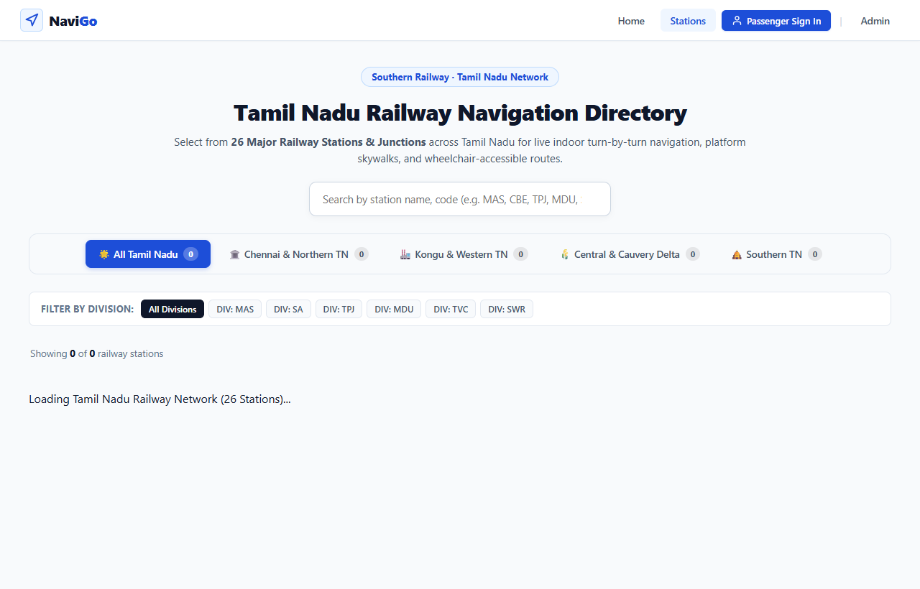
Figure A.1: Tamil Nadu Railway Station Selection & Search Directory
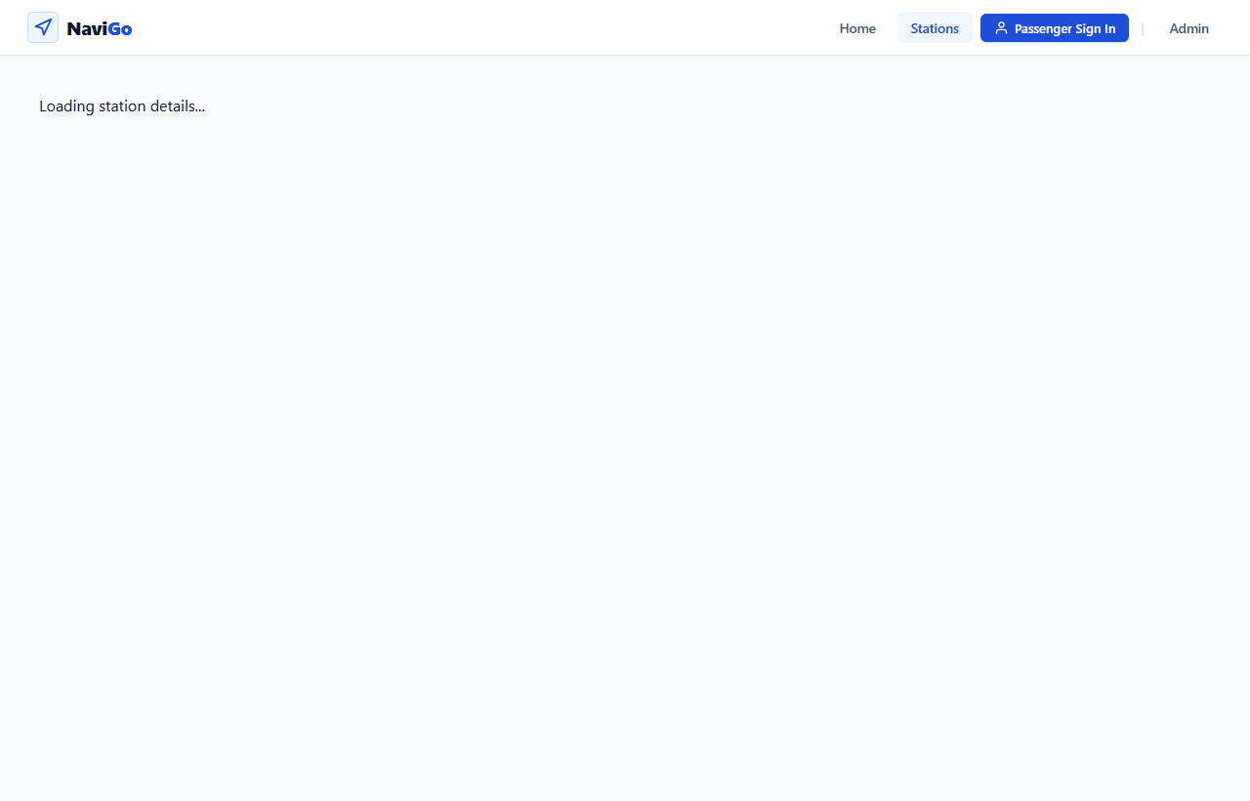
Figure A.2: Station Details & Interactive Facility Directory
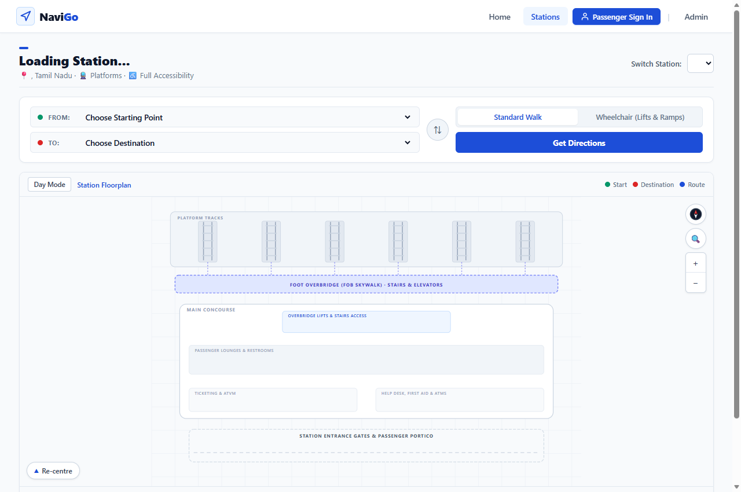
Figure A.3: Interactive 2D Floorplan & Turn-by-Turn Route Guidance
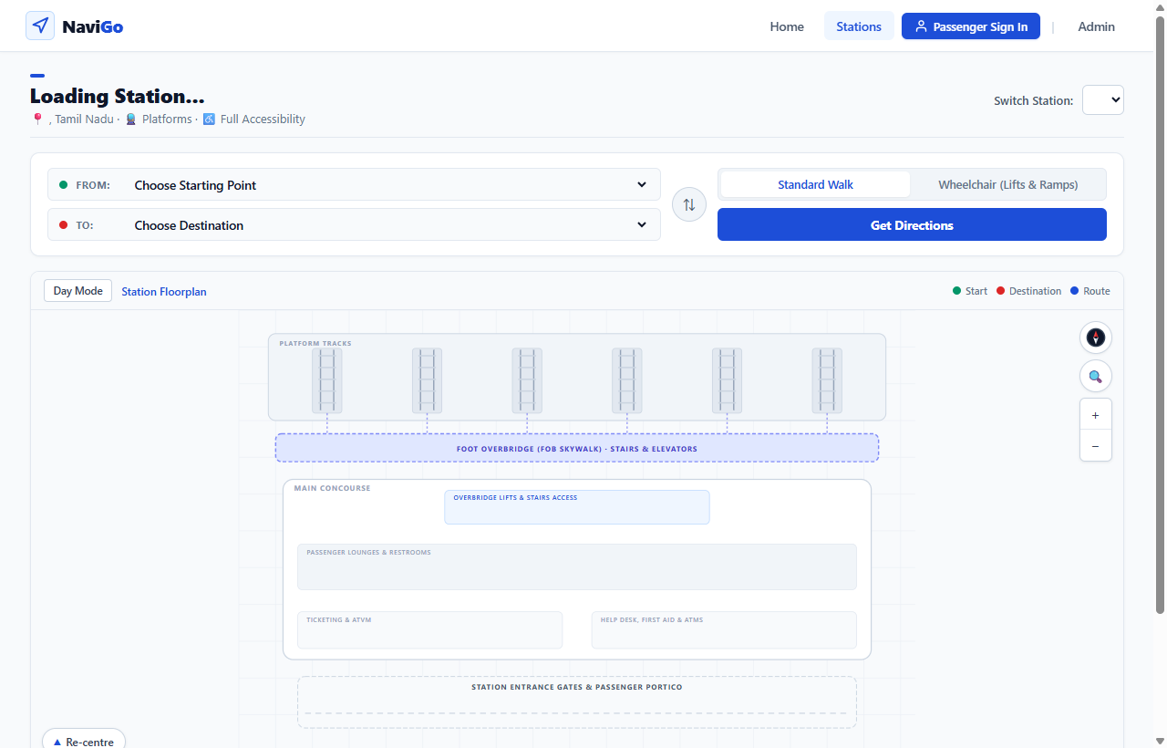
Figure A.4: Wheelchair-Accessible Step-Free Navigation Mode
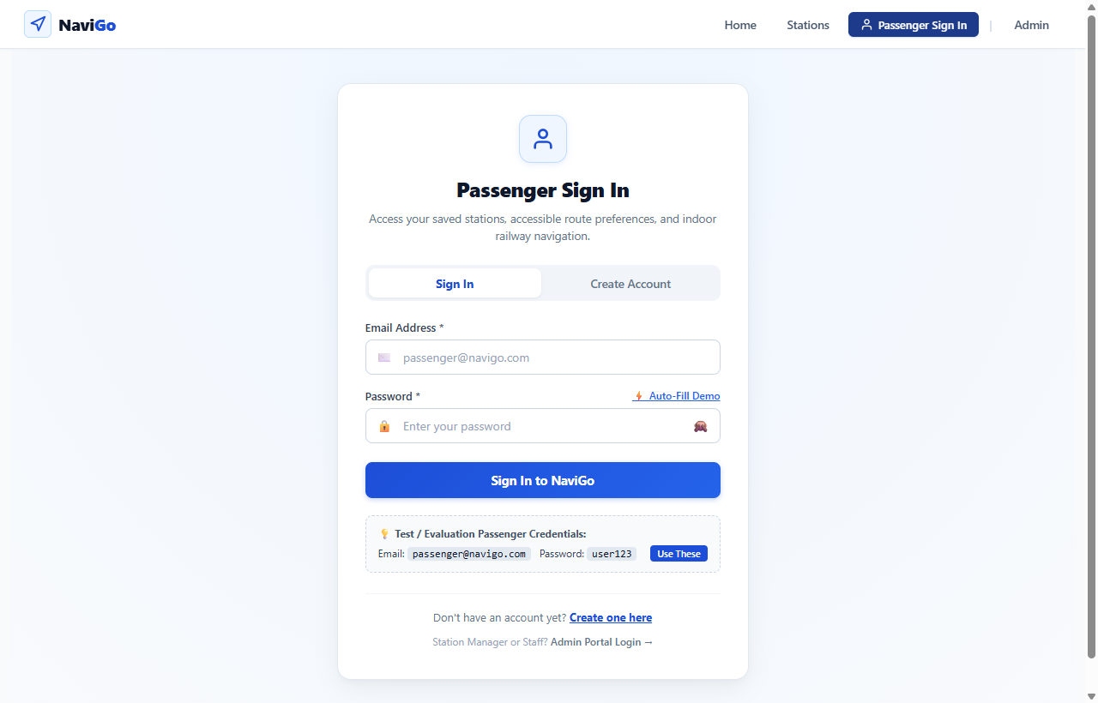
Figure A.5: Passenger Authentication & Accessibility Preferences Interface
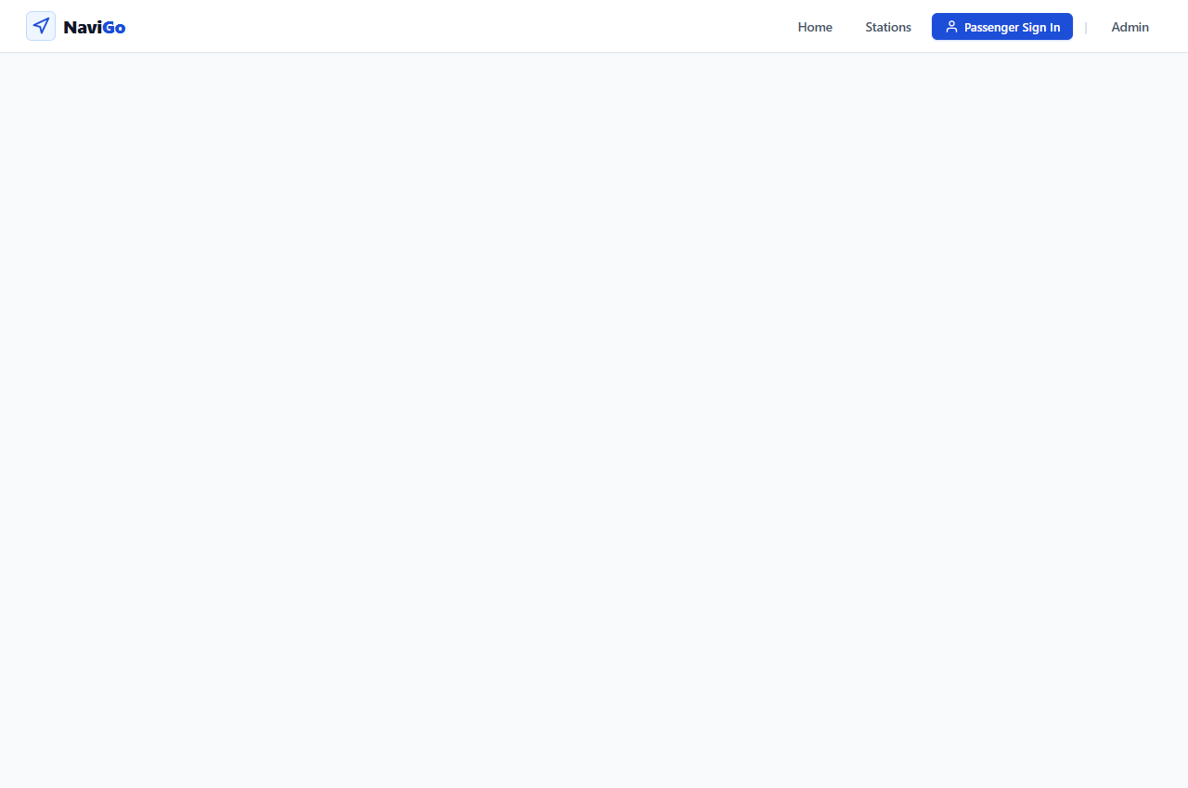
Figure A.6: Passenger Profile & Saved Favorite Stations View
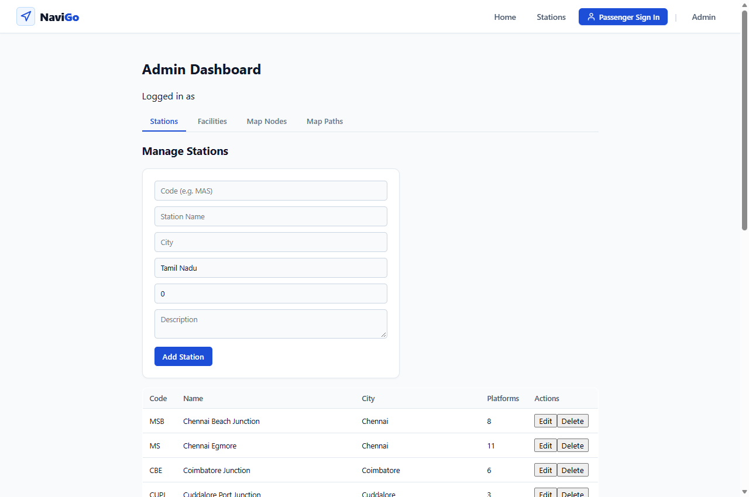
Figure A.7: Admin Dashboard for Station, Facility, Node & Path Management

REFERENCES
[1] Dijkstra, E. W. (1959). A note on two problems in connexion with graphs. Numerische Mathematik, 1(1), 269–271. https://doi.org/10.1007/BF01386390
[2] World Wide Web Consortium (W3C). (2023). Web Content Accessibility Guidelines (WCAG) 2.2. W3C Recommendation. https://www.w3.org/TR/WCAG22/
[3] Ministry of Law and Justice, Government of India. (2016). The Rights of Persons with Disabilities Act, 2016. The Gazette of India, Extraordinary, Part II, Section 1, No. 59.
[4] Fellner, N., Huang, H., & Gartner, G. (2017). Turn-by-turn indoor navigation instructions: Generating landmark-based directions. Journal of Location Based Services, 11(3–4), 185–207.
[5] Karimi, H. A. (2018). Advanced Location-Based Technologies and Services: Indoor Navigation and Universal Accessibility (2nd ed.). CRC Press.
[6] Indian Railways. (2024). Accessible Railway Stations Guidelines: Divyangjan Passenger Amenity Standards. Ministry of Railways, Railway Board, New Delhi.
[7] React Documentation. (2024). React 18 Architecture: Concurrent Rendering & Hooks. Meta Open Source. https://react.dev
[8] Node.js Foundation. (2024). Node.js v22 LTS Core API & Asynchronous Event-Driven Architecture. OpenJS Foundation. https://nodejs.org
[9] Express.js Documentation. (2024). Express 4/5 Fast, Unopinionated, Minimalist Web Framework for Node.js. StrongLoop / OpenJS Foundation. https://expressjs.com
[10] MongoDB Inc. (2024). MongoDB Manual 7.0 & Mongoose 8.0 Object Data Modeling Guide. MongoDB Inc. https://www.mongodb.com/docs/manual/
[11] Fielding, R. T. (2000). Architectural Styles and the Design of Network-based Software Architectures. Doctoral dissertation, University of California, Irvine.
[12] Martin, R. C. (2017). Clean Architecture: A Craftsman's Guide to Software Structure and Design. Prentice Hall.

