Instructions

1. A dataset called **National Radia Dataset (npr)** is provided.
2. The dataset is downloaded from [**www.npr.org**](http://www.npr.org)
3. The dataset has only one column

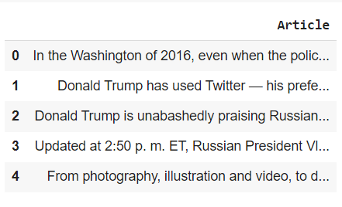

1. Group your data in 10 Topics using **LDA and NMF.**
2. After Topic Modeling, add a column “**Topics**” to your dataset to assign a topic to each article.
3. The final form of your dataset looks like the one shown below.

