SANO GHAR
Final Year Project Report
Web-Based Pet Adoption Center with Integrated Store, Donation, Community and Administrative Management

Student Name | [Insert Student Name]
Student ID | [Insert Student ID]
Programme | [Insert Programme / Department]
Institution | [Insert College / University]
Supervisor | [Insert Supervisor Name]
Submission Date | 04 May 2026

Prepared in alignment with the FYP final report template shared by the student. AI-specific template points are not applicable because this version of Sano Ghar relies on rule-based workflows rather than machine learning models.

Title and Declaration Sheet
Project Title: Sano Ghar: Web-Based Pet Adoption Center with Integrated Store, Donation, Community and Administrative Management
I declare that this report describes my own academic work and that all secondary material used in the preparation of this document has been acknowledged in the references and bibliography. I understand that the final submission should be reviewed by the student and supervisor before institutional submission.
Student Name | [Insert Student Name]
Signature | ____________________________
Supervisor | [Insert Supervisor Name]
Date | ____________________________

Abstract
This report presents Sano Ghar, a full-stack web application designed to support the end-to-end operation of a pet adoption center. The project responds to common operational problems in animal welfare environments: fragmented communication, low visibility of adoptable pets, manual follow-up for applications, disconnected donation records, and weak traceability between user actions and administrative decisions. The implemented system combines OTP-based account onboarding, pet listing and profile management, adoption applications, role-based staff and administrator workspaces, a product store, Khalti payment integration, direct charitable donation, community engagement posts, issue reporting, notifications, and administrative analytics into a single platform.
The artefact is implemented with React, Vite, Tailwind CSS, Express.js, MySQL, JWT-based authentication, Cloudinary media upload, Nodemailer email delivery, and Khalti payment services. A Scrum-based development approach was selected because the project contains multiple interacting modules whose requirements are easier to refine across iterations than in a rigid one-pass model. The report documents the problem domain, research grounding, project methodology, technology decisions, subsystem designs, and implementation evidence derived from the current codebase.
The outcome is an integrated digital platform that improves discoverability of pets, reduces duplicated administrative work, strengthens transaction traceability, and supports both adoption and welfare fundraising within the same system boundary. Although this version does not include artificial intelligence or mobile-native deployment, it establishes a stable operational foundation that can be extended with future matching, analytics, and multi-channel engagement features.

Contents
- 1 Introduction
- 1.1 Project Briefing
- 1.2 Aim
- 1.3 Objectives
- 1.4 Artefact Overview
- 1.5 Academic Question
- 1.6 Scope and Limitations
- 1.7 Report Structure
- 2 Literature Review
- 3 Project Methodology
- 4 Technologies and Tools Used for the Project
- 5 Artefact Designs
- 5.1 Subsystem 1: User Onboarding and Pet Adoption
- 5.2 Subsystem 2: Store, Donation, Community and Reporting
- 6 Conclusion
- 7 Critical Evaluation of the Project
- 8 Evidence of Project Management
- 9 References and Bibliography
- 10 Appendices

Table of Figures
- Figure 1. Functional Decomposition Diagram of the Sano Ghar platform
- Figure 2. High-level system architecture
- Figure 3. Use case diagram for user, staff, admin and external services
- Figure 4. Simplified core ERD derived from the implemented schema and queries
- Figure 5. Adoption approval sequence
- Figure 6. Store checkout and Khalti verification sequence

1 Introduction
Animal shelters and pet adoption centers frequently struggle with fragmented records, inconsistent follow-up, and limited public visibility of animals that need homes. ASPCA shelter statistics for 2024 report that 5.8 million dogs and cats entered shelters and rescues, while 4.2 million were adopted, showing the continuing operational pressure on animal welfare organisations [1]. Although these figures are U.S.-based, they illustrate a broader operational reality: adoption centres need systems that reduce process friction, improve transparency, and help staff respond faster.

1.1 Project Briefing
Sano Ghar is a web-based pet adoption center platform developed to digitise the main operational flows of a shelter-style service. The system serves three major user roles: end users who browse pets and adopt, staff members who review operational tasks, and administrators who manage strategic and financial oversight. Instead of separating adoption, donations, store purchases, community updates, and complaints into disconnected tools, Sano Ghar unifies them inside a single full-stack system.
At implementation level, the system provides OTP-supported account registration, secure login, pet browsing, detailed pet profiles, adoption application submission, profile management, issue reporting, direct donation, store checkout with Khalti, community interaction around charity impact posts, and role-based staff/admin dashboards. The current version does not include AI matching, classification, or recommendation models. The workflow is driven by deterministic business logic, transactional rules, and notification mechanisms.

1.2 Aim
The aim of this project is to design and implement an integrated digital platform that improves the accessibility, transparency, and operational efficiency of a pet adoption center while also supporting fundraising, order management, and community communication.

1.3 Objectives
- Provide a secure onboarding flow using email OTP verification and role-aware authentication.
- Allow users to browse pets, view relevant profile information, and submit structured adoption applications.
- Support staff and administrators in reviewing, approving, rejecting, and tracking adoption activity.
- Integrate a product store, cart workflow, and Khalti-based checkout process with traceable order records.
- Enable direct charitable donations and track the welfare contribution generated from store purchases.
- Support community engagement through impact posts, likes, comments, and notifications.
- Provide issue-reporting and administrative monitoring tools that improve accountability and response handling.

1.4 Artefact Overview
The artefact is modular rather than monolithic. Figure 1 summarises the functional decomposition of the platform. The highest level of decomposition separates access control, adoption management, commerce, charity and community engagement, and administrative monitoring. This decomposition is consistent with the implemented route structure in the Express backend and the role-specific page groups in the React frontend.
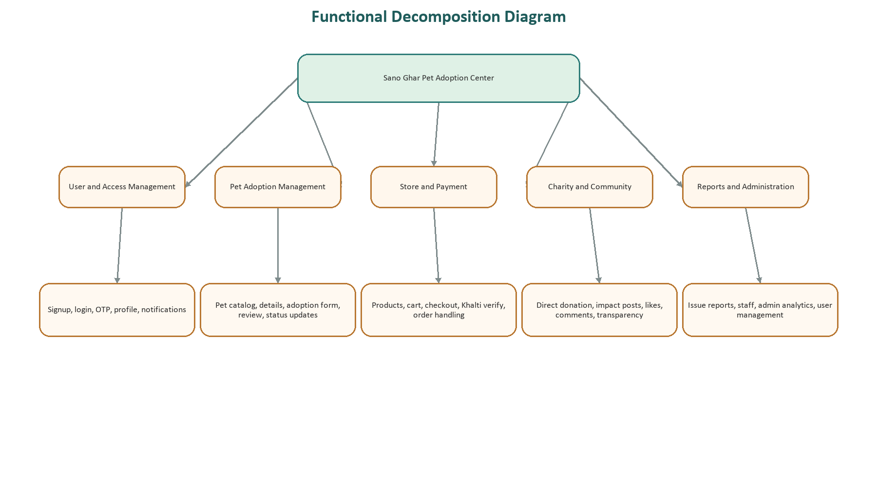
Figure 1. Functional Decomposition Diagram of the Sano Ghar platform

1.5 Academic Question
The academic question guiding the project is as follows:
How effectively can an integrated web-based platform improve process traceability, user experience, and administrative coordination for a pet adoption center compared with fragmented or manual workflows?

1.6 Scope and Limitations
- Scope: the project covers web-based account management, pet adoption, store checkout, charitable donation, community engagement, reporting, and role-based administration.
- Scope: the implementation includes email-based OTP and notification workflows, transactional payment verification, and image upload support.
- Limitation: the system depends on configured third-party services such as Khalti, Cloudinary, SMTP, and a live MySQL database.
- Limitation: there is no AI-driven pet recommendation, behaviour prediction, or automated suitability scoring in the current release.
- Limitation: the project is web-first and not packaged as a native Android or iOS application.

1.7 Report Structure
The remainder of this report is structured around the institution's FYP template. Chapter 2 reviews related research and comparable systems, Chapter 3 explains the methodology, Chapter 4 justifies the technology stack, Chapter 5 presents subsystem designs and implementation evidence, Chapter 6 concludes the work, Chapter 7 evaluates the outcome critically, Chapter 8 summarises project management evidence, and the final chapters provide references and appendices.

2 Literature Review
The literature review for Sano Ghar focuses on four themes that directly influence the system design: the operational pressure on adoption centres, the structure of effective pet profiles, the design of comparable pet adoption applications, and the use of payment-enabled digital fundraising.

2.1 Pet Adoption Operations and Information Needs
Bradley and Rajendran examined shelter adoption rates through data-driven analysis and highlighted how variables such as age, breed, size, and location influence adoption outcomes and length of stay [3]. Their work is useful for this project because it shows that operational decisions in shelters benefit from structured, queryable data rather than informal descriptions. Even though Sano Ghar does not implement predictive modelling, it stores the kinds of descriptive pet information that can later support analytics, prioritisation, or matchmaking enhancements.
Becerra et al. studied user information needs in online pet adoption profiles and found that adopters care strongly about behavioural and physical characteristics when evaluating pets [2]. This directly supports the Sano Ghar decision to keep pet records richer than a simple name-and-photo listing. Fields such as species, breed, health status, behaviour, description, and ownership history make the profile more useful and reduce ambiguity during adoption decisions.

2.2 Comparable Adoption Systems
The iPET study presents a web-based pet adoption application assessed through ISO 25010 quality criteria and reported positive user reception [4]. However, the same study recommends future mobile support and integrated communication features, implying that many adoption systems still stop at the listing-and-inquiry stage. Sano Ghar extends beyond that narrower model by integrating staff workflows, notifications, order management, issue reporting, and financial transparency into one platform.
This comparison suggests an important design gap: prior pet adoption systems often prioritise discoverability of pets but under-support operational continuity after an adoption inquiry begins. Sano Ghar therefore treats adoption not as an isolated form submission but as part of a broader ecosystem that includes review, notification, approval, rejection, and coordination between users and staff.

2.3 Digital Donations and Payment-Enabled Welfare Support
Krisnandy and Nurajijah describe an online donation information system with a payment gateway and argue that electronic fundraising improves accessibility and administrative flow compared with manual donation collection [5]. That finding is relevant because animal welfare projects often depend on continuous fundraising as much as on adoption outcomes. Sano Ghar addresses this by supporting both direct donations and a smaller charity amount derived from store orders, improving the linkage between commerce and welfare support.
Khalti's own ePayment documentation requires payment initiation from the merchant's server side and uses a unique `pidx` value for later verification [10]. This aligns with Sano Ghar's backend-first checkout flow, where the server creates orders, reserves stock, initiates payment, and then verifies transaction status before finalising or rolling back data changes.

2.4 Security and Technical Foundations
The system relies on established web technologies rather than experimental infrastructure. React's component model supports modular UI composition [7], Express formalises route-driven API behaviour [8], and MySQL remains a mature multi-user relational database option for transactional workloads [9]. For security, the platform uses JWT-based session handling in line with RFC 7519 [11], bcrypt hashing through existing Node tooling, and OTP flows that are broadly consistent with OWASP's guidance around multi-factor and password-related protections [12][13].

2.5 Research Gap and Contribution
The main gap identified across the reviewed literature is integration. Research and comparable applications show strong attention to the adoption portal itself, but they less frequently combine shelter operations, payment-enabled fundraising, order processing, issue reporting, and transparent community communication within a single web application. The contribution of Sano Ghar is therefore practical and architectural: it demonstrates how these interconnected functions can be implemented cohesively in a role-based full-stack system.

3 Project Methodology
A Scrum-oriented methodology was selected for the Sano Ghar project because the system contains multiple interacting subsystems whose detailed requirements become clearer during implementation rather than entirely before it. The official Scrum Guide remains the current reference released in November 2020 [6]. This project benefits from Scrum not because it is fashionable, but because the work involves continuous reprioritisation across frontend design, backend routes, schema adjustments, and service integrations.

3.1 Why Scrum Fits Sano Ghar
- The project includes different stakeholder perspectives: adopters, staff, administrators, and donors. Scrum makes it easier to refine features when those perspectives create new requirements.
- Adoption, payments, image upload, notifications, and analytics are tightly connected. Iterative delivery reduces the risk of designing all interfaces too early and discovering incompatibilities later.
- Third-party dependencies such as Khalti, SMTP, and Cloudinary introduce integration uncertainty. Shorter iterations make failures more visible and easier to isolate.
- The platform benefits from incremental demonstrations: an early pet listing and auth module can be validated before more complex order, donation, and reporting features are added.

3.2 Iterative Delivery Structure
Sprint | Focus | Primary Deliverables
Sprint 1 | Foundation and access | Project setup, route structure, user auth, OTP verification, core pet listing
Sprint 2 | Adoption operations | Adoption application flow, notifications, approval logic, staff and admin handling
Sprint 3 | Commerce and fundraising | Products, cart, checkout, Khalti flow, direct donation and store contribution
Sprint 4 | Administration and refinement | Community posts, reporting, analytics, security refinements, documentation

The methodology emphasised continuous refinement rather than static specification. For example, transactional order handling only becomes fully meaningful once product stock, payment verification, and user history are viewed together. Likewise, adoption status handling required later decisions about automatic rejection of competing pending applications for the same pet. An iterative method therefore matches the dependency pattern of the actual codebase.

4 Technologies and Tools Used for the Project
Technology choices in Sano Ghar were guided by fitness for purpose, learning value, ecosystem maturity, and compatibility with the project's full-stack architecture.
Technology | Role | Justification
React 19 + Vite 7 | Frontend interface | Supports modular component-based screens and fast development/build workflow [7].
Tailwind CSS 4 + Framer Motion | Styling and interface polish | Allows consistent responsive styling and modern user interaction patterns with low overhead.
Express 5 | Backend HTTP API | Route-driven structure fits the domain-oriented controllers used by auth, pets, payment, charity and admin flows [8].
MySQL + mysql2 | Relational persistence | Well suited to multi-user transactional data, foreign keys, and order/adoption/report relationships [9].
JWT + bcryptjs | Authentication and password security | Supports stateless session handling and hashed credentials following common web security practice [11][12].
Nodemailer + SMTP | OTP and workflow email | Needed for account verification and adoption status communication.
Cloudinary + multer | Media upload | Offloads image storage and simplifies profile, pet and post image handling.
Khalti ePayment | Checkout and donation processing | Provides a familiar payment flow for Nepal-targeted use cases and supports backend initiation / lookup [10].
npm, ESLint and Git | Quality and project support | Useful for dependency management, linting, and iterative source control across sprints.

4.1 Environment Summary
The frontend uses `VITE_API_BASE_URL` to target the backend API, while the backend environment includes database variables, JWT secrets, Khalti keys, Cloudinary credentials, and SMTP settings. This separation helps keep sensitive credentials away from the client build and is consistent with the architecture shown later in Figure 2.

5 Artefact Designs
This chapter groups the artefact into two main subsystem families. The grouping reflects the actual implementation more accurately than a chapter-per-route approach and keeps the report aligned with the functional structure already shown in Figure 1.

5.1 Subsystem 1: User Onboarding and Pet Adoption

5.1.1 SRS Summary
- The user shall be able to register an account and verify it through email OTP before full activation.
- The user shall be able to browse available pets and view profile details relevant to adoption decisions.
- The user shall be able to submit, edit, and delete adoption applications for eligible pets.
- Staff and administrators shall be able to review applications and update status as approved or rejected.
- The system shall prevent duplicate successful adoption approval for the same pet and notify affected users.
- The system shall preserve an auditable trail through notifications and status-linked messages.

5.1.2 Design and Modelling
Figure 3 shows the role and service interactions most relevant to the adoption subsystem. Users initiate onboarding and application activity, while staff and administrators review operational states. External email support is required because OTP verification and adoption outcome communication are integral to the workflow rather than optional extras.
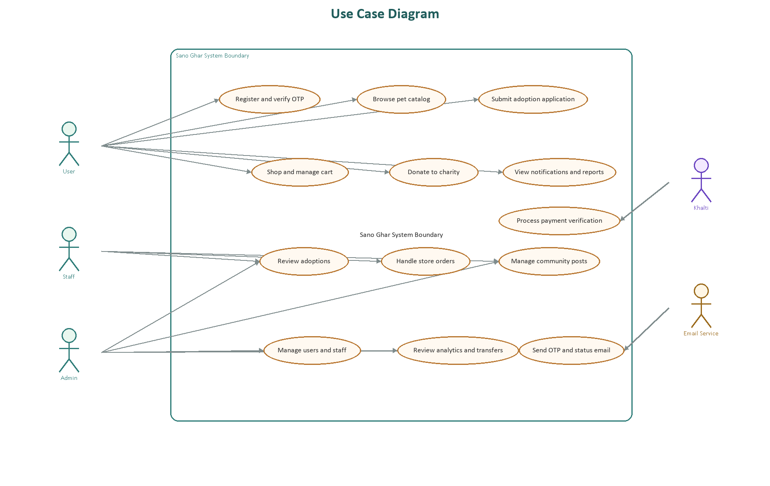
Figure 3. Use case diagram for user, staff, admin and external services
Figure 4 provides a simplified ERD derived from the implemented schema and SQL queries. The core adoption path depends on relationships between `users`, `pets`, `adoption_applications`, and `user_notifications`, while related service tables such as `reports` and `charity_posts` extend the user's engagement lifecycle.
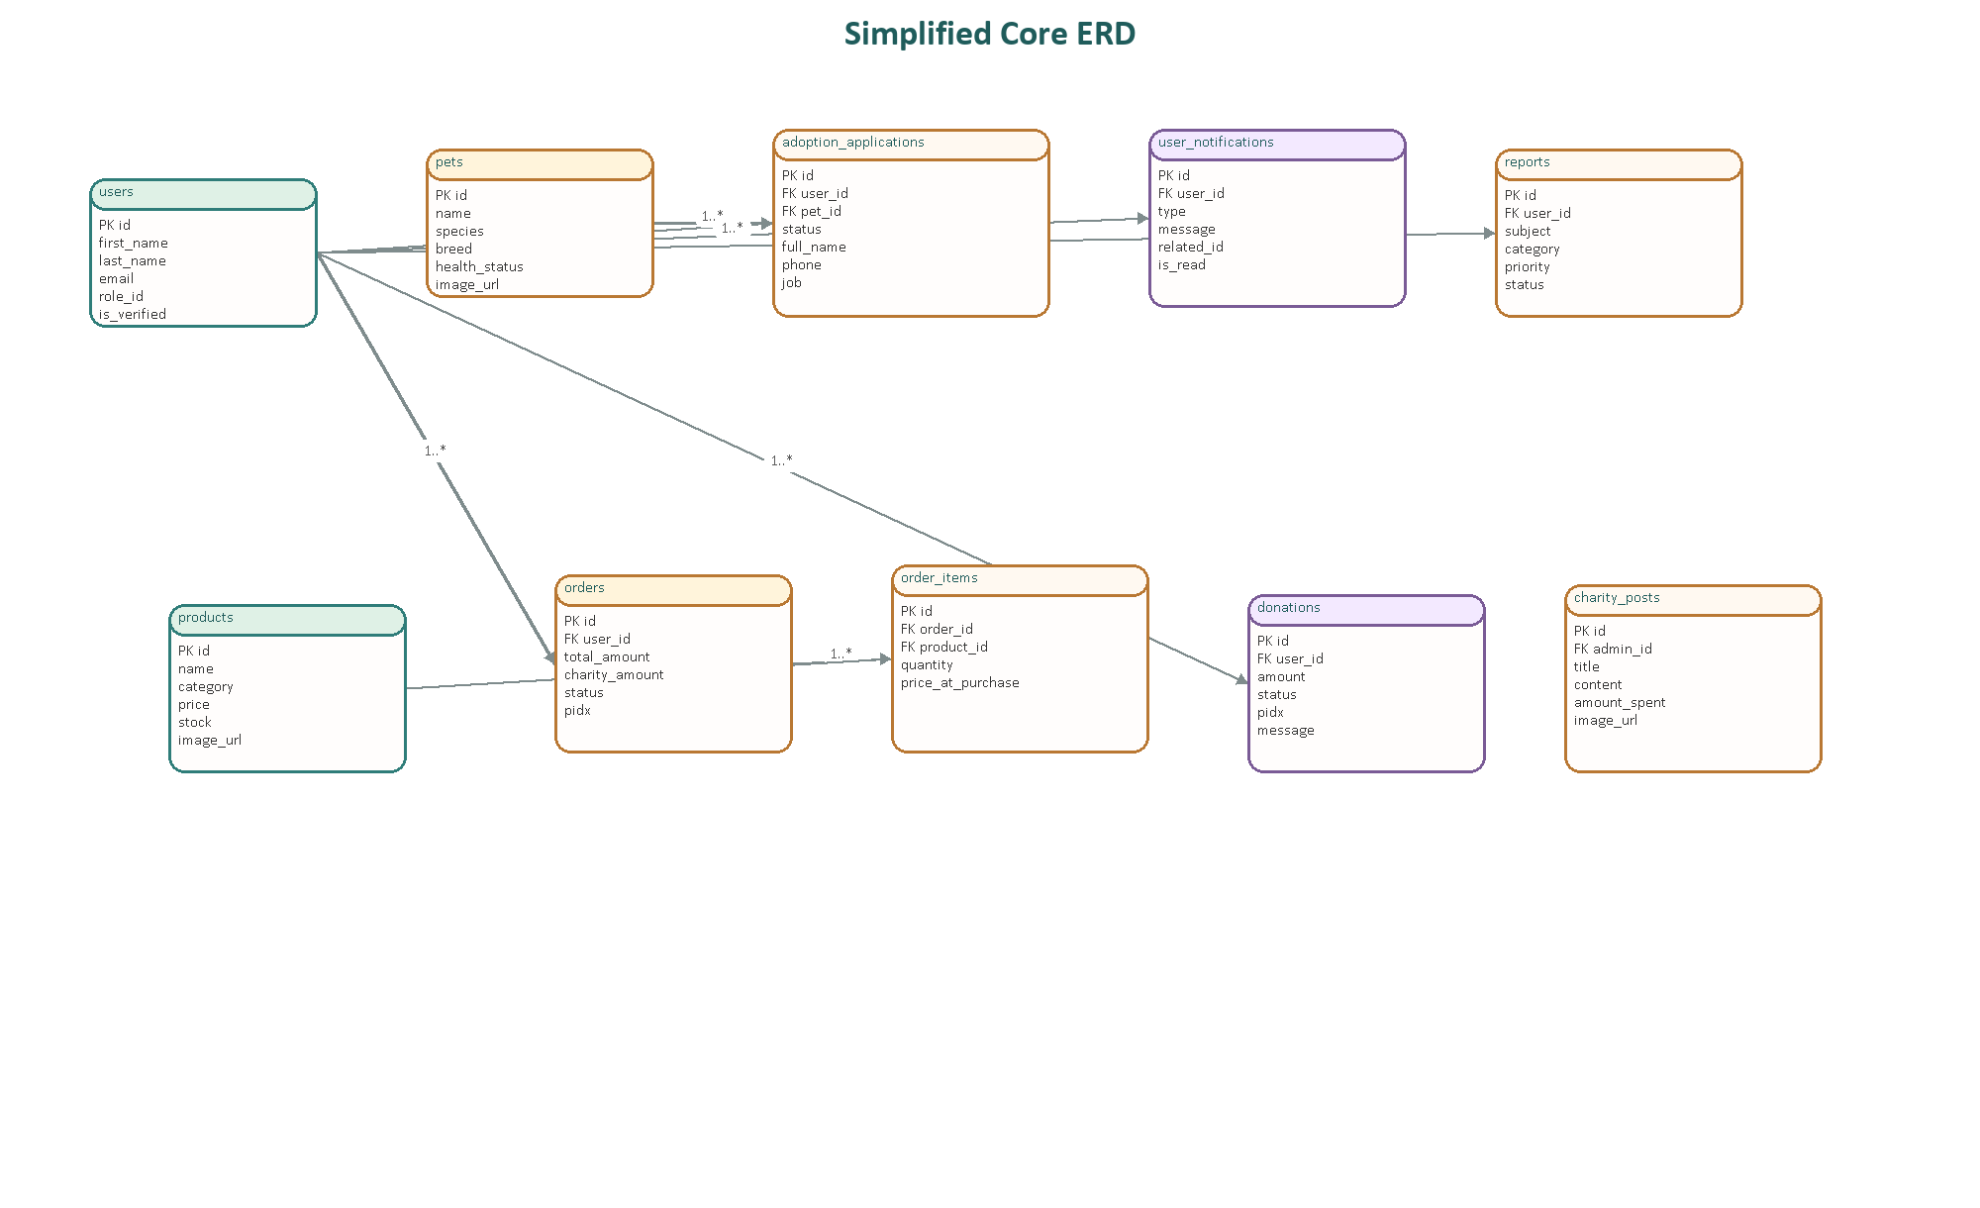
Figure 4. Simplified core ERD derived from the implemented schema and queries
Figure 5 models the approval sequence. A particularly important design decision is the use of transactional logic when an application is approved. The backend updates the chosen record, automatically rejects competing pending requests for the same pet, inserts user notifications, and then dispatches status emails. This keeps the business rule consistent and avoids partial approval states.
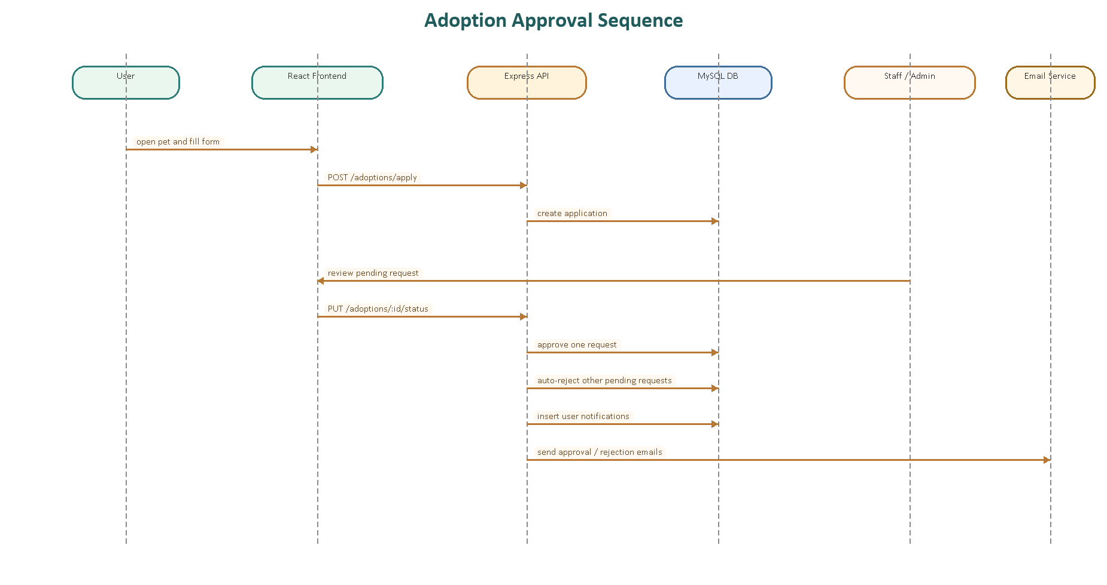
Figure 5. Adoption approval sequence

5.1.3 Testing and Verification Matrix
ID | Scenario | Expected Behaviour | Implementation Evidence
A1 | Signup with OTP verification | Account is created, OTP is sent, and verification activates the user | authController.signup + verifyOTP
A2 | Submit adoption form | A structured application is created for the selected pet | AdoptionForm.jsx + createAdoptionApplication
A3 | Prevent duplicate request for same pet | Existing application is detected and repeat submission is blocked | AdoptionForm.jsx existingApplication check + unique user/pet constraint
A4 | Approve one application for a pet | Selected application becomes approved and other pending ones are rejected | updateAdoptionStatus transaction logic
A5 | Delete pet with pending applications | Deletion is blocked until pending requests are resolved | petController.deletePet / staffPetController

5.2 Subsystem 2: Store, Donation, Community and Reporting

5.2.1 SRS Summary
- Users shall be able to browse products, manage a cart, provide shipping details, and initiate checkout.
- The backend shall create order records and reserve stock before handing control to the payment provider.
- The system shall verify Khalti transactions and either finalise the order or restore stock on failure.
- Users shall be able to donate directly and see community-facing charity impact posts.
- Administrators shall be able to review analytics, track donation inflow, manage posts, and manage users.
- Users shall be able to submit issue reports and receive notifications when report status changes.

5.2.2 Design and Modelling
The subsystem depends on several external integrations, so a high-level architecture view is useful. Figure 2 shows the relationship between the React client, Express backend, MySQL persistence layer, and third-party services for media, payments, and email. This architecture keeps sensitive actions such as payment initiation and verification on the server side, which is also the flow required by Khalti's documentation [10].
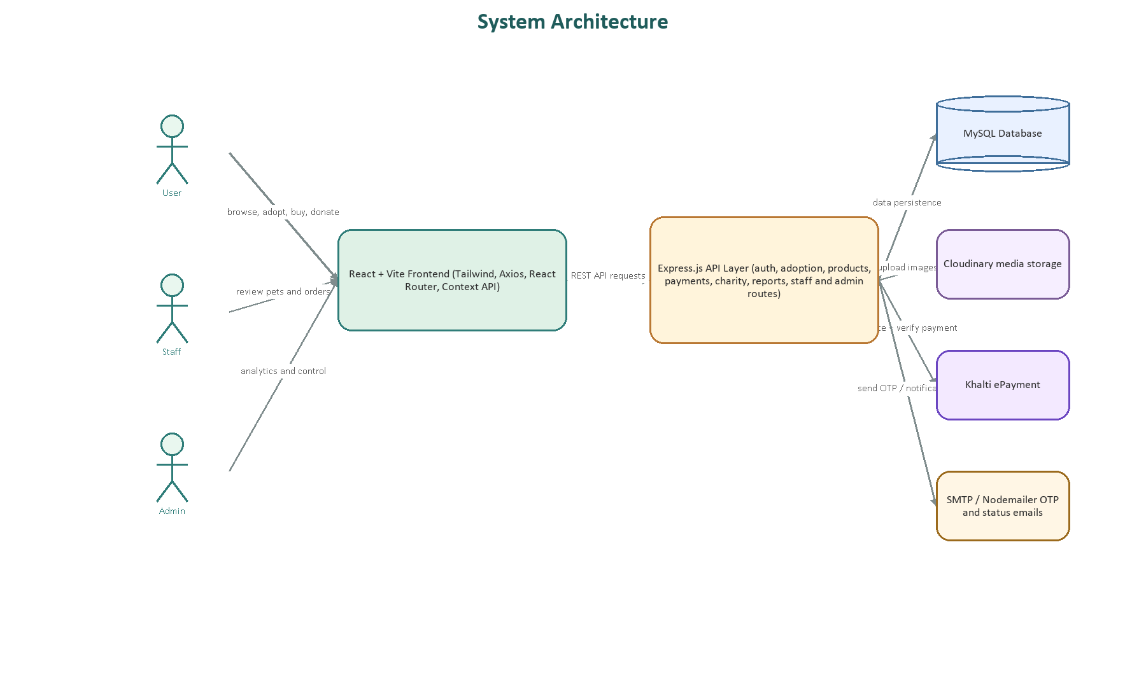
Figure 2. High-level system architecture
Figure 6 illustrates the checkout and payment lifecycle. The implementation deliberately creates the order and reserves stock before redirecting to Khalti. After payment lookup, successful transactions clear the cart and mark the order as completed, while failed or refunded outcomes restore reserved inventory. This reduces inconsistency between stock levels and payment outcomes.
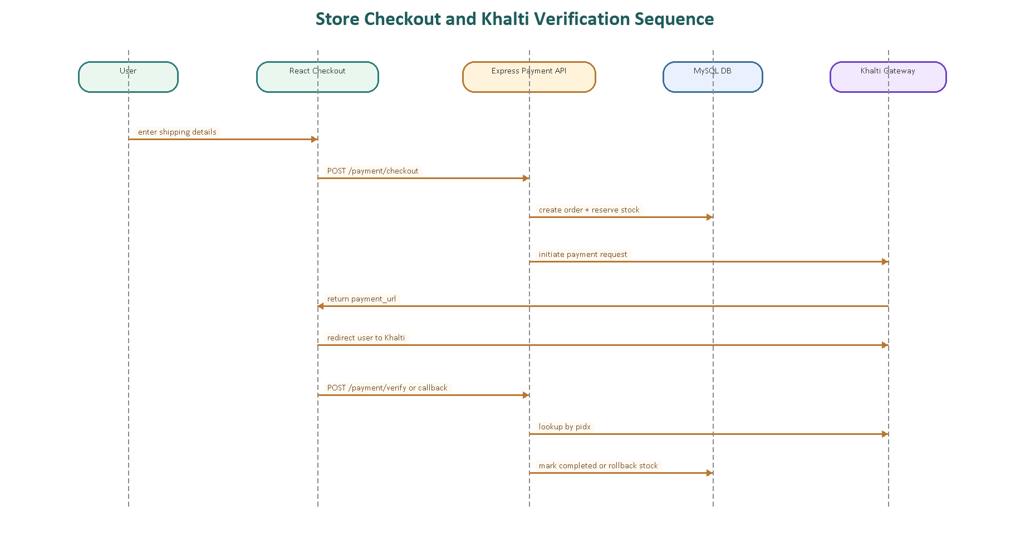
Figure 6. Store checkout and Khalti verification sequence

5.2.3 Testing and Verification Matrix
ID | Scenario | Expected Behaviour | Implementation Evidence
C1 | Add products and cart management | Products can be loaded and cart items are tied to the authenticated user | productController + cart flow described in FIXES_SUMMARY
C2 | Checkout initiation | Order is created, stock is reserved, and Khalti payment_url is returned | paymentController.handleCheckout
C3 | Payment failure or cancellation | Pending order is marked failed and reserved stock is restored | verifyPaymentAndUpdateOrder failure branch
C4 | Direct donation verification | Donation record status updates after Khalti lookup | charityController.initiateDonation + verifyDonation
C5 | Report status notification | User receives a notification when admin changes report status | reportController.updateReportStatus
C6 | Staff order acceptance | Paid orders can be accepted and assigned to staff with delivery metadata | staffOrderController.acceptStaffOrder

6 Conclusion
Sano Ghar demonstrates that an integrated web platform can improve operational coordination for a pet adoption center by connecting adoption, commerce, fundraising, reporting, and administrative oversight within the same system boundary. The project addressed the academic question by showing that process traceability becomes stronger when applications, notifications, payments, and role-specific dashboards all share a coherent backend and relational data model.
The implemented system goes beyond a basic adoption portal. It supports structured pet data, protected account onboarding, transactional payment flows, direct donations, community transparency, and issue escalation. The result is not merely a user-facing website, but an operational platform that reduces fragmentation across day-to-day shelter activities.

7 Critical Evaluation of the Project

7.1 Findings and Process
One of the strongest aspects of the project is its breadth of integration. Many student systems stop after authentication and CRUD, whereas Sano Ghar connects multiple real-world concerns: adoption review, stock-sensitive checkout, donation handling, email notifications, and analytics. This breadth increased implementation complexity, but it also made the final artefact more realistic and academically richer.

7.2 System Evaluation
- Strength: transactional logic in adoption approval and payment verification reduces inconsistent system states.
- Strength: role separation between user, staff, and admin improves maintainability and access clarity.
- Strength: the platform supports both mission activity (adoption) and sustainability activity (donation/store contribution).
- Weakness: the current system depends on third-party services and careful environment configuration for full end-to-end execution.
- Weakness: mobile-native delivery, advanced search, and recommendation support are not yet present.
- Weakness: a fuller automated test suite would strengthen long-term maintainability beyond manual or code-level verification.

7.3 Self Reflection
From a learning perspective, the project provides strong evidence of full-stack growth. It requires thinking across frontend interaction design, backend route composition, relational data modelling, third-party integration, and user communication flows. The work also reinforces a key professional lesson: high-value software is usually not about a single feature, but about how several features remain consistent when they interact.

8 Evidence of Project Management

8.1 Milestone Log Summary
The official signed supervisor log sheet should be attached by the student during final institutional submission. For report completeness, Table 8.1 summarises the major delivery milestones reflected in the implemented codebase.
Milestone | Focus | Outcome
1 | Project framing and problem definition | Adoption center workflow selected; scope expanded to store, donation and reporting support
2 | System foundation | React and Express project structure established; environment variables and API base URL configured
3 | User auth and pet modules | Signup, login, OTP verification, profile support and pet browsing/apply flows added
4 | Role-based operations | Staff and admin dashboards, adoption handling, user management and staff management added
5 | Commerce and fundraising | Products, cart, checkout, Khalti verification, donation flow and charity analytics added
6 | Community and reporting | Impact posts, likes/comments, notifications, reporting workflow and final refinements added

8.2 High-Level Gantt
Work Package | W1 | W2 | W3 | W4 | W5 | W6 | W7 | W8 | W9 | W10 | W11 | W12 | W13 | W14 | W15 | W16
Requirements and project framing
Architecture and schema planning
Authentication and user module
Adoption workflow
Store and payment workflow
Donation, community, reporting
Testing, fixes and documentation

9 References and Bibliography
[1] ASPCA, "U.S. Animal Shelter Statistics," Shelter Intake and Surrender, 2024 statistics page. Accessed: 04 May 2026. Available: https://www.aspca.org/helping-people-pets/shelter-intake-and-surrender
[2] Z. M. Becerra, S. Parmar, K. May, and R. E. Stuck, "Exploring User Information Needs in Online Pet Adoption Profiles," Proceedings of the Human Factors and Ergonomics Society Annual Meeting, vol. 64, no. 1, pp. 1308-1312, 2021. DOI: https://doi.org/10.1177/1071181320641311
[3] J. Bradley and S. Rajendran, "Increasing adoption rates at animal shelters: a two-phase approach to predict length of stay and optimal shelter allocation," BMC Veterinary Research, vol. 17, article 70, 2021. DOI: https://doi.org/10.1186/s12917-020-02728-2
[4] J. E. Gatmaitan, D. V. P. Azurin, J. P. T. Saclolo, J. A. G. Yango, K. P. Lorenzo, C. N. P. Olipas, and R. T. Alegado, "iPET: The Design, Development, and Assessment of a Web-Based Application for Pet Adoption," Formosa Journal of Computer and Information Science, vol. 3, no. 1, 2024. DOI: https://doi.org/10.55927/fjcis.v3i1.6031
[5] A. Krisnandy and N. Nurajijah, "Online Donation Information System with Payment Gateway," International Journal of Information System and Technology, vol. 6, no. 1, 2022. DOI: https://doi.org/10.30645/ijistech.v6i1.204
[6] K. Schwaber and J. Sutherland, "The Scrum Guide," official current version, Nov. 2020. Available: https://scrumguides.org/download.html
[7] React Documentation, "Quick Start," React.dev. Accessed: 04 May 2026. Available: https://react.dev/learn
[8] Express.js Documentation, "Routing," Expressjs.com. Accessed: 04 May 2026. Available: https://expressjs.com/en/guide/routing.html
[9] Oracle, "MySQL 8.0 Reference Manual," Accessed: 04 May 2026. Available: https://dev.mysql.com/doc/refman/8.0/en/introduction.html
[10] Khalti, "Web Checkout - Khalti Payment Gateway," Accessed: 04 May 2026. Available: https://docs.khalti.com/khalti-epayment/
[11] M. Jones, J. Bradley, and N. Sakimura, "RFC 7519: JSON Web Token (JWT)," Internet Engineering Task Force, May 2015. Available: https://datatracker.ietf.org/doc/html/rfc7519
[12] OWASP Cheat Sheet Series, "Password Storage Cheat Sheet," Accessed: 04 May 2026. Available: https://cheatsheetseries.owasp.org/cheatsheets/Password_Storage_Cheat_Sheet.html
[13] OWASP Cheat Sheet Series, "Multifactor Authentication Cheat Sheet," Accessed: 04 May 2026. Available: https://cheatsheetseries.owasp.org/cheatsheets/Multifactor_Authentication_Cheat_Sheet.html

10 Appendices

10.1 End User Manual
- Create an account using signup, then verify the OTP sent to the registered email address.
- Log in and browse the available pets from the adoption area.
- Open a pet profile, review its details, and submit an adoption application if eligible.
- Use the shop to add products to the cart and proceed to checkout with delivery details.
- Complete payments or donations through the Khalti redirection flow and return to the application for status verification.
- Check notifications to track adoption updates, report updates, and other system messages.

10.2 System Configuration Details
Layer | Variable(s) | Purpose
Frontend | VITE_API_BASE_URL | http://localhost:5000/api
Backend | DB_HOST / DB_USER / DB_PASSWORD / DB_NAME | MySQL connection settings
Backend | JWT_SECRET / ADMIN_JWT_SECRET / STAFF_JWT_SECRET | Authentication secrets
Backend | KHALTI_SECRET_KEY / KHALTI_TEST_SECRET_KEY / KHALTI_BASE_URL | Payment gateway credentials
Backend | FRONTEND_URL | Frontend callback target
Backend | CLOUDINARY_CLOUD_NAME / API_KEY / API_SECRET | Media upload support
Backend | EMAIL_HOST / EMAIL_PORT / EMAIL_USER / EMAIL_PASS | OTP and workflow email delivery

10.3 Diagram Source Files
Editable diagram sources for this report were generated in draw.io-compatible format and stored in the workspace under `report_assets/diagrams`. These files can be opened in diagrams.net / draw.io for further refinement before final academic submission.

