REFERENCER ON XBRL

MCA CIRCULAR

General Circular No. 09/2011

17/70/2011 – CL.V
Government of India
Ministry of Corporate Affairs

5th Floor, A Wing, Shastri Bhavan,
Dr. R.P. Road, New Delhi
Dated the 31.03.2011

To

All Regional Directors
All Registrar of Companies

Subject : Filing of Balance Sheet and Profit and Loss Account in extensible Business Reporting Language (XBRL) mode.
It has been decided by the Ministry of Corporate Affairs to mandate certain class of companies to file balance sheets and profit and loss account for the year 2010-11 onwards by using XBRL taxonomy. The Financial Statements required to be filed in XBRL format would be based upon the Taxonomy on XBRL developed for the existing Schedule VI, as per the existing, (non converged) Accounting Standards notified under the Companies (Accounting Standards) Rules, 2006. The said Taxonomy is being hosted on the website of the Ministry at www.mca.gov.in shortly. The Frequently Asked Questions ( FAQs ) about XBRL have been framed by the Ministry and they are being annexed as Annexure I with this circular for the information and easy understanding of the stakeholders.

Coverage in Phase I

2. The following class of companies have to file the Financial Statements in XBRL Form only from the year 2010-2011 :-
(i) All companies listed in India and their subsidiaries, including overseas subsidiaries;

(ii) All companies having a paid up capital of Rs. 5 Crore and above or a Turnover of Rs 100 crore or above .

Additional Fee Exemption

3. All companies falling in Phase -I are permitted to file upto 30-09-2011 without any additional filing fee.

Training Requirement

4. Stakeholders desirous to have training on the XBRL or on taxonomy related issues, may contact the persons as mentioned in Annexure II.

(J. N. Tikku)

Joint Director
Tel: 011-23381295

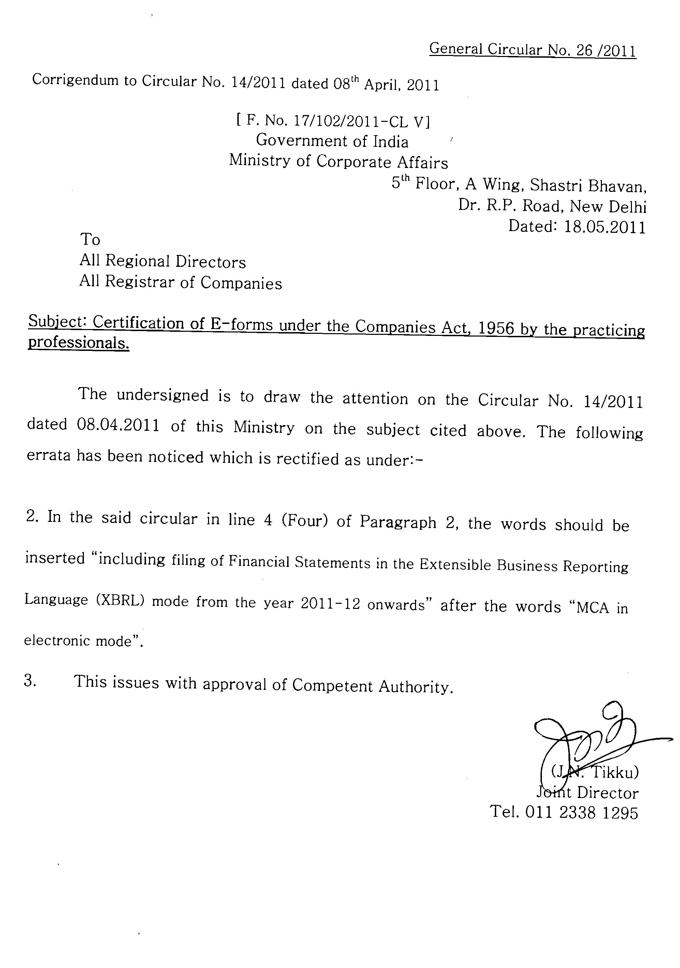
XBRL-AN OVERVIEW

Introduction
eXtensible Business Reporting Language (XBRL) is a language for the electronic communication of business and financial data revolutionizing business reporting around the world. XBRL is a member of the family of computer languages based on XML (Extensible Markup Language), which is a standard for the electronic exchange of data between businesses and on the internet. Under XML, identifying tags are applied to items of data so that they can be processed efficiently by computer software.
It provides major benefits in the preparation, analysis and communication of business information. It offers cost savings, greater efficiency and improved accuracy and reliability to all those involved in supplying or using financial data.
Origin
XBRL is being developed by XBRL International, an international non-profit consortium of approximately 450 major companies, organisations and government agencies working together to build the XBRL language and promote and support its adoption. This collaborative effort began in 1998 and has produced a variety of specifications and taxonomies to support the goal of providing a standard, XML-based language for digitizing business reports in accordance with the rules of accounting in each country or with other reporting regimes such as banking regulation or performance benchmarking.
Concept
As a concept, XBRL enables various systems and software to exchange business information using common, standardized, universal terminology. Instead of treating financial information as a block of text as in a standard internet page or a printed document - it provides an identifying tag for each individual item of data. This is computer readable.
It is a technical supply chain standard for moving financial and business reporting information into an interactive, comparable, intelligent, machine-readable information format. XBRL takes financial and business reporting frameworks developed by regulatory agencies and other financial and business reporting stakeholders and tag that data to an agreed upon XBRL taxonomies (classification) which then turns this information into intelligent information that can be consumed and understood by machines.
Meaning of Taxonomy
Taxonomies are the reporting-area specific hierarchical dictionaries used by the XBRL community. Specific tags are coined for each item and their attributes and interrelationships are defined. Different taxonomies are required for different business reporting purposes. Some national jurisdictions may need their own reporting taxonomies to reflect local accounting and other reporting regulations. Many organisations, including regulators, specific industries or even companies, may require taxonomies or taxonomy extensions to cover their own specific business reporting needs.
In the Indian context for example XBRL India has developed draft General Purpose Financial reporting XBRL taxonomy for Commercial and Industrial Companies.
Example of ‘Tag’ in XBRL Taxonomies
Company’s net profit has its own unique tag. Computers can treat XBRL data "intelligently": they can recognise the information in a XBRL document, select it, analyse it, store it, exchange it with other computers and present it automatically in a variety of ways for users. XBRL greatly increases the speed of handling of financial data, reduces the chance of error and permits automatic checking of information.
Application of XBRL
XBRL can be applied to a wide range of business and financial data. Among others it can handle:
􀁺 Company internal and external financial reporting.
􀁺 Business reporting to all types of regulators, including tax and financial authorities, central banks and governments.
􀁺 Filing of loan reports and applications; credit risk assessments.
􀁺 Exchange of information between government departments or between other institutions, such as central banks.
􀁺 Authorative accounting literature - providing a standard way of describing accounting documents provided by authoritative bodies.
􀁺 A wide range of other financial and statistical data which needs to be stored, exchanged and analysed.

Worldwide acceptance of XBRL
XBRL is quickly spreading across the world, by way of increasing participation from individual countries and international organizations. It is now preferred as a standard for business and financial reporting worldwide. Many countries are mandating XBRL, for example, China, India, Singapore, Germany, France, Belgium, Chile, Spain and State of Nevada while in others such as Canada, Sweden it is voluntary.
XBRL has gained momentum globally due to adoption by Regulatory authorities. The US Securities and Exchange Commission has played a vital role in accelerating adoption of XBRL in the US . A voluntary filing program for filing returns in XBRL format initiated by SEC in early years is moving towards mandatory filing in a phased manner. The SEC mandated the use of XBRL for public company reporting and other reporting applications as under:
1. Public Company Reporting – all public companies must file in XBRL format; companies with worldwide public float greater than $5 billion to comply first starting with period ending June 2009; all other large accelerated filers to comply starting with period ending June 2010; all other public companies comply with period ending June 2011
2. Risk Return Summary Portion of Mutual Fund Prospectus – mutual funds must begin publishing the risk return summary portion of their prospectuses in XBRL format starting January 1, 2011.
3. Credit Rating Agencies – Credit rating agencies are reporting all ratings actions (initial rating, upgrades, downgrades, etc.) in XBRL format starting in August 2009 (180 days after publishing in Federal register).
Japan is also one of the early adopters of XBRL and had started voluntary XBRL reporting program for financial services institutions gradually expanding the range of reports since 2005. The Financial Services Agency (FSA) has implemented a system which requires around 5,000 listed companies and 3,000 mutual funds to submit their financial information in the XBRL format. Many countries around the world are steadily implementing XBRL in their reporting frameworks.
XBRL-IFRS Taxonomy
International Accounting Standards Board published IFRS taxonomy 2009 which is a complete translation of IFRS into XBRL language. In February 2010, it has also published an exposure draft of IFRS taxonomy for Small and Medium Enterprises in XBRL for public comments.

XBRL in India
XBRL India is the Indian Jurisdiction of XBRL International. Its main objective is to promote and encourage the adoption of XBRL in India as the standard for electronic business reporting in India. Members of XBRL India among others include regulators such as Reserve Bank of India (RBI), Insurance Regulatory and Development Authority (IRDA), Securities and Exchange Board of India (SEBI), Ministry of Corporate Affairs (MCA), stock exchanges like Bombay Stock Exchange Limited (BSE) and National Stock Exchange of India Limited (NSE), and some private sector companies.
Some Regulatory Initiatives
RBI’s initiatives
The Reserve Bank of India has already launched the Basel II reporting system using eXtensible Business Reporting Language (XBRL) through the existing Online Returns Filing System. With a view to providing direction for implementation of XBRL, RBI had set up a high level Steering Committee to develop and test the XBRL based reporting format.
SEBI initiatives
Some of the significant developments which have since taken place in Indian securities market with the encouragement of SEBI include setting up of a XBRL enabled platform for corporate reporting (www.corpfiling.co.in) by BSE and NSE. Both these have migrated to XBRL from the paper based model and offer a unified electronic platform, popularly known as ‘CorpFiling’ system, which enables the companies listed in either or both of the exchanges to electronically file their disclosures.
An example of XBRL application in Industry
Infosys Technologies Limited
Infosys Technologies Limited voluntarily furnished eXtensible Buisness Reporting Language (XBRL) data to the United States Securities and Exchange Commission electronically in a 6-k exhibit (A monthly report of foreign private issuer with SEC) way back on May 2005. It was also participating in SEC’s voluntary program for Reporting Financial Information on EDGAR using XBRL.

References
http://www.xbrl.org/faq.aspx#15
http://www.xbrl.org/WhatIsXBRL/
http://www.xbrl.org/in/frontend.aspx?clk=LK&val=177
http://www.irisindia.net/newsletter/XBRLedge%20 %20Issue%2001.pdf
www.rbi.org.in
www.sebi.gov.in/press/2009/2009334.html
http://www.iasb.org/XBRL/IFRS+Taxonomy/IFRS+Taxonomy.htm

XBRL as Reporting Language for MCA 21 Portal

The Ministry of Corporate Affairs has resolved to introduce extensible business reporting language (XBRL) for its MCA 21 portal, which is the database for 9 lakh companies in India. This means that the companies will also have to file their documents in the XBRL format w.e.f April 01, 2011. At present, XBRL is being followed in many countries including the US, where after a period of voluntary compliance with XBRL, they are now moving towards mandatory XBRL filings for the domestic companies.
The XBRL is an electronic format for communication of business and financial data that allows the users of financial information to electronically retrieve data with greater assurance of accuracy. According to experts, while XBRL would involve some initial conversion costs for companies, the long-term benefits for investors and the capital markets would be significant.
According to Jamil Khatri, head of accounting advisory services, KPMG, “XBRL filings would ensure that financial data is filed in a standard format and is retrievable electronically. This would also facilitate detailed analysis of the underlying data using standard data analysis tools. This would only involve initial conversion cost but keeping in mind the long term benefits, it is a good move.”
With the use of XBRL, the software can also immediately confirm the financial data, highlighting errors and gaps which can immediately be addressed. It also helps the user in selecting and processing the data for re-use. At present, MCA 21 is only able to provide the information of one company at a time and the data filed in the scanned PDF format cannot be collated. In case of XBRL language, the user would be able to obtain information of a number of companies that can be collated, analysed and retrieved at the same time. This will be of a great help to the stakeholders as it would become easier for them to gather information about many companies.
The usage of XBRL in MCA 21 would make filing of documents much easier for companies, and at the same time the stakeholders would be able to receive the financial data in a customized manner. They would also come to know the profitability of a particular industry segment.
XBRL would be beneficial for those who collect business data including governments, regulators, economic agencies, stock exchanges, financial information companies and the like and those who produce or use it, including accountants, auditors, company managers, financial analysts, investors and creditors.

What is XBRL?
eXtensible Business Reporting Language (XBRL) is an emerging technology standard, which promises to bring “better, faster, cheaper” data to organizational decision-making, and specifically to business and financial reporting.
XBRL provides a computer-readable tag to identify each individual item of data, whereby, a business reporting document becomes “intelligent” data, allowing the exchange of business reporting data by encoding the information in a meaningful way.
XBRL enables computer applications to recognize the information in an XBRL document - selecting, analyzing, storing, and exchanging it with other computers and present it in a variety of ways for users.
Benefits of XBRL
XBRL is:
􀁺 An open technology standard for reporting and analyzing business and financial information
􀁺 Software agnostic, or independent
􀁺 Accounting framework neutral
􀁺 XBRL is not:
􀁺 A standardized chart of accounts
􀁺 A way to require the reporting of specific information
􀁺 A transaction level activity (although it can summarize general ledger transactions)
XBRL offers major benefits at all stages of business reporting and analysis by way of automation, cost saving, faster, more reliable and more accurate handling of data. Which in turn helps in improved analysis and in better quality of information and decision-making.
XBRL enables users of financial data to switch resources away from costly manual processes, typically involving time consuming comparison, assembly and re-entry of data. They are able to concentrate effort on analysis, aided by software which can validate and manipulate XBRL information. For example, information search which would otherwise have taken hours can be completed with XBRL before one blinks his eye.
Governments, regulators, economic agencies, stock exchanges, financial information companies, those who produce or use it, including accountants, auditors, company managers, financial analysts, investors and creditors, etc. stand to benefit from the use of XBRL. Accountancy software vendors, the financial services industry, investor relations companies and the information technology industry - all have a huge business opportunity to develop XBRL compliant packages.
The following table gives a birds eye view of the benefits that different stakeholders would derive out of XBRL:
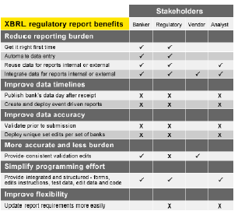
Steps involved in implementing the XBRL project
􀁺 define requirements towards future reporting platform
􀁺 analyse them regarding their fulfillment when XBRL is used
􀁺 what are the driving forces of XBRL implementation
􀁻 changes in legal regulations
􀁻 technical issues
􀁻 international adoption
􀁻 others
Conclusion
When it comes to XBRL, much is still unknown. This is true not only at the individual accounting and finance professional level, but also among the very regulators who are leading this call to action. Regardless of the many variables involved, implementation is becoming inevitable. Rather than being reactive and scrambling once mandated, forward-looking and strategic finance executives and organizations will take proactive steps to ensure their employees are ready to implement the most time- and cost-effective implementation possible.

Frequently Asked Questions

What is XBRL?
XBRL is a language for electronic communication of business and financial data, which has revolutionized business reporting around the world. It provides major benefits in the preparation, analysis and communication of business information. Moreover, it offers cost savings, greater efficiency and improved accuracy and reliability to all those involved in supplying or using financial data. XBRL stands for eXtensible Business Reporting Language. XBRL is already being put to practical use in a number of countries and implementations of XBRL are growing rapidly around the world.

Who developed XBRL?
XBRL International (XII), a not-for-profit consortium of agencies and companies internationally, developed the eXtensible Business Reporting Language (XBRL), which is an open, royalty-free software specification. XII is made up of over 650 members, which include global companies, accounting, technology, government and financial services bodies. XBRL is and will remain an open specification based on XML that is being incorporated into many accounting and analytical software tools and applications. For a current and comprehensive list of all companies participating in XBRL development, please go to http://www.xbrl.org , the website of XBRL International.

What are the advantages of XBRL?
XBRL offers major benefits at all stages of business reporting and analysis. The benefits are seen in automation, cost saving, faster, more reliable and more accurate handling of data, improved analysis and in better quality of information and decision-making. XBRL enables producers and consumers of financial data to switch resources away from costly manual processes, typically involving time-consuming comparison, assembly and re-entry of data. They are able to concentrate effort on analysis, aided by software which can validate and manipulate XBRL information. XBRL is a flexible language, which is intended to support all the current aspects of reporting in different countries and industries. Its extensible nature means that it can be adjusted to meet particular business requirements, even at the individual organization level.

Who can benefit from using XBRL?
All types of organizations can use XBRL to save costs and improve efficiency in handling business and financial information. XBRL can be adapted to a wide variety of different requirements, because of its extensible and flexible nature. All the participants in the financial information supply chain can benefit, whether they are preparers, transmitters or users of business data.

What is the future of XBRL?
XBRL is set to become the standard way of recording, storing and transmitting business and financial information. It is capable of use throughout the world, whatever the language of the country concerned, for a wide variety of business purposes. It will deliver major cost savings and gains in efficiency, improving processes in companies, governments and other organizations.

Does XBRL enhance comparability of financial statements ?
XBRL enhances the comparability of financial statements by identifying data, which is genuinely alike and distinguishing information, which is not comparable.

Does XBRL cause change in accounting standards?
No, XBRL is simply a language for transmitting information. It must accurately reflect data reported under different standards – it does not change them.

How do companies benefit by presenting financial data in XBRL?
XBRL enhances the usability of financial statement information. The need to re-key financial data for analytical and other purposes can be eliminated. By presenting its statements in XBRL, a company can benefit investors and improve its profile. Moreover, it also helps meet the requirements of regulators, lenders and others consumers of financial information, who are increasingly demanding reporting in XBRL. Thus it also helps enhance business relations and corporate image and lead to a range of benefits.
With complete adoption of XBRL, companies can automate data collection. For example, data from different company divisions with different accounting systems can be assembled quickly, cheaply and efficiently. Once data is gathered in XBRL, different types of reports using varying subsets of the data can be produced with minimum effort. A company’s finance division, for example, could quickly and reliably generate internal management reports, financial statements for publication, tax and other regulatory filings, as well as credit reports for lenders. Not only can data handling be automated, removing time-consuming, error-prone processes, but the data can be checked by software for accuracy.

How does XBRL work?
XBRL makes the data readable, with the help of two documents – Taxonomy and Instance document. Taxonomy defines the elements and their relationships based on the regulatory requirements. Using the taxonomy prescribed by the regulators, companies need to map their reports, and generate a valid XBRL instance document. The process of mapping means matching the concepts as reported by the company to the corresponding element in the taxonomy. In addition to assigning XBRL tag from taxonomy, information like unit of measurement, period of data, scale of reporting etc., needs to be included in the instance document.

How do companies create statements in XBRL?
There are a number of ways to create financial statements in XBRL:
- XBRL-aware accounting software products are becoming available which will support the export of data in XBRL form. These tools allow users to map charts of accounts and other structures to XBRL tags.
- Statements can be mapped into XBRL using XBRL software tools designed for this purpose
- Data from accounting databases can be extracted in XBRL format. It is not strictly necessary for an accounting software vendor to use XBRL; third party products can achieve the transformation of the data to XBRL.
- Applications can transform data in particular formats into XBRL. The route which an individual company may take will depend on its requirements and the accounting software and systems it currently uses, among other factors.

Is India a member of XBRL International?
India is now an established jurisdiction of XBRL International. A separate company, under section 25 has been created, to manage the operations of XBRL India. The main objectives of XBRL India are
- To create awareness about XBRL in India
- To develop and maintain Indian Taxonomies
- To help companies, adopt and implement XBRL.
For more information, visit www.xbrl.org/in

Which taxonomies have been developed for Indian reporting requirements? Where can I find them?
Taxonomies for Indian companies are developed based on the requirements of
- Schedule VI of Companies Act,
- Accounting Standards, issued by ICAI
- SEBI Listing requirements.
Taxonomies for Manufacturing and service sector (referred as Commercial and Industrial, or C&I) and Banking sector, is acknowledged by XBRL International. These taxonomies are available at http://www.xbrl.org/in/

What is an XBRL Document?
An XBRL document comprises the taxonomy and the instance document. Taxonomy contains description and classification of business & financial terms, while the instance document is made up of the actual facts and figures. Taxonomy and Instance document together make up the XBRL document.

What is Taxonomy?
Taxonomy can be referred as an electronic dictionary of the reporting concepts. Taxonomy consists of all the data definitions, the basic XBRL properties and the interrelationships amongst the concepts. It includes terms such as net income, EPS, cash, etc. Each term has specific attributes that help define it, including label and definition and potentially references. Taxonomies may represent hundreds or even thousands of individual business reporting concepts, mathematical and definitional relationships among them, along with text labels in multiple languages, references to authoritative literature, and information about how to display each concept to a user.

What is meant by extending taxonomy?
Taxonomy is extended to accommodate items/relationship specific to the owner of the information. Taxonomy extension therefore can be
  - Modification in the existing relationships
  - Addition of new elements in the taxonomy
  - Combination both a & b

Are Taxonomies based on any standards?
Yes, taxonomies are based on the regulatory requirements and standards which are to be followed by the companies. Accordingly, depending on the requirements of every country, there can be country-specific taxonomies.

What is an Instance document?
An XBRL instance document is a business report in an electronic format created according to the rules of XBRL. It contains facts that are defined by the elements in the taxonomy it refers to, together with their values and an explanation of the context in which they are placed. XBRL Instances contain the reported data with their values and “contexts”. Instance document must be linked to at least one taxonomy, which defines the contexts, labels or references.

Where can I find more information about XBRL?
Please visit www.xbrl.org

