# Q.1) int arr[]={1,2,2,3,3,4,4,4,4,5,5,5,5,5}
# alter array in such way that the element which occur most times will print first.
# sample output-arr[]={5,5,5,5,5,4,4,4,4,2,2,3,3,1};
mylist = [1,2,2,3,3,4,4,4,4,5,5,5,5,5]
freq = {}
for i in mylist:
freq[i] = freq.get(i, 0) + 1
result = []
for key, count in sorted(freq.items(), key = lambda x : x[1], reverse =True):
result.extend([key] * count)
print(result)
o/p :
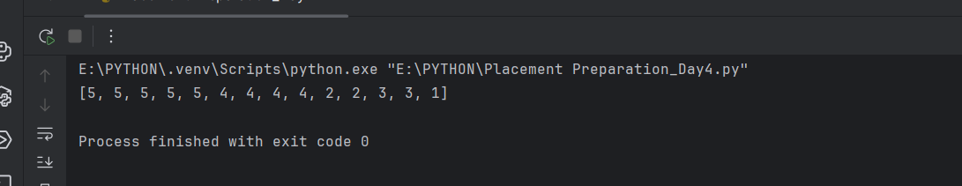
# Q.2) Write a Python program to find if a given string starts with a given character using
# Lambda.
schar = lambda s, char: s.startswith(char)
string1 = "hello world"
char1 = "h"
print(f" '{string1}' start with '{char1}'? {schar(string1, char1)}")
string2 = "python programming"
char2 = "j"
print(f"'{string2}' start with '{char2}'? {schar(string2, char2)}")
string3 = "apple"
char3 = "A"
print(f"'{string3}' start with '{char3}'? {schar(string3, char3)}")
o/p :
