# Q.4) Write a script to sort a dictionary based on its values and find the sum of middle two
# values
input_dict = {"x": 5, "y": 15, "z": 25}
sort_dict = dict(sorted(input_dict.items()))
values = list(input_dict.values())
add_values = values[0] + values[1]
print(add_values)
print(f"Sorted Dictionary: {sort_dict}")
o/p :
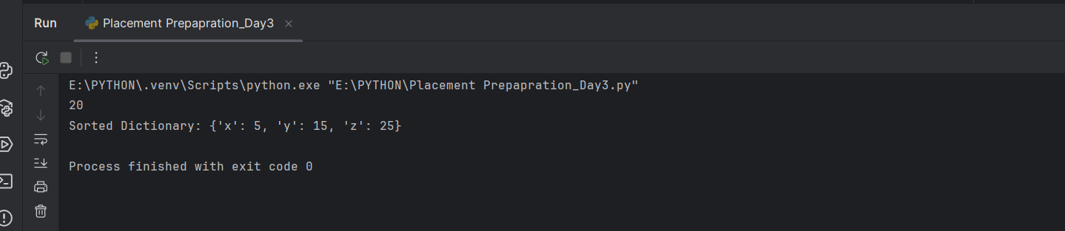

# Q.2) Write a code to catch an Exception in python?
try:
num = 10/0
except ZeroDivisionError as e:
print(e)
o/p:
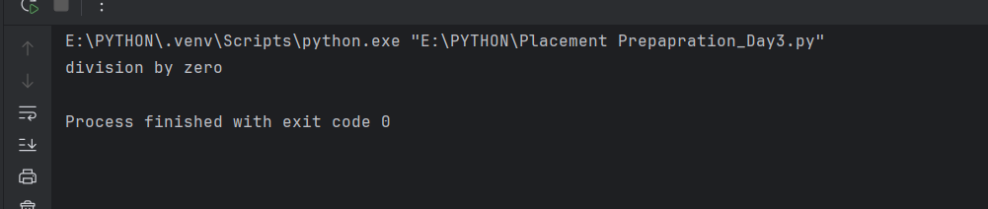

# Q.1) Write a code to Read a file and append lines to a list.
l_list = []
read = open("./details.json", "r")
for i in read:
l_list.append(i)
read.close()
print("you can read file here :")
print(l_list)
o/p:
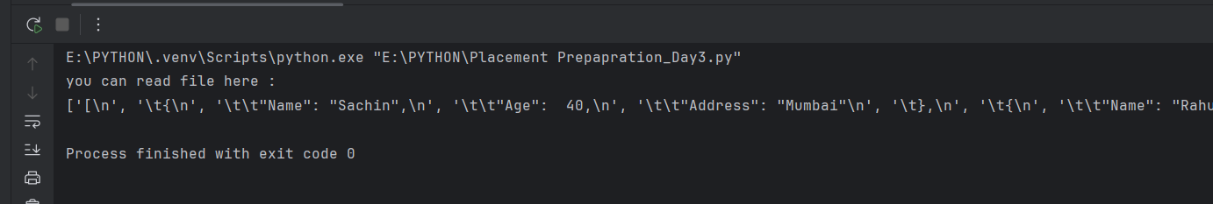

# Q.3) Write a Python function that accepts a list containing strings and integers.
# Merge all string elements using # and add all integer elements.
input_list = ['100', 'welcome', 'hi', '200', '300', 'bye', 'welldone', '500']
merge = "".join(input_list)
print(merge)
o/p :
