Q.1) Write a Python function to check whether a string is a pangram or not. Note : Pangrams are words or sentences containing every letter of the alphabet at least once. For example : "The quick brown fox jumps over the lazy dog"
Sentence = “The quick brown fox jumps over the lazy dog”
Pan_or_not = all(char in Sentence for char in string.ascii_lowercase)
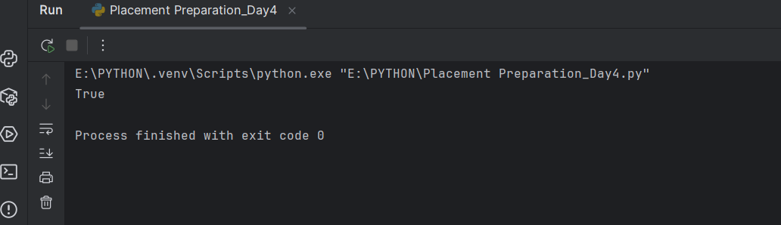
# Q.2) Write a Python program to calculate the sum of the digits in an integer.
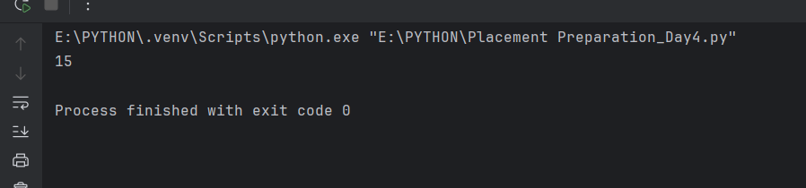
# Q.3) Write a Python program to sort three integers without using conditional statements and
# loops. [ u can use built in functions for this ]
num = [3,54,21]
num.sort()
print(num)
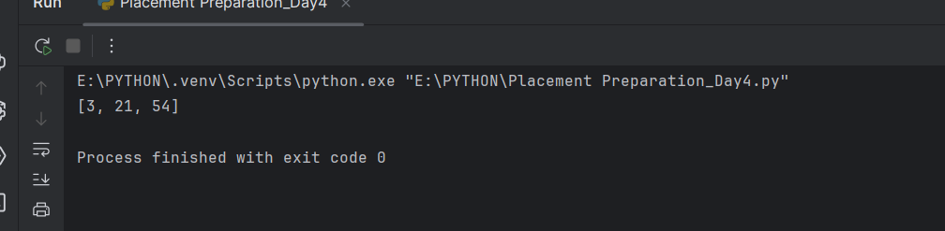
# Q.4) Write a Python function to check whether a number is perfect or not.
# According to Wikipedia : In number theory, a perfect number is a positive integer that is
# equal to the sum of its proper positive divisors, that is, the sum of its positive divisors
# excluding the number itself (also known as its aliquot sum). Equivalently, a perfect
# number is a number that is half the sum of all of its positive divisors (including itself).
# Example : The first perfect number is 6, because 1, 2, and 3 are its proper positive
# divisors, and 1 + 2 + 3 = 6. Equivalently, the number 6 is equal to half the sum of all its
# positive divisors: ( 1 + 2 + 3 + 6 ) / 2 = 6. The next perfect number is 28 = 1 + 2 + 4 + 7 +
# 14. This is followed by the perfect numbers 496 and 8128.
# def is_perfect_number(number):
# if number <= 0:
# return False # Perfect numbers are positive integers
#
# sum_of_divisors = 0
# for i in range(1, number): # Iterate from 1 up to (but not including) the number
# if number % i == 0:
# sum_of_divisors += i
#
# return sum_of_divisors == number
#
# print("6 is perfect number or not?",is_perfect_number(6))
# print("15 is perfect number or not?",is_perfect_number(15))
# print("18 is perfect number or not?",is_perfect_number(18))
