- # Q.1) Write a Python program to print all even numbers from a given list of numbers in the
# same order. Stop printing if any number that comes after 237 in the sequence is
# encountered.
numbers = [ 386, 462, 47, 418, 907, 344, 236, 375, 823, 566, 597, 978, 328, 615, 953, 345,
399, 162, 758, 219, 237, 412, 566, 731, 210, 912, 216, 244, 896, 101, 867, 355, 430 ]
for i in numbers:
if i % 2 == 0:
print(i)
elif i == 237 :
break
o/p :
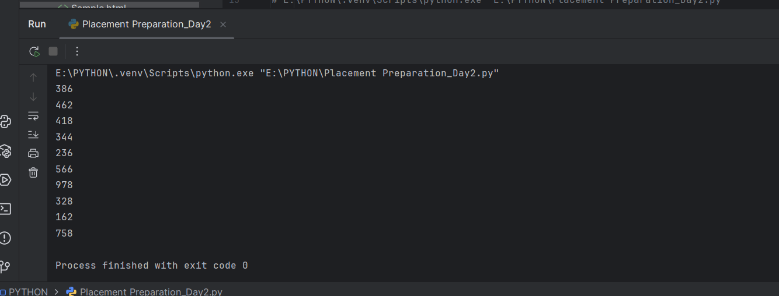

- # Q.2) Write a python program to get the path and name of the file that is currently executing
import os
current_dir = os.getcwd()
print(current_dir)
o/p :
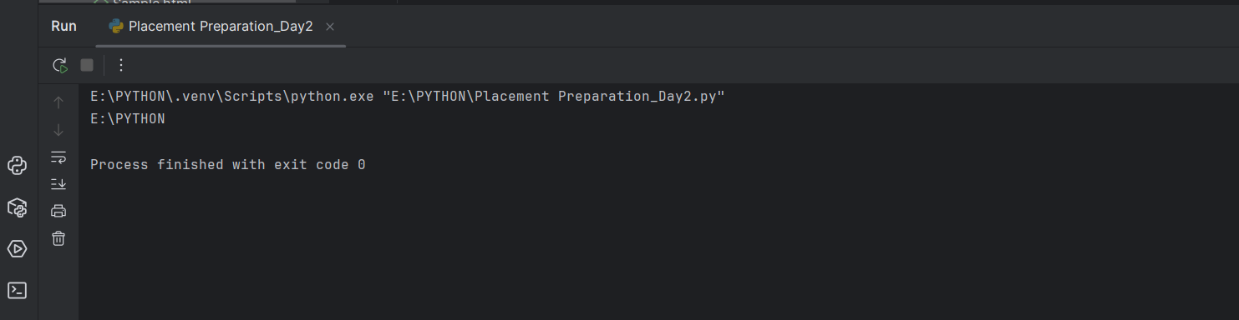
- # Q.4) Write a code to accept a number & print its digits in words .
# Ex: 321
from num2words import num2words
number = 32
inWord = num2words(number)
print(f"{number} in words {inWord}")
o/p :
