Author:

* SIDDESH N B
* 21f1004657
* 21f1004657@student.onlinedegree.iitm.ac.in
* I am also pursuing Bs Ms mathematics from IISER Bhopal

Description:

The project is a Ticket Booking application. The features that are enabled in the application are:

User Login, User registration, Admin Login, Admin registration, Admin Dashboard with Venue list, Show list, CRUD operations on the Venues and shows and then User Dashboard with show list with Booking option. The Backend of the application is

built on Flask, and the frontend is HTML with heavily built Vue components.

Technologies used

● Html

● Css

● Bootstrap

● Vue js

● Flask

● Celery

● Redis

DB Schema Design:

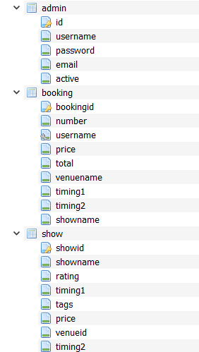

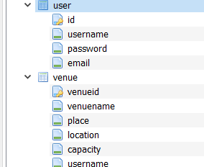

Architecture and Features:

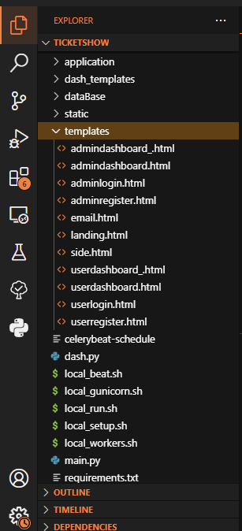

VIDEO:

<https://drive.google.com/file/d/1T1eRovFCzXDnvV-R9i_juFGPxGNx9xiR/view?usp=sharing>