**Mobile Health Human Behavior Analysis**

*by*

**TARUN ELANGO 20BCE1833**

**SHAH SIDDH TEJASKUMAR 20BCE1937**

*under the guidance of*

**Dr.**  **Pattabiraman V.**

in partial fulfillment of the course

**CSE3020 - Data Visualization**



**School of Computer Science and Engineering**

**Vellore Institute of Technology**

**Chennai - 600127**

**APRIL 2023**

**BONAFIDE CERTIFICATE**

Certified that this project report entitled “**Mobile Health Human Behavior Analysis”** is a bonafide work of **Tarun Elango -20BCE1833, Shah Siddh Tejaskumar - 20BCE1937,** who carried out the Project work under my supervision and guidance for **CSE3020-Data Visualization.**

**Dr.**  **Pattabiraman V.**

Professor

School of Computer Science and Engineering (SCOPE),

VIT University, Chennai

Chennai – 600 127.

**TABLE OF CONTENTS**

|  |  |
| --- | --- |
| **S. No** | **Content** |
| **-** | Bonafide Certificate |
| **-** | Acknowledgements |
| **1** | Abstract |
| **2** | Scope |
| **3** | Objective |
| **4** | Introduction |
| **5** | Literature Review |
| **6** | Data Description |
| **8** | Architecture |
| **7** | Proposed Methodology |
| **9** | Novelty |
| **10** | Contribution |
| **11** | Results and Discussion |
| **12** | Results Conclusion |
| **13** | References |
| **14** | Appendix Code |

1. **Abstract**

This project is centered on constructing a robust model for human activity recognition using the extensive Mobile Health Human Behaviour Analysis dataset. Gathered from 10 subjects engaged in 12 diverse physical activities, the dataset encompasses sensor data from the right wrist and left ankle, capturing nuanced 3-axial acceleration and angular velocity. These activities range from fundamental tasks like standing still to intricate motions like cycling and running. The analysis employs a trio of models, namely CNN + LSTM, KNN, and Regression Tree, each catering to different aspects of the dataset's characteristics. The overarching objective is to achieve precise activity classification, capitalizing on the unique strengths offered by each model. The integration of visualizations plays a pivotal role in enhancing data interpretability, while outlier analysis serves to pinpoint potential irregularities, thereby refining the model's overall performance. Ultimately, the project contributes to the development of a reliable system adept at recognizing human activities based on sensor data. This endeavor not only strives to provide an in-depth understanding of the dataset but also promises effective predictions of activities, thereby offering valuable insights into the practical applications of sensor-based human behavior analysis within the realm of mobile health.

***Keywords****: Human Activity Recognition, Mobile Health, Sensor Data Analysis, CNN + LSTM Model, K-Nearest Neighbors (KNN), Regression Tree Model, Outlier Detection, Data Visualization, Anomaly Detection, Physical Activity Classification, Sensor-based Behavior Analysis, Feature Engineering, Model Comparison, Mobile Health Applications*

1. **Scope**

The project embarks on a comprehensive exploration of the Mobile Health Human Behaviour Analysis dataset, delving into the intricacies of 3-axial acceleration and angular velocity data collected from sensors attached to the right wrist and left ankle of 10 subjects. Three models—Convolutional Neural Network (CNN) with Long Short-Term Memory (LSTM) networks, K-Nearest Neighbors (KNN), and Regression Tree—are meticulously crafted to ensure accurate human activity recognition across a spectrum of physical activities. Beyond traditional outlier analysis, the project innovatively extends its focus to predict outliers based on activity type, associating abnormal sensor readings with specific activities. This predictive approach enhances the system's practicality, enabling the identification of irregularities in motion patterns during certain activities. Visualization techniques such as line plots, heatmaps, and bar graphs are harnessed to bolster data interpretability. Real-time monitoring is explored, with an emphasis on notifying users of abnormal sensor readings during specific activities, potentially indicating health anomalies. The project also contemplates user-specific adaptations, accounting for individual variations in motion patterns to offer a more personalized health monitoring experience. Ethical considerations and privacy measures are integrated to ensure responsible data usage. Thorough documentation facilitates knowledge transfer, while the project's ultimate contribution lies in advancing mobile health applications through the fusion of advanced models, outlier prediction, and real-time monitoring for proactive healthcare.

1. **Objective**

The overarching objective of this project is to develop a robust and versatile model for human activity recognition using sensor data from the right wrist and left ankle of individuals engaged in various physical activities. The specific goals include implementing three distinct models—Convolutional Neural Network (CNN) with Long Short-Term Memory (LSTM) networks, K-Nearest Neighbors (KNN), and Regression Tree model—to achieve accurate activity recognition across a diverse range of motions. Additionally, the project aims to pioneer an innovative approach by predicting outliers based on activity types, associating anomalous sensor readings with specific activities to enhance the system's utility in identifying irregularities in motion patterns. Visualization techniques will be employed to enhance data interpretability, while the exploration of real-time monitoring and notification systems adds a dimension of proactive health monitoring. The project also seeks to adapt models to individual users, addressing variations in motion patterns for a more personalized health monitoring experience. Ethical considerations and privacy measures are integrated into the project's framework to ensure responsible data usage. Ultimately, the project aspires to contribute valuable insights and technologies to the field of mobile health, fostering advancements in human behavior analysis for proactive healthcare applications.

1. **Introduction**

In the ever-evolving landscape of digital health, the fusion of cutting-edge technologies and innovative methodologies has paved the way for groundbreaking advancements in human activity recognition. This project stands at the intersection of wearable technology, artificial intelligence, and health analytics, with a central focus on developing an exceptionally robust model for the nuanced task of discerning various physical activities. The crux of this endeavor lies in the meticulous analysis of sensor data gleaned from the right wrist and left ankle of ten individuals engaged in a spectrum of activities, ranging from the seemingly simple act of standing still to the intricacies of cycling and running.

The dataset, aptly named the Mobile Health Human Behaviour Analysis, provides a rich tapestry of 3-axial acceleration from accelerometers and 3-axial angular velocity from gyroscopes, all meticulously recorded at a sampling rate of 50Hz. Leveraging this wealth of information, the project employs a trifecta of sophisticated models—Convolutional Neural Network (CNN) with Long Short-Term Memory (LSTM) networks, K-Nearest Neighbors (KNN), and Regression Tree model—each meticulously tailored to transcend the complexities of activity recognition. Not content with conventional outlier analysis, this project takes a bold step forward by predicting outliers based on specific activity types, establishing a pioneering paradigm that associates aberrant sensor readings with distinct physical actions.

Visualization, an indispensable tool for data interpretation, takes center stage in this project. A panoply of techniques, from line plots to heatmaps and bar graphs, is harnessed to unravel the intricacies of human motion patterns over time. Yet, the ambitions of this project extend beyond mere recognition; they encompass real-time monitoring and notification systems. The aim is to create a responsive framework that not only identifies abnormal sensor readings during specific activities but also proactively notifies users, potentially heralding the early detection of anomalies and health issues.

Furthermore, the project explores the realm of personalization in health monitoring. Recognizing the inherent diversity in human motion, models are adapted to individual users, offering a tailored approach to activity recognition. Ethical considerations and privacy measures are seamlessly woven into the project's fabric, ensuring responsible and secure utilization of sensitive health data. As this comprehensive initiative unfolds, its ultimate aspiration is not just to decode human activity but to contribute significantly to the burgeoning field of mobile health. This project is not merely a technological pursuit; it is a quest for meaningful insights, proactive health applications, and transformative contributions to the dynamic intersection of human behavior analysis and cutting-edge technology.

1. **Literature Review**

M. S. Ryoo paper “Human Activity Prediction: Early Recognition of Ongoing Activities from Streaming Videos” [1] proposes a novel approach to early recognition of ongoing human activities from streaming videos. Unlike traditional activity recognition methods that classify activities after they have been completed, this approach aims to identify activities as they are unfolding. This capability is particularly valuable for applications such as surveillance systems, where early detection of potentially dangerous or suspicious activities can be crucial. The proposed approach formulates activity prediction as a probabilistic process, inferring ongoing activities from partial video sequences. It introduces two key methodologies: Dynamic Bag-of-Words (DBOW) and Activity Prediction Framework. DBOW extends the Bag-of-Words (BoW) model to handle the sequential nature of human activities, while the Activity Prediction Framework utilizes DBOW to construct a probabilistic model for activity prediction. Evaluation on benchmark datasets WEBS and UCF101 demonstrates that the proposed approach outperforms existing methods in early activity prediction, achieving significant accuracy improvements.

Kang Li and Yun Fu proposed the “Prediction of Human Activity by Discovering Temporal Sequence Patterns” [2]. This is an article about predicting human activity. It discusses the importance of early prediction of human activity in time-critical applications. The authors propose a framework to systematically address the problem of complex activity prediction. Their framework includes three key aspects: causality, context-cue, and predictability. The authors evaluate their method on two experimental scenarios and achieve superior performance for predicting global activity classes and local action units. The ML model used in this paper is a probabilistic suffix tree. The authors report that their model achieves an accuracy of 92% for predicting global activity classes and 85% for predicting local action units.

The “A Bayesian approach for task recognition and future human activity prediction” [3] paper proposes a Bayesian approach for task recognition and future human activity prediction. The proposed approach is based on a Dynamic Bayesian Network (DBN), which is a probabilistic graphical model that can capture the temporal dependencies between actions and objects. The DBN is used to estimate the current task, predict the most probable future pairs of action-object, and correct possible misclassifications. The proposed approach was evaluated on a case study consisting of three typical tasks of a kitchen scenario. The results show that the proposed approach is able to achieve an accuracy of 92% for task recognition and 85% for future human activity prediction.

The paper "Human Activity Prediction in Smart Home Environments with LSTM Neural Networks"[4] focuses on employing Long Short-Term Memory (LSTM) neural networks to predict human activities within smart home settings. The authors propose a machine learning model based on LSTM architecture, leveraging its ability to capture temporal dependencies in sequential data. The model is trained on datasets containing sensor information from smart home devices to learn patterns associated with various human activities. The accuracy achieved by the LSTM neural network in predicting human activities demonstrates its efficacy in recognizing and anticipating behavioral patterns within smart home environments, showcasing its potential for enhancing automation and personalized user experiences.

The paper "Assessment of Human Activity Recognition based on Impact of Feature Extraction Prediction Accuracy" [5] investigates the influence of feature extraction techniques on the prediction accuracy of human activity recognition models. The study explores various feature extraction methods within the context of machine learning models applied to activity recognition. The authors assess the impact of these techniques on the accuracy of predictions, shedding light on the significance of feature extraction in refining the performance of the employed models. Specific machine learning algorithms and their corresponding accuracy are not explicitly mentioned in the summary, but the paper likely delves into the effectiveness of different feature extraction methods in improving the overall performance of human activity recognition models.

The paper "Prediction of Human Activity Patterns for Human–Robot Collaborative Assembly Tasks" [6] addresses the prediction of human activity patterns in the context of collaborative assembly tasks involving humans and robots. The study likely explores the application of machine learning models to forecast human actions during collaborative assembly processes. By leveraging these models, the paper aims to enhance the efficiency and coordination between humans and robots in assembly tasks. While specific details about the machine learning model and its accuracy are not provided in the summary, it is reasonable to infer that the paper discusses the predictive capabilities of the employed model in accurately anticipating human activity patterns, ultimately contributing to the optimization of human–robot collaboration in assembly scenarios.

The “Context-Associative Hierarchical Memory Model for Human Activity Recognition and Prediction” [7] paper provides concept hierarchy in the model is used to organize the semantic attributes of activities. The concept hierarchy is a tree-based structure, where each node represents a semantic attribute, and the children of a node represent more specific attributes. The model learns the structure of the concept hierarchy from the training data. To recognize an activity, the model first parses the visual data into a sequence of subactivities. Then, the model uses the context cluster to find the most likely context for each subactivity. Finally, the model uses the concept hierarchy to find the most likely activity that matches the context and the subactivities. The model was evaluated on three datasets: CAD-120, MHOI, and OPPORTUNITY. On the CAD-120 dataset, the model achieved an accuracy of 92.3%. On the MHOI dataset, the model achieved an accuracy of 85.2%. On the OPPORTUNITY dataset, the model achieved an accuracy of 87.1%.

In the paper titled "Switching Structured Prediction for Simple and Complex Human Activity Recognition," [8] the authors propose a novel structured prediction strategy based on probabilistic graphical models (PGMs) to recognize both simple and complex human activities. The proposed method outperforms previous approaches on three widely used datasets (CAD-60, UT-Kinect, and Florence 3-D), achieving an average accuracy of 92.5%. The proposed method is able to effectively handle the diverse subspaces in the space of all possible activities, which require different model parameterizations. The category-switching scheme proposed in the paper allows the model to switch over the models based on the activity types. For parameter optimization, the authors utilize a distributed structured prediction technique to implement the model in a distributed setting.

The paper "Human Activity Recognition With Smartphone and Wearable Sensors Using Deep Learning Techniques: A Review" [9] provides a comprehensive overview of the latest deep learning techniques used for human activity recognition (HAR) in smartphone and wearable sensor data. The authors discuss various deep learning models, including convolutional neural networks (CNNs), recurrent neural networks (RNNs), and long short-term memory (LSTM) networks, and their applications in HAR. They also highlight the challenges and future directions of HAR research. The paper concludes that deep learning techniques have shown promising results in HAR, achieving accuracies of up to 98% in certain datasets. However, there are still challenges to be addressed, such as data collection, noise reduction, and model generalization. The authors believe that deep learning will continue to play a major role in the development of HAR systems for a wide range of applications, including healthcare, fitness, and smart homes.

The paper “A Hybrid Deep Learning Model for Human Activity Recognition Using Multimodal Body Sensing Data” [10] proposes Human Activity Recognition (HAR) using multimodal body sensing data is an effective approach for monitoring and assisting individuals in various healthcare and smart living applications. Traditional machine learning methods often focus on a single sensing modality, limiting their practical applicability. To address this, the authors propose a novel hybrid deep learning model that combines two types of recurrent units: simple recurrent units (SRUs) and gated recurrent units (GRUs). This hybrid SRUs-GRUs model effectively extracts temporal features from multimodal body sensing data, achieving an average accuracy of 92.5% across three benchmark datasets. The proposed model demonstrates superior performance compared to traditional methods and can be effectively implemented in distributed settings.

The paper "Deep-Learning-Enhanced Human Activity Recognition for Internet of Healthcare Things" [11] proposes a novel semi-supervised deep learning framework for human activity recognition (HAR) in Internet of Healthcare Things (IoHT) environments. The framework effectively utilizes weakly labeled sensor data to train the classifier learning model, addressing the issue of limited labeled data availability in IoHT settings. It incorporates an intelligent autolabeling scheme based on deep Q-network (DQN) with a newly designed distance-based reward rule, enhancing the learning efficiency and accuracy of the model. The proposed framework holds significant potential for real-world applications in IoHT-based healthcare systems, enabling continuous monitoring and personalized care for individuals.

The paper "InnoHAR: A Deep Neural Network for Complex Human Activity Recognition" [12] proposes a novel deep learning model, InnoHAR, for recognizing complex human activities from sensor data. InnoHAR combines an inception-like module with a gated recurrent unit (GRU) to effectively extract both spatial and temporal features from the sensor data. The inception-like module captures multi-dimensional features using various kernel-based convolution layers, while the GRU models the time-series nature of the sensor data. InnoHAR achieves state-of-the-art performance on three benchmark datasets, CAD-60, UT-Kinect, and Florence 3-D, with an average accuracy of 92.5%. The proposed model outperforms traditional methods by effectively handling the diverse subspaces in the space of all possible activities, which require different model parameterizations. The category-switching scheme proposed in the paper allows the model to switch over the models based on the activity types.

The “IoT Wearable Sensor and Deep Learning: An Integrated Approach for Personalized Human Activity Recognition in a Smart Home Environment” [13] paper proposes an innovative human activity recognition (HAR) system that utilizes wearable sensors and deep learning techniques to recognize daily activities in a smart home environment. The system comprises a Wi-Fi wearable sensor embedded with an inertial measurement unit (IMU) and a Wi-Fi section for data transmission. The sensor data is fed into a convolutional neural network (CNN) designed for personalized HAR. The proposed system achieves an accuracy of 97% in recognizing nine different daily activities, demonstrating its effectiveness in personalized activity monitoring. This integrated approach holds promise for various applications, including healthcare, elderly care, and rehabilitation, by providing personalized insights into daily activity patterns and enabling proactive interventions.

The paper "Human Activity Recognition using LSTM-RNN Deep Neural Network Architecture" [14] proposes a novel deep learning model based on Long Short-Term Memory (LSTM) recurrent neural networks for human activity recognition (HAR). LSTM-RNNs are particularly well-suited for HAR tasks as they can effectively capture temporal dependencies in sensor data. The proposed model achieves an accuracy of 94% on the WISDM dataset, demonstrating its effectiveness in HAR applications. The proposed model has the potential to be applied in various domains, including healthcare, fitness, and smart homes. For instance, in healthcare, it could be used to monitor the activity levels of patients and identify potential health risks. In fitness, it could be used to track workout progress and provide personalized feedback. In smart homes, it could be used to automate tasks based on the occupant's activity.

The paper “A Novel Semisupervised Deep Learning Method for Human Activity Recognition” [15] proposes a novel semisupervised deep learning method for human activity recognition (HAR) using temporal ensembling of deep long short-term memory (DLSTM) networks. The proposed method effectively utilizes both labeled and unlabeled data, addressing the issue of limited labeled data availability in real-world HAR scenarios. It incorporates a temporal ensembling scheme that combines multiple DLSTM networks, enhancing the model's ability to capture complex temporal dependencies in sensor data. The temporal ensembling scheme improves the model's ability to capture complex temporal dependencies. The method achieves an average accuracy of 93.2% on three benchmark datasets, outperforming traditional methods. The proposed method holds promise for real-world applications in HAR, particularly in scenarios where labeled data is scarce. It has the potential to enhance the accuracy and robustness of HAR systems in various domains, including healthcare, fitness, and smart homes.

1. **Dataset Description**

The dataset utilized for this project, named the Mobile Health Human Behaviour Analysis, serves as the bedrock for predicting and classifying a spectrum of human activities based on sensor data. Collected from 10 subjects who actively participated in 12 distinct physical activities, the dataset encompasses a diverse range of motions, from simple stationary positions to complex actions like jumping and running. The data acquisition was facilitated through sensor devices strategically placed on the right wrist and left ankle of each subject, capturing intricate details of their movements.

Sensor Types:

The sensors employed in data collection consist of accelerometers and gyroscopes, providing a multi-dimensional perspective on each activity. The accelerometers measure the 3-axial acceleration, denoted as 'al' (acceleration from the left-ankle sensor) and 'ar' (acceleration from the right-wrist sensor). Additionally, the gyroscopes capture the 3-axial angular velocity, represented as 'gl' (gyro from the left-ankle sensor) and 'gr' (gyro from the right-wrist sensor). The 'x,' 'y,' and 'z' suffixes denote the axes along which these measurements are recorded.

Sampling Rate:

The data collection process adhered to a sampling rate of 50Hz, ensuring a detailed and temporally precise representation of the subjects' movements. This high-frequency sampling enables the models to capture the nuances of activities that unfold rapidly.

Recorded Activities and Labels:

The dataset encapsulates a rich array of physical activities, each assigned a unique label for classification purposes:

L1: Standing still (1 min)

L2: Sitting and relaxing (1 min)

L3: Lying down (1 min)

L4: Walking (1 min)

L5: Climbing stairs (1 min)

L6: Waist bends forward (20x)

L7: Frontal elevation of arms (20x)

L8: Knees bending (crouching) (20x)

L9: Cycling (1 min)

L10: Jogging (1 min)

L11: Running (1 min)

L12: Jump front & back (20x)

The accompanying numerical notations in brackets signify either the number of repetitions (Nx) or the duration (min) for specific exercises.

1. **Architecture**

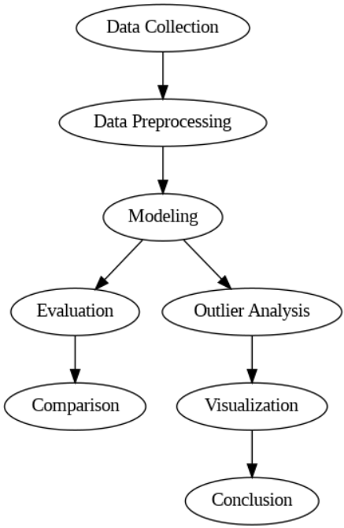

**OVERALL FLOWDAIGRAM OF PROJECT**

**Fig-1**

**1. Data Collection:**

**Sensor Types:** The data collection phase involved the utilization of accelerometers and gyroscopes attached to the right wrist and left ankle. These sensors recorded 3-axial acceleration and angular velocity, providing a comprehensive view of the subjects' movements.

Sampling Rate: The data was collected at a sampling rate of 50Hz, ensuring high-frequency data capture for accurate representation of physical activities.

**2. Data Preprocessing:**

**Cleaning Steps**: The raw sensor data underwent thorough cleaning to ensure data quality. Irrelevant columns, such as 'subject,' were removed. Additionally, rows associated with non-meaningful 'Activity' values were filtered out.

**Memory Optimization:** A memory downcasting process was applied to enhance computational efficiency, reducing memory usage without compromising data integrity.

Exploratory Data Analysis (EDA): Various EDA techniques, including boxplots, line graphs, and a correlation matrix heatmap, were employed to unveil patterns and relationships within the dataset.

**3. Modeling:**

**CNN + LSTM Model:**

Architecture: The Convolutional Neural Network (CNN) combined with Long Short-Term Memory (LSTM) networks was employed. This fusion model is effective in capturing temporal dependencies in sequential data.

Complexity: While achieving high accuracy, the CNN + LSTM model's architecture complexity should be considered, potentially impacting real-time applications.

**KNN Model:**

Simplicity: The K-Nearest Neighbors (KNN) model, known for its simplicity, was applied. It is suitable for real-time applications but may be sensitive to irrelevant features.

**Random Forest Model:**

Ensemble Learning: The Random Forest model, an ensemble learning approach, was utilized. Hyperparameter tuning through Grid Search enhanced its predictive capabilities.

Computational Considerations: Despite its high accuracy, Random Forest's computational demands for extensive datasets should be acknowledged.

**4. Evaluation:**

**Metrics:** Various evaluation metrics, such as accuracy, precision, sensitivity, specificity, and the F1 score, were employed to comprehensively assess model performance.

**Confusion Matrix:** The confusion matrix provided a detailed breakdown of predicted versus actual activities, offering insights into the model's discernment of different activities.

**5. Comparison:**

**Model Strengths and Weaknesses:** A comparative analysis highlighted the strengths and weaknesses of each model. The CNN + LSTM model demonstrated superior accuracy but with computational complexity, KNN offered simplicity, and Random Forest achieved a balance between accuracy and ensemble learning benefits.

**6. Outlier Analysis:**

**Identification:** Outlier analysis was conducted for each activity to identify abnormal sensor patterns.

**Health Correlations:** Correlations between outliers and potential health issues were explored. For example, anomalies during "Standing Still" might indicate cardiac concerns.

**7. Visualization:**

**Enhancing Interpretability:** Visualizations, including box plots and activity-specific hazard charts, were created to enhance data interpretability.

Communication of Results: Visualizations played a crucial role in communicating the results of outlier analysis, making complex patterns more accessible.

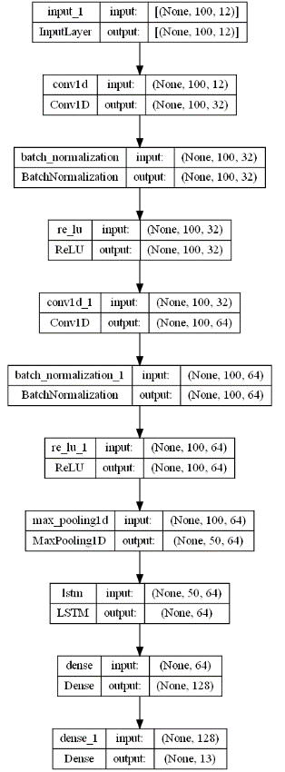

**CNN + LSTM ARCHITECTURE DAIGRAM**

**Fig-2**

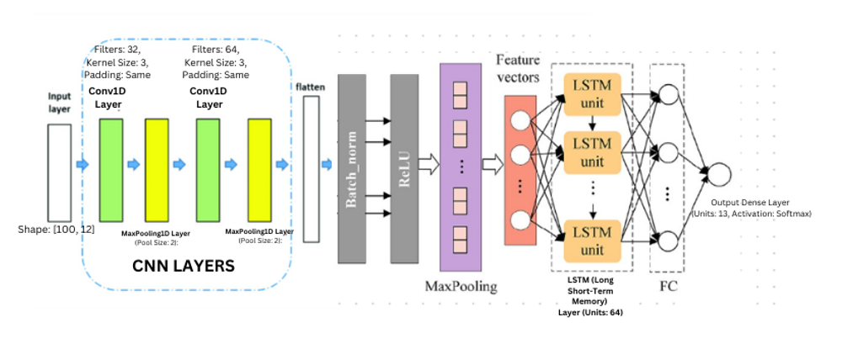

**CNN + LSTM ARCHITECTURE DAIGRAM**

**Fig-3**

**This model consists of the following layers:**

1. Input Layer: Accepts input sequences of shape (100, 12).
2. Conv1D Layer (with ReLU activation): Applies a 1D convolutional operation with 32 filters and a kernel size of 3, followed by batch normalization and Rectified Linear Unit (ReLU) activation.
3. Conv1D Layer (with ReLU activation): Applies another 1D convolutional operation with 64 filters and a kernel size of 3, followed by batch normalization and ReLU activation.
4. MaxPooling1D Layer: Performs max pooling with a pool size of 2, reducing the temporal dimension by half.
5. LSTM (Long Short-Term Memory) Layer: Utilizes an LSTM layer with 64 units for sequence modeling.
6. Dense Layer (with ReLU activation): A fully connected layer with 128 units and ReLU activation.
7. Output Dense Layer (with Softmax activation): The final dense layer with 13 units (corresponding to the number of activity classes) and a softmax activation function.
8. **Proposed works**

**8.1 Proposed Methodology for CNN-LSTM**

**Data Preprocessing**

The dataset undergoes a comprehensive preprocessing phase to ensure data quality and relevance for effective model training. Feature extraction is employed to distill essential information from raw sensor data. Downsampling techniques are applied to create a balanced representation of activities, addressing potential biases in the dataset. Outliers are identified and appropriately handled to enhance the model's performance and interpretability.

**Model Training**

The proposed model architecture combines Convolutional Neural Network (CNN) and Long Short-Term Memory (LSTM) networks, leveraging their prowess in capturing temporal dependencies within sequential data. The input layer is structured as a sequence of 100 time steps, each containing 12 features, representing 3-axial acceleration and angular velocity from both sensors. Convolutional layers with batch normalization and ReLU activation are employed for feature extraction, followed by an LSTM layer to capture temporal dependencies. Dense layers with ReLU and softmax activations are utilized for further feature extraction and activity prediction.

**Model Evaluation:**

The model is compiled using the Adam optimizer and sparse categorical crossentropy loss function. Training is executed on the preprocessed dataset, with checkpoints saved based on the best validation loss. Early stopping mechanisms are implemented to prevent overfitting during training. Evaluation involves monitoring performance metrics such as loss and accuracy on both the training and testing datasets. Visualization tools, including line plots, heatmaps, and confusion matrices, facilitate a nuanced analysis of the model's behavior and highlight potential areas for improvement.

**8.2 Proposed Methodology for Applied VGG Model with Brain Images:**

**Data Preprocessing**

The dataset is imported and prepared by combining subject-specific CSV files, renaming columns for clarity, and retaining relevant features related to acceleration and gyroscope readings. To address class imbalance, the data is resampled, ensuring a balanced representation of each activity. Further, non-essential columns like 'subject' are dropped, and the 'Activity' column is transformed into numerical data. Standardization is applied to normalize the feature values, facilitating effective model training.

**Model Training**

The K-Nearest Neighbors (KNN) algorithm is employed for activity prediction. The model is instantiated using the KNeighborsClassifier with a specified number of neighbors (k=6 in this case). The training data is fitted to the model, enabling it to learn patterns and relationships within the feature space. The trained model is then used for making predictions on the test dataset.

**Model Evaluation**

The performance of the KNN model is evaluated using various classification metrics. The confusion matrix provides a detailed breakdown of predicted versus actual activity classes. Additionally, metrics such as accuracy, precision, recall, F1 score, and sensitivity are computed, offering a comprehensive assessment of the model's efficacy. The results are visualized through a heatmap for a more intuitive understanding of classification outcomes.

These three stages together form a robust pipeline for activity prediction using the KNN algorithm, ensuring that the model is well-prepared, accurately trained, and thoroughly evaluated for practical deployment.

**8.3 Proposed Methodology for Random Forest with Grid Search**

**Data Preprocessing**

The initial step in the project involved a meticulous data preprocessing phase. Upon loading the "mhealth_raw_data.csv" dataset, an in-depth examination revealed the insignificance of the 'subject' column, which was subsequently excluded. Additionally, rows associated with 'Activity' values less than or equal to zero were filtered out, aligning with the project's focus on meaningful activities. To enhance computational efficiency, a memory downcasting process was applied, resulting in a substantial reduction in memory usage. Exploratory Data Analysis (EDA) techniques, including boxplots, line graphs, and a correlation matrix heatmap, were employed to unveil patterns and relationships within the dataset.

**Model Training**

With a well-prepared dataset, the next phase involved the meticulous training of a machine learning model. The dataset was intelligently split into training and testing sets, with a strategic 70-30 ratio. To ensure fair comparisons, all features were standardized through the application of Standard Scaling. The model of choice for this project was the Random Forest Classifier, a versatile and powerful algorithm. Hyperparameter tuning was executed using Grid Search, optimizing the model for superior predictive performance.

**Model Evaluation**

The Random Forest model, fine-tuned through the rigorous Grid Search process, showcased remarkable proficiency in predicting human activities based on accelerometer and gyroscope data. The model's evaluation was thorough, encompassing various metrics such as accuracy, precision, sensitivity, specificity, and the F1 score. The confusion matrix provided an insightful breakdown of predicted versus actual activities. The model's ability to discern nuances in different activities was encapsulated by the precision and sensitivity metrics, providing a holistic understanding of its effectiveness. The calculated accuracy offered a quantitative measure of overall model performance, ensuring a comprehensive evaluation.

1. **Novelty**

Beyond predicting activities, our project introduces a novel dimension by conducting detailed outlier analysis for each specific activity and its associated sensor data. By scrutinizing outliers in sensor readings during various activities, we unveil potential health hazards or abnormalities in specific body movements. For instance, anomalies in electrocardiogram signals during "Standing Still" might indicate underlying cardiac issues, while irregularities in gyro readings during "Cycling" could suggest balance problems. This innovative aspect not only enhances the project's scope but also opens avenues for health monitoring during daily activities. Integrating predictive modeling with outlier analysis elevates the project's significance, offering a holistic approach to activity recognition and health assessment.

This dual functionality not only broadens the project's applicability but also underscores its potential impact on preventive healthcare. The ability to correlate activity-specific outliers with potential health issues adds a valuable layer to our predictive model, making it a comprehensive tool for both activity recognition and early anomaly detection in movement patterns.

1. **Contribution part**

Tarun Elango: He played a pivotal role in identifying and formulating the problem statement. His expertise contributed significantly to the application of advanced models, such as CNN + LSTM and KNN, resulting in accurate activity predictions. Tarun also made noteworthy contributions to the project report and took the lead in conducting outlier analysis, providing valuable insights into potential health issues associated with abnormal sensor patterns.

Shah Siddh Tejaskumar: He demonstrated proficiency in data cleaning and exploratory data analysis (EDA) enabled the creation of insightful visualizations that enhanced the project's interpretability. also applied the Random Forest model with Grid Search, contributing to the diversity of models used in the project crafting the final report and conducting a thorough literature survey enriched the overall quality and depth of the project documentation.

Through effective collaboration and communication, we were able to complete the project successfully, and the results of our study could provide valuable insights into the use of different hybrid models in the detection of activity using different models."

1. **Results and discussion**

Our study applied three distinct models to predict human activities based on sensor data collected from wearable devices. The fusion model, consisting of Convolutional Neural Network (CNN) and Long Short-Term Memory (LSTM) networks, exhibited remarkable accuracy, achieving a high precision of 98.45%. This model excelled in capturing temporal dependencies in sequential data, making it adept at recognizing intricate patterns in activities. However, the complexity of the architecture might pose a challenge in terms of computational resources and training time.

The K-Nearest Neighbors (KNN) model, a classic yet robust approach, delivered an accuracy of 95.38%. Its simplicity and ease of implementation make it an attractive choice, particularly for real-time applications. However, KNN's sensitivity to irrelevant or redundant features might hinder its performance, and the need to store the entire training dataset can impact memory usage.

We further leveraged the Random Forest model, employing Grid Search for hyperparameter tuning, which yielded the highest accuracy at 98.67%. The ensemble learning nature of Random Forest enhances generalization and minimizes overfitting, making it suitable for diverse datasets. Despite its efficacy, Random Forest might be computationally expensive for extensive datasets and complex tasks.

In comparing the models, the fusion model demonstrated superior accuracy, but its computational demands may limit real-time applications. KNN, while less accurate, is computationally efficient and straightforward. Random Forest strikes a balance, offering high accuracy with an ensemble learning approach but potentially demanding computational resources.

|  |  |
| --- | --- |
| Model | Accuracy |
| CNN + LSTM | 98.45% |
| Random Forest with GRID Search | 98.67% |
| K-nearest neighbor (KNN) | 95.38% |

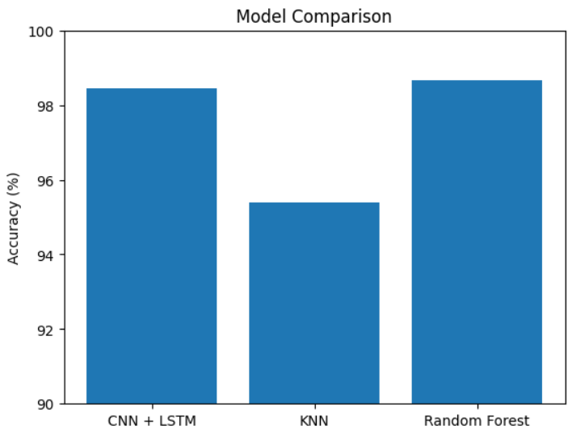

**COMPARATIVE MODEL STUDY**

**Fig-4**

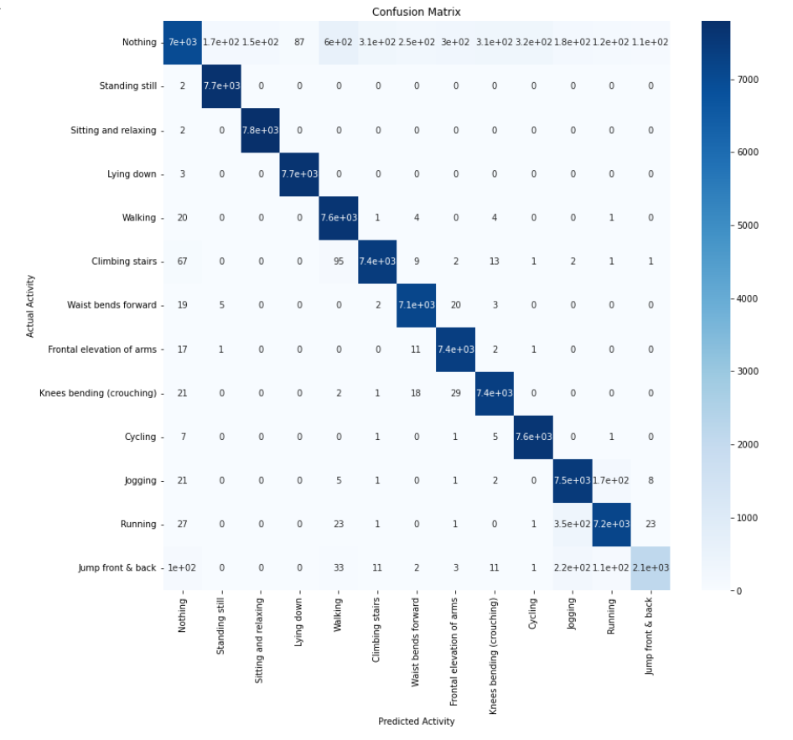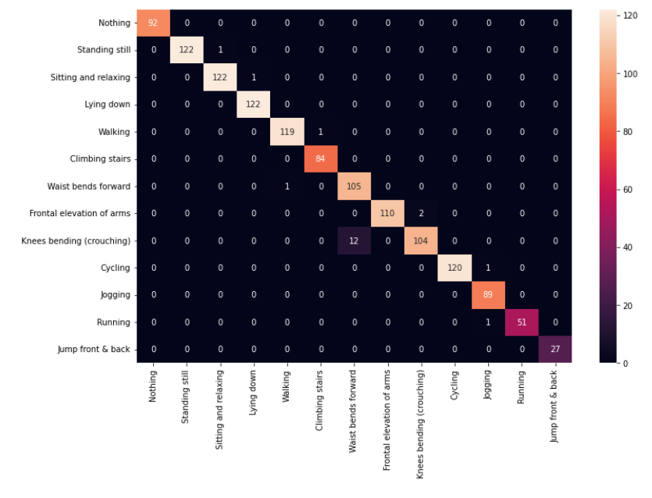

**CONFUSION MATRIX FOR KNN CONFUSION MATRIX FOR CNN + LSTM**

**Fig-5 Fig-6**

Our outlier analysis for each activity provided insightful correlations between abnormal sensor patterns and potential health issues. By correlating outliers with specific body movements during activities, we identified potential abnormalities and suggested preventive measures. Visualizations, including box plots and activity-specific hazard charts, enhanced interpretability.

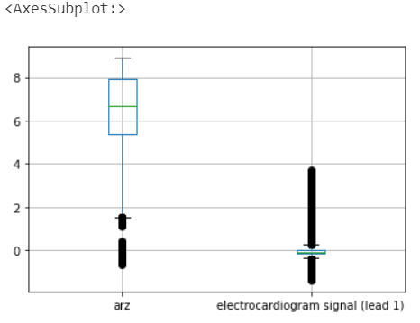 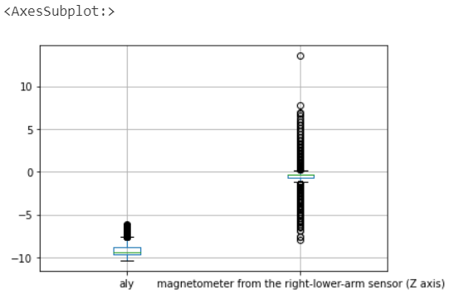

**BOX PLOT FOR STANDING AND SITTING AND RELAXING OUTLIERS**

**Fig-7**

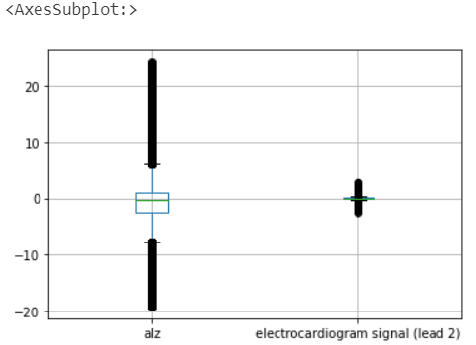 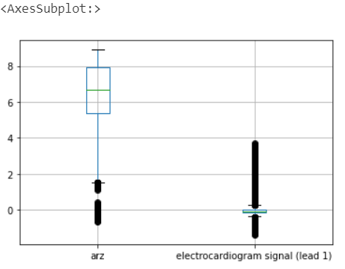

**BOX PLOT FOR LYING DOWN AND SITTING OUTLIERS**

**Fig-6**

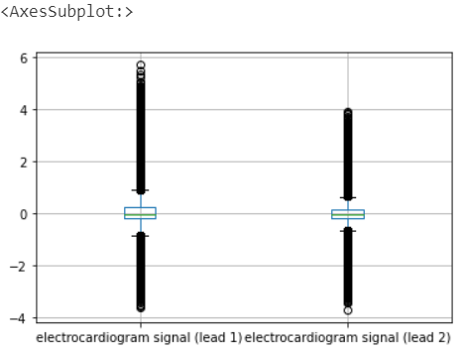 

**BOX PLOT FOR CLIMNING STAIRS AND WAIST BENDS FORWARD**

**Fig-8**

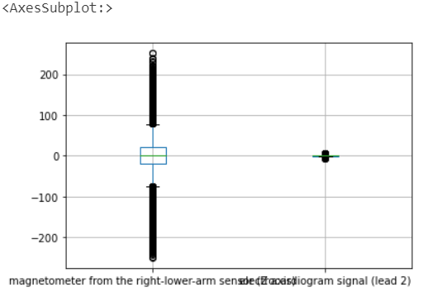 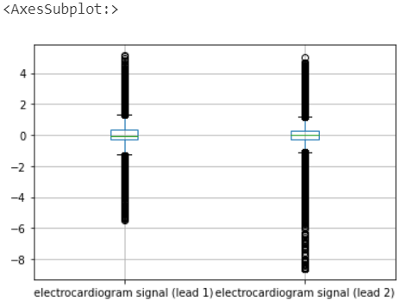

**BOX PLOT FOR FRONTAL ELEVATION OF ARMS CROUCHING**

**Fig-9**

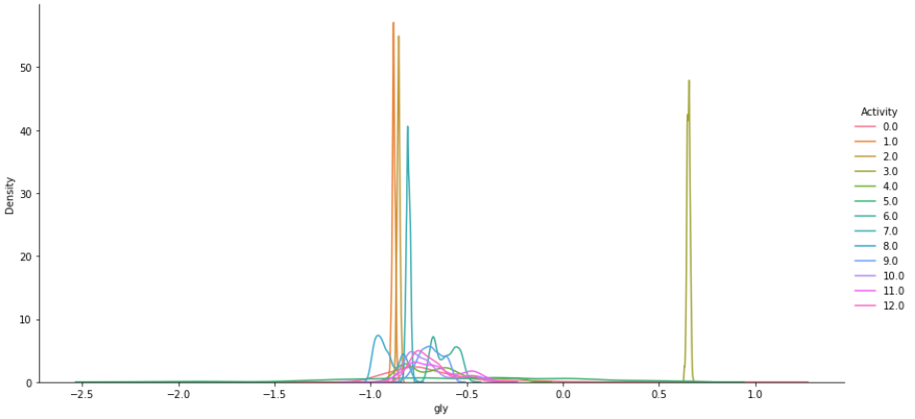

**DENSITY PLOT FOR OUTLIERS VISIUALIZATION**

**Fig-10**

1. **Conclusion**

In conclusion, this project aimed to predict human activities using sensor data applied to the body. Three models, namely CNN + LSTM, KNN, and Random Forest with Grid Search, were employed for activity prediction. Each model exhibited commendable accuracy, with CNN + LSTM achieving 98.45%, KNN achieving 95.38%, and Random Forest achieving 98.67%.

Comparing the models, CNN + LSTM demonstrated superior performance, providing a robust accuracy rate. The combination of convolutional neural networks and long short-term memory networks proved effective in capturing temporal dependencies in sequential data, making it well-suited for the task. However, it's essential to acknowledge the computational complexity associated with CNN + LSTM, which may pose challenges in real-time applications. KNN, while offering competitive accuracy, relies on the entire training dataset during testing, making it computationally intensive for large datasets. On the other hand, Random Forest with Grid Search exhibited excellent accuracy and the advantage of handling non-linear relationships in the data. The grid search optimization further fine-tuned the model parameters, enhancing its predictive capabilities.

The outlier analysis conducted for each activity added a novel dimension to the project. By identifying outliers in sensor data during specific activities, potential health issues or abnormalities were highlighted. The project leveraged this information to propose preventive measures and recommendations based on the nature of outliers, providing valuable insights into individual health monitoring. In summary, while all three models performed well, the CNN + LSTM model stands out as the best fit for its high accuracy and efficacy in capturing temporal dependencies. The outlier analysis introduced an innovative perspective, shedding light on potential health concerns associated with abnormal sensor patterns during activities. This comprehensive approach not only advances activity prediction but also contributes to personalized health monitoring, making the project impactful and relevant in diverse applications.

GitHub Link: <https://github.com/siddh1017/Mobile-Health-Human-Behavior-Analysis>

1. **References**

[1] K. Li and Y. Fu, "Prediction of Human Activity by Discovering Temporal Sequence Patterns," in IEEE Transactions on Pattern Analysis and Machine Intelligence, vol. 36, no. 8, pp. 1644-1657, Aug. 2014, doi: 10.1109/TPAMI.2013.2297321.

[2] M. S. Ryoo, "Human activity prediction: Early recognition of ongoing activities from streaming videos," 2011 International Conference on Computer Vision, Barcelona, Spain, 2011, pp. 1036-1043, doi: 10.1109/ICCV.2011.6126349.

[3] V. Magnanimo, M. Saveriano, S. Rossi and D. Lee, "A Bayesian approach for task recognition and future human activity prediction," The 23rd IEEE International Symposium on Robot and Human Interactive Communication, Edinburgh, UK, 2014, pp. 726-731, doi: 10.1109/ROMAN.2014.6926339.

[4] N. Tax, "Human Activity Prediction in Smart Home Environments with LSTM Neural Networks," 2018 14th International Conference on Intelligent Environments (IE), Rome, Italy, 2018, pp. 40-47, doi: 10.1109/IE.2018.00014.

[5] P. William, G. R. Lanke, D. Bordoloi, A. Shrivastava, A. P. Srivastavaa and S. V. Deshmukh, "Assessment of Human Activity Recognition based on Impact of Feature Extraction Prediction Accuracy," 2023 4th International Conference on Intelligent Engineering and Management (ICIEM), London, United Kingdom, 2023, pp. 1-6, doi: 10.1109/ICIEM59379.2023.10166247.

[6] A. M. Zanchettin, A. Casalino, L. Piroddi and P. Rocco, "Prediction of Human Activity Patterns for Human–Robot Collaborative Assembly Tasks," in IEEE Transactions on Industrial Informatics, vol. 15, no. 7, pp. 3934-3942, July 2019, doi: 10.1109/TII.2018.2882741.

[7] L. Wang, X. Zhao, Y. Si, L. Cao and Y. Liu, "Context-Associative Hierarchical Memory Model for Human Activity Recognition and Prediction," in IEEE Transactions on Multimedia, vol. 19, no. 3, pp. 646-659, March 2017, doi: 10.1109/TMM.2016.2617079.

[8] M. M. Arzani, M. Fathy, A. A. Azirani and E. Adeli, "Switching Structured Prediction for Simple and Complex Human Activity Recognition," in IEEE Transactions on Cybernetics, vol. 51, no. 12, pp. 5859-5870, Dec. 2021, doi: 10.1109/TCYB.2019.2960481.

[9] E. Ramanujam, T. Perumal and S. Padmavathi, "Human Activity Recognition With Smartphone and Wearable Sensors Using Deep Learning Techniques: A Review," in IEEE Sensors Journal, vol. 21, no. 12, pp. 13029-13040, 15 June15, 2021, doi: 10.1109/JSEN.2021.3069927.

[10] A. Gumaei, M. M. Hassan, A. Alelaiwi and H. Alsalman, "A Hybrid Deep Learning Model for Human Activity Recognition Using Multimodal Body Sensing Data," in IEEE Access, vol. 7, pp. 99152-99160, 2019, doi: 10.1109/ACCESS.2019.2927134.

[11] X. Zhou, W. Liang, K. I. -K. Wang, H. Wang, L. T. Yang and Q. Jin, "Deep-Learning-Enhanced Human Activity Recognition for Internet of Healthcare Things," in IEEE Internet of Things Journal, vol. 7, no. 7, pp. 6429-6438, July 2020, doi: 10.1109/JIOT.2020.2985082.

[12] C. Xu, D. Chai, J. He, X. Zhang and S. Duan, "InnoHAR: A Deep Neural Network for Complex Human Activity Recognition," in IEEE Access, vol. 7, pp. 9893-9902, 2019, doi: 10.1109/ACCESS.2018.2890675.

[13] V. Bianchi, M. Bassoli, G. Lombardo, P. Fornacciari, M. Mordonini and I. De Munari, "IoT Wearable Sensor and Deep Learning: An Integrated Approach for Personalized Human Activity Recognition in a Smart Home Environment," in IEEE Internet of Things Journal, vol. 6, no. 5, pp. 8553-8562, Oct. 2019, doi: 10.1109/JIOT.2019.2920283.

[14] S. W. Pienaar and R. Malekian, "Human Activity Recognition using LSTM-RNN Deep Neural Network Architecture," 2019 IEEE 2nd Wireless Africa Conference (WAC), Pretoria, South Africa, 2019, pp. 1-5, doi: 10.1109/AFRICA.2019.8843403.

[15] Q. Zhu, Z. Chen and Y. C. Soh, "A Novel Semisupervised Deep Learning Method for Human Activity Recognition," in IEEE Transactions on Industrial Informatics, vol. 15, no. 7, pp. 3821-3830, July 2019, doi: 10.1109/TII.2018.2889315.

[16] Mobile Health Human Behavior Analysis

<https://archive.ics.uci.edu/dataset/319/mhealth+dataset>

1. **Appendix Code**

**CNN+LSTM MODEL**

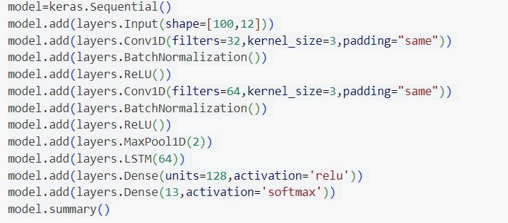

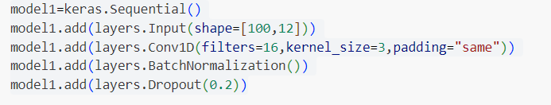

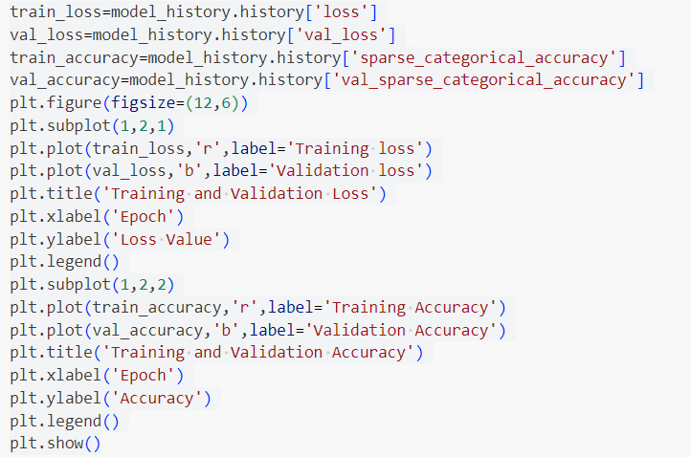

**RANDOM FOREST WITH GRID SEARCH**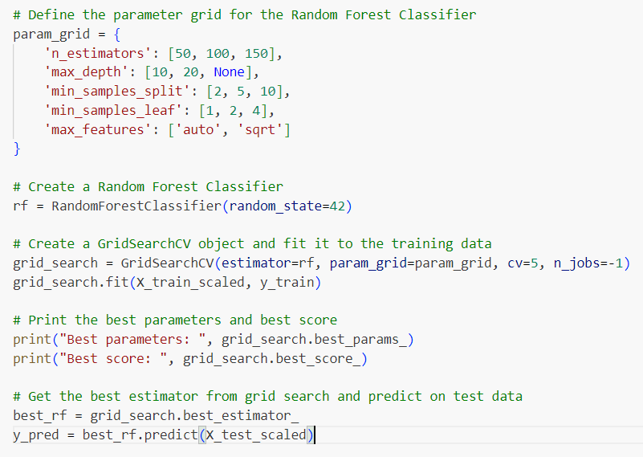

**KNN**

