Jenkins Sample Demo

To start Jenkins:

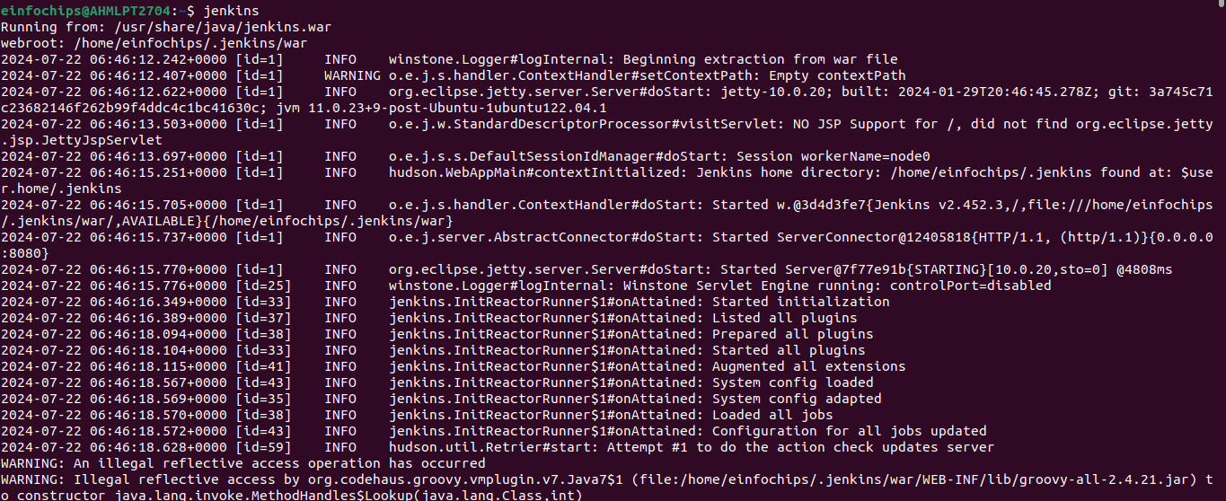
After Starting Jenkins:

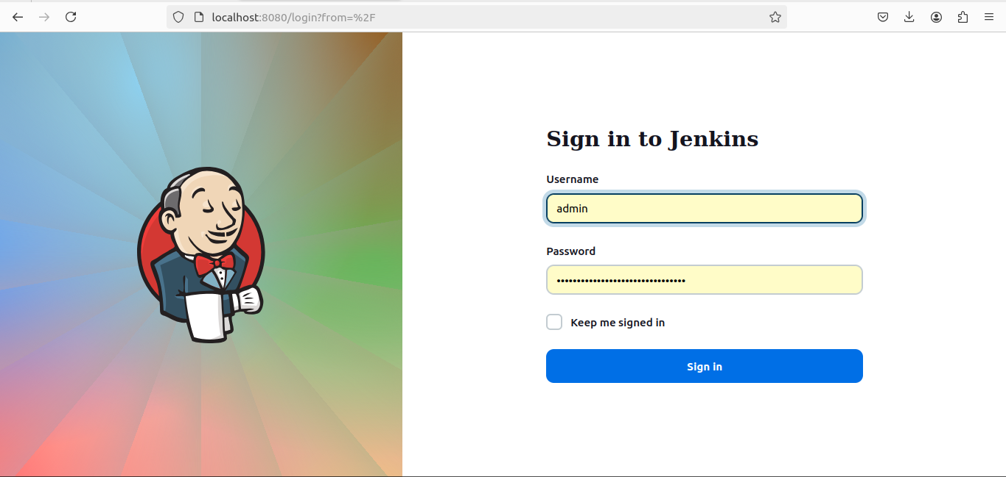
This will be the home page.

Create a sample jenkins project to test java app which is stored inside a git repository.
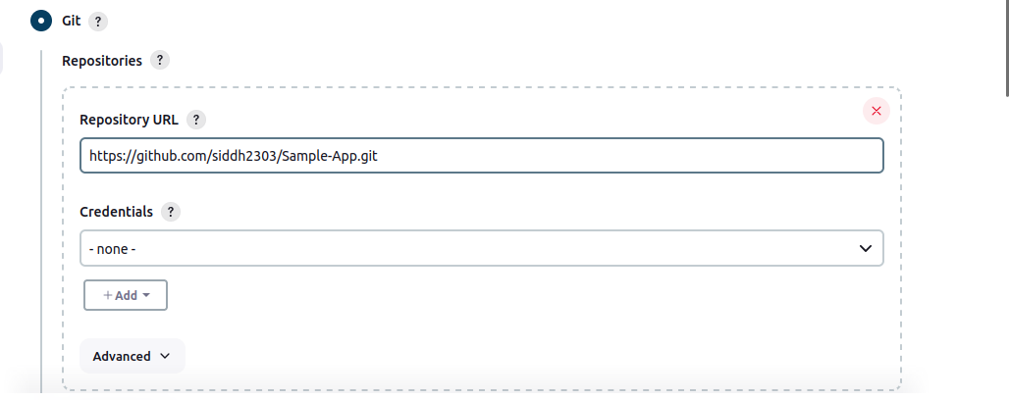
Output of this build:
