

LAB PROJECT REPORT

for

ECE 3144: SDPS Lab

“Mixed-Mode TCAD Simulation of a 180 nm CMOS Inverter Built from Physically Simulated 2D nMOS and pMOS Devices”

Submitted by

Siddhant Singh
Reg. No.: 240959278
Batch: ________

SCHOOL OF ELECTRICAL ENGINEERING,

MANIPAL INSTITUTE OF TECHNOLOGY, MANIPAL-576104

October, 2026

Index

- Objective
- Chapter 1: Introduction
- Chapter 2: Project Theory Explanation
- Chapter 3: Simulation Code (SDE Structure Scripts and SDevice Command Files)
- Chapter 4: Results (I–V Characteristics, VTC, Transient Waveforms, Device Internals)
- Conclusion
- References

Objective
The aim of this project is to build a CMOS inverter in which both transistors are full two-dimensional device simulations rather than SPICE compact models, and to obtain the inverter's static and dynamic characteristics directly from semiconductor device physics using the mixed-mode capability of Synopsys Sentaurus Device. The specific objectives were:
1. Create 180 nm nMOS and pMOS structures with Sentaurus Structure Editor (SDE) entirely from a script, run from the Linux terminal: geometry, 4 nm SiO₂ gate oxide, Si₃N₄ spacers, Gaussian source/drain and LDD doping, four contacts and a refined mesh.
2. Characterise each transistor on its own in Sentaurus Device (SDevice): Id–Vg at |Vd| = 0.05 V and 1.8 V, and Id–Vd for |Vg| = 0.6 to 1.8 V, and extract threshold voltage, subthreshold swing (SS), DIBL, Ion and Ioff.
3. Connect the two TCAD transistors into an inverter (VDD = 1.8 V, Wn = 1.0 µm, Wp = 1.5 µm) and simulate the DC voltage transfer characteristic (VTC) to obtain VM, VIL, VIH, VOH, VOL, the noise margins, the peak gain and the short-circuit current.
4. Simulate the transient response with a 10 fF load to obtain the propagation delays tpHL, tpLH and the 10–90 % rise and fall times.
5. Study pMOS sizing (Wp/Wn = 1.5 and 2.0) and explain the circuit results from the measured device currents.

Summary of the main results (Sentaurus X-2025.06, VDD = 1.8 V)
Table 1: Key results of the project
Quantity | Wp/Wn = 1.5 | Wp/Wn = 2.0
Switching threshold VM | 0.825 V | 0.870 V
Noise margins NML / NMH | 0.504 / 0.725 V | 0.567 / 0.654 V
Peak voltage gain |dVout/dVin| | 18.6 | 17.6
Peak short-circuit current IDD | 89.1 µA | 103.6 µA
tpHL / tpLH (CL = 10 fF) | 31.4 / 41.2 ps | 33.3 / 33.3 ps
Average delay tp | 36.3 ps | 33.3 ps
Fall / rise time (10–90 %) | 48.4 / 71.8 ps | 49.8 / 56.6 ps

Device level: Ion = 474.6 µA/µm (nMOS) and 238.6 µA/µm (pMOS), so Ion,n/Ion,p ≈ 1.99. This ratio predicts that the pMOS must be about twice as wide as the nMOS for a balanced inverter, and the circuit simulation confirms it: at Wp/Wn = 2.0 the two propagation delays become equal (33.3 ps and 33.3 ps).

Chapter 1: Introduction

1.1 Background
The CMOS inverter is the basic building block of digital logic. Its voltage transfer characteristic sets the noise margins of every gate built from it, and its switching speed sets the delay of every logic path. In a normal circuit design flow the transistors inside the inverter are represented by compact models such as BSIM. These are sets of equations whose parameters are fitted to measured silicon. They are fast and accurate within their fitting range, but they hide the physics: a compact model cannot tell you why the pMOS is weak, or what happens if the gate workfunction, the doping or the junction depth changes.
Technology Computer-Aided Design (TCAD) works from the other end. The device is described by its geometry, its materials and its doping profile, and the simulator solves the semiconductor equations (Poisson's equation and the electron and hole continuity equations) on a mesh. The terminal currents are then a result of the physics, not an input. The 180 nm node used here (VDD = 1.8 V, 4 nm gate oxide) is a classic node that is still widely used for analog, mixed-signal and power-management chips, and it is short enough for velocity saturation, DIBL and other short-channel effects to be visible.

1.2 Mixed-mode device–circuit simulation
Sentaurus Device can place several TCAD devices inside a small circuit and solve all of them together. Each transistor keeps its full 2D mesh and its own Poisson and continuity equations, and the circuit adds Kirchhoff's current law at every node. In this project the nMOS and the pMOS are two such devices, joined at the gate (input node in) and the drain (output node out), with a voltage source for VDD and, for the transient run, a 10 fF load capacitor. The inverter's VTC and switching waveforms therefore come straight from the device physics. This makes the project a bridge between semiconductor device physics and digital circuit behaviour: every circuit number in Chapter 4 can be traced back to a property of the transistors.

1.3 Tools and working environment
All simulations were run on the SDPS laboratory Linux workstations with Synopsys Sentaurus TCAD, version X-2025.06, entirely from the terminal. The structures were not drawn in the Structure Editor GUI. They were generated by running SDE scripts in batch mode. The tools used were:
• Sentaurus Structure Editor (SDE): builds the geometry, doping and contacts from a Scheme script (.scm), and calls Sentaurus Mesh to produce the simulation grid (*_msh.tdr).
• Sentaurus Device (SDevice): solves the device equations. It is used both for single transistors and for the mixed-mode inverter. Its input is a command file (*_des.cmd), and it writes current/voltage tables (.plt), 2D field snapshots (.tdr) and logs.
• Sentaurus Visual (SVisual): views structures, doping and carrier-density maps, I–V curves and waveforms.
• Python 3 scripts (analyze_plt.py, device_params.py): read the text .plt output and extract the inverter and transistor figures of merit automatically, so the numbers are reproducible and do not depend on reading values off a plot.
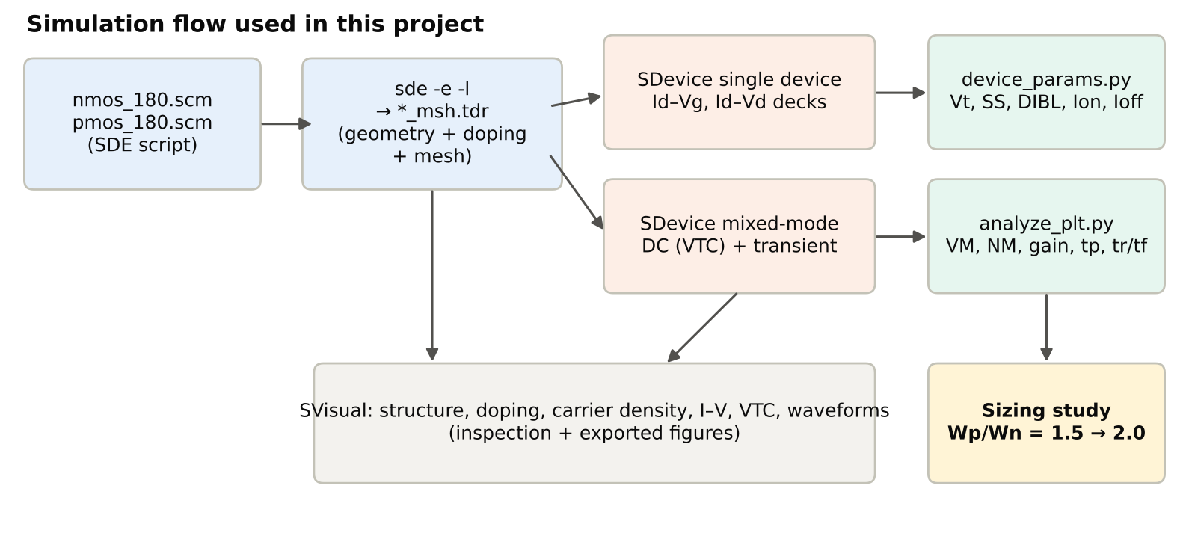
Fig. 1: Simulation flow followed in this project, from structure scripts to extracted figures of merit.

1.4 Organisation of the report
Chapter 2 explains the device physics, the models solved by SDevice and the inverter theory needed to interpret the results. Chapter 3 presents the simulation code: the SDE structure script, the single-device command files, the mixed-mode DC and transient decks and the post-processing scripts, together with the practical problems met and how they were solved. Chapter 4 presents and analyses the results. It also cross-checks them against analytical estimates and internal charge-conservation checks, shows the complete inverter built on a single substrate, and compares the results with published TCAD studies of CMOS inverters.

Chapter 2: Project Theory Explanation

2.1 The MOSFET and its operating regions
A MOSFET is a four-terminal device (gate, source, drain, body). For the nMOS, a p-type body sits under a thin gate oxide, with heavily doped n⁺ source and drain regions on either side. When the gate–source voltage Vgs exceeds the threshold voltage Vt, the surface inverts and a thin layer of electrons connects source and drain. The pMOS is the complement: n-type body, p⁺ source/drain, and a hole channel when Vgs < Vt (negative). The device has three regions:
• Cut-off / subthreshold (Vgs < Vt): only diffusion current flows. It rises exponentially with Vgs, with a slope set by the subthreshold swing.
• Linear (Vgs > Vt, small Vds): the channel behaves as a gate-controlled resistor, Id ≈ μCox(W/L)(Vgs − Vt)Vds.
• Saturation (Vds ≥ Vgs − Vt): the channel pinches off near the drain. In long devices Id ∝ (Vgs − Vt)², but at 180 nm the lateral field is high enough for carriers to reach their saturation velocity, so Id grows almost linearly with (Vgs − Vt).

2.2 Equations solved by Sentaurus Device
SDevice solves the drift–diffusion model of semiconductor transport. The electrostatic potential ψ and the electron and hole densities n and p are found at every mesh point from three coupled partial differential equations:
∇·(ε∇ψ) = −q (p − n + N_{D}⁺ − N_{A}⁻) (2.1)
∇·J_{n} = q (R − G) + q ∂n/∂t , −∇·J_{p} = q (R − G) + q ∂p/∂t (2.2)
J_{n} = q μ_{n} n E + q D_{n} ∇n , J_{p} = q μ_{p} p E − q D_{p} ∇p (2.3)
Equation (2.1) is Poisson's equation. It links the potential to the space charge, which comes from the carriers and the ionised dopants. Equations (2.2) are the continuity equations: carriers are conserved except for net recombination R − G. Equations (2.3) give the current as drift in the electric field plus diffusion down the concentration gradient. SDevice discretises these equations with the box method on the Delaunay mesh produced by Sentaurus Mesh, uses the Scharfetter–Gummel scheme for the current between neighbouring nodes, and solves the resulting non-linear system with Newton's method. In the command files this is the Coupled { Poisson Electron Hole } statement. In mixed mode the keywords Contact Circuit add the electrode and circuit (KCL) equations to the same Newton system.

2.3 Physical models used
Table 2: Physical models activated in the Physics section of every command file
Keyword in the deck | Physical effect | Why it matters here
EffectiveIntrinsicDensity(OldSlotboom) | Band-gap narrowing (Slotboom model) | Heavy S/D doping (5×10¹⁹ cm⁻³) shrinks the band gap and raises nᵢ, which changes junction behaviour
Mobility(DopingDep) | Mobility falls with doping (Masetti model) | Lower μ in the 3×10¹⁷ cm⁻³ body and in the S/D
eHighFieldsaturation(GradQuasiFermi), hHighFieldsaturation(...) | Velocity saturation (Canali model) | Lateral fields above 10⁴ V/cm in a 180 nm channel limit the carrier velocity, and so Ion
Enormal | Mobility degradation by the vertical field (Lombardi model: surface phonon and roughness scattering) | Strongly reduces channel mobility at high gate voltage. Holes are affected more than electrons
Recombination(SRH(DopingDep TempDependence)) | Shockley–Read–Hall generation/recombination | Sets the junction leakage and the off-state current floor

2.4 Threshold voltage and the choice of gate workfunction
The gate is modelled as a metal contact (TiN) whose workfunction Φm sets the flat-band voltage. For an nMOS with body doping NA, the long-channel threshold voltage is:
V_{t} = V_{FB} + 2φ_{F} + √(2ε_{Si}qN_{A}·2φ_{F}) / C_{ox} (2.4a)
V_{FB} = Φ_{m} − Φ_{s} , φ_{F} = (kT/q)·ln(N_{A}/n_{i}) (2.4b)
For this design (NA = 3×10¹⁷ cm⁻³, tox = 4 nm): φF = 0.0259·ln(3×10¹⁷/10¹⁰) ≈ 0.445 V, Cox = εox/tox = 0.863 µF/cm², the depletion charge term is 2.98×10⁻⁷ C/cm² ÷ Cox ≈ 0.345 V, and the silicon workfunction is Φs = χ + Eg/2 + φF = 4.05 + 0.56 + 0.445 ≈ 5.06 eV. With Φm = 4.25 eV, VFB ≈ −0.81 V and the long-channel estimate is Vt ≈ 0.43 V. The pMOS is the mirror image: with an n-type body of the same doping, Φs ≈ 4.17 eV, and Φm = 4.97 eV gives Vt ≈ −0.43 V. The two workfunctions were therefore chosen to give symmetric thresholds of about ±0.43 V, values close to the n⁺ and p⁺ band edges, as a dual-workfunction metal-gate process would use. The simulated values (Chapter 4) are slightly lower in magnitude because of short-channel charge sharing and DIBL.

2.5 Transistor figures of merit
• Threshold voltage, max-gm method: extrapolate the linear-region Id–Vg curve at its point of maximum transconductance down to Id = 0, and subtract Vd/2.
• Threshold voltage, constant-current method: the Vg at which Id = 100 nA/µm. It is evaluated at |Vd| = 0.05 V (Vt,lin) and |Vd| = 1.8 V (Vt,sat).
• Subthreshold swing: SS = dVg/d(log₁₀Id) in the subthreshold region. The ideal limit is (kT/q)·ln10 ≈ 60 mV/dec; the depletion capacitance raises it to SS = 60·(1 + Cd/Cox). Here Wdep ≈ 62 nm gives Cd/Cox ≈ 0.19, so the long-channel expectation is ≈ 71 mV/dec.
• DIBL (drain-induced barrier lowering) = (Vt,lin − Vt,sat)/(1.8 − 0.05 V), in mV/V. A high drain voltage lowers the source–channel barrier, a short-channel effect.
• Ion = Id at |Vg| = |Vd| = 1.8 V, and Ioff = Id at Vg = 0, |Vd| = 1.8 V. Both are per µm of width because a 2D simulation assumes 1 µm depth.

2.6 CMOS inverter: static behaviour
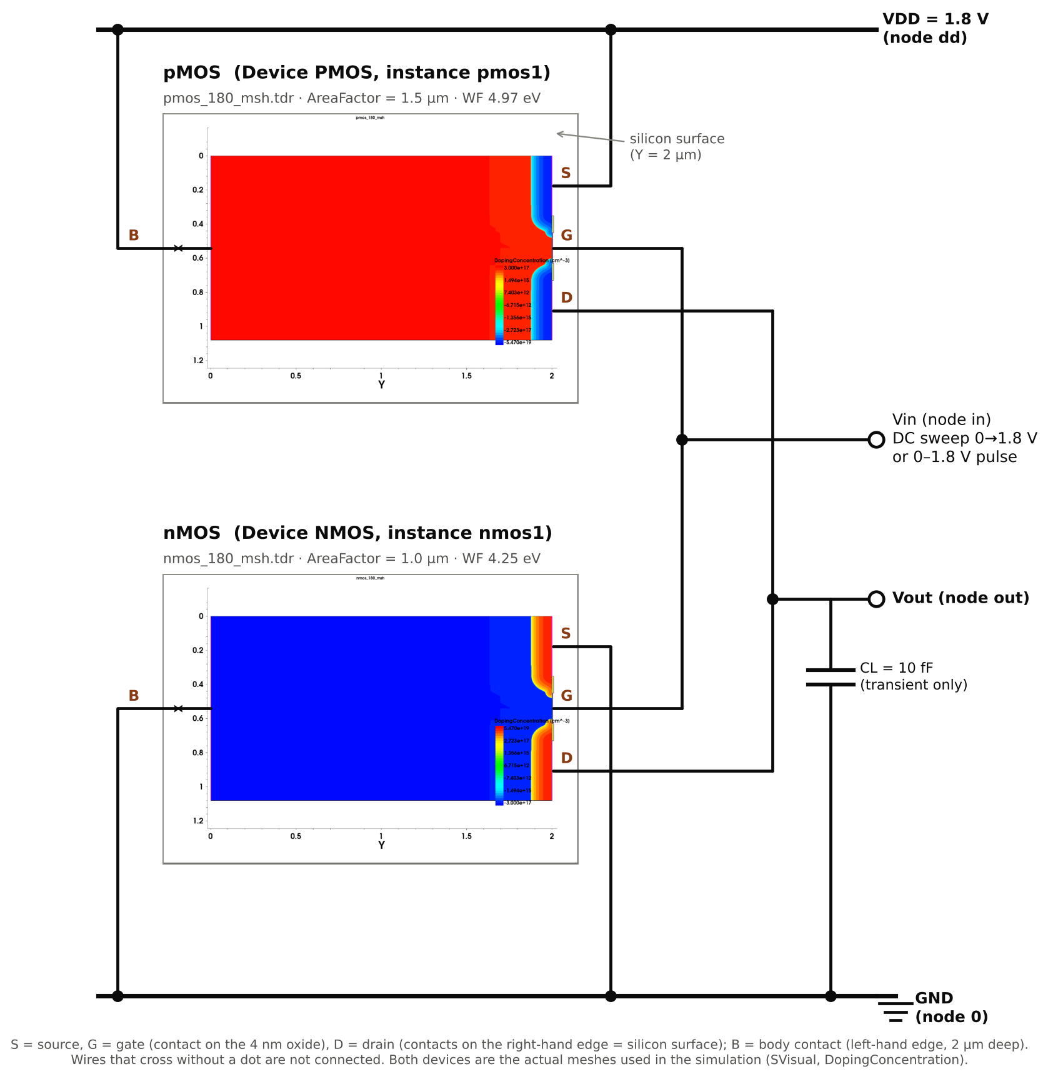
Fig. 2: The mixed-mode inverter: the actual nMOS and pMOS meshes used in the simulation (SVisual doping plots) connected as written in the System{} block of the decks. Gates → in, drains → out, pMOS source/body → VDD, nMOS source/body → GND, 10 fF load for the transient.
When Vin is low, the pMOS is on and the nMOS is off, so Vout = VDD. When Vin is high, the opposite holds and Vout = 0. In the transition region both devices conduct and the output swings sharply. The VTC is described by:
• VOH, VOL: output levels at the two points where the VTC slope is −1. VIL, VIH are the input voltages at those same points.
• Noise margins: NML = VIL − VOL and NMH = VOH − VIH. They are the amount of noise a logic level can tolerate.
• Switching threshold VM: the point where Vout = Vin. Equating the two drain currents (long-channel, both saturated) gives
V_{M} = [V_{tn} + r (V_{DD} − |V_{tp}|)] / (1 + r) , r = √(k_{p}/k_{n}) = √(μ_{p}W_{p} / μ_{n}W_{n}) (2.5)
A symmetric inverter (VM = VDD/2, NML = NMH) needs equal pull-up and pull-down strength, so the pMOS is made wider to compensate for the lower hole mobility. In a velocity-saturated short-channel device the useful measure of strength is the on-current itself, so the rule becomes Wp/Wn ≈ Ion,n/Ion,p (per µm). Near VM both transistors conduct, so a current flows from VDD to ground during switching. This is the short-circuit current IDD seen in the DC sweep.

2.7 CMOS inverter: dynamic behaviour
The output node carries a capacitance C = CL + C_intrinsic, where C_intrinsic is the drain junction capacitance plus the gate–drain overlap capacitance. A falling output is produced by the nMOS discharging C, and a rising output by the pMOS charging it. With the 50 % points defining the propagation delays,
t_{pHL} ≈ C·(V_{DD}/2) / I_{n} , t_{pLH} ≈ C·(V_{DD}/2) / I_{p} , t_{p} = (t_{pHL} + t_{pLH}) / 2 (2.6)
so the ratio tpLH/tpHL ≈ (Ion,n·Wn)/(Ion,p·Wp) is set by the same current ratio as VM. The 10–90 % rise and fall times measure the edge steepness. Each full output cycle draws an energy of about C·VDD² from the supply. Finally, the gate–drain capacitance couples a fast input edge straight to the output: when the input rises, the output first moves up briefly before the nMOS discharges it. This is Miller feedthrough, and a device-level simulation captures it automatically.

2.8 How mixed-mode simulation works in SDevice
• Each transistor is declared once as a Device block (its mesh, its electrodes, its physics) and instantiated in the System block like a circuit element, with its electrodes connected to circuit nodes.
• A 2D simulation gives current per µm of width. AreaFactor multiplies it by the transistor width (1.0 µm for the nMOS, 1.5 µm for the pMOS).
• Circuit elements (Vsource_pset, Capacitor_pset) add their equations to the same Newton system. A Quasistationary solve ramps a source parameter for DC sweeps, and Transient integrates in time (backward Euler, Transient = BE).
• The System block can write a circuit-level plot file (*_sys.plt) with node voltages and branch currents. This is what the analysis scripts read.

Chapter 3: Simulation Code (SDE Structure Scripts and SDevice Command Files)
This chapter lists the code that produced the results. Every step was run from the Linux terminal in the project folder. Table 3 summarises the commands, and the following sections explain each input file.

3.1 Commands used
Table 3: Terminal commands used, in the order they were run
Command | Purpose / output
source setup-tcad.bashrc | Sets STROOT, the licence server (SNPSLMD_LICENSE_FILE) and PATH for Sentaurus X-2025.06
sde -e -l nmos_180.scm | Batch SDE run (no GUI): builds the nMOS, writes nmos_180_msh.tdr (mesh + doping)
sde -e -l pmos_180.scm | Same for the pMOS → pmos_180_msh.tdr
svisual nmos_180_msh.tdr & | Inspect the structure, doping and mesh
sdevice nmos_idvg_des.cmd (and idvd, pmos_*) | Single-device Id–Vg / Id–Vd sweeps → IdVg_lin_, IdVg_sat_, IdVd_Vg_.plt
python3 device_params.py IdVg_lin_… IdVg_sat_… | Vt (max-gm, constant current), SS, DIBL, Ion, Ioff
sdevice inverter_dc_des.cmd | Mixed-mode DC sweep → vtc_inverter_dc_sys.plt
python3 analyze_plt.py dc vtc_inverter_dc_sys.plt | VM, VIL, VIH, VOH, VOL, NML, NMH, gain, peak IDD
sdevice inverter_tran_des.cmd | Mixed-mode transient → tran_inverter_tran_sys.plt
python3 analyze_plt.py tran tran_inverter_tran_sys.plt | tpHL, tpLH, tp, 10–90 % rise/fall
sed -e "s/AreaFactor= 1.5/AreaFactor= 2.0/" … > *_wp2_des.cmd | Creates the Wp = 2.0 µm variants of both decks for the sizing study

3.2 Device structure script (nmos_180.scm)
The structure is built in µm coordinates with the silicon surface at y = 2 µm and the body contact at y = 0. Along x the device is: source contact 0–0.35 µm, spacer 0.35–0.45 µm, gate 0.45–0.63 µm (L = 180 nm), spacer 0.63–0.73 µm, drain contact 0.73–1.08 µm. The script has five parts: (i) parameters, (ii) regions (silicon body, SiO₂ oxide, TiN gate, Si₃N₄ spacers), (iii) contacts (the TiN region's boundary becomes the gate contact and the metal body is then deleted, because SDevice represents the gate by its workfunction), (iv) doping (constant body doping plus Gaussian S/D and LDD profiles placed on reference lines at the surface), and (v) mesh refinement (a coarse global mesh with doping-gradient refinement, and a fine 0.5–1 nm mesh at the oxide interface and around the junctions in the channel window).
Listing 3.1: nmos_180.scm (complete SDE script)
;; =====================================================================
;; nMOS, L = 180 nm -- Sentaurus Structure Editor (SDE) script
;; SDPS Lab (ECE 3144) mini-project: mixed-mode CMOS inverter
;;
;; Run: sde -e -l nmos_180.scm
;; Output: nmos_180_msh.tdr (used by the SDevice decks)
;;
;; Same construction as Lab Manual Exp 4/5 (nMOSFET / pMOSFET), scaled
;; to a 180 nm channel. Coordinates in um; the silicon surface is at
;; y = Dsub (as in the manual, where it was y = 5).
;; =====================================================================
(sde:clear)
(sdegeo:set-default-boolean "ABA")

;; ---------------- parameters ----------------------------------------
(define Lg 0.18) ; gate (channel) length 180 nm
(define Tox 0.004) ; gate oxide thickness 4 nm
(define Lsp 0.10) ; Si3N4 spacer length 100 nm
(define Hsp 0.010) ; spacer / gate-stack height 10 nm
(define Lsd 0.35) ; source / drain contact length
(define Dsub 2.0) ; silicon depth (body contact at y = 0)

(define Nbody 3e17) ; BoronActiveConcentration body doping
(define Nsd 5e19) ; S/D peak (ArsenicActiveConcentration)
(define Xj_sd 0.12) ; S/D junction depth
(define Next 5e18) ; extension (LDD) peak
(define Xj_ext 0.035) ; extension junction depth
(define LatFac 0.8) ; lateral Gaussian factor (manual: 0.8)

(define X0 0.0)
(define X1 (+ X0 Lsd)) ; source | spacer
(define X2 (+ X1 Lsp)) ; spacer | gate
(define X3 (+ X2 Lg)) ; gate | spacer
(define X4 (+ X3 Lsp)) ; spacer | drain
(define X5 (+ X4 Lsd))
(define Ys Dsub) ; silicon surface
(define Yox (+ Ys Tox))
(define Ytop (+ Ys Hsp))

;; ---------------- regions (names as in the manual) ------------------
(sdegeo:create-rectangle (position X0 0.0 0.0) (position X5 Ys 0.0) "Silicon" "region_body")
(sdegeo:create-rectangle (position X2 Ys 0.0) (position X3 Yox 0.0) "SiO2" "region_oxide")
(sdegeo:create-rectangle (position X2 Yox 0.0) (position X3 Ytop 0.0) "TiN" "region_metal")
(sdegeo:create-rectangle (position X1 Ys 0.0) (position X2 Ytop 0.0) "Si3N4" "region_source")
(sdegeo:create-rectangle (position X3 Ys 0.0) (position X4 Ytop 0.0) "Si3N4" "region_drain")

;; ---------------- contacts ------------------------------------------
(sdegeo:define-contact-set "source" 4.0 (color:rgb 1.0 0.0 0.0) "##")
(sdegeo:define-contact-set "drain" 4.0 (color:rgb 0.0 1.0 0.0) "##")
(sdegeo:define-contact-set "gate" 4.0 (color:rgb 0.0 0.0 1.0) "##")
(sdegeo:define-contact-set "body" 4.0 (color:rgb 1.0 1.0 0.0) "##")

(sdegeo:set-current-contact-set "source")
(sdegeo:set-contact-edges (list (car (find-edge-id (position (/ (+ X0 X1) 2) Ys 0.0)))) "source")
(sdegeo:set-current-contact-set "drain")
(sdegeo:set-contact-edges (list (car (find-edge-id (position (/ (+ X4 X5) 2) Ys 0.0)))) "drain")
(sdegeo:set-current-contact-set "body")
(sdegeo:set-contact-edges (list (car (find-edge-id (position (/ X5 2) 0.0 0.0)))) "body")
;; Gate: the TiN region becomes the gate contact (its boundary), then the
;; metal body is removed -- SDevice models it through Workfunction.
(sdegeo:set-current-contact-set "gate")
(sdegeo:set-contact-boundary-edges (list (car (find-body-id (position (/ (+ X2 X3) 2) (/ (+ Yox Ytop) 2)
0.0)))) "gate")
(sdegeo:delete-region (list (car (find-body-id (position (/ (+ X2 X3) 2) (/ (+ Yox Ytop) 2) 0.0)))))

;; ---------------- doping --------------------------------------------
;; (a) constant body doping
(sdedr:define-constant-profile "ConstantProfileDefinition_body" "BoronActiveConcentration" Nbody)
(sdedr:define-constant-profile-region "ConstantProfilePlacement_body" "ConstantProfileDefinition_body"
"region_body")

;; (b) reference lines on the silicon surface (Mesh > Define Ref/Eval window > Line)
(sdedr:define-refeval-window "RefEvalWin_source" "Line" (position X0 Ys 0.0) (position X1 Ys 0.0))
(sdedr:define-refeval-window "RefEvalWin_drain" "Line" (position X4 Ys 0.0) (position X5 Ys 0.0))
(sdedr:define-refeval-window "RefEvalWin_source_ext" "Line" (position X1 Ys 0.0) (position X2 Ys 0.0))
(sdedr:define-refeval-window "RefEvalWin_drain_ext" "Line" (position X3 Ys 0.0) (position X4 Ys 0.0))

;; (c) Gaussian profiles: peak at the surface, value Nbody at the junction depth
(sdedr:define-gaussian-profile "AnalyticalProfileDefinition_sd" "ArsenicActiveConcentration"
"PeakPos" 0 "PeakVal" Nsd "ValueAtDepth" Nbody "Depth" Xj_sd "Gauss" "Factor" LatFac)
(sdedr:define-gaussian-profile "AnalyticalProfileDefinition_ext" "ArsenicActiveConcentration"
"PeakPos" 0 "PeakVal" Next "ValueAtDepth" Nbody "Depth" Xj_ext "Gauss" "Factor" LatFac)

(sdedr:define-analytical-profile-placement "AnalyticalProfilePlacement_source"
"AnalyticalProfileDefinition_sd" "RefEvalWin_source" "Both" "NoReplace" "Eval")
(sdedr:define-analytical-profile-placement "AnalyticalProfilePlacement_drain"
"AnalyticalProfileDefinition_sd" "RefEvalWin_drain" "Both" "NoReplace" "Eval")
(sdedr:define-analytical-profile-placement "AnalyticalProfilePlacement_source_ext"
"AnalyticalProfileDefinition_ext" "RefEvalWin_source_ext" "Both" "NoReplace" "Eval")
(sdedr:define-analytical-profile-placement "AnalyticalProfilePlacement_drain_ext"
"AnalyticalProfileDefinition_ext" "RefEvalWin_drain_ext" "Both" "NoReplace" "Eval")

;; ---------------- meshing -------------------------------------------
;; (i) global
(sdedr:define-refeval-window "RefEvalWin_global" "Rectangle" (position X0 0.0 0.0) (position X5 Ytop 0.0))
(sdedr:define-refinement-size "RefinementDefinition_global" 0.05 0.2 0.01 0.01)
(sdedr:define-refinement-placement "RefinementPlacement_global" "RefinementDefinition_global"
"RefEvalWin_global")
(sdedr:define-refinement-function "RefinementDefinition_global" "DopingConcentration" "MaxTransDiff" 1)
;; (ii) channel / junctions: fine mesh near the surface
(sdedr:define-refeval-window "RefEvalWin_channel" "Rectangle" (position (- X1 0.05) (- Ys 0.15) 0.0) (position
(+ X4 0.05) Ys 0.0))
(sdedr:define-refinement-size "RefinementDefinition_channel" 0.005 0.005 0.001 0.0005)
(sdedr:define-refinement-placement "RefinementPlacement_channel" "RefinementDefinition_channel"
"RefEvalWin_channel")
(sdedr:define-refinement-function "RefinementDefinition_channel" "MaxLenInt" "region_body" "region_oxide"
0.0005 1.4 "DoubleSide" "UseRegionNames")
(sdedr:define-refinement-function "RefinementDefinition_channel" "MaxLenInt" "region_body" "region_source"
0.001 1.4 "DoubleSide" "UseRegionNames")
(sdedr:define-refinement-function "RefinementDefinition_channel" "MaxLenInt" "region_body" "region_drain" 0.001
1.4 "DoubleSide" "UseRegionNames")

;; ---------------- save + build mesh ---------------------------------
(sde:save-model "nmos_180")
(sde:build-mesh "snmesh" "-a -c boxmethod" "nmos_180_msh")

Gaussian profile definition. "PeakVal" Nsd "ValueAtDepth" Nbody "Depth" Xj makes SDE choose the standard deviation so that the arsenic concentration falls from 5×10¹⁹ cm⁻³ at the surface to the body doping at the junction depth: σ = Xj/√ln(Nsd/Nbody) = 53 nm for the S/D and 21 nm for the LDD. "Gauss" "Factor" 0.8 makes the lateral spread under the mask edge 0.8 times the vertical one.
Table 4: Differences between the nMOS and pMOS scripts and decks (everything else is identical)
Item | nMOS | pMOS
Body doping (constant) | BoronActiveConcentration 3×10¹⁷ | PhosphorusActiveConcentration 3×10¹⁷
S/D and LDD species | ArsenicActiveConcentration | BoronActiveConcentration
Gate workfunction (in the deck) | 4.25 eV | 4.97 eV
Bias polarity in the sweeps | Vg, Vd: 0 → +1.8 V | Vg, Vd: 0 → −1.8 V
Width in the inverter (AreaFactor) | 1.0 µm | 1.5 µm (2.0 µm in the sizing study)

3.3 Single-device command file (nmos_idvg_des.cmd)
A Sentaurus Device command file has fixed sections: File (input mesh, output names), Electrode (initial bias and the gate workfunction), Physics (the models of Table 2), Plot (fields saved in the .tdr snapshot), Math (numerical controls) and Solve (the sequence of simulations). The Id–Vg deck first solves equilibrium (Poisson only, then fully coupled), ramps the drain to 0.05 V and saves that state, then sweeps the gate to 1.8 V. It reloads the saved state, ramps the drain to 1.8 V and sweeps the gate again. NewCurrentPrefix gives each sweep its own output file, which is why the results appear as IdVg_lin_… and IdVg_sat_….
Listing 3.2: nmos_idvg_des.cmd (File, Electrode, Physics, Math and Solve sections; the Plot list is omitted)
File {
Grid = "nmos_180_msh.tdr"
Plot = "idvg_nmos_180"
Current = "idvg_nmos_180"
Output = "idvg_nmos_180"
}
Electrode {
{ Name="gate" Voltage= 0.0 Workfunction= 4.25 }
{ Name="drain" Voltage= 0.0 }
{ Name="source" Voltage= 0.0 }
{ Name="body" Voltage= 0.0 }
}
Physics {
EffectiveIntrinsicDensity( OldSlotboom )
Mobility(
DopingDep
eHighFieldsaturation( GradQuasiFermi )
hHighFieldsaturation( GradQuasiFermi )
Enormal
)
Recombination(
SRH( DopingDep TempDependence )
)
}
Math {
NumberOfThreads= maximum
Extrapolate
Derivatives
RelErrControl
Digits=5
ErrRef(electron)=1.e10
ErrRef(hole)=1.e10
Iterations=20
Notdamped=100
Method=Blocked
SubMethod=Super
ACMethod=Blocked
ACSubMethod=Super
}
Solve {
*- initial solution
Coupled ( Iterations= 100 LineSearchDamping= 1e-8 ){ Poisson }
Coupled ( Iterations= 100 LineSearchDamping= 1e-8 ){ Poisson electron hole }

*- Vd = 0.05 V (linear region)
Quasistationary(
DoZero
InitialStep= 1e-3 Increment= 1.5
MinStep= 1e-6 MaxStep= 0.025
Goal { Name= "drain" Voltage= 0.05 }
){ Coupled { Poisson electron hole } }
Save ( FilePrefix= "nmos_vd_lin" )

NewCurrentPrefix= "IdVg_lin_"
Quasistationary(
InitialStep= 1e-3 Increment= 1.5
MinStep= 1e-6 MaxStep= 0.025
Goal { Name= "gate" Voltage= 1.8 }
){ Coupled { Poisson electron hole } }

*- Vd = VDD (saturation)
Load ( FilePrefix= "nmos_vd_lin" )
NewCurrentPrefix= "tmp_"
Quasistationary(
InitialStep= 1e-3 Increment= 1.5
MinStep= 1e-6 MaxStep= 0.1
Goal { Name= "drain" Voltage= 1.8 }
){ Coupled { Poisson electron hole } }
NewCurrentPrefix= "IdVg_sat_"
Quasistationary(
InitialStep= 1e-3 Increment= 1.5
MinStep= 1e-6 MaxStep= 0.025
Goal { Name= "gate" Voltage= 1.8 }
){ Coupled { Poisson electron hole } }
}

The Id–Vd deck has the same structure. From a saved equilibrium state it sets the gate to 0.6, 0.9, 1.2, 1.5 and 1.8 V in turn and sweeps the drain from 0 to 1.8 V each time. In Quasistationary, InitialStep, MaxStep and MinStep are fractions of the ramp. SDevice raises the step by Increment after each converged point and cuts it back automatically when Newton fails to converge.

3.4 Mixed-mode DC deck (inverter_dc_des.cmd)
The inverter deck declares the two transistors as Device blocks. Each points to its mesh, keeps the same physics, and is scaled to its width by AreaFactor. The System block then wires them into the inverter, and the Solve section first ramps VDD to 1.8 V with Vin = 0 and then sweeps Vin from 0 to 1.8 V.
Listing 3.3a: Device NMOS block (the Device PMOS block is the same with Workfunction 4.97 and AreaFactor 1.5)
Device NMOS {
Electrode {
{ Name="source" Voltage= 0.0 }
{ Name="drain" Voltage= 0.0 }
{ Name="gate" Voltage= 0.0 Workfunction= 4.25 }
{ Name="body" Voltage= 0.0 }
}
File {
Grid = "nmos_180_msh.tdr"
Plot = "inv_nmos"
}
Physics {
AreaFactor= 1.0 * device width in um (2D current is per um)
EffectiveIntrinsicDensity( OldSlotboom )
Mobility(
DopingDep
eHighFieldsaturation( GradQuasiFermi )
hHighFieldsaturation( GradQuasiFermi )
Enormal
)
Recombination( SRH( DopingDep TempDependence ) )
}
Plot { ... same field list as the single-device decks ... }
}

Listing 3.3b: circuit (System) and Solve sections of the DC deck
File {
Output = "inverter_dc"
}
System {
Vsource_pset vdd ( dd 0 ) { dc = 0.0 }
Vsource_pset vin ( in 0 ) { dc = 0.0 }
NMOS nmos1 ( "drain"=out "gate"=in "source"=0 "body"=0 )
PMOS pmos1 ( "drain"=out "gate"=in "source"=dd "body"=dd )
Plot "inverter_dc_sys.plt" ( v(in) v(out) v(dd) i(vdd dd) i(nmos1 out) i(pmos1 out) )
}
Solve {
*- equilibrium (all sources at 0 V)
Coupled ( Iterations= 100 LineSearchDamping= 1e-8 ){ Poisson }
Coupled ( Iterations= 100 LineSearchDamping= 1e-8 ){ Poisson Electron Hole Contact Circuit }

*- ramp the supply to VDD = 1.8 V (Vin = 0, so Vout follows VDD)
Quasistationary(
InitialStep= 1e-2 Increment= 1.5 MinStep= 1e-6 MaxStep= 0.1
Goal { Parameter= vdd.dc Value= 1.8 }
){ Coupled { Poisson Electron Hole Contact Circuit } }

*- VTC: sweep Vin 0 -> 1.8 V in <= 10 mV steps
NewCurrentPrefix= "vtc_"
Quasistationary(
InitialStep= 1e-3 Increment= 1.3 MinStep= 1e-7 MaxStep= 0.01
Goal { Parameter= vin.dc Value= 1.8 }
){ Coupled { Poisson Electron Hole Contact Circuit }
Plot ( FilePrefix= "vtc_vin" Time= ( 0.5 ) NoOverwrite )
}
}

Vsource_pset vdd ( dd 0 ) { dc = 0.0 } creates a DC voltage source between node dd and ground whose value is a parameter (vdd.dc) that a Quasistationary goal can ramp. The pMOS source and body go to dd, the nMOS source and body to 0, both gates to in and both drains to out. The Plot statement inside System writes the circuit quantities (node voltages, the supply current i(vdd dd) and the two drain currents) to the system plot file.
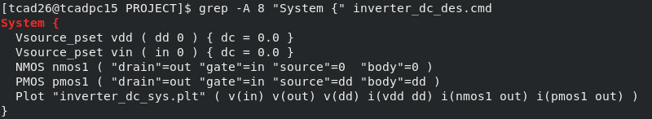
Fig. 3: The circuit netlist of the inverter, printed on the lab machine with grep -A 8 "System {" inverter_dc_des.cmd.

3.5 Mixed-mode transient deck (inverter_tran_des.cmd)
The transient deck reuses the same Device blocks. Only the circuit, the time integrator and the Solve section change:
Listing 3.4: System and Solve sections of the transient deck
System {
Vsource_pset vdd ( dd 0 ) { dc = 0.0 }
*- input pulse: 0 -> 1.8 V, delay 200 ps, rise/fall 20 ps, high for 400 ps
* pulse = ( v_low v_high delay t_rise t_fall t_high period )
Vsource_pset vin ( in 0 ) { pulse = ( 0.0 1.8 200e-12 20e-12 20e-12 400e-12 2e-9 ) }
Capacitor_pset cl ( out 0 ) { capacitance = 10e-15 } * 10 fF load
NMOS nmos1 ( "drain"=out "gate"=in "source"=0 "body"=0 )
PMOS pmos1 ( "drain"=out "gate"=in "source"=dd "body"=dd )
Plot "inverter_tran_sys.plt" ( time() v(in) v(out) v(dd) i(vdd dd) i(cl out) )
}
Math { ... as before, plus: Transient= BE }
Solve {
Coupled ( Iterations= 100 LineSearchDamping= 1e-8 ){ Poisson }
Coupled ( Iterations= 100 LineSearchDamping= 1e-8 ){ Poisson Electron Hole Contact Circuit }

*- DC operating point at VDD = 1.8 V, Vin = 0 (Vout = 1.8 V)
Quasistationary(
InitialStep= 1e-2 Increment= 1.5 MinStep= 1e-6 MaxStep= 0.1
Goal { Parameter= vdd.dc Value= 1.8 }
){ Coupled { Poisson Electron Hole Contact Circuit } }

*- transient: 0 .. 1 ns, step <= 2 ps
NewCurrentPrefix= "tran_"
Transient(
InitialTime= 0 FinalTime= 1.0e-9
InitialStep= 1e-13 MaxStep= 2e-12 MinStep= 1e-17 Increment= 1.3
){ Coupled { Poisson Electron Hole Contact Circuit } }
}

The input is a pulse from 0 to 1.8 V that starts after a 200 ps delay, with 20 ps rise and fall times and a 400 ps high time, so the input rises at 200–220 ps and falls at 620–640 ps. Capacitor_pset cl ( out 0 ) adds the 10 fF load. The Transient statement integrates from 0 to 1 ns with time steps between 0.1 ps and 2 ps (510 time points were stored), using backward-Euler integration of the coupled device and circuit equations.

3.6 Sizing variant
For the Wp = 2.0 µm runs the decks were copied with sed. The command changes only the pMOS AreaFactor and the output names, so the two cases differ in nothing else:
Listing 3.5: creating and running the Wp/Wn = 2.0 variant
sed -e "s/AreaFactor= 1.5/AreaFactor= 2.0/" \
-e "s/inverter_dc_sys.plt/inverter_dc_wp2_sys.plt/" \
-e 's/Output = "inverter_dc"/Output = "inverter_dc_wp2"/' inverter_dc_des.cmd >
inverter_dc_wp2_des.cmd
sdevice inverter_dc_wp2_des.cmd > wp2.log 2>&1
python3 analyze_plt.py dc vtc_inverter_dc_wp2_sys.plt

3.7 Post-processing scripts
SDevice .plt files are plain text in the DF-ISE format: a list of dataset names followed by a block of numbers. Two short dependency-free Python scripts read them and compute the figures of merit:
• analyze_plt.py dc: computes the gain g = dVout/dVin by central differences, finds VM where Vout − Vin = 0, finds VIL and VIH where g = −1 (first and last crossing), interpolates VOH and VOL at those inputs, and takes the maximum of the supply current.
• analyze_plt.py tran: finds the 50 % crossings of the input and output edges by linear interpolation to give tpHL and tpLH, and the 10 % and 90 % crossings of the output to give the fall and rise times.
• device_params.py: from the two Id–Vg sweeps it computes gm = dId/dVg and Vt at maximum gm, the constant-current Vt at 100 nA/µm, the minimum of dVg/dlog₁₀Id below 100 nA/µm (SS), DIBL, Ion (last point of the saturation sweep) and Ioff (first point).
Listing 3.6: VTC metric extraction (analyze_plt.py, dc function)
def dc(path):
names, data = read_plt(path)
vin, n_in = pick(names, data, r"^in\b|v\(in\)|\bin\s")
vout, n_out = pick(names, data, r"^out\b|v\(out\)|\bout\s")
print(f"using Vin = '{n_in}', Vout = '{n_out}'")
# gain by central differences
g = []
for i in range(len(vin)):
j0, j1 = max(i - 1, 0), min(i + 1, len(vin) - 1)
g.append((vout[j1] - vout[j0]) / (vin[j1] - vin[j0]) if vin[j1] != vin[j0] else 0.0)
diff = [o - i for i, o in zip(vin, vout)]
vm = interp(0.0, diff, vin)
idx = [i for i, x in enumerate(g) if x <= -1]
vil = interp(-1.0, g[: idx[0] + 1], vin[: idx[0] + 1]) if idx else float("nan")
vih = interp(-1.0, g[idx[-1]:], vin[idx[-1]:]) if idx else float("nan")
voh, vol = interp(vil, vin, vout), interp(vih, vin, vout)
res = dict(VM=vm, VIL=vil, VIH=vih, VOH=voh, VOL=vol, NML=vil - vol, NMH=voh - vih,
peak_gain=-min(g))
try:
idd, n_i = pick(names, data, r"vdd")
res["peak_Idd_uA"] = max(abs(x) for x in idd) * 1e6
except SystemExit:
pass
for k, v in res.items():
print(f" {k:12s} {v:10.4f}")

3.8 Practical problems met and how they were solved
• Goal syntax for circuit parameters. The supply and input ramps use Goal { Parameter= vdd.dc Value= 1.8 }. For a circuit parameter the keyword is Value=, not Voltage= (which is used for electrode goals). The decks were corrected before the first mixed-mode run.
• Where the sweep data goes. NewCurrentPrefix= "vtc_" opens a new output file for everything after it, including the circuit plot. The first inverter_dc_sys.plt (2.8 kB) therefore holds only the VDD ramp with Vin = 0, and running the analysis on it gave VM = 0 and undefined margins. The actual sweep is in vtc_inverter_dc_sys.plt (107 points); the transient is likewise in tran_inverter_tran_sys.plt.
• The structure script was overwritten. (sde:save-model "nmos_180") writes nmos_180.sat and also a nmos_180.scm model dump, which replaced the input script of the same name. A copy of the original script had been kept, and Listing 3.1 is that original. In future the script should be named differently from the saved model (e.g. nmos_180_build.scm).
• Run time. Adding NumberOfThreads= maximum to the Math sections let SDevice use the workstation's 28 threads. Each run then took between 45 s and 3.7 min (Section 4.10).

3.9 Single-substrate CMOS structure (cmos_inverter_build.scm)
Mixed mode keeps the two transistors as separate meshes, so there is no single drawing of the whole inverter in the simulation flow. To show the complete inverter as it would be fabricated, an additional SDE script places both transistors on one p-type substrate: the nMOS on the left, a 0.30 µm wide, 0.25 µm deep SiO₂ shallow-trench isolation (STI) in the middle, and the pMOS on the right inside a 0.6 µm deep n-well. The dimensions and the S/D/LDD profiles are identical to the single-device scripts. The n-well is made by adding 6×10¹⁷ cm⁻³ phosphorus on top of the 3×10¹⁷ cm⁻³ boron substrate, so the pMOS body is net n-type 3×10¹⁷ cm⁻³, exactly as in pmos_180.scm. Seven contacts are defined (n_source, n_gate, n_drain, p_source, p_gate, p_drain, body). The structure was generated with sde -l cmos_inverter_build.scm and meshed into 7,206 points and 14,629 elements. It is used for visualisation only: the electrical results in Chapter 4 come from the mixed-mode decks.
Listing 3.7: cmos_inverter_build.scm (regions and substrate/well doping; contacts, S/D profiles and meshing follow the single-device scripts)
;; ---------------- regions -------------------------------------------
;; silicon built from three touching rectangles around the STI (no overlaps)
(sdegeo:create-rectangle (position N0 0.0 0.0) (position N5 Ys 0.0) "Silicon"
"region_si_n")
(sdegeo:create-rectangle (position N5 0.0 0.0) (position S1 (- Ys Dsti) 0.0) "Silicon"
"region_si_mid")
(sdegeo:create-rectangle (position P0 0.0 0.0) (position P5 Ys 0.0) "Silicon"
"region_si_p")
(sdegeo:create-rectangle (position N5 (- Ys Dsti) 0.0) (position S1 Ys 0.0) "SiO2" "region_sti")
;; nMOS gate stack
(sdegeo:create-rectangle (position N2 Ys 0.0) (position N3 Yox 0.0) "SiO2" "region_n_oxide")
(sdegeo:create-rectangle (position N2 Yox 0.0) (position N3 Ytop 0.0) "TiN" "region_n_metal")
(sdegeo:create-rectangle (position N1 Ys 0.0) (position N2 Ytop 0.0) "Si3N4" "region_n_spacer_s")
(sdegeo:create-rectangle (position N3 Ys 0.0) (position N4 Ytop 0.0) "Si3N4" "region_n_spacer_d")
;; pMOS gate stack
(sdegeo:create-rectangle (position P2 Ys 0.0) (position P3 Yox 0.0) "SiO2" "region_p_oxide")
(sdegeo:create-rectangle (position P2 Yox 0.0) (position P3 Ytop 0.0) "TiN" "region_p_metal")
(sdegeo:create-rectangle (position P1 Ys 0.0) (position P2 Ytop 0.0) "Si3N4" "region_p_spacer_s")
(sdegeo:create-rectangle (position P3 Ys 0.0) (position P4 Ytop 0.0) "Si3N4" "region_p_spacer_d")

;; (a) p-substrate everywhere, n-well under the pMOS (window placements)
(sdedr:define-refeval-window "RW_substrate" "Rectangle" (position 0.0 0.0 0.0) (position Wtot Ys 0.0))
(sdedr:define-constant-profile "CPD_psub" "BoronActiveConcentration" Nbody)
(sdedr:define-constant-profile-placement "CPP_psub" "CPD_psub" "RW_substrate")
(sdedr:define-refeval-window "RW_nwell" "Rectangle" (position (- S1 0.15) (- Ys Dwell) 0.0) (position
Wtot Ys 0.0))
(sdedr:define-constant-profile "CPD_nwell" "PhosphorusActiveConcentration" (* 2 Nbody))
(sdedr:define-constant-profile-placement "CPP_nwell" "CPD_nwell" "RW_nwell")

Chapter 4: Results (I–V Characteristics, VTC, Transient Waveforms, Device Internals)

4.1 Device structure, doping and mesh
Running the structure script with the Structure Editor GUI open (sde -l "nmos_180 (copy).scm") builds the device step by step on screen. Fig. 4 shows the result: the silicon body (green), the source (red), gate (blue) and drain (green) contacts along the top surface, the body contact (yellow) along the bottom edge, and the channel refinement window under the gate. The Scheme-command log at the bottom confirms "Meshing successful".
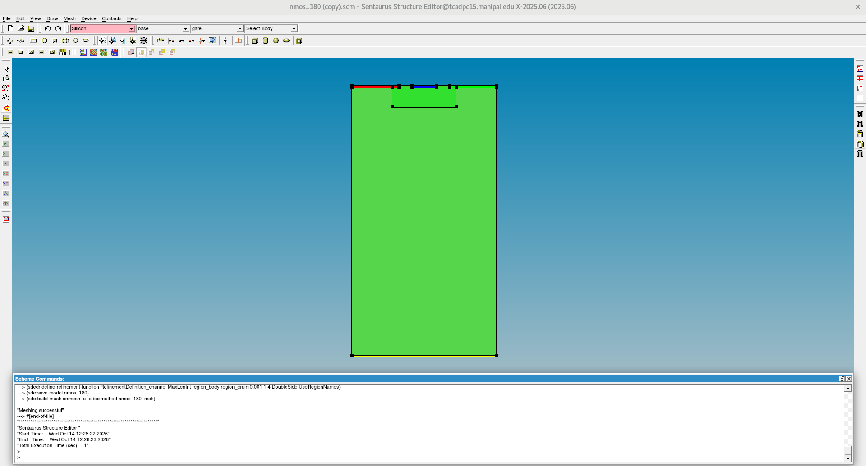
Fig. 4: The nMOS structure in Sentaurus Structure Editor, generated from nmos_180.scm (screenshot from the lab machine). The pMOS has the same geometry; only the doping species and the gate workfunction differ.
Table 5: Device geometry and doping defined in the SDE scripts
Parameter | nMOS | pMOS
Gate length / oxide | 180 nm / 4 nm SiO₂ | 180 nm / 4 nm SiO₂
Gate (contact) workfunction | TiN, 4.25 eV | TiN, 4.97 eV
Spacers | Si₃N₄, 100 nm | Si₃N₄, 100 nm
Body doping | Boron 3×10¹⁷ cm⁻³ | Phosphorus 3×10¹⁷ cm⁻³
S/D peak, junction depth | Arsenic 5×10¹⁹ cm⁻³, 120 nm | Boron 5×10¹⁹ cm⁻³, 120 nm
LDD peak, junction depth | 5×10¹⁸ cm⁻³, 35 nm | 5×10¹⁸ cm⁻³, 35 nm
Device size (x × y) | 1.08 µm × 2.0 µm | 1.08 µm × 2.0 µm
Width in the inverter | 1.0 µm | 1.5 µm (2.0 µm in Section 4.7)

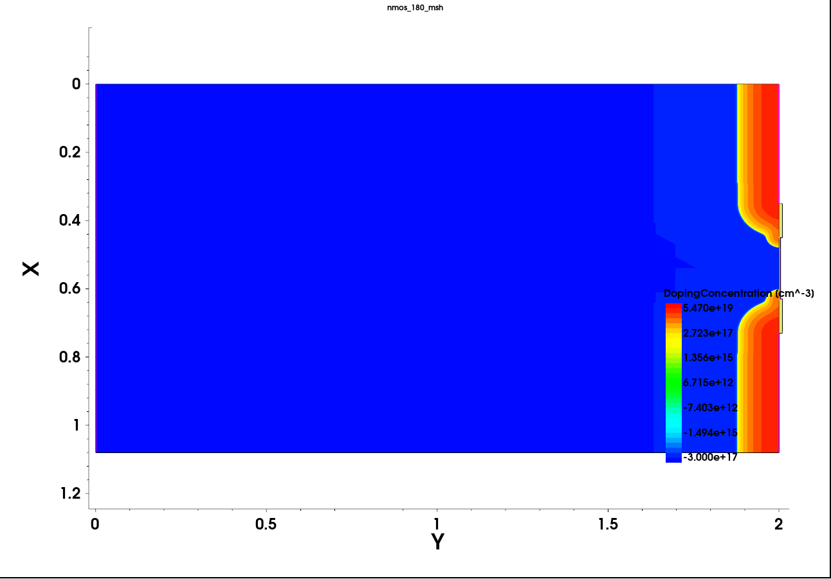
Fig. 5: Net doping of the generated nMOS mesh (SVisual, nmos_180_msh.tdr). The silicon surface is the right-hand edge (Y = 2 µm) and X runs along the channel. Red: n⁺ source (top) and drain (bottom). Blue: p-type body.
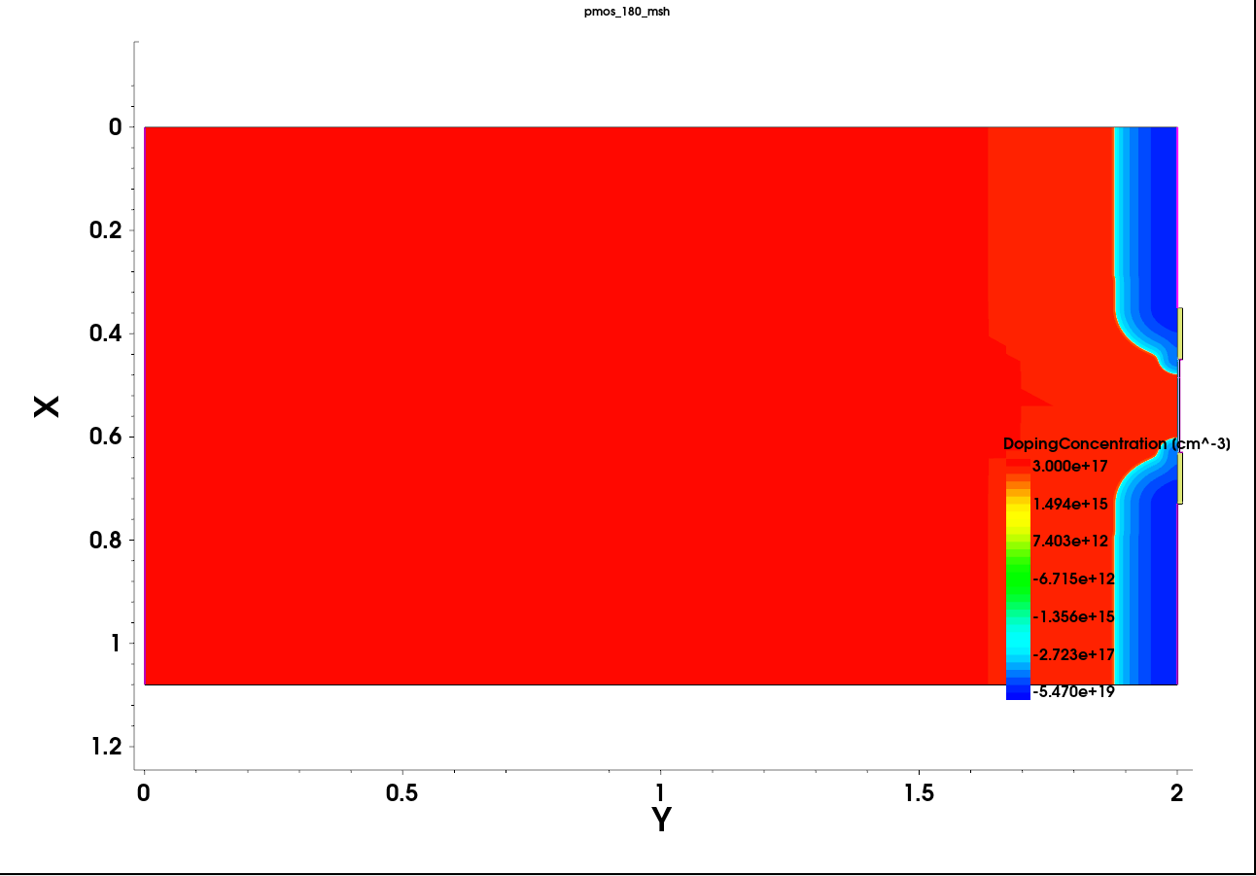
Fig. 6: Net doping of the pMOS mesh (pmos_180_msh.tdr): p⁺ source/drain (blue, negative net doping) in an n-type body (red).
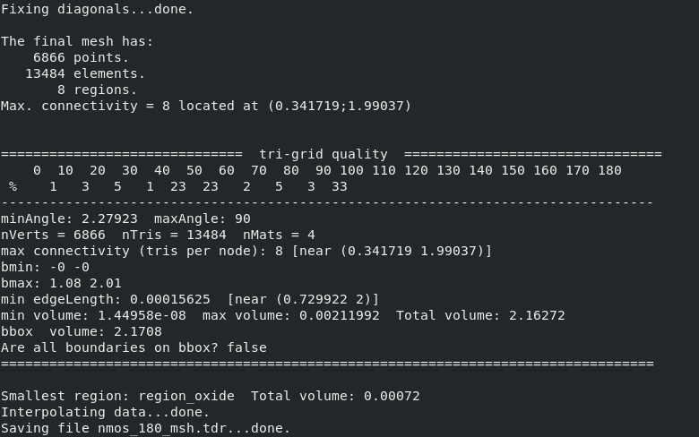
Fig. 7: Sentaurus Mesh report for nmos_180_msh.tdr (lab terminal): 6,866 points, 13,484 elements, 8 regions, smallest edge 0.156 nm at the drain-side interface, generation time 0.197 s.
The SDE runs produced meshes of 6,866 points and 13,484 triangular elements for each device. The element size is about 50 nm deep in the substrate and 0.5 nm at the Si/SiO₂ interface under the gate; the smallest edge (0.16 nm) sits where the channel and drain-junction refinements overlap. Fig. 5 shows the S/D junctions reaching about 0.12 µm below the surface, the shallower LDD extensions under the spacers, and the junction curving under the gate edge. Plotting the analytical profiles defined in the script (Fig. 8) shows something important: because of the lateral Gaussian spread, the p-type region at the surface is only ≈ 123 nm long, although the drawn gate is 180 nm. This shorter metallurgical channel explains why the simulated threshold voltages are a little lower than the long-channel estimate of Section 2.4, and why DIBL is visible.
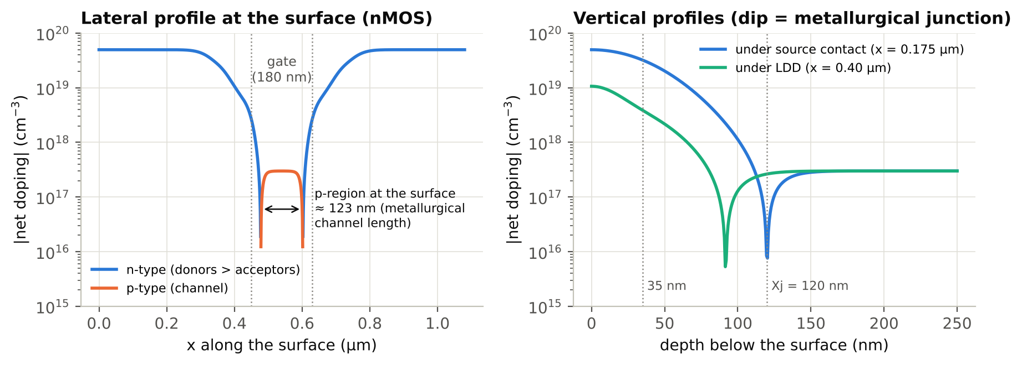
Fig. 8: Net doping computed from the SDE profile definitions: along the surface (left) and versus depth (right). The dips mark the metallurgical junctions.

4.2 Transfer characteristics (Id–Vg)
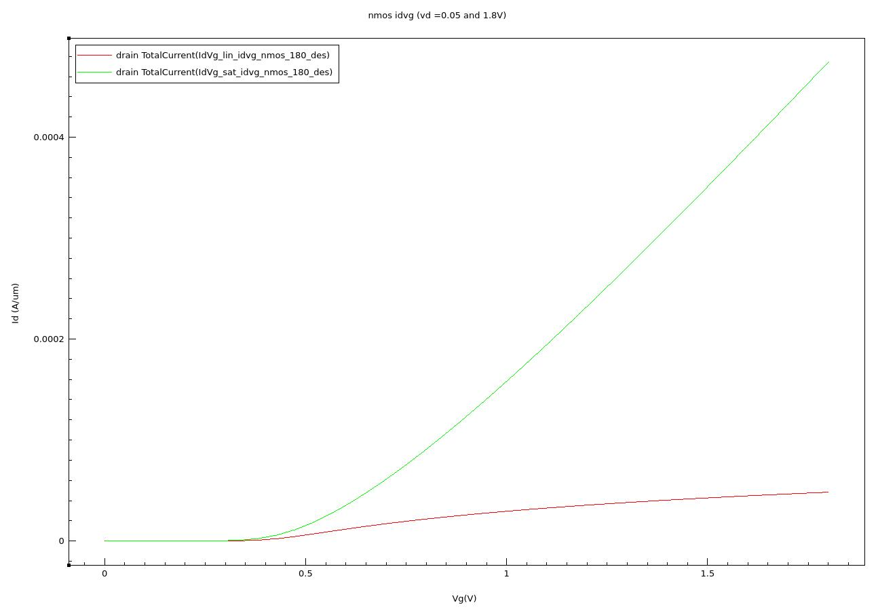
Fig. 9: nMOS Id–Vg on a linear scale, exported from SVisual (IdVg_lin_… = Vd 0.05 V, IdVg_sat_… = Vd 1.8 V; X: gate OuterVoltage, Y: drain TotalCurrent in A/µm).
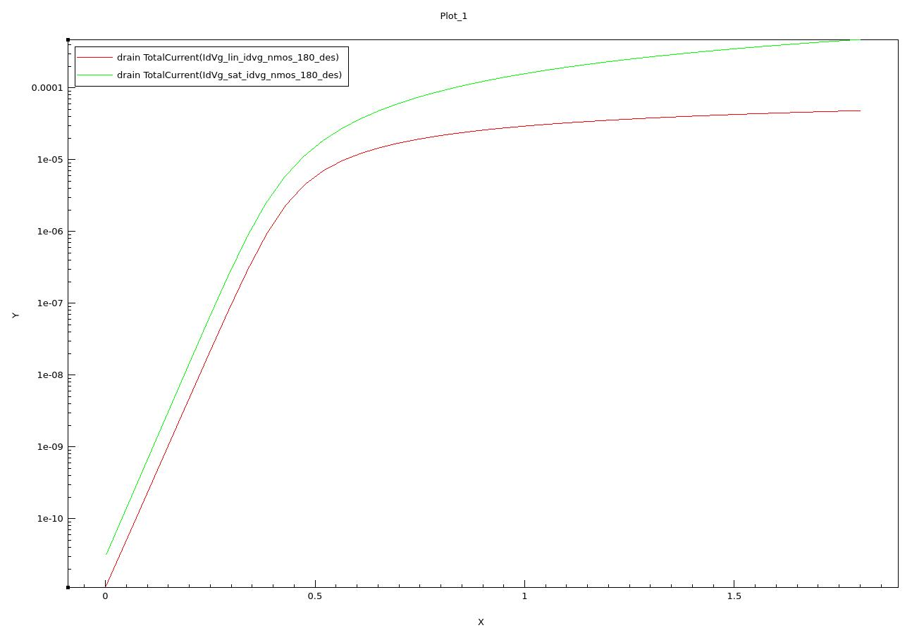
Fig. 10: nMOS Id–Vg on a logarithmic current scale (SVisual export). The straight low-Vg part is the subthreshold region.
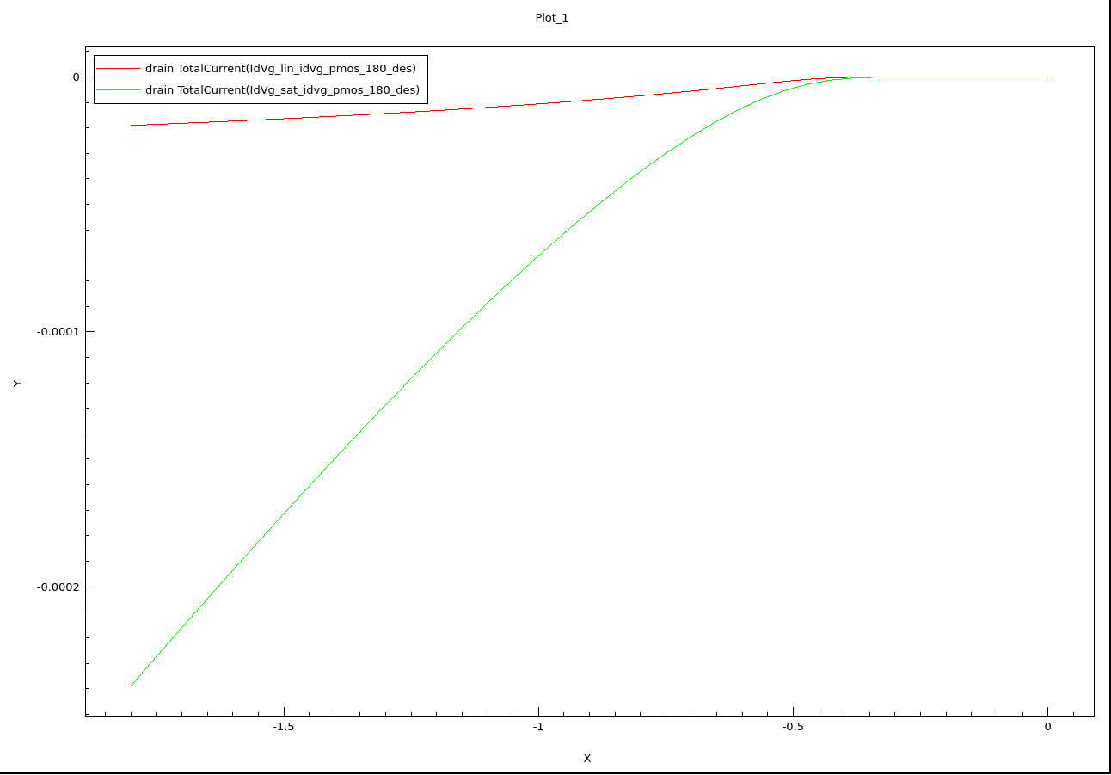
Fig. 11: pMOS Id–Vg on a linear scale (SVisual). Gate and drain voltages and the drain current are negative for the pMOS (red: Vd = −0.05 V, green: Vd = −1.8 V).
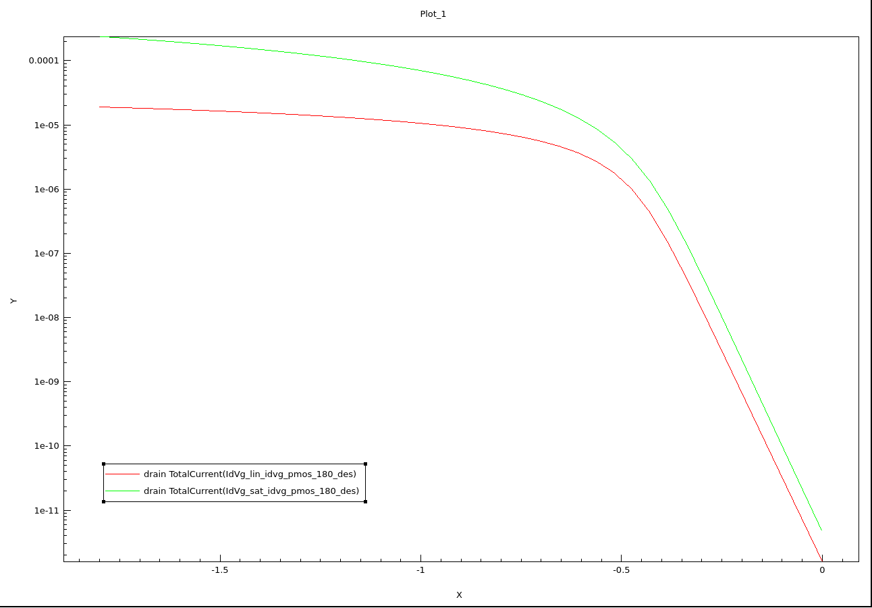
Fig. 12: pMOS Id–Vg on a logarithmic scale (SVisual plots |Id|).
Figs. 9–12 show well-behaved transistors. The log plots have a straight subthreshold region spanning about six decades, followed by a smooth turn-on. The saturation curve (Vd = 1.8 V) is shifted to the left of the linear curve; that shift is DIBL. In the linear plots the saturation current grows almost linearly with Vg above about 1 V rather than quadratically, the signature of velocity saturation and Enormal mobility degradation. The extracted parameters are listed in Table 5.
Table 6: Extracted transistor parameters (per µm width)
Parameter | nMOS | pMOS
Vt (max-gm), V | 0.373 | −0.409
Vt,lin @100 nA/µm, V | 0.301 | −0.370
Vt,sat @100 nA/µm, V | 0.263 | −0.327
Subthreshold swing, mV/dec | 75.7 | 76.2
DIBL, mV/V | 21.9 | 25.0
Ion, µA/µm | 474.6 | 238.6
Ioff, pA/µm | 31.7 | 4.9
Ion/Ioff | 1.5×10⁷ | 4.9×10⁷

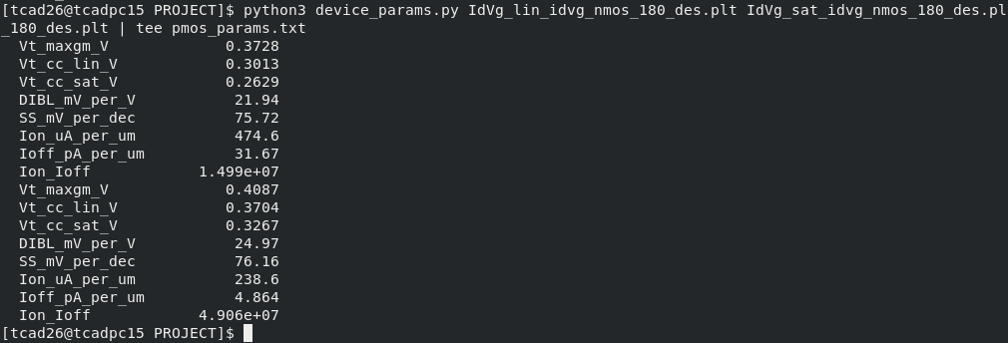
Fig. 13: Parameter extraction on the lab machine: device_params.py run on the nMOS (first block) and pMOS (second block) Id–Vg files.
• Good electrostatics. SS ≈ 76 mV/dec is close to the 71 mV/dec long-channel estimate of Section 2.5, and DIBL is a moderate 22–25 mV/V. The thresholds (|Vt| ≈ 0.37–0.41 V) are near the 0.43 V design value of Section 2.4, a little lower because of the ≈ 123 nm metallurgical channel.
• The pMOS delivers only half the nMOS current (238.6 vs 474.6 µA/µm). Holes have a lower mobility than electrons, and the Enormal surface-scattering model degrades hole mobility further. This single fact explains most of the inverter results below.
• The nMOS has the lower threshold (0.373 V vs 0.409 V). Leakage depends exponentially on Vt at ≈ 76 mV/dec, which is why the nMOS also has the higher off-current (31.7 vs 4.9 pA/µm).

4.3 Output characteristics (Id–Vd)
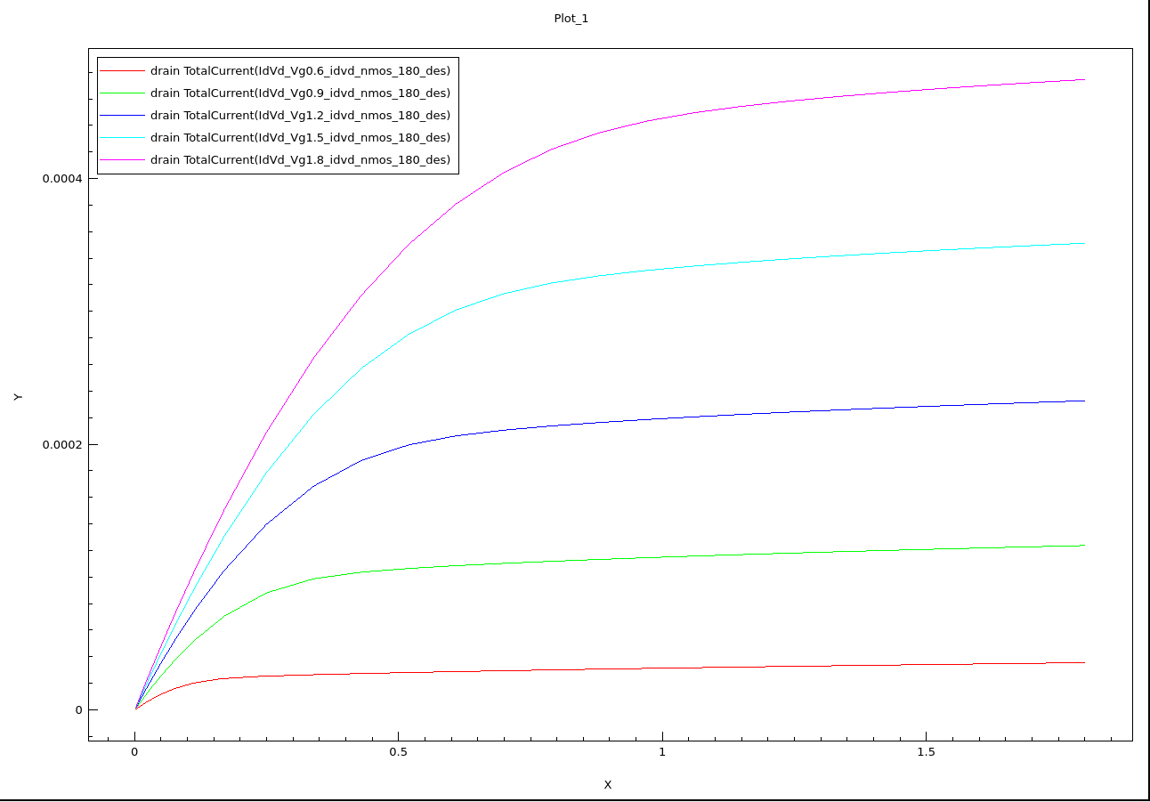
Fig. 14: nMOS Id–Vd for Vg = 0.6, 0.9, 1.2, 1.5 and 1.8 V (SVisual; X: drain OuterVoltage, Y: drain TotalCurrent in A/µm).
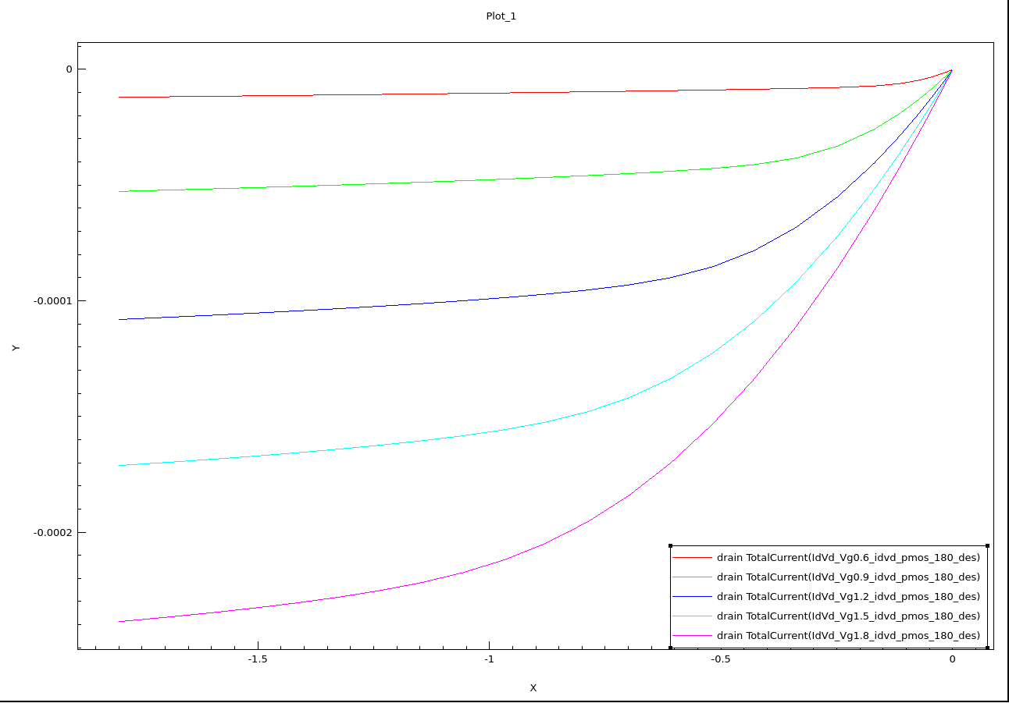
Fig. 15: pMOS Id–Vd for Vg = −0.6 … −1.8 V (SVisual; negative voltages and currents).
Table 7: Drain current at |Vd| = 1.8 V (µA/µm) and the nMOS/pMOS ratio
|Vg| (V) | nMOS | pMOS | Ratio n/p
0.6 | 35.5 | 12.1 | 2.94
0.9 | 123.7 | 52.7 | 2.34
1.2 | 232.7 | 108.1 | 2.15
1.5 | 351.3 | 171.2 | 2.05
1.8 | 474.6 | 238.6 | 1.99

Both devices show a clear linear region followed by saturation, with a small positive output conductance in saturation caused by DIBL and channel-length modulation. The spacing between curves is nearly uniform at high |Vg|, again showing velocity saturation (Id ∝ Vg − Vt rather than (Vg − Vt)²). The nMOS/pMOS current ratio at full gate drive is 1.99. This is the number that decides the inverter sizing in Section 4.6.

4.4 Inverter DC characteristics (VTC)
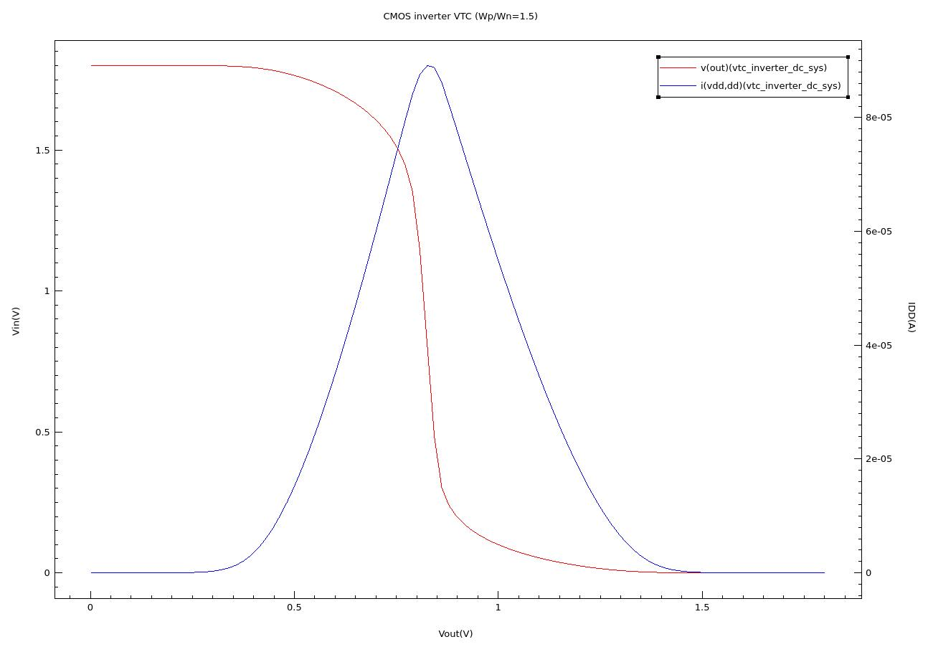
Fig. 16: VTC of the mixed-mode inverter, Wp/Wn = 1.5 (red, v(out) vs v(in), left axis) and the supply current i(vdd,dd) (blue, right axis), exported from SVisual (vtc_inverter_dc_sys.plt). Note: the horizontal axis is Vin and the left axis is Vout; the axis titles in this export are swapped.
Table 8: Inverter DC metrics (VDD = 1.8 V, Wp/Wn = 1.5), extracted by analyze_plt.py from vtc_inverter_dc_sys.plt
Metric | Value
VM (V) | 0.825
VIL (V) | 0.651
VIH (V) | 0.940
VOH (V) | 1.665
VOL (V) | 0.147
NML = VIL − VOL (V) | 0.504
NMH = VOH − VIH (V) | 0.725
Peak gain | 18.6
Peak IDD (µA) | 89.1

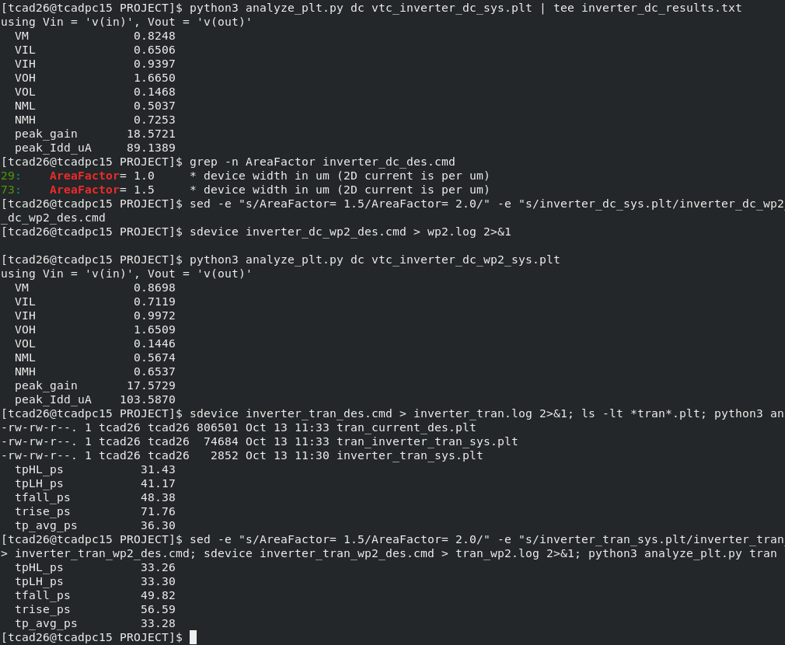
Fig. 17: Metric extraction on the lab machine: analyze_plt.py on the DC sweeps (Wp/Wn = 1.5 and 2.0) and on the transients.
The VTC has full rail-to-rail output (Vout = 1.8 V at Vin = 0 and below 10 nV at Vin = 1.8 V, so there is no static current in either logic state) and a sharp transition with a peak gain of 18.6. The switching threshold, however, is 0.825 V, below VDD/2 = 0.9 V. The pull-down is stronger than the pull-up, so the low noise margin (0.504 V) is smaller than the high one (0.725 V). This follows directly from Section 4.2: a 1.5× wider pMOS delivers 1.5 × 238.6 = 358 µA against the nMOS's 475 µA. As a first-order check, using r = √(Wp·Ion,p / Wn·Ion,n) = 0.868 and the extracted thresholds in Equation (2.5) gives VM ≈ 0.846 V, within 21 mV of the simulated 0.825 V. The supply current peaks at 89.1 µA close to VM, where both transistors conduct, and falls to the pA level in both logic states.

4.5 Inside the transistors at the switching point
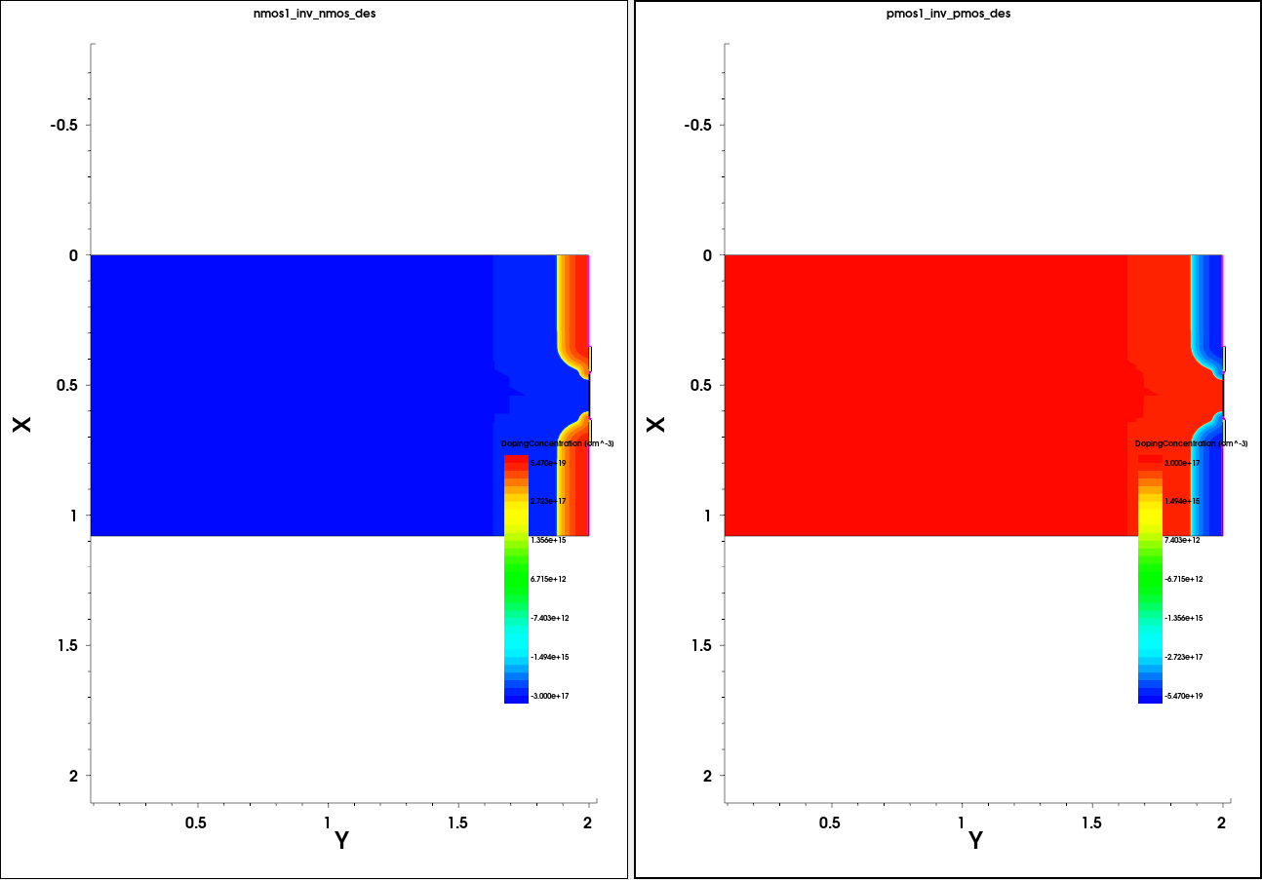
Fig. 18: Both transistors as they were used inside the inverter circuit (nmos1_inv_nmos_des.tdr and pmos1_inv_pmos_des.tdr, DopingConcentration), opened side by side in SVisual. These are the same two meshes, now carrying the solution of the mixed-mode run.
The DC deck saved a full 2D snapshot of both devices halfway through the sweep (Plot ( … Time= ( 0.5 ) ), i.e. Vin = 0.9 V, close to VM). These snapshots show what is happening inside the transistors while the inverter is switching:
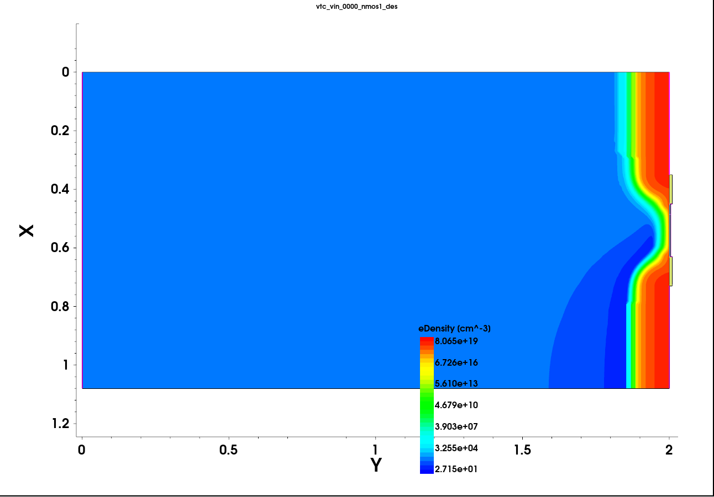
Fig. 19: Electron density in the nMOS at Vin ≈ 0.9 V (vtc_vin_0000_nmos1_des.tdr). The inversion layer (red/yellow strip along the surface between source and drain) is formed: the nMOS is on.
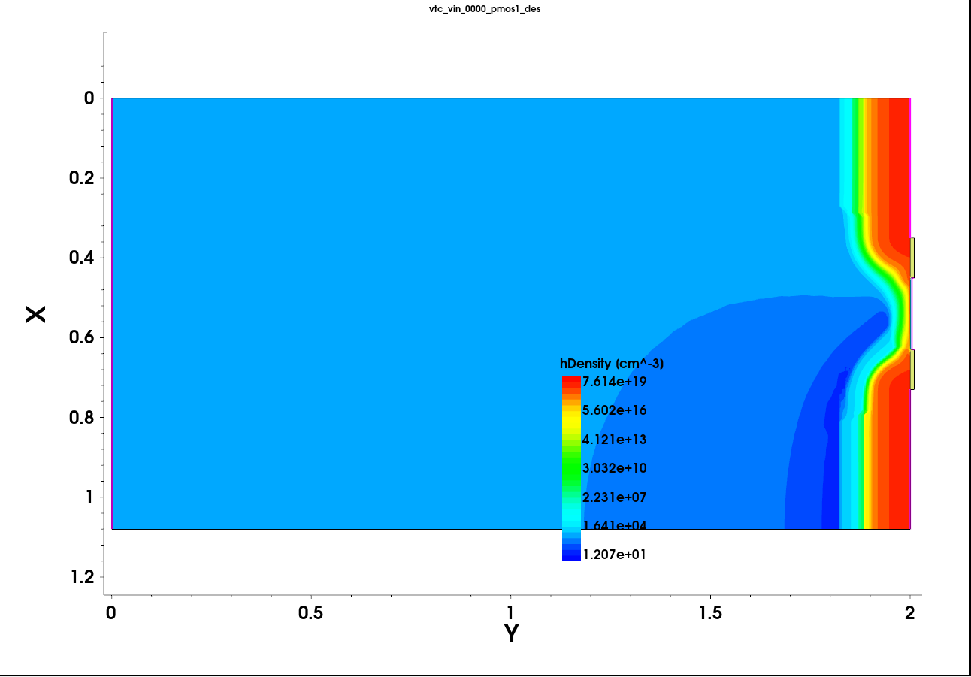
Fig. 20: Hole density in the pMOS at the same instant (vtc_vin_0000_pmos1_des.tdr). Holes still connect source and drain along the surface: the pMOS is also conducting, which is why IDD peaks here.
Both channels are present at the same time. This is the microscopic picture behind the short-circuit current peak in the VTC figure and behind the high gain: near VM both transistors are in saturation, and a small change of Vin changes the balance between their currents strongly.

4.6 Transient response
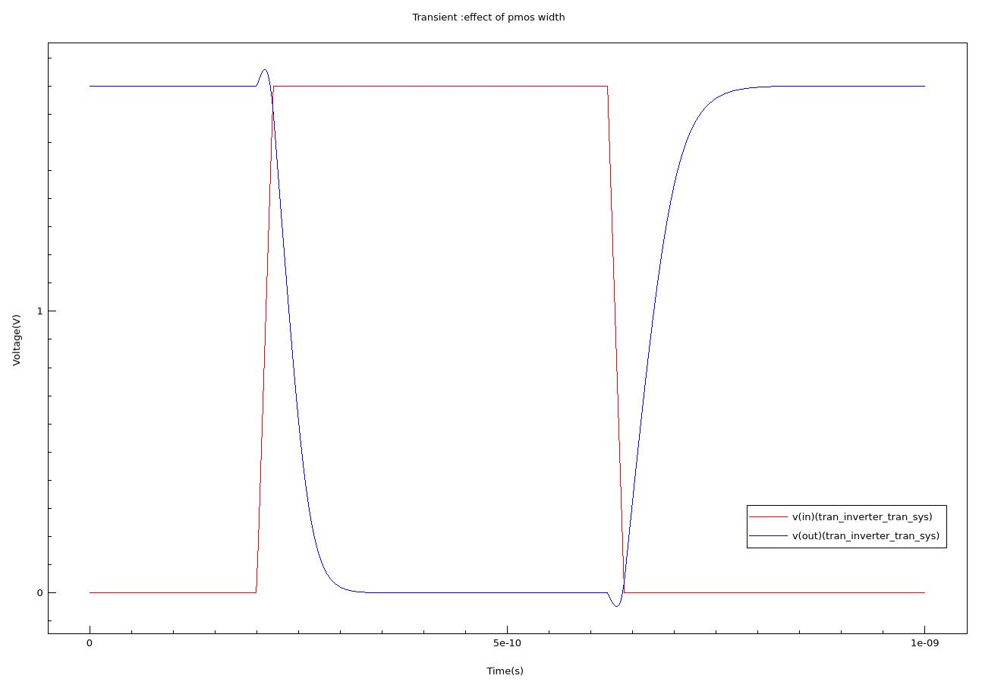
Fig. 21: Transient response of the inverter, Wp/Wn = 1.5, CL = 10 fF (SVisual export of tran_inverter_tran_sys.plt; red: v(in), blue: v(out); time axis 0–1 ns).
Table 9: Transient metrics extracted by analyze_plt.py (Wp/Wn = 1.5, CL = 10 fF, 20 ps input edges)
Metric | Value
tpHL (ps) | 31.4
tpLH (ps) | 41.2
tp average (ps) | 36.3
Fall time 10–90 % (ps) | 48.4
Rise time 10–90 % (ps) | 71.8
Miller overshoot / undershoot | +59 mV / -48 mV

The output switches cleanly between the rails. The falling output (nMOS discharging the load) takes 31.4 ps, and the rising output (pMOS charging it) takes 41.2 ps, with a much slower rise time (71.8 ps) than fall time (48.4 ps). This is the same weak pull-up seen in the DC results: Equation (2.6) predicts tpLH/tpHL ≈ (Ion,n·Wn)/(Ion,p·Wp) = 474.6/(1.5 × 238.6) = 1.33, and the simulation gives 1.31. The small bump of +59 mV above VDD when the input rises, and the matching dip below 0 V when it falls, are Miller feedthrough through the gate–drain capacitance (Section 2.7).

Charge and energy consistency checks
Integrating the load-capacitor current over the falling edge gives exactly 18.0 fC = 10 fF × 1.8 V. This confirms that the circuit equations are solved consistently with the devices. Integrating the supply current over the rising edge gives 24.6 fC, an effective switched capacitance of 24.6 fC / 1.8 V = 13.7 fF. The extra ≈ 3.7 fF is the inverter's own output capacitance (drain junctions and gate–drain overlap) plus a small short-circuit charge. The energy drawn per full output cycle is 43.3 fJ, compared with CL·VDD² = 32.4 fJ for the load alone. Inserting Ceff into Equation (2.6) gives tpHL ≈ 13.7 fF × 0.9 V / 474.6 µA ≈ 26 ps, the right order of magnitude. The simulated value is larger because the input itself takes 20 ps to rise, so the nMOS does not deliver its full Ion during the whole discharge.

4.7 pMOS sizing study (Wp/Wn = 1.5 vs 2.0)
Sections 4.2–4.6 point to the same cause: the pMOS is too weak for a 1.5× width ratio, and the device data suggest Wp/Wn ≈ 2. Both inverter decks were therefore rerun with the pMOS AreaFactor set to 2.0, with nothing else changed.
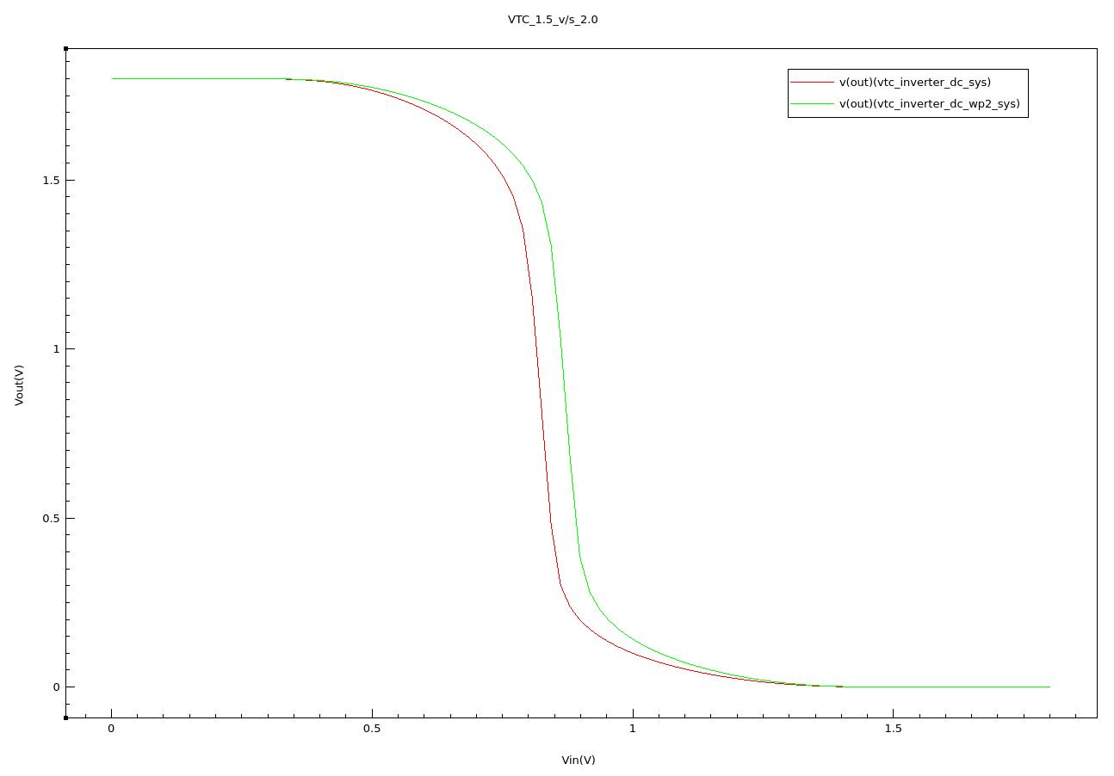
Fig. 22: VTC for Wp/Wn = 1.5 (red, vtc_inverter_dc_sys) and Wp/Wn = 2.0 (green, vtc_inverter_dc_wp2_sys), SVisual export. The wider pMOS moves the transition to the right, towards VDD/2.
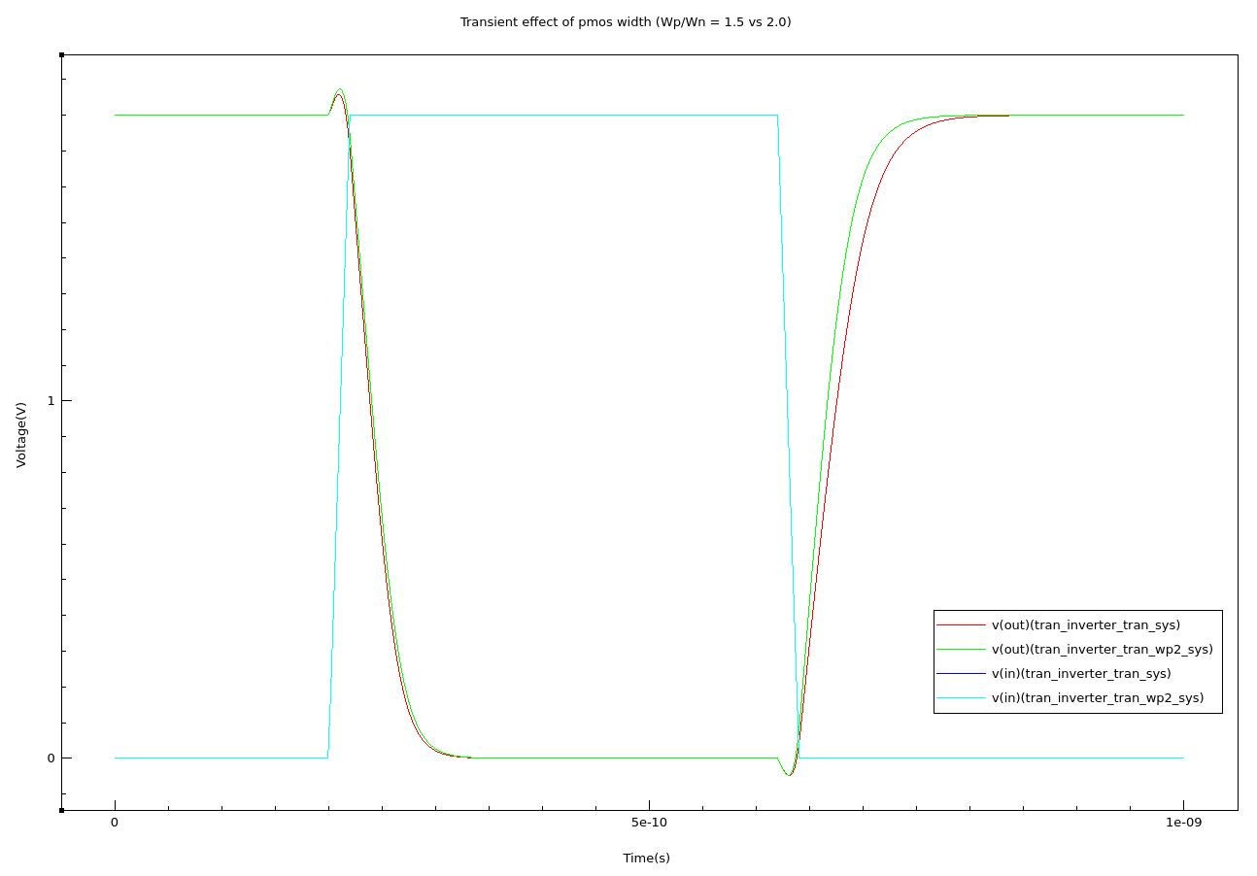
Fig. 23: Transient output for Wp/Wn = 1.5 (red) and 2.0 (green), with the two identical inputs (blue/cyan), SVisual export. The Wp/Wn = 2.0 output rises clearly faster after the input falls at ≈ 620 ps.
Table 10: Sizing study: all metrics for both pMOS widths
Metric | Wp/Wn = 1.5 | Wp/Wn = 2.0 | Change
VM (V) | 0.825 | 0.870 | +45 mV
VIL / VIH (V) | 0.651 / 0.940 | 0.712 / 0.997 | both shift up
NML / NMH (V) | 0.504 / 0.725 | 0.567 / 0.654 | margins converge
Peak gain | 18.6 | 17.6 | ≈ unchanged
Peak IDD (µA) | 89.1 | 103.6 | +16 %
tpHL (ps) | 31.4 | 33.3 | +6 %
tpLH (ps) | 41.2 | 33.3 | -19 %
tp average (ps) | 36.3 | 33.3 | -8 %
Fall / rise time (ps) | 48.4 / 71.8 | 49.8 / 56.6 | rise time −21 %
Effective output capacitance (fF) | 13.7 | 14.4 | +0.8 fF
Energy per cycle (fJ) | 43.3 | 45.4 | +5 %

• Delays become equal. tpLH falls from 41.2 ps to 33.3 ps and now matches tpHL (33.26 ps vs 33.30 ps). The prediction from device currents, tpLH/tpHL ≈ 474.6/(2 × 238.6) = 0.99, agrees with the simulated 1.00. The average delay improves by 8 %.
• VM moves towards VDD/2 (0.825 → 0.870 V; Equation (2.5) predicts 0.883 V) and the two noise margins move closer together.
• The cost: the wider pMOS adds ≈ 0.8 fF of drain capacitance to the output node, so tpHL rises slightly (31.4 → 33.3 ps), the short-circuit current rises by 16 %, the energy per cycle rises by 5 %, and the layout area grows. This is the classic speed–symmetry vs area–power trade-off of inverter sizing.
• VM is still about 30 mV below 0.9 V at Wp/Wn = 2.0. Exact VM = VDD/2 would need Wp/Wn ≈ 2.5, but the delays are already balanced at 2.0. The two criteria give different optima because VM depends on the currents near the threshold, while the delays depend on the full on-currents.

4.8 The complete inverter on one substrate
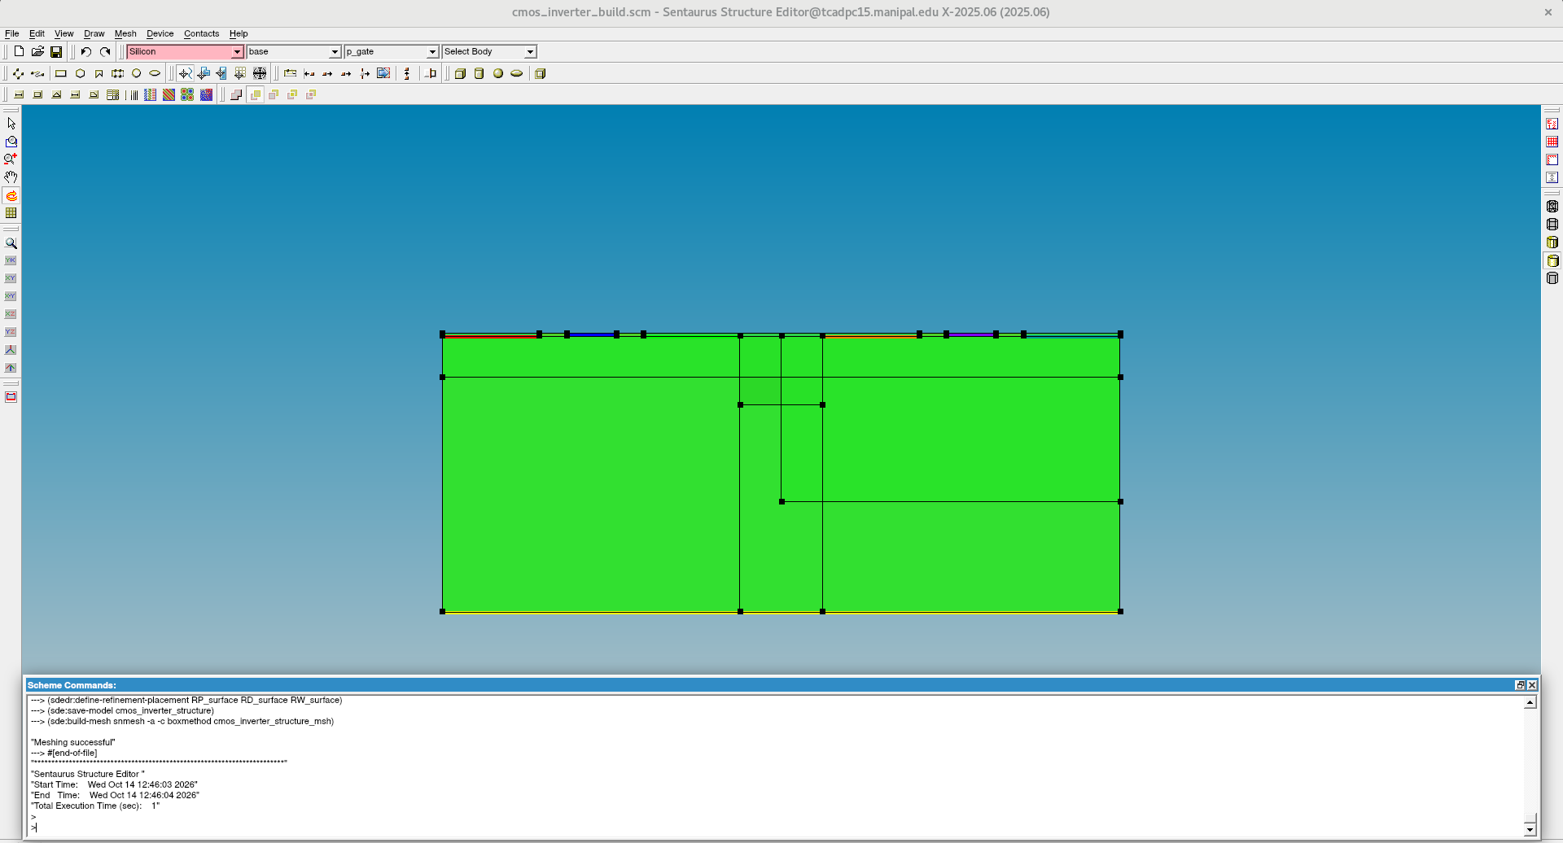
Fig. 24: The single-substrate CMOS inverter (cmos_inverter_build.scm) in Sentaurus Structure Editor: nMOS (left), STI (centre) and pMOS in the n-well (right); coloured edges are the seven contacts.
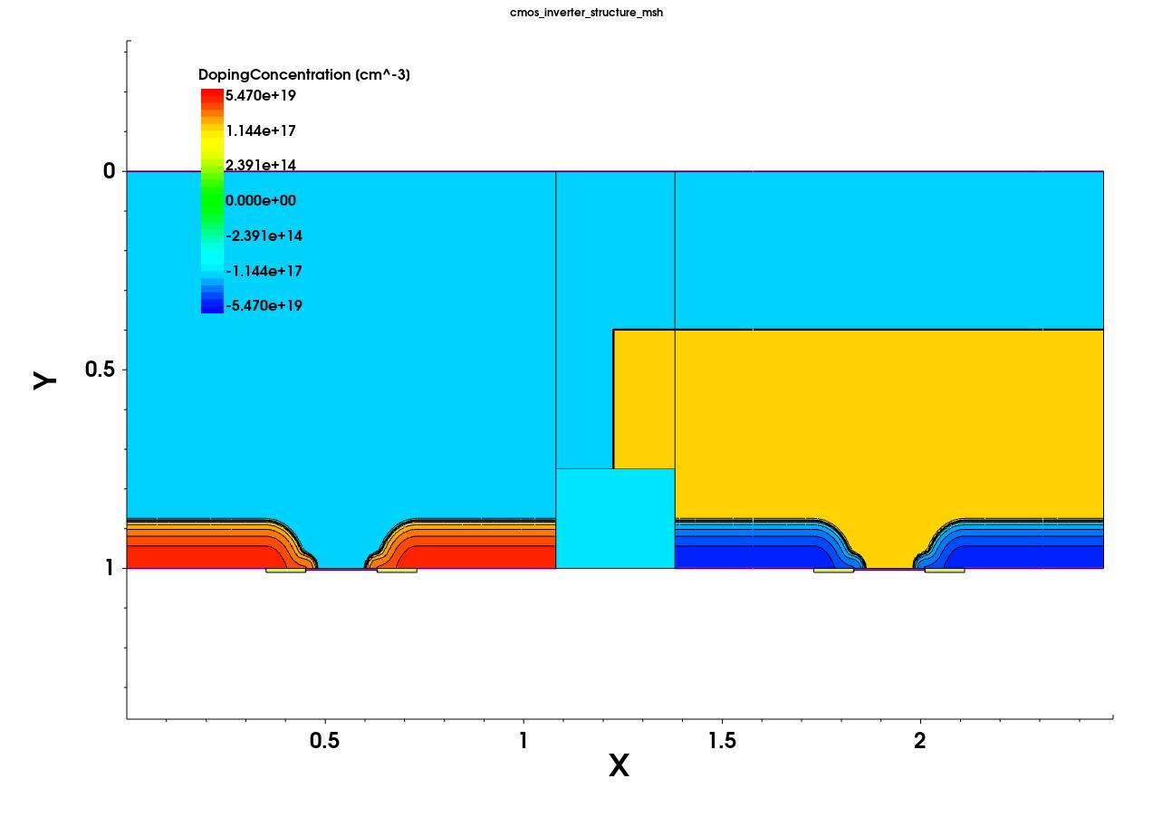
Fig. 25: Net doping of the complete CMOS inverter structure (cmos_inverter_structure_msh.tdr, SVisual). SVisual draws the y-axis downwards, so the silicon surface (y = 1 µm) is at the bottom edge. Red/orange: nMOS n⁺ source/drain in the p-substrate (light blue); dark blue: pMOS p⁺ source/drain inside the n-well (yellow); centre: STI oxide.
This is the inverter as it would be fabricated in an n-well bulk CMOS process: the nMOS sits directly in the p-substrate, the pMOS in its own n-well, and the shallow trench isolates them. The n-well/p-substrate junction (the thick outline around the yellow region) is reverse biased in operation (well at VDD, substrate at 0 V), which is what electrically separates the two transistors. In the mixed-mode simulation this isolation is ideal, because the two devices are separate meshes and are coupled only through the circuit nodes. Any well-to-substrate leakage or latch-up path is outside the scope of the mixed-mode results. At room temperature the leakage of a reverse-biased well junction is expected to be far below the transistors' own off-currents, so neglecting it should not change the results in this chapter.

4.9 Comparison with published TCAD studies
Two published works are directly relevant. Sulong et al. [16] simulated an 80 nm / 90 nm CMOS inverter technology with the same Sentaurus tool chain (process simulation followed by Sentaurus Device). Herrmann et al. [15] used Synopsys mixed-mode device–circuit simulation, the same method as this project, to determine CMOS inverter propagation delay. Table 11 compares the transistor-level figures with [16].
Table 11: Transistor-level comparison with Sulong et al. [16] (values as reported in [16], per µm of width)
Quantity | This work (180 nm, VDD 1.8 V) | [16] 90 nm | [16] 80 nm
nMOS Vt (V) | 0.373 (max-gm) | 0.518 | 0.499
pMOS Vt (V) | −0.409 (max-gm) | −0.526 | −0.491
nMOS Ion / IDSAT (µA/µm) | 474.6 | 400.8 | 429.3
pMOS Ion / IDSAT (µA/µm) | 238.6 | 215.4 | 240.0
Ion,n / Ion,p | 1.99 | 1.86 | 1.79
nMOS Ioff (pA/µm) | 31.7 | 48.8 | 79.1
pMOS Ioff (pA/µm) | 4.9 | 102.3 | 236.1

• Drive-current ratio. Both studies find the nMOS delivering about twice the pMOS current (1.8–2.0). This is the key number for inverter sizing, and it confirms that the Wp/Wn ≈ 2 conclusion of Section 4.7 is not an artefact of this project's device design but a general property of silicon CMOS (hole mobility ≈ ½–⅓ of electron mobility, further reduced by surface scattering).
• Drive-current magnitude. The on-currents are of the same order (≈ 400–475 µA/µm for the nMOS) even though [16] uses a shorter gate. The 180 nm devices here run at 1.8 V instead of ≈ 1.2 V and have a lower threshold voltage, which together compensate for the longer channel.
• Leakage. The off-currents here are lower, particularly for the pMOS. [16] obtains its doping from full process simulation (implant and anneal), which produces deeper, more graded junctions and stronger short-channel leakage at 80–90 nm; this project uses analytical Gaussian profiles at 180 nm, where short-channel effects are milder (DIBL 22–25 mV/V).
Herrmann et al. [15] compared three ways of estimating inverter delay: the simple CV/I formula, single-transistor simulations, and the full mixed-mode inverter, defining tp = (tpHL + tpLH)/2 between VDD/2 crossings exactly as analyze_plt.py does. They found that CV/I gives the lowest (most optimistic) delay and the full mixed-mode inverter the highest, because only the inverter simulation includes the finite input slope, the Miller coupling and the short-circuit current. This project reproduces that finding (Table 12).
Table 12: Delay estimate CV/I versus the mixed-mode result (Wp/Wn = 1.5, C = Ceff = 13.7 fF from Section 4.6)
Edge | CV/I estimate | Mixed-mode (this work) | CV/I underestimates by
Falling output (nMOS, I = 474.6 µA) | 25.9 ps | 31.4 ps | 18 %
Rising output (pMOS, I = 1.5 × 238.6 µA) | 34.4 ps | 41.2 ps | 17 %

Both edges show the same 17–18 % gap, which is the effect of the 20 ps input ramp and the Miller feedthrough that only a device-level simulation captures. The absolute delays of [15] (≈ 4–5 ps with a 3 fF load for 65–25 nm SOI devices) are an order of magnitude smaller than the 31–41 ps here, as expected for a 3× smaller load, shorter channels and SOI's lower junction capacitance; the method and the trend agree.

4.10 Simulation statistics
Table 13: Run statistics on the lab workstation (Sentaurus X-2025.06, 28 solver threads)
Simulation | Wall-clock time | Peak memory
SDE + meshing (each device) | < 1 s | –
nMOS / pMOS Id–Vg | 47 s / 44 s | ≈ 530 MB
nMOS / pMOS Id–Vd (5 curves) | 83 s / 80 s | ≈ 530 MB
Inverter DC, Wp/Wn = 1.5 / 2.0 | 79 s / 75 s | 696 / 706 MB
Inverter transient, Wp/Wn = 1.5 / 2.0 | 221 s / 213 s | 693 / 691 MB

Conclusion
A 180 nm CMOS inverter was built from two physically simulated 2D transistors and characterised with Sentaurus mixed-mode simulation, entirely from scripts run in the terminal. The main conclusions are:
• The scripted nMOS and pMOS structures behave as proper 180 nm transistors: |Vt| ≈ 0.37–0.41 V, SS ≈ 76 mV/dec, DIBL ≈ 22–25 mV/V and Ion/Ioff above 10⁷. The gate workfunctions of 4.25 eV and 4.97 eV give the symmetric thresholds intended by the long-channel design calculation.
• Sentaurus's surface-mobility model reduces the pMOS drive far more than the nMOS drive, giving Ion,n/Ion,p ≈ 1.99.
• With the planned Wp/Wn = 1.5 the inverter works correctly (rail-to-rail output, gain 18.6), but it is skewed: VM = 0.825 V, NML = 0.504 V vs NMH = 0.725 V, and tpLH = 41.2 ps vs tpHL = 31.4 ps.
• The device-level current ratio correctly predicted the fix. At Wp/Wn = 2.0 the delays are balanced (tpHL = tpLH = 33.3 ps), VM rises to 0.870 V and the average delay improves by 8 %, at the cost of 16 % more short-circuit current and a slightly slower falling edge.
• The results agree with published TCAD work: the nMOS/pMOS drive ratio (1.99) matches the 1.8–1.9 reported for Sentaurus-simulated 80–90 nm CMOS [16], and, as in the mixed-mode study of [15], the simple CV/I estimate underestimates the true inverter delay (here by 17–18 % on both edges).
• Internal checks confirm the simulations: the load charge is exactly CL·VDD, simple analytical formulas reproduce VM to within about 20 mV and the delay ratio to within about 1 %, and the 2D carrier maps show both channels present at the switching point.
Future scope. Natural extensions are: sweeping Wp/Wn more finely (2.0–2.5) to separate the VM-optimum from the delay-optimum; adding interface traps and a quantum-confinement correction (density-gradient model) to the device physics; simulating a ring oscillator or a fan-out-of-4 load in mixed mode to get a more realistic gate delay; and studying temperature and VDD scaling of the delay and the leakage.

References
[1] Synopsys, Inc., Sentaurus Device User Guide, Version X-2025.06, 2025.
[2] Synopsys, Inc., Sentaurus Structure Editor User Guide, Version X-2025.06, 2025.
[3] Synopsys, Inc., Sentaurus Visual User Guide, Version X-2025.06, 2025.
[4] J. M. Rabaey, A. Chandrakasan and B. Nikolić, Digital Integrated Circuits: A Design Perspective, 2nd ed. Prentice Hall, 2003.
[5] N. H. E. Weste and D. M. Harris, CMOS VLSI Design: A Circuits and Systems Perspective, 4th ed. Addison-Wesley, 2011.
[6] Y. Taur and T. H. Ning, Fundamentals of Modern VLSI Devices, 2nd ed. Cambridge University Press, 2009.
[7] S. M. Sze and K. K. Ng, Physics of Semiconductor Devices, 3rd ed. Wiley, 2007.
[8] S. Selberherr, Analysis and Simulation of Semiconductor Devices. Springer-Verlag, 1984.
[9] D. L. Scharfetter and H. K. Gummel, “Large-signal analysis of a silicon Read diode oscillator,” IEEE Trans. Electron Devices, vol. ED-16, no. 1, pp. 64–77, 1969.
[10] G. Masetti, M. Severi and S. Solmi, “Modeling of carrier mobility against carrier concentration in arsenic-, phosphorus-, and boron-doped silicon,” IEEE Trans. Electron Devices, vol. ED-30, no. 7, pp. 764–769, 1983.
[11] C. Canali, G. Majni, R. Minder and G. Ottaviani, “Electron and hole drift velocity measurements in silicon and their empirical relation to electric field and temperature,” IEEE Trans. Electron Devices, vol. ED-22, no. 11, pp. 1045–1047, 1975.
[12] C. Lombardi, S. Manzini, A. Saporito and M. Vanzi, “A physically based mobility model for numerical simulation of nonplanar devices,” IEEE Trans. Computer-Aided Design, vol. 7, no. 11, pp. 1164–1171, 1988.
[13] J. W. Slotboom and H. C. de Graaff, “Measurements of bandgap narrowing in Si bipolar transistors,” Solid-State Electronics, vol. 19, no. 10, pp. 857–862, 1976.
[14] SDPS Lab (ECE 3144) Lab Manual, Experiments 4 and 5 (nMOSFET and pMOSFET simulation), Manipal Institute of Technology.
[15] T. Herrmann, T. Feudel, J. Hoentschel, M. Horstmann, W. Klix and R. Stenzel, “Rigorous determination of CMOS inverter propagation delay time by TCAD,” University of Applied Sciences Dresden and AMD Saxony LLC & Co. KG (c. 2006). Available: https://www.htw-dresden.de/fileadmin/HTW/Fakultaeten/Elektrotechnik/Dokumente/Personen/Roland_Stenzel/Veroeffentlichungen/eds2006.pdf
[16] M. S. Sulong, A. A. Jamry, S. M. S. Shuib, R. Sanudin, M. Morsin and M. Z. Sahdan, “Process and device simulation of 80nm CMOS inverter using Sentaurus Synopsys TCAD,” in Proc. FEIIC Symposium on Engineering and Technology, Kuching, Malaysia, Dec. 2008, pp. 427–432.

