Exp:6 Handling Missing and Inappropriate Data in a Dataset
Aim: Demonstrate an experiment to handle missing data and inappropriate data in a Data set using Python Pandas Library for Data Preprocessing.
Dataset Given:
Hotel.csv
CustomerID | Age_Group | Rating(1-5) | Hotel | FoodPreference Bill | NoOfPax EstimatedSalary | Age_Group
1 | 20-25 | 4 | Ibis | veg 1300 | 2 40000 | 20-25
2 | 30-35 | 5 | LemonTree | Non-Veg 2000 | 3 59000 | 30-35
3 | 25-30 | 6 | RedFox | Veg 1322 | 2 30000 | 25-30
4 | 20-25 | -1 | LemonTree | Veg 1234 | 2 120000 | 20-25
5 | 35+ | 3 | Ibis | Vegetarian 989 | 2 45000 | 35+
6 | 35+ | 3 | Ibys | Non-Veg 1909 | 2 122220 | 35+
7 | 35+ | 4 | RedFox | Vegetarian 1000 | -1 21122 | 35+
8 | 20-25 | 7 | LemonTree | Veg 2999 | -10 345673 | 20-25
9 | 25-30 | 2 | Ibis | Non-Veg 3456 | 3 -99999 | 25-30
9 | 25-30 | 2 | Ibis | Non-Veg 3456 | 3 -99999 | 25-30
10 | 30-35 | 5 | RedFox | non-Veg -  6755 | 4 87777 | 30-35

About Dataset:
No.of Columns =9 (called as series – CustomerID, Age_Group, Rating(1-5),Hotel, FoodPreference, Bill, NoOfPax, EstimatedSalary)
CutomerID: Numerical Continuous data
Age: Categorical Data
Rating (1-5): Numerical Discrete Data
Hotel: Categorical Data
Food: Categorical Data
Bill: Numerical Continuous data
NoOfPax: Numerical Discrete
EstimatedSalary: Numerical Continuous data
Python Code:
# Upload Hotel.csv and convert it into dataFrame
import numpy as np
import pandas as pd
df=pd.read_csv("Hotel_Dataset.csv")
df
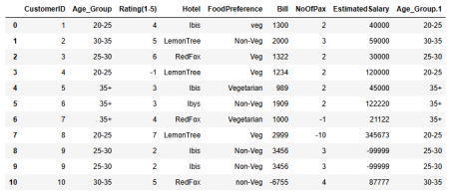#From the dataframe identify the duplicate row(i.e row 9)
# The duplicated() method returns a Series with True and False values that describe which rows in the DataFrame are duplicated and not.
df.duplicated()
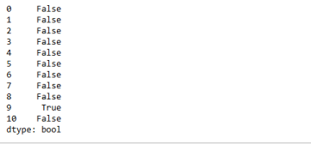# The info() method prints information about the DataFrame. The information contains the number of columns, column labels, column data types, memory usage, range index, and the number of cells in each column (non-null values).
df.info()
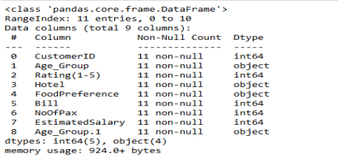# The drop_duplicates() method removes duplicate rows.
df.drop_duplicates(inplace=True)
df
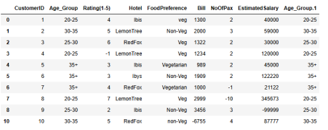#While removing duplicate record row index also removed
# The len() function to return the length of an object. With a dataframe, the function returns the number of rows.
len(df)
10
#Reset the index
index=np.array(list(range(0,len(df))))
df.set_index(index,inplace=True)
index
array([0, 1, 2, 3, 4, 5, 6, 7, 8, 9])
df
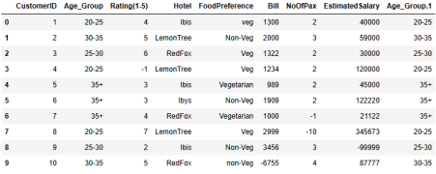# Axis refers to the dimensions of a DataFrame (index and columns) or Series (index only) Use axis=0 to apply functions row-wise along the index. Use axis=1 to apply functions column-wise across columns.
df.drop(['Age_Group.1'],axis=1,inplace=True)
df
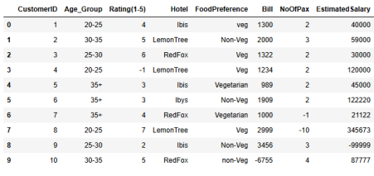# The function . loc is typically used for label indexing and can access multiple columns. df.CustomerID.loc[df.CustomerID<0]=np.nan
df.Bill.loc[df.Bill<0]=np.nan
df.EstimatedSalary.loc[df.EstimatedSalary<0]=np.nan
df
C:\Users\Ayyadurai\AppData\Local\Temp\ipykernel_5300\2580639570.py:1: S ettingWithCopyWarning:
A value is trying to be set on a copy of a slice from a DataFrame See the caveats in the documentation: https://pandas.pydata.org/pandas docs/stable/user_guide/indexing.html#returning-a-view-versus-a-copy
df.CustomerID.loc[df.CustomerID<0]=np.nan
df.Bill.loc[df.Bill<0]=np.nan
C:\Users\Ayyadurai\AppData\Local\Temp\ipykernel_5300\2580639570.py:2: S ettingWithCopyWarning:
A value is trying to be set on a copy of a slice from a DataFrame df.EstimatedSalary.loc[df.EstimatedSalary<0]=np.nan
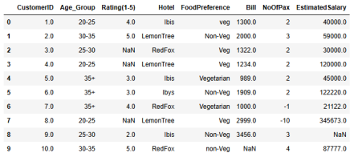df['NoOfPax'].loc[(df['NoOfPax']<1) | (df['NoOfPax']>20)]=np.nan
df
C:\Users\Ayyadurai\AppData\Local\Temp\ipykernel_5300\2129877948.py:1: S ettingWithCopyWarning:
A value is trying to be set on a copy of a slice from a DataFrame
See the caveats in the documentation: https://pandas.pydata.org/pandas docs/stable/user_guide/indexing.html#returning-a-view-versus-a-copy df['NoOfPax'].loc[(df['NoOfPax']<1) | (df['NoOfPax']>20)]=np.nan 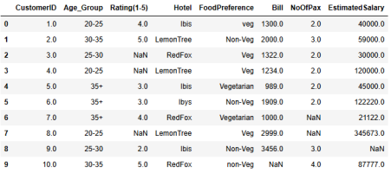df.Age_Group.unique()
array(['20-25', '30-35', '25-30', '35+'], dtype=object)
df.Hotel.unique()
array(['Ibis', 'LemonTree', 'RedFox', 'Ibys'], dtype=object)
# Using the inplace=True keyword in a pandas method changes the default behaviour such that the operation on the dataframe doesn't return anything, it instead 'modifies the underlying data
df.Hotel.replace(['Ibys'],'Ibis',inplace=True)
df.FoodPreference.unique
<bound method Series.unique of 0 veg
1 Non-Veg
2 Veg
3 Veg
4 Vegetarian
5 Non-Veg
6 Vegetarian
7 Veg
8 Non-Veg
9 non-Veg
Name: FoodPreference, dtype: object>
df.FoodPreference.replace(['Vegetarian','veg'],'Veg',inplace=True)
df.FoodPreference.replace(['non-Veg'],'Non-Veg',inplace=True)
# Fillna is a Pandas function to fill the NA/NaN values with the specified method.
# If column or feature is numerical continuous data then replace the missing(NaN) value by taking mean value.
# If column or feature is numerical discrete data then replace the missing(NaN) value by taking median value.
# If column or feature is non-numerical i.e Categorical data then replace the missing(NaN) value by taking mode value.
df.EstimatedSalary.fillna(round(df.EstimatedSalary.mean()),inplace=True) df.NoOfPax.fillna(round(df.NoOfPax.median()),inplace=True)
df['Rating(1-5)'].fillna(round(df['Rating(1-5)'].median()), inplace=True) df.Bill.fillna(round(df.Bill.mean()),inplace=True)
df
