Lap Configuration for HA DR Test
One AD domain controller and three nodes will be joined to the DC. The DC is going to act as shared storage as well by using iscsi controller. Node1 and Node2 will be in data centre 1 and Node 3 will be in data centre two as per our network configuration.

Do with following proper networking configuration. Only DC will have External internet connection and all other nodes will have Routing and Remote Access internet connection from DC only i.e. by having Internal network configuration.
Here is the diagram:
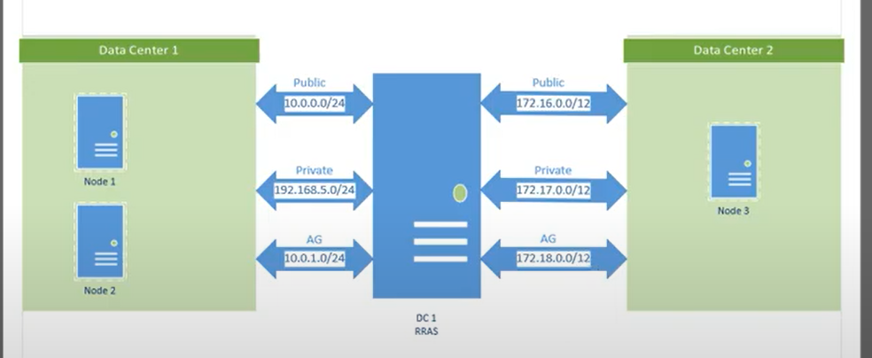
For more: https://techcommunity.microsoft.com/t5/core-infrastructure-and-security/build-a-sql-cluster-lab-part-1/ba-p/917572

Download latest windows server ISO and SQL server software.
For windows 10 home, enable Hyper-V is not supported, you need to run the bat file.
DOWNLOAD LINK: https://www.itechtics.com/?dl_id=80
After that, you can get Hyper-V, you can start create VMs.
Part 1 - Building the environment. Hyper-v VMs, Active Directory, DNS, and Routing and Remote Access Services
Creating VMs and do all the OS side installation and configuration.
Create two virtual switches one is external network to get internet rom your machine and other is internal network.
Create 4 virtual machines DC, node1, node2, node3.
Better disable all the 4 machine windows firewall.
Following is the configuration and naming format standards.
Machine | Ram | CPU | NIC
DC1 | 2048 | 2 | 7
Node 1 | 4096 | 2 | 3
Node 2 | 2048 | 2 | 3
Node 3 | 2048 | 2 | 3

Following is the network configuration. Whatever IP range you select for DC, make sure to that as gateway for computers. The preferred DNS should be domain controller public IP.
You need each computer IP NIC cards, since one for public, private and dedicated network for AG always on as well. So in the DC you need to have 6 NIC cards with the IP ranges which will have host A records, Forward zone etc. One IP for external NIC that is where you will get internet connection from your laptop or desktop – total 7 NIC cards.

DC1 is DC1 network and DC2 is DC2 network.

Details | DC1 | Node1 | Node2 | Node3
DC1 Net1 Public IP | 10.0.0.40 | 10.0.0.1 | 10.0.0.2
DC1 Net1 Public Subnet | 255.255.255.0 | 255.255.255.0 | 255.255.255.0
DC1 Net1 Public Gateway | None | 10.0.0.40 | 10.0.0.40
DC1 Net1 Public Preferred DNS | 127.0.0.1 | 10.0.0.40 | 10.0.0.40
DC1 Net2 Private IP | 192.168.5.40 | 192.168.5.1 | 192.168.5.2
DC1 Net2 Private Subnet | 255.255.255.0 | 255.255.255.0 | 255.255.255.0
DC1 Net2 Private Gateway | None | 192.168.5.40 | 192.168.5.40
DC1 Net2 Private Preferred DNS | 127.0.0.1 | 10.0.0.40 | 10.0.0.40
DC2 Net1 Public IP | 172.16.0.40 |  |  | 172.16.0.3
DC2 Net1 Public Subnet | 255.240.0.0 |  |  | 255.240.0.0
DC2 Net1 Public Gateway | None |  |  | 172.16.0.40
DC2 Net1 Public Preferred DNS | 127.0.0.1 |  |  | 10.0.0.40
DC2 Net2 Private IP | 172.17.0.40 |  |  | 172.17.0.3
DC2 Net2 Private Subnet | 255.248.0.0 |  |  | 255.248.0.0
DC2 Net2 Private Gateway | None |  |  | 172.17.0.40
DC2 Net2 Private Preferred DNS | 127.0.0.1 |  |  | 10.0.0.40
DC1 Net3 AG IP | 10.0.1.40 | 10.0.1.1 | 10.0.1.2
DC1 Net3 AG Subnet | 255.255.255.0 | 255.255.255.0 | 255.255.255.0
DC1 Net3 AG Gateway | None | 10.0.1.40 | 10.0.1.40
DC1 Net3 AG Preferred DNS | 127.0.0.1 | 10.0.0.40 | 10.0.0.40
DC2 Net3 AG IP | 172.18.0.40 |  |  | 172.18.0.3
DC2 Net3 AG Subnet | 255.252.0.0 |  |  | 255.252.0.0
DC2 Net3 AG Gateway | None |  |  | 172.18.0.40
DC2 Net3 AG Preferred DNS | 127.0.0.1 |  |  | 10.0.0.40
NAT to Host IP | DHCP
NAT to Host Subnet | DHCP
NAT to Host Gateway | DHCP
NAT to Host Preferred DNS | 127.0.0.1

https://www.youtube.com/watch?v=Bn4cSfazwg0&t=461s
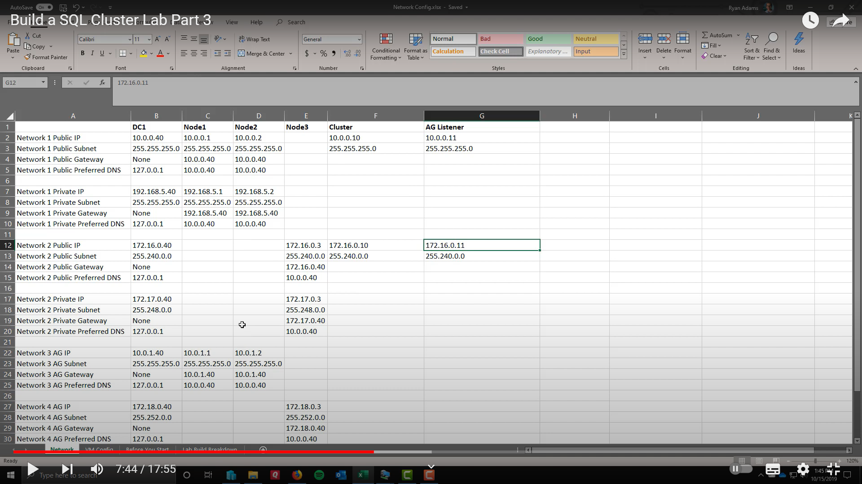

Details | Data centre 1 | Data Centre 2
Cluster | 10.0.0.10 | 172.16.0.10
AG Listener | 10.0.0.11 | 172.16.0.11
FCI | 10.0.0.15 | N/A

Steps
On all 4 VMs – Rename the NIC cards and assign the above IP address.
Example:
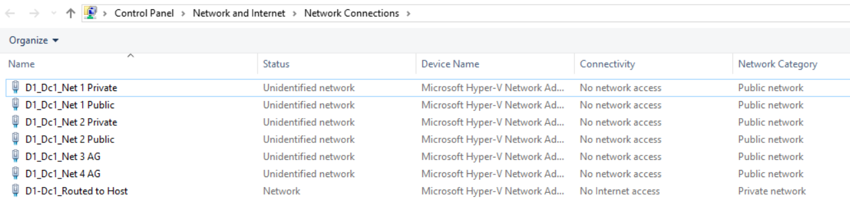

Rename the computer names for DC as DC1.
Install the Domain controller straight forward installation.
Server manager – Add roles and features – next – click active directory domain services – click add features – then next and next – finish and click notification bar run the Promote the machine to DC.
Choose add new forest -- Enter the domain name – Muthu.com –Enter password that is all – Next and next install and it will restart after installation.
Verify the computer is in domain or not. Verify in server manager – local server.
Configuration:
Create user
Click Active directory users and computers in tools – create one user called Muthu.kumaran
- New – users – enter details log on name as Muthu.kumaran – click never expire
Add the user in to member of other accounts with high permission (Not recommended in production) Right click – click member of – Add – domain admins; enterprise admins
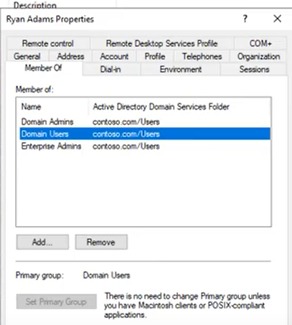
Create OU
Right click in the domain Muthu.com – new – OU – Service Accounts – ok
Create three SQL service accounts called - svc-sql1, svc-sql2 & svc-sql3 under the OU.
Verify the DNS – Make sure you have all 7 NIC cards with host A records are created.
Server manager – tools- dns –Right click Reverse lookup zone - Right click – new zone – next and next – enter the network ID 10.0.0 – next and finish.

Configuring Routing internet access to node 1, 2 & 3:
Go to DC1 -- Server manager – Add role and features – next – click remote access –Click Routing – click add features – next and next – install. Click close no need to do the configuration required (VPN RAS)
Go to server manager – tools – Routing and remote accessing – Right click – configure –next – Click custom configuration – next – click Nat and LAN routing – next – finish – Click start service –
Verify routing click -- IP4 – right click NAT – new interface – Choose routed to host - click public interface and enable NAT interface check box as well – check the node1 internet access – try google.

Add computers into domain – Only node1 (if the routing internet access sends any error add node1 into domain and try again. Since node1 & 2 are in same subnet and node 3 is from different subnet)
Go to node1 – Server manager – local server – Click computer name – Click change – fill the domain name Muthu.com – Enter the user name password of Muthu.kumaran created in DC1 – will get error click ok and reboot it – verify the computer added in DC.
Once added into domain. You should login with domain account Muthu.kumaran not using administrator.

Add node 2 and 3 into domain.

Part 2 - Windows Failover Clustering. Cluster validation, networks, and quorum
Go to Node1, 2 & 3 -- Server manager – Add role and features – next – click failover cluster – install.
Login to Node1 and open cluadmin.msc – click validate cluster – add all nodes – view the report and validate make sure all good – Click create cluster and create it.
Create cluster called “Cluster1” and assign only the two public IPs in the create cluster wizard – 10.0.0.10 & 172.16.0.10 and uncheck the remaining IPs and next and next.
Once created just validate the cluster and you can see DC2 IP will be offline under the cluster core resources that is perfectly normal in multi subnet environment.
Details | Data centre 1 | Data Centre 2
Cluster | 10.0.0.10 | 172.16.0.10

Configure the IPs in Windows cluster WSFC.
Rename the cluster network and configure. You have to click apply and then OK.
DC1_Net1_Public
Configure – Allow both cluster and clients communication. Also note: windows cluster is smart to use private network for the communication if it is there otherwise it will use the public network, kind of backup network.
DC1_Net2_Private
Configure – Allow only cluster communication.
DC1_Net3_AG
Configure – Do not allow cluster communication this network.
DC2_Net1_public
Configure – Allow both cluster and clients communication.
DC2_Net2_Private
Configure – Allow only cluster communication.
DC2_Net3_AG
Configure – Do not allow cluster communication this network.

Ex:
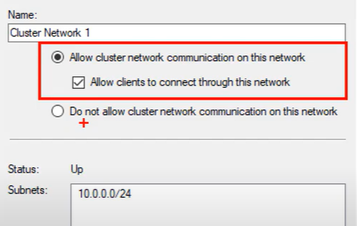
See the name of the networks.
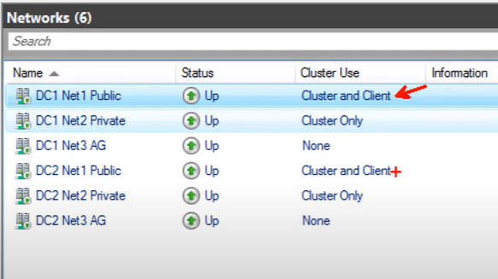

Create cluster quorum – File share witness in the DC1 machine.
Go to DC1 – create new folder called WSFC_FS – go to Share advanced sharing – grant permission to “Cluster1$” and now come to the security and grant permission to “Cluster1$” full control.
Go to the cluster – click configure cluster quorum – advanced quorum – configure FS - \\dc1\WSFC FS - click finish.
Install SQL

Install standalone SQL server in all three nodes – Developer edition is free. Use the SQL service accounts created before – Muthu\svc-sql1, Muthu\svc-sql2 & Muthu\svc-sql3
Better disable all the 4 machine windows firewall. Make sure TCP/IP enabled and telnet is working across nodes.

Part 3 - Availability Group. Dedicated network and AD permissions
Grant CNO permission to the cluster object in the AD to create always on listener by SQL in the AD.
Right click the computers in the AD – property –security -- click add –choose object type – enter “cluster1$” – full permission. (In production, you only grant read all property and create computer object CNO) If you do not see security - Open Active Directory Users and Computers and select “Advanced Features“under “View” tab. 2. Select any object and check its properties.

Enable always ON feature.
You can do this all by GUI, but the dedicated network for always ON will not be configured from GUI, you can set up from GUI and then can able to change IPs (That is also possible).

Script to create DB and configure AG.

Once all done, validate the AG and CNO object. Do failover and see the primary site DC1 IP online will go offline and DC2 secondary site IP will be back online.
Do all kind of test whatever you want.

Part 4 - Failover Cluster Instance. Creating shared storage using iSCSI and adding the storage to the cluster.

Configure shared storage
Create three divers for Data, log and MSDTC.
GO to DC1 - Server manager – Add roles and features – next – File and storage service – check iSCSI target server – next and next – install.
Click - file and storage service in the server manager – iSCSI – Click task on right side top - new iSCSI virtual disk – next – type name Data - size 10 Gb fixed size – next – Create new target – next – Type name as FCI1 – next – click add button and use option 1 type node1 add and node 2 add it - Click ok – click create.
Go and create drive for log and MSDTC.
Click task on right side top - new iSCSI virtual disk – next – type name Log - size 10 Gb fixed size – next – Choose a target as FCI1 –click create.
Click task on right side top - new iSCSI virtual disk – next – type name MSDTC - size 1 Gb fixed size – next – Choose a target as FCI1 –click create.

GO to Node1 - Server manager – tools- iSCSI initiator – type DC1 in the target quick connect. Click connect.
Go to disk management --- right click and online – initialize disk – Right click format it new simple volume – next – J – Data, 64k, click quick format.
Right click format it new simple volume – next – K – Log, 64k, click quick format.
Right click format it new simple volume – next – M – MSDTC, 64k, click quick format.
Do the same for node2 and configure iSCSI initiator.
Go to the cluster manger cluadmin.msc – click disk – add disk in right side –click ok.
Create one server account called svc-sqlcluster
Install SQL server fail over cluster
Make sure to click new failover cluster installation.
Pass the SQL cluster network name - SQLCLUS01 and named instance INST01.
Next and next – Choose only two disk data and log not the MSDTC
In network configuration – Choose only data centre 1 public network and leave the remaining. Enter the IP address 10.0.0.15 next and next
Change data J: and log disk directory K:\ & change TempDB file location as well.

Once it is done, just add node2 in the failover SQL cluster.
Once done, do all test whatever you want.

Do some DB mirroring, Log shipping and replication etc.

