Transactional Replication

Design:
Node1 – Publisher, Node2 – Subscriber & Node3 – Distributer
Pre request:
- Create new three service account for agents.
Svc_repl_snapshot , Svc_repl_logreader & Svc_repl_distributer
- Create share path for snapshot files BCP & DML
Create it on Distributer server and add permission at security of folder and advanced security of permission. Svc_repl_snapshot (Full control) , Svc_repl_logreader (Only read) & Svc_repl_distributer (Only read)
Better create logins into SQL and grant all necessary permission, before configure replication.
All three logins as db owners to replicated DB, for distributer give DB owner as well.
- Create DB on subscriber and grant permission to login accounts.
Configuration
On Distributer server Create and configure

Choose Node3 Next pass share path Leave Distributer DB name and change MDF and LDF file path Choose Publisher Add Node1 Pass the password and remember or store it for adding another publisher for this remote Distributer ConfigureFinish
- Grant permission for all three logins to Distribution DB.
Svc_repl_snapshot (DB_Owner) , Svc_repl_logreader (DB_Owner) & Svc_repl_distributer (DB_Owner)

After creation from GUI – 2 LS on DIST to 1 Pub and other DIST & 7 Jobs:
You will see 2 linked servers. 1 to publisher node1 and other is for Distributor i.e named as repl_distributor and 7 common jobs.
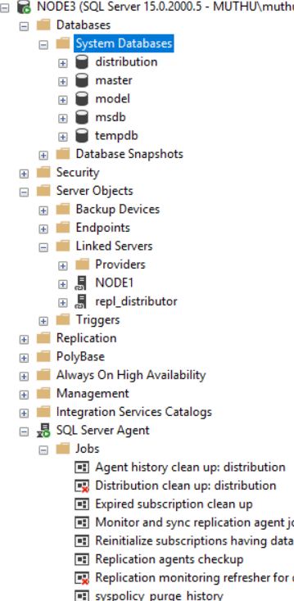
On Publisher server Create Publisher Distributer – You need to pass Snapshot &Log reader agent account

Before creating publisher, create DB name for Subscriber on Node2. You can have same name or different name. Better have same name.
- Grant permission for all three logins to DB.
Grant DB_Owner only for Svc_repl_distributer to the Subscriber DB.
- Create Publisher
- Grant permission to the logins
Svc_repl_snapshot (DB_Owner) , Svc_repl_logreader (DB_Owner) & Svc_repl_distributer (DB_Owner)
- Go to replication Local publication choose and add distributor server choose DB Transaction replication Choose articles (Tables, SP, Views / Indexed View, UDF). You can configure the article properties (FK, Constraint and index to replicate etc. For SP you can have both schema and execution to be replicated etc.) Next Mark check box Create snapshot immediately or schedule it in the agent pass snapshot agent credential & log reader credential Publication Name Finish
- Check snapshot agent status and make sure the data is replicated.
If the snapshot agent is says starting more than X time then there might be issue with password or permission etc. You can check that in Distributor DB Exec sp_helpdistpublisher Check column called active is 1. If it is 0 you need to enable to active.
sp_helpdistpublisher
sp_changedistpublisher @publisher = 'node1', @property = 'active' , @value = 'true'
You can get error like - string or binary data would be truncated transactional replication
- Right click on publication Properties publication access list add distributor agent (Svc_repl_distributer)

After creation from GUI: 1 LS on Pub to DIST & 3 Jobs
One linked server on publisher created that is to connect with distributor named as repl_distributor and only one job Expired subscription clean up.
Two jobs are created on distributor
1 is for snapshot agent and other is for log reader agent.
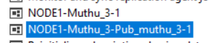
On Publisher server Create subscriber – You need to pass distributer agent account

- Right click on publication and new subscriber

Choose subscription choose push or pullpush add subscriber to Node2 choose DB next Pass credential for distributer agent (Svc_repl_distributer) Run continuously or in schedule nextFinish
- That’s all done. Do some changes in the table and make sure the changes are replicating.
After creation from GUI: 2 LS on Pub & DIST to SUB & 1 Job
There is one linked server created in publisher side which is having connection to subscriber Node2. One more linked server is created on distributer side which is having connection to subscriber Node2.
1 new job been created in distributer
That is for distributer push agent.

