SQL Server DBA – Knowledge Refresh
**********************************

1 Q) Hardware and Software requirements of SQL Server 2005/2008/2008R2/2012 installations?

SQL Server 2005 : Hardware Requirements:
1) Processor (1GHz)
2) RAM (Min: 512MB, Recommended: 1GB)

Software Requirements:
1) If SQL Server 2005 is installed on
Windows 2000 (Apply SP4)
Windows 2003 (Apply SP1)
2) Dotnet Framework 2.0
3) Windows Installer 3.1

SQL Server 2008/2008 R2 : Hardware Requirements:
1) Processor (Minimum 1GHz, Recommended 2GHz)
2) RAM (Minimum 1GB, Recommended 4GB)

Software Requirements:
1) If SQL Server 2008 R2 is installed on
Windows 2003 (Apply SP2)
2) Dotnet Framework 3.5 SP1
3) Windows Installer 4.5
4) Powershell 2.0

SQL Server 2012 : Hardware Requirements:
1) Processor (Minimum 1.4GHz, Recommended 2GHz)
2) RAM (Minimum 1GB, Recommended 4GB)

Software Requirements:
1) If SQL Server 2012 is installed on
Windows 2003 (Apply SP2)
2) Dotnet Framework 4.0 and Dotnet Framework 3.5 SP1
3) Windows Installer 4.5
4) Powershell 2.0

2 Q) What are the editions of SQL Server 2012?
Enterprise/Developer
Standard
Business Intelligence Edition
Web

3 Q) What are the components of SQL Server?
Database Services
Reporting Services
Analysis Services
Integration Services

4 Q) What is slipstream installation? How many types of slipstream installations are available?
Slipstream is a technique used by System Admins to easily update the setup packages of SQL Server 2008, where SQL Server Instance and Service Pack/CU can be packaged together.
Slip Stream is combination of RTM and Service packs. It started from 2008 SQL Server version and it is combined in one specific task.
There are two methods of Slipstream:
a) Basic
b) Advanced (formerly Merge Drop)
Basic Slipstream:
Merging the service pack with the base setup at the time of installation and this method is very simple and straight forward.
Steps (SQL 2008/2008 R2/2012/2014):-
Copy RTM Media into a directory.
Extract Service Pack into another directory. In this scenario it is C:\SP1
SQLServer2008SP1-KB968369-x64-ENU.exe /x:C:\SP1
Run setup.exe from RTM folder.
Setup.exe /PCUSource=C:\SP1

Advanced Slipstream:
The Advanced slipstream merges the original RTM and Service Pack media by combining the files inside them.
Steps of SQL Server 2008/2008R2:-
1) Copy your RTM media to a folder.
C:\SQL2008RTM
2) Extract Service Pack into another folder.
C:\SQL2008RTM\PCU
3) Copy setup.exe and setup.rll from Service Pack folder to RTM folder.
Copy C:\SQL2008RTM\PCU to C:\SQL2008RTM .
4) Copy all files in C:\SQL2008RTM\PCU\x64
Inside that copy all files, except Folders and Microsoft.SQL.Chainer.PackageData.dll files to RTM folder.
C:\SQL2008RTM\PCU\x64 to C:\SQL2008RTM\x64
5) Modify DefaultSetup.ini and mention
PCUSOURCE="{Full Path}\PCU".
PCUSOURCE=.\PCU
6) Start installation using Setup.exe to start installation normally.

SQL Server 2012 Slipstream installations:
Basic:
Run setup.exe from RTM folder.
Setup.exe /PCUSource=C:\SP
Advanced:
Setup.exe /Action=Install /UpdateEnabled=TRUE /UpdateSource="C:\SP"

5 Q) Unattended installation in SQL Server 2005 to 2012?
Unattended installations will automate a typical installation process without involvement of interacting with GUI screens.

Unattended installation of SQL Server 2005:

Start /wait H:\Servers\setup.exe /qb
ADDLOCAL=SQL_Engine,Client_Components,Connectivity,SQL_Documentation,SQL_Tools90
INSTANCENAME=SQLTEST01
SAPWD= KuR0Z@w@
SQLACCOUNT="NT AUTHORITY\SYSTEM"
SQLPASSWORD=SQL@dd!ct
AGTACCOUNT=MICRO\sqlserver
AGTPASSWORD=SQL@dd!ct
SQLBROWSERACCOUNT=MICRO\sqlserver SQLBROWSERPASSWORD=SQL@dd!ct
SECURITYMODE=SQL

Unattended installation of SQL Server 2008:

setup.exe /ACTION="Install" /FEATURES=SQLENGINE, RS /QS
/SQLSYSADMINACCOUNTS

Unattended installation of SQL Server 2008R2/2012:
setup.exe /ACTION="Install" /FEATURES=SQLENGINE, RS /Q
/IACCEPTSQLSERVERLICENSETERMS

Installing through Configuration File::--
SQL Server 2005:
start /wait setup.exe /Settings="C:\Config.ini"
[OPTIONS] parameter to be included in Configuration file.
SQL Server 2008/2008R2/2012/2014/2016:
setup.exe /CONFIGURATIONFILE="C:\Config.ini"

6 Q) How to perform SYSPREP Installation:
Advanced page of the SQL Server Installation Center has two options for preparing a SQL Server install. Using these options allows us to prepare a stand-alone instance of SQL Server and to complete the configuration at a later time. SQL Server SYSPREP involves a two-step process to get to a configured stand-alone instance of SQL Server:
a) Image preparation: This step stops the installation process after the product binaries are installed, without configuring the instance of SQL Server that is being prepared.
b) Image completion: This step enables you to complete the configuration of a prepared instance of SQL Server.

Limitations of SYSPREP:
1. Only the database engine and reporting services are supported by SYSPREP till SQL Server 2012, but from SQL Server 2012 SP1 CU2 it supports all features.
2. It cannot be used for clustering
3. It is not supported on IA64 system or supported in WOW64.
Refer:
http://www.mssqltips.com/sqlservertip/2719/install-sql-server-2012-using-sysprep/
http://blogs.technet.com/b/scvmm/archive/2013/01/25/expanded-sysprep-support-in-sql-server-2012-sp1-cu2.aspx

7 Q) Installing SQL Server through Powershell?

To perform SQL Server installation through powershell follow the below mentioned steps.
First copy the Powershell Script from the link referred below. Make any customization as needed.
Open Powershell Start->Run->Powershell
Set the execution policy from Restricted to RemoteSigned because we are copying a script from untrusted source may be, so it is important to set this execution policy.
Set-ExecutionPolicy RemoteSigned
After this load the script to have the function created. Note before the script file make sure “.” and “blank space” are compulsory to execute the script (Unix Style).
. c:\scripts\Install-Sql2012.ps1
After script is executed verify if the function for installation is created or not.
Get-Command Install-Sql2012
Finally perform installation of SQL Server 2012 from Powershell (Media is kept in C:\Scripts folder for ease):
Install-Sql2012 -Path C:\Scripts\SQL2012\ -SaPassword "Admin143$$" -InstanceName "INST2K12"
Refer: http://mscerts.wmlcloud.com/sql_server/Installing%20SQL%20Server%202012%20%20%20The%20Installation%20Process%20(part%203)%20-%20Installing%20SQL%20Server%202012%20Through%20the%20Command%20Line,%20Installing%20SQL%20Server%202012%20Through%20PowerShell.aspx

8 Q) How to troubleshoot failed installations?
If SQL Server installation fails then troubleshooting can be initiated with below methods in different versions.
SQL Server 2005:
1) Refer Summary.txt file on why installation failed.

Summary file will be located in C:\Program Files\Microsoft SQL Server\90\Setup Bootstrap\Log\Summary.txt
Installation Details, Timestamp, Component Details (Success/Failure), Individual Component failures.
First verify Summary.txt file for any failures
2) Identify if any components have failed and refer those individual log files.
3) Alternatively open Individual log files and search for “Return Value 3” or “Ue 3”
4) Verify Core.log and Core(Patched).log files to find more info on failed installation.
5) Event Viewer can give additional troubleshooting information for failed installations.

SQL Server 2008/2008 R2/2012/2014:
SQL Server installation is segregated as three main phases.
1) Global Rules
2) Component Update
3) Installation

Each phase has its own summary file in C:\Program Files\Microsoft SQL Server\110\Setup Bootstrap\Log. Also data store directory will be created to store all the information about installation in XML files.
1) Refer summary.txt file of in Global Rules/Component Update/Core Installation and see for any errors.

(Installation Details, Timestamp, Component Details Success/Failure, Individual Component log file)
First verify summary file for any errors.
2) Check if any components have failed or not. Identify any error numbers in failed component.
3) Check the detail.txt (or) detail_componentupdate.txt files
4) If detail files does not disclose any information about error then refer individual log files of every failed component and search for string likes

“Failure”, “Error”, “Watson Bucket”
5) Additionally event viewer can help in additional information if nothing is found in above said logs.

9 Q) How to troubleshoot failed service pack installations?
If SQL Server service pack installation fails then troubleshooting can be initiated with below methods in different versions.

SQL Server 2005:
In SQL 2005 look into directory "Hotfix" inside Log directory.
C:\Program Files\Microsoft SQL Server\VersionNumber\Setup Bootstrap\Log\Hotfix
Repeat the same troubleshooting steps as installation.

SQL Server 2008/2008R2/2012/2014:-
There is no Hotfix folder, but it is directly present under Log directory itself with a TIMESTAMP directory.
Repeat steps of troubleshooting as installations.

10 Q) Best Practices after installations. (Installation Checklist)

Best practices before and after performing SQL Server installation are
1. Creating Service Accounts and ensuring they are Domain Accounts.
2. Separate service accounts for SQL Server Main Service, Agent Service and other services.
3. Confirm SQL Server service account is NOT in the local Administrators group.
4. Validating all drives are created as per best practices for SQL Server like SQL Server Data and Log files in separate drive.
5. Keeping system databases in different drive and all user databases in separate drive.
6. Configuring drives exclusive for Backups and also Tapes for additional legacy backup needs.
7. Formatting drives and settings like Instant File Initialization for the best SQL Server performance
8. Setting up maintenance to run Backups, Managing Indexes (Rebuild/Reorg), Check consistency of databases (Integrity Checks), Updating statistics.
9. Designing the right number of files and layout for TEMPDB
10. Getting basic monitoring and alerting from the SQL Server Agent (DB Mail and Alerts)
11. Installing most recent Service Packs/Hotfixes
12. Verifying if Browser Service is disabled or not (if SQL Server 2005, as in 2008 and above it is disabled by default)
13. Changing Port number of SQL Server
14. Disabling unused Protocols (like Shared Memory/Named Pipes), if all communications happen through TCP/IP.
15. Rename SA account to any better naming convention (SAdmin) (In SQL 2008 and later)
16. Enabling Dedicated Admin Connection DAC.
17. Configuring Windows Authentication as preferred connection option (SQL Authentication if application has dependency)
18. Configure Lock Pages In Memory (as appropriate)
19. Run BPA (Best Practice Analyzer) to ensure that instance supports the environment standards.
20. Configure alerts for severity 16 through 25 as well as specific alerts for 823, 824 and 825 errors.
21. Set Max Degree Parallelism as appropriate (after confirmation from Application team)
22. Set Min and MAX Server Memory to an appropriate level.
23. Set trace flag -T1118. This helps elevate contention in TEMPDB. There is some debate on this, but it looks like it does not hurt to have it on.
24. Register an SPN. DBAs often do not have permission to do this. Have this done by a domain admin.
setspn -S MSSQLSvc/ServerName SQLServiceAccountName
setspn -S MSSQLSvc/ServerName:1433 SQLServiceAccountName
setspn -S MSSQLSvc/ServerName.root.DomainName:1433 SQLServiceAccountName

11 Q) How to change Instance Collation Settings?

1) SELECT SERVERPROPERTY(N'Collation')
2) Before changing the collation settings, make sure that current configurations are backed up.
SELECT * FROM sys.configurations;
(OR)
EXEC SP_CONFIGURE
3) Take backup of all system and user databases. Also script all the logins, jobs, maintenance plans as additional safety measure.
4) Detach all user databases before rebuilding system databases.
5) Rebuild has to be done with this command.
Setup /QUIET /ACTION=REBUILDDATABASE /INSTANCENAME=MSSQLSERVER /SQLSYSADMINACCOUNTS=KDSSG\KD /SAPWD= Admin143$$ /SQLCOLLATION=SQL_Latin1_General_CP1_CI_AI
6) Once instance rebuild is complete verify the newly changed collation setting.
SELECT SERVERPROPERTY(N'Collation')

12 Q) How to rename an instance of SQL Server?

Process for renaming an instance is as below.
1) Before renaming the instance on Production server take backup of all databases as safety measure.
2) Verify instance name before changing it. SELECT @@SERVERNAME
3) sp_dropserver ‘KDSSG\Instance1’
sp_addserver ‘KDSSG\Instance11’,’local’
Restart SQL Server instance once these steps are complete.
4) Verify changed instance name. SELECT @@SERVERNAME
13 Q) Rename computer name (or) Renaming Stand Alone Default Instance?

After renaming a computer, if there is default instance in the computer then SQL Server instance will not work. Below steps have to be performed to rename SQL Server instance name as computer name.
1) Before renaming the instance after changing computer name, take backup of all databases (System and User databases) as safety measure.
2) Verify instance name before changing it.
SELECT @@SERVERNAME ServerName, Host_Name() Hostname
3) sp_dropserver ‘KDSSG’
Sp_addserver ‘KDSSG143’,’local’
Restart SQL Server instance once these steps are complete. KDSSG is the old computer name and KDSSG143 is the new computer name.
4) Verify changed instance name. SELECT @@SERVERNAME

14 Q) What are the recent Service Packs of SQL Server?

SQL Server 2005 - SP4
SQL Server 2008 - SP4
SQL Server 2008R2 - SP3
SQL Server 2012 - SP2
SQL Server 2014 - SP1

15 Q) What is difference between Service Pack, CU and Hotfix?

Hotfix is a solution designed for a specific bug.
Cumulative Update is collection of hotfixes. CU's are cumulative.
Service Pack is a collection of CU and hotfixes and it is well tested. SP's are cumulative.

16 Q) What is QFE and GDR?

General Distribution Release (GDR)

GDR fixes are reserved for those issues identified by SQL Server support as important enough to install on every instance of SQL Server.

Quick Fix Engineering (QFE)

QFEs are used for the majority of fixes which are not widespread.

17 Q) Have you heard about Security Bulletin?

Exclusive security vulnerabilities are reported and solved through security bulletins.
Security Bulletin: MS14-044

18 Q) What are best practices pre/post installing Service Packs?

Best practices Pre/Post installation of Service Packs are
Pre-Installation:
1) Take backup of all system/user databases (including Binaries and Resource database)

Post-Installation:

1) Verify upgraded version and build number.
2) Ensure Application compatibility testing has been performed by Application team.

Perform patching on Production only after it has been tested on DEV/UAT environment.
19 Q) Can we rollback Service Pack of SQL Server 2005? If it is required to rollback how will you do?

No we cannot uninstall Service Pack of SQL Server 2005.
If there is a need, then uninstall the SQL Server instance and reinstall RTM. Restore the database backups (system and user).

20 Q) What are Instance Aware and Instance Unaware services?

Instance Aware Services are associated with specific instance of SQL Server.

SQL Server Main Service
SQL Server Agent Service
SQL Server Analysis Services
SQL Server Reporting Services
SQL Server Full Text Search

Instance Unaware Services are shared among all SQL Server instances.

Integration Services
SQL Server Browser
SQL Server Active Directory Helper
SQL Server Writer

21 Q) What is the default Root Directory Path of an instance?

Default root directory of default instance is
C:\Program Files\ Microsoft SQL Server\MSSQL11.MSSQLSERVER\
Default root directory of named instance is
C:\Program Files\ Microsoft SQL Server\MSSQL11.InstanceName\

22 Q) What are the tools you are aware of post installation of SQL Server?

SSMS, Configuration Manager, SQLCMD, Upgrade Advisor, BPA, Profiler, Surface Area Configuration (in SQL 2005), SQL Diag, PSS Diag

23 Q) What are different ways of Starting and Stopping Instance?

Starting/Stopping of SQL Server can be done in different ways as below.
1) Services.msc
Stop/Start
2) Configuration Manager -> SQL Server Services.
3) net start "SQL Server (MSSQLSERVER)"
net stop "SQL Server (KDSSGB15)"
4) SQL Server Management Studio
Instance right click Stop/Start
**Service Control will initiate the SQL Server service stop/start.
5) SQL Command (SQLCMD), connect to instance and issue Shutdown command.
sqlcmd -E -S "KD-THINK"
6) Kill sqlservr.exe process for respective instance (NOT RECOMMENDED)
Ctrl + Shift + Esc
Identify SQLServr.exe process, if multiple processes are found. Then select PID column and match with correct instance in Configuration Manager.
7) Stop and Start through Powershell
Start -> Run -> Powershell
Get-Service
Start-Service MSSQLServer -Force
Stop-Service MSSQLServer
8) Using SC Command
Default Instance:
sc stop MSSQLServer
sc start MSSQLServer
Named Instance:
sc stop MSSQL$InstanceName
9) Using xp_servicecontrol
xp_servicecontrol 'Stop/Start/Querystate','MSSQLServer'
10)
C:\Program Files\Microsoft SQL Server\MSSQL10_50.MSSQLSERVER\MSSQL\Binn\sqlservr.exe -s MSSQLServer
Once SQL Server starts it will load startup process. To stop SQL Server send Ctrl+C signal and it will initiate shutdown process.

24 Q) When SQL Server Instance starts what is database startup process?

The normal startup procedure of databases in SQL Server are
a) Master database always comes online first as it contains all metadata structures and is mentioned in startup parameter –d and –l. SQL Server instance starts with –d and –l parameters referring to Master data file and log file locations.
b) Second database that comes online would be resource
c) Model database comes online
d) TEMPDB comes online only after model database is online.
e) User databases are then bought online.

Note: It is not compulsory that user databases will start after system databases. TEMPDB may start sometimes after all user databases are started.

25 Q) What are startup parameters?

Startup parameters in SQL Server are
-d (Master data file location)
-l (Master log file location)
-e (Error Log location)
-m (Starts instance in Single User Mode)
-f (Starts instance in Minimal configuration mode)
-T (Enables the respective trace flag number mentioned next to parameter)
-x (Disables capturing of performance counters on the instance)
26 Q) Difference between 32-bit and 64-bit systems?

32-bit systems have lesser data transfer rates/computations/processing speed compared to 64-bit.
32-bit systems have RAM supported till 4GB, 64-bit systems have support till ~7-8TB
32-bit systems are less expensive compared to 64-bit systems.

27 Q) Difference between FAT32 and NTFS?

FAT32 and NTFS both are file systems on windows.
File and Folder Security (Encryption) is more in NTFS compared to FAT32.
NTFS performs faster than FAT32
File size maximum is 4GB in FAT32 where as in NTFS it is up to 16TB.
NTFS supports automatic bad cluster repair.
NTFS supports file name characters up to 255, it is 8.3 characters for FAT32.

28 Q) What are installation differences between SQL Server 2005, 2008,2008 R2 and 2012?

Installation differences of SQL Server 2005 to 2014 are referred as below.

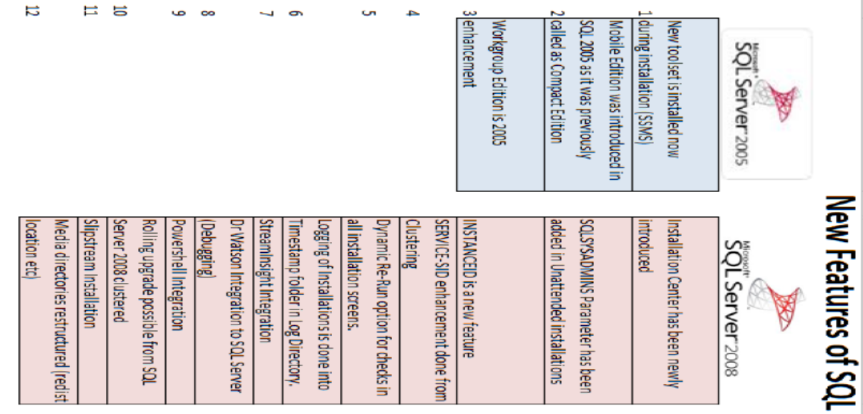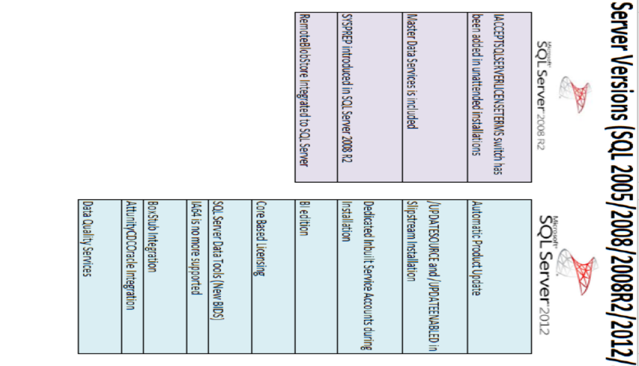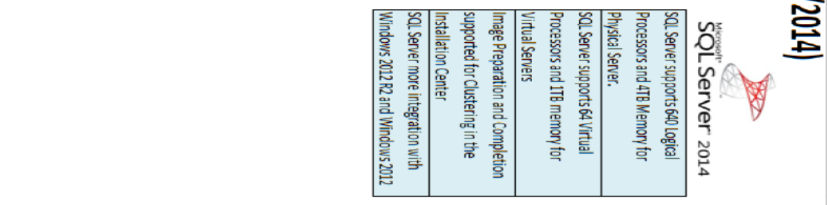
Best practices before and after performing SQL Server Installation are:
- Create service accounts and ensure they are domain accounts.
- Separate service accounts for SQL Server Main Service, Agent Service and other services.
- Confirm SQL Server service account is NOT in the local Administrators group.
- Validating all drives are created as per best practices for SQL Server like SQL Server Data and Log files in separate drive.
- Keeping system databases in different drive and all user databases in separate drive.
- Configuring drives exclusive for Backups and also Tapes for additional legacy backup needs.
- Formatting drives and settings like Instant File Initialization for the best SQL Server performance.
- Setting up maintenance to run Backups, Managing Indexes (Rebuild/Reorg), Check consistency of databases (Integrity Checks), Updating statistics.
- Designing the right number of files and layout for TEMPDB.
- Installing most recent Service Packs/Hotfixes.
- Verifying if Browser Service is disabled or not (if SQL Server 2005, as in 2008 and above it is disabled by default)
- Changing Port number of SQL Server
- Disabling unused Protocols (like Shared Memory/Named Pipes), if all communications happen through TCP/IP.
- Getting basic monitoring and alerting from the SQL Server Agent (DB Mail and Alerts)
- Rename SA account to any better naming convention (SAdmin) (In SQL 2008 and later)
- Enabling Dedicated Admin Connection DAC.
- Configuring Windows Authentication as preferred connection option (SQL Authentication if application has dependency)
- Configure Lock Pages In Memory (as appropriate)
- Run BPA (Best Practice Analyzer) to ensure that instance supports the environment standards.
- Configure alerts for severity 16 through 25 as well as specific alerts for 823, 824 and 825 errors.
- Set Max Degree Parallelism as appropriate (after confirmation from Application team)
- Set Min and MAX Server Memory to an appropriate level.
- Set trace flag -T1118. This helps elevate contention in TEMPDB. There is some debate on this, but it looks like it does not hurt to have it on.
- Register an SPN. DBAs often do not have permission to do this. Have this done by a domain admin.
setspn -S MSSQLSvc/ServerName SQLServiceAccountName
setspn -S MSSQLSvc/ServerName:1433 SQLServiceAccountName
setspn -S MSSQLSvc/ServerName.root.DomainName:1433 SQLServiceAccountName

All passwords to Instance are lost, how to regain access:-

1) Start instance with -m parameter.
-m : Single User Mode

2) Different Ways to start instance in Single User Mode

a) Configuration Manager-> Services->SQL Server Instance -> Properties-> Advanced->Startup Parameters.

Add an entry for -m in that parameters list seperated by ;

b) Open Command Prompt and execute below commands

net stop "SQL Server (MSSQLSERVER)"
net start "SQL Server (MSSQLSERVER)" /m

3) Once Successfully connected to the instance through Command Prompt

sqlcmd -E
sqlcmd -S "KD-THINK\KDSSGB21" -E

4) Create a login for [KD-THINK\DBATeam] and grant them Sysadmin rights.

create login [KD-THINK\DBATeam] from windows

sp_addsrvrolemember [KD-THINK\DBATeam],sysadmin

Different ways of Stopping/Starting SQL Server instance:

1) Services.msc
Stop/Start

2) Configuration Manager -> SQL Server Services.

3) net start "SQL Server (MSSQLSERVER)"
net stop "SQL Server (KDSSGB15)"

4) SQL Server Management Studio
Instance right click Stop/Start

**Service Control will initiate the SQL Server service stop/start.

5) SQL Command (SQLCMD), connect to instance and issue Shutdown command.

sqlcmd -E -S "KD-THINK"

6) Kill sqlservr.exe process for respective instance (NOT RECOMMENDED)
Ctrl + Shift + Esc
Identify SQLServr.exe process, if multiple processes are found. Then select PID column and match with correct instance in Configuration Manager.

7) Stop and Start through Powershell

Start -> Run -> Powershell

Get-Service
Start-Service MSSQLServer -Force
Stop-Service MSSQLServer

8) Using SC Command

Default Instance:
sc stop MSSQLServer
sc start MSSQLServer

Named Instance:
sc stop MSSQL$InstanceName

9) Using xp_servicecontrol

xp_servicecontrol 'Stop/Start/Querystate','MSSQLServer'

10) C:\Program Files\Microsoft SQL Server\MSSQL10_50.MSSQLSERVER\MSSQL\Binn\sqlservr.exe -s MSSQLServer

Once SQL Server starts it will load startup process. To stop SQL Server send Ctrl+C signal and it will initiate shutdown process.

1
Page Corruption:

Page corruption is individual pages getting corrupted in a Data file. Restoring entire database backup for a single page corruption is not feasible, hence SQL Server provides an option to restore single or multiple pages when corrupted from existing backups.

Steps:

1) Create a database and a table within it. Database recovery model should be FULL.

2) Take a full backup of the database and any additional log backups if needed.

3) Find the page number of the table which stores the data using below commands

Use TestPageLevelRestore
Select * from sys.indexes where OBJECT_NAME(object_id)='Shift'

DBCC IND ('TestPageLevelRestore', 'Shift',0)
DBCC TRACEON (3604,-1);
GO
DBCC PAGE('PageTest',1,153,3);

Once the page number is identified, multiply the page number with 8192 to get the offset value.

4) Make modifications to the page in the Hex Editor tool.

Change the database state to Offline before editing in Hex Editor Tool.

Ctrl+G should be used to find the hexadecimal value for the Offset value.

Replace the text in that offset rather than deleting the text. Replace will create Checksum

5) Bring database to Online state.
Query the table which would clearly show corruption in the specific page/object/database/fileid.

For detailed information DBCC CHECKDB can be run.

Take a log backup of the database WITH NORECOVERY.

backup log TestPageLevelRestore to disk=N'd:\TestPageLevelRestorelastlog.trn' with norecovery

6) Perform the restore of the page using restore command as below (Full and if any Tlogs)

Restore DATABASE TestPageLevelRestore Page='1:143' FROM DISK='D:\TestPageLevelRestore_FullBackup.bak'

7) If multiple pages are corrupted i.e. > feasible number like 30 or 40. It is better to restore entire database than single page level restores.

DBCC TRACEON(3604,-1)

Switches on the specified trace flags globally.

dbcc page ( {'dbname' | dbid}, filenum, pagenum [, printopt={0|1|2|3} ])

DBCC PAGE ('PageTest',1,153,3)
1 = FileNum (MDF)
153 = Page Number
3 = Printoptions

Printoptions:
0-print just the page header
1-page header plus per-row hex dumps and a dump of the page slot array
2- page header plus whole page hex dump
3- page header plus detailed per-row interpretation

(Or)
II) Page corruption:
----CREATE DATABASE SINGAM123
----CREATE TABLE SAMPU(PID INT,PAME VARCHAR(40))
----INSERT INTO SAMPU VALUES(1,'PESARATTU')
INSERT INTO SAMPU VALUES(2,'KOBBARIMATTU')
INSERT INTO SAMPU VALUES(3,'HRUDYAM KALEYAM')
INSERT INTO SAMPU VALUES(4,'BANDIPOTU')

----DBCC TRACEON(3604,-1)
----DBCC IND('SINGAM123','SAMPU',0)
----DBCC PAGE('SINGAM123',1,281,3)

BACKUP DATABASE SINGAM123 TO DISK=N'C:\BACKUP\SINGAM_FULL.BAK'
INSERT INTO SAMPU VALUES(2,'JAY')
BACKUP DATABASE SINGAM123 TO DISK=N'C:\BACKUP\SINGAM_DIFF.BAK' WITH DIFFERENTIAL
INSERT INTO SAMPU VALUES(2,'FAHIN')

BACKUP LOG SINGAM123 TO DISK=N'C:\BACKUP\SINGAM_LOG.TRN'

ALTER DATABASE SINGAM123 SET OFFLINE WITH ROLLBACK IMMEDIATE

ALTER DATABASE SINGAM123 SET ONLINE WITH ROLLBACK IMMEDIATE

SELECT * FROM SAMPU

BACKUP LOG SINGAM123 TO DISK=N'C:\BACKUP\SINGAM_LAST_LOGBACKUP.TRN' WITH NORECOVERY

RESTORE DATABASE SINGAM123 PAGE='1:281' FROM DISK=N'C:\BACKUP\SINGAM_FULL.BAK' WITH NORECOVERY
RESTORE DATABASE SINGAM123 FROM DISK=N'C:\BACKUP\SINGAM_DIFF.BAK' WITH NORECOVERY

RESTORE LOG SINGAM123 FROM DISK=N'C:\BACKUP\SINGAM_LOG.TRN' WITH NORECOVERY

RESTORE LOG SINGAM123 FROM DISK=N'C:\BACKUP\SINGAM_LAST_LOGBACKUP.TRN' WITH NORECOVERY

RESTORE DATABASE SINGAM123 WITH RECOVERY
Steps of Page Restore:

create database TestPageLevelRestore

use TestPageLevelRestore
go
create table Shift (sno int,sname varchar(50))

Use TestPageLevelRestore
Select * from sys.indexes where OBJECT_NAME(object_id)='Shift'

DBCC TRACEON(3604,-1)
DBCC IND('TestPageLevelRestore','Shift',0)

select DB_ID('TestPageLevelRestore')
select DB_NAME(5)

DBCC PAGE(5,1,153,3)

backup database TestPageLevelRestore
to disk=N'D:\Backup\TestPageLevelRestore.bak'

insert into Shift select * from Shift

BACKUP DATABASE TestPAgeLevelRestore
to disk=N'D:\Backup\TestPageLevelRestore.bak'
WITH DIFFERENTIAL

insert into Shift select * from Shift

BACKUP LOG TestPageLevelRestore
to disk=N'D:\Backup\TestPageLevelRestore_Tlog1.trn'
alter database TestPageLevelREstore
set offline with rollback immediate

alter database TestPageLevelREstore set online

use TestPageLevelRestore
go
select * from Shift

DBCC CHECKDB

Msg 8928, Level 16, State 1, Line 1
Object ID 2105058535, index ID 0, partition ID 72057594038779904, alloc unit ID 72057594039697408 (type In-row data): Page (1:153) could not be processed. See other errors for details.
Msg 8939, Level 16, State 98, Line 1
Table error: Object ID 2105058535, index ID 0, partition ID 72057594038779904, alloc unit ID 72057594039697408 (type In-row data), page (1:153). Test (IS_OFF (BUF_IOERR, pBUF->bstat)) failed. Values are 12716041 and -4.

backup log TestPageLevelRestore
to disk=N'D:\Backup\TestPageLevelRestore_LastLogBackup.trn'
WITH NORECOVERY

restore database TestPageLevelRestore
PAGE='1:153'
from disk=N'D:\Backup\TestPageLevelRestore.bak'
WITH FILE=1, NORECOVERY

restore database TestPageLevelRestore
from disk=N'D:\Backup\TestPageLevelRestore.bak'
WITH FILE=2, NORECOVERY

restore log TestPageLevelRestore
from disk=N'D:\Backup\TestPageLevelRestore_Tlog1.trn'
WITH NORECOVERY

restore log TestPageLevelRestore
from disk=N'D:\Backup\TestPageLevelRestore_LastLogBackup.trn'
WITH NORECOVERY

restore database TestPageLevelRestore with recovery

Fixed Server Roles:

1.Bulk Admin:
Members of this role can perform Bulk Insert operations on all the databases.

Scenario:-
Administrator:-

--Create the Database
CREATE DATABASE TESTDATA

--Create the Table
USE TestData
GO
CREATE TABLE CSVTest
(ID INT,
FirstName VARCHAR(40),
LastName VARCHAR(40),
BirthDate SMALLDATETIME)
GO

--Create CSV:-
1,James,Smith,19750101
2,Meggie,Smith,19790122
3,Robert,Smith,20071101
4,Alex,Smith,20040202

Praveen:-
--Bulk Insert Operation
BULK
INSERT CSVTest
FROM 'c:\csvtest.txt'
WITH
(
FIELDTERMINATOR = ',',
ROWTERMINATOR = '\n'
)
GO
--Check the content of the table.
SELECT *
FROM CSVTest
GO

2.DBCreator:

Members of this role can Create/Alter/Drop/Restore a database.

Permissions:
ALTER DATABASE
CREATE DATABASE
DROP DATABASE
Extend database
RESTORE DATABASE
RESTORE LOG
sp_renamedb

Scenario:
CREATE DATABASE INDIAWIN
CREATE DATABASE AUSTRALIA

DROP DATABASE AUSTRALIA

sp_renamedb 'AUSTRALIA','INDIA'

ALTER DATABASE INDIA ADD FILE (name='India2',filename='E:\India\India2.ndf')

3.Disk Admin:

Members can manage disk files for the server and all databases. They can handle backup devices.

Permissions:
DISK INIT
sp_addumpdevice
sp_diskdefault
sp_dropdevice

4.Process Admin:

Members of this role can manage and terminate the processes on the SQL Server.

Scenario:
KILL <SPID>
KILL 58

5.Server Admin:

Members of this role can change Server-wide configurations and shutdown SQL Server instance.

Permissions:
dbcc freeproccache
RECONFIGURE
SHUTDOWN
sp_configure
sp_fulltext_service
sp_tableoption

Scenario:
SHUTDOWN
6.Setup Admin:

Members of this role can Add/Remove Linked Servers.

Permissions:
Add/drop/configure linked servers
Mark a stored procedure as startup

7.Security Admin:

Members of this role can create/manage Logins, including changing and resetting passwords as needed, and managing GRANT, REVOKE and DENY permissions at the server and database levels.

Permissions:
Grant/deny/revoke CREATE DATABASE
Read the error log
sp_defaultdb
sp_defaultlanguage
sp_denylogin
sp_droplogin
sp_grantlogin
sp_helplogins
sp_password
sp_revokelogin

sp_remoteoption (update)
sp_addlinkedsrvlogin
sp_addlogin
sp_droplinkedsrvlogin
sp_dropremotelogin

Fixed Database Roles:
1) db_datareader:

The db_datareader role has the ability to run a SELECT statement against any table or view in the database.

Granted: SELECT

Scenario:-

As Administrator:
use Seeta
go
create table Family (sno int,
sname varchar(50))

insert into Family values (1,'Lava')
insert into Family values (2,'Kusa')
insert into Family values (3,'Lakshman')
insert into Family values (4,'Hanuman')
insert into Family values (5,'Bharat')
insert into Family values (6,'Sathrugnya')

User Mapping of Ram login to Seeta Database.
After this grant DataReader to Ram.

As RAM:-
select * from Family.
--------------------------------------------------------
2) db_datawriter:

The db_datawriter role has the ability to modify via INSERT, UPDATE, or DELETE data in any TABLE (or) VIEW in the database.

Granted: DELETE, INSERT, UPDATE

3) db_denydatareader:

The db_denydatareader role is the exact opposite of the db_datareader role: instead of granting SELECT permissions on any database object, the db_denydatareader denies SELECT permissions.

Denied: SELECT

4) db_denydatawriter:
db_denydatawriter role serves to restrict permissions on a given database. With this role, the user is preventing from modifying the data on any data via an INSERT, UPDATE, or DELETE statement

Denied: DELETE, INSERT, UPDATE
5) db_accessadmin:

The db_accessadmin fixed database role is akin to the securityadmin fixed server role: it has the ability to add and remove users to the database.

The db_accessadmin role does not, however, have the ability to create or remove database roles, nor does it have the ability to manage permissions.

Granted with GRANT option: CONNECT

sp_dbfixedrolepermission 'db_accessadmin'

Scenario:-
Deepika User has been granted DB_ACCESSADMIN by DBA.

Then Deepika created user for Ranveer (for Login Ranveer).
USE [RamLeela]
GO
CREATE USER [Ranveer] FOR LOGIN [Ranveer]
GO

6) db_securityadmin:

The db_securityadmin role has rights to handle all permissions within a database. The full list is:
DENY
GRANT
REVOKE
sp_addapprole
sp_addgroup
sp_addrole
sp_addrolemember
sp_approlepassword
sp_changegroup
sp_changeobjectowner
sp_dropapprole
sp_dropgroup
sp_droprole
sp_droprolemember
The list includes the DENY, GRANT, and REVOKE commands along with all the store procedures for managing roles.

Granted: ALTER ANY APPLICATION ROLE, ALTER ANY ROLE, CREATE SCHEMA, VIEW DEFINITION

7) db_ddladmin:
A user with the db_ddladmin fixed database role has rights to issue Data Definition Language (DDL) statements in order to CREATE, DROP, or ALTER objects in the database.

GRANTED: ALTER,CREATE, DROP
8) db_backupoperator

db_backupoperator has rights to create backups of a database. Restore permissions are not granted, but only backups can be performed.

GRANTED: BACKUP DATABASE

9) db_owner:

Equalent to a sysadmin at instance level, DB_OWNER can perform any task at DB Level.

10) public:

By default all the users in database level are granted Public Role.

How to change password of a Login:

ALTER LOGIN Rajesh WITH PASSWORD = 'Admin1234$$';

SysAdmin:
Members of this role have Full Control on the instance and can perform any task.

Windows Authenticated Logins:

Existing Windows users can be mapped to SQL Server instance for access. Mapping can be done at three levels.
1) Single User Mapping
2) Group Mapping
3) Builtin\Administrators Mapping

Single User Mapping:
A specific OS User is mapped to a SQL Server instance.
Ex: create login [KD-PC\Guru] from windows

Group Mapping:
A specific group at OS level is mapped to SQL Server instance.
Ex: create login [KD-PC\Khans] from windows

Containd DB:

login-------------instance-----sysadmin,secuirityadmin
user --------------database-----dbowner,accessadmin,

Database Level Security

Instance level security only gives Authentication. Database level security grants authorization at the DB level.

Principals at DB level are Users, Roles(DB, App).

Logins are mapped to the database through Users. Every login if mapped will have a dedicated user in the DB. The SID of the Login and the User will be the same.

Use Master
go
select * from sys.syslogins

USE <DBName>
go
select * from sys.sysusers

Default users at DB level are

1) dbo:
DBO user is the database owner in the database. DBO schema owned by DBO user is the default schema in SQL Server database.

Using dbo as the owner of all the database objects can simplify managing the objects. We will always have a dbo user in the database. Users in the database will be able to access any object owned by dbo without specifying the owner name before the object name.

guest:
GUEST is a default user present after database creation. Any user can access database with GUEST account enabled.

INFORMATION_SCHEMA:
The INFORMATION_SCHEMA views allow you to retrieve metadata about the objects within a database. These views can be found in the master database under Views / System Views and can be called from any database in your SQL Server instance. The reason these were developed was so that they are standard across all database platforms.

These views can be used from any of your databases. INFORMATION_SCHEMA user is the owner of the INFORMATION_SCHEMA schema.

INFORMATION_SCHEMA user handles all the metadata requirements of the database.

sys:
SYS holds all the system objects in the database.

Database Objects:

1) Tables *
2) Views *
3) Indexes **
4) Stored Procedures *
5) Functions
6) Triggers
7) Cursors
8) Synonyms
9) Sequences (Only for 2012)
10) Queue
11) Schema
12) XML
13) Asymmetric/Symmetric Keys
14) Credentials
15) Constraints
16) Type
17) Certificates

System Databases Corruptions:

1)Tempdb Corruption:

Tempdb corruption can occur and when tempdb corruption occurs, the best remedy is to restart SQL Server instance. Restarting SQL Server would recreate the new LDF files.

2) MSDB Corruption:

MSDB corruption can lead to situation where all the jobs, alerts, backups/restore history is lost. MSDB loss effects SQL Server agent directly, so this would lead to two situations i.e. Backup available and Backup not Available.

If Backup Available:
If backup is available perform a direct restore of MSDB while instance is running. MSDB is the only system database that can be restored when instance is up and running.

If Backup Not Available:
Method1:
If backup is not available then MSDB requires a rebuild/recreation. MSDB can also be restored/attached from another instance but not a recommended method. Steps to be performed when MSDB corrupted without backup are
a) Stop and Start the instance with -t3608
net start "Instance Name" /m /t3608
(or)
Make changes to Startup Parameters in Configuration Manager

b) Detach MSDB database
sp_detach_db MSDB

c) Remove the old corrupted physical data/log files of MSDB

d) Execute the script <InstanceRootDirectory>\Install\instmsdb.sql using SQLCMD or opening the script in SSMS

sqlcmd -S "ComputerName\InstanceName" -E -i "C:\Program Files\Microsoft SQL Server\MSSQL.1\MSSQL\Install\instmsdb.sql" -o "c:\Output.txt"

e) New MSDB would be created with all the internal objects like System Tables, Views and all other objects. Ignore any errors that are related to XP_CMDSHELL as it is built in the system and script that this option is disabled. Script will take care of the issue.

f) Once script execution is complete, stop and start the instance normally without the /m and /t3608

g) New MSDB gets created and if required perform additional few things
sp_configure 'Agent XPs',1
go
reconfigure with override
go

sp_configure 'Show Advanced Options',1
reconfigure with override
go
sp_configure 'XP CMDSHELL',1
reconfigure with override
go

h) Start the instance and verify if it starts normally

Method2:
a) Stop the instance
net stop MSSQL$INST2K12

b) Delete MSDB Data and Log files from DATA folder.

c) Copy the new MSDBdata.mdf and MSDBlog.ldf files from Binn\Templates folder to DATA directory.

d) Start SQL Server instance.
net start MSSQL$INST2K12

- Model Corruption:

Model database gets corrupted is a threat to the instance, because if model is corrupt it wouldn't allow the tempdb to recreated while starting the instance. If model is corrupt then it would lead to two scenarios WITH Backup or WITHOUT backup.

If there are backups available then we can follow below process and perform restore of the backup.

a) Start the instance with -t3608, and dont start with -m as Only master can be restored in single user mode and not other system databases.
b) net start "Instance Service Name" /t3608
This starts instance in Master only mode and which would allow us to perform Model database backup restore.

c) Restore the model database from the backup available.
restore database Model from disk=N'Path\Model.bak' WITH REPLACE

d) Once model has been restored, start the instance normally without any parameters and the issue would be fixed.

e) If backup is not available then the issue leads to entire Instance Master database rebuild which would create a new model. This process is explained in Master rebuild situation.

- Master Corruption:

Master database corruption causes entire instance damage. There are two ways if master is completely corrupt or partially corrupt. If it is partially corrupt then instance would start with /m /t3608 traces and that would allow us to perform restore if backup is available.

First identify if instance is starting or not, if instance is starting then we can perform master database backup restore as below.

a) Start the instance with -t3608 and -m , master can be restored only with -m option mentioned.
b) net start "Instance Service Name" /t3608 /m
This starts instance in Master only mode, this allow to perform master database restore
c) Restore the master database from the backup available.
restore database Master from disk=N'Path\Master.bak' WITH REPLACE
d) Once master has been restored, start the instance normally without any parameters and the issue would be fixed.

Second if instance is not starting partially then the only choice is to perform a rebuild of entire master database which is equal to entire instance rebuild (uninstall/reinstall).

a) Rebuilding master database can be done using rebuildm.exe in SQL Server 2000 and browse Master.mdf file which would be rebuilt. But this process has changed in SQL Server 2005 onwards and below command has to be fired.
b) Copy the SQL 2005 setup files from the CD to the hard disk. In the command prompt, navigate to the folder which contains the setup.exe file.

start /wait setup.exe /qn INSTANCENAME="MSSQLSERVER" REINSTALL=SQL_Engine REBUILDDATABASE=1 SAPWD="NewP@ssword"

Sometimes it might through error about installation of Database Services failing. It could be because when RTM was installed it was done from some other path and when again instance is being rebuilt is doing from another path. So get the path changed with below command first before running above command.

a)start /wait setup.exe /qn INSTANCENAME="MSSQLSERVER" REINSTALL=SQL_Engine REBUILDDATABASE=1 SAPWD="NewP@ssword" REINSTALLMODE=v

This would set the path to the new location and next time the installation would continue without any errors.

b) After executing the above query the rebuild process would take sometime and new master data/log files would be created.

c) Start the instance and verify it is working fine or not. Once the instance starts. If master & Model & MSDB backups are available then perform all the restores one by one and finally start the instance.

net start "Instance Service Name" /m /t3608
restore database master from disk='Path\Master.bak' with replace
net stop "Instance Service Name"
net start "Instance Service Name" /t3608
restore database model from disk='Path\Model.bak' with replace
restore database msdb from disk='Path\Msdb.bak' with replace

d) Verify all user databases are accessible or not through Management Studio and also through query.
select * from sys.databases where state=Online.

This recreates the entire master database if it is completely corrupt.

Master Corrupt:

Master is the most crucial database in an instance, if it is corrupt entire instance gets affected.

If master database is corrupt, it is either completely corrupt or partially corrupt. If partially corrupt (only some pages are corrupt) instance will start with -m;-t3608 and if it is completely corrupt instance wouldn't start.

Completely Corrupt:

1) Master database doesn't start with /m /t3608 and hence we need to rebuild the master database.

2) Rebuild master

SQL Server 2005:
start /wait setup.exe /qb INSTANCENAME=MSSQLSERVER REINSTALL=SQL_Engine REBUILDDATABASE=1 SAPWD=Admin143$$
SQL Server 2008:

setup.exe /QUIETSIMPLE /ACTION=REBUILDDATABASE /INSTANCENAME="SQL2K8R2" /SQLSYSADMINACCOUNTS="KD-THINK\KD" /SAPWD="Admin143$$"

SQL Server 2008R2/2012/2014:

setup.exe /QUIETSIMPLE /ACTION=REBUILDDATABASE /INSTANCENAME="SQL2K8R2" /SQLSYSADMINACCOUNTS="KD-THINK\KD" /SAPWD="Admin143$$" /IAcceptSQLServerLicenseTerms

3) Start instance with /m /t3608

net stop "SQL Server (MSSQLSERVER)"
net start "SQL Server (MSSQLSERVER)" /m /t3608

4) Restore master database WITH REPLACE option

restore database master from disk=N'F:\Master.bak' WITH REPLACE

Partially Corrupt:-

Partial corruption will allow to start the instance. Restore the master database to get back to the original state before corruption.

Master Corruption without BACKUP:-

If no backup of master database is available, then we will have to
1) Attach all the user database MDF files to the newly created master
2) Recreate all the logins by contacting Application team for credentials and also permissions
3) Proper user mappings have to be done after confirming from application team.
4) All instance settings needs to be verified if they are in sync with the environment.
5) Recreate if any extended stored procedures are required.
6) Recreate linked server, endpoints, certificates if any.

Note:
In SQL Server 2008/2008 R2/2012/2014 when master rebuilt is performed all system databases like Master, Model, MSDB, Tempdb are rebuilt. There is no choice to rebuild a specific system database.

In SQL Server 2005/2000 when master rebuilt is performed only MASTER database is rebuilt.

In SQL Server 2000 master rebuilt is possible through a tool called rebuildm.exe

Model Database Corruption:

Model database being one of the crucial database for new database creations and also for Tempdb recreation on every restart.

If model database is corrupt it is going to affect instance functionality.

Steps:
1) Verify if Model is corrupt or not in Eventviewer and SQL Server Error Logs.

2) Confirm if a valid database backup exists or not using restore verifyonly/headeronly.

3) As instance isn't starting, rebuilding entire instance is not correct approach for model database alone. Copy only the BINN\TEMPLATE model database files to DATA folder.

This would start the instance. Once instance starts restore Model just as a user database.

4) Restore the Model database from backup.

restore database model from disk=N'F:\Model.bak' WITH REPLACE
MSDB Corrupt:

1) Verify the reason of failure in the error logs and troubleshoot accordingly. If database is really corrupt then look out for a available valid backup. If backup is available restore MSDB as a normal user database and it would be restored.

2) If backup is not available, then stop the instance and start the instance in /m and /t3608 startup parameters.

net stop "SQL Server (MSSQLSERVER)"

net start "SQL Server (MSSQLSERVER)" /m /t3608

3) Connect to the Query window and detach MSDB database and delete the OS level files.

sp_detach_db 'MSDB'

Remove MSDB data/log files.

4) Execute the script in %Root Directory%\Install\instMSDB.sql file.
This would recreate the entire structure of MSDB database and might give some errors/warnings.
1)
Msg 15281, Level 16, State 1, Procedure xp_cmdshell, Line 1
SQL Server blocked access to procedure 'sys.xp_cmdshell' of component 'xp_cmdshell' because this component is turned off as part of the security configuration for this server. A system administrator can enable the use of 'xp_cmdshell' by using sp_configure.

2)Msg 15129, Level 16, State 1, Procedure sp_configure, Line 150
'-1' is not a valid value for configuration option 'Agent XPs'.

Solution:
sp_configure 'show advanced options',1
reconfigure with override
sp_configure 'xp_cmdshell',1
sp_configure 'Agent XPs',1
reconfigure with override
sp_configure

MSDB Corrupt:

1) Verify the reason of failure in the error logs and troubleshoot accordingly. If database is really corrupt then look out for a available valid backup. If backup is available restore MSDB as a normal user database and it would be restored.

2) If backup is not available, then stop the instance and start the instance in /m and /t3608 startup parameters.

net stop "SQL Server (MSSQLSERVER)"

net start "SQL Server (MSSQLSERVER)" /m /t3608

3) Connect to the Query window and detach MSDB database and delete the OS level files.

sp_detach_db 'MSDB'

Remove MSDB data/log files.

4) Execute the script in %Root Directory%\Install\instMSDB.sql file.

This would recreate the entire structure of MSDB database and might give some errors/warnings.

1)Msg 15281, Level 16, State 1, Procedure xp_cmdshell, Line 1
SQL Server blocked access to procedure 'sys.xp_cmdshell' of component 'xp_cmdshell' because this component is turned off as part of the security configuration for this server. A system administrator can enable the use of 'xp_cmdshell' by using sp_configure.

2) Msg 15129, Level 16, State 1, Procedure sp_configure, Line 150
'-1' is not a valid value for configuration option 'Agent XPs'.

Solution:
sp_configure 'show advanced options',1
reconfigure with override
sp_configure 'xp_cmdshell',1
sp_configure 'Agent XPs',1
reconfigure with override
sp_configure
Errors MSDB Corrupts:

1)Msg 15281, Level 16, State 1, Procedure xp_cmdshell, Line 1
SQL Server blocked access to procedure 'sys.xp_cmdshell' of component 'xp_cmdshell' because this component is turned off as part of the security configuration for this server. A system administrator can enable the use of 'xp_cmdshell' by using sp_configure.

2) Msg 15129, Level 16, State 1, Procedure sp_configure, Line 150
'-1' is not a valid value for configuration option 'Agent XPs'.

Resource Database Corruption:

Resource database is a binary and a system database and its corruption would not allow instance to start.

If resource database is corrupt it is going to affect instance functionality.

Steps:
1) Verify if RDB is corrupt or not, in Eventviewer and SQL Server Error Logs.

2) Confirm if a valid database backup exists. RDB backups are more of OS level file copy backups.

3) As instance isn't starting, if backup is available copy and paste the Resource database files into BINN directory from the backup.

Start the instance.

4) If RDB backup is not available, we will have to do REPAIR installation of SQL Server.

a) REPAIR will perform entire repair of instance and also Master, Model,MSDB and TEMPDB are rebuilt.

Approach1:
Appwiz.cpl -> SQL Server 2012 (64Bit) -> Right Click -> Uninstall/Change -> Repair -> It would ask to map to Media directory -> Perform Repair installation

Approach2:
Open Setup.exe from Media -> Maintenance -> Repair.

Using both approach is similar and it would perform rebuild of resource and system databases.

After rebuilding Resource database, restore Master, Model and MSDB backups (if they are available).

b) Alternate option is to COPY RDB files from another instance and overwrite existing RDB files in the instance. This should meet one criteria i.e. the files being copied should belong to SAME VERSION and BUILD.
Resource Database corruption:

If resource database gets corrupted, its more of a binary corruption. Hence a copy can be initiated preferably from same build, if not from a different build.

1) If resource is corrupt, try to start instance with /t3608 and /m to confirm if atleast instance starts with Master only mode.

2) Review the event viewer. Ideally if resource corruption identified, copy the files from colocated instances.

----Resource Corruption:
If resource database is corrupted, rebuilding master will rebuild the resource database.

Suspect State:

Suspect is a state where database becomes inaccessible due to different reasons

1) Data and Log files missing
2) Corruption of pages in the Data and Log files.
3) Synchronization issues between data and log files
4) Suspect Flag is enabled
5) File level permissions on data and log files
6) Issues that are caused during Recovery/Restoring process

NOTE: NEVER DETACH A DATABASE WHICH IS IN SUSPECT STATE TILL EXACT REASON IS KNOWN.

Steps to Resolve:
1) Identify if database is really in suspect state or not.
select databasepropertyex('KDTest','status')

2) Attempt to reset the suspect flag using sp_resetstatus

EXEC sp_resetstatus 'KDTest'

3) Set the EMERGENCY mode "ON" for the database for further troubleshooting. Emergency mode is a READ_ONLY state and gives some base for identifying the cause of the issue.

ALTER DATABASE [KDTEST] SET EMERGENCY

As backups are not possible in Emergency state, atleast Export/Import can be used to capture the important object(s) if backup is not available.

4) Put database in Single User mode, to avoid connection conflicts.

alter database <DBName> set single_user

5) Run DBCC CHECKDB on the database to identify if the issue is with Data files or Log files.

Running checkdb finds any consistency and allocation errors and if there are no errors found then Data file is considered to be clean. The issue might exist with Log file.

Output should say:
CHECKDB found 0 allocation errors and 0 consistency errors in database 'test'.

If backup is not available and issues found with data file/log file use

DBCC CheckDB ('KDTest', REPAIR_ALLOW_DATA_LOSS)

This command repairs the database but has the risk of data loss. Take proper approvals before performing this step.

If checkdb finds issues in the MDF/NDF files, then before restoring from the good available backup attempt Detach/Attach.

6) If data files are clean and consistent, the issue could be mostly with Log file.

If Log file corrupt:

1) Method1
Without detaching the database we can rebuild the log file. First rename/delete the old log file and create a new one using command below.

ALTER DATABASE
SuspectTest
REBUILD LOG ON (NAME=KDSSG_log,FILENAME='C:\Program Files\Microsoft SQL Server\MSSQL10_50.SQL2K8R2ID\MSSQL\DATA\KDSSG_log.LDF')

Alter database SuspectTest set multi_user

2) Method2
(Method works only when you have single log file)

Put database into OFFLINE state and delete existing log file and bring it back to ONLINE state.

OFFLINE to ONLINE rebuild process would not work if there are multiple log files.

3) Method3
DBCC CHECKDB('Suspect',REPAIR_ALLOW_DATA_LOSS)

Risk involved with this method is all log files will be removed and one single log file is created during rebuild process.

4) Method4
(Method works even if you have multiple log files)
CREATE DATABASE [name] ON (FILENAME = [path to mdf]) FOR ATTACH_REBUILD_LOG

CREATE DATABASE [Suspect] ON (FILENAME = 'C:\Program Files\Microsoft SQL Server\MSSQL11.B182K12A\MSSQL\DATA\Suspect.mdf')
FOR ATTACH_REBUILD_LOG

5) Method5
(Method works only when we have single log file)
USE master;
GO

EXEC sp_detach_db @dbname = 'AdventureWorks2008R2';

EXEC sp_attach_single_file_db @dbname = 'AdventureWorks2008R2',
@physname = N'C:\Program Files\Microsoft SQL Server\MSSQL10_50.MSSQLSERVER\MSSQL\Data\AdventureWorks2008R2_Data.mdf';

CREATE DATABASE PageTest
ON PRIMARY (FILENAME = 'F:\Program Files\Microsoft SQL Server\MSSQL.1\MSSQL\Data\PageTest.mdf')
FOR ATTACH
GO

This method works only when there is single log file

6) Method6
Perform Detach/Attach through GUI.

SUSPECT Summary:

1) databasepropertyex
2) sp_resetstatus
3) EMERGENCY Mode and Single User Mode
4) DBCC CHECKDB
5) If corruptions found, check Backup is available or not. If available take approval and restore. If not available attempt to perform Import/Export. But in some cases DB sizes are very huge, then upon approval attempt
DBCC CHECKDB ('Suspect',REPAIR_ALLOW_DATA_LOSS)
If no positive results, then after Import/Export is completed attempt a detach/attach.
6) If Log file is corrupt, perform all the steps.

Security Scenarios:-

Windows Level:-

1) Create Windows Principal (Windows Login) and map into SQL Server. This should be a single user mapping.

create login [KD-THINK\Satish] from windows

2) Create Windows Principal (Group) and map into SQL Server. This should be a Group mapping.

create login [KD-THINK\B21] from windows

3) Map Windows Principal (Administrators) and map into SQL Server.

create login [KD-THINK\Administrators] from windows

SQL Server Level:-

4) Create SQL Server Login and he should be able to create databases.

create login [Anchal] with password='Admin143$$'

grant CREATE ANY DATABASE to [Anchal]

sp_addsrvrolemember 'Anchal','dbcreator'

5) Create SQL Server Login and he should be able to Shutdown SQL Server, create database and create endpoint.

create login [Mastan] with password='Admin143$$'

grant SHUTDOWN,CREATE ANY DATABASE,CREATE ENDPOINT to Mastan WITH GRANT

If SQL 2012 then create a custom server role and add Mastan as member of that role.

6) Deny ALTER database permission to login Mastan.

DENY ALTER ANY DATABASE to Mastan

Database Level:-

7) Create a user in database [HELLODB]. This user should be able to perform backups.

CREATE LOGIN [KDSSG] with password='Admin143$$'

CREATE USER [KDSSG] FOR LOGIN [KDSSG]

sp_addrolemember 'db_backupoperator', 'KDSSG'

grant BACKUP DATABASE,BACKUP LOG to KDSSG

8) Create a user and he should be able to select data from table(s).

CREATE LOGIN [KDSSG] with password='Admin143$$'

CREATE USER [KDSSG] FOR LOGIN [KDSSG]

Ask and confirm if SELECT permissions needed on some tables or all tables.

If all tables then grant DBReader. If some tables then grant SELECT permission on the table.

use Friendship
go
grant SELECT on [SatishSch].Satti
to [Gopinath]

sp_addrolemember 'Gopinath','db_datareader'

9) Practical for creating Login, User, Schema and Table:

Perform this action with DBA Rights

1) Create Login L1 with password='Admin143$$'

2) use DB1
go
create user [L1] for login [L1]
go

3) Use DB1
go
GRANT CREATE SCHEMA to [L1]
GRANT CREATE TABLE to [L1]

4) Connect as L1
Use DB1
go
create Schema [L1]
create table [L1].T1(Sno int, sname varchar(50))

As L1 is the owner of the table and also schema. He can perform any action on the table.

Insert into [L1].[T1] values (1,'Hello')
select * from [L1].[T1]
delete from [L1].[T1]
grant SELECT ON [L1Sch].[T1] to L2
Complete Security Scenario:

1) Create two windows users RajuGowda, Prasanth.
lusrmgr.msc
2) Map these two windows users to SQL Server.
create login [KD-THINK\RajuGowda] from windows
go
create login [KD-THINK\Prasanth] from windows
go

3) Check for existence of UDB database.
CREATE DATABASE UDB

4) User Mapping to UDB database for both the windows authenticated logins.

use UDB
go
CREATE USER [KD-THINK\RajuGowda] FOR LOGIN [KD-THINK \RajuGowda]
go
CREATE USER [KD-THINK\Prasanth] FOR LOGIN [KD-THINK \Prasanth]
go

5) Granted [KD-THINK\RajuGowda] DDLADMIN rights at database level, so that he can create his own schema.
RAJUGOWDASCH

use UDB
go
CREATE SCHEMA [RajuGowdaSch] AUTHORIZATION [KD-THINK \RajuGowda]

6) DBA created Schema for Prasanth with name PrasanthSCH.

Wantedly given to RajuGowda first and then transferred ownership to Prasanth. This is just to understand Schema Ownership transfer commands.

use UDB
go
CREATE SCHEMA [PrasanthSch] AUTHORIZATION [KD-THINK \RajuGowda]

use UDB
go
ALTER AUTHORIZATION ON SCHEMA::PrasanthSCH TO [KD- THINK\Prasanth];
GO

7) RajuGowda has been granted DDLADMIN, DBREADER, DBWRITER to create his own table and insert values into it.

create Table RajuGowdaSCH.RajuMyTable (eno int,ename varchar(50))

insert into RajuGowdaSCH.RajuMyTable values (1,'Raju')
go
insert into RajuGowdaSCH.RajuMyTable values (2,'Gowda')
go

select * from RajuGowdaSCH.RajuMyTable

8) Prasanth has been granted DDLADMIN, DBREADER, DBWRITER to create his own table and insert values into it.

create Table PrasanthSCH.PrasanthMyTable (eno int,ename varchar(50))

insert into PrasanthSCH.PrasanthMyTable values (1,'Prasanth')
go
insert into PrasanthSCH.PrasanthMyTable values (2,'Reddy')
go

select * from PrasanthSCH.PrasanthMyTable

9) Prasanth asks for permission (SELECT) permission on RajuMyTable.

RajuGowda requests for UPDATE permission on PrasanthMyTable.

RajuGowda Executes:-

grant select,delete on RajuGowdasch.RajuMyTable to [KD-THINK\Prasanth]

Prasanth Executes:-

grant update on PrasanthSCH.PrasanthMyTable to [KD-THINK\RajuGowda]

BACKUP & RECOVERY:

1) How does the database recovery model impact database backups?

Recovery model impacts Log file behavior of taking transaction log back possibilities in Full/Bulk Logged. In simple recovery model it is not possible to take log backup.

2) Are backups in clear text?

The native SQL 2005 backups are in clear text.
True - With SQL Server 2008 is the introduction of natively encrypted database backups. Prior to SQL Server 2008 a third party product was necessary to encrypt the database backups.

BACKUP DATABASE [MYTestDB]
TO DISK = N'C:\Program Files\Microsoft SQL Server\MSSQL13.MSSQLSERVER\MSSQL\Backup\MyTestDB.bak'
WITH
COMPRESSION,
ENCRYPTION
(
ALGORITHM = AES_256,
SERVER CERTIFICATE = BackupEncryptCert
),
STATS = 10

3) How can we verify that backups are safe?

RESTORE VERIFYONLY FROM DISK=N'Path'

4) From a best practices perspective, what is your backup retention policy?

2 Weeks. It depends storage limitations of the environment.

5) What are some common reasons why database restores fail?
Space Issues
Backup is corrupt
Permission issue on the path where files are created
If restoring network backup, permission issues
WITH MOVE, path does not exist
Log backup LSN chain missing
WITH REPLACE, option if DB exists with same name.

6) What are the permissions required to perform backup and Restore?

Backup:-
sysadmin – fixed server role
db_owner – fixed database role
db_backupoperator – fixed database role

Restore:
Sysadmin – fixed server role
Dbcreator – fixed server role
db_owner – fixed database role

7) What are important backup tables?
The MSDB database is the database with the backup and restores system tables.

backupfile – contains one row for each data file or log file backed up

*backupmediafamily – contains one row for each media family

backupmediaset – contains one row for each backup media set

*backupset – contains one row for each backup set

restorefile – contains one row for each restored file

restorefilegroup – contains one row for each restored filegroup

restorehistory – contains one row for each restore operation

8) How is a point in time recovery performed?

RESTORE DATABASE DBName - Full Backup
RESTORE DATABASE DBName - Diff Backup
RESTORE LOG DBName - Log1 Backup
RESTORE LOG DBName - Log2 Backup

RESTORE LOG DBName WITH RECOVERY, STOPAT 'TimeStamp'
RESTORE LOG DBName WITH RECOVERY, STOPATMARK/STOPBEFOREMARK 'LSN Number'

To find information of LSN number from the log file:
fn_dblog

To find information of LSN number from the log backup:
fn_dump_dblog

9) What are the basic phases for database recovery and in what order do they occur?

Data Copy Phase/ Roll forward / Recovery Point / Roll Backward.

Analysis / Redo / Undo

10) Types of backups?

Full – Online operation to backup all objects and data in a single database

Differential – Backup all extents with data changes since the last full backup

Transaction log – Backup all transaction in the database transaction log since the last transaction log backup

File – Backup of a single file to be included with the backup when a full backup is not possible due to the overall database size

File group – Backup of a single file group to be included with the backup when a full backup is not possible due to the overall database size

STRIPE, MIRROR, COPY_ONLY, TAIL LOG, PARTIAL BACKUP, PARTIAL DIFFERENTIAL BACKUP.

11) How to perform the tail log backup?

----WITH NO_TRUNCATE

12) What is the difference between NO_LOG and TRUNCATE_ONLY?

Both removes the inactive part of the log without making a backup copy of it and truncates the log by discarding all but the active log. This option frees space. NO_LOG and TRUNCATE_ONLY are synonyms.

13) Consider a situation where I have to take a backup of one database of 60 GB. My hard drive lacked sufficient space at that moment. I don’t find 64GB free on any drive. Fortunately, I have 3 different drives where I can hold 20 GB on each drive.

---- using Stripped backup

14) What is piecemeal Restore?

Restoring filegroups in phases as per requirement of Application team.

RESTORE DATABASE DBName
Filegroup='Primary','FG1' from disk='Path'
WITH PARTIAL

15) Backup Command in short.

BACKUP [DATABASE/LOG] <File/FileGroup>
TO <Backup Device>

MIRROR TO <Backup performed to different locations>
MIRROR TO <>
MIRROR TO < Only 4 mirrors can be specified >

WITH <Options>
Below are the General WITH options
Backup Set Options

COPY_ONLY – Full backup on full recovery mode db’s. No chain breaking

COMPRESSION | NO_COMPRESSION – DB compression

DESCRIPTION

NAME

PASSWORD – Can assign a pwd, same password required to restore it

EXPIREDATE – Expires after the given date

RETAINDAYS – number of days that must elapse before this backup media set can be overwritten

Media Set Options

NOINIT | INIT – Append | Overwrite

NOSKIP | SKIP – Check Backupset expiration before overwritten | No checks

NOFORMAT | FORMAT –

MEDIADESCRIPTION

MEDIANAME

MEDIAPASSWORD

BLOCKSIZE

Data Transfer Options:
BUFFERCOUNT
MAXTRANSFERSIZE

Error Management Options:
NO_CHECKSUM | CHECKSUM

STOP_ON_ERROR | CONTINUE_AFTER_ERROR – Instructs BACKUP to fail if a page checksum does not verify | Continue after error

Compatibility Options:
RESTART

Monitoring Options:
STATS – Shows Percentage completed

Tape Options:
REWIND | NOREWIND
UNLOAD | NOUNLOAD

Log-specific Options:
NORECOVERY – Performs tal log and leave db in restoring mode
STANDBY – Performs a backup and leave db in read only mode
NO_TRUNCATE – Specifies that the log not be truncated and causes the Database Engine to attempt the backup regardless of the state of the database

16) Restore command.

RESTORE [DATABASE/LOG] <File/FileGroup>

FROM <Backup Device>

WITH <Options>

Below are the general WITH options

MOVE ‘logical_file_name_in_backup’ TO ‘operating_system_file_name’

REPLACE

RESTART

RESTRICTED_USER

Backup Set Options

FILE
PASSWORD

Media Set Options

MEDIANAME

MEDIAPASSWORD

BLOCKSIZE

Data Transfer Options
BUFFERCOUNT

MAXTRANSFERSIZE

Error Management Options

CHECKSUM | NO_CHECKSUM

STOP_ON_ERROR | CONTINUE_AFTER_ERROR

Monitoring Options

STATS [ = percentage ]

Tape Options

REWIND | NOREWIND }

UNLOAD | NOUNLOAD }

Replication_WITH_option

KEEP_REPLICATION

Point_in_time_options

STOPAT = { ‘datetime’| @datetime_var }

STOPATMARK = { ‘lsn:lsn_number’ }

STOPBEFOREMARK

17) What are the restore options available?

When you restore a backup, you can choose from 3 restore option.

With Recovery – Database is ready to use, and user can connect to database, user can change data inside database.

No Recovery – Database is not ready, there are few more backups that has to be applied to this database instance. User cannot connect to database because it is in Restoring Status. (Exception: Not considering Database Snapshots )

Standby / Read Only – Database is ready to use but database is in Read Only mode, user can connect to database but they cannot change data inside database. A running database con not be changed to standby mode. Only a data in no-recovery state can be moved to standby mode. This is an option that is specified while restoring a database or transaction log.
Compressed Backups:

Backup compression was introduced in SQL Server 2008 Enterprise.

SQL Server 2008 R2 it is possible in Standard and higher editions.

Restrictions:
1) Compressed and uncompressed backups cannot co-exist in a media set.

2) Previous versions of SQL Server cannot read compressed backups.

3) NTbackups cannot share a tape with compressed SQL Server backups.

Before attempting to take a backup with compression, we need to enable backup compression option at instance level if needed.

sp_configure 'show advanced options',1
reconfigure with override
sp_configure 'backup compression default',1
reconfigure with override
sp_configure

To run backup command is as below

backup database GroupTest to disk=N'f:\GT.bak' with compression

By default, compression significantly increases CPU usage, and the additional CPU consumed by the compression process might adversely impact concurrent operations.

Note: Creating compressed backups is supported only in SQL Server 2008 Enterprise and later, but every edition of SQL Server 2008 and later can restore a compressed backup.

Calculate the Compression Ratio of a Compressed Backup:

To calculate the compression ratio of a backup, use the values for the backup in the backup_size and compressed_backup_size columns of the backupset history table, as follows:

backup_size:compressed_backup_size

For example, a 3:1 compression ratio indicates that you are saving about 66% on disk space.

SELECT backup_size/compressed_backup_size FROM msdb..backupset

Recovery Models:

Recovery models are designed to control transaction log maintenance.

Recovery models control the behavior of the log file.

The recovery models in SQL Server are Full, Bulk Logged and Simple.

Full Recovery Model:
Every Transaction in Full Recovery Model is logged into the Transaction Log file.

Growth of the Tlog is very fast and drastic in this recovery model, so it is a recommended Practice to take regular Tlog Backups.

When tlog backup is taken all the committed log records will be backed up and truncated from Transaction Log file.

Pros:
1)Full Recovery Model is recommended in Production Environment.
2)Point-in-time recovery is possible only in this recovery model.
3)Almost no data loss

Cons:
1) Growth of log file is faster and requires additional storage
2) Costly due to disk space requirements

Bulk Logged Recovery Model:
Every transaction is logged into the transaction log file except Bulk Insert statements which are minimally logged.

Minimally logged operation means only few details are available in the log file like LSN number, Page Details and Transaction ID when compared to Full Recovery Model.

1) Point-in-time recovery not possible. Possible if no BULK INSERT commands are run.

2) Log file growth is not too large, but some amount of growth would be there.

3) Used especially during BULK INSERT statements only.

4) It is always recommended practice to take a FULL backup pre and post changing recovery model to BULK LOGGED.

Simple Recovery Model:
Every transaction is logged into the Transaction Log file. But at regular intervals Transaction Log file gets Truncated.

Pros:
1) This recovery model is used in Non-Critical environments (Testing and Development)
2) Automatic Maintenance of Log file, log file growth can be controlled.
3) In simple recovery model, Log File Truncation occurs when ever Checkpoint occurs.

Cons:
1)It is not possible to take a Tlog backup in Simple Recovery Model.
2)Point-in-time recovery is not possible

Recovery Phases:
Restore:
A restore scenario in SQL Server is the process of restoring data from one or more backups and then recovering the database. The supported restore scenarios depend on the recovery model of the database and the edition of SQL Server.

Possible Restore Scenarios are:

1) Complete database restore
2) File/Filegroup restore
3) Page restore
4) Piecemeal restore
5) Point in time restore

Restore and its Phases:
Restoring is the process of copying data from a backup and applying logged transactions to the data to roll it forward to the target recovery point.

A restore is a multiphase process. The possible phases of a restore include the data copy, redo (roll forward), and undo (roll back) phases:

Data Copy Phase:

The data copy phase involves copying all the data, log, and index pages from the backup media of a database to the database files.

The Redo Phase (Roll Forward):

The redo phase applies the logged transactions to the data copied from the backup to roll forward that data to the recovery point.

Recovery Point:
At this point, a database typically has uncommitted transactions and is in an unusable state. In that case, an undo phase is required as part of recovering the database.

Undo Phase (Rollbackward Phase):

The undo phase, which is the first part of recovery, rolls back any uncommitted transactions and makes the database available to users. After the roll back phase, subsequent backups cannot be restored.

Restore is only copying data/log but Recovery is ensuring that data is consistent and clean. Recovery is a subset of restore.

Restore Scenarios:

- Complete Database Restore:

A complete database restore involves restoring a full database backup followed by restoring and recovering a differential backup.

Backup Steps:
backup database friendship
to disk=N'D:\Backup\Friendship_Full_041420150659.bak'

backup database friendship
to disk=N'D:\Backup\Friendship_Diff1_041420150701.bak'
with differential

backup log friendship
to disk=N'D:\Backup\Friendship_Log1_041420150702.trn'

---:Restore Steps:---
RESTORE DATABASE [Friendship]
FROM DISK = N'D:\Backup\Friendship_Full_041420150659.bak' WITH MOVE N'Friendship' TO N'D:\Backup\Friendship.mdf',
MOVE N'Friendship2' TO N'D:\Backup\Friendship2.ndf',
MOVE N'Friendship3' TO N'D:\Backup\Friendship3.ndf',
MOVE N'Friendship_log' TO N'D:\Backup\Friendship.ldf', NORECOVERY, REPLACE, STATS = 10
GO

RESTORE DATABASE [Friendship]
FROM DISK = N'D:\Backup\Friendship_Diff1_041420150701.bak'
WITH NORECOVERY, STATS = 10
GO

RESTORE LOG [Friendship]
FROM DISK=N'D:\Backup\Friendship_Log1_041420150702.trn'
WITH NORECOVERY, STATS = 10
GO

RESTORE DATABASE [Friendship] WITH RECOVERY

2) File/Filegroup Restore:
Restore one or more damaged read-only files, without restoring the entire database. File restore is available only if the database has at least one read-only filegroup

Create a database with two filegroups and create two tables in each filegroup.

create table Table1
(Sno int, sname varchar(50))
on FG1

create table Table2
(Sno int, sname varchar(50))
on FG2

Take Full Backup and Differential and Tlog with some inserts between them.

BACKUP DATABASE FFGRESTORE
TO DISK=N'D:\BACKUP\FFGRESTORE_FULL_041520150653.BAK'

insert into FFGRestore.dbo.Table1 select * from FFGRestore.dbo.Table1
insert into FFGRestore.dbo.Table2 select * from FFGRestore.dbo.Table2

BACKUP DATABASE FFGRESTORE
TO DISK=N'D:\BACKUP\FFGRESTORE_DIFF1_041520150656.BAK'
WITH DIFFERENTIAL

insert into FFGRestore.dbo.Table1 select * from FFGRestore.dbo.Table1
insert into FFGRestore.dbo.Table2 select * from FFGRestore.dbo.Table2

BACKUP LOG FFGRESTORE
TO DISK=N'D:\BACKUP\FFGRESTORE_TLOG1_041520150657.TRN'

----:RESTORE COMMANDS:----
RESTORE DATABASE FFGRESTORE
FILEGROUP='PRIMARY'
FROM DISK=N'D:\BACKUP\FFGRESTORE_FULL_041520150653.BAK'
WITH REPLACE,NORECOVERY

RESTORE DATABASE FFGRESTORE
FILEGROUP='FG1'
FROM DISK=N'D:\BACKUP\FFGRESTORE_FULL_041520150653.BAK'
WITH NORECOVERY

RESTORE DATABASE FFGRESTORE
FILEGROUP='FG2'
FROM DISK=N'D:\BACKUP\FFGRESTORE_FULL_041520150653.BAK'
WITH NORECOVERY

RESTORE DATABASE FFGRESTORE
FILEGROUP='PRIMARY',
FILEGROUP='FG1',
FILEGROUP='FG2'
FROM DISK=N'D:\BACKUP\FFGRESTORE_DIFF1_041520150656.BAK'
WITH NORECOVERY

RESTORE LOG FFGRESTORE
FILEGROUP='PRIMARY'
FROM DISK=N'D:\BACKUP\FFGRESTORE_TLOG1_041520150657.TRN'
WITH NORECOVERY
------RESTORE DATABASE FFGRESTORE WITH RECOVERY
3) Page Restore:

Restores one or more damaged pages. An unbroken chain of log backups must be available, up to the current log file, and they must all be applied to bring the page up to date with the current log file

4) Point-in-time restore

create table Table1 (sno int, sname varchar(50))
insert into Table1 values (1,'Pit1')
insert into Table1 values (2,'Pit2')
insert into Table1 values (3,'Pit3')
insert into Table1 values (4,'Pit4')

--08:03AM (Full Backup)
backup database PIT to disk=N'D:\Backup\PIT_Full.bak'

-- 4 Inserts after Full
insert into Table1 values (5,'Pit5')
insert into Table1 values (6,'Pit6')
insert into Table1 values (7,'Pit7')
insert into Table1 values (8,'Pit8')

--08:04AM (Diff Backup)
backup database PIT to disk=N'D:\Backup\PIT_Diff.bak'
with differential

-- 4 Inserts after Diff
insert into Table1 values (9,'Pit9')
insert into Table1 values (10,'Pit10')
insert into Table1 values (11,'Pit11')
insert into Table1 values (12,'Pit12')

--08:05AM (TLog1 Backup)
backup log PIT to disk=N'D:\Backup\PIT_Tlog1.trn'

-- 4 Inserts after Tlog1
insert into Table1 values (13,'Pit13')
insert into Table1 values (14,'Pit14')
insert into Table1 values (15,'Pit15')
insert into Table1 values (16,'Pit16')

--08:06AM (TLog2 Backup)
backup log PIT to disk=N'D:\Backup\PIT_Tlog2.trn'

-- 4 Inserts after Tlog1
insert into Table1 values (17,'Pit17')
insert into Table1 values (18,'Pit18')
insert into Table1 values (19,'Pit19')
insert into Table1 values (20,'Pit20')
begin tran
insert into Table1 values (21,'Pit21')
insert into Table1 values (22,'Pit22')
insert into Table1 values (23,'Pit23')
insert into Table1 values (24,'Pit24')

--08:07AM DB Corrupt so Tail Log Backup
backup log PIT to disk=N'D:\Backup\PIT_Tail.trn'\
WITH NO_TRUNCATE

Restore Commands (Point Of Failure)
restore database PIT
from disk=N'D:\Backup\PIT_Full.bak'
with replace,norecovery

restore database PIT
from disk=N'D:\Backup\PIT_Diff.bak'
with norecovery

restore log PIT
from disk=N'D:\Backup\PIT_Tlog1.trn'
with norecovery

restore log PIT
from disk=N'D:\Backup\PIT_Tlog2.trn'
with norecovery

restore log PIT
from disk=N'D:\Backup\PIT_Tail.trn'

--For Point in Time recovery mention STOPAT parameter with appropriate timeline.

RESTORE LOG [PIT] FROM
DISK = N'D:\Backup\PIT_Tlog2.trn'
WITH STOPAT = N'2015-04-15T08:06:00'
GO

5) Piecemeal Restore

RESTORE DATABASE FFGRESTORE
FILEGROUP='PRIMARY'
FROM DISK=N'D:\BACKUP\FFGRESTORE_FULL_041520150653.BAK'
WITH REPLACE,NORECOVERY,PARTIAL

RESTORE DATABASE FFGRESTORE
FILEGROUP='FG1'
FROM DISK=N'D:\BACKUP\FFGRESTORE_FULL_041520150653.BAK'
WITH NORECOVERY

RESTORE DATABASE FFGRESTORE
FILEGROUP='PRIMARY',
FILEGROUP='FG1'
FROM DISK=N'D:\BACKUP\FFGRESTORE_DIFF1_041520150656.BAK'
WITH NORECOVERY

RESTORE LOG FFGRESTORE
FROM DISK=N'D:\BACKUP\FFGRESTORE_TLOG1_041520150657.TRN'
WITH RECOVERY

---Restoring FG2 seperately.

RESTORE DATABASE FFGRESTORE
FILEGROUP='FG2'
FROM DISK=N'D:\BACKUP\FFGRESTORE_FULL_041520150653.BAK'
WITH NORECOVERY

RESTORE DATABASE FFGRESTORE
FILEGROUP='FG2'
FROM DISK=N'D:\BACKUP\FFGRESTORE_DIFF1_041520150656.BAK'
WITH RECOVERY

RESTORE LOG FFGRESTORE
FROM DISK=N'D:\BACKUP\FFGRESTORE_TLOG1_041520150657.TRN'
WITH RECOVERY

Restore to LSN number (STOPATMARK, STOPBEFOREMARK):

CREATE DATABASE [FNDBLogTest];
GO
USE [FNDBLogTest];
GO
SET NOCOUNT ON;
GO

-- Create tables to play with
CREATE TABLE [ProdTable] (
[c1] INT IDENTITY,
[c2] DATETIME DEFAULT GETDATE (),
[c3] CHAR (25) DEFAULT 'a');

CREATE TABLE [ProdTable2] (
[c1] INT IDENTITY,
[c2] DATETIME DEFAULT GETDATE (),
[c3] CHAR (25) DEFAULT 'a');
GO

INSERT INTO [ProdTable] DEFAULT VALUES;
GO 1000
-- Take initial backups
BACKUP DATABASE [FNDBLogTest] TO DISK = N'D:\Backups\FNDBLogTest_Full.bak' WITH INIT;
GO

BACKUP LOG [FNDBLogTest] TO DISK = N'D:\Backup\FNDBLogTest_Log1.bak' WITH INIT;
GO

INSERT INTO [ProdTable2] DEFAULT VALUES;
GO 1000

DROP TABLE [ProdTable];
GO

INSERT INTO [ProdTable2] DEFAULT VALUES;
GO 1000

---------This select command shows DROP command in the SQL Server Transaction
Log file using fn_dblog if no log backup was taken and truncated.

SELECT
[Current LSN],
[Operation],
[Context],
[Transaction ID],
[Description]
FROM
fn_dblog (NULL, NULL),
(SELECT
[Transaction ID] AS [tid]
FROM
fn_dblog (NULL, NULL)
WHERE
[Transaction Name] LIKE '%DROPOBJ%') [fd]
WHERE
[Transaction ID] = [fd].[tid];
GO

If truncation was done then, we will have to pull the data from log backup.

BACKUP LOG [FNDBLogTest] TO DISK = N'D:\Backup\FNDBLogTest_Log2.bak' WITH INIT;
GO

Script to extract data from Log backup using below command:
SELECT
COUNT (*)
FROM
fn_dump_dblog (
NULL, NULL, N'DISK', 1, N'D:\SQLskills\FNDBLogTest_Log2.bak',
DEFAULT, DEFAULT, DEFAULT, DEFAULT, DEFAULT, DEFAULT, DEFAULT,
DEFAULT, DEFAULT, DEFAULT, DEFAULT, DEFAULT, DEFAULT, DEFAULT,
DEFAULT, DEFAULT, DEFAULT, DEFAULT, DEFAULT, DEFAULT, DEFAULT,
DEFAULT, DEFAULT, DEFAULT, DEFAULT, DEFAULT, DEFAULT, DEFAULT,
DEFAULT, DEFAULT, DEFAULT, DEFAULT, DEFAULT, DEFAULT, DEFAULT,
DEFAULT, DEFAULT, DEFAULT, DEFAULT, DEFAULT, DEFAULT, DEFAULT,
DEFAULT, DEFAULT, DEFAULT, DEFAULT, DEFAULT, DEFAULT, DEFAULT,
DEFAULT, DEFAULT, DEFAULT, DEFAULT, DEFAULT, DEFAULT, DEFAULT,
DEFAULT, DEFAULT, DEFAULT, DEFAULT, DEFAULT, DEFAULT, DEFAULT);
GO

To find who dropped the table can be found using

SUSER_SNAME (Transaction SID)

To restore and recover data to LSN below list of commands are needed:
RESTORE DATABASE [FNDBLogTest2]
FROM DISK = N'D:\SQLskills\FNDBLogTest_Full.bak'
WITH
MOVE N'FNDBLogTest' TO N'C:\SQLskills\FNDBLogTest2.mdf',
MOVE N'FNDBLogTest_log' TO N'C:\SQLskills\FNDBLogTest2_log.ldf',
REPLACE, NORECOVERY;
GO

RESTORE LOG [FNDBLogTest2]
FROM DISK = N'D:\SQLskills\FNDBLogTest_Log1.bak'
WITH
NORECOVERY;
GO

RESTORE LOG [FNDBLogTest2]
FROM
DISK = N'D:\SQLskills\FNDBLogTest_Log2.bak'
WITH
STOPBEFOREMARK = 'lsn:157000000054200001',
NORECOVERY;
GO

RESTORE DATABASE [FNDBLogTest2] WITH RECOVERY;
GO
Refer:
http://www.sqlskills.com/blogs/paul/using-fn_dblog-fn_dump_dblog-and-restoring-with-stopbeforemark-to-an-lsn/

Restore Scenarios:
1) Complete Database Restore:
A complete database restore involves restoring a full database backup followed by restoring and recovering a differential backup.
Backup Steps:
backup database friendship
to disk=N'D:\Backup\Friendship_Full_041420150659.bak'

backup database friendship
to disk=N'D:\Backup\Friendship_Diff1_041420150701.bak'
with differential

backup log friendship
to disk=N'D:\Backup\Friendship_Log1_041420150702.trn'
---:Restore Steps:---
RESTORE DATABASE [Friendship]
FROM DISK = N'D:\Backup\Friendship_Full_041420150659.bak' WITH MOVE N'Friendship' TO N'D:\Backup\Friendship.mdf',
MOVE N'Friendship2' TO N'D:\Backup\Friendship2.ndf',
MOVE N'Friendship3' TO N'D:\Backup\Friendship3.ndf',
MOVE N'Friendship_log' TO N'D:\Backup\Friendship.ldf', NORECOVERY, REPLACE, STATS = 10
GO

RESTORE DATABASE [Friendship]
FROM DISK = N'D:\Backup\Friendship_Diff1_041420150701.bak'
WITH NORECOVERY, STATS = 10
GO
RESTORE LOG [Friendship]
FROM DISK=N'D:\Backup\Friendship_Log1_041420150702.trn'
WITH NORECOVERY, STATS = 10
GO

RESTORE DATABASE [Friendship] WITH RECOVERY

2) File/Filegroup Restore:
Restore one or more damaged read-only files, without restoring the entire database. File restore is available only if the database has at least one read-only filegroup
Create a database with two filegroups and create two tables in each filegroup.
create table Table1
(Sno int, sname varchar(50))
on FG1
create table Table2
(Sno int, sname varchar(50))
on FG2

Take Full Backup and Differential and Tlog with some inserts between them.

BACKUP DATABASE FFGRESTORE
TO DISK=N'D:\BACKUP\FFGRESTORE_FULL_041520150653.BAK'

insert into FFGRestore.dbo.Table1 select * from FFGRestore.dbo.Table1
insert into FFGRestore.dbo.Table2 select * from FFGRestore.dbo.Table2

BACKUP DATABASE FFGRESTORE
TO DISK=N'D:\BACKUP\FFGRESTORE_DIFF1_041520150656.BAK'
WITH DIFFERENTIAL

insert into FFGRestore.dbo.Table1 select * from FFGRestore.dbo.Table1
insert into FFGRestore.dbo.Table2 select * from FFGRestore.dbo.Table2

BACKUP LOG FFGRESTORE
TO DISK=N'D:\BACKUP\FFGRESTORE_TLOG1_041520150657.TRN'
----:RESTORE COMMANDS:----
RESTORE DATABASE FFGRESTORE
FILEGROUP='PRIMARY'
FROM DISK=N'D:\BACKUP\FFGRESTORE_FULL_041520150653.BAK'
WITH REPLACE, NORECOVERY

RESTORE DATABASE FFGRESTORE
FILEGROUP='FG1'
FROM DISK=N'D:\BACKUP\FFGRESTORE_FULL_041520150653.BAK'
WITH NORECOVERY

RESTORE DATABASE FFGRESTORE
FILEGROUP='FG2'
FROM DISK=N'D:\BACKUP\FFGRESTORE_FULL_041520150653.BAK'
WITH NORECOVERY

RESTORE DATABASE FFGRESTORE
FILEGROUP='PRIMARY',
FILEGROUP='FG1',
FILEGROUP='FG2'
FROM DISK=N'D:\BACKUP\FFGRESTORE_DIFF1_041520150656.BAK'
WITH NORECOVERY

RESTORE LOG FFGRESTORE
FILEGROUP='PRIMARY'
FROM DISK=N'D:\BACKUP\FFGRESTORE_TLOG1_041520150657.TRN'
WITH NORECOVERY

RESTORE DATABASE FFGRESTORE WITH RECOVERY
3) Page Restore:
Restores one or more damaged pages. An unbroken chain of log backups must be available, up to the current log file, and they must all be applied to bring the page up to date with the current log file
4) Point-in-time restore
create table Table1 (sno int, sname varchar(50))
insert into Table1 values (1,'Pit1')
insert into Table1 values (2,'Pit2')
insert into Table1 values (3,'Pit3')
insert into Table1 values (4,'Pit4')

--08:03AM (Full Backup)
backup database PIT to disk=N'D:\Backup\PIT_Full.bak'

-- 4 Inserts after Full
insert into Table1 values (5,'Pit5')
insert into Table1 values (6,'Pit6')
insert into Table1 values (7,'Pit7')
insert into Table1 values (8,'Pit8')

--08:04AM (Diff Backup)
backup database PIT to disk=N'D:\Backup\PIT_Diff.bak'
with differential
-- 4 Inserts after Diff
insert into Table1 values (9,'Pit9')
insert into Table1 values (10,'Pit10')
insert into Table1 values (11,'Pit11')
insert into Table1 values (12,'Pit12')

--08:05AM (TLog1 Backup)
backup log PIT to disk=N'D:\Backup\PIT_Tlog1.trn'

-- 4 Inserts after Tlog1
insert into Table1 values (13,'Pit13')
insert into Table1 values (14,'Pit14')
insert into Table1 values (15,'Pit15')
insert into Table1 values (16,'Pit16')

--08:06AM (TLog2 Backup)
backup log PIT to disk=N'D:\Backup\PIT_Tlog2.trn'

-- 4 Inserts after Tlog1
insert into Table1 values (17,'Pit17')
insert into Table1 values (18,'Pit18')
insert into Table1 values (19,'Pit19')
insert into Table1 values (20,'Pit20')

begin tran
insert into Table1 values (21,'Pit21')
insert into Table1 values (22,'Pit22')
insert into Table1 values (23,'Pit23')
insert into Table1 values (24,'Pit24')

--08:07AM DB Corrupt so Tail Log Backup
Backup log PIT to disk=N'D:\Backup\PIT_Tail.trn'\WITH NO_TRUNCATE

Restore Commands (Point Of Failure)
restore database PIT
from disk=N'D:\Backup\PIT_Full.bak'
with replace,norecovery

restore database PIT
from disk=N'D:\Backup\PIT_Diff.bak'
with norecovery

restore log PIT
from disk=N'D:\Backup\PIT_Tlog1.trn'
with norecovery

restore log PIT
from disk=N'D:\Backup\PIT_Tlog2.trn'
with norecovery

restore log PIT
from disk=N'D:\Backup\PIT_Tail.trn'

--For Point in Time recovery mention STOPAT parameter with appropriate timeline.

RESTORE LOG [PIT] FROM
DISK = N'D:\Backup\PIT_Tlog2.trn'
WITH STOPAT = N'2015-04-15T08:06:00'
GO

5) Piecemeal Restore
RESTORE DATABASE FFGRESTORE
FILEGROUP='PRIMARY'
FROM DISK=N'D:\BACKUP\FFGRESTORE_FULL_041520150653.BAK'
WITH REPLACE,NORECOVERY,PARTIAL

RESTORE DATABASE FFGRESTORE
FILEGROUP='FG1'
FROM DISK=N'D:\BACKUP\FFGRESTORE_FULL_041520150653.BAK'
WITH NORECOVERY

RESTORE DATABASE FFGRESTORE
FILEGROUP='PRIMARY',
FILEGROUP='FG1'
FROM DISK=N'D:\BACKUP\FFGRESTORE_DIFF1_041520150656.BAK'
WITH NORECOVERY

RESTORE LOG FFGRESTORE
FROM DISK=N'D:\BACKUP\FFGRESTORE_TLOG1_041520150657.TRN'
WITH RECOVERY

---Restoring FG2 seperately.

RESTORE DATABASE FFGRESTORE
FILEGROUP='FG2'
FROM DISK=N'D:\BACKUP\FFGRESTORE_FULL_041520150653.BAK'
WITH NORECOVERY

RESTORE DATABASE FFGRESTORE
FILEGROUP='FG2'
FROM DISK=N'D:\BACKUP\FFGRESTORE_DIFF1_041520150656.BAK'
WITH RECOVERY

RESTORE LOG FFGRESTORE
FROM DISK=N'D:\BACKUP\FFGRESTORE_TLOG1_041520150657.TRN'
WITH RECOVERY

1.)create database siri
on primary
(
name='siri',filename=N'C:\backup\siri.mdf'
)
log on
(
name='siri_log',filename=N'C:\backup\siri_log.ldf'
)
------create two filegroups
alter database siri add filegroup [fg1]

alter database siri add filegroup [fg2]

-----create two files and map to filegroups
alter database siri add file (name='sat1',filename=N'C:\backup\sat1.mdf') to filegroup [fg1]

alter database siri add file(name='sat2',filename=N'C:\backup\sat2.ndf') to filegroup [fg2]
-----create two tables o filegroups
create table ashok(sno int,sname varchar(40)) on [fg1]
create table ashok143(sno int,sname varchar(40)) on [fg2]

insert into ashok values(1,'satish'),(2,'anand')
insert into ashok select * from ashok
insert into ashok143 values(1,'naani')
insert into ashok143 select * from ashok143

----- Take backups
backup database siri to disk=N'C:\backup\siri_full.bak' with medianame='satish',format

insert into ashok select * from ashok
insert into ashok143 select * from ashok143

backup database siri to disk=N'C:\backup\siri_diff.bak' with differential

insert into ashok select * from ashok
insert into ashok143 select * from ashok143

backup log siri to disk=N'C:\backup\siri_log.trn'

insert into ashok143 select * from ashok143
drop table ashok

select * from ashok143
insert into ashok143 select * from ashok143

--------------This select command shows DROP command in the SQL Server Transaction
Log file using fn_dblog if no log backup was taken and truncated.
------------> select * from fn_dblog(null,null) to see all current lsn transactions
-----> dbcc loginfo ----to see all log records (o means - inactive portion,2 means - active portion)
------> sp_spaceused ----to check datafile space
-------> select * from sys.databases ----to check how many databases in ur instance
-------->select * from sys.schemas ----- to check how many many schemas
select * from sys.tables ------to check how many tables in ur database
SELECT
[Current LSN],
[Operation],
[Context],
[Transaction ID],
[Description]
FROM
fn_dblog (NULL, NULL),
(SELECT
[Transaction ID] AS [tid]
FROM
fn_dblog (NULL, NULL)
WHERE
[Transaction Name] LIKE '%DROPOBJ%') [fd]
WHERE
[Transaction ID] = [fd].[tid];
GO
------00000026:000001e0:0001 -----00038000000048000001
-----If truncation was done then, we will have to pull the data from log backup.
backup log siri to disk=N'C:\backup\siri_log2.trn'
select count(*) from ashok ----12288+512=12800
----Script to extract data from Log backup using below command:
SELECT
COUNT (*)
FROM
fn_dump_dblog (
NULL, NULL, N'DISK', 1, N'C:\backup\siri_Log2.trn',
DEFAULT, DEFAULT, DEFAULT, DEFAULT, DEFAULT, DEFAULT, DEFAULT,
DEFAULT, DEFAULT, DEFAULT, DEFAULT, DEFAULT, DEFAULT, DEFAULT,
DEFAULT, DEFAULT, DEFAULT, DEFAULT, DEFAULT, DEFAULT, DEFAULT,
DEFAULT, DEFAULT, DEFAULT, DEFAULT, DEFAULT, DEFAULT, DEFAULT,
DEFAULT, DEFAULT, DEFAULT, DEFAULT, DEFAULT, DEFAULT, DEFAULT,
DEFAULT, DEFAULT, DEFAULT, DEFAULT, DEFAULT, DEFAULT, DEFAULT,
DEFAULT, DEFAULT, DEFAULT, DEFAULT, DEFAULT, DEFAULT, DEFAULT,
DEFAULT, DEFAULT, DEFAULT, DEFAULT, DEFAULT, DEFAULT, DEFAULT,
DEFAULT, DEFAULT, DEFAULT, DEFAULT, DEFAULT, DEFAULT, DEFAULT);
GO
----To restore and recover data to LSN below list of commands are needed:
restore database [siri] from disk=N'C:\backup\siri_full.bak' with replace,norecovery
restore database [siri] from disk=N'C:\backup\siri_diff.bak' with norecovery
restore log siri from disk=N'C:\backup\siri_log.trn' with norecovery
restore log siri from disk=N'C:\backup\siri_log2.trn' with STOPBEFOREMARK='lsn:38000000048000001',NORECOVERY;
restore database siri with recovery

Upgardation and Migration:
Upgradation:

Upgradation involves overwriting existing SQL Server instance and upgrading from one version to another version.

Migration:

Migration involves moving data (databases/objects) between homogenous and heterogenous SQL Server instances and also to other RDBMS softwares.

Reasons of Upgradation:

1) Upgrading between versions.
2) Upgrading with a Service Pack
3) Upgrading from one edition to another.

Reasons of Migration:

1) Upgrading server hardware (from old server to new server)
2) OS Upgradation
3) Upgrading to a newer version
4) Moving databases from one drive to another drive
5) Moving data between different RDBMS

Different ways of Migration:

1) Backup and Restore
2) Detach and Attach
3) Copy Database Wizard
4) Import/Export
5) BCP

Difference between Upgrade/Migrate:

Upgrade is change of state i.e. from
i) Version to another version
ii) Edition to another edition
iii)License upgrade
iv) Service Pack upgrade

Migration is moving from one location to another location and also between versions. Migration means moving a database from one server to another, or from one drive to another.

Migrate a database from
i) 2000 to 2005 instance
ii) 2005 to 2008 instance
iii) 2008 to 2012 instance

Upgradation/Migration can be implemented in kind of two ways:

1) In-place Upgrade
2) Side-by-Side Migrate

In-place Upgrade is overwriting an existing instance to new instance.

Side-by-Side upgrade is minimal downtime, a new instance is built in parallel to the existing instance. Once tested the new instance is released.

In-Place Upgrade Steps:

1) Take a backup for safety measure (All Databases)
2) Run Upgrade Advisor to detect any potential issues during upgradation
3) Check the 32-bit or 64-bit version of SQL Server 2005 instance
4) Launch the SQL Server 2008 installation and select Upgrade SQL Server instance 2000 or 2005 option.
5) Select the instance to upgrade and complete Inplace upgrade from 2005 to 2008.

Migration Steps:

Migration is moving databases from one instance to another with minimal downtime whereas upgradation involves more downtime.

Upgradation is referred as InPlace Upgrade and the other method is Side-by-Side Migration.

Pre-Implementation:

1) Run Upgrade Advisor Tool and contact Application Team with necessary actions to be performed /confirmed from their end.

2) Take a backup of all databases. (System and User)

3) If required take a system state backup.

Implementation:

1) Install the Target Instance

2) Restore the database from source to target.

Before restoring analyze the Source and Target and restore databases accordingly.

Homogenous instances (Restore System and User database if it is entire instance migration)

For Heterogenous instances restore only User databases.

restore database UDB1 from disk=N'D:\UDB1.bak' with
move 'UDB1' to 'C:\Program Files\Microsoft SQL Server\MSSQL10_50.MIGRATESRC\MSSQL\Data\UDB1.mdf',
move 'UDB1_log' to 'C:\Program Files\Microsoft SQL Server\MSSQL10_50.MIGRATESRC\MSSQL\Data\UDB1_log.ldf'

Post-Implementation:

1) Change the compatibility level of database to Target.

2) Run DBCC UPDATEUSAGE

DBCC UPDATEUSAGE('database_name') WITH COUNT_ROWS

Up until SQL 2005, the table or index row counts and the page counts for data, leaf, and reserved pages could become out of sync. DBCC UPDATEUSAGE resolves this issue.

From SQL Server 2005 onwards the mis calculated values of free spaces and any integrity issues related to metadata are resolved using DBCC UPDATEUSAGE.

3) Run DBCC CHECKDB on the database in the target.

Check the allocation, structural and logical integrity of a database and its objects

DBCC CHECKDB('database_name') WITH ALL_ERRORMSGS
DBCC CHECKDB('database_name') WITH NO_INFOMSGS

4) Update statistics

sp_updatestats

The sp_updatestats system stored procedure runs the UPDATE STATISTICS command against every user and system table in the database.

Command:

1) sp_updatestats
Will update statistics for all objects including system and user on a specific database.

2) use DB1
go
UPDATE STATISTICS dbo.TAB11

Updates statistics of a single table.

3) use DB1
go
UPDATE STATISTICS dbo.TAB11
WITH SAMPLE 60 PERCENT

4)use DB1
go
UPDATE STATISTICS dbo.TAB11
WITH FULLSCAN

5)Finding date of last updated statistics

USE AdventureWorks2008R2;
GO
SELECT name AS stats_name,
STATS_DATE(object_id, stats_id) AS statistics_update_date
FROM sys.stats
WHERE object_id = OBJECT_ID('dbo.Tab11');
GO

6)use DB1
go
UPDATE STATISTICS dbo.TAB11 TAB11_Sno_IDX

Updating statistics of Index

5) Set database options

Database settings

If migrating from Pre SQL 2005, change the Page Verify option from TORN_PAGE_DETECTION to CHECKSUM.

6) Transfer the logins

Precautions when transferring logins:
a) After login creation script is executed, delete unwanted logins like SA,BUILTIN\Admins,SQL Server Groups.

b) Verify especially the windows logins, which one is a Login or a Group mapped to a login.

So that windows team can be informed correctly about OS Users and Groups.

c) Collect information about Server Roles / Permissions for all logins.

d) SID is already considered in the script of the sp_help_revlogin.

The generated script contains SID and hence there would be minimal chances of orphan users.

sp_hexadecimal code contains Conversion logic from hexadecimal to character.

sp_help_revlogin uses sp_hexadecimal for its processing.

7) Fixing Orphan Users
Orphan users can exist when database is restored and the logins for these users are not present in the source. It is also possible that orphan user exists in the source itself.

It is also possible that DBA doing the migration has missed some logins.
Finding orphan users:

sp_change_users_login report

Fix Orphan Users:

UPDATE_ONE: This fixes the provided Login name and Username.
sp_change_users_login UPDATE_ONE,'OrphanUsr','Orphan'

AUTOFIX:

Fixes the provided username and assumes the same login name as the user name.

sp_change_users_login AUTOFIX ,'OrphanUsr'

8) Transfer the Jobs
Transfer of jobs can be done through scripting of Jobs and execute the code at the target.

SSIS Package can be used to transfer the jobs from source to target.

SSIS (BI Studio) -> New Service Project -> SSIS Services -> Control Flow -> Drag Job Transfer Task -> Open properties of the task -> Configure Source and Destination and other config values.

9) If High Availability is involved, ensure that the HA option is first disabled before doing Migration.

10) Inform and Confirm from Application team that the newly Migrated instance is functional without any errors/warnings.

Testing will be performed by Application Team.

11) As part of rollback plan, it is good to configure REPLICATION between Destination and Source involved in migration.

This is just anticipating that if any errors occur data is available at both 2012 and 2005 and it becomes easy to switch between the source and destination.

Migration/Upgradation:-
1) Restore
2) Transfer the logins
3) Fix Orphan User issue (if any)
4) Change Compatibility Level
5) DBCC UPDATEUSAGE('dbname')
6) DBCC CHECKDB
7) sp_updatestats
UPDATE STATISTICS
8) Transfer the Jobs (using Script/BIDS)
9) CHECKSUM/Torn Page Detection Database Settings

Migration Steps:

1) Run Upgrade Advisor to find faults before starting the migration/upgradation.

2) Disable all HA options and ensure all jobs are also disabled.

3) Take backup of Source (2000/2005) and restore at destination (2005/2008) (or) follow Detach/Attach. ONLY user databases should be backed up.

4) Change compatibility level from 80 to 90 for all the database(s) that have been migrated
sp_dbcmptlevel

5) Transfer all the logins from Source to the Destination using

sp_help_revlogin

6) Fix orphan users issue if any.

sp_change_users_login

7) DBCC UPDATEUSAGE

The table or index row counts and the page counts for data, leaf, and reserved pages could become out of synch with time in the database system tables. DBCC UPDATEUSAGE command corrects these inaccuracies and ensures the counts are updated.

DBCC UPDATEUSAGE('database_name') WITH COUNT_ROWS

8)DBCC CHECKDB

DBCC CHECKDB is a commonly used command that can check the allocation, structural and logical integrity of a database and its objects.

DBCC CHECKDB('database_name') WITH ALL_ERRORMSGS

CHECKDB found 0 allocation errors and 0 consistency errors in database 'DBName'.

9)Update Statistics

Statistics of SQL Server 2005 can be outdated and hence it is very important to update the statistics after moving the database to 2008.

Update statistics updates the header information(Page), count information, histograms, metadata allocations.
sp_updatestats
10) Changing Page Verify Option

Torn Page Detection: Torn Page detection is a method that calculates Bit values for every 512 byte sector and stores the final values in the page header. While retrieving the page it checks if the page is Corrupted or not.

Checksum: Checksum generates a checksum number and stores in the page header and when retrieving the page checks if the checksum is correct or not and hence this is how it validates the page is 'not corrupted'/'corrupted'.

NONE: This doesn't perform any page verification

11) Transfer of Jobs(/Logins) can also be done using DTS Packages by DTS/SSIS team. If there are any DTS Packages in SQL Server 2000 they can be migrated to SSIS Packages in 2005.

If Jobs have to be transferred by DBA, then manually he/she has to script all the jobs and execute that commands at the destination.

12) Finally after migration is completed ask Application team to perform App checks and validate if SQL Server 2005 is compatible with the respective application or not.
Once final Go is given by App team that confirms that migration is a success.

Moving System database from one location to another:

1) Start the instance in single/master only mode.

net stop "SQL Server (MSSQLSERVER)
net start "SQL Server (MSSQLSERVER) /m /t3608

2) Execute the commands for all system databases.

Resource logical names are "Data" and "Log" and database name is "mssqlsystemresource".

alter database mssqlsystemresource modify file(name='Data',filename='F:\Program Files\Microsoft SQL Server\MSSQL.1\MSSQL\mssqlsystemresource.mdf')
alter database mssqlsystemresource modify file(name='Log',filename='F:\Program Files\Microsoft SQL Server\MSSQL.1\MSSQL\mssqlsystemresource.ldf')

3) Move the files physically and update the Startup parameters Master MDF/LDF locations (ONLY IF MASTER DATABASE IS MOVED).

4) Stop and Start instance normally.

Moving all databases from one drive to another drive:

select 'alter database '
+DB_NAME(dbid)
+' modify file(name='
+''''
+name
+''''
+','
+'filename='
+''''
+filename
+''''
+')'
from sys.sysaltfiles

alter database master modify file(name='master',filename='c:\dummy\master.mdf')
alter database master modify file(name='mastlog',filename='c:\dummy\mastlog.ldf')
alter database tempdb modify file(name='tempdev',filename='c:\dummy\tempdb.mdf')
alter database tempdb modify file(name='templog',filename='c:\dummy\templog.ldf')
alter database model modify file(name='modeldev',filename='c:\dummy\model.mdf')
alter database model modify file(name='modellog',filename='c:\dummy\modellog.ldf')
alter database msdb modify file(name='MSDBData',filename='c:\dummy\MSDBData.mdf')
alter database msdb modify file(name='MSDBLog',filename='c:\dummy\MSDBLog.ldf')
alter database BKPTest modify file(name='BKPTEST',filename='c:\dummy\BKPTEST.mdf')
alter database BKPTest modify file(name='BKPTEST_log',filename='c:\dummy\BKPTest_1.ldf')

alter database
mssqlsystemresource
modify file
(name='data',
filename='c:\dummy\mssqlsystemresource.mdf'
)

alter database
mssqlsystemresource
modify file
(name='log',
filename='c:\dummy\mssqlsystemresource.ldf'
)

Moving all databases from one drive to another:

1) Stop the instance

2) Change master database location in Configuration Manager -> Startup Parameters -> -d and -l.

It is a recommended practice to modify master database location through Startup parameters.

3) Move all the planned files to the respective locations.

4) Start instance with /t3608 and /m.

net start "SQL Server (DESTINY)" /m /t3608

5) Fire all the alter commands prepared using script.

Note : Resource database cannot be moved to any other location starting from SQL Server 2008. Resource database has to reside in Root directory -> Binn folder.

Resource can be moved only in SQL Server 2005.

6) Stop and Start the instance normally without /m and /t3608.

Difference between Detach-Attach and Offline-Online:

1) If database is offline, the database connectivity to the instance is still available. For detach, the database is disconnected from the instance.

2) Risk involved with Detach/Attach is permission loss, Offline-Online will not cause any permission issues.

HIGH AVAILABILITY:

H.A means creating a copy of the database/instance/server that can be immediately take over in case of a problem with the main database/server/instance with little downtime,and no loss of data.

Disaster Recovery:

D.R is a process intended to take over in the event of a disaster at Data Center level. It fails due to any reason (Natural calamity/Human issues) then immediate switch of business should happen to other planned Data Center.

RTO(Recovery time objective):

The RTO is the duration of time and a service level within which is a business process must be restored after a disaster.

RPO(Recovery point objective):

A RPO is the maximum tolerable period in which data might be lost during disaster.
If a secondary data center comes back online after crash in 35minutes and if amount of a data loss is 15minutes then
RTP = 35min
RPO = 15min

DR TEST:
A simulated test to ensure that DR site is intact. DR Test generally are performed every 3months to 6 months.

BCP(Business continuity plan):
A BCP is a plan to continuous opeartions if adverse conditions occurs(Natural calamity or Human Errors).

Log Shipping:

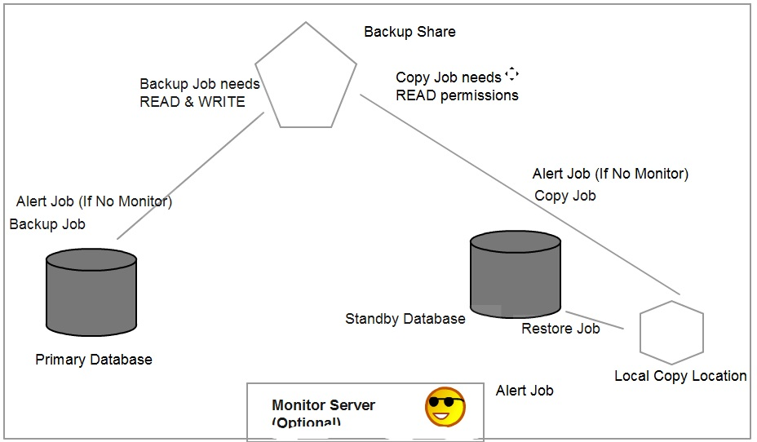

1) What is Log shipping and purpose of Log shipping?
Log Shipping is a database level HA/DR option.

Purpose of Log Shipping:
a) HA/DR option for maintaining copy of database.
b) Load Balancing of reports with Standby.

2) What is Primary Server, Secondary Server & Monitor Server?
Primary Server is the instance which contains Primary Database.

Secondary server contains Secondary Database.

Monitor server contains Log Shipping status in MSDB tables for all Backup/Copy/Restore jobs.

3) What are the Jobs running for Log shipping and explain them?
Backup, Copy, Restore and Alert (If no monitor then on Primary and Standby)
4) Requirements for Log shipping?

a) Recovery Model should be FULL/BULK LOGGED
b) Service Accounts if being run on domain.
c) Backup Share creation and assigning permissions
d) Local Copy Folder on the secondary.
e) Agent should be running
f) Minimum two servers (if possible third server for Monitor/Backup Share)

5) How to configure Log shipping?

6) What are permissions required for Log shipping?

a) Main Service Account of Primary should have read & write permissions on backup share.
b) Agent Service Account of Secondary should have read permission on backup share.
c) If monitor server is available, Agent Service account of Primary/Standby should have SYSADMIN rights on Monitor server.

7) In Logshipping which Recovery Models can we used?

FULL and BULK LOGGED

8) Where you monitoring Log shipping and how?

Monitor Server:
Log_shipping_monitor_primary:- Stores primary server status
Log_shipping_monitor_secondary:- Stores secondary servers status
Log_shipping_monitor_history_detail:- Contains history details for logshipping agents.
Log_shipping_monitor_error_detail:- Stores error details for log shipping jobs.
Log_shipping_monitor_alert:- Stores Alert Job ID

Primary Server:
Log_Shipping_Primary_Databases

Secondary Server:
Log_Shipping_Secondary_Databases

9) What are errors occurred in Log shipping?

14420 - Backup Job has some issue on Primary
14421 - Copy/Restore Job have some issues on Secondary

10) How to manually failover secondary server, when the Primary Server fails?

a) Take a tail log backup if possible.
b) Make sure all the log backups have been restored to secondary.
c) Last log backup/Tail log backup should be restored WITH RECOVERY.
d) Inform Application Team about the new Primary server (IP Address, Instance Name, Port Number)
e) Configure reverse log shipping with New Primary and Secondary.
11) What is TUF and WRK file in Log Shipping?

What is.tuf file.?

File containing information regarding any modifications that were made as part of incomplete transactions at the time the backup was performed.

A transaction undo file is required if a database is loaded in read-only state (STANDBY Mode). In this state, further transaction log backups may be applied.

What is a WRK file?

When the transaction log backup files are copied from the backup share to the secondary server the file is named as a work file(.wrk) till the copy operation is completed.

12) Is it possible to configure Log Shipping from lower version to upper version and Vice versa?

Log Shipping can be configured between Lower Version of Primary and Higher Version of secondary but not between Higher and Lower (because backups of Higher version cannot be restored on Lower version).

13) What is STANDBY Mode on the secondary database?

STANDBY mode provides an option to perform READ operations on Secondary while maintaining HA also.

14) What will happen to Log Shipping if TUF file is corrupted or lost?

Log Shipping will fail and we need to reconfigure log shipping.

16) If you add a file on the Primary database in a location which does not exist on the target, will it automatically be created on the secondary or not?

a) First disable all the Backup/Copy/Restore jobs.
b) Use the backup file (TRN) after last log backup restored. To restore on the secondary WITH MOVE option and specify the required path.

RESTORE LOG DBName from disk='\\Path\DBName.trn'
WITH MOVE 'DBName_2' to 'F:\SQLDATAFILES\DBName_2.ndf', NORECOVERY

c) Enable all the jobs BACKUP/COPY/RESTORE.

17) Is it possible to configure Log shipping on the database server with different collation?

No, log shipping cannot be configured with different collation settings.
18) Can we configure Log Shipping between the different domains?

Log Shipping can be configured in WORKGROUP and also between different domains (conditionally domains should have TRUST relationship).

19) Can we setup multiple secondary databases in Log Shipping?

Yes, it is possible to configure multiple standby databases, 10 being recommended value.

20) What editions of SQL Server is log shipping available in?

2012 – Enterprise, Business Intelligence, Standard, and Web
2008R2 – Datacenter, Enterprise, Standard, Web, and Workgroup
2008 – Enterprise, Standard, Web, and Workgroup
2005 – Enterprise, Standard, and Workgroup
21) Can we take full backup of the log shipped database in secondary server?

Full backup will not disturb log chain, hence if full backup is taken log shipping setup would not be disturbed.

Log backup will affect the log chain if manually taken, hence avoid log backups on databases participating in Log Shipping.

22) How to remove log shipping?

a) Disable/Delete all the jobs

b) Right Click on Database -> Properties -> Uncheck "Enable Log Shipping"

c) master.dbo.sp_delete_log_shipping_primary_secondary

sp_delete_log_shipping_secondary_database N'LogShipAdventureWorks'

sp_delete_log_shipping_primary_database N'AdventureWorks'

Log Shipping:

Log shipping is a HA option. Log shipping ensures that log backups from Primary are applied on standby.

Log shipping follows a warm standby method because manual process is involved to ensure standby is made primary during disaster.

Log shipping involves four jobs in major Backup, Copy, Restore and Alert job.

Backup job is always present on the Primary server and Copy/Restore jobs are present on Standby server.

Alert job is generally present in Monitor server, if monitor server is not available then Alert job would be present at both Primary and Standby.

Backup job requires Read and Write permissions on the Backup Share. Copy job required only Read permissions on it.

Implementation Plan for Log Shipping:

1) Verified all the deployed servers are able to ping each other (Primary, Standby and Monitor)

2) Verified that all Instances and Agents are up and running with domain service accounts.

SQLPriSrv and SQLPriAgt
SQLSTBSrv and SQLSTBAgt
SQLMonSrv and SQLMonAgt

3) Create backup share on a third server and grant SQL Server Main Service account of Primary instance Read and Write permissions.

Verify the backup share from Primary server with a sample DB backup test.
4) Grant Read Permissions to SQL Server Agent and Main Service Account of Standby instance on backup share.

5) Create a Local Copy folder, so that Copy job can copy files from backup share into it.

6) Identify the Primary database in the Primary server and check the recovery model of the database.

7) LSDB -> Properties -> Transaction Log Shipping

a) Enable this database as Primary in Log Shipping Configuration

b) Configure Backup settings
Provide network path:
\\10.10.10.103\BackupShare

c) Change the backup job schedule as needed and alert timelines.

d) Add Standby Servers (one or many). LS allows unlimited standby but Microsoft recommendation is 10 standby databases per Primary.

e) Add Standby and configure settings for Standby database.
Enable Remote Connections in Standby instance.

sp_configure 'remote admin connections',1
reconfigure with override

Enable protocols in Configuration Manager at both Client and Server.
f) Initialize the standby.
Let LS only initialize the standby but we need to grant "Read" permissions to Secondary Server Main Service Account. Only then Secondary server can restore the Full backup directly from Backup share.

g) Map Service Accounts of both Primary and Standby Agents into Monitor Instance as logins and grant them Sysadmin rights. This is required for Backup, Copy, Restore jobs to communicate their status to Monitor instance.

Alternatively we can also use a SQL Authenticated Account if service accounts should not be mapped.

Create a SQL Authenticated login in Monitor server and make sure the instance connectivity mode is Mixed mode. Also grant this login (monitorinfo) SYSADMIN rights to save secondary and primary configuration information.

Backup Job - 15mins
Copy Job - 15mins
Restore Job - 15mins

08:00
Backup - 1 File backup started
Copy - Do Nothing
Restore - Do Nothing

One file is present in your Backup Share.

08:15
Backup - 2nd file is being backed up.
Copy - Copy First File
Restore - Do Nothing

Two files are present in your backup share.

08:30
Backup - 3rd file is being backed up
Copy - Copy 2nd File
Restore - Restore first file.

Metadata tables in Log shipping:

Tables at Primary server:-

1) log_shipping_primary_databases contains last backup file and date/timestamp.

2) log_shipping_primary_secondaries contains primary and secondary details.

3)log_shipping_primaries contains additional columns and has focus on Planned Outage Timings.
Tables at Secondary server:-

1) log_shipping_secondary contains information about last copied file and timestamp.

2) log_shipping_secondary_databases contains information about last restored file and timestamp.

3) log_shipping_secondaries contains additional columns and has focus on Planned Outage Timings.

Tables at Monitor server:
log_shipping_monitor_primary
log_shipping_monitor_secondary
log_shipping_monitor_alert
log_shipping_monitor_error_detail
log_shipping_monitor_history_detail

restore database LogShip_STBY
from disk=N'c:\localcopy\LogShip_20120824032215.trn'
WITH MOVE 'LogShip1' to 'C:\Program Files\Microsoft SQL Server\MSSQL10_50.MSSQLSERVER\MSSQL\DATA\LogShip1.ndf'
,norecovery

Reasons for Log Shipping Failure:

1) Jobs disabled can be a cause for LS failure.

2) Backup Share permission issues.

3) Space issues in the backup share/local copy location.

4) SQL Server Agents stopped at Primary/Standby/Monitor.

5) Manual log backup can cause LS break.

6) Recovery Model change from Full/Bulk Logged to Simple.

7) Backup/Copy/Restore Job owner change can cause permission issues and break LS.

8) Network Issues with Backup Share.

9) WITH RECOVERY statement fired at Standby server can bring secondary database ONLINE breaking LS.

10) Service Account changes can lead to permission issues.

11) Log backups getting corrupted/deleted.

12) Backup schedule if changed can cause lot of delay which might raise an alert.

13) Timezone differences between servers(Primary/Standby/Monitor) can cause issues in the backup/restore/copy timings and can cause an issue.

14) Log shipping may fail due to TUF file corruption.

Scenarios

Failover Operation in Log Shipping:

1) Primary is corrupt and hence we would want to perform Failover. First verify if it is a suspect situation and if database can be rectified without Failover.

2) Check the possibility of transfering logins from Primary to Standby server. If entire instance crashes then it would be difficult to transfer logins, hence a automated job that transfers logins at regular intervals from P-S is a recommended practice.

3) Disable/Delete all the Log Shipping Jobs. This will stop the log shipping which is in progress.

4) Verify whether all backups have been moved to Backup share and also copied to Local Copy or not.

select * from log_shipping_primary_databases
Verify column Last Backup file and timestamp

select * from log_shipping_secondary_databases
Verify column Last Restored file and timestamp

5) If all backups have been moved and are in sync. Attempt last tail log backup on the Primary database and copy the file to the Backupshare and Local Copy.

6) Copy job follows a pattern and hence would not copy the file to Local Copy directory. Restore job restores and verifies each and every file and ensures that the manual Tail log backup is restored.

7) Restore the standby database WITH RECOVERY.

8) Confirm the customer the new IP Address, Instance Name, Port Number, New database name.

9) Customer will test the application and confirm on the usage.

10) Verify if any Orphan users exist or not.

11) Reconfigure Reverse Log Shipping with Standby as New Primary.

Switchover Operation in Log Shipping:

1) As a part of DR Test (or) upon Customer/Application Team/Client approval switch over operation is normally performed.

2) Transfer the logins from Primary to Standby server and Vice-Versa.

3) Disable/Delete all the Log Shipping Jobs. This will stop the log shipping which is in progress.

4) Verify whether all backups have been moved to Backup share and also copied to Local Copy or not.

5) If all backups have been moved and are in sync. Attempt last log backup WITH NORECOVERY on the Primary database and copy the file to the Backupshare and Local Copy.

backup log DBName to disk=N'\\Monitor\GaneshaShare\Ganesha_Last.trn' WITH NORECOVERY

This will set the Primary database to Restoring state to ensure that it will accept backups from Standby server.

6) Copy job follows a pattern and hence would not copy the file to Local Copy directory. Restore job restores and verifies each and every file and ensures that the manual last log backup is restored on the standby server.

7) Restore the standby database WITH RECOVERY. This will make the standby database ONLINE and it becomes the new Primary.

8) Confirm the customer the new IP Address, Instance Name, Port Number, New database name.

9) Customer will test the application and confirm on the usage.

10) Verify if any Orphan users exist or not.

10b) Delete existing log shipping configurations using below commands

sp_delete_log_shipping_primary_database LShip
sp_delete_log_shipping_secondary_database LShip_STBY

Query manually all the log_shipping_* tables to verify the old configurations are deleted or not.

11) Reconfigure Reverse Log Shipping with Old Standby as New Primary and Old Primary as New Standby.

List of Scenarios:

1) Configuring Log Shipping with Single and Multiple standby

2) Configuring standby database in standby mode

3) Adding files on Primary and check if it adds on standby

4) Performing shrink operation on primary and check on standby

5) Truncate on primary and check if log shipping breaks or not.

6) Failover

7) Switchover

8) Take a copy only backup for a log shipping configuration and check if LS fails or not

9) Disable jobs and troubleshooting LS

Completed:-
1) Configuring Log Shipping with Single and Multiple standby

2) Configuring standby database in standby mode

3) Adding files on Primary and check if it adds on standby

4) Performing shrink operation on primary and check on standby

5) Truncate on primary and check if log shipping breaks or not.

6) Failover

7) Switchover

9) Disable jobs and troubleshooting LS

8) Take a copy only backup for a log shipping configuration and check if LS fails or not.
10.10.10.1 - Primary
10.10.10.2 - Secondary
10.10.10.3 - Monitor
10.10.10.3 - BackupShare
\\10.10.10.3\LSBackupShare.

Important Points for Log Shipping:-
1) Agent should be up and running
2) DB should be in Full Recovery Model
3) Backup Share should be created
4) Permissions should be granted.

How to troubleshoot LOG SHIPPING:

Find out where is the backup/copy/restore information present. On Primary/Standby or Monitor server, to find this out check if monitor server is configured or not in Log Shipping Properties.

1) Verify the backup timings and job executions in the msdb table.

select * from log_shipping_primary_databases

Last Backup File / Last Backup Date are the two critical columns which will confirm the execution of backup jobs accurately.

2) Verify the copy/restore timings and files in the msdb tables.

select * from log_shipping_secondary_databases

Verify Last restored file and the dates.

select * from log_shipping_secondary

Verify Last Copied File and the dates.

3) Based on the delay being caused on Primary (Error 14420) and issues on Standby (Error 14421) the troubleshooting can be performed at the respective server.

4) Based on the scenario and the description of the Job History troubleshooting should be done accordingly.
Advantages:
1) DR Option and its low cost
2) Ease of implementation
3) Warm Standby
4) Load balancing of reports
5) Can add multiple standby
6) DR Test implementations possible
7) Works even on Workgroup edition.

Disadvantages:
1) Manual failover
2) Restricted for only databases
3) Latency is more
4) Data Loss possible
5) Bit more Downtime compared to other HA/DR

-----*****Disaster Recovery Planning
BCP (Business Continuity Plan)
-----*****High Availability:-
Instance Level - Clustering
Database Level - Log Shipping,Mirroring
Object Level - Replication
2012 -> Clustering+Mirroring -> AlwaysOn

Replication:

1) Types of Replications?

Snapshot, Transactional, Merge, Peer-To-Peer and Transactional Replication with Updateable Subscriptions (SQL 2012 onwards it is discarded)

2) Topologies?

Central Publisher: Centralized publisher with multiple subscribers. Distributor is present with Publisher.

Central Publisher with Remote Distributor:

Same as Central Publisher but Distributor is located in another server.

Central Subscriber:

One subscriber has subscriptions from multiple Publishers.

Central Distributor:

Distributor assisting multiple Publishers to serve subscibers.

Publishing Subscriber:

Subscriber further Publishes the data to another subscriber acting as a Publisher.

3) Agents in Replication?

Snapshot, Distributor, Log Reader, Merge, Queue Reader Agent

4) How data transfer happens between Pub and Sub?

Explain Replication Architecture of Publisher, Distributor and Subscriber.
5) Primary Key Violation Error?

We identify Primary Key Violation error from Replication monitor. Once identify the record that is causing PKey violation needs to be informed to Application team. The record deletion would be done from Subscriber end but confirmation from Application team is compulsary before resolving the issue.

7) Adding an Article to existing Publication?

sp_addarticle needs to be executed to add new article. But before doing it Allow_Anonymous and Immediate_Sync settings needs to be disabled. Then we can add article and then run the snapshot again and it would generate snapshot of newly added article only.

8) Adding columns to existing table in Replication?

Adding columns to existing tables in Article will replicate the data in the subscriber without even re-initializing the table. This action is applied on the subscriber without any action taken.

9) Explain about Snapshot, Transactional, Transational BiDirectional, Merge and Peer-to-Peer?

Explain all types of replication along with their agents.

10) How to troubleshoot replication failures?

For all replication related errors we troubleshoot using Replication Monitor and Replication tables.

11) Different ways of Monitoring Replication?

To identify replication information query
select * from sys.databases

Verify columns is_published, is_subscribed,is_merge_published,is_distributor

Finding all the Publications that are created on a table:

SELECT P.name Publication,
A.name TableName,
A.dest_table DestinationTable FROM
syspublications P INNER JOIN
sysarticles A ON P.pubid = A.pubid
WHERE p.name ='TableName'

Distribution Database contains lots of tables that are helpful to find Replication information.

SELECT Publication, Publisher_DB FROM Distribution.dbo.MSpublications;

Monitoring through DMVs and get information about Latency of Log Reader Agent:

select * from sys.dm_os_performance_counters where object_name like '%Replica%'
and counter_name like '%Logreader:%latency%'

Monitoring through DMVs and get information about Latency of Distributor Agent:
select * from sys.dm_os_performance_counters where object_name like '%Replica%'
and counter_name like '%Dist%latency%'

Monitoring Replication through Stored Procedures::--

(Run at Distributor and it returns all Publishers information)
sp_replmonitorhelppublisher

(Run at Distributor and it returns all Publications information)
sp_replmonitorhelppublication

(Run at Distributor and it returns all Publications information)
sp_replmonitorhelpsubscription

(Run at Distributor to find commands waiting to be applied on Subscriber)
sp_replmonitorsubscriptionpendingcmds

(Pending changes to be applied in Merge Replication on Publisher)
sp_showpendingchanges

(Pending changes to be applied in Merge Replication on Subscriber)
sp_showpendingchanges

(Monitoring Merge Replication Session at Distributor)
sp_replmonitorhelpmergesession
sp_replmonitorhelpmergesessiondetail

11) Trace Token?

Tracer token measures latency between Publisher to Subscriber (Publisher to Distributor and from Distributor to Subscriber).

An empty network packet that tracks timelines travels through Publisher to Subscriber and tracks the timelines.

Tracer token narrows down troubleshooting to specific issue area.

12) If Agents fail how to troubleshoot?

All agents involved in Replication work through Jobs and the location of the Agent is mostly at Distributor(Push) or Subscriber(Pull).

The important jobs involved with Replication are:
Agent History Cleanup in Distribution
Distribution Cleanup
Expired Subscription Cleanup
Snapshot Agent Job
Log Read Agent Job
Distributor Agent Job
and few more.

13) If data sync fails or slow performance what to do?

Initiate Tracer Token and identify the real reason behind data flow slowness, whether issue is between Publisher-Distributor (or) Distributor-Subscriber. To identify this

14) If my Snapshot folder is full, what to do?

If snapshot folder is full, then there is a way of changing the snapshot location in Distributor properties. Also FTP Snapshot directory can be created based on the requirement.

15) How to remove replication?

Removal of Subscriptions, then Publications and then we need to remove Publisher and finally the Distributor. This is the reverse order of configuring.

17) What is Distributor_Admin account?

The distributor_admin RPC link is needed by replication because most replication administrative functions require processing at both the publisher database as well as the distribution database. For example, when a new publication is added through sp_addpublication, it is necessary to add a row in the syspublications table at the publisher database and the MSpublications table at the distribution database and this process uses the distributor_admin link under the cover.

19) Is it compulsary to grant SYSADMIN rights to all the Service Accounts of Replication Agents?

It is not compulsary to grant SYSADMIN rights, the same can be achieved by granting DBOwner rights on the Publication/Subscription/Distribution databases.

Refer:--
https://technet.microsoft.com/en-us/library/ms151868(v=sql.105).aspx

18) What is PAL (Publication Access List)?

When we create a publication, SQL Server creates a publication access list (PAL) for the publication. It contains the list of logins that have been granted access to the publication. By default, the PAL contains the members of the sysadmin fixed server role and the login of the user who created the publication.

Access to a publication is controlled by the publication access list (PAL). Logins and groups can be added and removed from the PAL.

19) How to reinitialize subscription using Command?

For Pull Subscription:

sp_reinitpullsubscription 'Publisher_Server','Publisher_DB','Publication_Name'

For Push Subscription:

EXEC sp_reinitsubscription 'Subscriber_Server','Subscription_DB','Publication_Name'

16) What is conflict detection and resolution in Merge Replication?

When a Publisher and a Subscriber are connected and synchronization occurs, the Merge Agent detects if there are any conflicts. If conflicts are detected, the Merge Agent uses a conflict resolver to determine which data is accepted and propagated to other sites.

Conflict detection is based on the three things:

Column-level tracking; it is considered a conflict if changes are made to the same column in the same row at more than one replication node

Row-level tracking; it is considered a conflict if changes are made to any columns in the same row at more than one replication node

Logical record-level tracking; it is considered a conflict if changes are made to any row in the same logical record at more than one replication node

After a conflict is detected, the Merge Agent launches the selected conflict resolver and uses the resolver to determine the conflict winner. The winning row is applied at the Publisher and Subscriber, and the data from the losing row is written to a conflict table.

In merge replication, conflict resolution takes place at the article level.
Merge replication offers four types of conflict resolvers:

a) The default priority-based conflict resolver
b) A business logic handler
c) A COM-based custom resolver
d) A COM-based resolver supplied by Microsoft

Merge replication offers a variety of methods to detect and resolve conflicts.

If a conflict occurs between a Publisher and a Subscriber, the Publisher change is kept and the Subscriber change is discarded.

If a conflict occurs between two Subscribers using client subscriptions the change from the first Subscriber to synchronize with the Publisher is kept, and the change from the second Subscriber is discarded.

If a conflict occurs between two Subscribers using server subscriptions the change from the Subscriber with the highest priority value is kept, and the change from the second Subscriber is discarded. If the priority values are equal, the change from the first Subscriber to synchronize with the Publisher is kept.

Q) What are triggers in Merge Replication?

SQL Server installs triggers that track changes to the data in each row or each column.

The triggers capture changes made to the publishing table and record the changes in merge system tables.

Tracking triggers on the publishing tables are created while the Snapshot Agent for the publication runs for the first time. Triggers are created at the Subscriber when the snapshot is applied at the Subscriber. Different triggers are generated for articles that track changes at the row level or the column level.

Adding an Article in TR:

Adding an article to a publication involves consideration of two things
1) Downtime at the subscriber
2) Sizes of the tables to be replicated.

Steps:

1) Verify the options using sp_helppublication and check

a. Immediate_sync
b. Allow_anonymous

Both the fields were set to ON as they showed a value 1 which is enabled. If the Immediate_sync is enabled, everytime you add a new article it will cause the entire snapshot to be applied and not the one for the particular article alone.

EXEC sp_changepublication
@publication = 'TranRepl',
@property = N'allow_anonymous',
@value = 'false'
GO

EXEC sp_changepublication
@publication = 'TranRepl',
@property = N'immediate_sync',
@value = 'false'
GO

2) Adding an article

Command for adding article.
Exec sp_addarticle
@publication = TranRepl,
@article = Table_2,
@source_object = Table_2,
@force_invalidate_snapshot=1

Adding an article so can generate an error

Msg 20607, Level 16, State 1, Procedure sp_MSreinit_article, Line 99
Cannot make the change because a snapshot is already generated.

Set @force_invalidate_snapshot to 1 to force the change and invalidate the existing snapshot.

3) Add the subscriber with below command to ensure the properties are updated.

EXEC sp_addsubscription
@publication ='TranRepl',
@subscriber = 'FTDCCWPCTRXSQL',
@destination_db = 'ReplTest',
@reserved='Internal'

To avoid error "Specify all articles when subscribing to a publication using concurrent snapshot processing"

i) By specifying @reserve = 'internal' when we add the subscription for the new article and the snapshot agent should generate snapshot for the new article after that

(or)

ii) Changing the sync_method from 'concurrent' to either 'database snapshot' (enterprise edition only in SQL Server 2005) or 'native'.

Adding an article to an existing publication (Transactional Replication):

Adding an article directly in the Publication properties under Article option can be costly, if the table sizes are very large. If article is directly added without making configuration changes, when a new snapshot is generated to initialize the subscription both old tables and the new tables will be part of snapshot (T-200Gb and NewT-100GB).

Configuration changes needed are:

1) @force_invalidate_snapshot

Invalidate the existing snapshot so that a new snapshot can be taken.

2) Set allow_anonymous property to false.

@property = N'allow_anonymous',
@value = 'false'

3) Set immediate_sync property to false.

@property = N'immediate_sync',
@value = 'false'

Commands:-

Run the commands on Publisher:

EXEC sp_changepublication
@publication = 'TranRepl_Stu',
@property = N'allow_anonymous',
@value = 'false'
GO

EXEC sp_changepublication
@publication = 'TranRepl_Stu',
@property = N'immediate_sync',
@value = 'false'
GO

use ReplTest
go
sp_addarticle @publication='TranRepl_Stu', @article='dbo.NewT',@source_table='NewT' , @force_invalidate_snapshot=1
go

Command On Subscriber:

EXEC sp_addsubscription
@publication = 'TranRepl_Stu',
@article = 'dbo.NewTT',
@subscriber = 'Node3',
@destination_db = 'ReplTest',
@reserved='Internal'

Publication was set up with concurrent snapshot option and means that you can't synchronize subscriptions for such publications without a complete resynchronization.

There are 2 workarounds:
(a) By specifying @reserve = 'internal' when you add the subscription for the new article and the snapshot agent should generate snapshot for the new article

b.)
Changing the sync_method from 'concurrent' to either 'database snapshot' (enterprise edition only in SQL Server 2005) or 'native' (which locks table during snapshot generation).

Change the sync_method will force a reinitialization of all your subscriptions at this point.

http://ansqldba.blogspot.in/2012/02/adding-new-article-to-existing.html#!/2012/02/adding-new-article-to-existing.html
Snapshot creates files as below:-
Schema (.sch)
Constraints and indexes (.dri)
Triggers (.trg)
System table data (.sys)
Conflict tables (.cft)
Data (.bcp)
Indexes (.idx)
Preperation Tables (.pre)

Transactional Replication:

1) Configure the Distributor

2) Update Publisher details in the Distributor

3) Configure Distributor at the Publisher.

4) Share the REPLData Folder and give Read/Write access to all Agent Service Accounts on the ReplData Folder.

Create a login for the Distributor Agent Service Account and grant it DBOwner rights on the replicated database.

If Pull Subscription is used, create a login for Subscriber Agent Service Account and grant it DBOwner rights on the distribution database.

If Push Subscription is used, create a login for Distributor Agent Service account in the Subscriber instance and grant it DBOwner rights on the Subscription database.

5) Configure Publication.

It is important that the tables should have Primary Key for a key column.

6) Configure Subscription (select Push/Pull subscription).

Transactional Replication with Updatable Subscriptions:

Updatable subscriptions for transactional replication allow Subscribers to replicate changes to the Publisher.

Triggers are added to the published tables in the subscription database, and when a change is made at the Subscriber, the trigger fires:

i) For immediate updating subscriptions, the change is propagated directly to the Publisher and applied using Microsoft Distributed Transaction Coordinator (MSDTC).

ii) For queued updating subscriptions, the change is first propagated to a queue and then applied to the Publisher by the Queue Reader Agent.

Components of Immediate Updating:
1) Tracking column is added to the published tables for conflict detection and change tracking. The column name is msrepl_tran_version.
2) MSDTC
3) Triggers on tables in the subscription database
4) Stored Procedures

Components of Queued Updating:
1)Tracking column is added to the published tables for conflict detection and change tracking. The column name is msrepl_tran_version.
2) Triggers
3) Stored Procedures
4) Microsoft SQL Server Queue (MSreplication_queue)
5) Queue Reader Agent

Configuring Transactional Replication:

1) Create database on Publisher with tables. Make sure the tables have Primary Key column.

2) Create REPLDATA directory (or use default directory in Root directory of instance).

If Push grant permissions on REPLDATA
B18Domain\SnapReplAgt (Read and Write) in Security Tab [Monitor Server].

If Pull grant permissions on REPLDATA
B18Domain\SnapReplAgt (Read and Write) in Sharing Tab [Monitor Server].

If Push Subscription, then Grant Distribution Agent (DistribReplAgt) Read permissions in Security Tab [Monitor Server].

If Pull Subscription then Grant Distribution Agent (DistribReplAgt) Read permissions in Sharing Tab [Monitor Server].

3) Creating Logins.

Snapshot Agent:
1) Sysadmin rights on the Publisher (Primary)
2) Sysadmin rights on the Distributor (Monitor)

Log Reader:
1) Sysadmin rights on the Publisher (Primary)
2) Sysadmin rights on the Distributor (Monitor)

Distributor Agent:
1) Sysadmin rights on the Subscriber (Secondary)
2) Sysadmin rights on the Distributor (Monitor)

4) Configure Distributor in the respective instance (Monitor). Specify Publisher details and provide Admin Password for distributor_admin login.

***********************************
Distributor_admin login is present in Distributor and Publisher will connect using this login to do Administrative tasks (like Adding Publisher, Removing Publisher, Changing configurations etc).
***********************************

Also in Publisher configure Distributor and inform Publisher about Monitor Distributor.

5) Configure Publication and make sure Table has Primary key and apply filtering accordingly.

6) Configure Subscriber and "Add Publisher" to search for Replication.

6) Why is Primary Key mandatory for Tran Replication?

Implementing Snapshot Replication:

1) Configure Distributor (Local/Remote Distributor)
Node3

If it is a local distributor Grant Full control permissions on ReplData directory to the Service Account created for Replication Purpose.

If it is Remote Distributor, ensure ReplData directory is shared with a network path and Full control permissions are granted to Service Account created for Replication Purpose.

1b) Map the Replication account to all (Publisher/Distributor/Subsriber) with SYSAdmin Rights.

2) Mention the shared REPLData folder (Network or Local path).

3) Specify the properties of Distribution database.

4) Mention the Publisher during distribution configuration.

5) Configure Publisher and Publication. (Node1)

6) Configure Publisher and mention the Remote Distributor (Node3).

7) Create a Publication with all the Properties related to Snapshot Replication.

8) Create the Subscription by mapping it to respective Publisher.

Transactional Replication:

1) Configure Replication Service Account as a Domain.

2) Configure the Distributor (Node3) as Local Distributor and update the Publisher details (i.e. Node1).

3) Configure Distributor properties in Publisher as Remote Distributor (with Node3).

4) Create the Publication and select the Articles. Also mention Security Settings for Log Reader and Snapshot agents. (Node1)

5) Create the Subscription referring to Publisher created on Node1. Select Continuously option and Initialization settings.

Updateable Subscriptions:

Two methods of updateable Subscriptions are available to transfer the data from the subscriber to the Publisher.

1) Immediate Updating
Immediate Updating ensures that data is sent to Publisher using MSDTC (and Linked Servers as a direct connection is established with Publisher).

Immediate Updating requires Publisher and Subscriber to be connected constantly.

2) Queue Updating

Queue reader agent present at the distributor ensures that the Queued Transactions are transferred to Publisher.

The Queue Reader Agent is used with transactional replication with the queued updating option. The agent runs at the Distributor and moves changes made at the Subscriber back to the Publisher. Unlike the Distribution Agent and the Merge Agent, only one instance of the Queue Reader Agent exists to service all Publishers and publications for a given distribution database.

MSRepl_Tran_Version Unique Identifier column gets added to Publisher and also to the subscriber(s).

Triggers are used internally at the Subscriber to track the changes.

Stored Procedures are used in entire replication to perform the actions.

Implementation:
1) Create the Publication as Transactional Replication with Updateable Subscribtions.

2) Configure the Subscriber with Immediate/Queued Updating.

3) Provide Service Account for the Queue Reader Agent, configure MSDTC in the Subscriber instance, either manually create linked server or let Replication GUI create it.

4) Change the Authentication modes at Publisher and Subscriber to Mixed mode.

5) Linked Servers have to be configured.

Merge Replication:

Merge replication must initialize both the Publisher and Subscriber before data can flow between them.

Snapshot agent first takes the snapshot of the database and Merge agent initializes the snapshot on the subscriber.

Components of Merge Replication:

1) ROWGUID column is added as an additional uniqueidentifier column.

2) Insert, update, and delete triggers are added to published tables to track changes.

3) Stored procedures are created to handle inserts, updates, and deletes to published tables

4) Views are created to manage inserts, updates, deletes, and filtering

5) Conflict tables are created to store conflict information.

Transactional Replication with US Versus Merge Replication:

Transaction Replication with Updatable Subscriptions:

1) Scenario is Server-to-Server.

2) Number of subscribers are less than 10

3) Subscribers update data infrequently

4) Subscribers, distributor and publisher are connected most of the time

5) Expect less update conflicts with queued updating. This type does not have rich facilities for handling conflicts.

6) No publisher, no transaction, If you are using immediate updating subscribers, the instant the publisher is unavailable, you can not issue transactions against the subscriber.

Transactional Publication with Updatable Subscriptions officially removed in SQL Server 2012. Microsoft is recommending that users switch to Peer-to-Peer Replication instead. Peer-to-Peer is Enterprise only feature.

Merge Replication Benefits:
1) Merge replication is infinitely scalable i.e. any number of subscribers

2) Merge replication can tolerate the bulk of the DML occurring at either the publisher or subscriber.

3) It has rich conflict detection and resolution functionality

4) Merge was designed to be mobile and disconnected. Subscribers, distributors and publisher are not always connected

5) Scenario is Server-to-Client.

-----Deciding parameters between Transactional Replication with updatable subscription or Merge replication

How many subscribers are there?
What data do they need?,
How long do they plan to be disconnected?
How soon do they need the publisher changes?
How many changes do subscribers plan to upload?

Peer to Peer Replication:

1) Configure Distributors on all the Nodes.

2) Add all their nodes as Own Publishers

2b) Add Agent/Dedicated Service Accounts to all Peers with Admin rights on the database.

3) Perform a manual intialization using Backup/Restores from Peer1 to all other Peers.

4) Choose the First Peer and configure Transactional Publication.

5) Right click on the Publication -> Properties -> Subscription Options -> Allow Peer to Peer Subscription to True.

This is an irreversable action and cannot be moved back to normal Transactional Publication.

6) Right click on Publication (Peer1) and Configure Peer-to-Peer Topology.

7) Add all the nodes and Ensure all nodes are connected.
Notes:
1) Peer to Peer replication doesn't use Snapshot during initialization.

2) Peer to Peer replication recommends to enable Browser Service.

Differences between Peer-to-Peer and Merge Replication:

1) Merge is trigger action based and P2P is Transaction Log based.

2) Merge Repl uses Merge Agent and P2P uses Log Reader and Distribution Agent.

3) Merge can track both column and row changes, P2P tracks changes made per row.

4) Merge replication is used for loosely connected systems and P2P is used for Tightly connected systems.

5) Merge replication offers Conflict Detection and Resolution with a Conflict Resolver Module. P2P offers only Conflict detection and resolution can be implemented through a logic.

In Peer to Peer replication also there is conflict detection using $sys_p2p_cd_id psuedo column inserted in all the tables at all peers.

This columns helps in detecting the conflicts. Conflict Resolution is decided based on Peer Originator ID.

Peer Originator ID can exist both in Postive values and negative values.

For example Node1 has Peer ID as -2 and Node2 has Peer ID as 2.
Peer-to-Peer:

1) Take backup of the Publication database and restore on all the nodes to initialize the databases between the nodes.

2) Configure Distributor on all the nodes.

3) If impersonating Agent account (Considering Node1,Node2,Node3 P2P)

Add Node1 Agent account as login in all other nodes(Node2,Node3)

Add Node2 Agent account as login in all other nodes (Node1,Node3)

Add Node3 Agent account as login in all other nodes (Node1,Node2)

4) Snapshot agent might have permission issue on the Repldata folder, so add Node1 (Primary Peer) Agent account full permissions on the Repldata folder.

5) Configure Transactional replication on the Primary Peer and convert that to Peer-to-Peer in Subscription options.

6) Configure Peer-to-Peer topology

Mirroring:
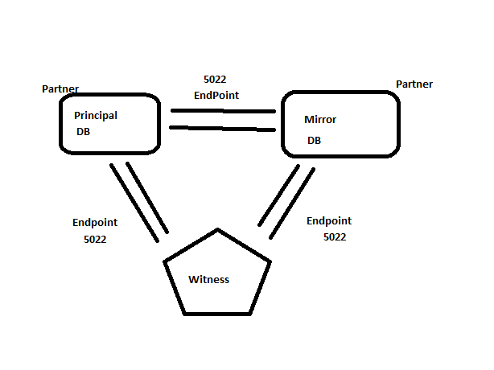

Database mirroring is a primarily software solution for increasing database availability. Mirroring is implemented on a per-database basis and works only with databases that use the full recovery model.

Database mirroring maintains two copies of a single database that MUST reside on different server instances of SQL Server Database Engine.

One server instance serves the database to clients (the principal server).

The other instance acts as a hot or warm standby server (the mirror server), depending on the configuration and state of the mirroring session.

Benefits:
1) Increases data protection.
2) Increases availability of a database.

When a database mirroring session is synchronized, database mirroring provides a hot standby server that supports rapid failover without a loss of data from committed transactions.

When the session is not synchronized, the mirror server is typically available as a warm standby server (with possible data loss).

Architecture:

The principal and mirror servers communicate and cooperate as partners in a database mirroring session.

The two partners perform complementary roles in the session: the principal role and the mirror role.

At any given time, one partner performs the principal role, and the other partner performs the mirror role.

Each partner is described as owning its current role. The partner that owns the principal role is known as the principal server, and its copy of the database is the current principal database. The partner that owns the mirror role is known as the mirror server, and its copy of the database is the current mirror database.

Database mirroring involves redoing every insert, update, and delete operation that occurs on the principal database onto the mirror database as quickly as possible.

Redoing is accomplished by sending a stream of active transaction log records to the mirror server, which applies log records to the mirror database, in sequence, as quickly as possible.

Unlike replication, which works at the logical level, database mirroring works at the level of the physical log record.

Operating Modes:

A database mirroring session runs with either synchronous or asynchronous operation.

High Availability (Synchronous)
High Protection (Synchronous)
High Performance (Asynchronous)

Under asynchronous operation, the transactions commit without waiting for the mirror server to write the log to disk, which maximizes performance.

Under synchronous operation, a transaction is committed on both partners, but at the cost of increased transaction latency.

There are two mirroring operating modes. One of them, high-safety mode supports synchronous operation. Under high-safety mode, when a session starts, the mirror server synchronizes the mirror database together with the principal database as quickly as possible. As soon as the databases are synchronized, a transaction is committed on both partners.

The second operating mode, high-performance mode, runs asynchronously. The mirror server tries to keep up with the log records sent by the principal server. The mirror database might lag somewhat behind the principal database. However, typically, the gap between the databases is small. However, the gap can become significant if the principal server is under a heavy work load or the system of the mirror server is overloaded.

In high-performance mode, as soon as the principal server sends a log record to the mirror server, the principal server sends a confirmation to the client. It does not wait for an acknowledgement from the mirror server. This means that transactions commit without waiting for the mirror server to write the log to disk. Such asynchronous operation enables the principal server to run with minimum transaction latency, at the potential risk of some data loss.
High-safety mode with automatic failover requires a third server instance, known as a witness. Unlike the two partners, the witness does not serve the database. The witness supports automatic failover by verifying whether the principal server is up and functioning. The witness server initiates automatic failover only if the mirror and the witness remain connected to each other after both have been disconnected from the principal server.

Prerequisites for Database Mirroring:

1) Database recovery model should be FULL
2) Enable the protocols (TCP exclusively) at both Principal, Mirror and Witness servers.
3) Principal, Mirror and Witness should exist in seperate instances
4) Endpoints should be created for all partners and the witness
5) Database names should be same both on Principal and Mirror
6) Manual initialization has to be done by restoring a Full Backup of principal on mirror and additionally transaction log backups as well.
7) Mirror should be restored with NO RECOVERY
8) Hardware configurations preferably should be the same (Witness can be a low end server)
9) Firewall/Antivirus should not block the TCP port number for mirroring i.e. 5022
10) TCP 5022 port telnet has to be verified
11) If encryption is enabled on Principal the same should be followed on Mirror. Both Principal and Mirror should use same Encryption methodology(algorithm).
12) If SQL Server 2005 instance is used and if it is RTM then enable 1400 trace

1) Principal Server:

In database mirroring, the partner whose database is currently the principal database.

2) Mirror Server:

In a database mirroring configuration, the server instance on which the mirror database resides.

3) Principal Database:

In database mirroring, a read-write database whose transaction log records are applied to a read-only copy of the database (a mirror database).

4) Mirror Database:

The copy of the database that is typically fully synchronized with the principal database.

5) Witness:

For use only with high-availability mode, an optional instance of SQL Server that enables the mirror server to recognize when to initiate an automatic failover. Unlike the two failover partners, the witness does not serve the database. Supporting automatic failover is the only role of the witness.

6) Mirroring Session:

The relationship that occurs during database mirroring among the principal server, mirror server, and witness server (if present).

After a mirroring session starts or resumes, the process by which log records of the principal database that have accumulated on the principal server are sent to the mirror server, which writes these log records to disk as quickly as possible to catch up with the principal server.

7) Transaction Safety:

A mirroring-specific database property that determines whether a database mirroring session operates synchronously or asynchronously. There are two safety levels: FULL and OFF.

Troubleshooting Mirroring Issues:

1) Launch Mirror Monitor and verify all the status of Principal, Mirror and Witness (if available)

2) Check for History at Principal to see if log records are passing by. Also check History for Mirror if log records are being received. This option is available in Mirror Monitor

3) Check if Mirroring endpoints on Principal, Mirror and Witness are started or not.

4) If network is working fine or not, check through Ping command.

5) Verify the port functionality through telnet command

telnet IPAddress PortNumber

6) Verify if Unsent log, Unrestored log, Last Transaction Sent, Commit Overhead parameter values are increasing. If possible set Alerts for these parameters for Mirroring monitoring.

Quorum in Mirroring:-

Quorum is a relationship that exists when two or more server instances in a database mirroring session are connected to each other.

Three types of quorum are possible:
1) A full quorum includes both partners and the witness.
2) A witness-to-partner quorum consists of the witness and either partner.
3) A partner-to-partner quorum consists of the two partners.
1) What is default port of Database Mirroring Endpoint?
5022

2) Database Mirroring comes with which edition?

SQL Server 2005 SP1. Or SQL Server 2005 RTM with trace flag 1400.

3) When I configure mirroring I’m receiving the below error?

1412 Error.
The fully qualified computer name of each server can be found running.

4) How to enable mirroring by Script ?

ALTER DATABASE [AdventureWorks] SET PARTNER = N'TCP://A.corp.kdssg.com:5022';

ALTER DATABASE [AdventureWorks] SET PARTNER = N'TCP://B.corp.kdssg.com:5022';

5) How to disable mirroring by script?

ALTER DATABASE [AdventureWorks] SET PARTNER OFF

6) How to do manual failover to Mirror when principle is working fine?

ALTER DATABASE <DB Name> SET PARTNER FAILOVER

7) Can we configure mirroring between Standard Edition & Enterprise Edition or Vice Versa?

Both principal and mirror should have same edition

8) Is it possible to take backup of mirrored database in mirror server?
No

9) Is it possible to perform readonly operation at mirrored database in mirror server?

Yes, we can create snapshot.

10)Can I configure a single database to be mirrored to more than one server.

No, Mirroring supports only one Principal and one Mirror.

11) What status of mirroring has if secondary is down?

If secondary is down principle or Mirror show status disconnected.

12) What are the Mirroring modes
High-Availability - Synchronous
High-Protection - Synchronous
High-Performance - Asynchronous
13) What are Mirroring States?

SYNCHRONIZING
SYNCHRONIZED
SUSPENDED
PENDING_FAILOVER
DISCONNECTED

14) What is endpoint in Mirroring?

Endpoint:
An endpoint is a SQL Server object that enables SQL Server to communicate over the network. It encapsulates a transport protocol and a port number.

15) How to configure mirroring?
Steps:
1) Configuring endpoint
2) Creating logins for other servers service accounts and grant sysadmin rights.
3) Grant connect permission to this logins on endpoints
4) Create mirror database
5) Take full and T.Log backup from principal server and restore it in mirror server with NORECOVERY.
6) Establish mirroring session using ALTER DATABASE command

16) Explain DB Mirroring Monitor parameters

Unsent Log (at principal)
Unrestored Log (at mirror)
Transaction Rate
Commit Overhead (Transactions applied rate at mirror)
Mirror commit overhead is related to the configurable threshold for the amount of time in milliseconds that the principal server will wait for the transaction to be written to the mirror server redo queue.

17) What are the major new features introduced in Mirroring 2008 version?

a.)Auto Page Repair.

Select * from sys.dm_db_mirroring_auto_page_repair

b. ) Transactions are sending to Mirror by compressing.

To view total bytes send from principal and total bytes received at mirror we can use (run in witness server)

Select * from sys.dm_db_mirroring_connections

c. Automatic Client Side Redirect

18) Disadvantages of Mirroring.

a) Does not support filestream.
b) potential loss of data in async mode(high performance).
c) Mirror server is not available for read-only purpose.
d) It works at the database level, not at the server level.
e) Multiple database fail-over.

19) Advantages of Mirroring?

a) It increases the data protection(DR).
b) Increases the database availability on sync mode.
c) Cost of DB mirroring less compare to clustering.
d) It is robust and efficient than log shipping and replication.
e) It support the full text.
f) Failover is fast compare to cluster.
g) Mirror server can be used to host databases for other application

20) Can we configure mirroring on different domain.

Yes. Both domain's should be trust each other.

21) Can we configure mirroring on workgroup?

Yes. It can be implemented through Certificates.

21) How many Databases can configure Mirroring?

Can't configure more than 10 DB's on 32 bit but we can on 64 Bit. But not recommended.

What is Quorum in Mirroring?

Quorum is a communication channel in Mirroring.
1) Full Quorum
2) Partner-Partner Quorum
3) Partner-Witness Quorum

How to failover manually in Mirroring?

1) ALTER DATABASE <DB Name> SET PARTNER FAILOVER
2) ALTER DATABASE <DB Name> SET FORCE_SERVICE_ALLOW_DATA_LOSS
3) ALTER DATABASE <DB Name> SET PARTNER OFF
RESTORE DATABASE <DB Name> WITH RECOVERY
Inform Application team about the new server, ip address, port number. If client side redirect is mentioned then nothing to do.
Q) Why are principal and mirror not in sync?

1) Principal and Mirror have endpoint issues.
2) Mirroring was paused
3) No space on the mirror database in mirror server.
Prerequisites for Mirroring:

1) It is possible only in Full Recovery Model
2) Creation of Endpoints (for Principal/Mirror/Witness) and giving connect permissions on endpoints.
3) Take full backup and tlog backup and restore on Mirror with NORECOVERY
4) DB Name should be same.
5) Databases should be in different instances
6) Should be same edition.
7) Add port number for firewall exception.

Log Shipping and Mirroring Differences?

1) Log Shipping recovery models are full and bulk logged. For mirroring it is only full.
2) Automatic failover is possible in mirroring.
3) Automatic page repair is possible in mirroring
4) Mirroring is hot standby (with witness),LS is warm standby.
5) Mirror database names should be same, LS no rule.
6) Only one standby is possible in Mirror, no rule for LS.
7) LS is less expensive compared to Mirroring.
8) Log Stream compression possible in Mirroring.
9) Between same versions and editions mirroring is possible. No rule for LS.
10)LS is ideally a good DR option.
11)LS can be configured in Standby or NoRecovery, Mirroring works only in No Recovery model.
12)Client side redirect is supported by Mirroring.
13)Standby needs to be read through snapshot in Mirroring.

-:::1418 Error in Mirroring:::-

SQL Server Service Accounts:
1) SQL Server service account requires CONNECT permissions to partner's endpoints.

Connect to all the instances (Prin,Mirr,Witt) and grant CONNECT permission as below.

GRANT CONNECT ON ENDPOINT::Mirroring_Prin TO [USDomain\SQLSrvMirr]

2) Dont use Local System Account, but if its mandatory to use then Certificates needs to be created.
The mode of communication used is Certificate Authentication.

3) Use Domain Accounts and grant Connect permissions on mirroring endpoints is the best choice.

Verify Ports:-

1) Use Telnet to test that the port is open and something is listening
Telnet verifies whether the port is blocked/unblocked. If port seems to be blocked it could be issue with Windows Firewall. Contact Windows team to add this port number as firewall exception.

Also check if the Port is enabled or not by Network Team. Network team has to enable the port and then Windows team has to add this port to Firewall Exception.

Endpoints:-
1) Verify if the endpoints are started or not.

select * from sys.endpoints

select * from sys.database_mirroring_endpoints

Run this command on all the instances and confirm endpoints are started or not.

If endpoint is stopped, start the endpoint.

ALTER ENDPOINT
endpoint_mirroring
STATE = STARTED
AS TCP ( LISTENER_PORT = 5022 )
FOR DATABASE_MIRRORING
( AUTHENTICATION = WINDOWS KERBEROS,
ENCRYPTION = SUPPORTED,
ROLE=ALL);
GO

Scenarios:-

HA Mode:
1) Principal Crashes then witness performs failover and makes Mirror the Principal.

Mirror becomes Principal,DISCONNECTED.

2) If Mirror Crashes, then Principal becomes

Principal,DISCONNECTED

Once Mirror comes back then it will be Principal/Synchronized

3) If Principal and Witness Crash at same time.

As there is no one to perform Automatic Failover.

Mirror will be
Mirror/DISCONNECTED

A manual failover has to be performed.

Command:

alter database MirrorDB set partner OFF

FAILOVER FORCE_SERVICE_ALLOW_DATA_LOSS (Last Solution)
OFF

RESUME
SAFETY { FULL | OFF }
SUSPEND
TIMEOUT integer

4) If Mirror and Witness crash at same time.

As the Principal is still functional business would continue but state will be

Principal/Disconnected
Terminologies:

Unsent Log:
Specifies how many kilobytes (KB) of unsent log generate a warning on the principal server instance. This warning helps measure the potential for data loss in terms of KB and is especially relevant for high-performance mode.

Unrestored Log:
Specifies how many KB of unrestored log generate a warning on the mirror server instance. This warning helps measure failover time.

Oldest unsent transaction:
Specifies the number of minutes worth of transactions that can accumulate in the send queue before a warning is generated on the principal server instance.

Send Rate(Transaction Rate):
The data transfer rate from Principal to Mirror

States of Mirroring:

1) SYNCHRONIZING: The contents of the mirror database are lagging behind the contents of the principal database.

2) SYNCHRONIZED: Both principal and mirrorm are in sync.

3) SUSPENDED: The mirror copy of the database is not available. The principal database is running without sending any logs to the mirror server.

4) PENDING_FAILOVER: This state is found only on the principal server after a failover has begun.

5) DISCONNECTED: The partner has lost comunication with the other partner.

Clustering:

What is Clustering?
A cluster is a group of independent computer systems, referred to as nodes, working together as a unified computing resource. A cluster provides a single name for clients to use and a single administrative interface, and it guarantees that data is consistent across nodes.
Microsoft servers provide three technologies to support clustering: Network Load Balancing (NLB), Component Load Balancing (CLB), and Microsoft Cluster Service (MSCS) Failover Cluster.

Network Load Balancing
Network Load Balancing acts as a front-end cluster, distributing incoming IP traffic across a cluster of servers, and is ideal for enabling incremental scalability and outstanding availability for e-commerce Web sites. Up to 32 computers can be connected to share a single virtual IP address. NLB enhances scalability by distributing its client requests across multiple servers within the cluster. As traffic increases, additional servers can be added to the cluster; up to 32 servers are possible in any one cluster. NLB also provides high availability by automatically detecting the failure of a server and repartitioning client traffic among the remaining servers within 10 seconds, while it provides users with continuous service.

Component Load Balancing
Component Load Balancing distributes workload across multiple servers running a site's business logic. It provides for dynamic balancing of COM+ components across a set of up to eight identical servers. Both CLB and Microsoft Cluster Service can run on the same group of machines.

Failover Clustering
Cluster Service acts as a back-end cluster; it provides high availability for applications such as databases, messaging and file and print services. MSCS attempts to minimize the effect of failure on the system as any node (a server in the cluster) fails or is taken offline.
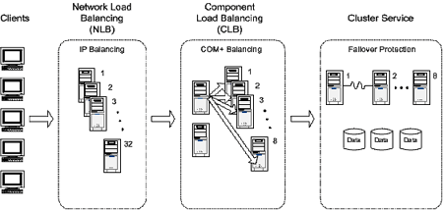
Figure 1. Three Microsoft server technologies support clustering

MSCS failover capability is achieved through redundancy across the multiple connected machines in the cluster, each with independent failure states. Windows 2003 supports up to 8 nodes in a cluster, 2008 supports upto ___ Nodes and 2012 supports ___ Nodes.

Each node has its own memory, system disk, operating system and subset of the cluster's resources. If a node fails, the other node takes ownership of the failed node's resources (this process is known as "failover"). Microsoft Cluster Service then registers the network address for the resource on the new node so that client traffic is routed to the system that is available and now owns the resource. When the failed resource is later brought back online, MSCS can be configured to redistribute resources and client requests appropriately (this process is known as "failback").

Microsoft Cluster Service is based on the shared-nothing clustering model. The shared-nothing model dictates that while several nodes in the cluster may have access to a device or resource, the resource is owned and managed by only one system at a time.

Microsoft Cluster Service is comprised of three key components: the Cluster Service, Resource Monitor and Resource DLLs.

The Cluster Service
The Cluster Service is the core component and runs as a high-priority system service. The Cluster Service controls cluster activities and performs such tasks as coordinating event notification, facilitating communication between cluster components, handling failover operations and managing the configuration. Each cluster node runs its own Cluster Service.

The Resource Monitor
The Resource Monitor is an interface between the Cluster Service and the cluster resources, and runs as an independent process. The Cluster Service uses the Resource Monitor to communicate with the resource DLLs. The DLL handles all communication with the resource, so hosting the DLL in a Resource Monitor shields the Cluster Service from resources that misbehave or stop functioning. Multiple copies of th e Resource Monitor can be running on a single node, thereby providing a means by which unpredictable resources can be isolated from other resources.

The Resource DLL
The third key Microsoft Cluster Service component is the resource DLL. The Resource Monitor and resource DLL communicate using the Resource API, which is a collection of entry points, callback functions and related structures and macros used to manage resources.

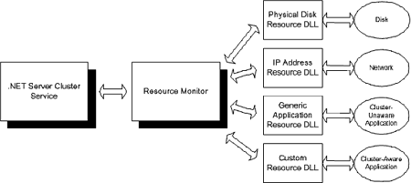

What is a Quorum?
What is a quorum? To put it simply, a quorum is the cluster’s configuration database. The database resides in a file named \MSCS\quolog.log. The quorum is sometimes also referred to as the quorum log.
Although the quorum is just a configuration database, it has two very important jobs. First of all, it tells the cluster which node should be active. Think about it for a minute. In order for a cluster to work, all of the nodes have to function in a way that allows the virtual server to function in the desired manner. In order for this to happen, each node must have a crystal clear understanding of its role within the cluster. This is where the quorum comes into play. The quorum tells the cluster which node is currently active and which node or nodes are in standby.
It is extremely important for nodes to conform to the status defined by the quorum. It is so important in fact, that Microsoft has designed the clustering service so that if a node cannot read the quorum, that node will not be brought online as a part of the cluster.
The other thing that the quorum does is to intervene when communications fail between nodes. Normally, each node within a cluster can communicate with every other node in the cluster over a dedicated network connection. If this network connection were to fail though, the cluster would be split into two pieces, each containing one or more functional nodes that cannot communicate with the nodes that exist on the other side of the communications failure.
When this type of communications failure occurs, the cluster is said to have been partitioned. The problem is that both partitions have the same goal; to keep the application running. The application can’t be run on multiple servers simultaneously though, so there must be a way of determining which partition gets to run the application. This is where the quorum comes in. The partition that “owns” the quorum is allowed to continue running the application. The other partition is removed from the cluster.

Types of Quorums
So far in this article, I have been describing a quorum type known as a standard quorum. The main idea behind a standard quorum is that it is a configuration database for the cluster and is stored on a shared hard disk, accessible to all of the cluster’s nodes.
In Windows Server 2003, Microsoft introduced a new type of quorum called the Majority Node Set Quorum (MNS). The thing that really sets a MNS quorum apart from a standard quorum is the fact that each node has its own, locally stored copy of the quorum database.
Types:
- Quorum Disk
- Local Only Quorum
- MNS (Majority Node Set)
Windows 2008/2008 R2/2012 have different types of Quorums:
Cluster Aware Applications:
- SQL Server Database Services
- SQL Server Analysis Services
Cluster Unaware Applications:
- SQL Server Reporting Services
- Integration Services
- Notification Services
How Clustering Works
In a two-cluster node Active / Active setup, if any one of the nodes fail, then the another active node will take over the active resources of the failed instance. It is always preferred while creating two-node cluster that each node be connected to a shared disk array using either fiber channel or SCSI cables.
The shared data in the cluster must be stored on shared disks, otherwise, when a failover occurs; the node which is taking over in the cluster pack cannot access it. As we are already aware, clustering does not help protect data or the shared disk array that it is stored on. So it is very important that you select a shared disk array that is very reliable and includes fault tolerance.
Both nodes of the cluster are also connected to each other via a private network. This private network is used for each node to keep track of the status of the other node. For example, if one of the node experiences a hardware failure, the other node will detect this and will automatically initiate a failover.
When clients initiate a connection, how will they know what to do when a failover occurs? This is the most intelligent part of Microsoft Cluster Services. When a user establishes a connection with SQL Server, it is through SQL Server’s own virtual name and virtual TCP/IP address. This name and address are shared by both of the servers in the cluster. In other words, both nodes can be defined as preferred owners of this virtual name and TCP/IP address.
Usually, a client will connect to the SQL Server cluster using the virtual name used by the cluster. And as far as a client is concerned, there is only one physical SQL Server, not two. Assuming that the X node of the SQL Server cluster is the node running SQL Server ‘A’ in an Active/Active cluster design, then the X node will respond to the client’s requests. But if the X node fails, and failover to the next node Y occurs, the cluster will still retain the same SQL Server virtual name and TCP/IP address ‘A’, although now a new physical server will be responding to client’s requests.
During the failover period, which can last up to several minutes, clients will be unable to access SQL Server, so there is a small amount of downtime when failover occurs. The exact amount of time depends on the number and sizes of the databases on SQL Server, and how active they are.

http://msdn.microsoft.com/en-us/library/ms952401.aspx#wns-introclustermscs_topic1
http://www.good.com/documentation5/Exchange_Admin_Guide/Good%20Messaging%205.0%20Admin%20for%20Exchange-10-02.html

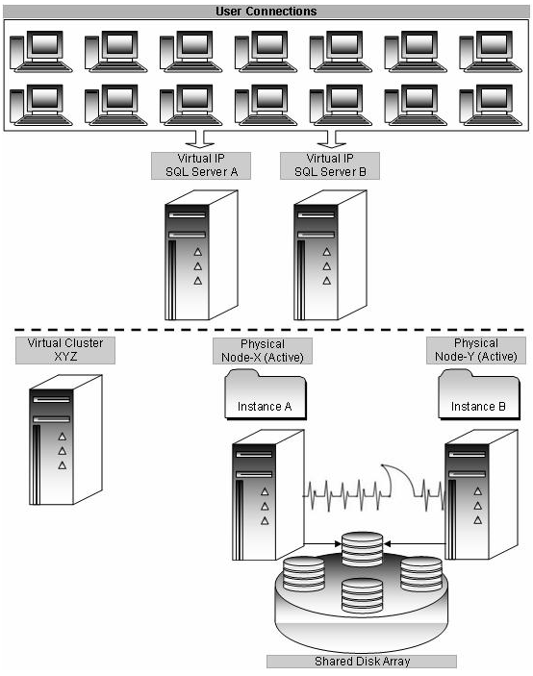

Clustering Terms
Cluster Nodes
A cluster node is a server within a cluster group. A cluster node can be Active or it can be Passive as per SQL Server Instance installation.
Heartbeat
The heartbeat is a checkup mechanism arranged between two nodes using a private network set up to see whether a node is up and running. This occurs at regular intervals known as time slices. A failover is initiated, if heartbeat is not functioning, and another node in the cluster will take over the active resources.
Private Network
The Private Network is available among cluster nodes only. Every node will have a Private Network IP address, which can be ping from one node to another. This is to check the heartbeat between two nodes.
Public Network
The Public Network is available for external connections. Every node will have a Public Network IP address, which can be connected from any client within the network.
Shared Cluster Disk Array
A shared disk array is a collection of storage disks that is being accessed by the cluster. This could be SAN or SCSI RAIDs. Windows Clustering supports shared nothing disk arrays. Any one node can own a disk resource at any given time. All other nodes will not be allowed to access it until they own the resource (Ownership change occurs during failover). This protects the data from being overwritten when two computers have access to the same drives concurrently.
Quorum Drive
This is a logical drive assigned on the shared disk array specifically for Windows Clustering. Clustering services write constantly on this drive about the state of the cluster. Corruption or failure of this drive can fail the entire cluster setup.

Cluster Name
This name refers to Virtual Cluster Name, not the physical node names or the Virtual SQL Server names. It is assigned to the cluster as a whole.
Cluster IP Address
This IP address refers to the address which all external connections use to reach to the active cluster node.
Cluster Administrator Account
This account must be configured at the domain level, with administrator privileges on all nodes within the cluster group. This account is used to administer the failover cluster.
Cluster Resource Types
This includes any services, software, or hardware that can be configured within a cluster. Ex: DHCP, File Share, Generic Application, Generic Service, Internet Protocol, Network Name, Physical Disk, Print Spooler, and WINS.
Cluster Group
Conceptually, a cluster group is a collection of logically grouped cluster resources. It may contain cluster-aware application services, such as SQL Server 2000.
SQL Server Network Name (Virtual Name)
This is the SQL Server Instance name that all client applications will use to connect to the SQL Server.
SQL Server IP Address (Virtual IP Address)
This refers to the TCP/IP address that all client applications will use to connect to SQL Server; the Virtual Server IP address.
SQL Server 2000 Full-text
Each SQL Virtual Server has one full-text resource.
Microsoft Distributed Transaction Coordinator (MS DTC)
Certain SQL Server Components require MS DTC to be up and running. MS DTC is shared for all named / default instances in cluster group.
SQL Server Virtual Server Administrator Account
This is the SQL Server service account, and it must follow all the rules that apply to SQL Service user accounts in a non-clustered environment.

How to Cluster Windows Server 2003

Before Installing Windows 2003 Clustering
Before you install Windows 2003 clustering, we need to perform a series of important preparation steps. This is especially important if you didn't build the cluster nodes, as you want to ensure everything is working correctly before you begin the actual cluster installation. Once they are complete, then you can install Windows 2003 clustering. Here are the steps you must take:
- Double check to ensure that all the nodes are working properly and are configured identically (hardware, software, drivers, etc.).
- Check to see that each node can see the data and Quorum drives on the shared array or SAN. Remember, only one node can be on at a time until Windows 2003 clustering is installed.
- Verify that none of the nodes has been configured as a Domain Controller.
- Check to verify that all drives are NTFS and are not compressed.
- Ensure that the public and private networks are properly installed and configured.
- Ping each node in the public and private networks to ensure that you have good network connections. Also ping the Domain Controller and DNS server to verify that they are available.
- Verify that you have disabled NetBIOS for all private network cards.
- Verify that there are no network shares on any of the shared drives.
- If you intend to use SQL Server encryption, install the server certificate with the fully qualified DNS name of the virtual server on all nodes in the cluster.
- Check all of the error logs to ensure there are no nasty surprises. If there are, resolve them before proceeding with the cluster installation.
- Add the SQL Server and Clustering service accounts to the Local Administrators group of all the nodes in the cluster.
- Check to verify that no antivirus software has been installed on the nodes. Antivirus software can reduce the availability of clusters and must not be installed on them. If you want to check for possible viruses on a cluster, you can always install the software on a non-node and then run scans on the cluster nodes remotely.
- Check to verify that the Windows Cryptographic Service Provider is enabled on each of the nodes.
- Check to verify that the Windows Task Scheduler service is running on each of the nodes.
- If you intend to run SQL Server 2005 Reporting Services, you must then install IIS 6.0 and ASP .NET 2.0 on each node of the cluster.
These are a lot of things you must check, but each of these is important. If skipped, any one of these steps could prevent your cluster from installing or working properly.

How to Install Windows Server 2003 Clustering
Now that all of your physical nodes and shared array or SAN is ready, you are now ready to install Windows 2003 clustering. In this section, we take a look at the process, from beginning to end.
To begin, you must start the Microsoft Windows 2003 Clustering Wizard from one of the nodes. While it doesn't make any difference to the software which physical node is used to begin the installation, I generally select one of the physical nodes to be my primary (active) node, and start working there. This way, I won't potentially get confused when installing the software.
If you are using a SCSI shared array, and for many SAN shared arrays, you will want to make sure that the second physical node of your cluster is turned off when you install cluster services on the first physical node. This is because Windows 2003 doesn't know how to deal with a shared disk until cluster services is installed. Once you have installed cluster services on the first physical node, you can turn on the second physical node, boot it, and then proceed with installing cluster services on the second node.
ew in Windows Server 2003
These are some of the improvements Windows Server 2003 has made in clustering:
- Larger clusters:The Enterprise Edition now supports up to 8-node clusters. Previous editions only supported 2-node clusters. The Datacenter Edition supports 8-node clusters as well. In Windows 2000, it supported only 4-node clusters.
- 64-bit support: This feature allows clustering to take advantage of the 64-bit version of Windows Server 2003, which is especially important to being able to optimize SQL Server 2000 Enterprise Edition.
- High availability: With this update to the clustering service, the Terminal Server directory service can now be configured for failover.
- Cluster Installation Wizard: A completely redesigned wizard allows you to join and add nodes to the cluster. It also provides additional troubleshooting by allowing you to view logs and details if things go wrong. It can save you some trips to the Add/Remove Programs applet.
- MSDTC configuration: You can now configure MSDTC once and it is replicated to all nodes. You no longer have to run the comclust.exe utility on each node.

1) Installing SQL Server SP on a cluster both SQL 2005 and 2012

When applying Service Pack on a cluster follow Rolling upgrade. In SQL Server 2005 if patch is applied entire instance will face downtime as resource database and all binaries are patched at same time and there is only one resource database in shared disk.

Whereas in SQL Server 2008 onwards, each node has its own resource database and hence patching can be split between the nodes. We can first patch Passive node and then restart the server (during this time business will run from Active Node) and perform Failover and patch the previously active node (Now business will run from New Active Node).

2) Configuring Backups on a cluster?

Backups on a cluster are to be taken to a dedicated SAN Shared Clustered Disk which is a part of the Clustered Group. SQL Backups on cluster cannot happen to a local drive and hence a clustered disk is good configuration setting considering a risk of failover.

Jobs can be created and configured to Shared Disk, so that if even if failover occurs the jobs will re-run as per schedule and continue to use the shared disk.

3) How many IPs are required for a Cluster?

This question can be answered only when we know the number of nodes.

Assume number of nodes is n value then 2(n)+3
n = number of nodes
the three additional IPs are
1) Windows Virtual IP
2) SQL Virtual IP
3) MSDTC IP

4) Multiple Instance cluster (Active-Active)

If there are multiple instances on a cluster to utilize Node hardware resources optimally then that configuration is called Active-Active or Multi-Instance cluster.

5) Adding a Disk on a cluster

Adding a disk is a multi step process.

1) First Add disk to the Cluster Administrator as Clustered Disk.
2) After adding cluster disk, make sure that Clustered Disk is added to SQL Server Cluster Group.
3) After Adding to SQL Server Cluster Group, set Dependency to SQL Server Main Service with the newly added clustered disk.
4) Verify in sys.dm_io_shared_disks DMV in the SQL Server instance if the newly added drive is visible.

7) What are dependencies in a cluster? What is Dependency Report?

Dependencies are important for Cluster functionality.

SQL Server Agent ->AND->SQL Server Main Service -> AND -> All Disks + SQL Server Name

SQL Server Name -> AND -> SQL Server Virtual IP

As a thumb rule all dependencies mostly in SQL Server clustered instances will ideally be AND dependency (except in the case of Multi-Subnet Failover Clusters)

8)Possible Owners and Preferred Owners

Possible Owners:-

It is the list of all the nodes that are configured for a clustered instance. If a failover occurs the choice of failover WILL/MUST be from one of the members from this list. If a node is not a possible owner then failedover instance will not come online on that node. If no possible owner nodes are up, then the group will still failover to a node that’s not a possible owner, but it will not come online.

Preferred Owners:-

Preferred owners are the nodes we would like to have it on under ideal conditions, but maybe not the only one it can be on. For example, Node 1 and 3 are "Preferred" owners, and nodes 1,2 and 3 are Possible owners, then if the service is on node 1 and node 1 fails, then the service will move to Node 3 and only go to Node 2 if both 1 and 3 are not available.

10) Clustering Commands?

cluster /list
cluster node /status
cluster group /status
cluster network /status
cluster netinterface /status
cluster resource /status
cluster group "SQL Server (SQLSEENU143)" /move:Node2

11) How to read Quorum log?

Cluster log can be read from C:\Windows\Cluster\Reports\Cluster.log file from each node.

Reading from Quorum Drive is not recommended as Local Admin we would not have admin rights on the MSCS Cluster directory in Quorum Drive.

cluster log /gen
Generates recent cluster.log on Node1 and Node2.

12) Cluster Checks? IsAlive and LookAlive?

LookAlive check (called as Basic resource health check) verifies that SQL Server is running on the current node. By default it checks every 5 seconds. If LookAlive check fails Windows Cluster performs IsAlive check.

IsAlive check (called as Thorough resource health check) runs every 60 seconds and verifies instance is up and running or not using the command in Resource DLL called SELECT @@SERVERNAME every 60 seconds. If this query fails, the check runs additional retry logic to avoid stress-related failures.

sp_server_diagnostics

13) How to failover SQL Server cluster using a command?

cluster group "SQL Server (SQL2K12)" /move:Node22

14) Splitbrain situation

A split-brain scenario happens when all the network communication links between two or more cluster nodes fail. In these cases, the cluster may be split into two or more partitions that cannot communicate with each other.

HA clusters usually use a heartbeat private network connection which is used to monitor the health and status of each node in the cluster. If heartbeat communication fails for any network reason, split-brain situation occurs (Partitioning). Every node thinks that other node is down and there is a risk of starting services. So to avoid this risk, Quorum updates the nodes about well being of other nodes. Quorum acts as a point of communication till Private network is up and running.

The node that owns the quorum resource puts a reservation on the device every three seconds; this guarantees that the second node cannot write to the quorum resource. When the second node determines that it cannot communicate with the quorum-owning node and wants to grab the quorum, it first puts a reset on the bus.

The reset breaks the reservation, waits for about 10 seconds to give the first node time to renew its reservation at least twice, and then tries to put a reservation on the quorum for the second node. If the second node's reservation succeeds, it means that the first node failed to renew the reservation. And the only reason for the failure to renew is because the node is dead. At this point, the second node can take over the quorum resource and restart all the resources.

15) What is the significance of MSDTC? Can we configure Multiple MSDTC's.

MSDTC is used for distributed transactions between clustered SQL Server instances and any other remote data source. If we need to enlist a query on a clustered instance in a distributed transaction we need MSDTC running on the cluster as a clustered resource. It can run on any node in your cluster - We usually have it running on the passive node.

1) Before installing SQL Server on a failover cluster, Microsoft strongly recommends that you install and configure Microsoft Distributed Transaction Coordinator (MS DTC)

2) SQL Server requires MS DTC in the cluster for distributed queries and two-phase commit transactions, as well as for some replication functionality.

3) Microsoft only supports running MSDTC on cluster nodes as a clustered resource. We do not recommend or support running MSDTC in stand-alone mode on a cluster. Using MSDTC as a non-clustered resource on a Windows cluster is problematic and it can cause data corruption if a cluster failover occurs.

4) To help ensure availability between multiple clustered applications, Microsoft highly recommends that the MS DTC have its own resource group and resources.

16) Why is SQL Server Service Manual on a cluster?

Whenever node restarts each node should not attempt to start SQL Server. Hence by design in SQL Server clustering the services are configured as manual.

17) What to do if Quorum fails? (Windows Task)

Quorum crash/failure is more of disk corruption that would have occurred crashing the Quorum. Ideally we have windows team addressing this issue through Monitoring implementation.

18) Intro to Mirror/Log Shipping on Cluster?

19) Service SID?

It is a mechanism that assigns privileges to the service itself, rather than to the account under which the service runs.

Service SIDs managed to improve our security because they enable you to use the user Service Account with the least privileges required.

20) How to cluster troubleshooting?

1) Refer Cluster Administrator (cluadmin.msc) and check Cluster Events.
2) Issues can be Disk Related, Network Related, Service Related (SQL Server), Cluster Related.
3) As per the issue contact the respective team.
4) If SQL Server is the issue, Check Event Viewer on why Service went down.
i) Check Event Viewer
ii) Check SQL Server Error Log
iii) Verify for any errors and troubleshoot as per issue.

5) Additional sources of troubleshooting.

C:\Windows\Cluster\Report\cluster.log file will help in identifying underlying issue in the cluster in the specific node. Cluster log would be present on both the nodes.

http://www.sql-server-performance.com/articles/clustering/cluster_infrastructure_p1.aspx

http://www.sql-server-performance.com/articles/clustering/clustering_best_practices_p1.aspx

http://www.sql-server-performance.com/articles/clustering/cluster_sql_server_2005_p1.aspx

Cluster Aware Applications:
SQL Server Database Services
SQL Server Analysis Services

Cluster Unaware Applications:
SQL Server Reporting Services
Integration Services
Notification Service:

Instance Aware Services:
SQL Server Main Service
SQL Server Agent Service
SQL Server Full Text Search

Instance UnAware Services:
Browser Service
VSS Writer
SQL Server AD Helper
Prerequisites for Configuring SQL Server Prerequisites of Cluster:-

1) SQL Server Media on both nodes
2) Create three Global Groups (Domain Groups) Optional
3) Create service accounts
4) SQL Server Virtual IP (Ask Network Team)
5) SQL Server Virtual Name
6) S: drive for Data/Log files as Shared iSCSI drives
7) Components that are cluster aware are Database Services and Analysis Services
8) Configure MSDTC as a Cluster Resource
9) Add Disk Dependency in SQL Server group to the SQLData drives.
10) Hardware check on both nodes (equal)
11) Validate Windows Cluster

Sequence of Cluster Resources during Failover:

Stopping Order
1) SQL Server Agent Service
2) SQL Server Main Service
3) SQL Server IP
4) SQL Server Name
5) All Disk(s)

Starting Order
1) All Disks
2) SQL Server IP
3) SQL Server Name
4) SQL Server Main Service
5) SQL Server Agent Service

Scenarios in Cluster:

1) Applying SP in SQL Server 2005 cluster (v)

2) Adding a disk to the cluster for SQL Server (v)

5) Failovers and Failbacks. (v)

4) Adding/Deleting a Node in a cluster.

6) Preferred Owner and Possible owners. (v)

7) Look Alive and IsAlive. (v)

8) Changing the Virtual IP for the SQL Server cluster. (V)

9) Master corruption in SQL Server cluster.

10) IP Addresses needed for Two Cluster configuration.

If it is a two node cluster --→ 2(N)+3 => 2(2)+3=7 IP’S

1 Public, 1 Private at Node1
1 Public, 1 Private at Node2
1 IP for Windows Cluster
1 Virtual IP for SQL Cluster
1 IP for MSDTC
1 IP for Quorum
1 IP for Backups (iff third party backup solutions are used)

Adding a new disk to the cluster:

1) Contact Storage team checking for possibility of Extending the disk or Adding a new disk. Extending disk sometimes involves downtime, so it depends on customer providing downtime.

2) Once the disk is either extended/added. Ensure Windows team makes the disk as a Clustered Disk.

Cluadmin.msc->Storage->Add Disk

3) Add the disk as a resource under SQL Server Cluster Group.

Cluadmin.msc->SQLServer Cluster Group-> Add Storage-> Add the new clustered disk.

4) Set Disk Dependency.

Cluadmin.msc->SQLServer Cluster Group->Right click on SQL Server Main Service->Properties->Dependencies->Insert->AND (Disk Number).

Single Instance:

Active/Passive clustering means having instances running in the cluster as Active on one Node and second node is always Passive to take over responsibilities when First node crashes.

The terminology has been changed to Single Instance Cluster to avoid confusion.

Multiple Instance:

Active/Active clustering simply means having two separate instances running in the cluster—one (or more) per machine.

The terminology has been changed to Multi-Instance Cluster.

MSDTC:-
MSDTC is an acronym for Microsoft Distributed Transaction Coordinator.

The Microsoft Distributed Transaction Coordinator service (MSDTC) tracks all parts of the transactions process, even over multiple resource managers on multiple computers.

This helps ensure that the transaction is committed, if every part of the transaction succeeds, or is rolled back, if any part of the transaction process fails.

Do we need MSDTC? Is it Compulsary?

SQL 2005 does require MSDTC for setup, since it uses a transactions to control setup on multiple nodes. However, SQL Server 2008/2008R2/2012 and SQL 2014 setup does NOT require MSDTC to install SQL.

N+1:-
Having one passive dedicated for failovers.

Assume 3 Node cluster, 2 Nodes are Active and 1 Node is allocated to be Passive.

N+M:-
Having multiple passives dedicated for failovers.

Assume 5 Node cluster, 3 Nodes are Active and 2 Nodes are allocated to be Passive.

Geo Cluster:-
Geo-cluster is a cluster between two different subnets or a group of subnets. These subnets may be present at same place or at different geographies.

Ideally Geo clustering involves when performing clustering between different data centers.

Maximum number of instances on a clustered instance is 25. 50 instances are possible if we choose SMB file shares.

Reason behind 25 instances on a cluster is due to Shared Disk Drive Letter Availability.

Number of Nodes on a Cluster:-

Windows 2003 - 8 Nodes
Windows 2008/2008R2 - 16 Nodes
Windows 2012/2012R2 - 64 Nodes

Quorum:
1) Quorum stores cluster configurations. Also called as cluster config database
2) Quorum contains information of active owner
3) Quorum helps in communications during heartbeat breakdown.

Types of Quorums:

1) Node Majority quorum mode -
This model requires an odd number of nodes. (Example 3).

Then the cluster can survive till 1 node failure. Where majority of votes are available to keep the cluster alive.

-- Lets say we are starting our cluster using N nodes than , at any point of time , we must have atleast (N + 1)/2 no of nodes alive\working. means this cluster can sustain upto (N-1)/2 node failures.
example - (N + 1)/2
If N = 11 than ( 11 + 1)/2 =6
then at any point of time It needs atleast\minimum 6 working nodes

2) Node and Disk Majority quorum mode -
This model is combination of Node and Quorum disk and it is used when there are even number of nodes.

This Quorum Model can be used for clusters where the nodes are all in the one data center. An extra vote gets added in the form of Disk. So that the risk of failure can be reduced.

If there are 4 nodes, an extra node gets added to make cluster survive till 2 failures.

-- Lets say we are starting our cluster using N nodes than , at any point of time , we must have atleast (N+1 + 1)/2 no of nodes alive\working. means this cluster can sustain upto (N+1 - 1)/2 node failures.
example - (N+1 + 1)/2
If N = 10 than ( 10+1 + 1)/2 =6
then at any point of time It needs atleast\minimum 6 working nodes including disk vote , that is 5 working nodes + disk vote.

4)Node and File Share Majority quorum mode –

This model is combination of Node and File Share Application majority.

An extra vote gets added in form of File Share Application so that the risk of failure can be reduced.

4)No Majority: Disk Only quorum mode –

Traditional Windows 2003 Quorum Disk Model. Recommend to discontinue use of this Model

Only Disk contains the Quorum and there is high risk of failure of cluster if Quorum crashes.

AlwaysON:

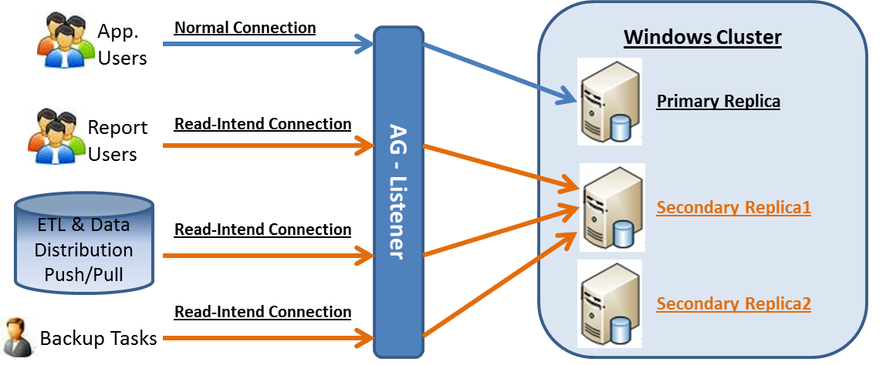

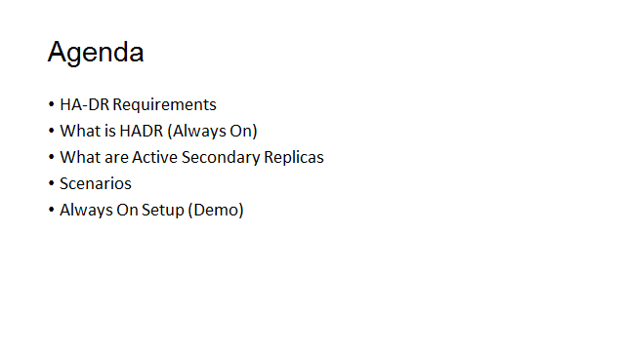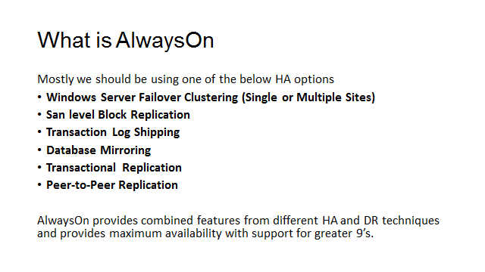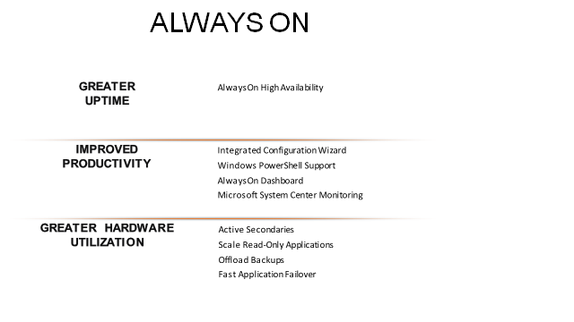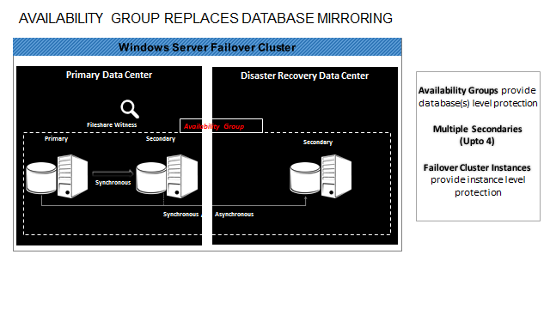

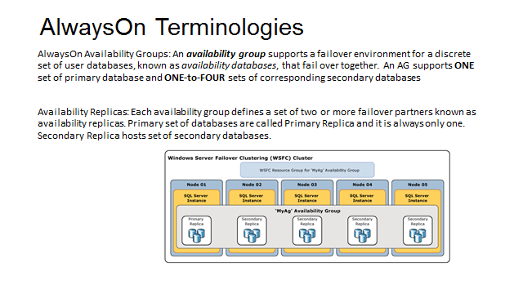

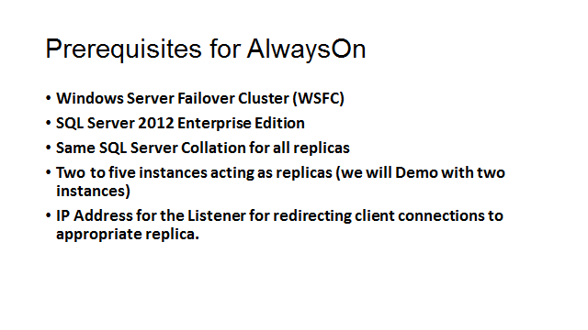

SQL Server Denali - AlwaysON (HADR): Step-by-Setup setup guide
Balmukund
As you might be aware that SQL Server Code-Named “Denali” has introduced a new feature called Always ON for enhancing the availability of user database in an enterprise environment. In simple terms, AlwaysON is a high-availability and disaster recovery solution, which will enable you maximize availability of your critical user databases by use of “availability groups”
WARNING: The blog-post is based on pre-release software so things could change. For more details on CTP, please refer SQL Server Code-Named "Denali" CTP1 Release Notes
So what are “Availability Groups”?
Availability groups are set of failover partners (a.k.a availability replicas) to provide high availability to user database in Denali. Sure, this is lot more in depth and I suggest reading DenaliBooks-on-line for details.
In this blog post, I will guide you on how to configure AlwaysON – STEP-BY-STEP? Lets get going then !

Step 1. Windows OS and Cluster Configuration
a. For the purpose of testing, I have created a Windows 2008R2 two NODE cluster on virtual machine using Hyper-V and a Domain Controller
Machine configurations:
Machine Name | Role | OS | IP Address
INDNUKE- BANGALOREDC | Domain Controller | Windows 2008R2 | 192.168.1.1
INDNUKE- DELHI | Cluster Node 1 | Windows 2008R2 | 192.168.1.2 Public  X.X.10.1  Heartbeat
INDNUKE-MUMBAI | Cluster Node 2 | Windows 2008R2 | 192.168.1.3 Public  X.X.10.2  Heartbeat
If in case you need step-by-step guide on setting up windows cluster using Hyper-V (Guest Clustering), please refer my team blog:
http://blogs.msdn.com/blakhani/archive/2010/04/01/how-to-install-clustered-sql-server-2008-on-windows-2008-cluster-using-hyper-v-guest-clustering-part-1.aspx
http://blogs.msdn.com/blakhani/archive/2010/04/28/how-to-install-clustered-sql-server-2008-on-windows-2008-cluster-using-hyper-v-guest-clustering-part-2.aspx
Step 2. Install “Standalone” Denali instance on both the nodes
Yes, you’ve heard it right. AlwaysON is NOT a clustered SQL Server Instance. As such a standalone SQL Server setup is required on both the clustered nodes.
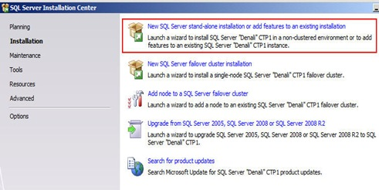
I’ve installed 2 DEFAULT instances on both the clustered nodes as below:
INDNUKE-DELHI\MSSQLSERVER
INDNUKE-MUMBAI\MSSQLSERVER
Step 3. Enable AlwaysON feature on both the instances
•Open SQL Server Configuration Manager
•Select SQL Server Services
•Right-click on your SQL Server, in my case SQL Server (MSSQLSERVER) and select Properties
•Select SQL HADR TAB and check "Enable SQL HADR service"
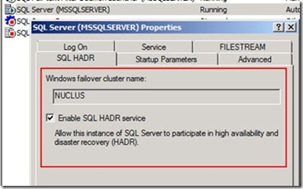
Note: SQL Server service needs to be re-started for changes to take affect
Step 4. Create a sample database on both SQL Server Instances
For this testing, I will be using AdventureWorks sample database
Step 5. Create Availability Group
•Choose any one instance to become PRIMARY (say INDNUKE-DELHI\MSSQLSERVER)
•Open SQL Server Management Studio on INDNUKE-DELHI\MSSQLSERVER
•Expand Management folder
•Right-click Availability Groups and select New Availability Group
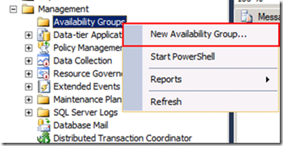
•Click Next on Introduction Screen
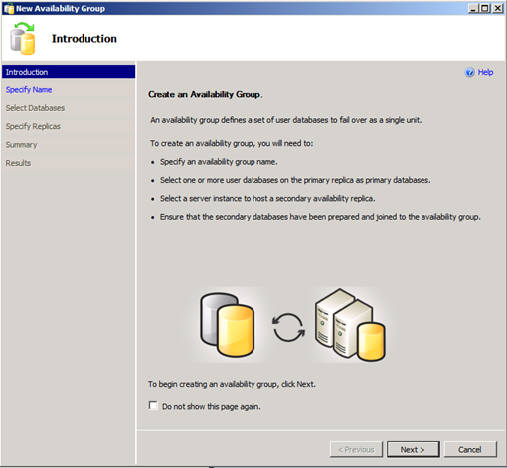
•Provide a name to Availability Group
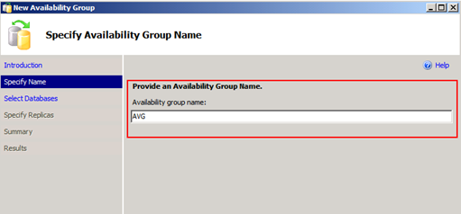
•Select the user database to be added to Availability Group
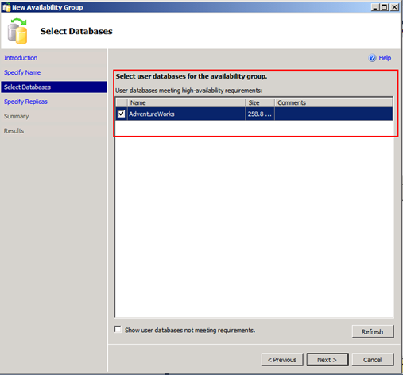
•Specify Replicas – Add the other instances (INDNUKE-MUMBAI\MSSQLSERVER) to assume the role of secondary of this user database
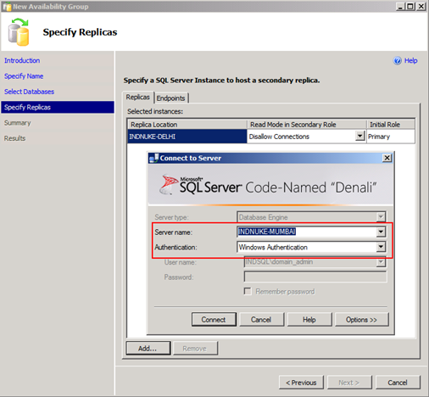
•Optionally, you can specify endpoint details (similar to database mirroring) or leave them default
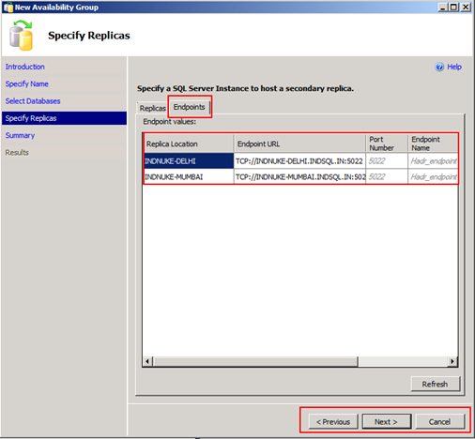
•Summary Screen
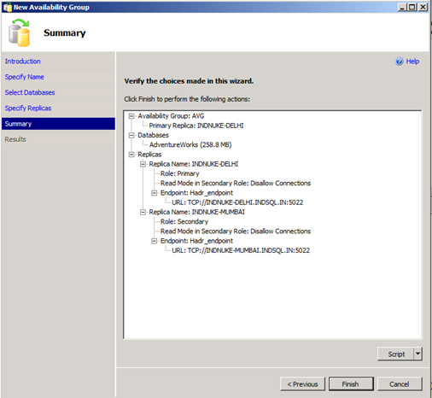
•Result Screen
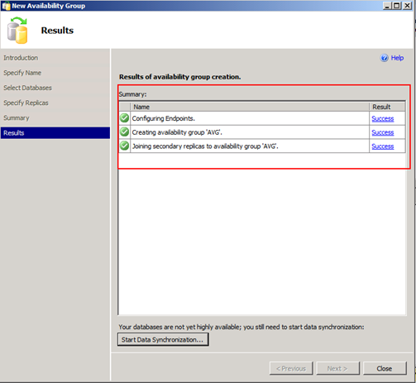
IMP: Once done, you will be able to see the Availability Group as a Cluster Resource in Windows Server Failover Cluster Manager
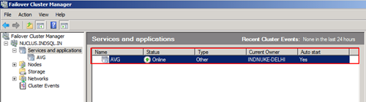
Step 6. Start Data Synchronization
•This step will allow you to synchronize your user PRIMARY and SECONDARY server by taking backup of user database and restoring this on secondary server

•Specify a shared location, where both SQL Server start-up accounts has read/write access and press OK
•Once synchronization completes, expand the tree and you will be able to see the Availability Replicas (along with current role ) and Availability Databases
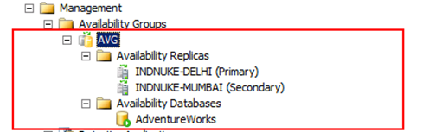

Step 7. Test the Availability Groups
•To understand how failover functions in AlwaysON, follow simple steps
1. Create a simple table (can use below script) on PRIMARY (INDNUKE-DELHI) and insert some rows (can use below script)
Use AdventureWorks
GO
CREATE TABLE [dbo].[New_Table](
[ID][int] NULL,
[NAME] [varchar](50) NULL
) ON [PRIMARY]
GO
INSERT INTO dbo.New_Table values (5001, 'NORTH')
GO
SELECT * from dbo.New_Table
GO
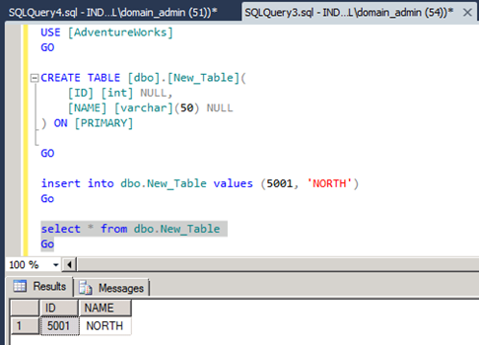
2. Then, connect to SECONDRY (INDNUKE-MUMBAI) and try selecting the rows. This will work!!
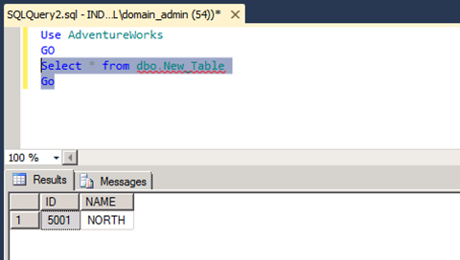
Step 8. Test the Failover
•To FAILOVER, follow below steps
Before FAILOVER
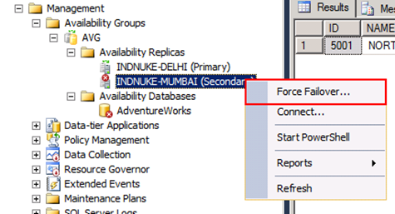
After FAILOVER – server roles will change

Conclusion,
AlwaysON by design looks similar to database mirroring, but is actually a combination of both databases mirroring and clustering. The goal is to maximize the database availability and also give benefits of disaster recovery. And we term this – AlwaysON!!!!

Interview Questions:

1)How many databases can be added to AG Group?

The actual number of databases and availability groups you can put on a computer (VM or physical) depends on the hardware and workload, but there is no enforced limit.

Microsoft has extensively tested with 10 AGs and 100 DBs per physical machine.

2) Can databases be added on the fly to existing AG?

Yes, we can add.

3) How many AG Groups can we create?

Technically No Limitation, but needs to be tested in a specific environment.

4) What is READ-Intent Only?

Whenever a query is to be routed to a dedicated node, we have to set read-intent at node level and at application level also.

5) What is Allow All Connections?

Accepting Connections from Application.

6) Can we set Automatic Failover Partner as Synchronous/Asynch?

No, if Automatic is configured it should be Synchronous.

7) Should name of databases be same?
Yes

8) How does Quorum work in AlwaysOn?

9) Adding a file to DB on AG Primary?

Yes Possible

10) How does backup get initiated in AG?

Database Backups: Full Backup With Copy_Only, Transaction Log Backups

Full backups of replicas must be copy_only backups. Also, differential backups cannot be performed against replicas.

11) Automatic Page Repair in AG?

Automatic page repair is supported by database mirroring and by AlwaysOn Availability Groups. After certain types of errors corrupt a page, making it unreadable, a database mirroring partner (principal or mirror) or an availability replica (primary or secondary) attempts to automatically recover the page. The partner/replica that cannot read the page requests a fresh copy of the page from its partner or from another replica. If this request succeeds, the unreadable page is replaced by the readable copy, and this usually resolves the error.

12) Can we configure AlwaysOn and Mirroring together on same database?
Need to Test

13) Maintenance Tasks on AG?

Database Backups: Full Backup With Copy_Only, Transaction Log Backups
DBCC CheckDB
Reporting
Database Snapshots

14) What is a Listener in AG?

An Availability Group Listener is a Virtual Server Name that applications connect to. From the applications point of view it does not matter where the Availability Database is active and available for use. The AAGL consists of:

Virtual Network Name (VNN)
Listener Port
One or more Virtual IP Addresses (VIPs)
For your application to connect, you can either set up a connection string for your AAGL or connect directly to your SQL Server Instance. However, a direct connection does not give the failover support which this technology has been built for.

15) How many Automatic Failovers and Synchronous modes are possible in 2014?

SQL 2012: Automatic Failovers are 2
Synchronous Mode are 3 (rest all are Asynch)

SQL 2014: Automatic Failovers are 2
Synchronous Mode are 3 (rest all are Aysnch)

16) How to do manual failover in AG?

Failover can be performed using
a) Cluster Administrator (cluadmin.msc) by performing failover of AG Service.

b) Through AlwaysOn Availability Group Failover option and by selecting which Secondary replica to convert as Primary replica.

c) Failover through Command. Failover command needs to be fired at Secondary Replica which has to be converted as Primary replica.
ALTER AVAILABILITY GROUP KDSSGAG FORCE_FAILOVER_ALLOW_DATA_LOSS;

ALTER AVAILABILITY GROUP KDSSGAG FAILOVER;

17) Can we create multiple listeners for AG?

Yes, it is possible. But SQL Server supports only 1 listener per AG.

Whereas additional listeners can be created from Cluster Administrator (or) Powershell.

Go to Cluadmin.msc -> Services -> AlwaysOn AG Service -> Add New Resource -> Client Access Point.

5) How to connect through Listener?

6) How to configure backups in AG configuration?

7) How to add a file to a ADB's which is participating in AG?

If file is added on Primary Replica and the path differs with Secondary Replica. AlwaysON would immediately break and the respective secondary replicas would move to Non Synchronized state (SUSPECT).

1) Take a log backup of the Primary Replica to a network shared path to restore on the secondary replica.

2) Break the database that has the issue from the AlwaysON AG.
ALTER DATABASE [DBNAME] SET HADR OFF

If SET HADR OFF doesn't work, remove secondary replica from AlwaysON.

3) Restore the backup performed on Secondary replica WITH MOVE option.

restore log [DBName] from disk=N'\\20.20.20.1\KDSSG\DBName.trn'
WITH MOVE 'DBName_2' to 'C:\Program Files\Microsoft SQL Server\MSSQL11.MSSQLSERVER\MSSQL\Data\DBName_2.ndf',
NORECOVERY

4) If log backup doesnt get restored, attempt a FULL Backup (or) in some cases File and Filegroup backup if only a new file/filegroup is added.

5) Add the secondary database back to the AlwaysON AG.

7) How to change Modes(Synchronous/Asynchronous) using command?

10) How to apply SP on a instance which is participating in AlwaysOn?

1.What is AlwaysON?
2.How to configure AlwaysON?
3.How many replicas are possible in AlwaysON SQL 2012, 2014 and 2016?
4.How many Synchronous modes are possible?
5.How many automatic failovers are possible?
6.What is dependency between AlwaysON and Clustering?
7.What is listener?
8.What is read intent only option in AlwaysON?
9.How to configure backups in AlwaysON?
10.Can we create multiple listeners in AlwaysON? and how?
11.How to connect through listener?
12.AllowAllConnections?
13.What are important monitoring parameters in AlwaysON dashboard?
14.What are the prerequisites of AlwaysON?
15.How to failover in AlwaysON AG?

System tables of AlwaysOn:

select * from sys.availability_groups
select * from sys.dm_hadr_cluster
select * from sys.dm_hadr_cluster_members
select * from sys.dm_hadr_availability_group_states
select * from sys.dm_hadr_auto_page_repair

select * from sys.dm_hadr_cluster_networks
select * from sys.availability_groups_cluster

select * from sys.availability_replicas
select * from sys.dm_hadr_availability_replica_cluster_nodes
select * from sys.dm_hadr_availability_replica_cluster_states
select * from sys.dm_hadr_availability_replica_states
select * from sys.dm_hadr_database_replica_states
select * from sys.dm_hadr_database_replica_cluster_states
select * from sys.availability_group_listener_ip_addresses
select * from sys.availability_group_listeners
select * from sys.dm_tcp_listener_states

Performance Tunning:

100% cpu:

If CPU Utilization is 100%, then identify
1) If SQL Server is consuming CPU or some other process.

2) If SQL Server is not consuming then assign the incident to Windows team to investigate.

3) If SQL Server is consuming 100% CPU then

Monitor % Processor Time (_Total) to confirm the utilization of all processors is high or less.

Investigating High Processor Utilization:
High processor utilization is to break it down into Processor(_Total)\% Privileged Time and Processor(_Total)\% User Time

If kernel mode utilization is high, your machine is likely underpowered as it's too busy handling basic OS housekeeping functions to be able to effectively run other applications. And if user mode utilization is high, it may be you have your server running too many specific roles and you should either beef hardware up by adding another processor or migrate an application or role to another box.

System\Processor Queue Length counter gives an indication of how many threads are waiting for execution.

If multiple instances are present in the server, check which instance is busy with Processor in Task Manager and identify instance using PID in Configuration Manager.

4) Verify the session count to SQL Server instance.

select count(*) from sys.dm_exec_sessions

Validate with the benchmark value and find the load on the system.

5) Verify if any blockings are there in SQL Server instance.

6) If blockings are not identified, then identify the session which are causing blocking.

7) Identify long running queries and inform application team about the longest and oldest transactions which are taking maximum CPU utilization.

select * from sys.dm_exec_requests order by cpu desc

8) After identifying long running queries find out why they are waiting (WAIT TYPE)

a) AYNC_NETWORK_IO: Cause of this wait type is RBAR (Row-By-Agonizing-Row) processing of results in a client, instead of caching the results client-side and telling SQL Server to send more.

b) CXPACKET: This wait type is connected with parallelism, as the control thread in a parallel operation waits until all threads have completed. However, when parallel threads are given unbalanced amounts of work to do, the threads that finish early also create this wait type.

As a solution we can set MAXDOP (Max Degree of Parallelism) parameter for queries which are having this wait type.

c) LCK_M_S / LCK_M_X / LCK_M_IX:- These are lock wait types. Identify the object which is locking and ideally the wait type is due to locks held on objects.

d)PAGELATCH_EX: This wait type is caused by tempdb allocation bitmap contention (from lots of concurrent threads creating and dropping temp tables combined with a small number of tempdb files and not having TF1118 enabled). This is TEMPDB contention and we can enable traceflag -T1118 as a solution.

e) PAGEIOLATCH_SH: This wait type occurs when a thread is waiting for a data file page to be read into memory. Common causes of this wait being the most prevalent are when the data doesn’t fit in memory and the buffer pool has to keep evicting pages and reading others in from disk.

f) SOS_YIELD_SCHEDULER: This wait can indicate mostly high CPU usage. It is possible that server must be under CPU pressure, or that a spinlock is the problem.
Thread exhausting its scheduling quantum and heavily recurring instances can lead to SOS_SCHEDULER_YIELD.

Important Perfmon Counters:

Processor Related:
%Processor Time:
The simplest measure of a system's busyness is Processor(_Total)\% Processor Time, which measures the total utilization of your processor by all running processes.

Note that if you have a multiprocessor machine, Processor(_Total)\% Processor Time actually measures the average processor utilization of your machine (i.e. utilization averaged over all processors).

%Privileged Time, %User Time

Memory Related:
Memory\Available Bytes, and if this counter is greater than 10% of the actual RAM in your machine then you probably have more than enough RAM and don't need to worry.

Disk Related:
Physical Disk (instance)\Disk Transfers/sec counter for each physical disk and if it goes above 25 disk I/Os per second then you've got poor response time for your disk.

Avg Disk Sec/Read- Look for <8Msec or less as optimal.
Avg Disk Sec/Write - Look for <8Msec(Non Cached) <1Msec(Cached)
Average Disk Queue Length can vary based on the activities (Typically 30 is a red flag)

Note: PerfMon is far less useful against a SAN. Check the vendor for monitoring disk performance tools specific to SAN.

PLE: Page Life Expectancy
The time in seconds the page stays in memory pool without being referenced before it is flush. should be >= 300. A lower or declining value may indicate memory pressure.

SQL Compiles/sec & Recompiles/sec
<2/sec negligible, 2-20/sec could be investigated, 20-100 poor, >100 potentially serious, I would really like a means of assessing the cost of compiles, as simple statement compile cost is low, a complex query could take 1min to compile.

Page Splits/Sec
Occurs when a 8KB page fills and must be split into two new 8K pages.

Buffer Cache Hit Ratio:
Indicates how often SQL Server can get data from the buffer rather than disk (since the last restart of instance).
>90% for OLAP, >95% for OLTP system

Lazy Writes/Sec
The number of times per second that lazy writer moves dirty pages from buffer to disk to free buffer space.
<20

Page Reads/Sec and Page Writes/Sec
Number of physical database page reads and writes issued respectively
<90

Troubleshooting 100% Memory / Memory Leak(s):

1) Verify Task Manager for basic understanding of Memory utilization by which Process.

2) If memory is consumed by other processes contact respective team to get it fixed.

3) If memory is consumed high by SQL Server follow below steps

a) Verify SQL Server Error logs for any memory related errors.

MTL Based Errors:
i) SQL Server 2000
WARNING: Failed to reserve contiguous memory of Size

ii) SQL Server 2005
Failed Virtual Allocate Bytes: FAIL_VIRTUAL_RESERVE

iii)SQL Server 2005
Failed to initialize the Common Language Runtime (CLR)

BPool Based Errors:
i) BPool::Map: no remappable address found.
ii) BufferPool out of memory condition
iii)LazyWriter: warning, no free buffers found.

BPool (or) MemToLeave errors:
i) Error: 17803 “Insufficient memory available..”
ii) Error: 701, Severity: 17, State: 123.
There is insufficient system memory to run this query.

b) If MTL is the reason for the Memory issue we have to determine whether it is SQL Server or some non-SQL component that is using the most MemToLeave memory

Query:
select sum(multi_pages_kb) from sys.dm_os_memory_clerks

In MTL if SQL Server Owned memory is very less ,then determine if there are COM objects, SQL Mail, or 3rd party extended stored procedures being used, and move them out of process if possible(or contact App Team).

c) If MTL is not the reason then we need to focus on BPool portion and who is occupying more in BPool.

To find out who is consuming more in BPool fire below query:
select * from sys.dm_os_memory_clerks order by Single_pages_kb desc

To calculate the BPool approximate usage size use below command:
select sum(single_pages_kb) from sys.dm_os_memory_clerks

Extra Counters to Monitor:-

Monitor PLE(Perfmon Counter):-
PLE is the expected time a read page from file is maintained in Buffer Pool.

Monitor BCHR(Perfmon Counter):-
Buffer Cache Hit Ratio is the utilization ratio of Buffer Pool towards I/O operation. Microsoft recommends >95% for OLTP and >90% for OLAP.

18456 Error:

Before troubleshooting 18456 failed Logins option should be enabled for tracking error in the SQL Server Error logs.

Review the error logs for 18456 and track the STATE of the error.

Error 18456, Severity 14, State X

X can vary from 1 to 56 (or even greater) value based on the error and situation.

Additionally checks:

1) Protocols are enabled or not on both Client and Server side.

2) Browser service is started or not.

3) Verify Remote Admin connections for the instance

4) Verify if Ports are enabled both on Client and Server.

5) Verify if firewall is enabled or not, if enabled set the Firewall Exception.

6) Telnet and identify Port is open or not.

7) Verify if machine ping is happenning or not.

8) Verify if Login has proper permissions to connect to the instance. Also if he is mapped to respective databases for performing operations.

9) If connect permissions are Denied and if Login is Disabled.

10) Verify if endpoints are started or not.

11) Verify if connection limit has reached. If reached then connect through DAC and accordingly increase the limit or free up sessions if approved.

select count(*) from sys.sysprocesses where spid>50
select count(*) from sys.dm_exec_connections

12) Verify if the login connecting is part of same domain or if the login belons to any untrusted domain.

13) A windows mapped login cannot connect to SQL Server, if the Windows User gets deleted (Orphan Login). Remapping the user with same SID is the solution.

14) SSPI Handshake Error.

Query Performing Slowly:

1) Identify the SPID of the query from Sys.sysprocesses

2) Find any blockings exists or not and if it exists find the LEAD Blocker.

3) Identify how many connections are there, Benchmark if exceeds is an issue.

4) CPU Utilization, Memory Utilization, System Memory Information and how much SQL Server is consuming. If AWE is enabled or not.

5) Any jobs are running both at OS level and SQL Server level.

6) Affinity Mask for Processor and IO should be checked.

7) Query observation, Coding standards have been followed or not. Commit issued at regular intervals in the code.

8) Table statistics are outdated. Need to update stats.

9) Indexes are created on correct columns are not. Verify the query and check the columns listed under WHERE condition and ensure that there are indexes created.

10) Even if indexes are created, they are fragmented or not.

11) Run server side trace to track what other activities are currently being rolled out to find the cause of the issue. If approved Profiler also can be used.

12) Network Latency between Client and the Server can cause performance issue.

13) MAXDOP feature can be utilized to improve the parallel execution of the query.

14) If clustered instance and Active-Active (N+1/N+M) Multiple Instance. If all nodes fail the last surviving node has all instances running on it causing performance issue.

Log Used > 95%:

1) Verify the space utilization of the log file

DBCC SQLPERF(logspace)

2) Verify the recovery model of the database.

3) Verify if Log File is awaiting any operation through.

select name,log_reuse_wait_desc from sys.databases

Verify the LOG_REUSE_WAIT_DESC and check the description of the WAIT. Multiple states are possible and respective action should be taken based on the state.

Reuse of transaction log space is currently waiting on one of the following:

0 = Nothing
1 = Checkpoint
2 = Log backup
3 = Active backup or restore
4 = Active transaction
5 = Database mirroring
6 = Replication
7 = Database snapshot creation
8 = Log Scan

4) If in FULL/Bulk Logged recovery model, take log backup of the database.
Once backup is complete, perform shrink operation to release the space back to OS.

5) Sometimes shrink doesn't completely clear the space in the log file. Then attempt taking log backup and performing shrink operation 2-3 times.

6) Identify what all transactions are running on the database.

select * from sys.sysprocesses where dbid=<int>

DBCC INPUTBUFFER(spid)

Find out what the transactions are doing and whether COMMIT has been issued or not. Whether Replication/DB Mirroring are enabled or not. Inform application team to issue COMMIT for the uncommitted transactions.

Stop Replication/DB Mirroring, On approval Kill the Sessions. Ask app team to commit.

7) If space is never a constraint, Add another log file from different drive which has ample space.

Check if space cleanup can be performed.

8) Change Recovery Model to Simple, then perform Shrink Operation.
If Log Shipping/Mirroring are enabled then disable them first and perform this operation.

Condition: After changing recovery model from Full to Simple and again to Full. Take a FULL Backup.

9) If SQL Server 2005, as last remedy we can try TRUNCATE_ONLY, this option has been removed from SQL Server 2008 onwards.

SQL Server 2005:
backup log [DatabaseName] to disk='C:\Backups\DBName.trn'
WITH TRUNCATE_ONLY

In SQL Server 2008 if we have to perform TRUNCATE operation on Log file, it is not possible directly but there is an undocumented command (DO NOT TRY THIS UNLESS IT IS CRITICAL SITUATION)

BACKUP LOG [DatabaseName] TO DISK = 'nul:' WITH STATS = 10

10) Planning of the log file space utilization and moving databases to new drive where space is available.

Also inform Application Team about transactions count to be short.

If simple recovery model, perform shrink operation.
10)
If shrink is unsuccesful then find the transactions that are holding the log file.

Never attempt to take a log backup in Simple Recovery Model. Adding a file is possible, if space is available.

Data File Full:

1) Find the space utilization
sp_spaceused

2) Find the drive space availability

xp_fixeddrives

3) Add a new data file to the database, if no space request your Windows team to add more space (or) perform cleanup operations. See if any other database log files have grown big which can be shrunk.

4) Export all the data out of the database, and perform truncation of all the tables. Then reimport all the data into the database. This clears fragmentation issues and might give space in the data file.

Negative Log File free space:

This behavior is by design
1) sp_updatestats
2) dbcc updateusage (0) with count_rows

This is an indication that Tlog is sized too small for normal operations and needs to be expanded.

What to do if Tempdb is FULL:

TEMPDB Data File Full:-
1) Try to add more space if possible from any other drive

2) Perform a shrink operation if possible

3)
If tempdb is full, rather than taking any action identify the cause of the increase in size

select * from sys.sysprocesses where dbid=2

kill spid

Approval MANDATORY.

4) Perform a truncate operation if possible (but highly not recommended method)

backup log Tempdb to disk=N'd:\Tempdb.trn' with TRUNCATE_ONLY

5) Drop clean buffers and DBCC FREEPROCCACHE can help in clearing the buffer so that some space can be created for processing transactions in Memory and pull pages from
TEMPDB to Buffer pool.

DBCC FREEPROC CACHE
DBCC DROPCLEANBUFFERS
DBCC FREESYSTEMCACHE

BE VERY CAUTIOUS WHEN FIRING THIS COMMAND.

6) Moving Tempdb files from one drive to another where there is ample space. This also requires restart of instance as the new files added will be in affect only after restarting the instance.

alter database Tempdb modify file(name='Tempdev',filename='Physical Path')

alter database Tempdb modify file(name='Templog',filename='Physical Path')

7) Restart the instance.

TEMPDB Log File Full:

1) Verify the size of log file currently
dbcc sqlperf(logspace)

2) Perform Shrink operation on the log file of tempdb for any free space.

3) Verify if Log File is awaiting any operation through

select name,log_reuse_wait_desc from sys.databases

Verify the LOG_REUSE_WAIT_DESC and check the description of the WAIT. Multiple states are possible and respective action should be taken based on the state.

4) DBCC FREEPROCCACHE
After free the cache then perform Shrink operation again.

5) Add another log file from same drive or different drive

6) Find the transaction which is occupying maximum amount in Tempdb and kill that transaction upon approval

select * from sys.sysprocesses where dbid=2

7) Strictly in SQL Server 2005 and lower versions

backup log Tempdb to disk=N'd:\Tempdb.trn' WITH TRUNCATE_ONLY

8) Move the Tempdb files from one location to another, but it requires instance restart.

9) Restart the instance

Overall Application Running Slow:

1) Verify CPU utilization of the server.
If CPU is 100% busy, follow troubleshooting steps accordingly.

2) Verify Memory utilization of the server.
If memory is 100% occupied, follow troubleshootnig steps for memory issue.

3) Verify if Disk utilization is normal.
Counters to be checked.

4) Verify if any blockings exist

5) Verify any jobs are running or not (Backups/Application Jobs/DBA Maintenance Jobs)

6) Load on the system, Example average load is 2500 but we could see 10,000 connections.

Slow Running Query:

1) Ask requestor for the Query. Verify the Estimated Execution Plan of the Query.

2) Check if any Table Scans are present in the Plan. Table Scans are very expensive from resource perspective.

3) Recommend Indexes to be created. Index creation recommendation should be based on columns mentioned after WHERE clause. Identifying MISSING indexes.

4) If indexes are already created, check Fragmentation of the indexes. Take necessary actions like REORG and REBUILD indexes based on fragmentation percentage and also considering Internal and External fragmentation.

5) Find if query is running slow because of Blockings

6) Are statistics updated or out of date.

7) Check disk space availability for that database and also for system databases.

8) Check BCHR counter and verify the instance hit ratio.

9) Check the load on the system, current connections.

10) Identify top 10 long running queries and see if they are causing the performance lag.

11) Network bandwidth to be verified and also Storage SAN bandwidth when accessing data. Contact Network/Storage team.

12) Verify if any Application or Database specific jobs are running or not.

TEMPDB CONTENTION refers to a bottleneck for threads trying to access allocation pages that are in-memory; it has nothing to do with I/O.

If TEMPDB contention is identified then it can be found with sys.dm_os_waiting_tasks DMV.

The query to find contention can be found @
http://www.sqlskills.com/blogs/paul/the-accidental-dba-day-27-of-30-troubleshooting-tempdb-contention/

Solutions
1) Recommend Application team to use TEMP Tables in the respective database than using Temporary tables in TEMPDB

2) Enable trace 1118

3) Add multiple data files to TEMPDB related to Processor count.

If <8 Procs then create equal amount of files
If >8 Procs then add only 8 files.

If still contention is identified, add 4 files in chunks till issue is resolved. Also all files should be of same size.

By enabling 1118 traceflag, SQL Server instance prevents contention on the SGAM pages by slightly changing the allocation algorithm used. This trace flag tells SQL Server that it should avoid “mixed extents” and use “full extents.

I/O bottleneck Issues:-

1) If benchmark values are already defined. If no benchmark values are defined observe similar look-alike servers and try to figure out disk reads/writes.

If that is also not possible contact Windows/Storage team for bench mark values of

Avg Disk Reads/sec
Avg Disk Writes/sec
Avg Disk Transfer
Avg. Disk Queue Length

Physical disk is the direct attached hard disk. Where as Logical disk the LUN thats are pulled through SAN externally.

2) Sometimes it is possible that Disk is a iSCSI on fiber optics, Network slow down can also cause Disk issues.

Contact Storage Team (in turn contact Network team) to verify if any bandwidth issues over the network.

This can be monitored through Async IO Network counters.

Performance monitoring:

Blockings:
Blockings can occur due to a session getting interrupted by another.

Ex: An UPDATE statement having exclusive lock will Block a SELECT statement with a Shared lock.

Temporary blockings are quite common in SQL Server, where are long lasting blockings need immediate attention.

1) select * from sys.sysprocesses where blocked<>0 and spid>50 and waittime>1200000 (in milliseconds)

Query for identifying blocking. But if we want to identify long running blocked queries.

Blocked column represents the SPID that is blocking the current session.

2) Find out what those blocked sessions are doing.

a) DBCC INPUTBUFFER(SPID)
Results the last query that was run.

Sometimes LOC can be large then

DECLARE @Handle binary(20)
SELECT @Handle = sql_handle FROM sysprocesses WHERE spid = 52
SELECT * FROM ::fn_get_sql(@Handle)

b) select cmd from sys.sysprocesses where spid=57

c) Using Profiler/Server Side Trace we can identify the running query.

3) Once sessions are identified, a decision point on the session to be killed has to be taken. Confirm from Application team about session to be killed. DO NOT KILL WITHOUT TICKET AND APPROVAL.

DMVs:

1)
select * from sys.dm_exec_requests where session_id>50 and blocking_session_id<>0

Deadlock:

A deadlock occurs when two or more tasks permanently block each other by each task having a lock on a resource which the other tasks are trying to lock.

SQL Server Engine kills the low priority process when a deadlock occurs and the deadlock victim is chosen.

Deadlock Victim:

1) The session which takes less time to rollback

2) Based on deadlock priority

3) If both sessions have same deadlock priority and same time to rollback, SQL Server randomly choses session to kill.

Enable Trace 1204,1222 for tracking deadlock information and also SQL Server Profiler can be used with event Deadlock Graph (GUI).

1204 gives output in Text Format in the Logs with the help of 3605 trace.

1222 gives output in XML format and also some additional information.

How to avoid deadlock:

1) Inform Application team to SET DEADLOCK PRIORITY

SET DEADLOCK_PRIORITY (LOW|NORMAL|Integer-0 to 10)

2) Inform Application Team to change the sequence of the code

3) Inform Application team to change the schedule of the tasks

4) Inform application team to re-write the code accurately.

Simulating Deadlock:

1) Create Login L1, L2 (Sysadmin)
2) Create Tables T1, T2
3) Connect as L1 and fire below query

use DTest
go
begin tran
insert into T1 values (1,'Hello')
WAITFOR DELAY '00:01';
select * from T2

4) Connect as L2 and fire below query
use DTest
go
begin tran
insert into T2 values (1,'Bolo')
WAITFOR DELAY '00:01';
select * from T1

Deadlock:

Deadlocking occurs when two user processes have locks on separate objects and each process is trying to acquire a lock on the object that the other process has. When this happens, SQL Server identifies the problem and ends the deadlock by automatically choosing one process and aborting the other process, allowing the other process to continue. The aborted transaction is rolled back and an error message is sent to the user of the aborted process.

Generally, the transaction that requires the least amount of overhead to rollback is the transaction that is aborted.

Note:
Most well-designed applications, after receiving a deadlock message, will resubmit the aborted transaction, which most likely can now run successfully.

Factors to consider for Deadlock:
1) Ensure the database design is properly normalized
2) Have the application access server objects in the same order each time
3) During transactions, don’t allow any user input. Collect it before the transaction begins
4) Avoid cursors
5) Keep transactions as short as possible.

How to monitor Deadlocks:
1) First time when a deadlock occurs, DBA has no clue on this because information is not tracked in the SQL Server Logs.

2) Application Team will raise a concern with DBA team that they are receiving constantly deadlocks. They will forward the error message which they got to DBA's.

3) DBA Team would enable trace 1204 (or) 1222 globally to track the INPUTBUFFER results to be stored in the SQL Server error logs.

Information that is tracked would be
Deadlocks information, processes involved, objects involved, locks acquired, Object ID, SPID of both the processes etc.

Difference between 1204 and 1222:
1204 at times truncates the critical data
1222 provides detailed information without truncate

1204 writes output to SQL Server logs Only
1222 can generate output in XML format

4) If traces are not used the next best option is to use Profiler

Set the events as below to track deadlock details

Deadlock Graph
Lock: Deadlock
Lock: Deadlock Chain

Profiler:

Microsoft SQL Server Profiler is a graphical user interface to SQL Trace for monitoring an instance of the Database Engine or Analysis Services. We can capture and save data about each event to a file or table to analyze later. Code logic, Performance monitoring and server activity can be analyzed through profiler.

Profiler can be used for:
1) Analyzing and debugging SQL statements and stored procedures
2) Monitoring slow performance
3) Stress analysis
4) General debugging and troubleshooting
5) Fine-tuning indexes
6) Auditing and reviewing security activity

Template
Use a template to define the criteria for each event you want to monitor. You don't actually execute a template. Rather, a template is used by a trace.

Trace
The trace does the actual data capture, based on the events you defined in the template.

Event
An event is an action generated by the SQL Server engine, such as a login connection or the execution of a T-SQL statement. Events are grouped by event categories. All the data generated by an event is displayed in the trace, which contains columns of data that describe in detail the event.

Event Class
One of the data columns in a trace—this particular column describes the event.

Data Column
Another data column in a trace—this column describes the type of data collected.
Notes:
1) To run profiler minimum permissions needed are ALTER TRACE
2) Profiler should not be run on direct Server, collect the trace file and run the profiler on development/test server
3) Don't run Profiler on the server during heavy load operations, because it can hinder the performance of the instance
4) For successful running of Profiler minimum 10MB free space is neede

Isolation Levels:

1) Read Uncommitted Isolation Level
2) Read Committed Isolation Level
3) Repeatable Read Isolation Level
4) Serializable Isolation Level
5) Snapshot Isolation Level
6) Read Committed Snapshot Isolation Level

1.Read Uncommitted Isolation Level:
Reading uncommitted data can be achieved through RUIL.

SET TRANSACTION ISOLATION LEVEL READ UNCOMMITTED

SELECT HireDate
FROM dbo.Employees
WHERE EmployeeID = 1

Issues in Read Uncommitted:
1)Dirty Reads.

2.Read Committed Isolation Level:
Reading committed data is possible through this isolation level. This is the Default Isolation Level in SQL Server.

SELECT HireDate
FROM dbo.Employees
WHERE EmployeeID = 1

Issues in Read Committed:
1) Lost Updates
2) Nonrepeatable reads
3) Phantom reads

Repeatable Read Isolation Level:
This Isolation Level addresses all concurrency related problems except Phantom reads. Unlike Read Committed, it does not release the shared lock once the record is read. It obtains the shared lock for reading and keeps till the transaction is over.

Issues in Repeatable Read:
1) Phantom Reads

3.Serializable Isolation Level:
This is the highest Isolation Level and it avoids all the concurrency related problems. The behavior of this level is just like the Repeatable Read with one additional feature. It obtains key range locks based on the filters that have been used. It locks not only current records that stratify the filter but new records fall into same filter.

All concurrency related issues have been fixed in this Isolation Level.

What is Live Lock?

A Live lock is one, where a request for exclusive lock is denied continuously because a series of overlapping shared locks keeps on interfering each other and to adapt from each other they keep on changing the status which further prevents them to complete the task.

In SQL Server Live Lock occurs when read transactions are applied on table which prevents write transaction to wait indefinitely.

A human example of live lock would be two people who meet face-to-face in a corridor and each moves aside to let the other pass, but they end up moving from side to side without making any progress because they always move the same way at the same time and never cross each other. This is good example of live lock.

Microsoft SQL Server has multigranular locking that allows different types of resources to be locked by a transaction.

Locks can be acquired on:
RID, Key, Page, Extent, Table and Table Partitions, Database.

Types of Locks:

Shared (S)
Update (U)
Exclusive (X)
Intent (I)
Schema (Sch)
Bulk Update (BU)
Key Range

Shared Lock(S):

This lock is applied for read operation where the data is not updated. A good example would be the select statement.

EXCLUSIVE Lock:-

Used for data-modification operations, such as INSERT, UPDATE, or DELETE. Ensures that multiple updates cannot be made to the same resource at the same time.

Update Lock (U):

This lock is applied on those resources that can be updated. This lock prevents the common form of dead lock that occurs when multiple sessions are locking the data so that they can update it later.

Used on resources that can be updated. Prevents a common form of deadlock that occurs when multiple sessions are reading, locking, and potentially updating resources later.

Update Lock is kind of Exclusive Lock except it can be placed on the row which already have Shared Lock on it. Update Lock reads the data of row which has Shared Lock, as soon as Update Lock is ready to change the data it converts itself to Exclusive Lock.
INTENT - Used to establish a lock hierarchy.

The Database Engine uses intent locks to protect placing a shared (S) lock or exclusive (X) lock on a resource lower in the lock hierarchy.

Intent locks are named intent locks because they are acquired before a lock at the lower level, and therefore signal intent to place locks at a lower level.

The different types of intent locks are:
Intent Shared(IS)
Intent Exclusive(IX)
Shared with Intent Exclusive(SIX)
Intent Update (IU)
Shared Intent Update (SIU)
Update Intent Exlusive (UIX)

SCHEMA –

Used when an operation dependent on the schema of a table is executing. The different types of schema locks are:
Schema Modification
Schema Stability

BULK UPDATE –

This lock is applied when there is a bulk copying of data and the TABLOCK is applied

KEY RANGE (KEY)-

Protects the range of rows read by a query when using the serializable transaction isolation level.
Ensures that other transactions cannot insert rows that would qualify for the queries of the serializable transaction if the queries were run again.

Lock Escalation:

Lock Escalation avoids more lower level locks and acquires few higher level locks in the hierarchy. This improves system performance by reducing burden of maintaining more locks.

The decision of Escalation is taken by SQL Server Engine.

SQL Server supports escalating the locks to the table level. The locks can only be escalated from rows to the table or pages to the table level.

RID->Pages->Tables

Indexes:

1) What is an index?

Index improves performance of a query when created on a table.

Index stores location values of the table and helps in quickly searching the value needed.

2) What is Index Key? Explain architecture of Index Key?

Index key is a key that contains the location specific of the data selected in the table.

Index keys present at the leaf/non-leaf node map to the actual data in a non-clustered index. But for a clustered index data is present at the leaf node itself hence intermediate index keys map to the leaf node where data is stored.

Index key size cannot grow more than 900 bytes.

3) What are different types of Indexes? (Clustered and Non-Clustered)

There are two types of Indexes in SQL Server.

Clustered Index:

In clustered index, data is present at the leaf node and data is physically arranged as per the selected column. We can create only one clustered index.
Index ID of clustered index is 1.

Ex:create clustered index Student_CI on Student (sno)

NonClustered Index:

In non-clustered index, leaf node points to the actual data pages and data is NOT physically. We can create 249 (SQL 2005), 999(SQL 2008) non-clustered indexes.
Index ID of non-clustered index will be >1 and <1001.

create [nonclustered] index Student_NCI on Student (sname)

4) What is composite Index?

A composite index is an index that is made up of more than one column.

Maximum columns that can be mentioned in Composite Index are 16.

5) What is filtered Index?

Filtered indexes for SQL Server were introduced in SQL Server 2008.

Filtered indexes are nonclustered indexes that have the addition of a WHERE clause.

CREATE NONCLUSTERED INDEX <index name>
ON <table> (<columns>)
WHERE <criteria>;
GO

6) What is column store Index?

Columnstore indexes in the SQL Server Database Engine can be used to significantly speed-up the processing time of common data warehousing queries.

The columnstore index in SQL Server 2012 stores columns instead of rows, and is designed to speed up analytical processing and data-warehouse queries.

Command:-
CREATE NONCLUSTERED COLUMNSTORE INDEX csi_FactResellerSales
ON dbo.FactResellerSales
(ProductKey, UnitPrice, CustomerPONumber, OrderDate);

Data related to SELECTED columns (defined in Index) is fetched to Memory and then processed from there.

7) What is covering Index?

A covering index satisfies all requested columns in a query without performing a further lookup into the clustered index.

A covering index can provide some or all of the indexed columns that a covered query uses.

CREATE UNIQUE NONCLUSTERED INDEX ix_Productid ON dbo.SalesOrderDetail(ProductId,SalesOrderId)
include(OrderQty ,UnitPrice)

Covering Index (or) Included Column. They can be created only on NON-Clustered Index.

8) What is Included Column?

Included Columns increase the covered range of an index.

Covering Index or Index with included Columns is a new functionality which is introduced in SQL Server 2005 onwards and is an extension to Non-Clustered Indexes.

9) What is Fill Factor? PAD Index?

Fill factor is the value that determines the percentage of space on each leaf-level page to be filled with data.

Changing Fill Factor:-
?
Instance Level:
EXEC [sys].[sp_configure] 'fill factor',80
GO

Object Level:
ALTER INDEX YourIndexName ON [YourSchemaName].[YourTableName] REBUILD WITH (FILLFACTOR = 80);
GO

PAD Index:

PAD_INDEX only applies to non leave level pages. By default those are filled full.

Specifying PAD_INDEX=ON together with FILLFACTOR is useful.

10) What is Fragmentation?

Fragmentation causes performance backlogs in the query execution because if Index is fragmented it takes more time to access the page and hence leads to more number of I/O's.

Fragmentation can be defined as any condition that causes more than optimal amount of disk I/O to be performed in accessing a table or cause the longer disk I/O.

11)What are different types of Fragmentation?

Internal and External Fragmentation:

Internal fragmentation:

Internal fragmentation is measured in average page fullness of the index(Page density).

A page that is 100% full has no internal fragmentation. In other words, internal fragmentation occurs when there is empty space in the index page and this can happen due to insert/update/delete DML operation.

External Fragmentation:

External Fragmentation happens when the logical order of the pages does not match the physical order of the pages. External fragmentation refers to the lack of correlation between the logical sequence of an index and its physical sequence. It is measured as the percentage of out-of-order pages in the leaf pages of an index.

12)How to identify Fragmentation?
SQL 2000:
DBCC SHOWCONTIG(TableName,IndexName)
go

SQL 2005 and later:
select * from sys.dm_db_index_physical_stats(db_id('DBName'),object_id('TableName'),NULL,NULL,NL)

avg_fragmentation_percent is the column value that needs to be checked to verify fragmentation.

Fragmentation recommendations are as below (DEPENDS ON ENVIRONMENT)
% is 40

0-10% ->
10%-30% -> Reorganize
30%-100% -> Rebuild

As per recent documentation (Books Online):

avg_fragmentation_in_percent
If value >5% and <=30% then ALTER INDEX REORGANIZE
If value >30% then ALTER INDEX REBUILD WITH (ONLINE = ON)

13.Page Split:

Page split occurs, when there is no more space to accommodate data in leaf-level pages. Page split is movement of data from one page to another page, when data changes in the table.

14)What is Scan Density in DBCC SHOWCONTIG?

Scan Density [Best Count: Actual Count]
Best count is the ideal number of extent changes if everything is contiguously linked. Actual count is the actual number of extent changes. The number in scan density is 100 if everything is contiguous; if it is less than 100, some fragmentation exists. Scan density is a percentage.

13)How to rebuild/reorganize Index?

SQL Server 2000:
DBCC INDEXDEFRAG (AdventureWorks2012, 'Production.Product', PK_Product_ProductID);
GO

DBCC DBREINDEX ('HumanResources.Employee', PK_Employee_BusinessEntityID,80);
GO

SQL Server 2005 and later:
ALTER INDEX IX_Employee_OrganizationalLevel_OrganizationalNode ON HumanResources.Employee
REORGANIZE ;
GO
ALTER INDEX PK_Employee_BusinessEntityID ON HumanResources.Employee
REBUILD;
GO
16)What is Key/Bookmark Lookup and RID Lookup?

If a table has clustered index, and search is performed based on index keys then it is called bookmark lookup (or key lookup).

If the table does not have clustered index, but a non-clustered index, and search is based on index keys then it is called RID lookup. RID lookup is expensive over key lookup.

If the table does not have any index and we are searching for data is called Full Table Scan.

To optimize any query containing bookmark lookup or RID lookup, it should be removed from the execution plan to improve performance. There are two different ways to remove bookmark/RID lookup.

Included Columns and Creating covering Index mentioning required columns used in where condition.

18)How to rebuild index online? Basics of Online Index rebuild?

ONLINE option allows concurrent user access to the underlying table or clustered index data and any associated nonclustered indexes during these index operations. That means when clustered index is being rebuilt by one user, that user and others can continue to update and query the underlying data.

Online index operation, such as creating a clustered index on a nonindexed table (heap), the source and target go through three phases: Preparation, Build, and Final phase.

ALTER INDEX [IX_Test] ON [dbo].[Test] REBUILD WITH (ONLINE = ON);
ALTER INDEX ALL ON [dbo].[Test] REBUILD WITH (ONLINE = ON);

Conditions:
1) SQL Server 2005 the online option for index rebuilds is only available in Enterprise edition. In SQL Server 2008 it is available in Enterprise, Developer, and Evaluation editions.
2) Index is an XML/Spatial index
3) Index is on a local temp table
4) Index is clustered and the table contains a LOB database column(s)

15)What are Index statistics?

SQL Server exposes a set of information through DMVs and one set of information is SQL Server Index Statistics.

Index Usage can be tracked through:
dm_db_index_usage_stats

17)How to identify Unused Indexes, Missing Indexes?

To track missing indexes
dm_db_missing_index_details
https://www.mssqltips.com/sqlservertip/2979/querying-sql-server-index-statistics/

‘DYNAMIC MANAGEMENT VIEWS

DMVs return server state information that can be used to monitor the health of a server instance, diagnose problems, and tune performance. There are two types of DMVs:
- Server-scoped DMVs These require the VIEW SERVER STATE permission on
the server.
- Database-scoped DMVs These require the VIEW DATABASE STATE permission
on the database.
DMVs are organized into the following categories
- Common Language Runtime Related
- Database Mirroring Related
- Database Related
- Execution Related
- Full-Text search Related
- Index Related
- I/O Related
- Query Notifications Related
- Replication Related
- Service Broker Related
- SQL Operating System Related
- Transaction Related

Database Mirroring Related DMVs
- sys.dm_db_mirroring_connections:- Returns a row for each connection established for database mirroring.

Database Related DMVs
- sys.dm_db_file_space_usage:- Returns space usage information for each file in the database
- sys.dm_db_session_space_usage:- Returns the number of pages allocated and deallo-cated by each session for the database
- sys.dm_db_task_space_usage:- Returns page allocation and deallocation activity by task for the database (To identify large queries, temporary tables, or table variables that are using a large amount of tempDB disk space)
- sys.dm_db_partition_stats:- Returns page and row-count information for every partition in the current database

Execution Related DMVs
- sys.dm_exec_requests :- Returns one row for each request executing within SQL Server (Used for find blocking queries)
- sys.dm_exec_query_stats:- Returns aggregate performance statistics for cached query plans.
- sys.dm_exec_sessions:- Used for information about active sessions
- sys.dm_exec_cached_plans:- Returns a row for each query plan that is cached by SQL Server for faster query execution.

Index Related DMVs
- sys.dm_db_index_operational_stats:- Returns current low-level I/O, locking, latching, and access method activity for each partition of a table or index in the database.
- sys.dm_db_index_usage_stats:- Returns counts of different types of index operations and the time each type of operation was last performed.
- sys.dm_db_missing_index_details:- Returns detailed information about missing indexes.
- sys.dm_db_index_physical_stats:- Returns size and fragmentation information for the data and indexes of the specified table or view.

I/O Related DMVs
- sys.dm_io_backup_tapes:- Returns the list of tape devices and the status of mount requests for backups
- sys.dm_io_virtual_file_stats:- Returns I/O statistics for data and log files.

Replication Related DMVs
- sys.dm_repl_articles:- Returns information about database objects published as articles in a replication topology.
- sys.dm_repl_tranhash:- Returns information about transactions being replicated in a transactional publication.
- sys.dm_repl_schemas:- Returns information about table columns published by replication.
- sys.dm_repl_traninfo:- Returns information on each replicated transaction.

SQL Server Operating System Related DMVs
- sys.dm_os_buffer_descriptors:- Returns information about all the data pages that are currently in the SQL Server buffer pool.
- sys.dm_os_memory_cache_counters:- Used for check the health of the system memory cache
- sys.dm_os_memory_objects:- Returns memory objects that are currently allocated by SQL Server. sys.dm_os_memory_objects is primarily used to analyze memory use and to identify possible memory leaks.
- sys.dm_os_tasks:- Returns one row for each task that is active in the instance of SQL Server.
- sys.dm_os_threads:- Returns a list of all SQL Server Operating System threads that are running under the SQL Server process.
- sys.dm_os_performance_counters:- Returns a row per performance counter maintained by the server.
Transaction Related DMVs
- sys.dm_tran_database_transactions:- Returns information about transactions at the database level.
- sys.dm_tran_session_transactions:- Returns correlation information for associated transactions and sessions
- sys.dm_tran_transactions_snapshot:- Returns a virtual table for the sequence_number of transactions that are active when each snapshot transaction starts
- sys.dm_tran_active_transactions:- Returns information about transactions for the SQL Server instance.
- sys.dm_tran_current_transaction:- Returns a single row that displays the state information of the transaction in the current session
- sys.dm_tran_locks :- Returns information about currently active lock manager resources. Each row represents a currently active request to the lock manager for a lock that has been granted or is waiting to be granted.

Daily Checklist:-
1) Backups
2) SQL Server Error Logs
3) SQL Server Agent Jobs
4) HA or DR Logs
5) Shift Handover (Pending Tickets)
6) Implementing planned Change Tickets

Weekly Checklist:-
1) Integrity Checks
2) Index Maintenance
3) Updation of Statistics
4) Cycle SQL Server Error Logs
5) Reporting of Tickets Handled
6) Planning of Change Tickets
7) If any Weekly Meetings, then Prepare MOM (Minutes of Meeting).
8) Attending CAB Meetings and taking approvals for Changes.

Monthly Checklist:-
1) Backup Validation Test.
2) Capacity Planning
------- Disk, CPU and Memory.
3) Plan if any Security Patches or Critical Hotfixes are released.
4) Report on overall Uptime/Downtime

Quarter Checklist:-
1) DR Test
2) Check who all have SYSADMIN permission and remove unwanted logins having this permission.
3) SOX Audit Standard

Yearly Checklist:-
1) Licensing Validation (if it is Volume Based Licensing)
2) Service Pack validation and applying newly released SPs.

Daily Tasks:-
1) Check Emails
2) Accept Shift Handover
3) Ticketing Tool
4) Checklist Monitoring
5) Change Requests Implement it

About Environment:

1) No of Servers: 300-400
2) Production Server Count, Staging/Testing Server Count, Development Server Count.
3) How many databases
4) Maximum size of database (420GB)
5) Hardware:
Processors(Xeon): 32 to 64(High End)
RAM : 16GB or 32GB or 64GB(High End)
Hardware Vendor: Dell, IBM, HP.

6) Team Size: 9-14
7) Shift Roaster
8) What is Oncall

Customer Raised Tickets:-

1) Unable to connect to SQL Server
2) Unable to access a database
3) Unable to identify a table
4) Want to run a script, but need DBA assistance
5) Queries are running slow
6) Queries are failing due to space issues (Log file full or Data file full)
7) Server is running/responding slow
8) Customers not able to find replicated data in subscriber. Reports are failing.
9) Customer trying to access table in another instance through Linked Server, but not able to query it.
10) Customer asks for Adhoc restore in another server.

Monitoring Tool Raised:-

1) Space issues (Log File Full, Data File Full) 90% Full
2) Job Failures
3) CPU 100%
4) Memory 100%
5) Blockings
6) Deadlocks
7) Database Crash
8) Corruption (DB, Page)
9) Log Shipping Out of Sync
10) Mirroring Out of Sync
11) Replication Out of Sync
12) Node failures in a cluster.

Level 1 (0-2): (Freshers)
Monitoring
User Management
Backups

Level 2(2-6):
Monitoring
User Management
Backups
Most of the responsibilities (80% of work)

Level 3: Subject Matter Expert (SME)
Escalations
Troubleshoot Advanced Issues
Performance Tuning
Management Tasks
Handling Clients

Level 4: Architects
----------------------------------------------------------------------------------------------------------------------------------------

DBA Team Does:-
1) Installation of SQL Server software and configuring as per DBA standards.
2) Configuring backups
3) Managing newly released Service Packs or Patches as per requirement.
4) Migration or Upgradation from lower end versions to higher end.
5) Alerts and Monitoring
6) Services and Database failures or corruptions.
7) Database restores as per requirements (for example Suspect state, DB crash, Server Crash, Accidental deletion of tables or databases)
8) Code analysis (review and recommendation of modifications to your SQL code)
9) Query Tuning and improving performance of queries if requested.
10) Adhoc Backup or Restore requests.
11) Database Health Monitoring
12) Handling blocking or deadlock situations.
13) Troubleshooting database weekly maintenance operations if any fail.
14) Performing COB refresh for running bench mark test on it.
-------------------------------------------------------------------------

How To change the server name in sql server :

---How to find server name
select @@SERVERNAME

exec sp_helpserver

---How to change server name(default instace)

sp_dropserver'LACHHU-PC'
go
sp_addserver'LUCKY','LOCAL'
go
---How to change server name(Named instance)

sp_dropserver'LACHHU-PC\KISHU'
go
sp_addserver'LUCKY\KISHU','LOCAL'
go

--Finally Restart the sql server

--Again check the serever name

select @@SERVERNAME

exec sp_helpserver

DBCC LOGINFO:

Displays information about VLF count and status.

FN_DBLOG:
It is a SQL Server Internal Function (Table Valued Function) that displays Log record information.

Example:
select * from fn_dblog(null,null)

FN_DUMP_DBLOG:
It is a SQL Server Internal Function that displays log record information even from a Log backup.

Example:
select * from fn_dump_dblog(DEFAULT,DEFAULT,DEFAULT,DEFAULT,LogFilePath,.............)

Courtesy:-
http://www.sqlskills.com/blogs/paul/using-fn_dblog-fn_dump_dblog-and-restoring-with-stopbeforemark-to-an-lsn/

Monitoring Tools:

MOM ( Microsoft Operations Manager)
SCOM (Systems Center Operation Manager) 2007 SP1
Nagios
BMC Patrol
OPALIS
Ctrl+M

How to track checkpoints?

DBCC TRACEON (3502, 3605, –1);

The 3502 turns on checkpoint information and the 3605 lets the info go to the error log

How to track checkpoints through Extended Events.
http://www.sqlskills.com/blogs/joe/setting-indirect-checkpoints-by-database-in-sql-server-2012/

What is BPA?

Best Practice Analyzer

What is SQL Nexus?

Nexus is a performance monitoring tool.

What is SQLIO SIM?

To verify performance of the IO operations.

What is PAL?

Performance Analyzer is a performance monitoring tool.

What is SQL Diag/PSS Diag?

Microsoft Internal PSS team tools.

SQL Server Service Broker provides native support for messaging and queuing applications in the SQL Server Database Engine.

This makes it easier for developers to create sophisticated applications that use the Database Engine components to communicate between databases. Application developers who use Service Broker can distribute data workloads across several databases without programming complex communication and messaging internals.

A database administrator installs Service Broker applications in databases, monitors application performance, and configures routing and security for Service Broker applications.

Terminologies:

Queues:
Service Broker uses queues to provide loose coupling between the message sender and the message receiver

Dialogs:
Service Broker implements dialogs, which are bidirectional streams of messages between two endpoints.

Conversation Groups:
Service Broker provides a way of grouping all the dialogs that are used for a particular task.

Activation:
You use the activation feature of Service Broker to specify a stored procedure that will handle messages destined for a particular service.

ALTER DATABASE [Database_name] SET ENABLE_BROKER;
ALTER DATABASE [Database_name] SET DISABLE_BROKER;

Negative SPID:-
It can range in -2 or -3.

Distributed transactions are sometimes hung and can lead to blocking of other SPID. Negative SPID is not the real SPID and has been assigned by SQL Server engine to identify orphaned transactions during MSDTC distributed transactions.

To identify the transaction details behind negative SPID.
Select req_transactionUOW from master..syslockinfo where req_spid = -2

Kill the UOW (UnitOfWork).
KILL ‘FA4A8712-12D5-11D3-7213-C12345ABC7E9'

At times it is possible that UOW might not get killed.

Error:-
Distributed transaction with UOW {D35565AF-4CCD-4443-B5F9-63F7E3BCCD22} is in prepared state. Only Microsoft Distributed Transaction Coordinator can resolve this transaction. KILL command failed.

UOW can be killed from MSDTC console.
Start-> Run-> dcomcnfg

Kerberos and NTLM:

Kerberos and NTLM are two internal protocols that work associated with Windows Authentication in the aspect of SQL Server TCP/IP connections.

Kerberos is a widely accepted network authentication protocol that is used to provide a highly secure method to authenticate users.

NTLM Authentication: Challenge- Response mechanism.
In the NTLM protocol, the client sends the user name to the server; the server generates and sends a challenge to the client; the client encrypts that challenge using the user’s password; and the client sends a response to the server.

If it is a local user account, server validate user's response by looking into the Security Account Manager; if domain user account, server forward the response to domain controller for validating and retrive group policy of the user account, then construct an access token and establish a session for the user.

Kerberos authentication: Trust-Third-Party Scheme.

Kerberos authentication provides a mechanism for mutual authentication between a client and a server on an open network.

The three heads of Kerberos comprise the Key Distribution Center (KDC), the client user and the server with the desired service to access.

The KDC is installed as part of the domain controller and performs two service functions: the Authentication Service (AS) and the Ticket-Granting Service (TGS).

When the client user log on to the network, it request a Ticket Grant Ticket(TGT) from the AS in the user's domain;

then when client want to access the network resources, it presents the TGT, an authenticator and Server Principal Name(SPN) of the target server, contact the TGS in the service account domain to retrive a session ticket for future communication w/ the network service, once the target server validate the authenticator, it create an access token for the client user.

Extended Events:-

Extended Events has a highly scalable and highly configurable architecture that allows users to collect as much or as little information as is necessary to troubleshoot or identify a performance problem.

EXTENDED EVENTS :

SQL Server Extended Events (Extended Events or X-Events) is a general event-handling system for server systems. SQL Server Extended Events were first introduced in SQL Server 2008, and provided a new mechanism for capturing information about events inside the Database Engine.Extended Events will be taking over the Profiler completely in future.

The Extended Events Engine
The Extended Events engine is the central service that manages the objects and resources for Extended Events. The engine manages a pool of workers known as dispatchers that are responsible for processing event information from the memory buffers to the targets based on the session options.
Packages are registered by modules in the Extended Events Engine and contain the information about what Extended Events objects the module contains.
Packages are the top level containers of metadata for the other objects that exist inside of Extended Events. Packages can contain a combination of events, actions, targets, maps, predicates and types
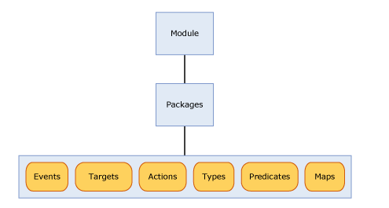

Packages can contain a combination of events, actions, targets, maps, predicates and types.
In SQL Server 2008, there are only four packages; sqlserver, sqlos, package0, and a private internal use only package SecAudit, which is used by Server Audits. All of these packages are loaded by the sqlservr.exe module.
Extended Events : In Layman’s language.
If some events happens, the Extended Events captures the details of actions about that event.
Target : To whom does the Extended Events send the information to.
Predicates : Filters which needs to be applied… for example CPU more than 50 %.

ETW – Event Tracing for Windows
- Enables correlation between SQL Server and Windows trace information.
- Enables SQL Server – SQL Client correlated trace.

SQLServer 2008
Module
sqlservr.exe

SecAudit
A private internal use only package
package0
sqlos
sqlserver 4

PACKAGES

SQL Server 2012
Module
sqlservr.exe
sqldk.dll

Sqlserver
Sqlclr
ucs (unified communications stack)
SecAudit
Sqlos
package0

PACKAGES

In 2012, the sqlos and package0 is loaded by the sqldk.dll service and in the sqlservr.exemodule, two additional packages were introduced – sqlclr and ucs.

These modules are loaded by the Win32 process, Win32 module.

We will now get a closer look at the SQL Server part of the Extended Events.

Events provide information about the execution of the module that loaded the package containing the event. An event corresponds to a specific point in code where something of interest occurs inside the Database Engine.

MODULE with PACKAGES
DATABASE ENGINE

The Events are captured by the packages…In SQL Server 2008, there are 253 events that can be used to capture information and as previously mentioned, while there are a lot of events, not all of the common events from SQL Trace were implemented in Extended Events. In SQL Server Denali CTP1, the number of events has expanded to 446, and now includes a corresponding event for all of the events from SQL Trace.
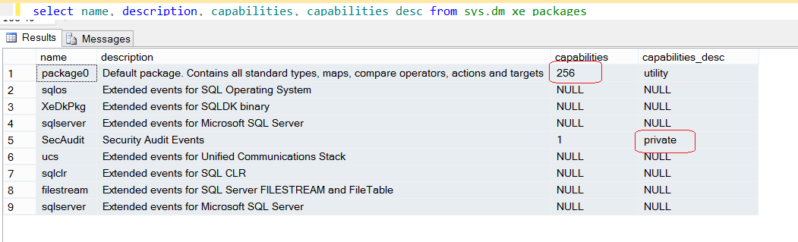
The sys.dm_xe_packages – DMV gives this list. We can use the dm_exe kind of view to see all the Extended events kind of info. This is from SQL 2012 version.

select*fromsys.dm_xe_sessions
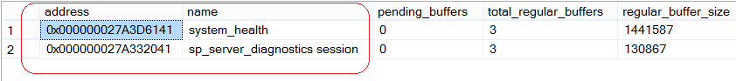
The address column in this output is a unique identifier for each event session.
We have a default session running named “ system_health” and the id is - 0x000000027A3D6141

I have an Event session - 0x000000027A3D6141 running in my laptop.

selectevent_session_address,action_name,event_namefromsys.dm_xe_session_event_actionswhereevent_session_address= 0x000000027A3D6141

I ran the above mentioned query and found the following results.

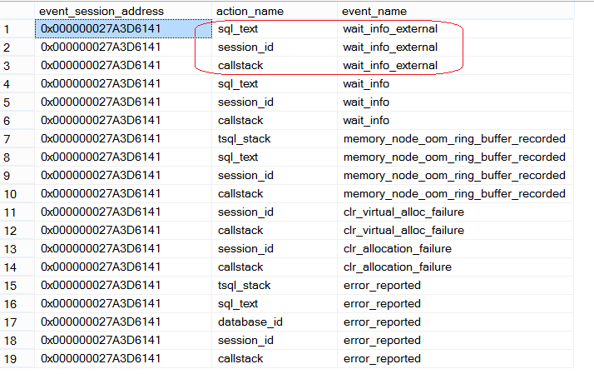

If you see the items marked in RED … we see that the my session is running an event named – wait_info_externaland it has 3 actions associated with it.
Sql_text
Session_id
Callstack

In order to check : All the events of any package.. use the query below.
SELECT
PackageName=p.name,EventName=o.name,
EventDescription=o.description
FROMsys.dm_xe_objectso
JOINsys.dm_xe_packagespONo.package_guid=p.guid
ORDERBYp.name,o.object_type

Configuring a basic session:

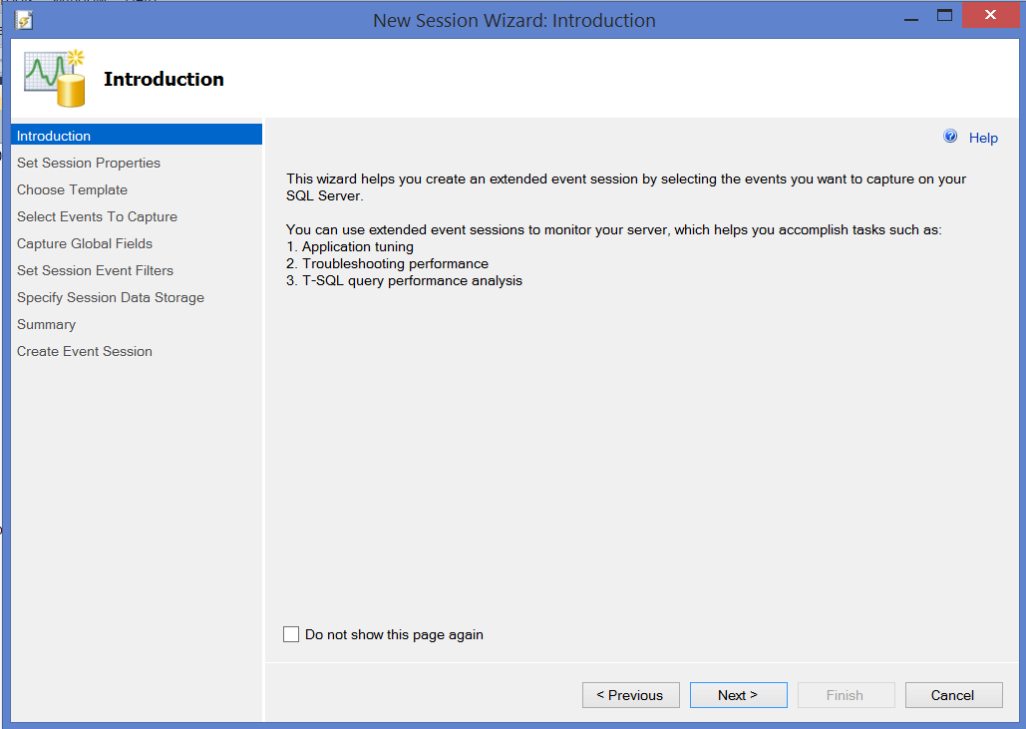
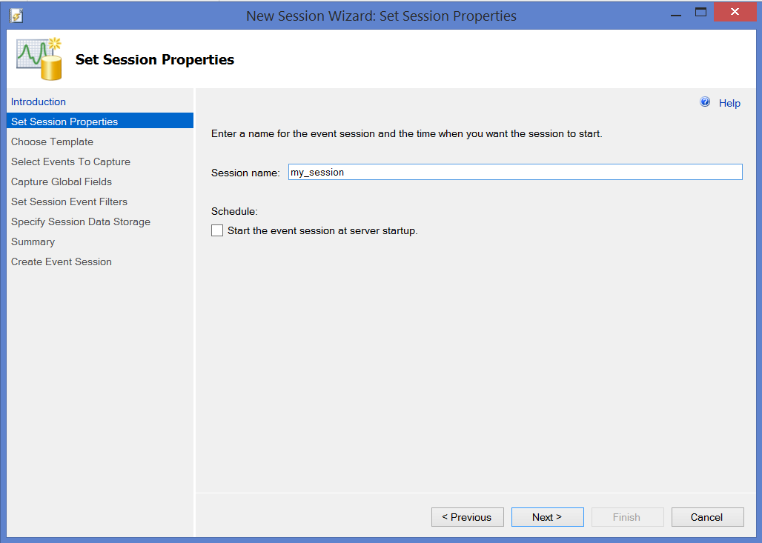
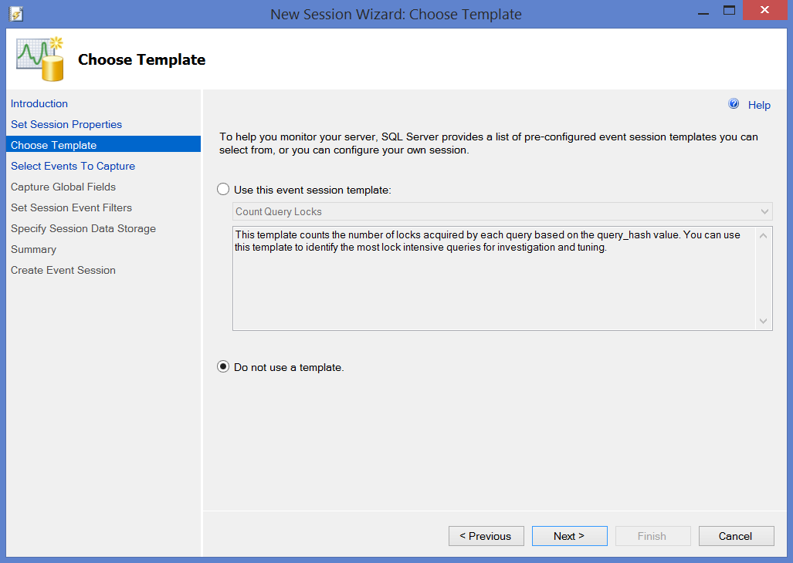
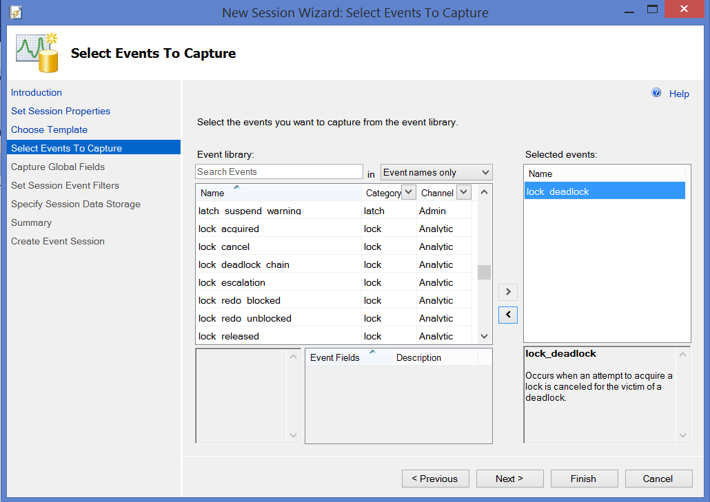
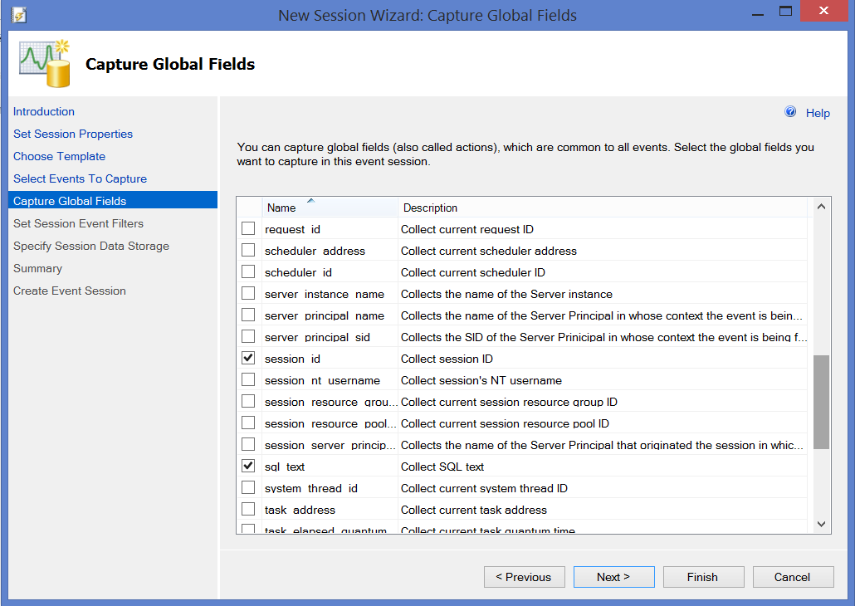
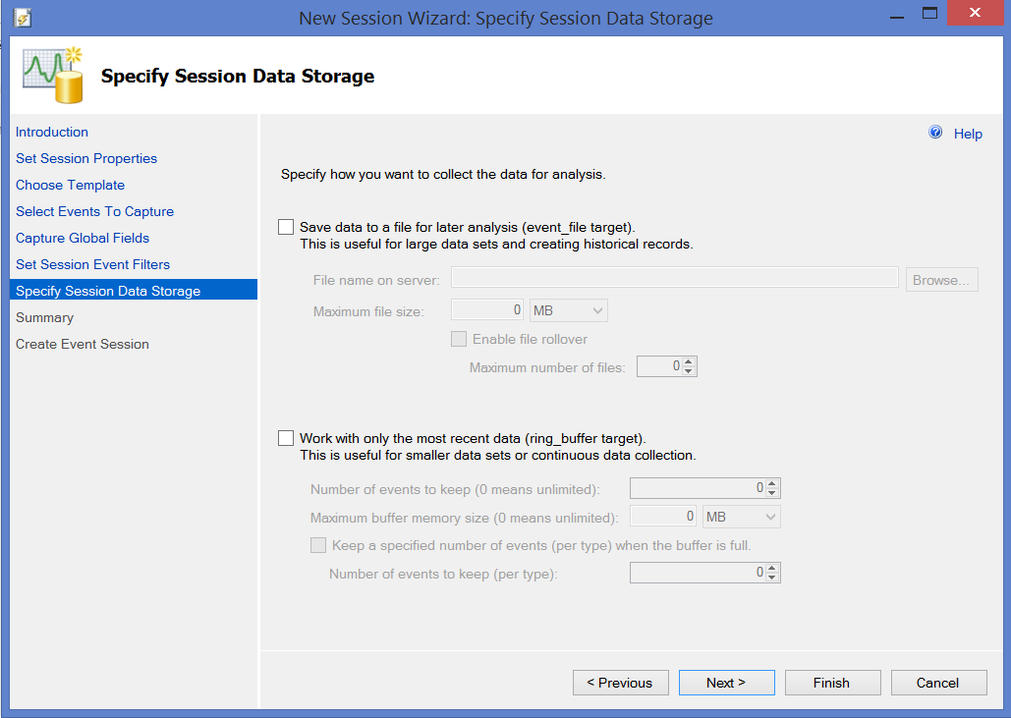

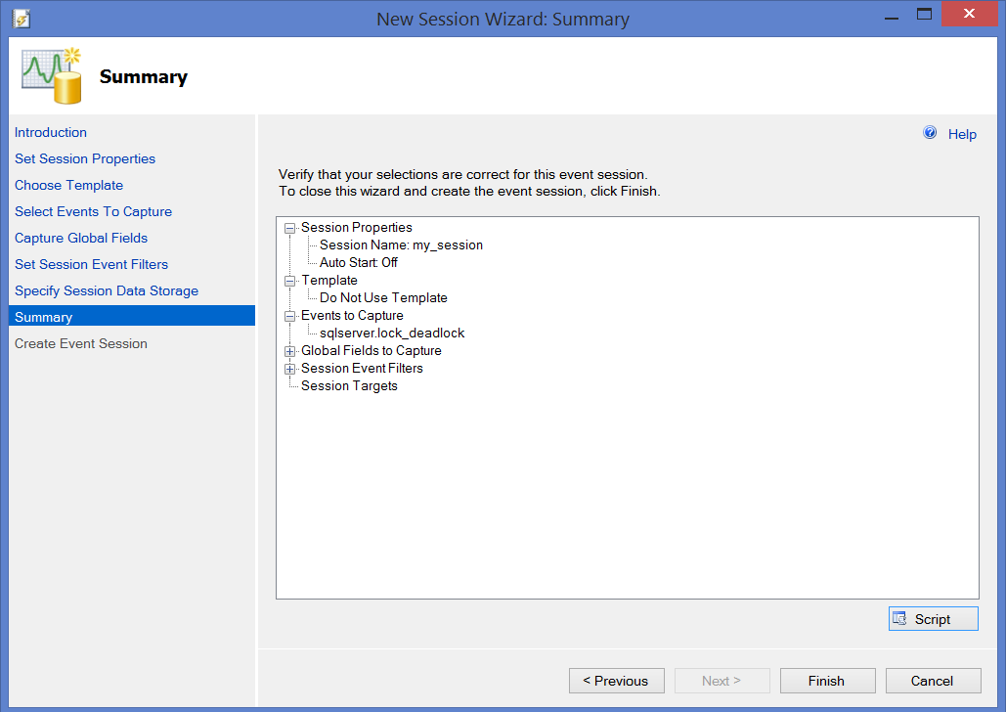
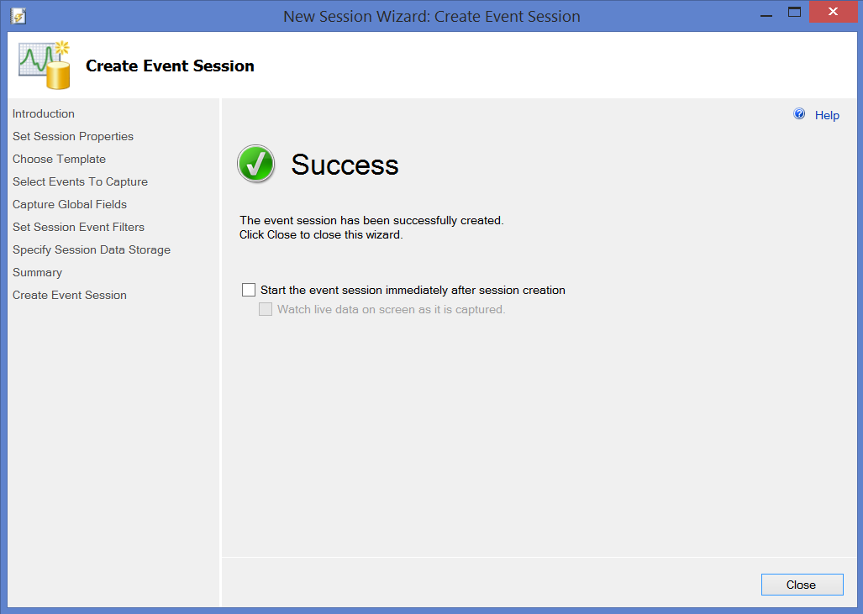

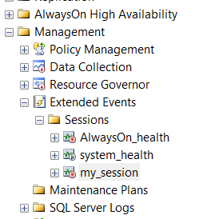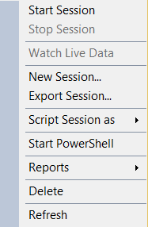
By default, the session is in stopped state, we can right click and START.

How to watch live data when the Extended Events session is running:

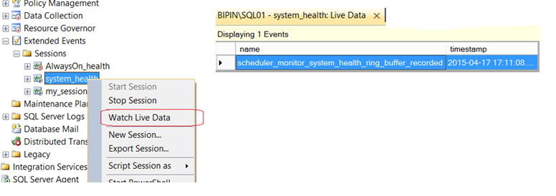
Below seen is a sample code for creating a new session :

CREATEEVENTSESSION[my_session]ONSERVER
ADDEVENTsqlserver.lock_deadlock(
ACTION(sqlserver.database_id,sqlserver.session_id,sqlserver.sql_text))
WITH (STARTUP_STATE=OFF)
GO

To modify an existing session :

ALTEREVENTSESSION[my_session]ONSERVER
ADDEVENTsqlserver.locks_lock_waits
GO

Similarly we can also drop a session.By default, we will have a session named – “system_health” running in SQL2012. I have scripted out the code for it.
CREATEEVENTSESSION[system_health]ONSERVER
ADDEVENTsqlclr.clr_allocation_failure(
ACTION(package0.callstack,sqlserver.session_id)),
ADDEVENTsqlclr.clr_virtual_alloc_failure(
ACTION(package0.callstack,sqlserver.session_id)),
ADDEVENTsqlos.memory_broker_ring_buffer_recorded,
ADDEVENTsqlos.memory_node_oom_ring_buffer_recorded(
ACTION(package0.callstack,sqlserver.session_id,sqlserver.sql_text,sqlserver.tsql_stack)),
ADDEVENTsqlos.scheduler_monitor_deadlock_ring_buffer_recorded,
ADDEVENTsqlos.scheduler_monitor_non_yielding_iocp_ring_buffer_recorded,
ADDEVENTsqlos.scheduler_monitor_non_yielding_ring_buffer_recorded,
ADDEVENTsqlos.scheduler_monitor_non_yielding_rm_ring_buffer_recorded,
ADDEVENTsqlos.scheduler_monitor_stalled_dispatcher_ring_buffer_recorded,
ADDEVENTsqlos.scheduler_monitor_system_health_ring_buffer_recorded,
ADDEVENTsqlos.wait_info(
ACTION(package0.callstack,sqlserver.session_id,sqlserver.sql_text)
WHERE ([duration]>(15000)AND([wait_type]>(31)AND([wait_type]>(47)AND[wait_type]<(54)OR[wait_type]<(38)OR[wait_type]>(63)AND[wait_type]<(70)OR[wait_type]>(96)AND[wait_type]<(100)OR[wait_type]=(107)OR[wait_type]=(113)OR[wait_type]>(174)AND[wait_type]<(179)OR[wait_type]=(186)OR[wait_type]=(207)OR[wait_type]=(269)OR[wait_type]=(283)OR[wait_type]=(284))OR[duration]>(30000)AND[wait_type]<(22)))),
ADDEVENTsqlos.wait_info_external(
ACTION(package0.callstack,sqlserver.session_id,sqlserver.sql_text)
WHERE ([duration]>(5000)AND([wait_type]>(365)AND[wait_type]<(372)OR[wait_type]>(372)AND[wait_type]<(377)OR[wait_type]>(377)AND[wait_type]<(383)OR[wait_type]>(420)AND[wait_type]<(424)OR[wait_type]>(426)AND[wait_type]<(432)OR[wait_type]>(432)AND[wait_type]<(435)OR[duration]>(45000)AND([wait_type]>(382)AND[wait_type]<(386)OR[wait_type]>(423)AND[wait_type]<(427)OR[wait_type]>(434)AND[wait_type]<(437)OR[wait_type]>(442)AND[wait_type]<(451)OR[wait_type]>(451)AND[wait_type]<(473)OR[wait_type]>(484)AND[wait_type]<(499)OR[wait_type]=(365)OR[wait_type]=(372)OR[wait_type]=(377)OR[wait_type]=(387)OR[wait_type]=(432)OR[wait_type]=(502))))),
ADDEVENTsqlserver.connectivity_ring_buffer_recorded(SETcollect_call_stack=(1)),
ADDEVENTsqlserver.error_reported(
ACTION(package0.callstack,sqlserver.database_id,sqlserver.session_id,sqlserver.sql_text,sqlserver.tsql_stack)
WHERE ([severity]>=(20)OR([error_number]=(17803)OR[error_number]=(701)OR[error_number]=(802)OR[error_number]=(8645)OR[error_number]=(8651)OR[error_number]=(8657)OR[error_number]=(8902)))),
ADDEVENTsqlserver.security_error_ring_buffer_recorded(SETcollect_call_stack=(1)),
ADDEVENTsqlserver.sp_server_diagnostics_component_result(SETcollect_data=(1)
WHERE ([sqlserver].[is_system]=(1)AND[component]<>(4))),
ADDEVENTsqlserver.xml_deadlock_report
ADDTARGETpackage0.event_file(SETfilename=N'system_health.xel',max_file_size=(5),max_rollover_files=(4)),
ADDTARGETpackage0.ring_buffer(SETmax_events_limit=(5000),max_memory=(4096))
WITH (MAX_MEMORY=4096 KB,EVENT_RETENTION_MODE=ALLOW_SINGLE_EVENT_LOSS,MAX_DISPATCH_LATENCY=120 SECONDS,MAX_EVENT_SIZE=0
KB,MEMORY_PARTITION_MODE=NONE,TRACK_CAUSALITY=OFF,STARTUP_STATE=ON)
GO
If we find difficulty in creating our own session in a scripted form, we can modify the above script and add/remove and then create a new session with a different name.

*********** wishing you all the best **************

