SQL Server 2008 Upgrade

Author: Sql Server Dba Team
Creation Date: 25/11/2010
Control Number: Uncontrolled
Version: Final

Approvals:
DBA Team Leader | ..........................................
 | ..........................................
 | ..........................................

Document Control

Change Record
Date | Author | Version | Change Reference
25/11/2010 |  | 1 | No previous document – not controlled
22/12/2010 |  | 1.1 | Incorporated suggestions from team
17/01/2011 |  | 1.2 | Final comments/amendments to layout and app owner responsibilities
20/01/2011 |  | Final | Changes approved

Reviewers
Name | Position
Chris Hutchings | SQL Server DBA
Mark Smith | SQL Server DBA
Mervyn Coburn | SQL Server DBA
Jonathan Kerr | SQL Server DBA

Distribution
Approved versions of this document (i.e., where the Version is ISSUE rather than DRAFT) have been distributed to the following:
Name | Location/Title

Contents
Document Control ii

Introduction 1
Upgrade Strategies 2
Pre-Upgrade Tasks: 5
SQL Server Primary Upgrade Tools 7
SQL Server Secondary Upgrade Tools 8
Upgrade Tasks 11
Upgrade Checklist 13
Development Responsibilities 15
Appendix A: Discontinued Features in SQL Server 2008 16
Appendix B: Deprecated Features in SQL Server 2008 20

Introduction

The purpose of this document is to outline the GO SQL DBA policy for upgrading SQL Server databases from versions 2000/2005 to version 2008 R2

This document outlines the necessary tasks and responsibilities for both the Application/Business owners as well as the DBA’s. It must be stressed however that the onus is on Business owners to ensure that they are conversant with the requirements for upgrading their respective applications and that proper Change Control process is followed.

A database upgrade is a significant change and to achieve a smooth transition, sufficient planning and testing needs to be devoted to each one. Each application owner will be responsible for ensuring sufficient time and resources are dedicated to achieve this end.

The upgrade strategies are outlined together with the options for moving objects from the old database to the new one. A high level summary of pre-upgrade and upgrade tasks is provided followed by a detailed check list of the actions required to successfully upgrade a database.

Finally to emphasise that development input is a critical to the success of the upgrade, a section detailing Development Responsibilities has been included.

Responsibilities

THE GO DBA’s are responsible for upgrading corporate databases once due change control process has been followed and the associated resources booked via the Resource Booker. The level of support is extended to offering advice on the upgrade procedure, pre-qualifying the database by using Upgrade Advisor (please note the caveats for Upgrade Advisor in the Migration Strategies below), migrating the database and finally auditing the database to ensure it complies with corporate database standards.

Application owners are responsible for ensuring that their database applications meet the required criteria beforehand to ensure a smooth transition. To this regard, application owners will need to review the significant changes associated with migrating apps to v2008 R2 and also review their application functionality to identify any components that will need to change or be migrated independently of the database. A comprehensive (but not conclusive) list of these is outlined below. In addition, owners are responsible for allocating and coordinating resources along with thoroughly testing all logic, interfaces, client software and modules of their respective applications. For 3rd Party applications confirmation from the vendor should be obtained to ensure their product is compatible with v2008 R2.

- Under no circumstances will v2008 R2 databases be able to run in v2000 or v2005 compatibility mode. Application Owners must ensure their databases are fully v2008 R2 compatible.

- Application Owners must also ensure all legacy code is recompiled to v2008 R2 compatibility. There will be no exceptions allowed for legacy code.

- Project teams will be responsible for organising the running of Upgrade Advisor on those servers GOI DBA’s do not support.

Upgrade Strategies

There are 2 fundamental strategies for upgrading existing instances to SQL Server 2008 R2: an in-place upgrade and a side-by-side upgrade.

In-Place Upgrade
With an In-Place upgrade, you use the SQL Server 2008 R2 setup program to automatically and directly replace an instance of SQL Server 2005 or 2000 with SQL Server 2008 R2. The in-place upgrade will convert the system metadata while preserving all user data on the current installation. The older SQL Server instance is replaced:

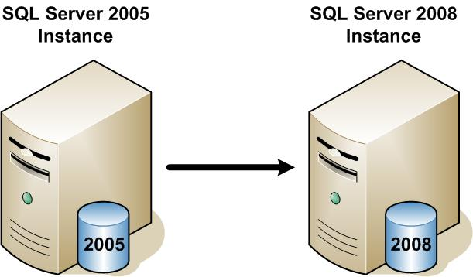
Figure 1: Direct upgrade of SQL Server 2005 to SQL Server 2008

Side-by-Side Migration
With a side-by-side upgrade, the SQL Server 2008 relational database engine is installed as a second instance, and the SQL Server 2000/2005 relational database engine(s) remains installed and unchanged. You then migrate (move or copy) one or more user databases to the SQL Server 2008 instance (each migrated database is automatically upgraded via the restore database option).

As the 2008 instance name will be different to the 2005 instance name, all database clients will need to be reconfigured accordingly. The new SQL Server 2008 instance runs alongside the legacy SQL Server 2005 by using two servers or a single server:
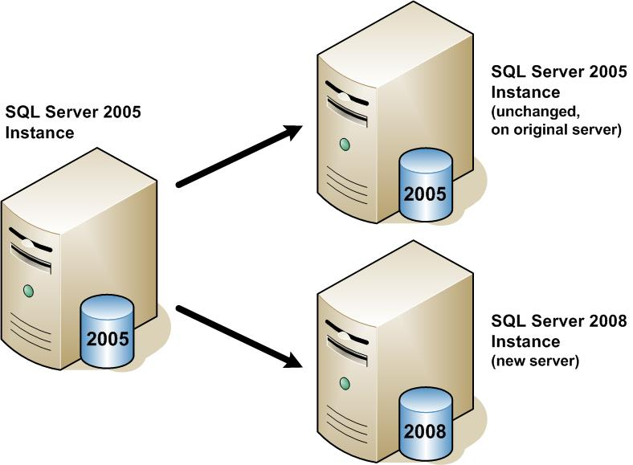
Figure 2: Side-by-side upgrade to SQL Server 2008 using two servers
You may also use the side-by-side method to upgrade to SQL Server 2008 R2 on a single server. Figure 3 shows a side-by-side upgrade on a single server:

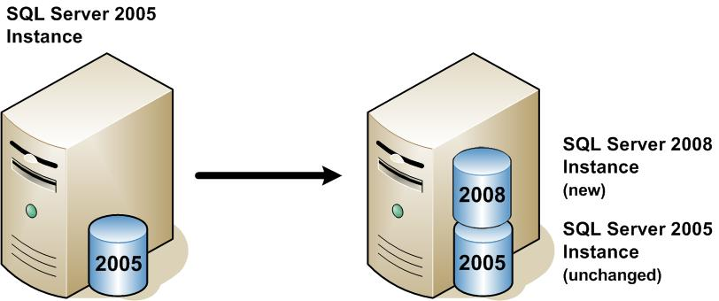
Figure 3: A side-by-side upgrade on a single server, leaving both instances running
Regardless of whether a side-by-side upgrade is performed using one or two servers, certain data and other database objects must be transferred using other utilities.

Objects requiring other transfer methods include:
- Data files
- System Database objects
- SSAS cubes
- Unique Configuration settings
- Unique Security settings
- SQL Server Agent jobs
- SSIS packages (please note it is recommended that DTS/SSIS packages be recompiled for v2008 R2)

It is extremely important to note the list of deprecated features and upgrade caveats Appendix A and Appendix B
Each application owner is responsible for ensuring they have identified potential pitfalls and addressed and tested these well before scheduling the final upgrade. The SQL Upgrade Advisor will also report any non-conforming features and SQL DBA’s can offer assistance where needed. PLEASE NOTE THOUGH, THAT THE UPGRADE ADVISOR IS NOT A CATCH ALL TOOL and it is up to the application owners to ensure they have reviewed their respective application functionality for v2008 R2 readiness.

The Recommended Upgrade Approach: Side-by-Side
XXX will always adopt the Side-by-Side migration strategy because:

- Rolling back an In-Place upgrade is complex and time consuming involving a full server rebuild. In contrast, with a Side-by-Side upgrade, the old instance will still be available for a rollback scenario ensuring a quick and simple recovery.
- An In-Place upgrade can only upgrade an entire instance. The side-by-side migration is more granular, allowing individual databases to be migrated. Given the majority of GO Supported SQL Server 2005 databases are hosted on shared instances, this is the only practical upgrade option.
- As some legacy SQL Server 2000/2005 folders and registry keys would persist, the In-Place upgrade would result in a different build specification to the GO Standard SQL Server 2008 R2 build.
- A Side-by-Side upgrade results in simpler post migration testing scenarios because both versions are available at the same time.
- Some components such as SQL Server Integration Services and Notification Services can not be directly upgraded and must be migrated. MS have recommended that all DTS/SSIS packages be recompiled and tested individually for v2008 R2.

It should be noted that spare hardware will initially be required to deploy a Side-by-Side upgrade. However, as each host is upgraded it will become redundant and could be used to upgrade the next host. Once the upgrade exercise is complete the number of hosts in use should equal the number of hosts pre-upgrade.

Options for moving databases
There are 4 methods for moving databases from one SQL Server instance to another during a Side-by-Side migration: detach/attach, backup/restore, the Copy Database Wizard, and a manual schema rebuild combined with data export/import.

As the backup/restore method offers the best all round balance in terms of risk, speed and simplicity, this is the method we will adopt.

Pre-Upgrade Tasks:

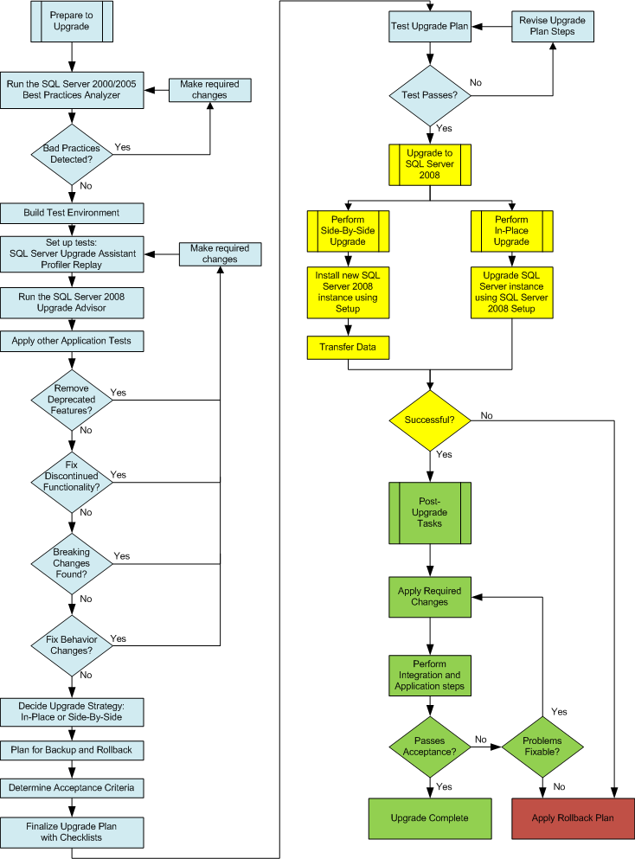
Figure 4 An example upgrade process plan

Plan the Upgrade
Business Owners need to be aware that each upgrade needs to be treated as a major change and must follow the standard XXX Change control process to ensure –
- There is full visibility of the change
- The upgrade process is documented
- The correct contacts approve documentation, integration and quality assurance tests
- Verification and acceptance tests are developed by the appropriate teams
- Deployment process and rollback plans are fully tested

Typically the pre upgrade steps will entail:
- Document upgrade plan
- Review any deprecated features or incompatibility issues and flag these
- Develop criteria and unit/verification tests
- Capture Baseline Data (see Baseline Performance consideration steps below)
- Capturing query plans for complex queries
- Ensure clean/consistent environments
- Backup old instances/databases and verify
- Engage all associated teams – Wintel, SAN, Apps Support etc

It is the responsibility of the application owners to ensure the above steps are carried out in consultation with all relevant support groups.

Functionality Considerations
Some SQL Server 2005 features on which XXX applications rely may be discontinued in SQL Server 2008 R2 or in future versions of SQL Server. A list of these is provided at Appendix A and Appendix B.
Application compatibility testing is a good practice to identify and resolve potential issues that may arise after upgrading the database. A typical set of Application Compatibility Testing tasks should include the following:

- Determine how much Application and associated interface compatibility testing is appropriate.
- Ensure testing of all RDBMS queries, stored proc’s and trigger/constraint functionality
- Test databases with the current compatibility level. In the case of SQL Server 2008 R2, it is level 100.
- Test application setup with SQL Server 2008 R2.
- Confirm and get in writing that any third-party vendor software is certified on SQL Server 2008 R2.

It is the responsibility of the application owners to ensure the above steps are carried out in consulation with all relevant support groups.
- Project teams will be responsible for organising the running of Upgrade Advisor on those servers GOI DBA’s do not support.

Application Backward Compatibility
When planning for an upgrade to SQL Server 2008 R2, application owners need to understand which features have been deprecated, discontinued, or changed in the new version.

As the scope of these features is comprehensive it is not within the remit of this document to identify them all. The following links are provided for application owners to familiarise themselves with requirements:
- Backward Compatibility: http://msdn.microsoft.com/en-us/library/cc707787.aspx.
- Discontinued Features: http://msdn.microsoft.com/en-us/library/cc707782.aspx
- Deprecated Features: http://msdn.microsoft.com/en-us/library/cc707789.aspx.
- Note: Your upgrade will not be blocked if you use deprecated features. However, GO DBA team insist that wherever feasible, any deprecated features are indentified and resolved prior to migration.
- Under no circumstances will v2008 R2 databases be able to run in v2000 or v2005 compatibility mode. Application Owners must ensure their databases are fully v2008 R2 compatible.

- Application Owners must also ensure all legacy code is recompiled to v2008 R2 compatibility. There will be no exceptions allowed for legacy code.

- Breaking Changes: http://msdn.microsoft.com/en-us/library/cc707784.aspx.
  - Note: Breaking changes to SQL Server 2008 are those that might require changes to the applications because the features in question now have a different behavior. If you do not use the feature, there is no impact on you, but if you do use the feature, your application might be affected

- Behaviour Changes: http://msdn.microsoft.com/en-us/library/cc707785.aspx.
  - Behavior changes may not visibly affect your database code or applications, but you need to be aware of them. Database operations that depend on features with modified behaviors may be adversely affected.

The majority of SQL Server 2008 functionality and behavior is backward compatible with SQL Server 2005. However, you should examine feature changes during the planning process. The SQL Server 2008 Upgrade Advisor is the best tool for finding these types of blocking issues ahead of time although it must be stressed again that this is not a catch all tool and therefore vigorous testing is required by the application teams.

SQL Server Primary Upgrade Tools

The Upgrade Advisor
Before performing an upgrade to SQL Server 2008 R2, the DBA’s will run Upgrade Advisor against the target database once proper change control process has been initiated and resources assigned for this purpose.
The Upgrade Advisor tool can be used to identify upgrade blocking issues or backward compatibility issues that might affect the upgrade. It analyses the legacy instance and reports on each SQL Server component detailing upgrade issues together with potential fixes. In addition to analysing data and database objects, Upgrade Advisor can analyse Transact SQL scripts and Profiler Traces. Upgrade Advisor examines SQL code for syntax that is no longer valid in SQL Server 2008 R2.
It performs only read operations on the target instance and does not cause much overhead on the target SQL Server. However, report generation and analysis is CPU intensive, so you should always try to run it remotely when working with production database servers.
Use representative profile traces (normal BAU day and critical operational profiles) and assess with Upgrade Advisor . Reason for this is that there may be business essential dynamic transactions, or temp objects/variables created within proc’s/code that use deprecated features and these would not otherwise by flagged by the Upgrade Advisor. It is the responsibility of the application owners to determine if profile traces would be more suitable to assist with migration and would need to organise a simulation environment for this to occur.

Make any required compatibility changes in advance
If the Upgrade Advisor highlights any anomalies, it is essential these changes be made and tested thoroughly in advance of the actual migration (i.e. the changes should have been running in production for at least two weeks prior to the migration). Although this will make the upgrade a 2 stage process, the overall risk will be reduced because it will be splitting the changes into more manageable portions.

Establish Performance Baselines
A Profiler trace, where required, indicating typical system performance should be taken over the course of a standard working day on the SQL 2005 database. These baselines can be used during the SQL 2008 test migration or after the Production upgrade if users report that performance has changed.

SQL Server Secondary Upgrade Tools

The GO DBA’s will assess if these tools are appropriate for specific server/database migrations.

There are multiple additional tools that fit specialised needs in the upgrade planning and execution process, including:

- Microsoft® Assessment and Planning Toolkit 3.2
- SQL Server 2008 Upgrade Assistant
- Application Compatibility Testing Tool
- SQL Server Best Practices Analyzer
- System Configuration Checker
- SQL Server Profiler
- SQL Server: Deprecated Features Object Counter
- Other tools
Of the above, the SQL Server Profiler in conjunction with the Upgrade Advisor will mostly be used for migrations:

SQL Server Profiler
SQL Server Profiler can record a running workload and then replay that same activity from a given SQL Server instance, making it a valuable tool for preparing an upgrade. Profiler is useful for simulating an upgrade to determine performance and correct behaviour. For example, you can use SQL Server 2008 Profiler to trace a SQL Server 2005 database under load and save the trace. You can then restore the SQL Server 2005 database to two instances on equivalent hardware: a SQL Server 2005 instance and a SQL Server 2008 instance. Run the replay on each (but at different times if on the same server), and while running the replay, also run a Profiler trace on each of the two runs, capturing errors and query durations. By comparing the results, you can determine whether the upgrade behaves correctly (without error) and performs well.

GO DBA’s will work alongside application owners in determining the best method to upgrade applications. Where there is a significant amount of dynamic sql, it may be appropriate to use Profiler to trap potential pitfalls. Discretion lies with the application owners to determine if they believe their applications could benefit from this approach and in conjunction with the DBA’s arrange for a benchmark profile.

Upgrade Tasks

Revisit pre-upgrade tasks.

Side-by-Side upgrade
Perform a Side-by-Side upgrade using the Backup / Restore method. Backup the database on the SQL Server 2005 host and restore onto the SQL Server 2008 host.
DBA’s will then run the 2008 Upgrade script which performs the following:

Modify the Compatibility Level
To minimise potential problems when a database is upgraded it retains its existing compatibility level (80 for SQL Server 2000 and 90 for 2005.). However, sp_dbcmptlevel provides only partial backward compatibility and the database should be set to compatibility level 100 (For specific guidance, review the sp_dbcmptlevel topic in SQL Server 2008 Books Online) -
Exec sp_dbcmptlevel @dbname=name, @new_cmptlevel=100

Change the Page_Verify Option if required
Page checksum provides a stronger mechanism than torn-page to detect any corruptions in IO path.

ALTER DATABASE [DB_Name] SET PAGE_VERIFY CHECKSUM

Run DBCC’s and Update Stats
The script will also run DBCC UpdateUsage, Data Purity (required only for v2000 databases but included for purpose) and CheckDB as well as update stats and finally verify specific options.
DBCC CHECKDB should be run both pre and post upgrade: It checks the logical and physical integrity of all the objects in the specified database by performing the following operations:
- Runs DBCC CHECKALLOC on the database.
- Runs DBCC CHECKTABLE on every table and view in the database.
- Runs DBCC CHECKCATALOG on the database.
- Validates the contents of every indexed view in the database.
- Validates link-level consistency between table metadata and file system directories and files when storing varbinary (max) data in the file system using FILESTREAM.
- Validates the Service Broker data in the database.

Manually Upgrade Dependent Objects
A Side-by-Side upgrade does not upgrade any system databases which means the objects in these databases must generally be migrated separately and/or recreated manually. The following is a list of objects which will need to be manually migrated -
- server logins (NB 2008 password policy will be adopted so are likely to need to change)
- login permissions,
- SQL Server Agent jobs,
- alerts,
- maintenance plans,
- Linked Servers,
- Extended Stored Procedures,
- user stored procedures in the system databases,
- user-defined error messages,
- DTS/SSIS packages (Please see note below - only SSIS is supported post R2. Further, as per MS recommendation, packages will need to be rebuilt as there is no direct migration option. )
- The replication topology

DTS/SSIS:
DTS no longer supported post R2. Migration to 2008 R2 is possible but will not be supported– use SSIS. Be very careful when using the Visual Studio tool to migrate SSIS packages to 2008 R2 as it may ‘comment out’ deprecated code syntax despite the results of running package still showing as having run successfully. Check the debugger for every package migrated and test thoroughly!
SSIS – use SQL Server Destination rather than OLEDB destination for any local SSIS packages as it’s quicker (uses name pipes thereby bypassing tcp bottlenecks).

Re-Populate Full Text Catalogs
Refer BOL for required procedures

Log Shipping Requirements:
MS recommend to break LS prior to upgrading to 2008 and upgrade each database independently.

Replicated Databases:
Please review MSDN Considerations for Upgrading Replicated Databases: http://msdn.microsoft.com/en-us/library/ms143699.aspx

Audit Database:
Once the database has been migrated to v2008 R2 run the audit database script to ensure it complies with GO DBA database standards.

Point the application at the new Database
Each database can potentially be accessed in a variety of ways. Along with standard middle-tier components, the system may receive data imports and be the source of data exports using a variety of tools.
As the instance name will have changed, the application support team must re-point all the application components at the upgraded database.
It should be noted that SQL Server 2008 R2 uses case-sensitive password accounts and this needs to be considered when pointing the applications at the database.

Upgrade Checklist
Pre-Upgrade
- Confirm that a Profiler Trace providing typical database performance has been created.
- Run Upgrade Advisor against the 2005 SQL database to ensure that all compatibility issues have already been addressed
- Confirm there is sufficient disk space on the new SQL 2008 host
- Restore a current copy of the user database to be migrated onto the Production SQL 2008 Instance.
- Put the SQL Server 2008 database into Restricted_User mode.
- Manually copy server logins. Please note, we will be adopting SQL 2008 R2 password policies and so it is a requirement that the password may need to change.
- Manually copy login permissions.
- Confirm equivalent maintenance plans have been setup and scheduled.
- Manually copy SQL Server Agent jobs.
- Check for Linked Servers and recreate as necessary.
- Upgrade SSIS packages and repoint.
- Check for user-defined error messages. If any exist manually copy.
- Check for alerts. If any exist manually copy.
- Check for Extended Stored Procedures such as xp_smtp_sendmail (which must be replaced by the SQL Server 2008 equivalent Database Mail tool).
- Check for user stored procedures in the system databases. If any exist these are likely to need to be recoded to take into account structural changes.
- Check for any startup stored procedures and configure appropriately on new host.
- If replication is used, confirm that a suitable installation script has been created and tested.

Upgrade
- Inform the Event Control Team that the upgrade is starting (for PROD releases only)
- Put the user database(s) in Restricted_User mode
- Run DBCC CHECKDB on the source v2000/2005 database(s)
- Ensure that the data and log files are set to autogrow and auto_update_statistics is switched on
- Quiesce and backup all user and system databases
- Copy the user database(s) backup(s) to the new host
- Restore the user database(s)
- Delete existing users
- Run the v2008 upgrade script
- If replication is used apply the replication setup scripts
- If full text search is used confirm that the catalog population process completed successfully (this should automatically start after the restore completes). See http://msdn.microsoft.com/en-us/library/ms142490.aspx for further info.
- Run the Audit Script to ensure the migrated database complies with corporate DB standards
- Create users and assign required privileges
- Backup the database
- Recreate Log Shipping, SSIS packages and any additional requirements as outlined in Pre-Upgrade considerations.
- Re-point application components at new instance
- Perform post migration test plan and thoroughly test all application modules, interfaces and external dependent databases/applications or jobs
- Communicate details about the successful database migration

Development Responsibilities
Planning and testing are going to be crucial to the success of each database upgrade. There is going to be a significant reliance on the development teams to provide the necessary resources to assist the DBAs. Key development responsibilities include –

- Reviewing changes to the new v2008 R2 architecture and how these will affect their respective applications and interfaces
- Changing code which is not SQL Server 2008 compliant
- Rewriting DTS packages and converting to SSIS
- Note Full Text Changes in v2008 R2 and upgrade as required
- System /full integration testing
- Generating pre and post migration test plans
- Coordinating the Change Control/Release process and assigning necessary resources
- Obtaining vendor certification/support for v2008 R2 for any 3rd party applications

Application and business owners are advised to make themselves aware of the new features available, limitations and those features that are no longer supported with v2008 R2 that may ultimately affect the running of their applications.

- Under no circumstances will v2008 R2 databases be able to run in v2000 or v2005 compatibility mode. Application Owners must ensure their databases are fully v2008 R2 compatible.

- Application Owners must also ensure all legacy code is recompiled to v2008 R2 compatibility. There will be no exceptions allowed for legacy code.

- Project teams will be responsible for organising the running of Upgrade Advisor on those servers GOI DBA’s do not support.

Appendix A: Discontinued Features in SQL Server 2008
The following features are not supported in SQL Server 2008; for the most up-to-date list of discontinued features, see http://msdn.microsoft.com/en-us/library/cc280407.aspx.
Database Engine | Discontinued feature
Aliases | sp_addalias
APIs | Registered Servers API  SQL-DMO based Windows® Management Instrumentation (WMI) provider  SQL Namespace API (SQL-NS)
Backup and restore | Named pipe backup devices  DUMP statement  LOAD statement  BACKUP LOG WITH NO_LOG  BACKUP LOG WITH TRUNCATE_ONLY  BACKUP TRANSACTION
Command prompt utilities | isql utility
Compatibility level | 60, 65, and 70 compatibility levels
Configuration options | 'allow updates' option of sp_configure  'open objects' option of sp_configure  'set working set size' option of sp_configure
Database creation | DISK INIT  DISK RESIZE
Database creation | FOR LOAD option of CREATE DATABASE
DBCC | DBCC CONCURRENCYVIOLATION  DBCC DBREPAIR  DBCC NEWALLOC  DBCC PINTABLE, DBCC UNPINTABLE  DBCC ROWLOCK  DBCC TEXTALL  DBCC TEXTALLOC
Extended store procedure programming | Use of SRV_PWD field in the SRV_PFIELD structure when there has been an impersonation context switch from the original login
Groups | sp_addgroup  sp_changegroup  sp_dropgroup  sp_helpgroup
Network protocols | The following protocols: NWLink IPX/SPX, AppleTalk, Banyan Vines, Multiprotocol
Rebuild master | Rebuildm.exe
Sample databases | Northwind and pubs
Setup.exe | Remote Setup - the TARGETCOMPUTER parameter - is not supported
Tools | Surface Area Configuration Tool
Transact-SQL | *= and =* outer join operators
Virtual tables | Syslocks
Web Assistant | sp_makewebtask  sp_dropwebtask  sp_runwebtask  sp_enumcodepages
Analysis Services | Discontinued Feature
Connection string properties | Mining Execution Location  Mining Location  Log File  Execution Location  Distinct Measures by Key  Large Level Threshold
Features | Aggregated Providers  Linked Cubes  Custom Level Formulas  Cube and Database Role Commands
MDX | CreateVirtualDimension  CreatePropertySet  Ignore  With Cache  Create Cache
Other | Active Directory® Registration  Skipped levels in parent-child hierarchies  Notification Services
Reporting Services | Discontinued Feature
Rendering | HTML 3.2 Rendering Extension  HTML OWC Rendering Extension  SQL Server 2000 Report Server Web Service Endpoint
Report server initialization | Rsactivate.exe  Windows® Internet Explorer® 5.5 Support  Report Builder Runs in Full Trust Mode Only
Tools | Surface Area Configuration Tool
Replication | Discontinued Feature
All types of replications | - Creating push subscriptions without a connection to the Subscriber in the New Subscription Wizard  - Using file transfer protocol (FTP) to initialize Subscribers running SQL Server version 7.0  - Creating subscriptions in Windows® Synchronization Manager  - Subscribing to a publication by locating it in Active Directory  - Snapshot ActiveX® control  - Remote agent activation  - Microsoft®Office Access® (Microsoft® Jet 4.0) Subscribers
Transactional replication | Message Queuing option for queued updating subscriptions
Merge replication | IVBCustomResolver interface
Other Tools and Features | Discontinued Feature
Setup command-line parameters | ADDLOCAL  DISABLENETWORKPROTOCOLS  DISABLENETWORKPROTOCOLS  INSTALLSQLDATADIR  REINSTALL  REINSTALLMODE  REMOVE  SAMPLEDATABASE  SAVESYSDB  SKUUPGRADE  UPGRADE  USESYSDB
Database Engine | Discontinued Feature
Backup and restore | Named pipe backup devices
Command prompt utilities | isql utility
Configuration options | 'allow updates' option of sp_configure  'open objects' option of sp_configure  'set working set size' option of sp_configure
Database creation | DISK INIT  DISK RESIZE
Database creation | FOR LOAD option of CREATE DATABASE
DBCC | DBCC DBREPAIR  DBCC NEWALLOC  DBCC PINTABLE, DBCC UNPINTABLE  DBCC ROWLOCK  DBCC TEXTALL  DBCC TEXTALLOC
Extended store procedure programming | Use of SRV_PWD field in the SRV_PFIELD structure when there has been an impersonation context switch from the original login
Network protocols | The following protocols: NWLink IPX/SPX, AppleTalk, Banyan Vines, Multiprotocol
Rebuild master | Rebuildm.exe
Sample databases | Northwind and pubs
Setup.exe | Remote Setup - the TARGETCOMPUTER parameter - is not supported
APIs | SQL-DMO based WMI provider
APIs | SQL Namespace API (SQL-NS)
Transact-SQL | *= and =* outer join operators
Virtual tables | Syslocks
Analysis Services | Discontinued Feature
Connection string properties | Mining Execution Location  Mining Location  Log File  Execution Location  Distinct Measures by Key  Large Level Threshold
Features | Aggregated Providers  Linked Cubes  Custom Level Formulas  Cube and Database Role Commands
MDX | CreateVirtualDimension  CreatePropertySet  Ignore  With Cache  Create Cache
Other | Active Directory Registration  Skipped levels in parent-child hierarchies
Reporting Services | Discontinued Feature
Report server initialization | Rsactivate.exe
Replication | Discontinued Feature
All types of replications | - Creating push subscriptions without a connection to the Subscriber in the New Subscription Wizard  - Using file transfer protocol (FTP) to initialize Subscribers running SQL Server version 7.0  - Creating subscriptions in Windows Synchronization Manager  - Subscribing to a publication by locating it in Active Directory  - Snapshot ActiveX control  - Remote agent activation  - Microsoft Access (Jet 4.0) Subscribers
Transactional replication | Message Queuing option for queued updating subscriptions
Merge replication | IVBCustomResolver interface
Other Tools & Features | Discontinued Feature
Setup command-line parameters | ADDLOCAL  DISABLENETWORKPROTOCOLS  DISABLENETWORKPROTOCOLS  INSTALLSQLDATADIR  REINSTALL  REINSTALLMODE  REMOVE  SAMPLEDATABASE  SAVESYSDB  SKUUPGRADE  UPGRADE  USESYSDB
Appendix B: Deprecated Features in SQL Server 2008
The following features will not be supported in the next version of SQL Server:
Database Engine | Feature Not Supported in the Next Version of SQL Server
Backup and restore | BACKUP { DATABASE | LOG } WITH PASSWORD  BACKUP { DATABASE | LOG } WITH MEDIAPASSWORD  RESTORE { DATABASE | LOG } WITH DBO_ONLY  RESTORE { DATABASE | LOG } WITH PASSWORD  RESTORE { DATABASE | LOG } WITH MEDIAPASSWORD
Compatibility levels | 80 compatibility level and upgrade from version 80
Database objects | WITH APPEND clause on triggers
Database options | sp_dboption
Instance options | Default setting of disallow results from triggers option = 0
Metadata | DATABASEPROPERTY
Query hints | FASTFIRSTROW hint
Remote servers | sp_addremotelogin  sp_addserver  sp_dropremotelogin  sp_helpremotelogin  sp_remoteoption  @@remserver  SET REMOTE_PROC_TRANSACTIONS
Security | sp_dropalias
SET options | SET DISABLE_DEF_CNST_CHK  SET ROWCOUNT for INSERT, UPDATE, and DELETE statements
System tables | sys.database_principal_aliases
Transact-SQL syntax | Use of *= and =*  COMPUTE / COMPUTE BY  RAISERROR syntax
Tools | sqlmaint Utility
Analysis Services | Feature Not Supported in the Next Version of SQL Server
Connection string properties | Mining Execution Location, Mining Location, Log File, Execution Location, Distinct Measures by Key, Large Level Threshold
Features | Aggregated Providers, Linked Cubes, Custom Level Formulas, Cube and Database Role Commands
MDX | CreateVirtualDimension, CreatePropertySet, Ignore
Other | Active Directory Registration, Skipped levels in parent-child hierarchies, Surface Area Configuration Tool
Replication | Feature Not Supported in the Next Version of SQL Server
All types of replications | Attachable subscriptions  Adding publications to Active Directory  Checksum validation  Schema changes usingsp_repladdcolumn andsp_repldropcolumn  SQL Distributed Management Objects (SQL-DMO)  Subscriber registration  -UseInprocLoader parameter
Transactional replication | Distribution ActiveX control  "No sync" subscriptions to transactional publications  ODBC Subscribers  Replicating to Oracle 8 subscribers and from Oracle 8 publishers  Replication Distributor Interface  Subscription expiration for transactional publications  Transformable subscriptions  Updatable subscriptions including immediate updating and queued updating with snapshot and transactional publications
Merge replication | Alternate synchronization partners  @allow_partition_realignmentproperty in sp_addmergepublication  @delete_tracking property in sp_addmergearticle  -ExchangeType parameter  Logical Records  Merge ActiveX control  Multicolumn UPDATE option  "No sync" subscriptions to merge publications  -ParallelUploadDownloadparameter
Other Tools and Features | Feature Not Supported in the Next Version of SQL Server
Setup command-line parameters | ADDLOCAL  DISABLENETWORKPROTOCOLS  INSTALLSQLDATADIR  REINSTALL  REINSTALLMODE  REMOVE  SAMPLEDATABASE  SKUUPGRADE  UPGRADE  USESYSDB

The following features will not be supported in a future version of SQL Server:
Database Engine | Feature Not Supported in a Future Version of SQL Server
Backup and restore | BACKUP { DATABASE | LOG } TO TAPE  BACKUP { DATABASE | LOG } TO device_that_is_a_tape  sp_addumpdevice 'tape'  sp_helpdevice
Collations | Azeri_Latin_90  Azeri_Cyrilllic_90  Hindi  Korean_Wansung_Unicode  Lithuanian_Classic  Macedonian  SQL_AltDiction_CP1253_CS_AS
Compatibility levels | sp_dbcmptlevel  Database compatibility level 90
Configuration | - SET ANSI_NULLS OFF and ANSI_NULLS OFF database option  - SET ANSI_PADDING OFF and ANSI_PADDING OFF database option  - SET CONCAT_NULL_YIELDS_NULL OFF and CONCAT_NULL_YIELDS_NULL OFF database option  - SET OFFSETS
Data types | sp_addtype  sp_droptype  timestamp syntax for rowversion data type  Ability to insert null values into timestamp columns  'text in row' table option  Data types:  - text  - ntext  - image
Database management | sp_attach_db  sp_attach_single_file_db
Database objects | CREATE DEFAULT  DROP DEFAULT  sp_bindrule  sp_bindefault  sp_change_users_login  sp_depends  sp_renamedb  sp_renamedb  sp_getbindtoken  sp_unbindrule  sp_unbindefault
Database options | Ability to return result sets from triggers  sp_bindsession  sp_bindsession  sp_resetstatus  sp_resetstatus  TORN_PAGE_DETECTION option of ALTER DATABASE
DBCC | DBCC DBREINDEX  DBCC INDEXDEFRAG  DBCC SHOWCONTIG  DBCC PINTABLE  DBCC UNPINTABLE
Extended properties | Level0type = 'type' and Level0type = 'USER' to add extended properties to level-1 or level-2 type objects
Extended stored procedures | xp_grantlogin  xp_revokelogin  xp_loginConfig
Extended stored procedure programming | sp_addextendedproc  sp_dropextendedproc  sp_helpextendedproc  srv_alloc  srv_convert  srv_describe  srv_getbindtoken  srv_got_attention  srv_message_handler  srv_paramdata  srv_paraminfo  srv_paramlen  srv_parammaxlen  srv_paramname  srv_paramnumber  srv_paramset  srv_paramsetoutput  srv_paramstatus  srv_paramtype  srv_pfield  srv_pfieldex  srv_rpcdb  srv_rpcname  srv_rpcnumber  srv_rpcoptions  srv_rpcowner  srv_rpcparams  srv_senddone  srv_sendmsg  srv_sendrow  srv_setcoldata  srv_setcollen  srv_setutype  srv_willconvert  srv_wsendmsg
Functions | fn_get_sql
Index options | CREATE TABLE, ALTER TABLE, or CREATE INDEX syntax without parentheses around the options  sp_indexoption
Instance options | sp_configure option 'allow updates'  sp_configure options:  - 'locks'  - 'open objects'  - 'set working set size'  sp_configure options 'user instances enabled'  sp_configure option 'priority boost'  sp_configure option 'remote proc trans'
Linked servers | A linked server uses OLEDB
Locking | sp_lock
Mail | SQL Mail
Metadata | FILE_ID  INDEXKEY_PROPERTY
Native XML Web Services | The CREATE ENDPOINT or ALTER ENDPOINT statement with the FOR SOAP option  EXT_endpoint_webmethods  EXT_soap_endpoints
Programmability | SQL Server Database Management Objects (SQL-DMO)
Removable databases | sp_certify_removable  sp_create_removable  sp_dbremove
Security | The ALTER LOGIN WITH SET CREDENTIAL syntax  sp_addapprole  sp_dropapprole  sp_addlogin  sp_droplogin  sp_adduser  sp_dropuser  sp_grantdbaccess  sp_revokedbaccess  sp_addrole  sp_droprole  sp_approlepassword  sp_password  sp_changeobjectowner  sp_defaultdb  sp_defaultlanguage  sp_denylogin  sp_grantlogin  sp_revokelogin  sp_srvrolepermission  sp_dbfixedrolepermission  sp_srvrolepermission  sp_dbfixedrolepermission  GRANT ALL  DENY ALL  REVOKE ALL  USER_ID  SETUSER  PERMISSIONS intrinsic function  RC4 encryption algorithm
SMO classes | Microsoft.SQLServer.Management.Smo.Information class  Microsoft.SQLServer.Management.Smo.Settings class  Microsoft.SQLServer.Management.Smo.DatabaseOptions class  Microsoft.SqlServer.Management.Smo.DatabaseDdlTrigger.NotForReplication property
SQL Server Agent | net send notification  Pager notification  ActiveX subsystem
SQL Server Management Studio | Solution Explorer integration in SQL Server Management Studio  Source Control integration in SQL Server Management Studio
System functions | fn_virtualservernodes  fn_servershareddrives
System tables | sysaltfiles  syscacheobjects  syscolumns  syscomments  sysconfigures  sysconstraints  syscurconfigs  sysdatabases  sysdepends  sysdevices  sysfilegroups  sysfiles  sysforeignkeys  sysfulltextcatalogs  sysindexes  sysindexkeys  syslockinfo  syslogins  sysmembers  sysmessages  sysobjects  sysoledbusers  sysopentapes  sysperfinfo  syspermissions  sysprocesses  sysprotects  sysreferences  sysremotelogins  sysservers  systypes  sysusers  sys.numbered_procedures  sys.numbered_procedure_parameters
System views | sys.sql_dependencies
Table compression | Use of the vardecimal storage format  Use of the sp_db_vardecimal_storage_format procedure  Use of the sp_estimated_rowsize_reduction_for_vardecimal procedure
Table hints | Specifying NOLOCK or READUNCOMMITTED in the FROM clause of an UPDATE or DELETE statement  Specifying table hints without using the WITH keyword
Textpointers | TEXTPTR()  TEXTVALID()  READTEXT  UPDATETEXT  WRITETEXT
Transact-SQL syntax | - :: function-calling sequence  - Three-part and four-part column references in SELECT list  - A string enclosed in quotation marks used as a column alias for an expression in a SELECT list: for example, 'string_alias' = expression  - Numbered procedures  - table_name.index_name syntax in DROP INDEX  - Not ending Transact-SQL statements with a semicolon  - Use of #, ## as temporary table and temporary stored procedure names  - Use of @, @@, or @@ as Transact-SQL identifiers  - Use of DEFAULT keyword as default value  - Use of a space as a separator between table hints  - The select list of an aggregate indexed view must contain COUNT_BIG (*) in 90 compatibility mode  - The indirect application of table hints to an invocation of a multi-statement table-valued function (TVF) through a view  - GROUP BY ALL  - ROWGUIDCOL as a column name in DML statements  - IDENTITYCOL as a column name in DML statements  - ALTER DATABASE syntax:  - MODIFY FILEGROUP READONLY  - MODIFY FILEGROUP READWRITE
XML | Inline XDR Schema Generation
Other | DB-Library  Embedded SQL for C
Analysis Services | Feature Not Supported in a Future Version of SQL Server
Connection string properties | InsertInto CreateCube
Features | SQL Server 2000 PMML
Multidimensional Expressions (MDX) | Create Action  CalculationPassValue  CalculationCurrentPass  NON_EMPTY_BEHAVIOR query optimizer hint was turned on by default
Other | CELL_EVALUATION_LIST intrinsic cell property
Objects | COM assemblies
Replication | Feature Not Supported in a Future Version of SQL Server
Replication | Adding publications to Active Directory  Attachable subscriptions  Checksum validation  PublisherAddress , PublisherNetwork, DistributorNetwork, and DistributorAddress parameters in Distribution and Merge Agents  Schema changes using sp_repladdcolumn and sp_repldropcolumn  SQL Distributed Management Objects (SQL-DMO)  Subscriber registration  -UseInprocLoader parameter
Transactional Replication | "No sync" subscriptions to transactional publications  Distribution ActiveX control  ODBC Subscriber  Replicating to Oracle 8 subscribers and from Oracle 8 publishers  Replication Distributor Interface  Subscription expiration for transactional publications  Transformable subscriptions  Updatable subscriptions including immediate updating and queued updating with snapshot and transactional publications
Merge Replication | @allow_partition_realignment property in sp_addmergepublication  @delete_tracking property in sp_addmergearticle  Alternate synchronization partners  -ExchangeType parameter  Logical Records  Merge ActiveX control  Multicolumn UPDATE option  No sync subscriptions to merge publications  -ParallelUploadDownload parameter
Other Tools and Features | Feature Not Supported in a Future Version of SQL Server
Management Tools | Net send notifications (SQL Server Agent)  osql.exe  Pager notifications (SQL Server Agent)  SMO Class: Microsoft.SqlServer.Management.Smo.DatabaseDdlTrigger.NotForReplication property  SMO Class: Microsoft.SQLServer.Management.Smo.DatabaseOptions class  SMO class: Microsoft.SQLServer.Management.Smo.Information class  SMO class: Microsoft.SQLServer.Management.Smo.Settings class  SQL Server 2005 Registered Server API  SQL-DMO  SQLMail  The ActiveX subsystem (SQL Server Agent)  The Database Project System, including source-control integration, in SSMS

