Programming Assignment to solve 1-D Transient Heat Transfer Problem using Finite Difference Numerical Method

Submitted for Core Course MM204

For the requirements of the MEMS B.Tech. Program

By

Siddhant Dutta (200110106)

Rahul Meena (16d170017)

Suryansh Karnatak (200110113)

Sujata Ramteke (20d110019)

Guide:

Professor Depoo Kumar



Department of Metallurgical Engineering and Materials Science

INDIAN INSTITUTE OF TECHNOLOGY BOMBAY

(May 2022)

PROBLEM STATEMENT

A fuel element of a nuclear reactor is in the shape of a plane wall of thickness 2L = 20 mm and is convectively cooled at both surfaces, with h = 1100W/m2.K and T∞ = 250oC. At normal operating power, heat is generated uniformly within the element at a volumetric rate of q1 = 107 W/m3. A departure from the steady-state conditions associated with normal operation will occur if there is a change in the generation rate. Consider a sudden change to , and use the explicit finite-difference method to determine the fuel element temperature distribution after 1.5 s. The fuel element thermal properties are k = 30 W/m.K and α = 5 x 10^-6 m^2/s

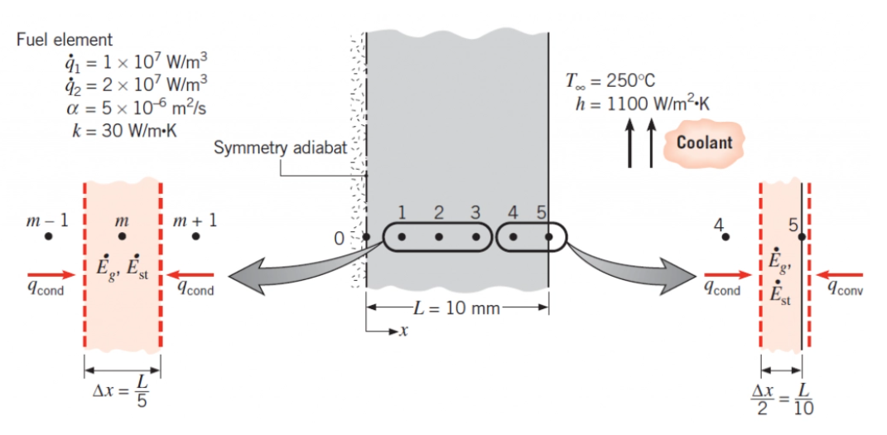

Known: Conditions associated with heat generation in a rectangular fuel element with surface cooling.

Find: Temperature distribution 1.5 s after a change in operating power.

Assumptions:

1. One-dimensional conduction in x.

2. Uniform generation.

3. Constant properties.

PROBLEM SOLVING APPROACH

**ANALYSIS**:

A numerical solution will be obtained using a space increment of

Δ*x=2mm*. Since there is symmetry about the midplane, the nodal network yields 6unknown nodal temperatures. Using the energy balance method, Equation 5.84, an explicit finite-difference equation may be derived for any interior node m.

**HEAT TRANSFER EQUATION FOR INTERMEDIATE NODES**

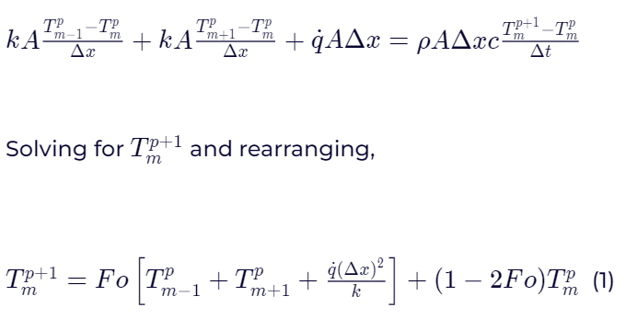

**HEAT TRANSFER EQUATION FOR SURFACE NODE**





**STABILITY CRITERION**

Since the most restrictive stability criterion is associated with Equation 2, we select Fo from the requirement that

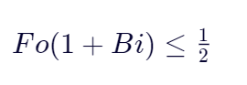

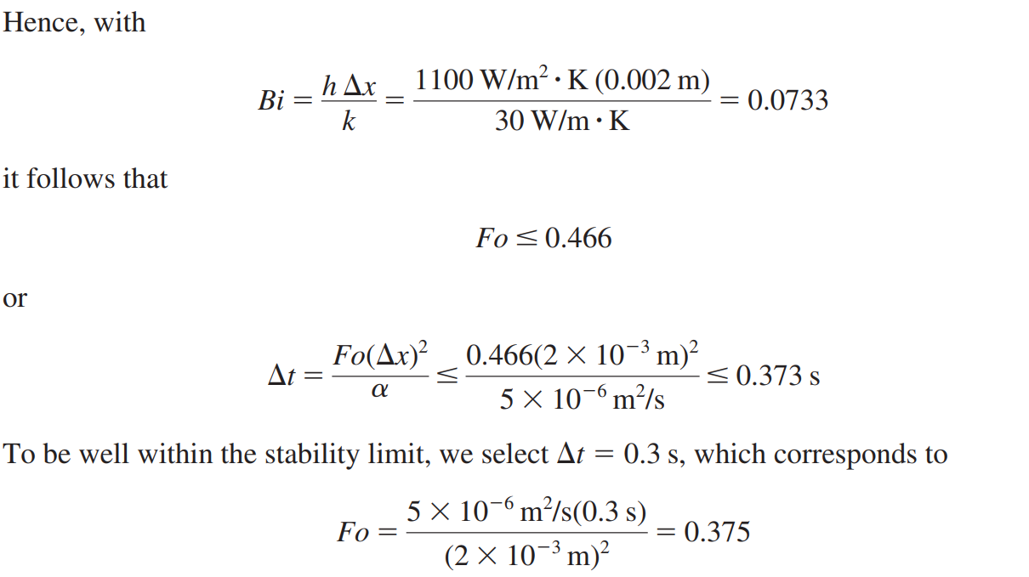

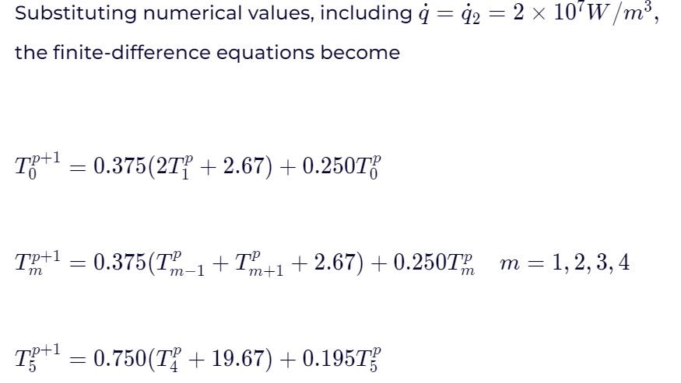

**INITIAL CONDITION (t=0)**

Using equations derived for plane walls at steady state with heat generation at the center (here q = q1 ).



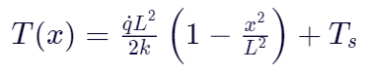

Initial temperatures for the nodal points are shown in the first row of the accompanying table.

**RESULTS**

Using the finite-difference equations, the nodal temperatures may be sequentially calculated with a time increment of 0.3 s until the desired final time is reached.

