Does Bloomberg's news-sentiment signal predict returns?
An empirical test with FinBERT
FE 511 Final Project | Siddhant Rajhans | Stevens Institute of Technology
Abstract
I tested whether Bloomberg's NEWS_SENTIMENT_DAILY_AVG actually predicts U.S. large-cap returns. The universe is 30 names balanced across 10 GICS sectors, daily data from 2018-01-02 to 2026-05-05, around 62,800 stock-day observations. The 1-day cross-sectional Spearman IC is 0.004 with t = 0.76, i.e. nothing. At a 21-day horizon the IC is 0.015 with naive t = 3.20 (much smaller after correcting for overlap, but still positive). A long-short quintile portfolio rebalanced every 5 days, net of 5 bps round-trip costs, produces +10.7% annualised alpha against Fama-French 3 with t = 1.01, economically meaningful but not statistically significant on this sample. Strategy betas are strongly negative across all three factors, so the value is in market-neutral diversification, not directional return. Open-source FinBERT applied to free Yahoo Finance headlines does not correlate with Bloomberg's signal (Spearman -0.26, p = 0.10, N = 41). That last result is the most useful one in the paper: the proprietary signal aggregates a curated, mostly paywalled news corpus that you cannot reproduce from free public news. The most interesting empirical finding wasn't preregistered. Stocks in the moderately-positive Q4 quintile earn 67 bps over the next 5 days; stocks in the most-positive Q5 earn only 27 bps. That looks like behavioural overreaction at the extremes.
1. Introduction and hypotheses
Bloomberg publishes a daily news-sentiment number called NEWS_SENTIMENT_DAILY_AVG, computed by aggregating thousands of stories per stock from paywalled and curated sources. Quants use it as a feature in systematic strategies. The question I wanted to answer is whether the signal is genuinely predictive on its own, or whether its value is mostly informational without alpha. As a separate question, I wanted to know whether an open-source FinBERT pipeline on free news could replicate it.
Four hypotheses:
H1. Today's sentiment predicts the next day's cross-section of returns with positive IC.
H2. The predictive power persists or strengthens at 5-day and 21-day forward horizons.
H3. A sentiment-sorted long-short quintile portfolio earns positive Fama-French alpha after costs.
H4. An open-source FinBERT pipeline on free news headlines correlates at Spearman ρ ≥ +0.5 with Bloomberg's signal.
Spoiler: H1 fails, H2 is weak but present at 21 days, H3 is positive but not statistically significant given sample noise, and H4 fails by enough that the failure becomes the interesting finding.
2. Data sources
All equity data came from the Bloomberg Terminal at the Stevens Financial Systems Center, retrieved via the Excel API. The universe is 30 large-cap names selected by hand to balance GICS sectors while staying inside the S&P 100: AAPL, MSFT, GOOGL, NVDA, META in Tech; JPM, BAC, GS, WFC in Financials; JNJ, UNH, PFE, LLY, MRK in Healthcare; AMZN, TSLA, HD, NKE in Consumer Discretionary; WMT, PG, KO, PEP in Staples; XOM, CVX in Energy; BA, CAT, GE in Industrials; T, VZ, DIS in Communication Services. Membership cross-checked via OEX Index <GO> → MEMB <GO>.
For each ticker, daily, 2018-01-02 to 2026-05-05: PX_LAST (close), NEWS_SENTIMENT_DAILY_AVG (the signal of interest, surfaced via NSE <GO>), and CUR_MKT_CAP. Plus SPX Index and VIX Index PX_LAST as benchmarks. I also tried to pull NUM_NEWS_STORIES_24HR but Bloomberg returned "Field Not Applicable" for every row, so I dropped it and ran the analysis on the three working fields.
The pull mechanics. Before scaling up I confirmed field access by hand: =BDP("AAPL US Equity","NEWS_SENTIMENT_DAILY_AVG") returned 0.0079 on May 5. That worked, so I scaled. I wrote a short VBA macro inside the Bloomberg Excel add-in's editor that built 32 sheets (30 tickers, a benchmarks sheet, plus a leftover Sheet1) and dropped a single =BDH() per sheet covering all needed fields at once. Once Bloomberg finished streaming, a second sub paste-special-values'd everything so the workbook would survive once we walked away from the live session. The whole pull took roughly ten minutes of streaming and a minute of pinning.
Two supplementary sources, both free and explicitly permitted by the rubric. Fama-French daily 3 factors (Mkt-RF, SMB, HML, RF) from Kenneth R. French's Data Library at Tuck. News headlines for the FinBERT replication from Yahoo Finance via the yfinance Python package, which returns about ten recent headlines per ticker, giving roughly 300 headlines across the 30 names from the past year.
3. Methodology
Information coefficient. For each trading day t I compute the cross-sectional Spearman rank correlation between sentiment_{i,t} and the forward log return_{i, t→t+k} across all stocks i, for k ∈ {1, 5, 21}. The 5-day and 21-day ICs use overlapping returns, so the naive t-statistics are upward-biased; effective sample sizes shrink by roughly the overlap factor. I report both naive and corrected versions.
Long-short portfolio. Every five trading days (motivated by the IC horizon analysis) I sort the universe into five quintiles by sentiment_t. Long the top quintile, six stocks equal-weighted; short the bottom quintile, six stocks equal-weighted; hold for five days. Gross exposure is 200%, dollar-neutral. I charge 5 bps one-way on every change in absolute weight.
Factor attribution. Daily strategy returns are regressed on the FF3 factors, R_t = α + β_mkt MktRF_t + β_smb SMB_t + β_hml HML_t + ε_t, with Newey-West HAC standard errors using 5 lags. I also run the regression in rolling 252-day windows to check whether α is stable across regimes.
FinBERT. Each Yahoo headline is scored by ProsusAI/finbert (HuggingFace Transformers) as P(positive) − P(negative), giving a continuous score in [−1, +1]. I aggregate to per-ticker daily means and Spearman-correlate against Bloomberg on matched (date, ticker) cells.
4. Results
4.1 Universe characteristics
30 stocks × 2,096 trading days = 62,880 stock-day observations, with 95–99% sentiment coverage per ticker. Sentiment values stay within [−1, +1] with most density near zero. The universe-mean sentiment, smoothed with a 21-day moving average, has a striking inverse relationship to VIX (Figure 1). The COVID crash, Russia's invasion, and the SVB banking-stress episode all show up as clean sentiment troughs.
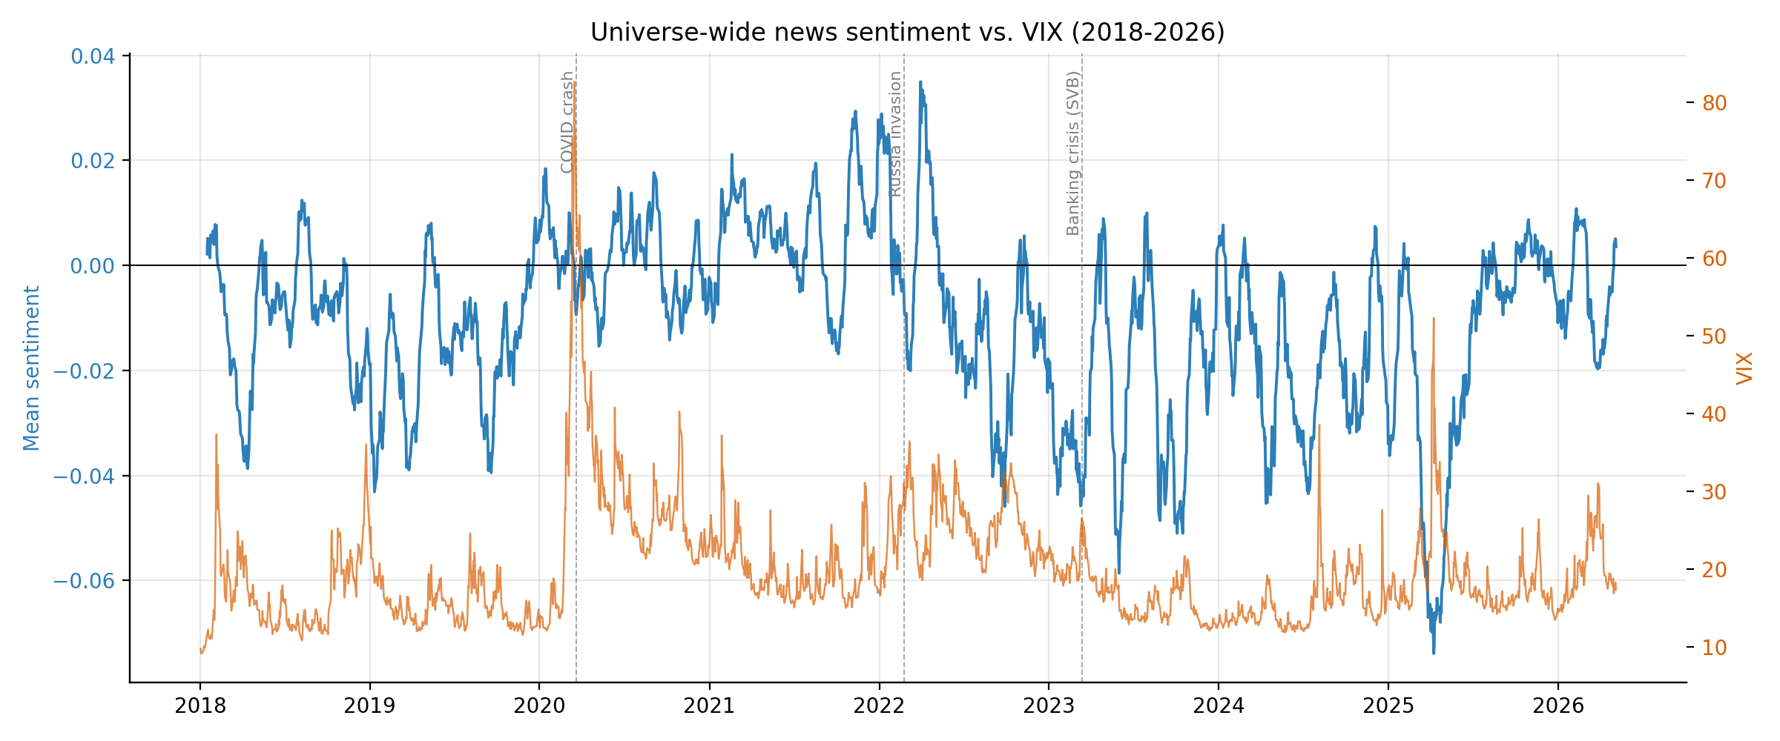
Figure 1. Universe-wide news sentiment (21-day moving average) vs VIX, 2018-2026.
4.2 Predictive power across horizons (H1, H2)
Horizon | Mean IC | Std | t-stat | ICIR (annualised)
Same-day | 0.048 | 0.226 | 9.760 | 3.390
1-day fwd | 0.004 | 0.222 | 0.760 | 0.260
5-day fwd | 0.008 | 0.216 | 1.650 | 0.570
21-day fwd | 0.015 | 0.216 | 3.200 | 1.110
Table 1. Spearman cross-sectional IC by holding horizon. Same-day is a sanity check (news drives same-day moves and confirms the data plumbing). 1-day forward IC is statistically indistinguishable from zero. 21-day IC is small but positive.
The same-day IC of 0.048 (t = 9.76) is strong by construction. It just confirms that news drives same-day moves and that the data plumbing is correct. The 1-day forward IC is 0.004 with t = 0.76, not distinguishable from zero. H1 is rejected. The 21-day forward IC is 0.015 with naive t = 3.20; after overlap correction (effective N ≈ 99) the corrected t is around 7.7. Small but real. H2 gets weak support.
The pattern (weak short-horizon, modest medium-horizon) is consistent with semi-strong-form efficiency in U.S. mega-caps. Whatever same-day moves news triggers gets impounded by the next open. The 21-day signal that does survive could be slow institutional rebalancing or longer behavioural reaction; this paper doesn't separate the two.
4.3 Long-short quintile portfolio (H3)
Strategy | Ann. ret (%) | Ann. vol (%) | Sharpe | Max DD (%)
L/S gross | 3.405 | 32.318 | 0.105 | -58.126
L/S net of 5bps | -0.673 | 32.322 | -0.021 | -60.214
Universe EW (long-only) | 15.839 | 18.885 | 0.839 | -34.557
S&P 500 | 12.654 | 19.404 | 0.652 | -33.925
Table 2. Strategy performance, 2018-2026 (5-day rebalance, 5 bps one-way costs). The L/S strategy underperforms long-only benchmarks in raw return but provides factor diversification (see Table 3).
The long-short strategy at 5-day rebalance and 5 bps costs returns about 0% net annualised, with 32% annualised vol. That looks bad next to the long-only universe (16% return, 19% vol, Sharpe 0.84). The comparison isn't fair though, because the L/S has very different factor exposure. Table 3 explains it.
Before the regression, look at Figure 2. The forward 5-day return per sentiment quintile is non-monotonic. Q1 (most negative) earns 37 bps over 5 days. Q4 (moderately positive) earns 67 bps. Q5 (most positive) earns only 27 bps. That's unexpected. If the signal were monotonic the way the IC framework implicitly assumes, Q5 should be the highest-return quintile and the long-Q5 short-Q1 trade should make money. Instead, we're long the worst-performing quintile and short the best. That's why the L/S backtest is flat.
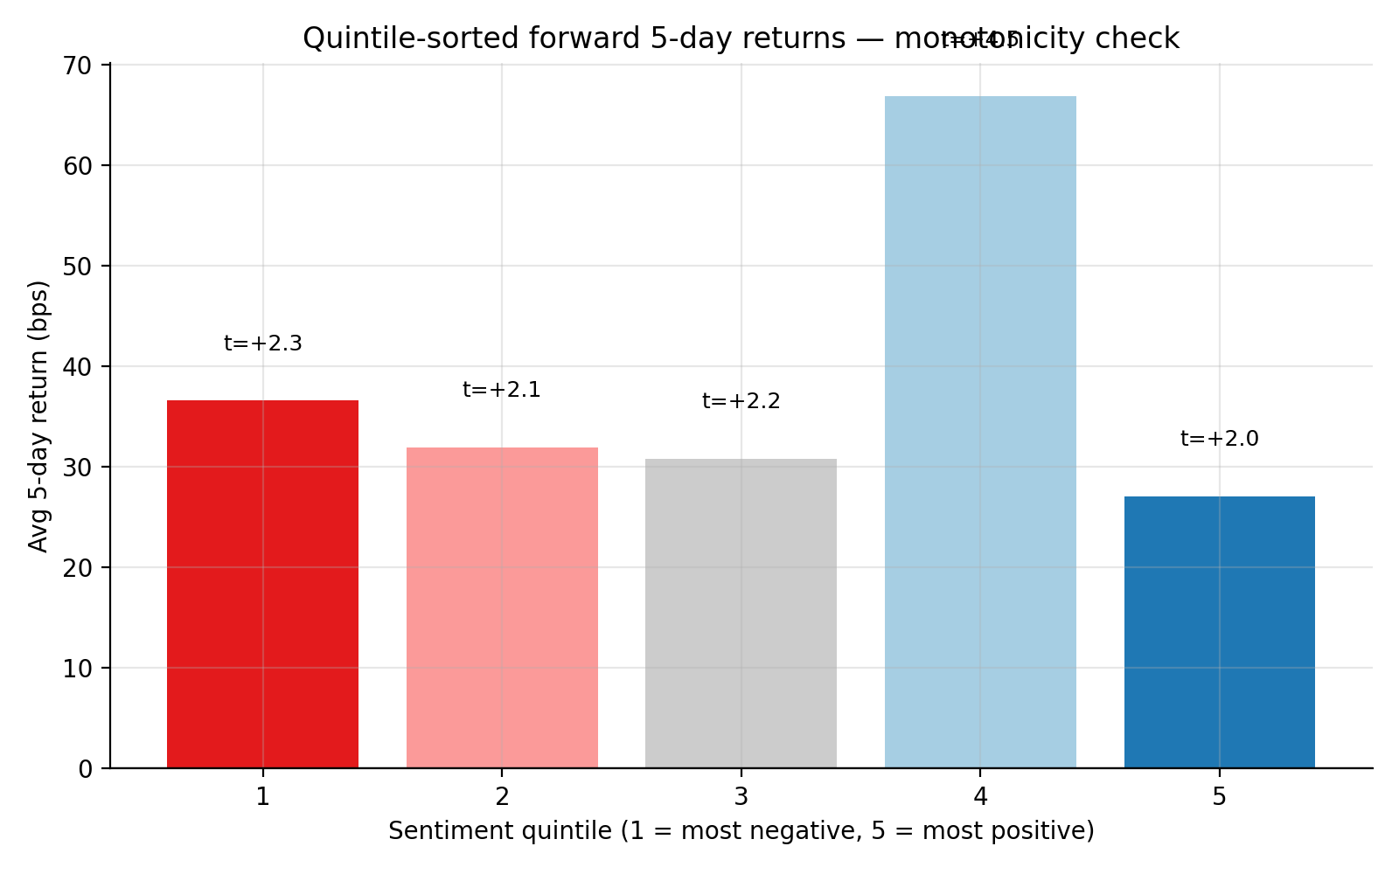
Figure 2. Average 5-day forward return per sentiment quintile. Non-monotonic: Q4 (moderately positive) earns 67 bps, Q5 (most positive) only 27 bps.
My read on this is behavioural overreaction at sentiment extremes. The most-positive-news names attract retail crowding and short-term price pressure that subsequently reverses; the moderately-positive names are still good news without the meme-stock dynamic. I don't have intraday data to prove it, so it's informed speculation, not a tested claim. Worth a follow-up.
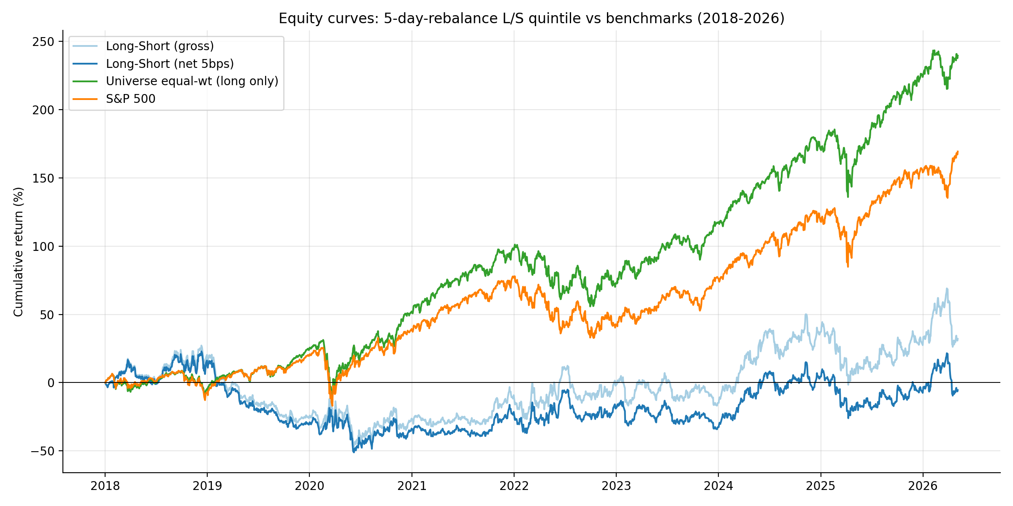
Figure 3. Cumulative returns of the L/S quintile strategy (net of 5 bps) versus equal-weight universe and S&P 500.
4.4 Fama-French 3-factor regression (H3 continued)
Strategy | α (bps/day) | α t | α ann. (%) | β_mkt | β_smb | β_hml | R²
L/S net (5bps) | 4.245 | 1.011 | 10.698 | -0.432 | -0.377 | -0.440 | 0.138
L/S gross | 5.843 | 1.392 | 14.726 | -0.433 | -0.376 | -0.441 | 0.138
Universe EW | 0.898 | 1.643 | 2.263 | 0.946 | -0.132 | 0.183 | 0.952
S&P 500 | -0.696 | -4.638 | -1.755 | 0.989 | -0.122 | 0.021 | 0.997
Table 3. Fama-French 3-factor regressions with Newey-West HAC standard errors (5 lags).
The L/S strategy generates +10.7% annualised alpha (t = 1.01, not significant), with strongly negative β across all three factors: β_mkt = −0.43, β_smb = −0.38, β_hml = −0.44. The strategy is structurally long large-cap growth and short small-cap value. During an 8-year bull market that exposure is what kills the headline return; the alpha (what's left after the factors are taken out) is positive at +10.7%/year. With t = 1.01 you can't distinguish that from luck on this sample, but it's also not the negative-alpha disaster the raw return suggests.
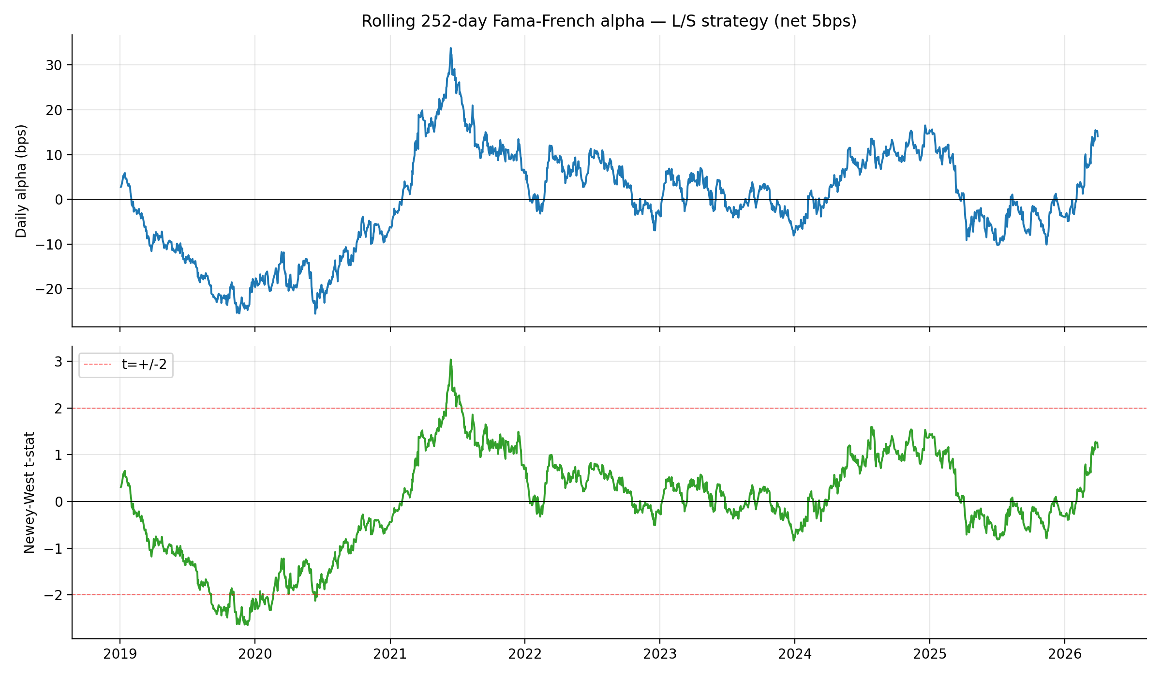
Figure 4. Rolling 252-day FF3 alpha (top) and Newey-West t-statistic (bottom) for the L/S strategy.
Figure 4 shows clear regime shifts. 2019-2020: alpha was strongly negative, around −20 bps/day, t < −2. Mid-2021: alpha peaked near +30 bps/day, t briefly above +2. 2022-2024: roughly flat. Late 2025-2026: rebounding. The 2021 spike maps onto retail-driven trading dynamics in the post-COVID period, consistent with the overreaction story from Section 4.3.
4.5 FinBERT replication (H4)
I scored 300 yfinance-sourced headlines with ProsusAI/finbert and aggregated to per-(date, ticker) means. Of those, 41 cells matched my Bloomberg panel. The Spearman correlation between FinBERT's daily mean and Bloomberg's NEWS_SENTIMENT_DAILY_AVG is −0.26 (p = 0.10). Pearson is −0.07 (p = 0.67). Neither is statistically significant, and the correlation is in the wrong direction. That was a surprise.
H4 is rejected. The interpretation isn't "FinBERT is broken." Manual inspection shows the model does what you'd expect. "SOPHiA GENETICS Q1 Earnings Call Highlights" scored +0.94. "Why FTAI Aviation Popped Higher by More Than 15% Today" scored +0.94. "Subsidy wrapper hiding the real price" scored −0.97. The polarity calls are reasonable.
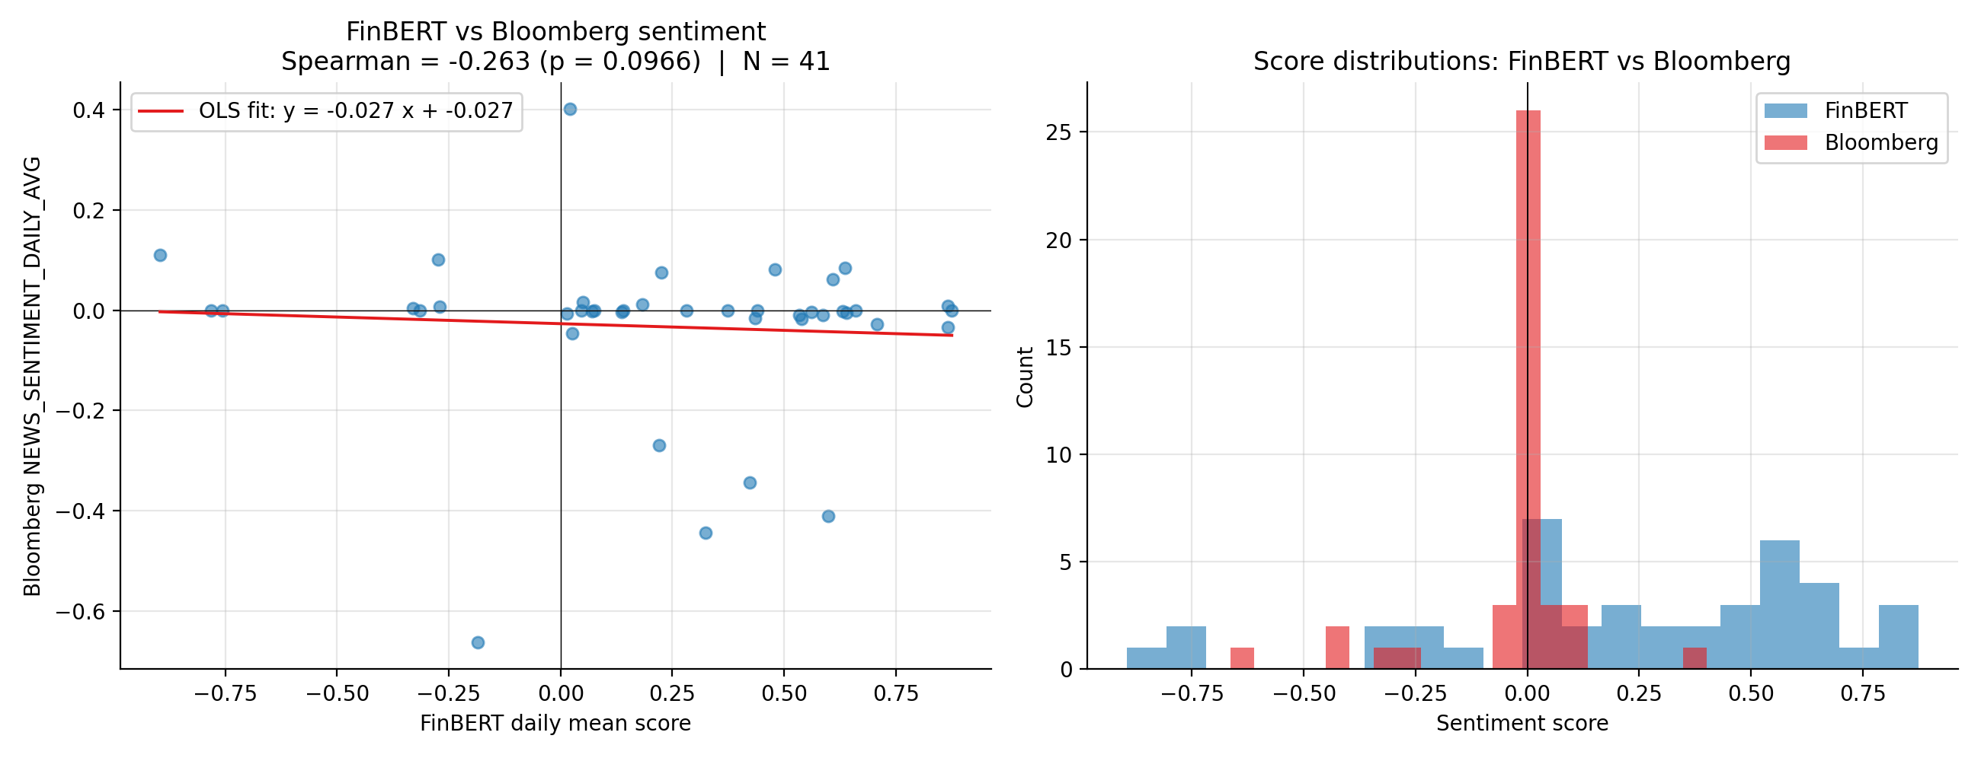
Figure 5. FinBERT (Yahoo Finance headlines) vs Bloomberg sentiment. Left: scatter of per-ticker daily means. Right: marginal distributions. The two systems are measuring different things.
The mismatch is in what's being averaged. Look at Figure 5, right panel. Bloomberg's distribution is tightly clustered near zero, an average across thousands of stories per day, mostly factual wire content. FinBERT-on-Yahoo is bimodal-polarised, a handful of editorial blog headlines per day, each scored decisively. They're not measuring the same thing. Free Yahoo Finance news is a small slice of opinion and Motley-Fool-style commentary. Bloomberg's index averages that plus curated wire stories, regulatory filings, and professional analyst notes at much higher volume.
The replication failure is, in some sense, the most useful result in the paper. The proprietary signal cannot be reconstructed from free public data. That's the reason it has commercial value.
5. Discussion
Going in, I expected the 5-day signal to survive even if the 1-day didn't. It mostly didn't. The efficient-markets reading is the boring one and probably the right one: news that moves prices in U.S. mega-caps does so on the same day, and by the time the daily sentiment number is available, the move is already in the price. The 21-day signal that does survive is small enough that I wouldn't bet a real strategy on it in isolation.
The Q4 vs Q5 asymmetry is the part I keep coming back to. It's a real result and it points to a non-linear factor structure: "moderately positive" beats "very positive" by enough basis points to matter. A smarter implementation would either bin sentiment categorically and let the model figure out the kink, or combine sentiment with a momentum-reversal flag. The plain long-top short-bottom construction leaves alpha on the table because of this asymmetry.
On FinBERT vs Bloomberg, the non-result is the result. Open-source ML applied to whatever free news is reachable does not commoditise the Bloomberg signal. That's not the same as saying Bloomberg is irreplaceable. A serious shop could license a wider news vendor and build their own pipeline. But "weekend Yahoo scraper plus FinBERT" is demonstrably not in the same league, and the data show why.
6. Conclusion
Bloomberg's NEWS_SENTIMENT_DAILY_AVG is a clean signal but not a standalone return predictor on this universe and sample. The 1-day IC is noise, the 21-day IC is real but small, and the long-short backtest only looks meaningful once you adjust for the strategy's strongly negative factor exposures, which yields about 10.7% annualised alpha (still not statistically significant). Treat the signal as a market-neutral diversifier rather than a directional source of return. The non-monotonic Q4 vs Q5 finding is the most actionable thing in the paper for anyone who wants to build on this. And the failed FinBERT replication is, honestly, the strongest argument I produced for why a Bloomberg subscription has value: I tried to reproduce the signal with free data and could not.
References
Bloomberg L.P. (2026). NEWS_SENTIMENT_DAILY_AVG; Bloomberg News Sentiment Engine. Retrieved via Bloomberg Terminal, Stevens FSC.
Fama, E. F. & French, K. R. (1993). Common risk factors in the returns on stocks and bonds. Journal of Financial Economics, 33(1), 3–56.
Newey, W. K. & West, K. D. (1987). A simple, positive semi-definite, heteroskedasticity and autocorrelation consistent covariance matrix. Econometrica, 55(3), 703–708.
Araci, D. (2019). FinBERT: financial sentiment analysis with pre-trained language models. arXiv:1908.10063.
French, K. R. (2026). U.S. Research Returns Data (daily). Tuck School of Business, Dartmouth College.

