**SOFTWARE REQUIREMENTS SPECIFICATION**

JURASSIC WORLD-PARK MANAGEMENT SYSTEM

**Table of Contents**

1. **INTRODUCTION**
   1. Purpose
   2. Scope
   3. Document Conventions
   4. Intended Audience and Reading Suggestions
   5. References
2. **OVERALL DESCRIPTIONS**
   1. Product Perspective
   2. Product Features
   3. User Class and Characteristics
   4. Operating Environment
3. **EXTERNAL INTERFACE REQUIREMENTS**
   1. User Interfaces
   2. Hardware Interfaces
   3. Software Interfaces

**1. INTRODUCTION**

**1.1 Purpose**

The main objective of this document is to illustrate the requirements of the project- Jurassic World Park Management System. The document gives the detailed description of the both functional and non-functional requirements proposed by the client. The purpose of this project is to provide a friendly environment (admin side)-maintain the details of dinosaurs, their details and visitors of the park, manage the hotels and tour packages and (user side)-to book their tickets with the best choice available and an option to cancel the ticket. The main purpose of this project is to maintain easy circulation system using computers and to provide different reports. This project describes the hardware and software interface requirements using ER diagrams.

**1.2 Scope**

The scope of development of Park Management System is basically updating the manual(offline) Park system into an internet-based application (fully automated) so that the users can know the details of their accounts, availability of tickets and maximum limit for booking and have the best choice to book the ticket. The project is specifically designed for the use of visitors and staff. The system is based on relational database with its ticket booking functions. The project can be easily implemented under various situations for e.g. It can be used for National Park, Biological Park and even Amusement Park. We can add new features as and when we require, making reusability possible as there is flexibility in all the modules.

The language used for developing the project is PHP, MYSQL, HTML, CSS and JS as it is quite advantageous than other languages in terms of performance, tools available, cost (freely available), and development process.

**1.3 Document Conventions**

DB Database

ER Entity Relationship

**1.4 Intended Audience and Reading Suggestions**

This project is a prototype of Park Management system and it is restricted within the college premises. This has been implemented under the reference of various sites and books and under the guidance of college professors. This project is useful for park administration staff as well as to the tourists.

**1.5 References**

Books: Database System Concepts 6th edition McGraw Hill Education

Websites: [www.w3chools.com](http://www.w3chools.com), www.wikipedia.org

**2. OVERALL DESCRIPTIONS**

**2.1 Product Perspective**

The park database system stores the following information:

* **Account holders**

It includes the username, name, contact no., email, etc.

* **Hotel details**

It includes the hotel id, name, location and no. of rooms of each type and their prices.

* **Ticket description**

It includes the details of tickets booked by a valid username at valid hotel with checkin date and checkout date and tour package details with card no. as payment reference.

* **Enquiry description**

It includes the enquiry details asked by website user related to park.

* **Feedback details**

It includes the feedback details posted by tourist after his/her tour experience.

* **Dinosaurs information**

It consists the dinosaur id and its details.

* **Card Details(Dummy Payment)**

It includes card number, card name and balance with cvv , expiry details.

**2.2 Product Features**

The major features of park management system is shown in below entity-relationship model(ER Diagram)

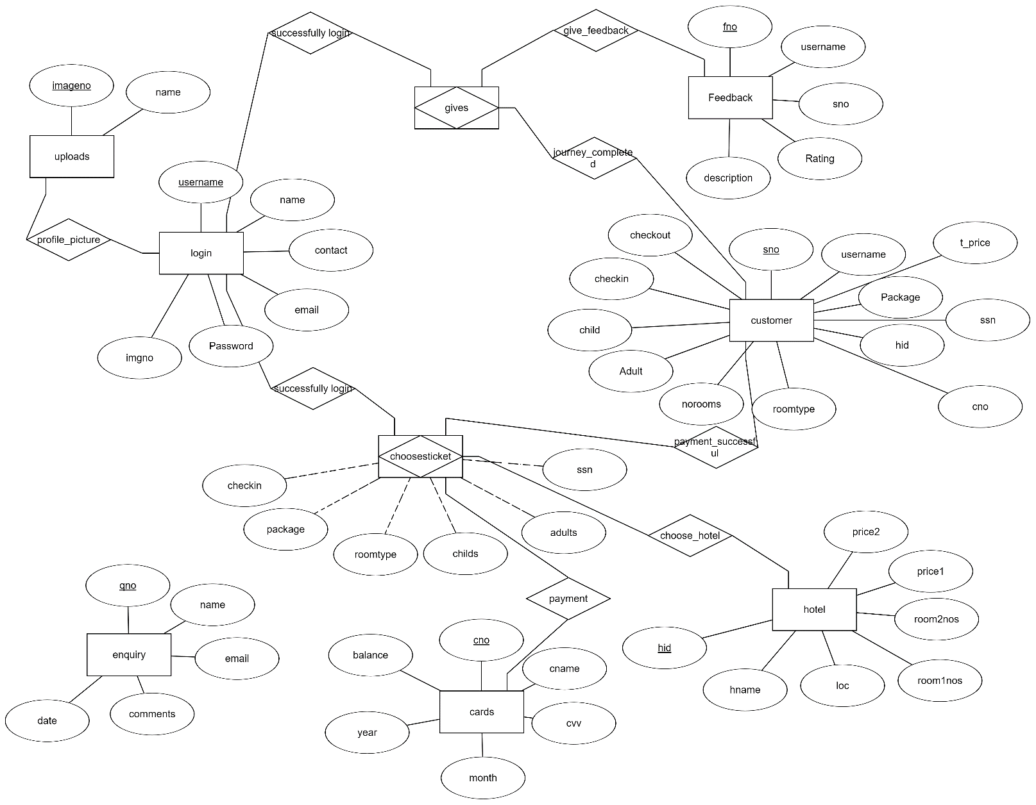

**2.3 User Class And Characteristics**

Users of the system should be able to retrieve the information about packages and then select the available hotel options to confirm their ticket for tour in park and accommodation in park hotels. The system will support two user privileges: Customer and Admin Employee.

Customer will have access to customer functions, and the admin employees will have access to both customer and park management functions.

The customer should be able to do following functions:

* Can view the different breed of dinosaurs in the park.

* Put a new booking request in the following available tour packages
* Adrenaline Package
* John Hammond Package
* Family Package
* Can select the available hotel options for accomodation.
* Cancel an existing ticket.
* View his/her profile.
* Can put a feedback on the tickets booked through his dashboard.

The admin employee should be able to do following functions:

* Add the dinosaur and update an existing dinosaur information.
* View the tickets booked.
* Respond to the queries asked by the website users.
* Hotels Administration
* Get the details of the hotel through id.
* Update the no. of rooms and their prices (Increase/Decrease).
* Get the information about tickets booked in the particular hotel.
* Same functions as of Customer to check if faults occur in customer side.

**2.4 Operating Environment**

Operating System: Windows

Database: mySQL

Platform: PHP

Browsers: Google Chrome, Mozilla Firefox

**3. EXTERNAL INTERFACE REQUIREMENTS**

**3.1 User Interfaces**

* Front End Software: HTML, CSS, Javascript
* Back End Software: PHP, mySQL

**3.2 Hardware Interfaces**

* Windows
* A browser which support HTML,CSS & Javascript

**3.3 Software Interfaces**

* Operating System: We have chosen Windows OS for its best support and user-friendliness.
* Database: To save the database information we have chosen mySQL database.
* Sublime Text: To implement the project we have chosen sublime text software.