**COEN 380**

**Project 1**

1. **JDBC DRIVER CONNECTED IS Connector/ J 8.0.19**
2. **CREATE TABLES**

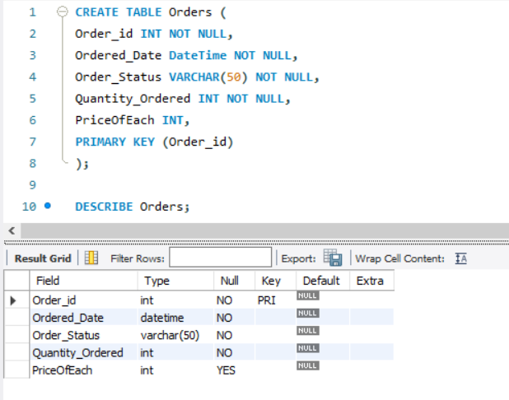

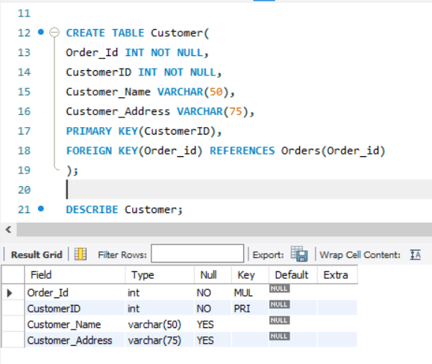

1. **INSERT STATEMENT**

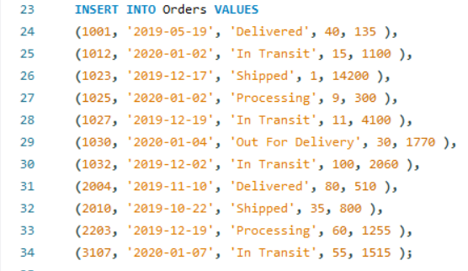

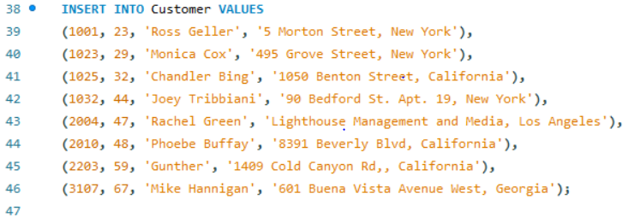

1. **SELECT STATEMENT**

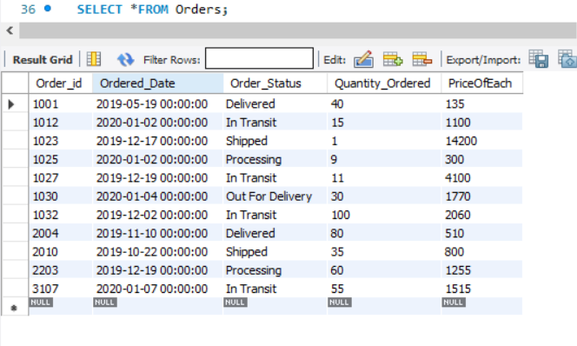

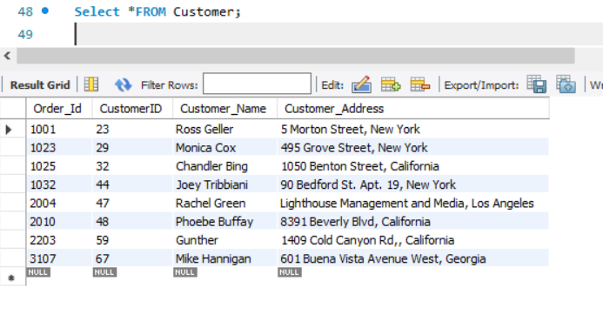

1. **UPDATE STATEMENT**

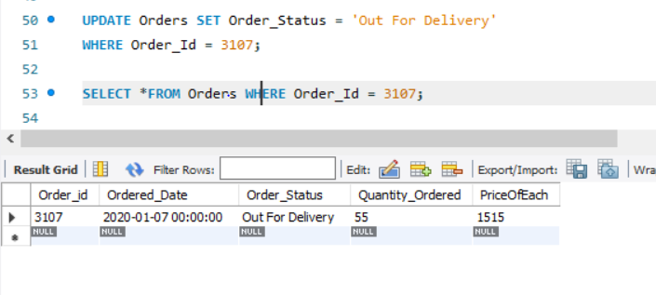

1. **DELETE STATEMENT**

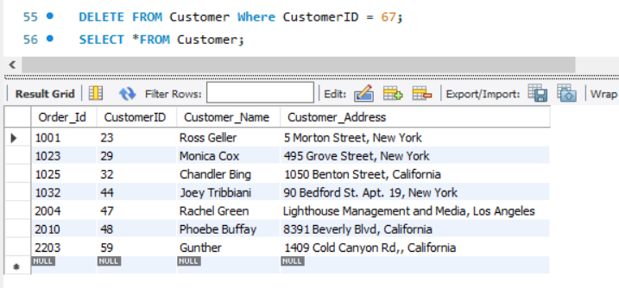

1. **INNER JOIN STATEMENT**

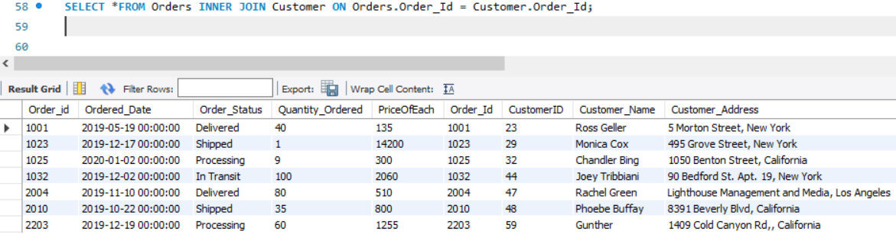

1. **LEFT JOIN STATEMENT**

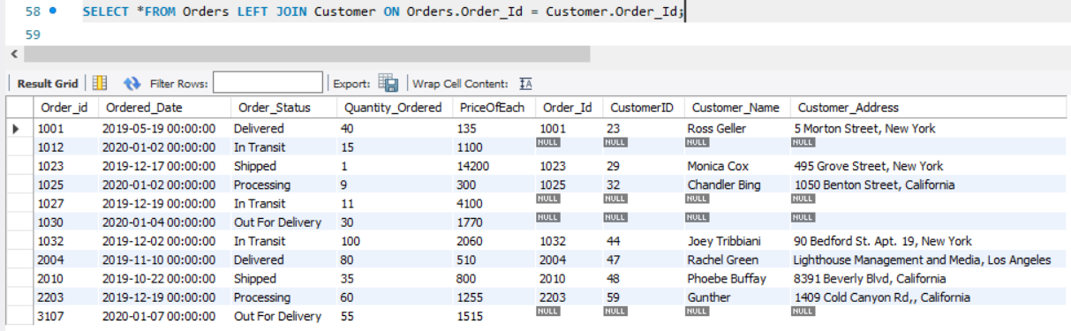

1. **RIGHT JOIN STATEMENT**

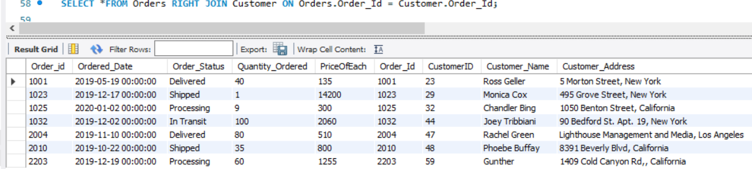

1. **ORDER BY STATEMENT**

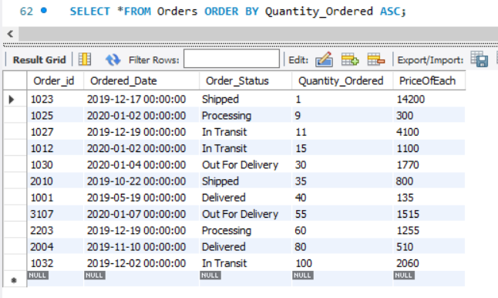

1. **GROUP BY STATEMENT**

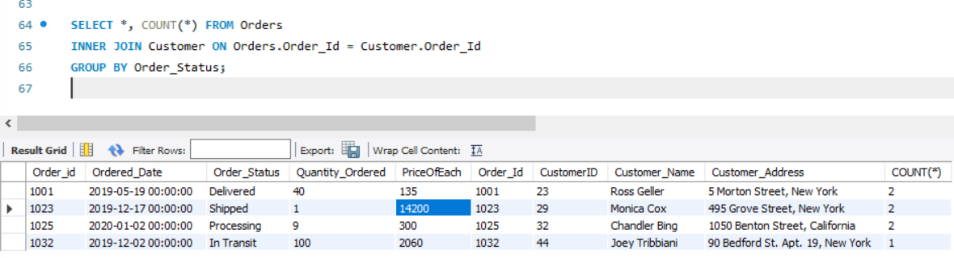

1. **AGGREGATE FUNCTIONS STATEMENT**

**MAX() MIN() COUNT() AVG() SUM()**

