Name :- Ashutosh Ulhas Chandurkar Div :- A Roll No :- 30

Assignment 4 :- Write a Program in Solidity to create students data. Use the following Constructs

* Structure
* Arrays
* Fallback

Code :-

pragma solidity >= 0.5.1;

//Declare the smart Contract contract StudentMarks {

struct Student { int ID; string fname; string lname; int marks;

}

address owner;

int public stdCount = 0;

mapping(int => Student) public stdRecords;

modifier onlyOwner { require(owner == msg.sender);

_;

}

//Declaring the Constructors constructor () public

{

owner == msg.sender;

}

function addNewRecords( int _ID,

string memory _fName, string memory _lName, int _marks

) public onlyOwner { stdCount = stdCount + 1;

//fetch the data

stdRecords[stdCount] = Student(_ID, _fName, _lName, _marks);

}

//function to add bonus marks

function bonusMarks(int _bonus) public onlyOwner{ stdRecords[stdCount].marks = stdRecords[stdCount].marks + _bonus;

}

}

**Output** :-

* Compile and Run :-

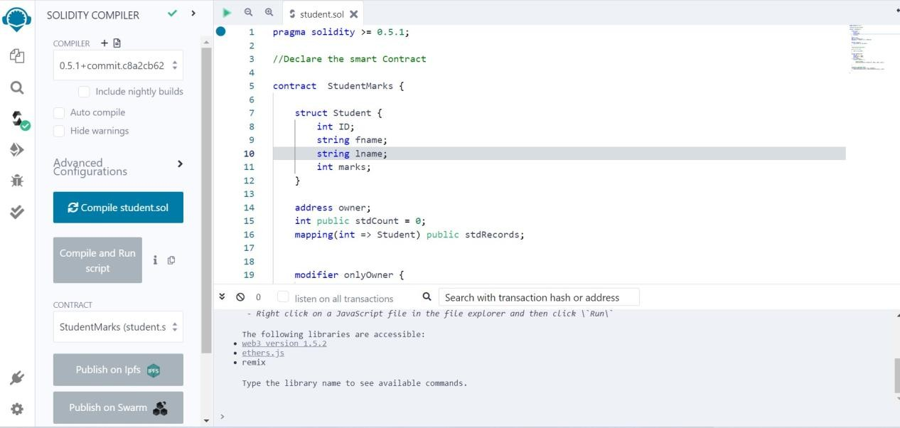

* Deploy :-

