ECG SIMULATION USING MATLAB

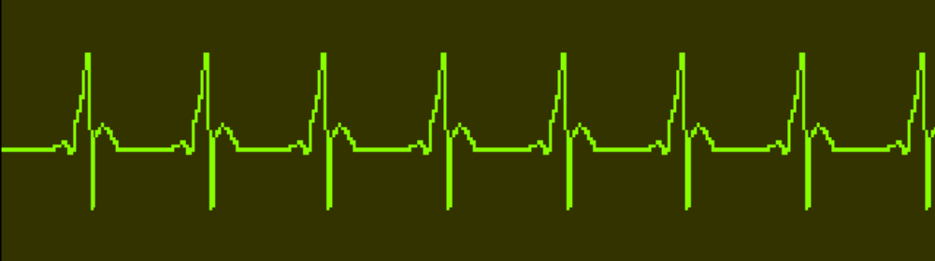

SIGNALS AND SYSTEM
PROF. SHARMILA N

MADE BY:
SIDDHANT AGARWAL(17BEC0431)
SHUBHAM AGARWAL(17BEC0693)

Introduction:
The aim of the ECG simulator is to produce the typical ECG waveforms of different leads and as many arrhythmias as possible. My ECG simulator is a matlab based simulator and is able to produce normal lead II ECG waveform.

The use of a simulator has many advantages in the simulation of ECG waveforms. First one is saving of time and another one is removing the difficulties of taking real ECG signals with invasive and noninvasive methods. The ECG simulator enables us to analyze and study normal and abnormal ECG waveforms without actually using the ECG machine. One can simulate any given ECG waveform using the ECG simulator.

Significant features of ECG waveform:
A typical scalar electrocardiographic lead is shown in Fig. 1, where the significant features of the waveform are the P, Q, R, S, and T waves, the duration of each wave, and certain time intervals such as the P-R, S-T, and Q-T intervals.

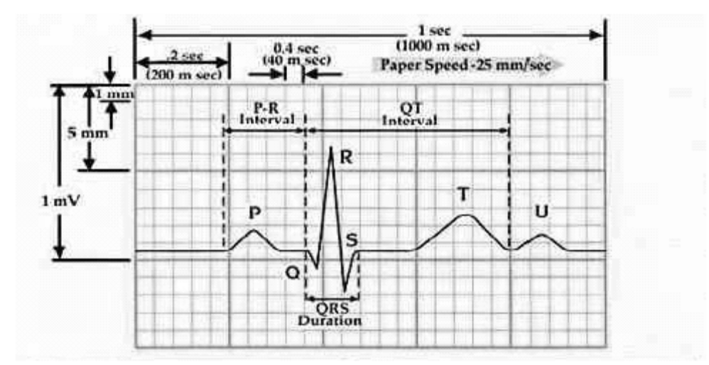
fig 1.Typical ECG signal

Main features of this simulator:
- Any value of heart beat can be set
- Any value of intervals between the peaks (ex-PR interval) can be set
- Any value of amplitude can be set for each of the peaks
- Fibrillation can be simulated
- Noise due to the electrodes can be simulated
- Heart pulse of the particular ECG wave form can be represented in a separate graph

Calculations:
If we observe figure1, we may notice that a single period of a ECG signal is a mixture of triangular and sinusoidal wave forms. Each significant feature of ECG signal can be represented by shifted and scaled versions one of these waveforms as shown below.
- QRS, Q and S portions of ECG signal can be represented by triangular waveforms
- P, T and U portions can be represented by triangular waveforms
Once we generate each of these portions, they can be added finally to get the ECG signal.

MATLAB CODE
x=0.01:0.01:2;
default=input('Press 1 if u want default ecg signal else press 2:\n');
if(default==1)
li=30/72;

a_pwav=0.25;
d_pwav=0.09;
t_pwav=0.16;

a_qwav=0.025;
d_qwav=0.066;
t_qwav=0.166;

a_qrswav=1.6;
d_qrswav=0.11;

a_swav=0.25;
d_swav=0.066;
t_swav=0.09;

a_twav=0.35;
d_twav=0.142;
t_twav=0.2;

a_uwav=0.035;
d_uwav=0.0476;
t_uwav=0.433;
else
rate=input('\n\nenter the heart beat rate :');
li=30/rate;

%p wave specifications
fprintf('\n\np wave specifications\n');
d=input('Enter 1 for default specification else press 2: \n');
if(d==1)
a_pwav=0.25;
d_pwav=0.09;
t_pwav=0.16;
else
a_pwav=input('amplitude = ');
d_pwav=input('duration = ');
t_pwav=input('p-r interval = ');
d=0;
end

%q wave specifications
fprintf('\n\nq wave specifications\n');
d=input('Enter 1 for default specification else press 2: \n');
if(d==1)
a_qwav=0.025;
d_qwav=0.066;
t_qwav=0.166;
else
a_qwav=input('amplitude = ');
d_qwav=input('duration = ');
t_qwav=0.1;
d=0;
end

%qrs wave specifications
fprintf('\n\nqrs wave specifications\n');
d=input('Enter 1 for default specification else press 2: \n');
if(d==1)
a_qrswav=1.6;
d_qrswav=0.11;
else
a_qrswav=input('amplitude = ');
d_qrswav=input('duration = ');
d=0;
end

%s wave specifications
fprintf('\n\ns wave specifications\n');
d=input('Enter 1 for default specification else press 2: \n');
if(d==1)
a_swav=0.25;
d_swav=0.066;
t_swav=0.125;
else
a_swav=input('amplitude = ');
d_swav=input('duration = ');
t_swav=0.125;
d=0;
end

%t wave specifications
fprintf('\n\nt wave specifications\n');
d=input('Enter 1 for default specification else press 2: \n');
if(d==1)
a_twav=0.35;
d_twav=0.142;
t_twav=0.18;
else
a_twav=input('amplitude = ');
d_twav=input('duration = ');
t_twav=input('s-t interval = ');
d=0;
end
%u wave specifications
fprintf('\n\nu wave specifications\n');
d=input('Enter 1 for default specification else press 2: \n');
if(d==1)
a_uwav=0.035;
d_uwav=0.0476;
t_uwav=0.433;
else
a_uwav=input('amplitude = ');
d_uwav=input('duration = ');
t_uwav=0.433;
d=0;
end
end

pwav=p_wav(x,a_pwav,d_pwav,t_pwav,li);

%qwav output
qwav=q_wav(x,a_qwav,d_qwav,t_qwav,li);

%qrswav output
qrswav=qrs_wav(x,a_qrswav,d_qrswav,li);

%swav output
swav=s_wav(x,a_swav,d_swav,t_swav,li);

%twav output
twav=t_wav(x,a_twav,d_twav,t_twav,li);

%uwav output
uwav=u_wav(x,a_uwav,d_uwav,t_uwav,li);

%ecg output
ecg=pwav+qrswav+twav+swav+qwav+uwav;
figure(1)
plot(x,ecg);

FOR P WAVE
function [pwav]=p_wav(x)
l=1;
a=0.25
x=x+(1/1.8);
b=3;
n=100;
p1=1/l
p2=0
for i = 1:n
harm1=(((sin((pi/(2*b))*(b-(2*i))))/(b-(2*i))+(sin((pi/(2*b))*(b+(2*i))))/(b+(2*i)))*(2/pi))*cos((i*pi*x)/l);
p2=p2+harm1
end
pwav1=p1+p2;
pwav=a*pwav1;

FOR Q WAVE
function [qwav]=q_wav(x)
l=1;
x=x+l/6
a=0.025;
b=15;
n=100;
q1=(a/(2*b))*(2-b);
q2=0
for i = 1:n
harm5=(((2*b*a)/(i*i*pi*pi))*(1-cos((i*pi)/b)))*cos((i*pi*x)/l);
q2=q2+harm5;
end
qwav=-1*(q1+q2);

FOR R WAVE
function [qrswav]=qrs_wav(x)
l=1;
a=1;
b=5;
n=100;
qrs1=(a/(2*b))*(2-b);
qrs2=0
for i = 1:n
harm=(((2*b*a)/(i*i*pi*pi))*(1-cos((i*pi)/b)))*cos((i*pi*x)/l);
qrs2=qrs2+harm;
end
qrswav=qrs1+qrs2;

FOR S WAVE
function [swav]=s_wav(x)
l=1;
x=x-l/6
a=0.25;
b=15;
n=100;
s1=(a/(2*b))*(2-b);
s2=0
for i = 1:n
harm3=(((2*b*a)/(i*i*pi*pi))*(1-cos((i*pi)/b)))*cos((i*pi*x)/l);
s2=s2+harm3;
end
swav=-1*(s1+s2);

FOR T WAVE
function [twav]=t_wav(x)
l=1;
a=0.35
x=x-(1/1.8);
b=7;
n=20;
t1=1/l
t2=0
for i = 1:n
harm2=(((sin((pi/(2*b))*(b-(2*i))))/(b-(2*i))+(sin((pi/(2*b))*(b+(2*i))))/(b+(2*i)))*(2/pi))*cos((i*pi*x)/l);
t2=t2+harm2
end
twav1=t1+t2;
twav=a*twav1;

FOR U WAVE
function [uwav]=u_wav(x)
l=1;
a=0.03;
x=x-(1/1.1);
b=21;
n=100;
u1=1/l;
u2=0;
for i = 1:n
harm4=(((sin((pi/(2*b))*(b-(2*i))))/(b-(2*i))+(sin((pi/(2*b))*(b+(2*i))))/(b+(2*i)))*(2/pi))*cos((i*pi*x)/l);
u2=u2+harm4;
end
uwav1=u1+u2;
uwav=a*uwav1;

Default Specification

- Heart beat :72
- Amplitude:
P wave 25mV
R wave 1.60mV
Q wave 0.025mV
T wave 0.35mV
- Duration:
P-R interval 0.16s
S-T interval 0.18s
P interval 0.09s
QRS interval 0.11s

References:
1. https://www.Wikipedia.com/
2. https://www.medicalnewstoday.com/articles/
3. https://www.mathworks.com/matlabcentral/
4. https://www.ncbi.nlm.nih.gov/pmc/articles/

