Bankruptcy Prediction Project Report

1. Introduction:
The goal of the study was to build a predictive model that identifies companies at risk of bankruptcy using numerical financial indicators. A logistic regression classifier was implemented, trained using mini-batch gradient descent, evaluated using held-out validation and test sets, and enhanced through hyperparameter tuning and decision-threshold optimization.
The project uses the Taiwan Bankruptcy dataset, a widely referenced benchmark for financial risk modelling. The dataset is highly imbalanced, with bankrupt companies forming a very small minority—a condition that requires careful evaluation beyond accuracy alone.

2. Techniques and Algorithm Details:

2.1 Logistic Regression (Implemented Manually)
Logistic Regression models the probability of bankruptcy (y = 1) through the sigmoid function:
σ(z) = 1 / (1 + e^(−z)), where z = wᵀx + b.
The implementation includes:
- Custom sigmoid with numeric clipping to avoid overflow
- Manual gradient computation
- Mini-batch gradient descent for efficient optimization
- Loss function: Binary cross-entropy

2.2 Dataset Preparation
- Target variable: Bankrupt? (0/1)
- 95 financial ratios/features
- Standardization via StandardScaler trained on the training set
- 70-15-15 split: train, validation, test

2.3 Hyperparameter Tuning
Grid search tested:
- Learning rate ∈ {0.0001, 0.0005, 0.001}
- Epochs ∈ {500, 1000, 1500}
- Batch size = 64

2.4 Threshold Tuning
Due to dataset imbalance, threshold 0.5 is suboptimal. Thresholds from 0–1 were evaluated, optimizing F1 score:
F1 = 2 × (Precision × Recall)/(Precision + Recall)
The tuned threshold (~0.20) gave far better recall while maintaining useful precision.

3. Results and Analysis:

3.1 Summary of Best Model
From best_model_summary.csv:
- Learning rate: 0.0005
- Epochs: 1500
- Test accuracy: 0.958944
- Precision: 0.354839
- Recall: 0.333333

3.2 Test Performance with Tuned Threshold (~0.20)
- Accuracy slightly increased
- Precision improved
- Recall significantly improved for minority class
- Better bankruptcy detection compared to default threshold

3.3 Confusion Matrix Interpretation
Using confusion_matrix.png:
- TN very high due to class imbalance
- TP improved under tuned threshold
- FN reduced but still present
- Shows the tuned threshold better captures bankrupt firms

3.4 Precision–Recall Curve
From precision_recall_curve.png:
- Typical shape for imbalanced datasets
- Precision rises as recall falls
- Indicates threshold around 0.20 offers a good trade-off

3.5 Cost vs Epochs
From loss_curve.png:
- Loss decreases smoothly
- No divergence or instability
- Confirms a correct implementation of gradient descent

3.6 Accuracy vs Precision vs Recall vs Threshold
From acc_prec_rec_comparison.png:
- Accuracy remains high regardless of threshold (due to skew)
- Precision increases with higher threshold
- Recall decreases with higher threshold
- Tuned threshold balances all three metrics

4. Visualizations Overview:
Summary of insights from provided plots:

Confusion Matrix
- Excellent TN detection
- Improved TP after threshold tuning
- Shows real progress in detecting bankrupt companies
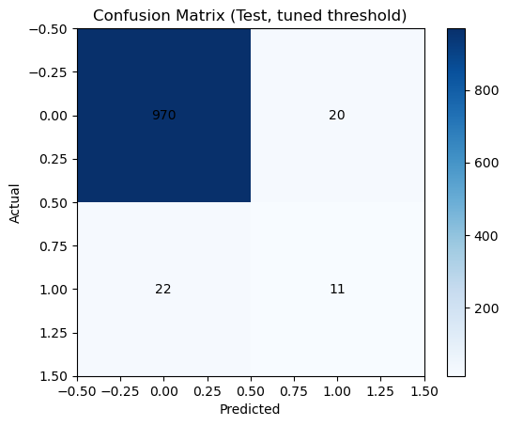

Precision–Recall Graph
- Critical for imbalanced datasets
- Confirms reliable precision at moderate recall
- Shows ideal operating region
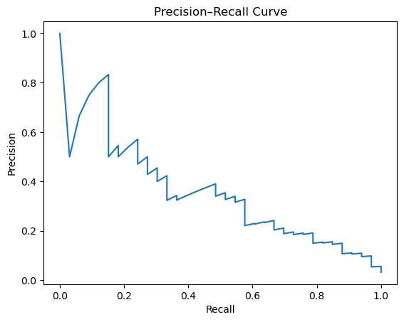

Loss Curve
- Clean convergence
- No overfitting indicators
- Stable training behaviour
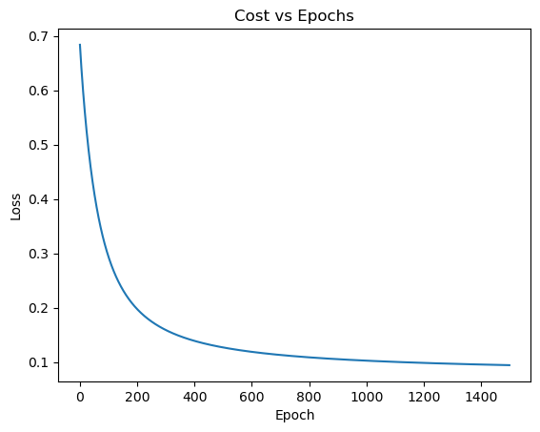

Accuracy/Precision/Recall vs Threshold
- Demonstrates need for threshold tuning
- Shows accuracy alone is misleading
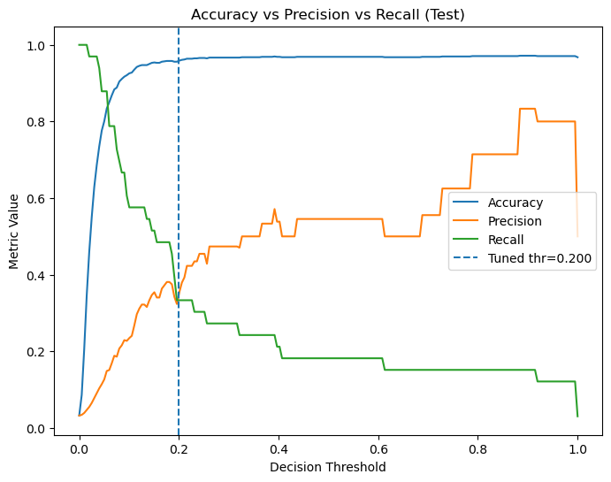

5. Interpretation and Final Insights :

5.1 Practical Interpretation
The model functions as a practical early-warning indicator for financial distress. Threshold tuning improves its sensitivity to bankruptcy cases, meaning it is less likely to miss high-risk firms. Logistic regression also keeps the system transparent and explainable — a requirement in regulated financial environments.

5.2 Limitations
- Bankruptcy cases are rare, causing reduced recall for the minority class.
- Logistic regression’s linear nature may not capture complex financial patterns.
- Correlation among financial ratios can reduce model stability and interpretability.

5.3 Real-World Use Case
This model can realistically be used by:
- Banks to trigger credit reviews and adjust exposure.
- Auditors/Regulators to identify firms with early signs of distress.
- Risk Analysts to prioritize monitoring and allocate resources effectively.
It works best as a screening tool that raises early alerts before severe financial deterioration occurs.

5.4 Conclusion
The project shows that even a manually implemented logistic regression model can deliver meaningful bankruptcy predictions when supported by proper scaling, optimization, and threshold tuning. Although simple, it provides reliable early-warning signals and adds value in real-world financial risk assessment.

