# Assignment -6 (Big Data Lab)

## Name :- Aditya Prakash

## Roll No. :- 11

## Section :- C

## URN :- 201500036

## Submitted to :- : Dr. Robin Singh Bhadoria

**1) Use ‘diamonds’ dataset and qplot ( ) of ggplot2 Package for following operations:**

**(a) Plot a relationship between parameters like price and carats (weight)**

**(b) Customize colour, size, & shape**

**(c) Adding a smoother to a plot using geoms**

**(d) Boxplots and jittered points using geoms**

**(e) Histogram and density plots using geoms**

**(f) Bar charts using geoms**

**(g) faceting method in qplot()**

**(h) Building a scatterplot using factor ( ) function**

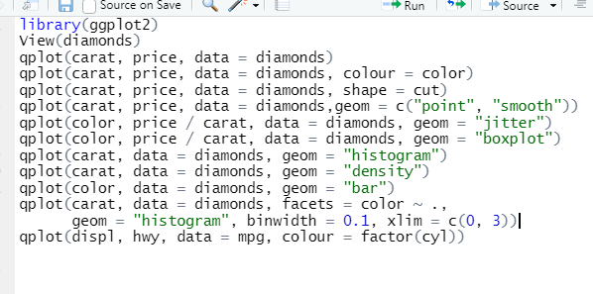

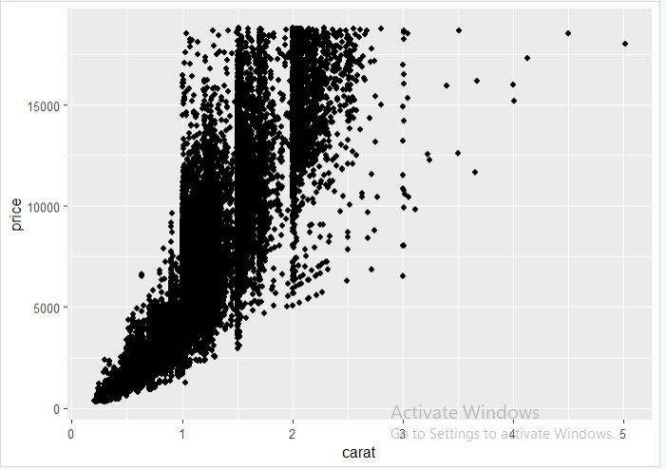

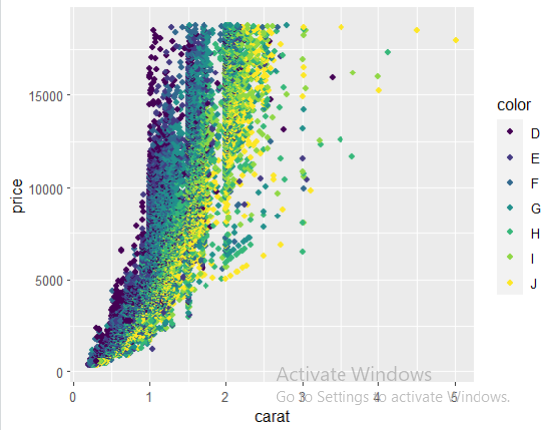

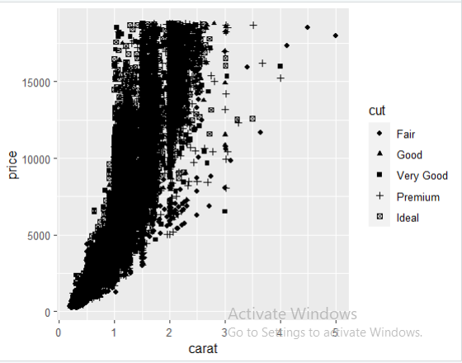

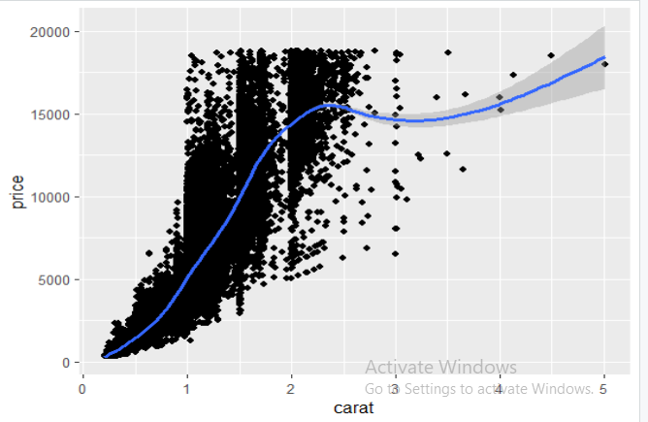

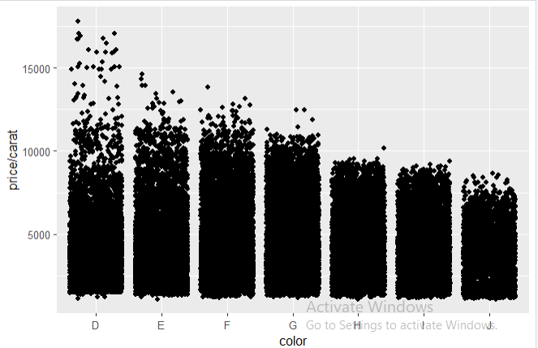

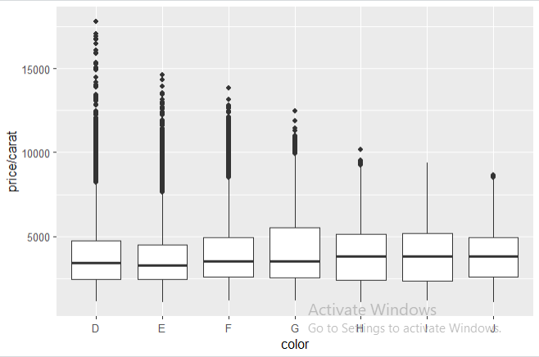

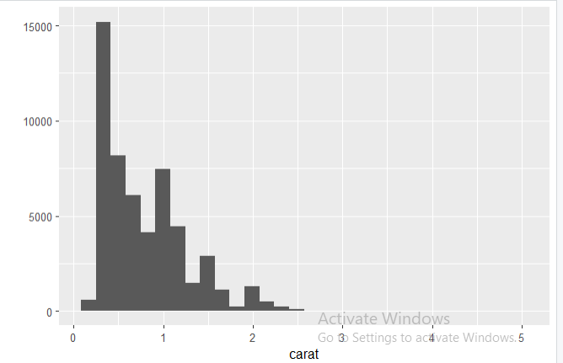

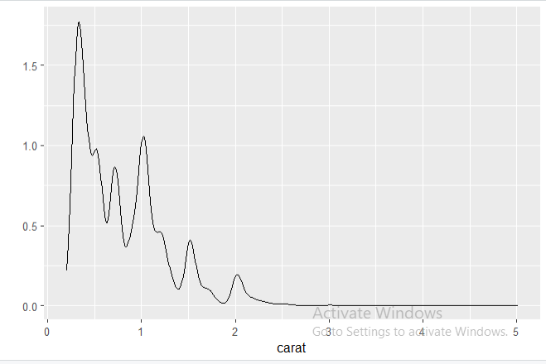

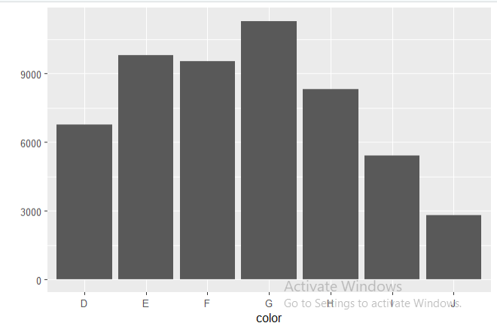

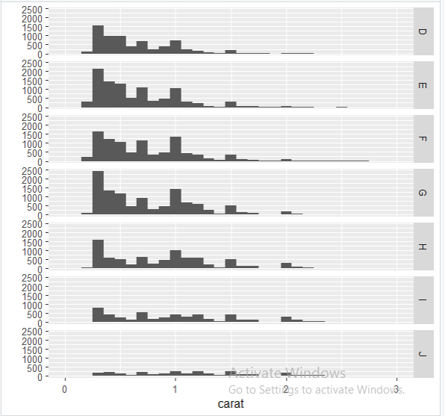

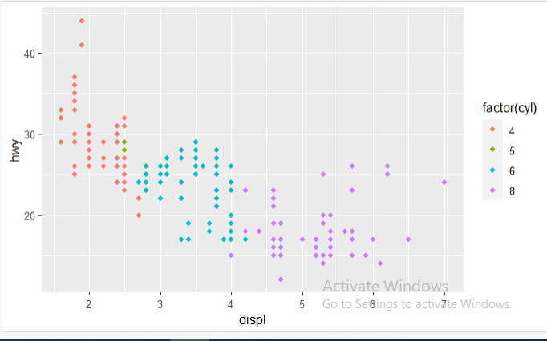

**2) Use ‘mtcars’ dataset and ggplot ( ) of ggplot2 Package for following operations**

**(a) Data Layer**

**(b) Aesthetic Layer**

**(c) Geometric layer**

**(d) Adding size**

**(e) Adding color and shape**

**(f) Histogram plot**

**(g) Facet Layer**

**(h) Statistics layer**

**(i) Coordinates layer: Control plot dimensions**

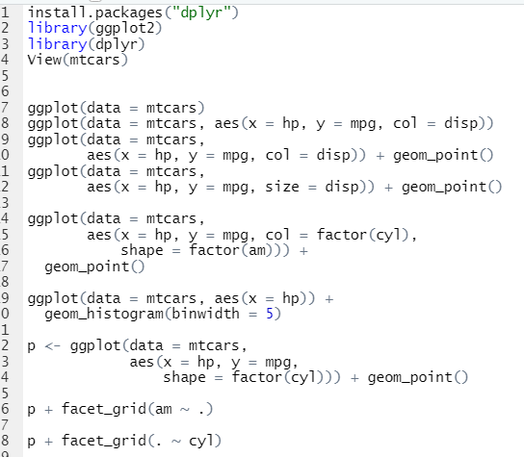

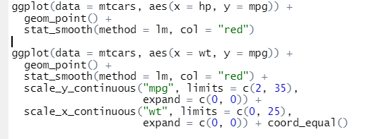

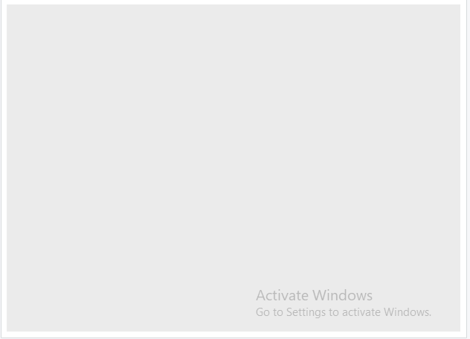

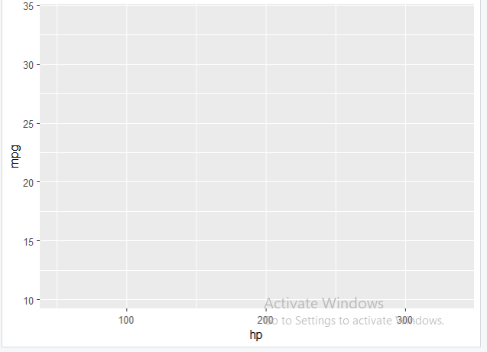

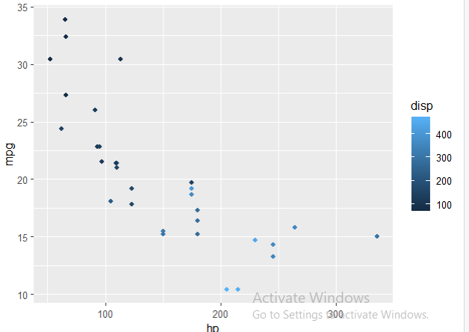

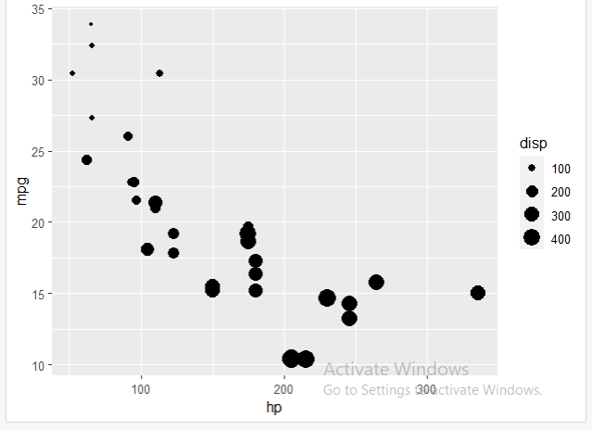

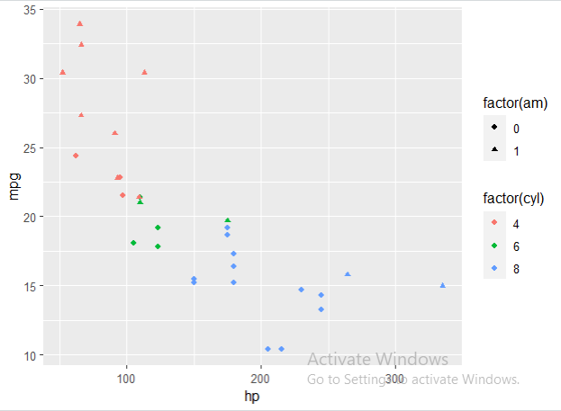

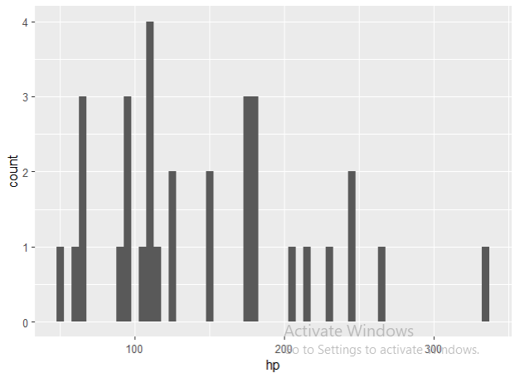

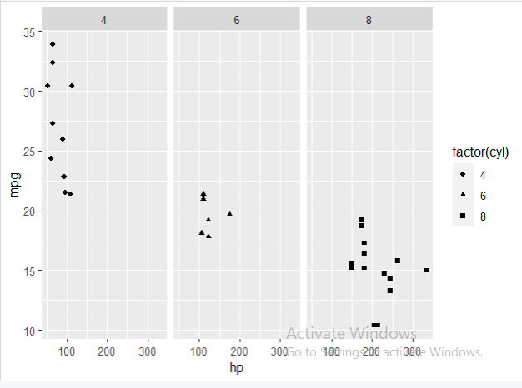

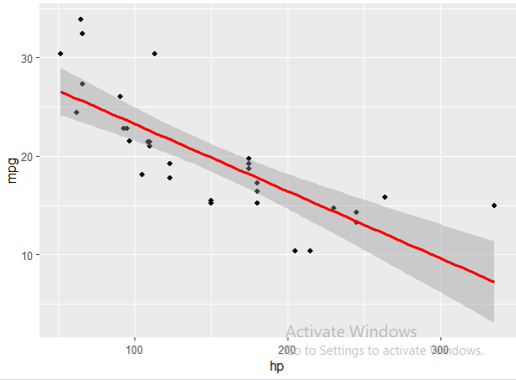

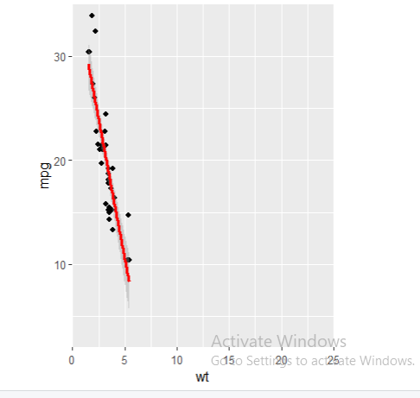

3) Display Import and load dataset from external sources like:

(a) Excel File

(b) Statistical Analysis System (SAS) File

(c) Text File (base)

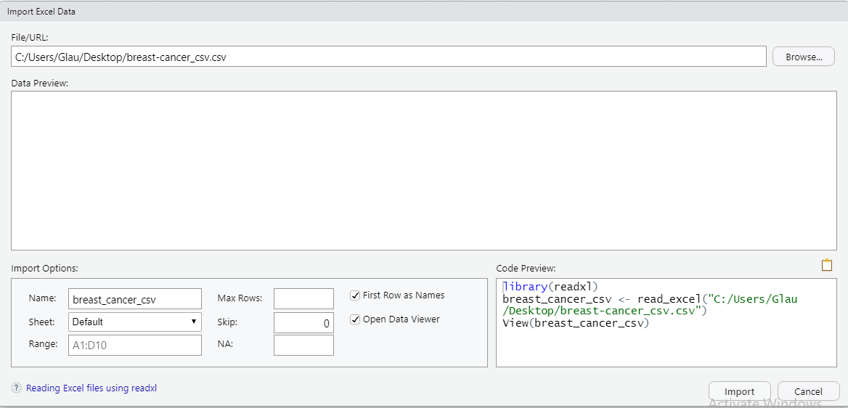

4) Read file using below function commands:

(a) read.delim( ) and read.delim2( )

(b) read.table( )

(c) read.csv( )

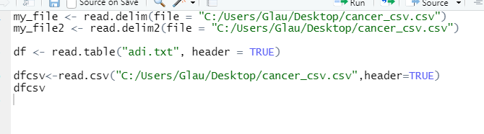

(5) Write a program in Java for counting the number of words.

