# Assignment -2 (Big Data Lab)

## Name :- Aditya Prakash

## Roll No. :- 11

## Section :- C

## URN :- 201500036

## Submitted to :- : Dr. Robin Singh Bhadoria

1. Write a R program to perform below operations on Data Structures like vector and list – (a) Determining the length of elements (b) Sorting the elements (c) Accessing the elements (d) Changing the element’s value (e) Join the two lists (f) Repeat elements of vector

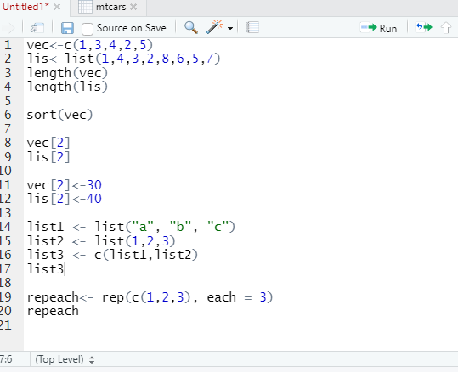

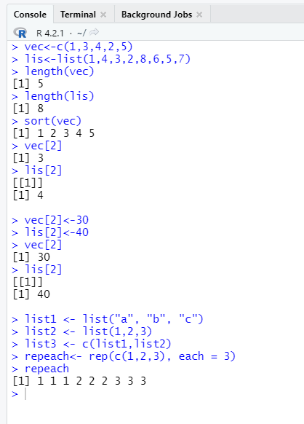

1. Write a R program to perform below operations on Data Structures like matrix and array – (a) Determining the length (b) Accessing the elements (c) Check element exists or not (d) Add row and column (e) Remove row and column (f) Combining the two matrices

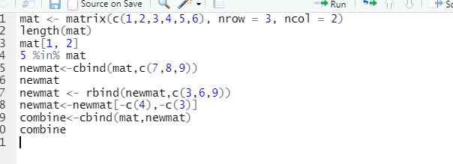

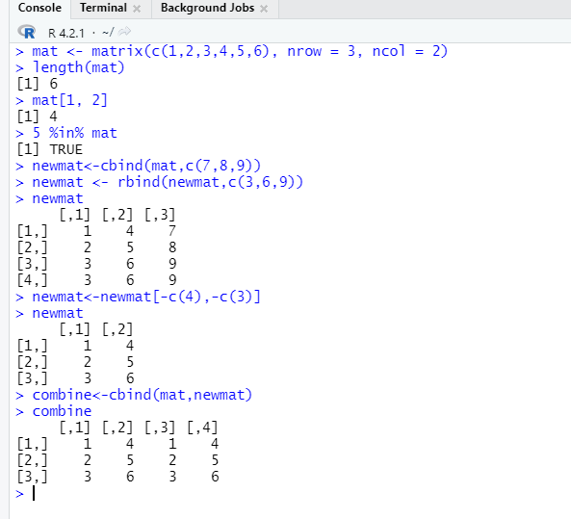

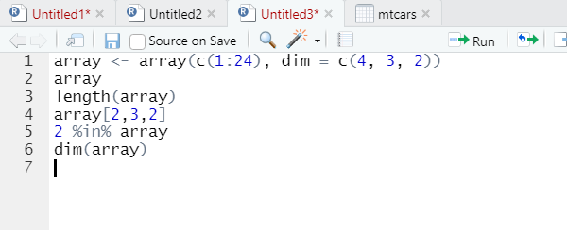

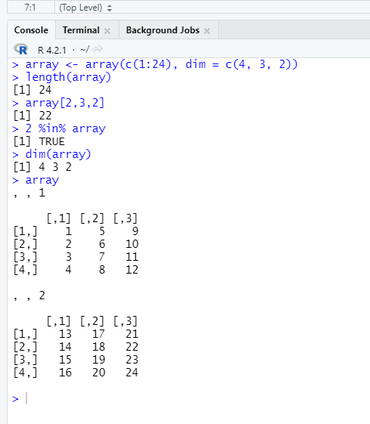

1. Create R Code for Condition Statements - (a) if ( ) (b) if ( ) … else {...} (c) else if ( )

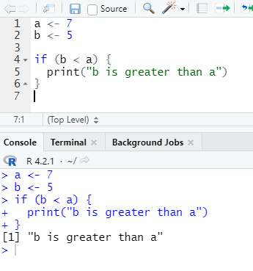

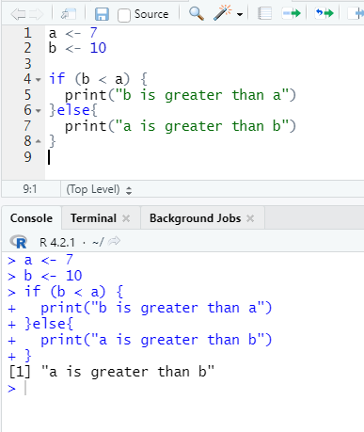

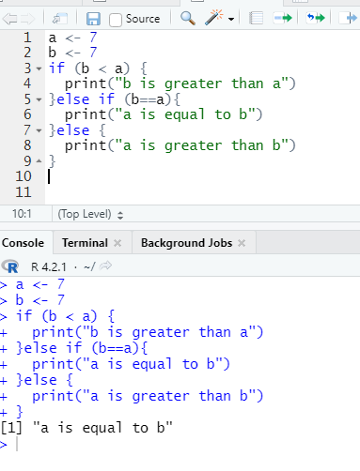

1. Create R Code for Selection Control Structures – (a) switch statement (b) next statement (c) break statement

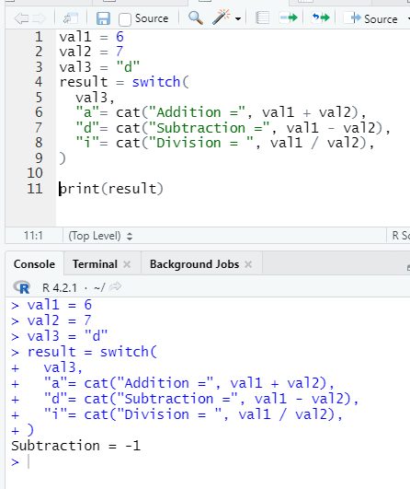

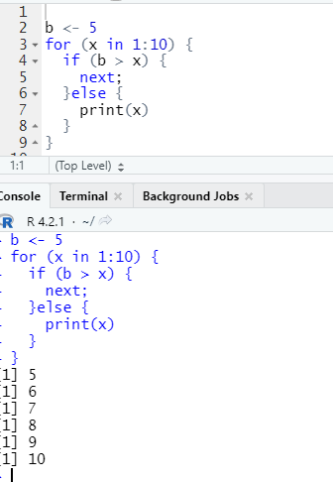

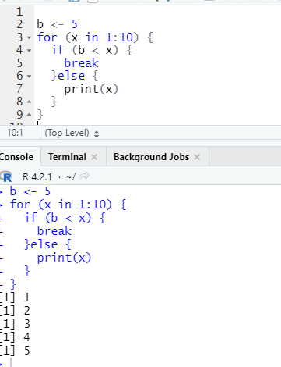

1. Create R Code for Looping Statements – (a) repeat Loop (b) while Loop (c) for Loop

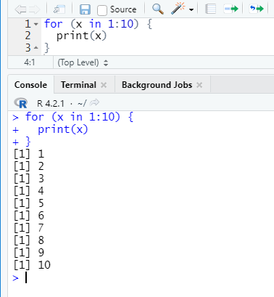

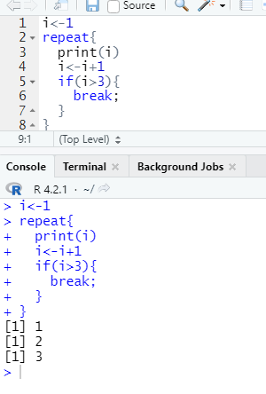

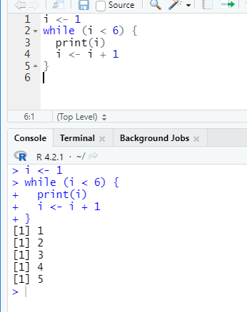

1. Write a R program to perform below operations using String functions – (a) String Length (b) Check a String (c) Multiline Strings (d) Combine Two Strings (e) Escape Characters

