WEEK 4 — COMPREHENSIVE DATA SCIENCE REPORT & INSIGHTS PRESENTATION PLAN
A Hypothetical End-to-End Data Science Project
Prepared as a strategic planning exercise

Important Note on the Results
This report is a presentation plan for a hypothetical project. No real dataset was supplied for the internship exercise. Accordingly, the findings and numerical examples in this document are explicitly illustrative scenarios, not measured results. They demonstrate how a final report could communicate evidence once real analysis has been completed.

1. Executive Summary
The proposed project uses Python-based data science to analyze customer churn for a subscription service. The planned analysis combines data-quality checks, exploratory analysis, feature engineering, classification modeling, validation, and stakeholder reporting. The final output would translate model results into understandable customer-retention insights while clearly separating association from causation. For illustration only, the presentation could show that declining recent engagement, shorter tenure, repeated support interactions, and payment friction appear as candidate risk signals. These are hypotheses to be tested against real data, not established findings.

2. Methodology Overview
- Define churn and the prediction horizon.
- Assemble customer, subscription, engagement, payment and support data.
- Profile quality, missingness, duplicates, ranges and temporal consistency.
- Conduct univariate, bivariate and multivariate EDA.
- Engineer valid features using only information available before prediction.
- Train baseline and ensemble classification models.
- Validate using cross-validation and a final holdout strategy.
- Evaluate discrimination, precision, recall, F1, PR-AUC and calibration.
- Translate statistically supported patterns into business-facing insights.
- Document limitations, monitoring requirements and future research.

3. Illustrative Findings & Analysis

3.1 Engagement Trend
Illustrative insight: suppose the completed analysis showed that customers whose weekly engagement declined substantially over several weeks had a higher observed churn rate than customers with stable engagement. The final report would show the sample sizes, confidence intervals or uncertainty measures where appropriate, the exact feature definition, and the time period analyzed.

3.2 Tenure and Customer Lifecycle
Illustrative insight: suppose early-tenure customers displayed a different churn pattern from long-tenure customers. The presentation could use a tenure-band chart to show the pattern and then discuss onboarding, product adoption, and service experience as possible areas for further investigation rather than claiming that tenure itself causes churn.

3.3 Service Interactions
Illustrative insight: a higher frequency of support interactions might coincide with increased churn. The analysis should distinguish between simple association and possible reverse causality: customers may contact support because they are already dissatisfied. A final report would therefore avoid presenting support contacts as a causal driver unless an appropriate causal design supports that conclusion.

3.4 Model Performance Communication
The final report should present model performance using a compact metric table, confusion matrix, precision-recall curve, and calibration view. The selected operating threshold should be connected to the available outreach capacity and the relative consequences of false positives and false negatives.
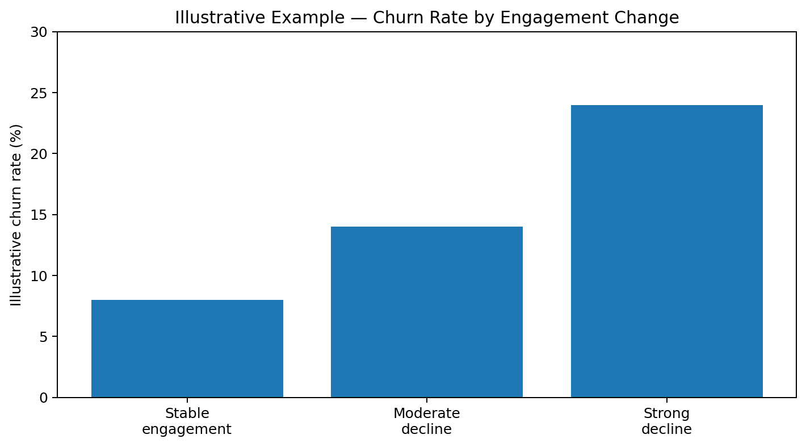
Figure 1. Illustrative values only; they are not derived from a real dataset.

4. Mock-Up Visualization Set
Visual | Message | Audience Value
Churn trend line | Shows how churn changes over time | Provides temporal context
Segmented churn-rate bars | Compares customer groups | Makes segment differences easy to scan
Feature distribution plots | Shows data shape and outliers | Supports data-quality interpretation
Correlation heat map | Summarizes numerical relationships | Helps identify redundant or related variables
Precision-recall curve | Shows classification trade-offs | Supports threshold selection
Calibration plot | Compares predicted and observed probabilities | Explains whether risk scores are reliable
Feature importance / explanation plot | Shows influential model inputs | Improves transparency

5. Example Insight-to-Action Framework
Observed Pattern | Question to Investigate | Potential Next Step
Engagement decline associated with higher churn | Is reduced engagement a leading signal or a consequence of dissatisfaction? | Test targeted onboarding/engagement interventions
Higher support-contact frequency associated with churn | Are unresolved issues driving the association? | Review support resolution time and recurring issue categories
Payment friction concentrated in a segment | Are payment failures preventable? | Improve reminders, retry flows or payment-method support
Model identifies a high-risk group | Does the model generalize to future periods? | Run prospective validation before operational rollout

6. Communicating Results to Non-Technical Stakeholders
The presentation should use a problem-to-evidence-to-action storyline. Begin with the business question, explain why churn matters, show the most important evidence, explain what the model can and cannot say, and finish with a small number of testable next steps. Technical terms such as ROC-AUC, feature engineering, and cross-validation should be explained only when necessary. Every chart should answer one question and include a plain-language takeaway.

7. Suggested 10-Slide Presentation Structure
Slide | Content
1 | Title, business question and project purpose
2 | Why churn analysis matters and project scope
3 | Data sources, quality and analytical approach
4 | Key EDA patterns
5 | Customer segments and behavioral differences
6 | Modeling approach and validation design
7 | Model performance and threshold trade-offs
8 | Top interpretable insights and limitations
9 | Recommended experiments / next steps
10 | Conclusion, governance and monitoring plan

8. Recommendations for Future Work
- Collect and validate a real historical dataset with a clearly defined prediction window.
- Perform temporal validation to estimate future-period performance.
- Conduct prospective experiments before claiming retention impact.
- Investigate fairness and segment-level performance where relevant and lawful.
- Add monitoring for drift, calibration, missingness and realized churn.
- Document model versions and retraining criteria.
- Evaluate whether interventions based on model outputs actually improve customer outcomes rather than merely improving prediction metrics.

9. Limitations
- No real dataset was provided, so numerical results are illustrative.
- Association in observational customer data does not establish causality.
- Model performance can change as customer behavior and products change.
- A technically strong model does not automatically produce business value; interventions must be tested.
- Privacy, security, governance and appropriate data minimization are required for real deployment.

10. Timeline — 31 Hours
Activity | Hours | Deliverable
Executive narrative | 4 | Business problem and summary
Methodology synthesis | 4 | Clear end-to-end methodology
Insights framework | 6 | Evidence-to-insight structure
Visualization mock-ups | 5 | Charts, tables and captions
Stakeholder presentation plan | 4 | 10-slide narrative
Recommendations & limitations | 4 | Future work and governance
Final editing & quality review | 4 | Polished report
Total | 31

11. Conclusion
The final reporting plan is designed to bridge technical analysis and practical decision support. It emphasizes transparent evidence, clear visuals, explicit uncertainty, and testable next steps. Once real data is analyzed, the illustrative sections should be replaced with measured results, documented methodology, statistical context, and validated model performance.

