WEEK 2 — EDA & VISUALIZATION FRAMEWORK
A Hypothetical End-to-End Data Science Project
Prepared as a strategic planning exercise

1. Introduction to Exploratory Data Analysis
Exploratory Data Analysis (EDA) is the systematic process of inspecting, summarizing, visualizing, and questioning a dataset before formal modeling. For the hypothetical customer churn project, EDA would be used to understand the structure and quality of customer records, discover distributions and relationships, identify anomalies, assess missingness, and generate hypotheses for feature engineering. EDA does not prove causation; it helps identify patterns that require further testing.

2. Potential Data Types
Type | Examples in Churn Project | Typical Treatment
Numerical — continuous | Monthly spend, session duration | Distribution checks, scaling where required
Numerical — discrete | Support tickets, login count | Counts, rate features, skew analysis
Categorical — nominal | Plan type, region, channel | Frequency tables, encoding
Categorical — ordinal | Satisfaction rating | Ordered encoding when justified
Datetime | Signup date, last activity | Recency, tenure, time-window features
Boolean | Auto-renew enabled | Binary encoding / proportions

3. EDA Framework

3.1 Data Quality Profiling
- Inspect dimensions, column names, data types, unique values, duplicates and memory usage.
- Quantify missingness by column and by relevant customer segment.
- Check ranges, impossible values, inconsistent labels and timestamp validity.
- Verify key uniqueness and referential integrity across source tables.

3.2 Univariate Analysis
- Numerical variables: count, mean, median, standard deviation, quartiles, skewness and distributions.
- Categorical variables: frequency and proportion tables.
- Target variable: overall churn prevalence and class balance.
- Outlier review using IQR, robust z-scores and domain-specific thresholds.

3.3 Bivariate Analysis
- Compare numerical variables against churn using box plots, violin plots or grouped summaries.
- Compare categorical variables against churn using count plots and churn-rate tables.
- Use scatter plots to investigate numerical relationships and possible nonlinear patterns.
- Use appropriate statistical tests only after checking assumptions and sample size.

3.4 Multivariate Analysis
- Correlation matrix for numerical variables, with caution about correlation versus causation.
- Pair plots for a selected subset of features.
- Segment-level analysis to identify whether patterns differ by plan, tenure, or customer type.
- Dimensionality-reduction visuals only when they answer a clear exploratory question.

4. Missing Data Strategy
Step | Approach
Measure | Calculate missing percentage overall and by important segments
Diagnose | Determine whether missingness appears structural, operational, or random
Decide | Drop, impute, or preserve missingness depending on meaning and volume
Implement | Use sklearn Pipeline/ColumnTransformer so transformations are learned only from training data
Validate | Compare model behavior and distributions before/after treatment

5. Outlier Strategy
Outliers will not automatically be deleted. Each extreme value will be investigated against business rules and source-system context. Possible actions include retaining valid extremes, winsorization, robust scaling, transformation, or removal only when an observation is demonstrably erroneous. All decisions will be documented so the analysis remains auditable.

6. Visualization Strategy
Question | Recommended Visual | Purpose
What does a numerical feature look like? | Histogram + KDE | Distribution and skew
Are there extreme values? | Box plot | Outlier screening
How does churn differ by category? | Count plot + churn-rate bar | Segment comparison
Do two numerical variables relate? | Scatter plot | Association and nonlinearity
How do variables correlate? | Heat map | Compact relationship overview
How does a metric change over time? | Line chart | Trend and seasonality
Which segments have different behavior? | Grouped bar / box plot | Segment-level comparison
How does model performance vary by threshold? | Precision-recall curve | Decision-threshold analysis

7. Python Tools & Libraries
Library/Tool | Contribution
pandas | Data profiling, grouping, aggregation and cleaning
NumPy | Numerical calculations and array operations
Matplotlib | Controlled, publication-ready static charts
Seaborn | Statistical graphics and compact EDA visuals
Plotly | Interactive charts for exploratory and stakeholder use
scikit-learn | Preprocessing utilities and validation-oriented workflows
Jupyter | Narrative analysis, code, outputs and documentation
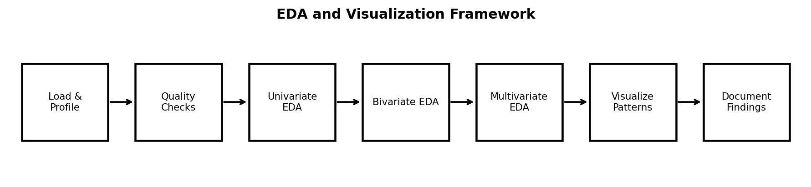

8. Reporting & Documentation Plan
- Executive overview: one-page summary of the main data-quality and pattern findings.
- Dataset profile: sources, grain, dimensions, variable groups, missingness and limitations.
- EDA findings: organized by business question rather than by chart type.
- Visualization appendix: selected plots with clear titles, units, labels and interpretation notes.
- Data-quality log: decisions for missing values, duplicates, outliers and inconsistent records.
- Reproducibility notes: Python version, package versions, notebook structure and random seeds where relevant.

9. Proposed Notebook Structure
- 01_project_context.ipynb
- 02_data_ingestion_and_quality.ipynb
- 03_univariate_eda.ipynb
- 04_bivariate_and_multivariate_eda.ipynb
- 05_feature_ideas.ipynb
- 06_visualization_export.ipynb
- 07_findings_and_limitations.ipynb

10. Timeline — 32 Hours
Workstream | Hours | Activities
EDA planning & business questions | 4 | Define analytical questions and target context
Data profiling framework | 5 | Quality checks, types, missingness and duplicates
Univariate analysis design | 4 | Distributions, target balance and outlier review
Bivariate/multivariate design | 6 | Relationships, segments and interactions
Visualization framework | 5 | Chart selection, annotation and accessibility
Reporting/reproducibility | 4 | Notebook structure and findings template
Review & refinement | 4 | Quality checks, editing and diagram preparation
Total | 32

11. Key Principles
- Ask a business question before creating a chart.
- Use the simplest visualization that communicates the intended pattern.
- Do not infer causation from exploratory association.
- Show denominators and sample sizes where they materially affect interpretation.
- Document exclusions and transformations.
- Keep visual scales, labels, units and definitions consistent.

12. Conclusion
This framework creates a reusable EDA process for the proposed churn project and other structured datasets. It combines data-quality assessment, univariate, bivariate and multivariate analysis with purposeful visualization and reproducible documentation. The framework is designed to support the transition from raw data to defensible modeling hypotheses.

