WEEK 3 — MACHINE LEARNING MODEL DEVELOPMENT & EVALUATION PLAN
A Hypothetical End-to-End Data Science Project
Prepared as a strategic planning exercise

1. Problem Definition
The hypothetical task is binary customer churn prediction: estimate whether a customer is likely to churn during a defined future period using information available before that period. This is a supervised classification problem because historical examples would contain a known target outcome. The objective is not to automate customer decisions, but to create a risk signal that can be reviewed alongside business context.

2. Data Preprocessing Strategy
- Define the prediction unit, cutoff date, outcome window, and target label.
- Split the data before target-aware preprocessing to prevent leakage.
- Separate numerical, categorical, datetime-derived and binary feature groups.
- Impute missing numerical values using a justified training-only strategy and encode categorical variables using training data only.
- Scale numerical features when required by the chosen algorithm; tree-based models generally do not require standardization.
- Engineer features such as recent engagement change, tenure, support-contact frequency and payment behavior when supported by available fields.
- Remove direct identifiers and variables that are unavailable at prediction time.
- Use ColumnTransformer and Pipeline for reproducible preprocessing.

3. Candidate Model Set
Model | Role in Comparison | Strengths | Considerations
Logistic Regression | Interpretable baseline | Simple, fast, probability output | Linear decision boundary
Decision Tree | Interpretable nonlinear baseline | Rules are easy to explain | Can overfit without constraints
Random Forest | Ensemble candidate | Handles nonlinearities and interactions | Less compact to explain
Gradient Boosting | Higher-capacity candidate | Strong tabular-data performance potential | Requires careful tuning and validation

4. Model Selection Strategy
The final candidate should be selected based on the business objective, validation evidence, calibration, interpretability requirements, computational cost, and operational constraints. A model will not be chosen solely because it produces the highest single metric. A simple baseline will remain important for detecting whether additional complexity provides meaningful improvement.

5. Training & Hyperparameter Tuning
- Use a fixed, documented train/validation/test strategy. If the problem has temporal ordering, prefer time-aware validation.
- Use stratified k-fold cross-validation for non-temporal classification when appropriate.
- Start with a baseline configuration before tuning.
- Tune a limited set of high-impact hyperparameters using GridSearchCV or RandomizedSearchCV.
- For larger search spaces, consider Bayesian optimization/Optuna in a future implementation.
- Keep the test set untouched until the final model-selection decision is complete.
- Record parameters, validation metrics, preprocessing version and experiment identifier.
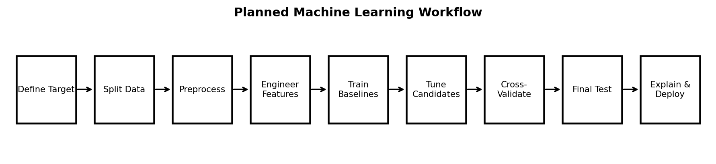

6. Evaluation Metrics
Metric | Meaning | Why It Matters
Accuracy | Share of all predictions that are correct | Useful only when class balance and error costs make it informative
Precision | Of predicted churners, share that actually churn | Important when outreach capacity is limited
Recall | Of actual churners, share identified | Important when missing at-risk customers is costly
F1-score | Harmonic mean of precision and recall | Useful for balancing the two
ROC-AUC | Ranking ability across classification thresholds | General discrimination measure
PR-AUC | Precision-recall performance across thresholds | Especially informative with class imbalance
Calibration | Agreement between predicted probabilities and observed outcomes | Important when probabilities drive prioritization

7. Validation Strategy
- Use cross-validation to estimate performance across multiple training/validation splits.
- Preserve class proportions where stratification is appropriate.
- If customer records span time, evaluate whether a future-period holdout is more realistic than random splitting.
- Report mean and variation across folds rather than only one score.
- Perform threshold analysis because the operational decision may not use 0.50 as the probability cutoff.
- Check performance by important segments to identify uneven behavior.

8. Potential Challenges & Solutions
Challenge | Potential Effect | Planned Response
Imbalanced target | Accuracy may look strong despite poor churn detection | PR-AUC, recall, precision, class weights and threshold analysis
Leakage | Unrealistically high validation performance | Strict temporal/data availability rules
Overfitting | Performance falls on unseen data | Cross-validation, regularization, constrained trees and simpler baselines
Drift | Performance changes after deployment | Monitoring, periodic evaluation and retraining policy
Uncalibrated probabilities | Risk scores are misleading | Calibration curves and calibration methods
Interpretability | Stakeholders may not trust outputs | Feature importance, local explanations and clear limitations

9. Conceptual Deployment Plan
- Package preprocessing and model together so inference uses the same transformations as training.
- Expose predictions through a controlled batch job or API.
- Store model version, feature version and prediction timestamp.
- Monitor data drift, missingness, latency, prediction distribution, calibration and realized outcomes.
- Define a retraining trigger based on data volume, performance degradation, drift or scheduled review.
- Maintain human review and documented governance for any customer-facing action.

10. Reproducibility Checklist
- Python environment and dependency versions recorded.
- Random seeds documented where applicable.
- Data split logic stored in code.
- Feature definitions versioned.
- Model parameters and validation results logged.
- Final model artifact linked to the exact preprocessing pipeline.
- README explains setup, workflow and limitations.

11. Timeline — 34 Hours
Phase | Hours | Activities
Problem framing & target design | 3 | Target, horizon, decision context
Preprocessing architecture | 5 | Pipelines, encoding, scaling and leakage controls
Baseline models | 4 | Logistic regression and decision tree
Ensemble models | 5 | Random forest and gradient boosting
Validation & hyperparameter tuning | 7 | Cross-validation, search and threshold analysis
Evaluation & explainability | 5 | Metrics, calibration, segment checks and interpretation
Documentation & deployment plan | 5 | Model card, workflow diagram, monitoring design
Total | 34

12. Model Governance Considerations
A churn model should be treated as a decision-support component rather than an unquestioned authority. Feature definitions, data provenance, validation results, known limitations, and monitoring responsibilities should be documented. Sensitive or unnecessary personal information should not be included merely because it is available. Any production use would also require appropriate organizational privacy, security, and governance review.

13. Conclusion
The proposed workflow provides a practical path from a defined classification problem to a validated, explainable and monitorable machine learning system. It emphasizes leakage prevention, multiple evaluation metrics, cross-validation, probability calibration, interpretability, and operational monitoring.

