WEEK 1 — DATA SCIENCE PROJECT PLANNING & STRATEGY
A Hypothetical End-to-End Data Science Project
Prepared as a strategic planning exercise

1. Project Background
This report proposes a hypothetical data science project focused on customer churn prediction for a subscription-based digital service. Customer churn occurs when an existing customer stops using or paying for a service. For a subscription business, unexpected churn can reduce recurring revenue, increase acquisition costs, and make growth less predictable. The project will use Python as the primary analytical environment and will design an end-to-end process that can later be implemented when an appropriate dataset becomes available.
The motivation is to move from reactive customer support toward evidence-based retention planning. Instead of treating every customer identically, the proposed system would identify patterns associated with higher churn risk, quantify the factors that contribute to risk, and provide interpretable insights that business teams can use to design retention actions. Because this is a planning exercise, no real customer data or actual predictive results are assumed.

2. Problem Statement and Motivation
Problem statement: Can historical customer behavior, subscription information, engagement measures, and service interactions be used to estimate the probability that a customer will churn within a defined future period?
- Reduce uncertainty around customer retention by creating a repeatable analytical process.
- Identify measurable behavioral and service-related patterns associated with churn.
- Develop a transparent modeling approach that can be evaluated before any production use.
- Create a reporting structure that converts technical results into business-relevant retention insights.

3. Project Objectives
- Define a reliable target variable and prediction horizon for churn.
- Design a data collection and data-quality framework for customer-level records.
- Perform systematic data cleaning, exploratory analysis, and feature engineering.
- Compare suitable classification algorithms and establish a reproducible validation strategy.
- Evaluate model performance using multiple metrics rather than a single accuracy value.
- Design a conceptual reporting and deployment pathway for future operational use.

4. Project Scope
In Scope | Out of Scope
Customer-level churn definition and prediction strategy | Actual production deployment
Data quality, EDA, feature engineering and modeling plan | Use of personally identifiable customer information
Python-based analytics and reproducible workflow | Real-time intervention automation
Model evaluation and interpretability plan | Guaranteed business revenue improvement
Executive reporting and monitoring design | Collection of real customer data for this exercise

5. Methodology & Strategy

5.1 Business Understanding
Confirm the business question, churn definition, prediction window, acceptable false-positive/false-negative trade-offs, stakeholders, and decision process before touching the data.

5.2 Data Collection Strategy
- Potential sources: customer master records, subscription history, payment history, product usage logs, support interactions, and customer feedback.
- Define data ownership, refresh frequency, grain, keys, retention period, and permitted use.
- Create a data dictionary documenting each field, data type, unit, allowed values, and business meaning.
- Avoid leakage by ensuring that features only use information available before the prediction cutoff.

5.3 Data Cleaning & Preparation
- Profile missing values, duplicates, inconsistent categories, impossible values, and date anomalies.
- Standardize data types and categorical labels.
- Investigate outliers using domain rules and robust statistical methods.
- Separate training, validation, and test data before transformations that could learn from the target.
- Build a reproducible preprocessing pipeline with pandas and scikit-learn.

5.4 EDA & Feature Engineering
- Analyze churn rate and customer distributions.
- Compare engagement, tenure, subscription type, service contacts, and payment behavior across churn groups.
- Create features such as recent usage change, engagement frequency, tenure bands, support-contact rate, and payment delay indicators where appropriate.
- Use correlation and model-based techniques cautiously; retain features that are useful, valid, and interpretable.

5.5 Modeling & Evaluation
- Establish a simple baseline before more complex models.
- Compare logistic regression, decision tree, random forest, and gradient-boosting approaches.
- Use stratified cross-validation where appropriate.
- Evaluate precision, recall, F1-score, ROC-AUC, PR-AUC, confusion matrix, and probability calibration.
- Use explainability techniques such as feature importance and SHAP-style analysis if the final implementation requires them.
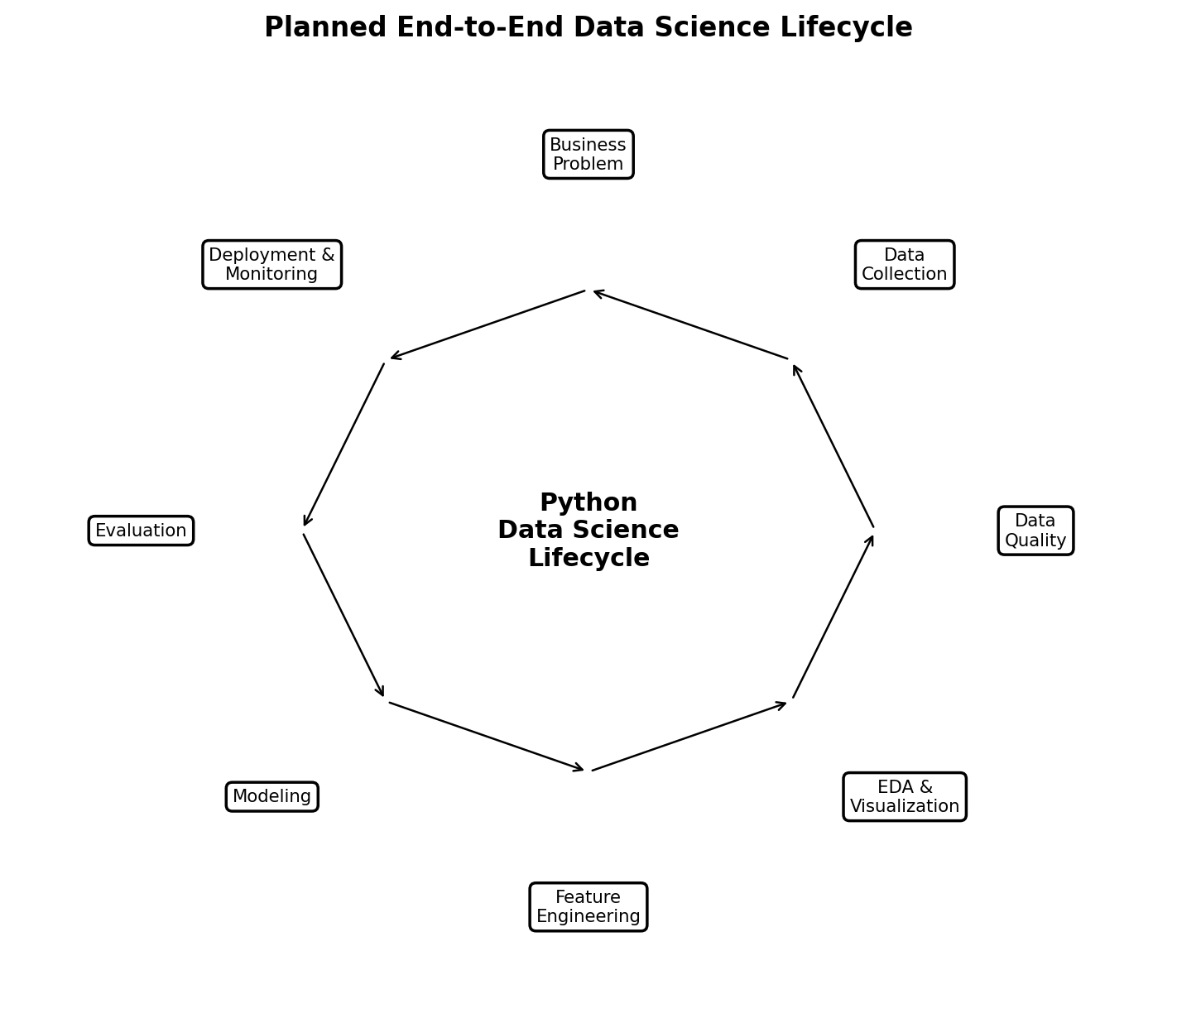

6. Timeline — 33 Hours
Phase | Hours | Key Activities
Business understanding & requirements | 3 | Problem definition, stakeholders, churn definition
Data architecture & collection plan | 4 | Sources, data dictionary, governance, leakage checks
Cleaning & preprocessing strategy | 5 | Quality rules, missingness, outliers, transformations
EDA & feature engineering plan | 5 | Analysis questions, feature candidates, visualization plan
Modeling & validation strategy | 6 | Model candidates, splits, CV, tuning and metrics
Reporting & deployment design | 4 | Dashboard/reporting, monitoring, handoff
Documentation, diagrams & review | 6 | Editing, diagrams, quality checks, final packaging
Total | 33

7. Tools & Python Libraries
Tool/Library | Planned Use
Python | Primary programming and analytical language
Jupyter Notebook / VS Code | Experimentation, documentation and development
pandas | Data loading, cleaning, transformation and tabular analysis
NumPy | Numerical operations and array handling
Matplotlib / Seaborn | Static statistical visualization
Plotly | Interactive exploratory and executive visuals
scikit-learn | Preprocessing, models, validation and metrics
SHAP (optional) | Model explanation and feature contribution analysis
Git/GitHub | Version control, reproducibility and portfolio documentation

8. Expected Outcomes
- A documented and reproducible data science workflow.
- A cleaned analytical dataset and feature specification once real data becomes available.
- A validated candidate churn model with transparent performance reporting.
- A set of business-facing insights explaining which measurable factors are associated with churn.
- A roadmap for deployment, monitoring, retraining, and governance.

9. Anticipated Challenges & Mitigation
Challenge | Risk | Mitigation
Class imbalance | Minority churn class may be underrepresented | Use stratification, PR-AUC, class weights and threshold analysis
Data leakage | Future information can inflate validation results | Time-aware feature cutoff and pipeline isolation
Missing data | Bias or loss of usable records | Profile missingness; use justified imputation or explicit missing categories
Concept drift | Customer behavior can change over time | Monitor performance and feature distributions
Interpretability | Complex models may be difficult to explain | Compare with interpretable baselines and use explanation methods
Privacy | Customer records may contain sensitive information | Minimize data, control access and remove unnecessary identifiers

10. Success Criteria
The project plan will be considered successful if it defines a clear business problem, a defensible target, a reproducible data workflow, a logically justified modeling strategy, appropriate evaluation metrics, a realistic timeline, and a deployment/monitoring concept. No claim of model accuracy or business impact will be made until actual data is collected and tested.

11. Conclusion
The proposed plan provides a structured foundation for implementing customer churn analytics in Python. It emphasizes business understanding, data quality, leakage prevention, reproducibility, validation, interpretability, and communication. The next stages can build directly on this architecture when a suitable dataset is available.

