## Question 2:

Answer key for next level: guidovonrossum {Enter the longest entry from the crossword puzzle}

### Set A:

Solve this simple crossword puzzle with the help of the given clues and reach the next level of the scavenger hunt. Ready? Set? Go.

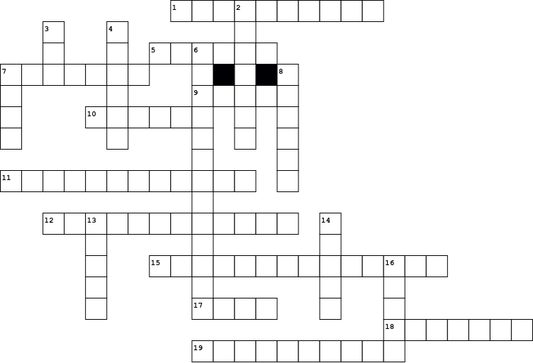

| | **Across** | | | --- | --- | | **1.** | this brainchild of a hunter taught python programmers to plot | | **5.** | A library for C++ works in python too | | **7.** | This came out in 2008 and made the whole python world change | | **9.** | pythons own little family containing its members and what all they do | | **10.** | this is python's anonymous function, but wait it won’t hack your PC | | **11.** | This library can make use of your camera but only if you have OpenCV | | **12.** | module to manage user-editable configuration files for an application | | **15.** | there are many creators of python as its opensource but there is only one benevolent dictator | | **17.** | Python doesn't speak English but this library helps in understanding it | | **18.** | It was initially developed by the Facebook artificial-intelligence research group and Uber’s Pyro software | | **19.** | The function returns True if the specified object is of the specified type | |  | | **Down** | | | --- | --- | | **2.** | work your brains like a jet with this python editor | | **3.** | this function from the NumPy library is used to calculate scalar products of vectors and matrices | | **4.** | This library's name was derived from the word panel data | | **6.** | an oops concept to wrap up your data | | **7.** | it joins point to point to create a 2D hexagonal diagram | | **8.** | Microsoft made this blue beast but not for windows, even Mac and Linux users prefer this when coding | | **13.** | Working with numerics was made possible using this Travis' project | | **14.** | This library acts as a Python interface for artificial neural networks | | **16.** | datasets can be big and small, some might even look like a pig or a mole, attributes they all have, and this one's pandas' fav | |
| --- | --- | --- | --- | --- | --- | --- | --- | --- | --- | --- | --- | --- | --- | --- | --- | --- | --- | --- | --- | --- | --- | --- | --- | --- | --- | --- | --- | --- | --- | --- | --- | --- | --- | --- | --- | --- | --- | --- | --- | --- | --- | --- | --- | --- | --- | --- |

### Set B:

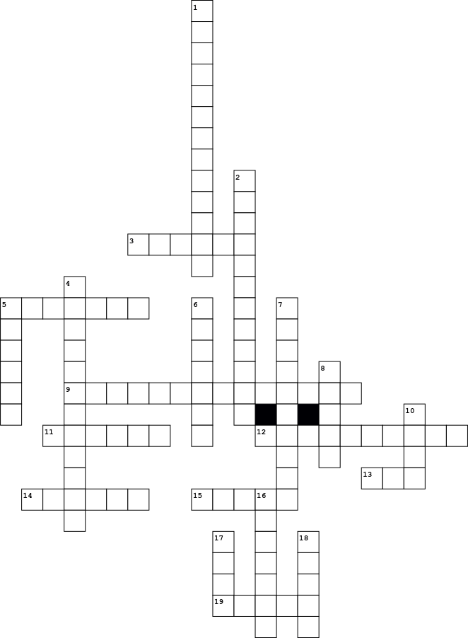

| | **Across** | | | --- | --- | | **3.** | Microsoft made this blue beast but not for windows, even Mac and Linux users prefer this when coding | | **5.** | It was initially developed by Facebook artificial-intelligence research group, and Uber’s Pyro software | | **9.** | there are many creators of python as its opensource but there is only one benevolent dictator | | **11.** | this is python's anonymous function, but wait it wont hack your PC | | **12.** | this brainchild of a hunter taught python programmers to plot | | **13.** | this function from NumPy library is used to calculated scalar products of vectors and matrices | | **14.** | A library for C++ works in python too | | **15.** | datasets can be big and small, some might even look like a pig or a mole, attributes they all have, and this one's pandas' fav | | **19.** | This library acts as a Python interface for artificial neural networks | |  | | **Down** | | | --- | --- | | **1.** | an oops concept to wrap up your data | | **2.** | This library can make use of your camera but only if you have opencv | | **4.** | module to manage user-editable configuration files for an application | | **5.** | This library's name was derived from the word panel data | | **6.** | This came out in 2008 and made the whole python world change | | **7.** | function returns True if the specified object is of the specified type | | **8.** | Working with numerics was made possible using this Travis' project | | **10.** | it joins point to point to create a 2D hexagonal diagram | | **16.** | work your brains like a jet with this python editor | | **17.** | Python doesn't speak english but this library helps in understanding it | | **18.** | pythons own little family containing its members and what all they do | |
| --- | --- | --- | --- | --- | --- | --- | --- | --- | --- | --- | --- | --- | --- | --- | --- | --- | --- | --- | --- | --- | --- | --- | --- | --- | --- | --- | --- | --- | --- | --- | --- | --- | --- | --- | --- | --- | --- | --- | --- | --- | --- | --- | --- | --- | --- | --- |

### 

### 

### Set C :

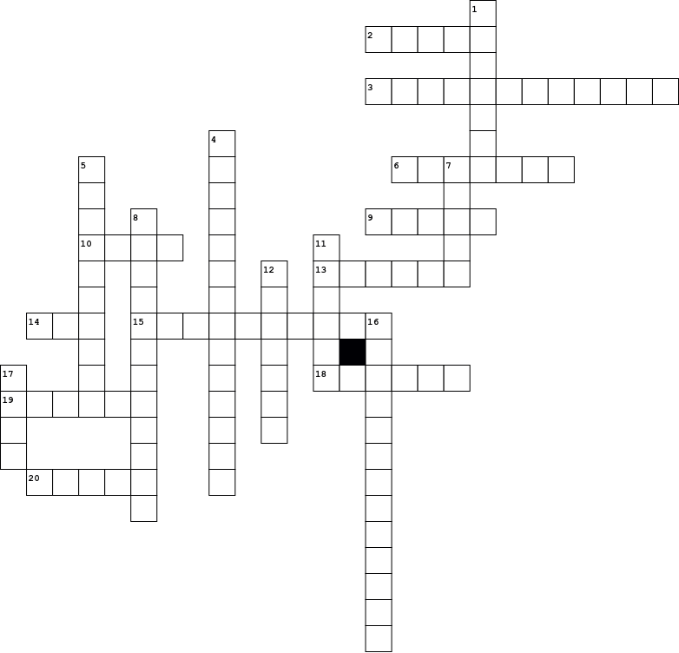

| | **Across** | | | --- | --- | | **2.** | Working with numerics was made possible using this Travis' project | | **3.** | This library can make use of your camera but only if you have opencv | | **6.** | work your brains like a jet with this python editor | | **9.** | This library acts as a Python interface for artificial neural networks | | **10.** | it joins point to point to create a 2D hexagonal diagram | | **13.** | This library's name was derived from the word panel data | | **14.** | this function from NumPy library is used to calculated scalar products of vectors and matrices | | **15.** | function returns True if the specified object is of the specified type | | **18.** | Microsoft made this blue beast but not for windows, even Mac and Linux users prefer this when coding | | **19.** | this is python's anonymous function, but wait it wont hack your PC | | **20.** | datasets can be big and small, some might even look like a pig or a mole, attributes they all have, and this one's pandas' fav | |  | | **Down** | | | --- | --- | | **1.** | It was initially developed by Facebook artificial-intelligence research group, and Uber’s Pyro software | | **4.** | there are many creators of python as its opensource but there is only one benevolent dictator | | **5.** | this brainchild of a hunter taught python programmers to plot | | **7.** | pythons own little family containing its members and what all they do | | **8.** | module to manage user-editable configuration files for an application | | **11.** | A library for C++ works in python too | | **12.** | This came out in 2008 and made the whole python world change | | **16.** | an oops concept to wrap up your data | | **17.** | Python doesn't speak english but this library helps in understanding it | |
| --- | --- | --- | --- | --- | --- | --- | --- | --- | --- | --- | --- | --- | --- | --- | --- | --- | --- | --- | --- | --- | --- | --- | --- | --- | --- | --- | --- | --- | --- | --- | --- | --- | --- | --- | --- | --- | --- | --- | --- | --- | --- | --- | --- | --- | --- | --- |