1.Write a JAVA program for checking the speed of drivers. Enter the value of speed •If speed is less than 70, it should print “Ok”. •Otherwise, for every 5km above the speed limit (70), it should give the driver one demerit point and print the total number of demerit points. For example, if the speed is 80, it should print: “Points: 2”. •If the driver gets more than 12 points, the function should print: “License suspended”

import java.util.Scanner;

public class speed{

    public static void main(String[] args) {

        Scanner s= new Scanner(System.in);

        System.out.println("Enter speed of the driver-");

        int speed=s.nextInt();

        if(speed<70){

            System.out.println("OK");

        }

        else{

            int c=(speed-70)/5;

            if(c>12)

            {

                System.out.println("License Suspended");

            }

        }

    }

}

Output-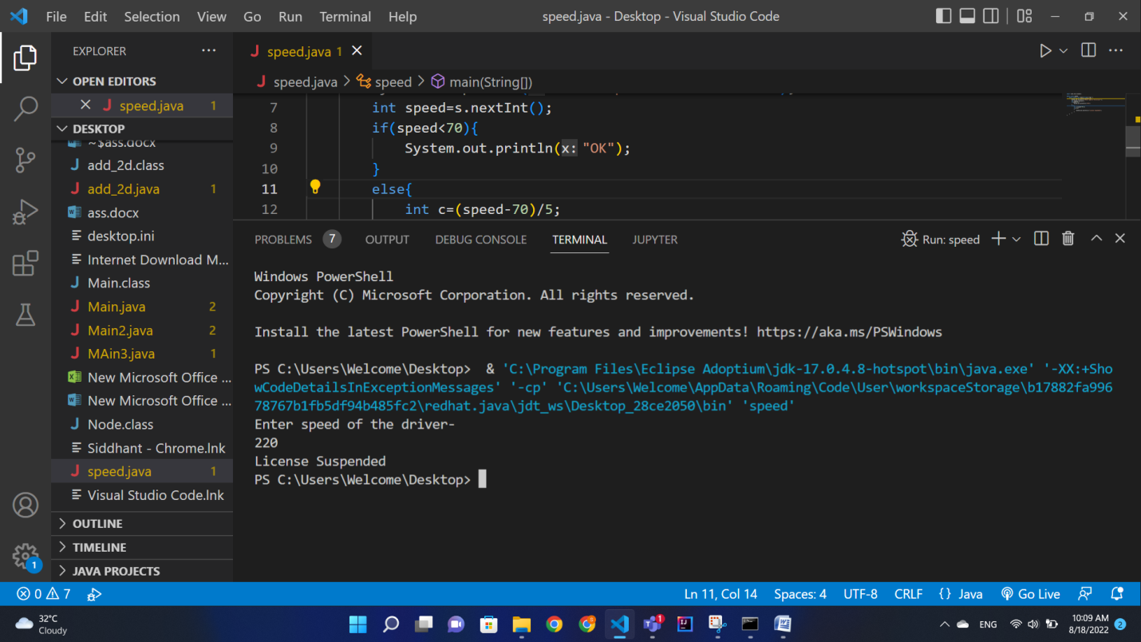

2.Initialize two dimensional array of 3×3. Perform following operations •Find the sum of each row •Find the sum of each column •Find the sum of each elementDisplay output of each operations

import java.util.Scanner;;

public class add_2d {

    public static void main(String[] args) {

        int[][] arr= new int[3][3];

        int sr=0,sc=0,s=0;

        Scanner a=new Scanner(System.in);

        for (int i = 0; i < 3; i++){

            for ( int j=0; j<3; j++){

                System.out.println("Enter Element at index " + i +"," + j + " : ");

                arr[i][j] = a.nextInt();

            }

        }

        for (int i = 0; i < 3; i++){

            sc=0;

            sr=0;

            for ( int j=0; j<3; j++){

                sr+=arr[i][j];

                sc+=arr[j][i];

                s+=sc+sr;

            }

            System.out.println("Sum of row "+i+" : "+sr+"\nSum of column "+i+" : "+sc);

        }

        System.out.println("Sum of all elements -"+s);

    }

}

Output-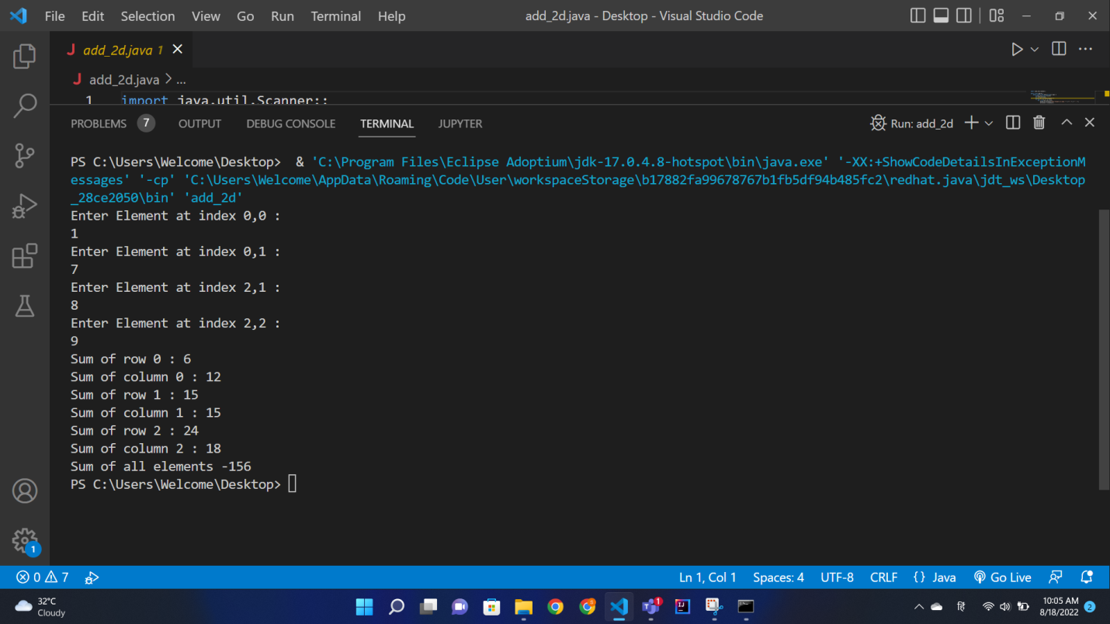

3.Write a program to calculate overtime pay of 10 employees. Overtime is paid at the rate of Rs. 12.00 per hour for every hour worked above 40 hours. Assume that employees do not work for fractional part of an hour.

import java.util.Scanner;

public class work {

    public static void main(String[] args) {

        int arr[]=new int[10];

        int rate;

        Scanner sc= new Scanner(System.in);

        for(int i=0; i<10; i++){

            rate=0;

            System.out.println("enter working time of employee no. "+(i+1)+" -");

            arr[i]= sc.nextInt();

            if(arr[i]>40){

                rate=(arr[i]-40)*12;

            }

            System.out.println("Overtime pay-"+rate);

        }

    }

}

Output-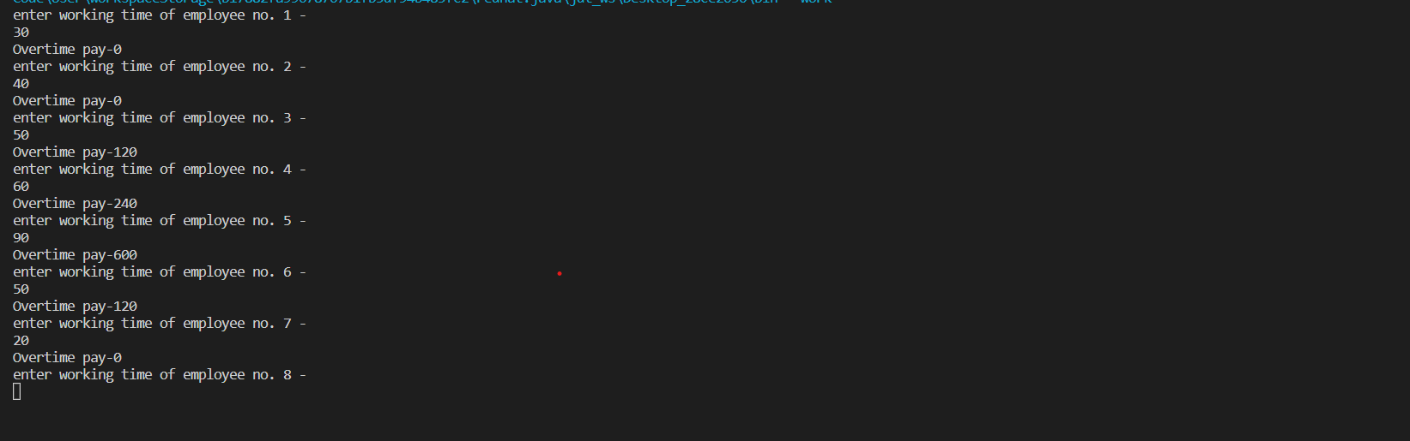

4.A library charges a fine for every book returned late. For first five days the fine is 50 paise, for 6-10 days fine is one rupee and above 10 days fine is 5 rupees. If you return the book after 30 days your membership will be cancelled. Write a program toaccept the number of days the member is late to return the book and display the fine or the appropriate message.

import java.util.Scanner;

public class fine {

    public static void main(String[] args) {

        Scanner sc= new Scanner(System.in);

        System.out.println("Enter the no. od days the member is late- ");

        int late= sc.nextInt();

        if(late>0 && late<=5)

        { System.out.println("Fine- Rs. 0.5");}

        else if(late>=6 && late<=10)

        { System.out.println("Fine- Rs. 1");}

        else if( late>10)

        {

            System.out.println("Fine- Rs. 5");

            if(late>30)

            { System.out.println("Membership Cancelled!");}

        }

    }

}

Output-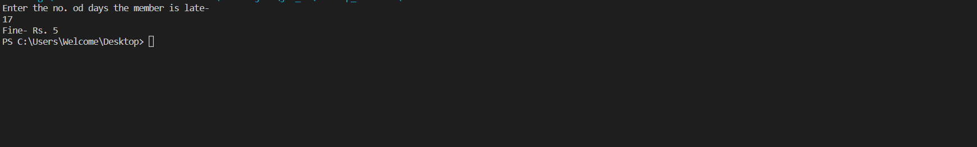

5.Write a function calledfizz_buzzthat takes a number. •If the number is divisible by 3, it should return “Fizz”. •If it is divisible by 5, it should return “Buzz”. •If it is divisible by both 3 and 5, it should return “FizzBuzz”. •Otherwise, it should return the same number

import java.util.Scanner;

public class fizz_buzz {

    public static void main(String[] args) {

        int x;

        Scanner sc = new Scanner(System.in);

        System.out.println("Enter any Integer");

        x=sc.nextInt();

        if(x%3==0 && x%5==0)

        System.out.println("FizzBuzz");

        else if (x%5 ==0)

        System.out.println("Buzz");

        else if (x%3==0)

        System.out.println("Fizz");

        else

        System.out.println(x+" ");

        }

}

Output-