Linear Regression With the Iris Dataset
-Siddhant Gawsane, 1001231597

1. Problem
To learn a regression model based on the UCI iris dataset, perform classification based on it and validate it using n-fold cross validation.

2. Data
The UCI iris dataset is a commonly used dataset for beginners in pattern analysis. It contains 4 attributes:
- Sepal length(in cm)
- Sepal width(in cm)
- Petal length(in cm)
- Petal width(in cm)
and 3 Classes:
- Iris Setosa
- Iris Versicolour
- Iris Virginica

3. Method
The solution entails the use of a set of different methodologies. They are:
- Data representation
The data is represented as a matrix of float values. Class values are converted to integers as ‘1’,’2’ and ‘3’
- Data normalization
The data matrix is normalized by assuming max and min values of 10 and 0 respectively for the attributes, and 3 and 1 for the classes.

- N-fold cross validation
N-fold cross validation is used to split the data into training and test sets in a uniform manner, so that our model isn’t partial to any particular section of the data.
- Learn the regression coefficients using stochastic gradient descent
Stochastic gradient descent is a variant of the gradient descent optimization method that is used to minimize the objective function in the regression. We use to SGD to incrementally learn the coefficients of the regression.
- Test the learned model, calculate model accuracy metrics, generate graphs etc

4. Experimental Parameters
- n_folds = 5
Using 5 folds seems quite logical since the dataset contains only 150 data points, there-by leaving only 30 points in each fold. Decreasing n results in higher RMSE values, and increasing n seems like a case for over-fitting the data
- learn_rate = 0.01
- n_epoch = 10000
As experimentally verified, a learning rate of 0.01 with 10000 iterations yields the best results, with the lowest RMSE values. Increasing the iterations can be balanced out by decreasing the learning rate, but this setup yields the best results, experimentally.

5. Results
The learned model yields a RMSE value of between 11.2% to 12.9%. The predictions(as seen from the graphs) are also quite accurate and closely follow the actual values.
However, learning a model from such a small dataset and testing it on the same dataset might wrongly show accuracy due to over-fitting.
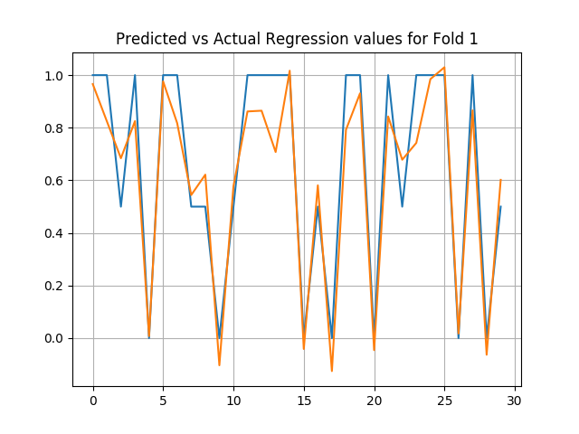
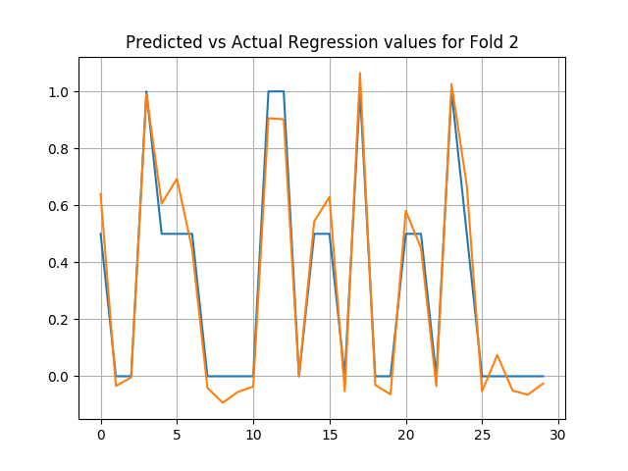
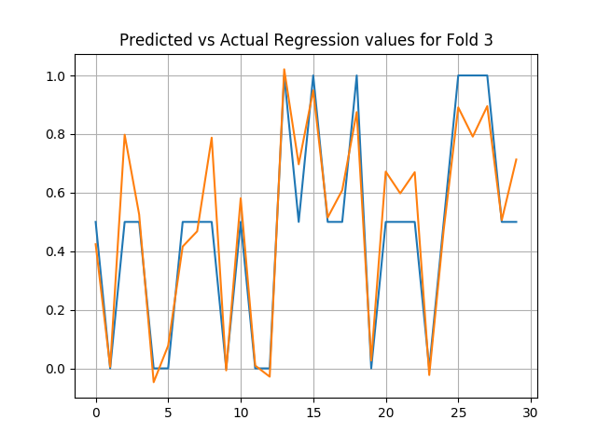
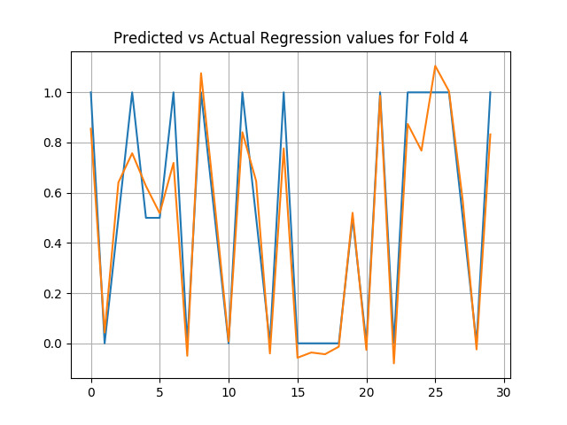

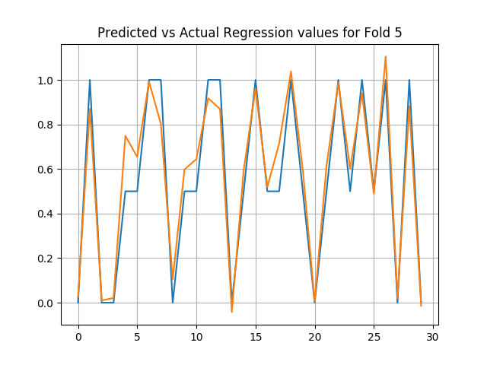

6. References
https://en.wikipedia.org/wiki/Stochastic_gradient_descent
https://machinelearningmastery.com/implement-linear-regression-stochastic-gradient-descent-scratch-python/
https://pythonspot.com/en/matplotlib-line-chart/

