DSB Assignment
Global Events, Commodities
and Currency Markets
Market analysis report for a financial research team
Ivan Logutov
Siddhant Santosh Mathapati
Muthoju Sandeep
Kongara Joseph Sudheer
July 2026
- Introduction

This report examines how the prices of Brent crude oil, gold and silver behaved over the past decades, and what the SWIFT currency tracker reveals about which currencies actually settle the world's payments. We wrote it from the position of a junior market analysis team inside a financial research company: the reader we have in mind is a manager who does not work with data directly but has to make decisions about risk and market exposure.
The work is split into two parts, following the assignment brief. Part I is descriptive: we clean the four provided datasets, summarise them, and build the charts and tables that show what happened, when prices peaked, how volatile each market is, and how the currencies rank against each other. Part II is interpretive: we take the major global events described in the supplied briefings, from the oil embargo of the 1970s through the sanctions wave of 2022 to the shipping disruption of early 2026, and check whether the data patterns are consistent with those events. The two parts are deliberately kept separate, because a chart can show a price jump but it cannot prove what caused it. Where the connection between an event and a price move is strong we say so, and where it is circumstantial we say that too.
The report closes with a business recommendation section written in plain language: two short risk notes, one for a company exposed to oil prices and one for a company holding assets in dollars, gold or renminbi, followed by three practical recommendations. All calculations behind the numbers quoted here are reproducible from the project notebooks and the consolidated Excel workbook that accompany this report; the appendix explains how.

2. Data Overview
Four files were provided. Three of them are long monthly price histories for individual commodities, and the fourth is a structured extract of four monthly SWIFT currency tracker reports. Table 1 summarises what each file contains after cleaning.
Table 1. Datasets after cleaning: size, coverage and frequency.
Dataset | Rows | Coverage | Frequency
Brent Oil | 963 | Jan 1946 - Mar 2026 | Monthly
Gold | 1,336 | Jan 1915 - Apr 2026 | Monthly
Silver | 1,336 | Jan 1915 - Apr 2026 | Monthly
SWIFT Currency Tracker | 330 | 4 reports, Jan - Apr 2026 (data Dec 2025 - Mar 2026) | Monthly reports

Cleaning the commodity files was mostly about dates. The raw date strings come in a month-first format with the day always fixed at 01, which pandas can silently misread if left to guess, so we parsed them with an explicit format and then derived separate month and year columns for grouping. Prices were coerced to numeric. After that the three price series turned out to be remarkably clean: no missing values, no missing months, no duplicated dates in any of them.
The SWIFT file needed a different treatment because it is a panel, not a single time series. Each row is one observation of one metric for one currency or economy in one report month. The file carries eight distinct metrics; the ones we use most are the global payment share ranking, the trade finance share, the international payment share excluding intra-Eurozone flows, and the offshore renminbi share by economy. There are 42 missing values in the value and unit fields, and the renminbi rank column is empty for most rows simply because it only applies to renminbi entries. None of this affected the analysis: the gaps sit in rows and fields we did not need for the questions asked.
One caveat about the price levels deserves a paragraph of its own, because it changes how some headline numbers should be read. The Brent series records its all-time monthly high at 211.21 dollars in June 2008, yet the widely reported nominal Brent price that month averaged around 130 dollars a barrel. The series also starts at around 21 dollars in 1946, which is far above nominal crude prices of that era. Both facts point to the same explanation: the oil series appears to be quoted in inflation-adjusted dollars rather than in the prices of the day. The gold and silver series, by contrast, look nominal, since gold sits near 19 to 35 dollars an ounce through the gold-standard decades, which matches the historical fixed price. We could not fully verify this against the file documentation, so we flag it as an assumption. It does not affect anything that happens within a single series, such as trends, turning points or percentage changes, but it does mean that comparing the level of the 2008 oil peak directly against a nominal metal price would be misleading, and we avoid doing that.
The tracker data has one more quirk worth knowing: each report is published one month after the data it describes. When we say the April 2026 report, we mean the most recent snapshot available, which covers payment flows from March 2026. We use the report label throughout, consistently.

3. Data Analytics Findings

3.1 Price extremes and the strongest years
The three commodities set their record highs at very different points in time, and that alone tells a story. Oil peaked in June 2008 at 211.21 dollars (in the adjusted terms discussed above), during the price surge that preceded the global financial crisis. Gold and silver both peaked within the last few months of the dataset: gold at 5,277.89 dollars in February 2026 and silver at 113.95 dollars in January 2026. The lows sit at the opposite end of history, with oil bottoming at 21.11 dollars in March 1946, gold at 19.25 dollars in January 1915 and silver at 0.28 dollars in January 1932, in the middle of the Great Depression.
Ranking the years by average price sharpens the picture. For oil, the five strongest years are 2008 (150.96 dollars), 1980 (149.86), 2011 (142.12), 2013 (138.30) and 2012 (135.27), so every one of oil's best years is at least a decade in the past. For gold the top five are 2026, 2025, 2024, 2023 and 2022, in that order, a perfect staircase ending at 4,881.62 dollars for the 2026 year-to-date average. Silver's list is almost the same, led by 2026 (96.08) and 2025 (41.50), with only 2011 and 2012 surviving from the previous cycle. Oil's era of record prices ended around 2013; the metals are living theirs right now.

3.2 Brent oil over time
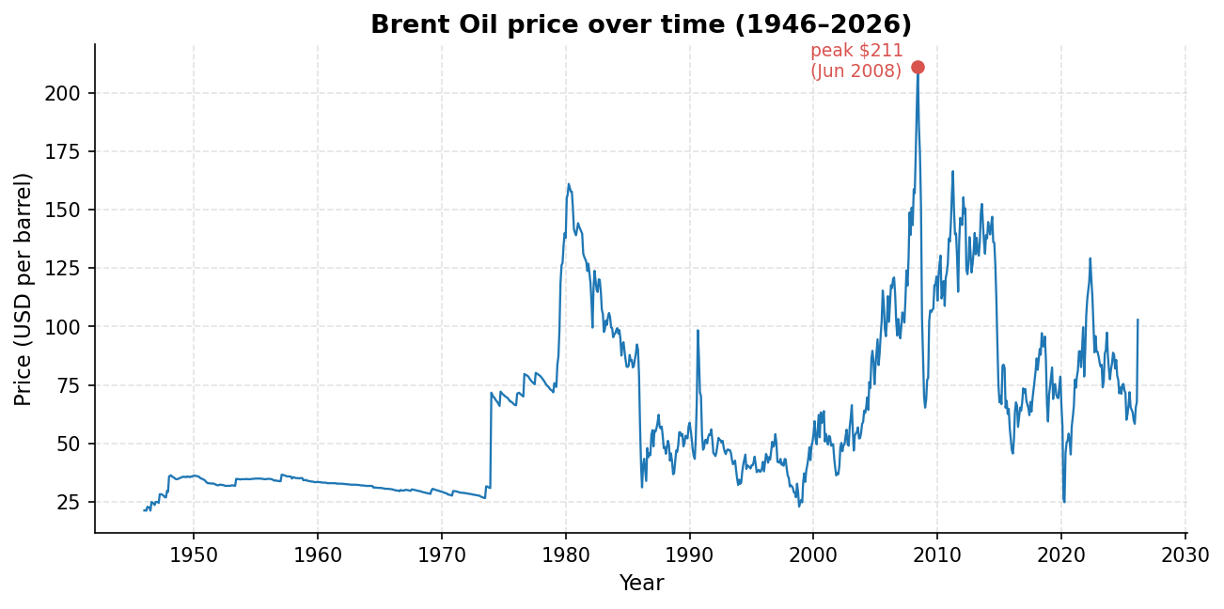
Figure 1. Brent oil monthly price, 1946 - 2026. Source: Brent Oil.csv, own calculation (Part I, question 13).
Figure 1 shows the full oil history. The price is close to flat for the first twenty-five years, then the 1970s break the pattern: the 1973-74 embargo and the 1979-81 Iranian disruptions push it up in two violent steps. What follows is a long descent through the 1986 price war and the 1990s, a steep climb through the 2000s into the June 2008 peak, a crash, a recovery into the 100-150 dollar plateau of 2011-2013, and then the 2014-16 shale-driven slide. The last decade is choppy without a clear direction, which Figure 2 makes easier to see.
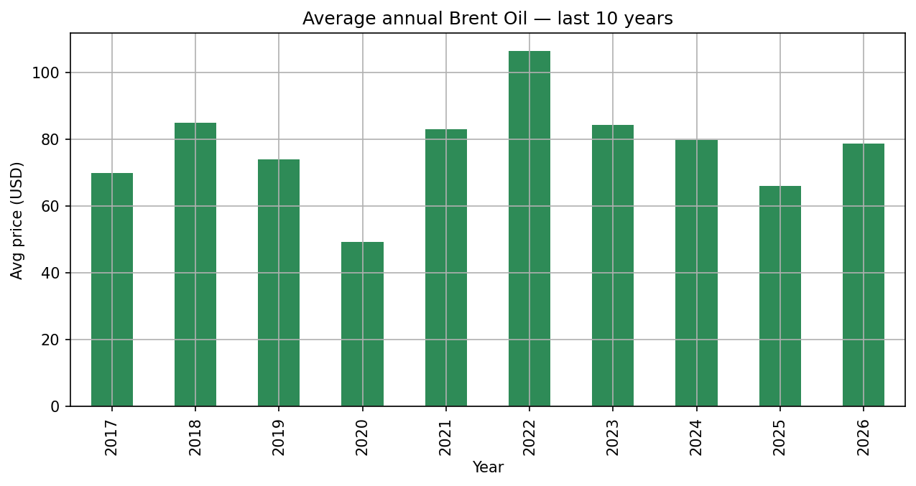
Figure 2. Average annual Brent oil price, last ten years in the dataset. Source: Brent Oil.csv, own calculation (Part I, question 17).
The ten annual bars swing between 49.19 dollars in 2020, the pandemic low, and 106.45 dollars in 2022, the year of the Russian invasion of Ukraine, with no trend connecting them, just alternating better and worse years. 2025 averaged 65.93 dollars and drifted lower through the year, and then 2026 broke upward: the monthly price jumped from 67.66 dollars in February to 102.86 in March, a 52 percent move in a single month. We come back to that jump in Part II because it coincides with the shipping disruption described in the event briefings.

3.3 Gold over time
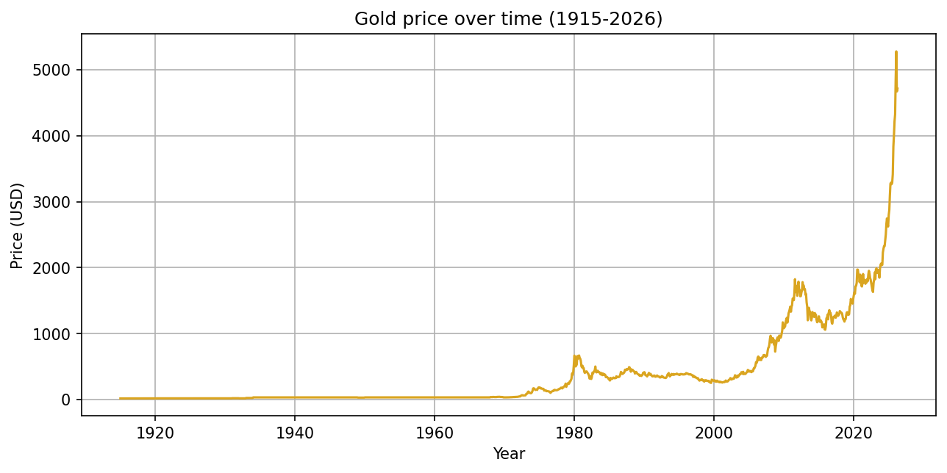
Figure 3. Gold monthly price, 1915 - 2026. Source: Gold 100years.csv, own calculation (Part I, question 14).
Gold spends the first half of its series doing almost nothing, pinned near 19 to 35 dollars an ounce through the gold-standard era. Everything changes after 1971, when the dollar's link to gold is cut: the price runs up to a 607.76 dollar annual average in 1980, corrects for two decades down to roughly 277 dollars in 2000, climbs through the 2000s, and jumps 27 percent in 2020 during the pandemic.
The most striking stretch is the last one. From a 2022 average of 1,798.96 dollars, gold rises every single year to 4,881.62 dollars in 2026, roughly two and seven tenths times the 2022 level in four years. This is not a one-year spike like 2020; it is a sustained climb, and the moving averages in Figure 4 confirm that.
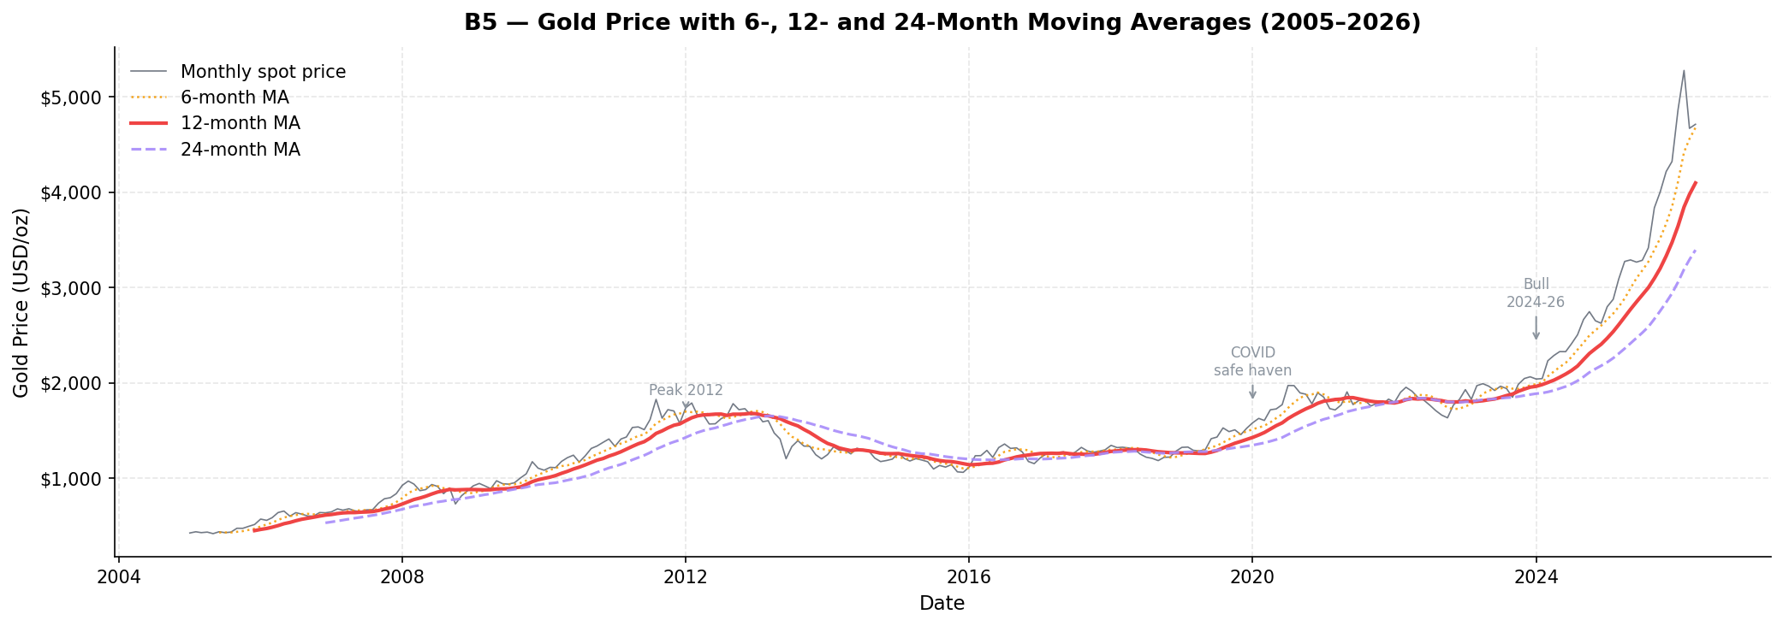
Figure 4. Gold price with 12-month and 24-month moving averages. Source: Gold 100years.csv, own calculation (bonus question B5).
Both the 12-month and the 24-month average turn decisively upward from around 2023 and keep rising. A short-lived shock bends the fast average and leaves the slow one alone; here both curves climb together, which is what a durable trend looks like. Whether it continues is a separate question, and section 3.7 shows why a naive extrapolation should be treated with suspicion.

3.4 Silver, and how it compares with gold
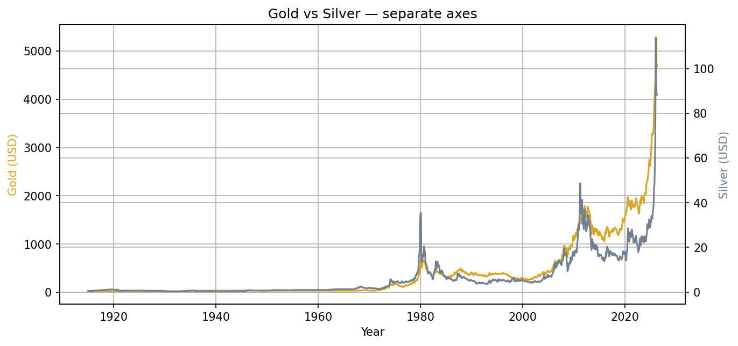
Figure 5. Gold and silver prices on twin axes (silver on the right axis). Source: Gold 100years.csv and silver 100 years.csv, own calculation (Part I, question 16).
Silver traces a similar shape to gold at a fraction of the price, which is why Figure 5 needs a second axis: silver trades at roughly 2 to 5 percent of gold's level. Its clearest historical peaks are 1980, with a 19.48 dollar annual average during the Hunt brothers episode and the inflation scare, and 2011 at 35.56 dollars. The current run dwarfs both: the 2026 year-to-date average is 96.08 dollars.
The two metals turn at the same points in 1980, 2011, 2020 and again in the mid-2020s, but silver overshoots in both directions. In 2026 alone silver's annual average is up 131.5 percent against gold's 40.6 percent. That asymmetry matters for the question of what kind of asset silver really is, and Part II picks it up using the gold-to-silver ratio.

3.5 Where prices stand now
Table 2. Latest available price against the full-history average. Note the commodities are not quoted for the same month: the oil series ends in March 2026, the metals in April 2026.
Commodity | Latest value | Latest month | Full-history average | Position
Brent Oil | 102.86 | Mar 2026 | 62.71 | 64% above average
Gold | 4,712.89 | Apr 2026 | 397.55 | About 12 times the average
Silver | 88.36 | Apr 2026 | 6.42 | About 14 times the average

All three commodities currently sit above their long-term averages, but the comparison is more meaningful for oil than for the metals. Oil's history is (apparently) inflation-adjusted, so being 64 percent above the average is a real statement about how expensive oil is now. Gold at twelve times its full-history average mostly reflects the fact that more than half of the gold series comes from the fixed-price era before 1971; the long-term average of 397.55 dollars is dragged down by decades in which the price was not allowed to move. The number is correct, it just should not be read as a valuation signal on its own.

3.6 Which market swings hardest
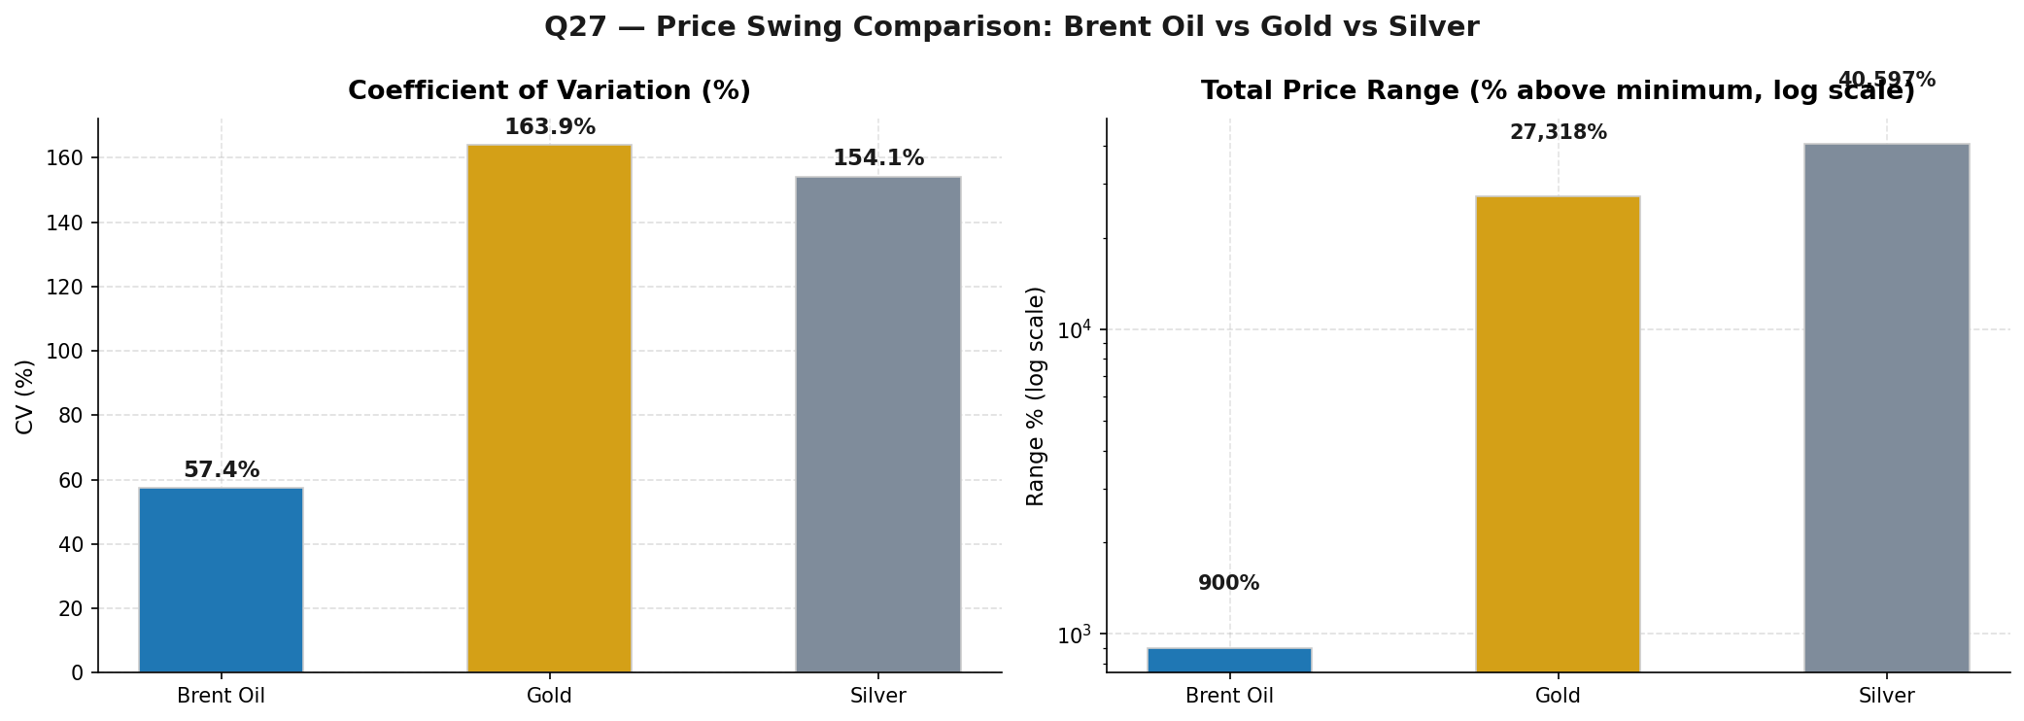
Figure 6. Price swing comparison across the three commodities. Source: own calculation (Part I, question 27).
Measured across the full history by coefficient of variation, which expresses the standard deviation as a share of the mean, gold comes out at 163.9 percent and silver at 154.1 percent, both far above oil's 57.4 percent. Part of that gap is a base effect: the metals started their series at a few dollars and now trade in the thousands and the nineties respectively, which inflates any mean-based measure. Year-to-year moves give a fairer view, and they still favour the metals for size: silver's largest annual rise is 131.5 percent (the current 2026 move) and its worst annual fall is 48.6 percent, while oil's extremes are a 141.5 percent rise in 1974 and a 49.3 percent fall in 1986. Oil's swings are rarer but tied tightly to identifiable supply events; the metals move big and often.
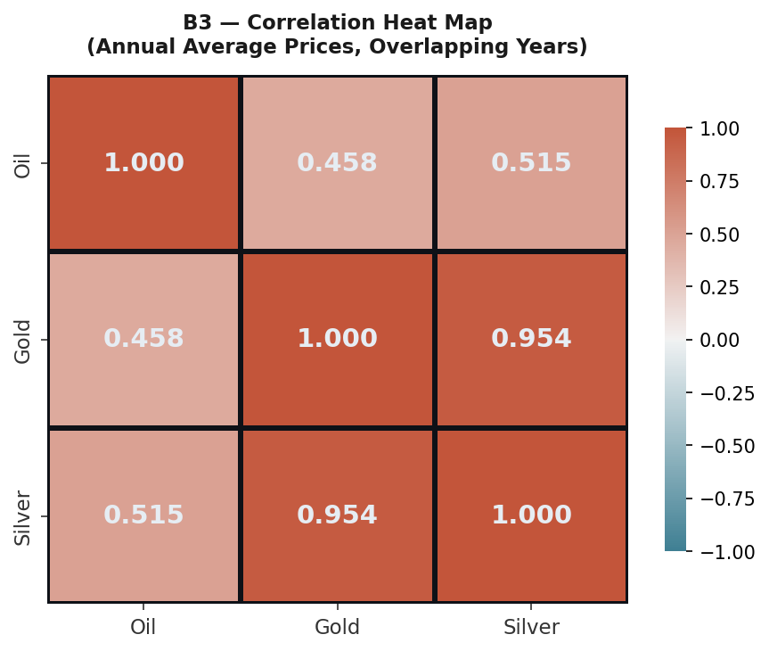
Figure 7. Correlation of annual average prices between the three commodities. Source: own calculation (bonus questions B2 and B3).
The correlation structure in Figure 7 is clean. Gold and silver move almost in lockstep, with a correlation of 0.954 on annual averages. Oil correlates only moderately with either metal, at 0.458 with gold and 0.515 with silver. Statistically that says the metals share one set of drivers, monetary and safe-haven demand, while oil answers to a different master, physical supply and demand. This single table quietly predicts most of what Part II finds when it lines the prices up against events.

3.7 A trendline forecast, and why to distrust it
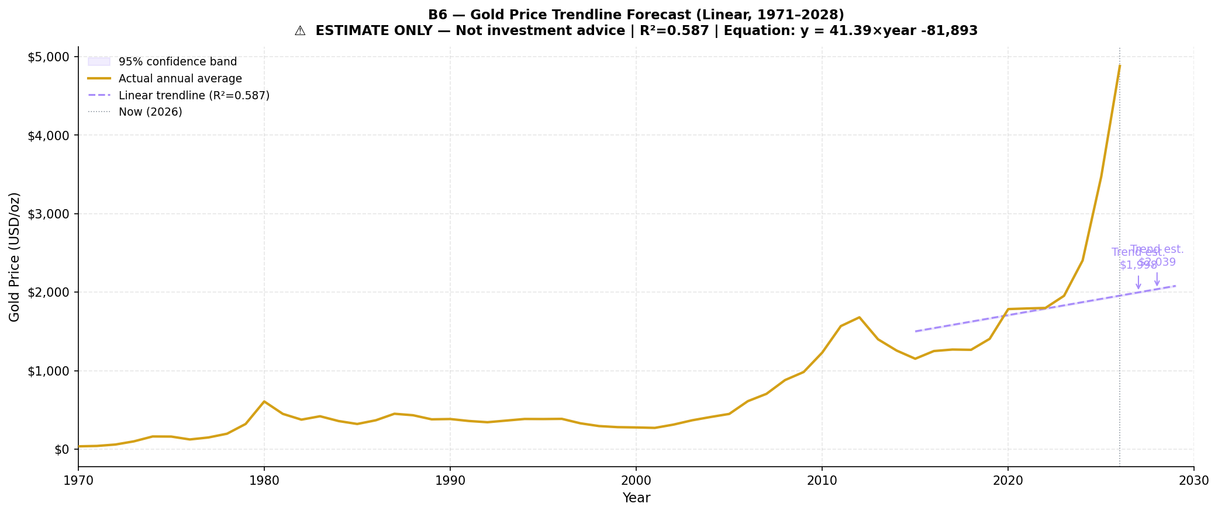
Figure 8. Linear trendline on gold annual averages since 1971, extended forward as a rough estimate. Source: own calculation (bonus question B6).
For the bonus forecasting question we fitted a simple linear regression to gold's annual averages since 1971. The fit explains about 59 percent of the variance (R squared of 0.587), which sounds respectable until you look at where the actual price is: the 2026 average sits far above where the line says it should be. A straight line through five decades cannot capture regime changes, and the post-2022 climb is exactly that. We include the forecast because the assignment asks for one, but the honest reading is that it is an estimate of the long-run drift, not a prediction of next year's price, and the recent data is already off the line.

3.8 The currency tracker: who settles the world's payments
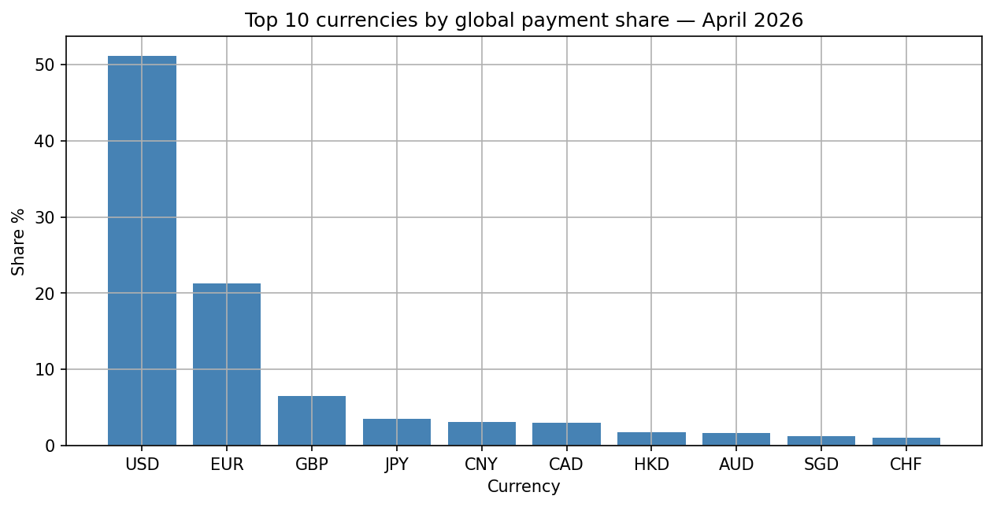
Figure 9. Top ten currencies by global payment share, April 2026 report. Source: swift_currency_tracker_all_reports.csv (Part I, question 24).
The April 2026 report puts the US dollar at 51.14 percent of global SWIFT payments, more than the next nine currencies combined. The euro follows at 21.30 percent, then the British pound at 6.54, the Japanese yen at 3.53 and the Chinese renminbi at 3.10 percent in fifth place. The remaining top-ten currencies, from the Canadian dollar down to the Swiss franc, all sit below 3.1 percent. When intra-Eurozone euro flows are excluded, which is arguably the fairer measure of genuinely international payments, the dollar's share rises further to 58.50 percent while the renminbi's drops to 2.44 percent.
Across all four available reports the top of the ranking barely moves. The dollar, the euro, the pound and the yen appear in the top five in every report; the fifth seat rotates between the Canadian dollar and the renminbi, each of which makes the top five in two of the four months. Payment shares are structural numbers, and four months of them behave accordingly.
Table 3. US dollar against Chinese renminbi across the three payment metrics, April 2026 report. Source: swift_currency_tracker_all_reports.csv.
Metric | US dollar | Renminbi
Global payment share | 51.14% | 3.10% (rank 5)
Trade finance share | 80.73% | 8.04% (rank 2)
International payments excl. Eurozone | 58.50% | 2.44%

Table 3 contains the most interesting asymmetry in the whole tracker. In everyday payments the renminbi is a rounding error next to the dollar, yet in trade finance it is the second currency in the world at 8.04 percent, behind only the dollar's 80.73. The renminbi is internationalising through the channel its government can influence most directly, trade settlement, rather than through broad payment adoption. There is momentum too: the tracker's growth metric shows renminbi payment values rising 12.65 percent and 11.44 percent month-on-month in the January and February 2026 reports. Two data points do not make a trend, but the direction is consistent with the trade finance picture.
The offshore renminbi data adds a geographic angle. Hong Kong processes 75.23 percent of offshore renminbi activity in the April 2026 report, more than ten times the United Kingdom's 6.90 percent, with Singapore third at 4.37. Whatever the renminbi's global ambitions, its offshore plumbing runs through a single city, and that concentration is itself a risk worth noting for anyone building exposure to the currency.

3.9 The picture on one page
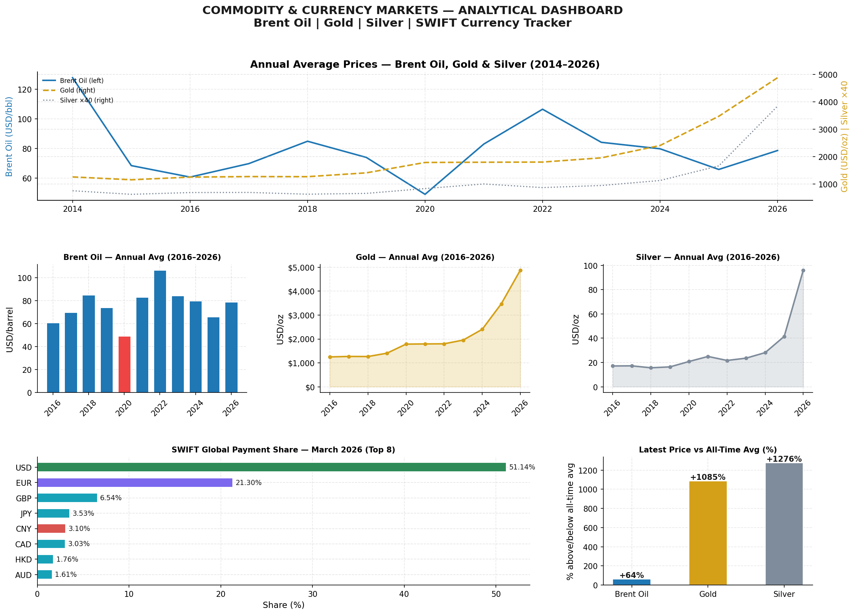
Figure 10. Summary dashboard of the main Part I findings. Source: own calculation (Part I, question 29).
Figure 10 condenses the analysis into a single dashboard page. For a manager with two minutes, the three takeaways we would put on a sticky note are these. First, oil is volatile around events: it fell 33.6 percent in 2020 and rose 28.2 percent in 2022, so any budget exposed to fuel should tolerate annual moves of thirty percent in either direction. Second, gold has been in a sustained four-year climb, from about 1,800 dollars in 2022 to nearly 4,900 in 2026, and moving averages say trend, not spike. Third, the dollar still dominates settlement with over half of global payments, while the renminbi is small overall but already number two in trade finance, which is the corner of the system to watch.

4. Market Research Findings

4.1 The events that show up in the data
The supplied briefings describe a set of global events: the Strait of Hormuz shipping crisis, energy supply shocks, sanctions on Russia, tariff disputes, central-bank gold accumulation, the BRICS settlement discussions and the gradual shifts in currency markets. Before linking any of them to prices, it is worth being explicit about method. A price series cannot prove causation; what it can do is show whether the timing, direction and size of a move are consistent with an event, and whether competing explanations fit worse. That is the standard we apply below.
Table 4. Timeline of major events against the observed reaction in each market. Percentages are year-on-year changes in annual average prices from the datasets.
Period | Event | Oil | Gold / Silver | Currency angle
1973-74 | OPEC embargo | +141.5% | Gold surge begins | Dollar weakens
1979-81 | Iranian revolution, Iran-Iraq war | Spike above 130 | Gold +89.3% (1979) | Inflation, Volcker shock
1986 | OPEC price war | -49.3% | Metals quiet | Limited
2008-09 | Global financial crisis | Peak, then crash | Gold +24.9% (2008) | Dollar as safe haven
2014-16 | US shale oversupply | Roughly halves | Silver falls hard | Dollar strengthens
2020 | Covid-19 pandemic | -33.6% | +27.0% / +27.1% | Global rate cuts
2022 | Russia-Ukraine war, sanctions | +28.2% | +0.3% / -13.2% | Renminbi settlement grows
2022-26 | Gold accumulation, de-dollarisation | Drifts lower | Multi-year climb | Renminbi rank 5, trade finance rank 2
2026 | Hormuz-type shipping disruption | +52% in one month | At record highs | Not yet visible

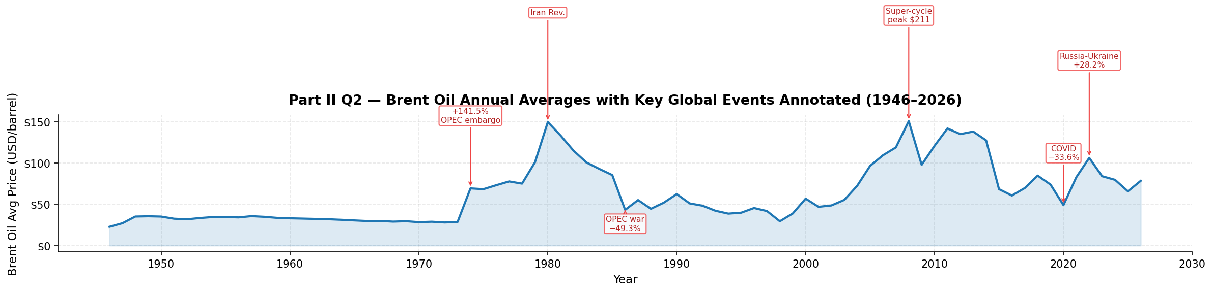
Figure 11. The event timeline annotated on the oil price history. Source: own calculation (Part II, question 2).
Three events stand out as most clearly visible in the data. The Russia-Ukraine war and the SWIFT sanctions of February 2022, because oil's reaction was immediate and large. The pandemic of 2020, because it split the markets cleanly in opposite directions. And the 2022-26 wave of central-bank gold buying tied to de-dollarisation, because it lines up with the largest sustained move anywhere in the dataset. The next sections take these one at a time.

4.2 Oil and supply shocks
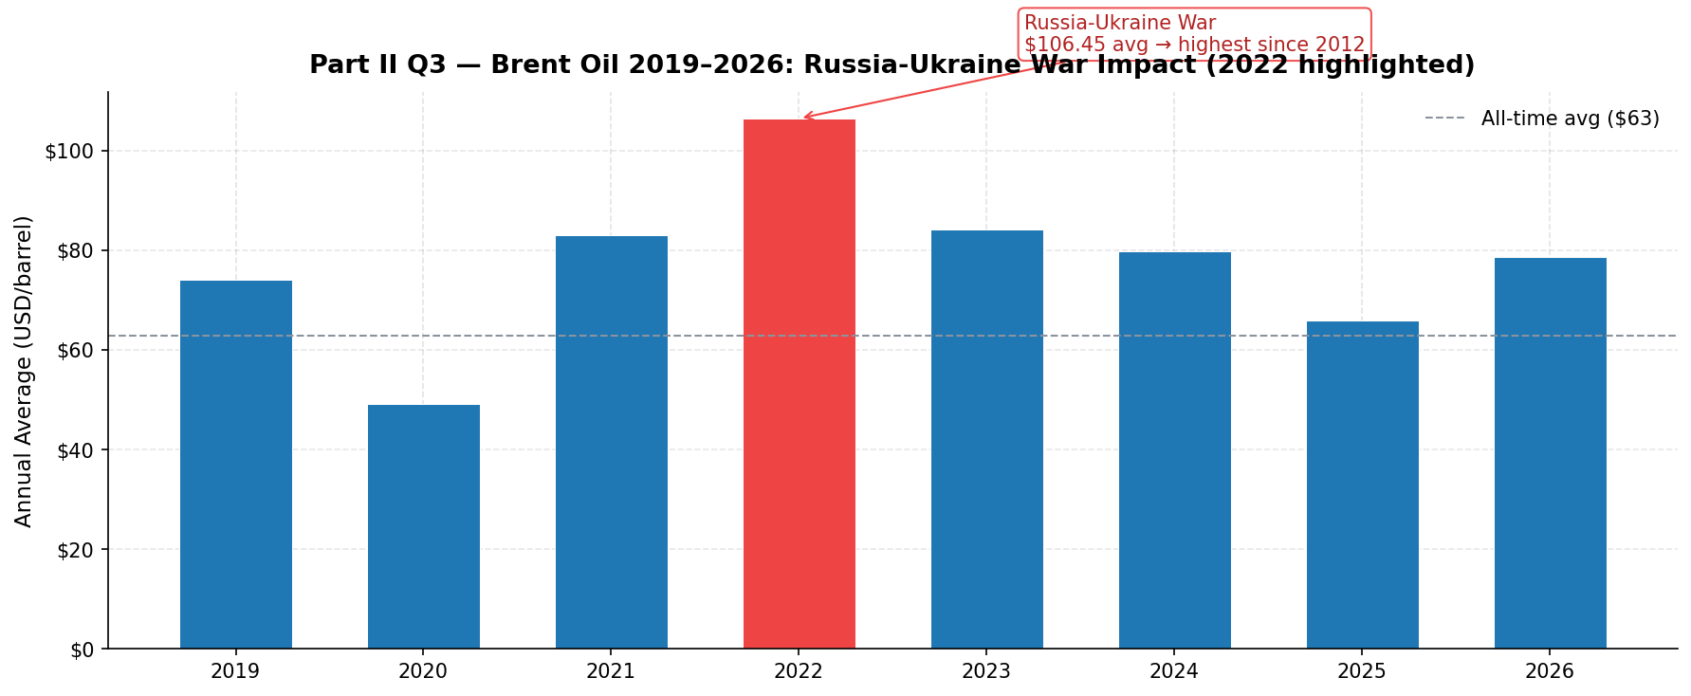
Figure 12. Brent oil around the February 2022 invasion of Ukraine. Source: Brent Oil.csv, own calculation (Part II, question 3).
Of all the events in the briefings, the Russian invasion of Ukraine is the one most directly stamped on the oil series. Russia is one of the world's largest crude exporters. Within weeks of the invasion the monthly average moved from 104.72 dollars in January 2022 to a peak of 129.22 in May, and the full-year average of 106.45 dollars came in 28.2 percent above 2021 and the highest since 2012. The shape of the move, a fast vertical jump rather than a slow build, is the signature of a supply shock: barrels leave the market faster than demand can adjust, so the price gaps up.
The same mechanism explains the most recent data point. Through 2025 oil drifted from about 75 dollars down toward 58, and then jumped 52 percent between February and March 2026, from 67.66 to 102.86 dollars. The briefings attribute this to the Strait of Hormuz shipping crisis, and the fit is good: roughly a fifth of the world's seaborne oil passes through that strait, so even a credible threat to it repricing the entire curve is exactly what the textbook predicts. We would still be careful about the strength of the claim, since we have only one month of post-event data and no way to separate the Hormuz effect from anything else that happened in March 2026. Direction and size are consistent; that is as far as the evidence goes.
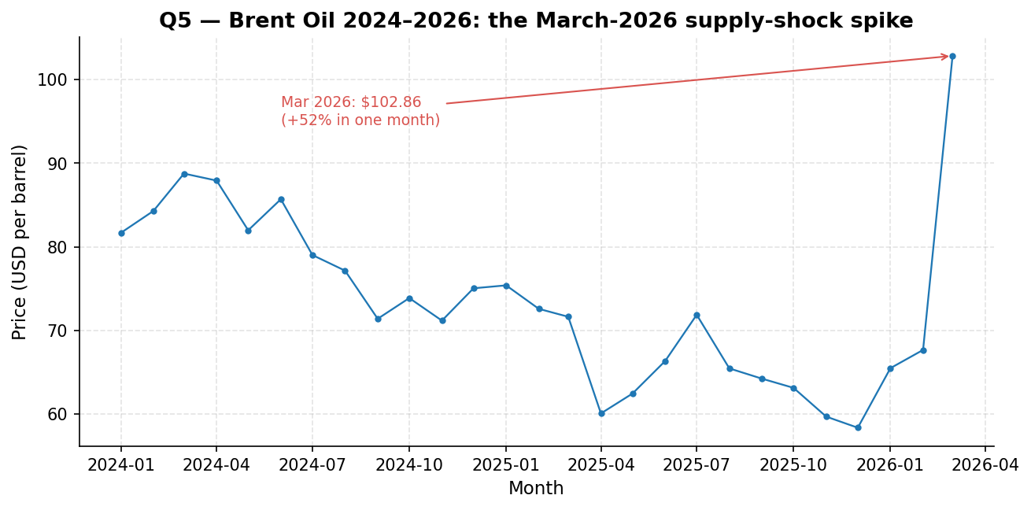
Figure 13. Brent oil in the recent period, showing the February to March 2026 jump. Source: Brent Oil.csv, own calculation (Part II, question 5).

4.3 Gold, uncertainty and the central banks
Gold's usual argument is simple: it is a liquid store of value that is nobody's liability. It cannot default and, importantly after 2022, it cannot be frozen the way currency reserves held abroad can. When geopolitical risk rises, both private investors and central banks reach for it.
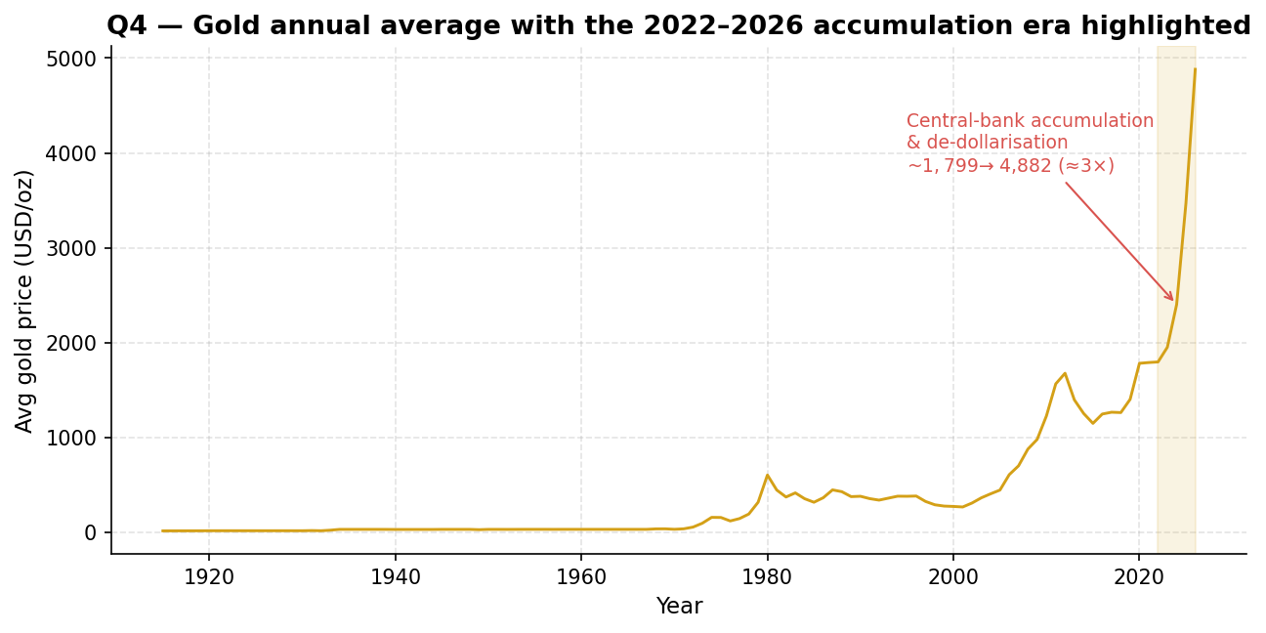
Figure 14. Gold's climb from 2022 to 2026 against the earlier safe-haven episode of 2020. Source: Gold 100years.csv, own calculation (Part II, question 4).
The dataset shows this behaviour twice, in two different flavours. In 2020 gold jumped 27 percent in a classic one-year flight to safety and then went sideways; that is what fear looks like in the data. The 2022-26 move is different in kind, not just in size. The annual average rises every year, from 1,798.96 dollars in 2022 through 1,953.69, 2,404.58 and 3,472.54 to 4,881.62 in 2026. Fear spikes and fades; this is accumulation. The briefings describe central banks, particularly in countries watching what sanctions did to Russia's reserves, steadily rotating out of dollar assets into gold, and a slow multi-year climb is precisely the footprint such buying would leave. We cannot see central-bank purchase volumes in our price data, so the attribution rests on the briefings plus the shape of the curve, but no alternative explanation we considered fits a four-year staircase as well.

4.4 What kind of asset is silver?
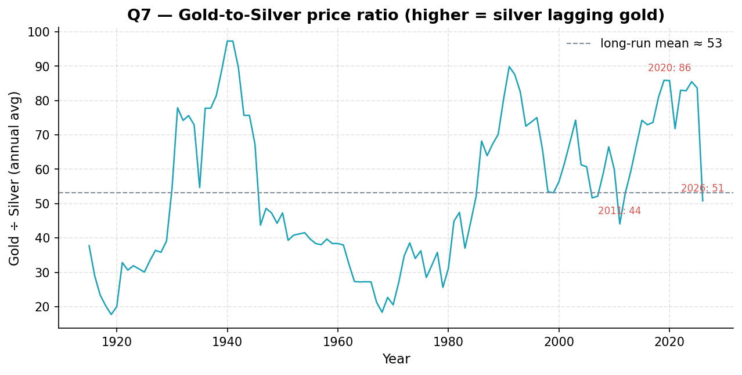
Figure 15. The gold-to-silver price ratio over the recent period. A rising ratio means silver lags gold; a falling ratio means silver outruns it. Source: own calculation (Part II, question 7).
Silver has a split personality on paper: it is a precious metal by tradition and an industrial input in practice, going into solar panels and electronics. The data lets us ask which side dominated in this period. The answer is the precious side, with a volatility twist. Silver turned at every one of gold's major turning points (Figure 5), which is safe-haven co-movement, not independent industrial demand. The ratio in Figure 15 shows the twist: it rose to about 86 in 2020, meaning silver lagged during the initial fear-driven rally, and has since compressed toward 53 as silver outran gold, gaining 131.5 percent in 2026 against gold's 40.6. Silver behaves like gold with the volume turned up, lagging early in a rally and overshooting late. For a portfolio that means silver is not a calmer alternative to gold; it is a louder one.

4.5 One crisis, three markets
Table 5. Year-on-year change in annual average prices during three crisis years. Source: own calculation (Part II, question 8).
Crisis year | Oil | Gold | Silver
2008, financial crisis peak | +26.7% | +24.9% | +10.8%
2020, Covid-19 | -33.6% | +27.0% | +27.1%
2022, Russia-Ukraine | +28.2% | +0.3% | -13.2%

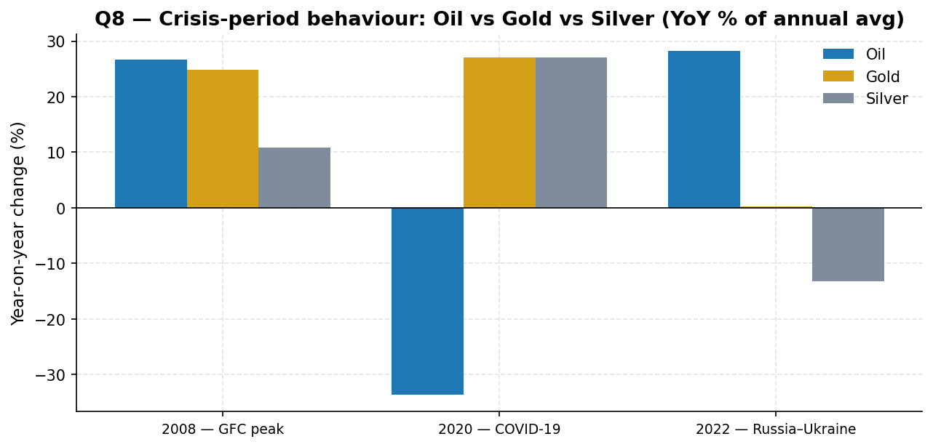
Figure 16. The three crisis years side by side. Source: own calculation (Part II, question 8).
Table 5 is the most instructive table in the report, because it shows that crises are not interchangeable. In 2020 the pattern is textbook: a demand collapse crushed oil by a third while both metals rose 27 percent as safe havens, an almost perfect mirror image. In 2022 the pattern flips. Oil rose 28.2 percent because the shock was to supply, while gold barely moved and silver actually fell 13.2 percent; there was no broad flight to safety, just an energy problem. 2008 sits between the two, with oil and gold rising together into the crisis peak before the crash. The practical lesson for a manager: knowing that a crisis is coming is not enough to position for it, because the type of crisis, demand-side or supply-side, decides which way each market goes.

4.6 Currencies: a slow game with high stakes
Against the drama in commodities, the currency data moves at a glacial pace, and that is the finding. The dollar handles 51.14 percent of global payments and 80.73 percent of trade finance in the most recent report, and its payment share hardly varies across the four available months. Nothing in this dataset suggests the dollar's settlement role is eroding quickly.
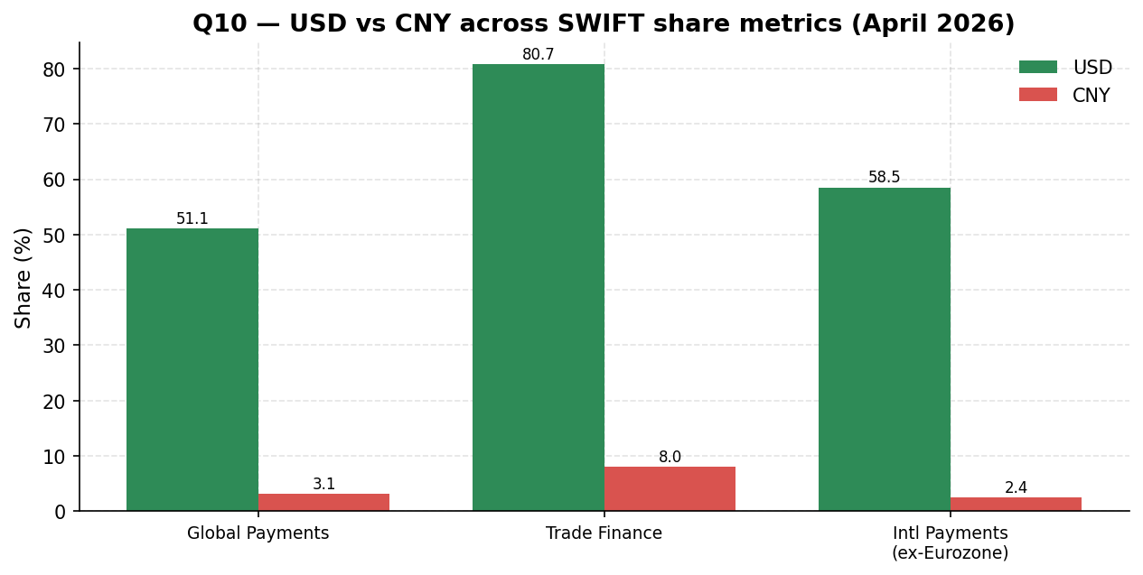
Figure 17. US dollar and renminbi compared across payment metrics, April 2026 report. Source: swift_currency_tracker_all_reports.csv (Part II, question 10).
Why then do the briefings spend so much time on sanctions, BRICS Pay and alternative settlement systems? Because the same dominance that makes the dollar convenient also makes it a lever. When Russia was largely cut off from SWIFT in 2022, it had to settle trade in something else, and the tracker shows where some of that flow went: the renminbi is now the second trade-finance currency at 8.04 percent, and its payment values grew 11 to 13 percent month-on-month in early 2026. Alternative rails such as CIPS and the BRICS Pay discussions, and for that matter the central-bank gold buying in section 4.3, all point in the same direction, toward reducing dependence on a system that can be switched off. None of this threatens the dollar's position this year or next. It is a slow-moving risk, but slow-moving is not the same as small, and the cost of being wrong about it compounds.
The offshore renminbi numbers sharpen one specific vulnerability. With Hong Kong handling 75.23 percent of offshore renminbi activity, the internationalisation of China's currency currently depends on one financial centre. Any disruption there, regulatory or geopolitical, would bottleneck most offshore renminbi flow at once. London and Singapore are far behind at 6.90 and 4.37 percent. For a company considering renminbi exposure, that concentration belongs in the risk assessment alongside the currency's managed exchange rate and capital controls.

4.7 Which market is most sensitive to global events?
The honest answer is that sensitivity splits into two different things, speed and amplitude, and different markets win each. On speed, oil is unmatched: it repriced 52 percent within a single month of the 2026 shipping disruption, and its 2022 spike played out in weeks. On amplitude over time, the metals win, with coefficients of variation near 164 and 154 percent against oil's 57, and silver alone moving 131.5 percent in 2026. Currencies finish last on both counts; the dollar's payment share is close to immobile across the four reports, with a coefficient of variation of about 1.7 percent. So a one-line summary for a manager reads: oil reacts fastest, metals move furthest, currencies barely move at all but matter most when they finally do.

5. Final Recommendation

5.1 Risk note: a company exposed to oil prices
Oil's own recent record defines the risk. Within six years the annual average fell 33.6 percent (2020), rose 28.2 percent (2022) and jumped 52 percent in a single month (early 2026). Because supply shocks reprice oil within days, fuel costs can outrun budgets and fixed-price contracts before anyone has time to react. The exposures that follow are margin compression for fuel-intensive operations, working-capital strain during spikes, and demand destruction if high prices persist. Our view is that an oil-exposed company should treat a thirty percent annual price move in either direction as a planning assumption rather than a tail scenario, hold hedges or pass-through clauses that survive a one-month 50 percent spike, and stress-test cash flow against the 2026 pattern specifically, a long drift down followed by a sudden reversal, because that sequence punishes companies that let hedges lapse during the calm.

5.2 Risk note: a company holding dollars, gold or renminbi
These three assets carry three different risk profiles, and the mistake would be treating them as interchangeable stores of value. The dollar remains the safest for liquidity and settlement, with 51.14 percent of payments and 80.73 percent of trade finance, but it earns no crisis premium and its long-term settlement dominance is the exact thing the de-dollarisation trend is aimed at. Gold has been the standout performer, roughly two and three quarter times higher over 2022-26, and it hedges precisely the scenario in which currency reserves get frozen; against that, it pays no yield, and an asset that has climbed four years without pause can correct hard. The renminbi offers exposure to the fastest-growing corner of trade settlement, but it comes with a managed exchange rate, capital controls, and an offshore market three quarters of which runs through a single city. A holder of all three should decide explicitly which risk each asset is there to cover, rather than sizing them by past performance, which in this period would simply mean buying whatever already went up.

5.3 Three recommendations
First, hedge oil exposure explicitly and budget for large swings. The data supports planning around annual moves of thirty percent and stress cases of fifty, using forward purchases, options, or fuel-surcharge clauses in customer contracts. The cheap moment to buy protection is the calm stretch, which is exactly when it feels least necessary; 2025 was that stretch and March 2026 was the bill.
Second, treat gold as a strategic allocation, not a trade. The 2022-26 climb tracks a structural driver, reserve diversification by central banks, rather than a passing scare, so some allocation is justified for entities exposed to sanctions risk or dollar concentration. At the same time, entering after a near-tripling means accepting correction risk, so the sensible route is a fixed target percentage of reserves built up gradually, not a lump purchase at the record high.
Third, keep settlement operations on the dollar but build renminbi capability now. The dollar's share says it remains the operational backbone for years. The renminbi's trade finance rank says the second rail is already being laid. For a company trading with Asia, having tested renminbi settlement channels, banking relationships and, given the Hong Kong concentration, a view on where its offshore renminbi clearing actually happens, is cheap insurance today and expensive scrambling later. Policymakers reading the same data should draw a parallel conclusion about how much power sanctions will retain as alternative rails mature.
The one-paragraph summary for a manager who reads nothing else: oil is fast and event-driven, so hedge it; gold is in a slow structural climb driven by official buying, so hold some deliberately; the dollar still runs the world's payments, so keep using it, but the growth is happening on the renminbi's trade rail, so learn it before you need it.

6. Appendix

6.1 Methodology and reproducibility
All analysis was done in Python with pandas for data handling and matplotlib for charts. The work is organised in four Jupyter notebooks: three for Part I, covering data preparation and descriptive statistics, trends and the currency tracker, and comparisons with the bonus questions, plus one notebook for all sixteen Part II questions. Every table and figure in this report is generated by those notebooks from the four raw csv files, with no manual editing of numbers, and the key outputs are consolidated in the accompanying Excel workbook (DSB_Group8_Workbook.xlsx) with a contents sheet mapping each tab to the assignment questions. Dates were parsed with explicit formats, aggregations are simple annual means of monthly values, correlations are Pearson coefficients on annual averages, and the forecast in section 3.7 is an ordinary least squares line on annual averages since 1971.

6.2 Data caveats collected in one place
Three caveats from the body of the report are worth restating together. The oil series appears to be inflation-adjusted while the metal series appear nominal, so cross-series level comparisons are avoided; within-series trends and percentage changes are unaffected. The 2026 figures are year-to-date averages over an incomplete year and can still change materially. And the currency tracker covers only four monthly reports, which is enough to describe the current structure of payment shares but not enough to establish trends; the month-on-month renminbi growth figures in particular should be read as observations, not as an established growth rate.

6.3 Supplementary tables
Table 6. Average annual Brent oil price, last ten years (dollars per barrel).
Year | 2017 | 2018 | 2019 | 2020 | 2021 | 2022 | 2023 | 2024 | 2025 | 2026*
Average | 69.85 | 84.91 | 74.03 | 49.19 | 83.02 | 106.45 | 84.19 | 79.83 | 65.93 | 78.67

The 2026 value is a year-to-date average through March and reflects only the first quarter, including the March jump.
Table 7. Volatility statistics across the full history of each series.
Commodity | Mean | Std. dev. | Coeff. of variation | Largest annual rise | Largest annual fall
Brent Oil | 62.71 | 35.96 | 57.4% | +141.5% (1974) | -49.3% (1986)
Gold | 397.55 | 651.39 | 163.9% | +89.3% (1979) | -26.0%
Silver | 6.42 | 9.90 | 154.1% | +131.5% (2026) | -48.6%

Table 8. Event-sensitivity summary used in section 4.7.
Market | Amplitude (coeff. of variation) | Largest single-month move | Largest annual move
Brent Oil | 57.4% | +52% (Mar 2026, most recent example) | +141.5%
Gold | 163.9% | +32.2% | +89.3%
Silver | 154.1% | +69.5% | +131.5%
Dollar payment share | 1.7% | negligible | n/a (4 reports)

Full question-by-question outputs, including the tables for questions not reproduced here, are available in the project repository under part1/tables and part2/tables, and in the consolidated workbook.

