Swift Currency Tracker - EDA Report

1. Overview
The dataset contains 330 rows and 10 columns.
This exploratory data analysis (EDA) report examines
currency/economy values, RMB rankings, distributions,
correlations, and outlier behaviour.

2. Data Quality Checks
Missing Values: 388
Duplicate Rows: 0
The dataset was checked for completeness,
missing values, and duplicate records.
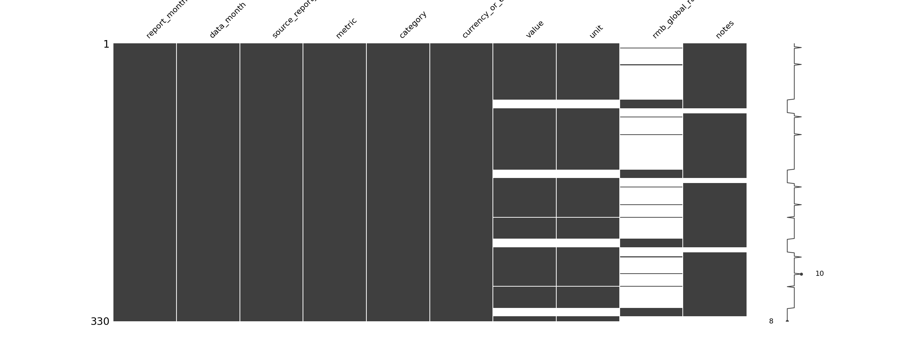

3. Distribution Analysis
Histogram and boxplot analysis were performed
to understand the spread, skewness,
and distribution of currency values.
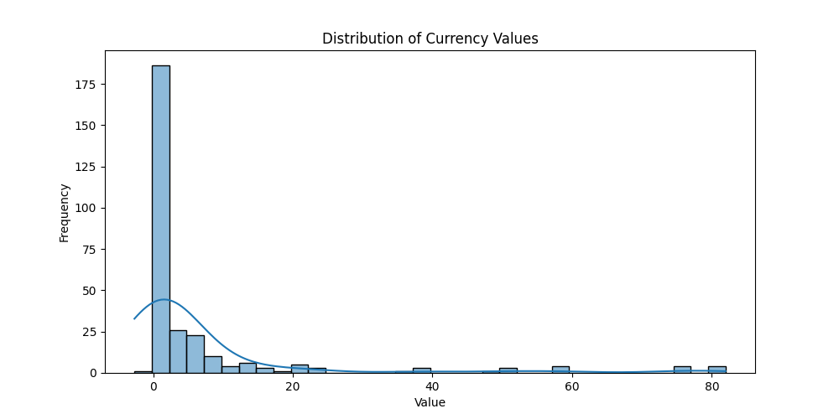
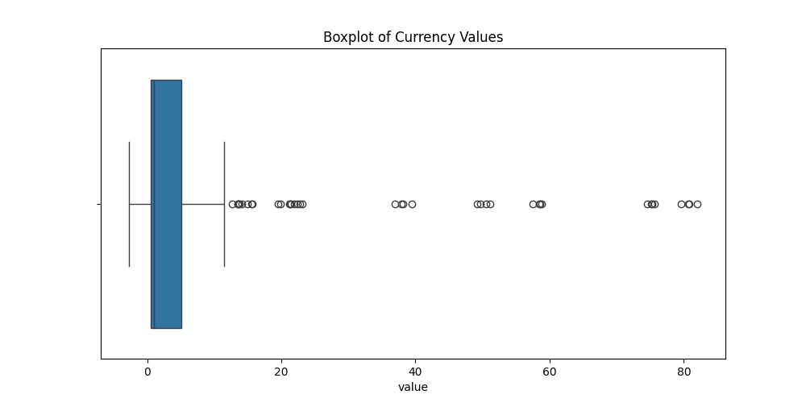

4. Top Economies by Value
The top 10 economies/currencies were identified
based on the highest recorded values.
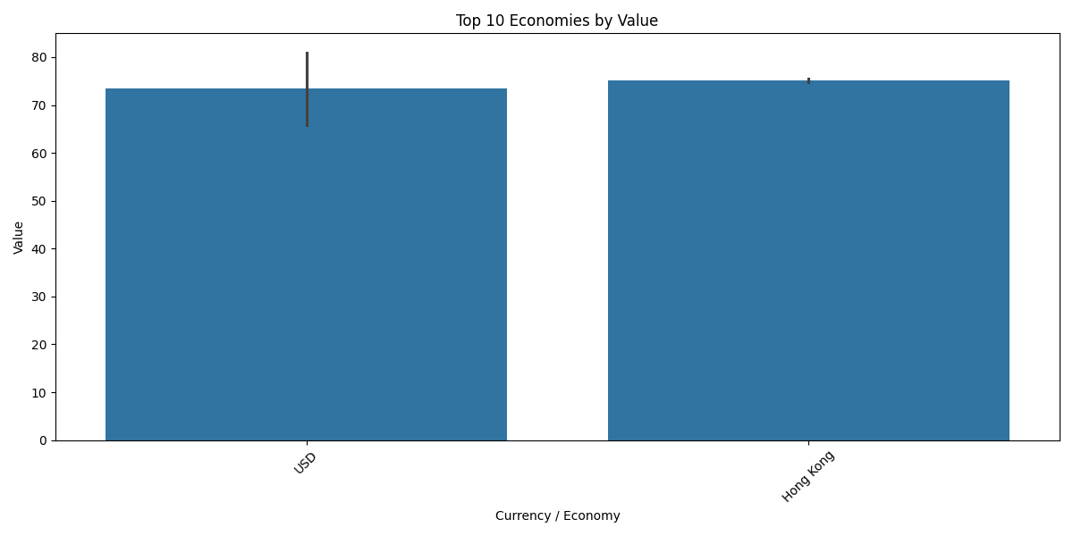

5. RMB Global Rank Analysis
Distribution analysis of RMB global rankings
was performed to understand ranking patterns
across economies.
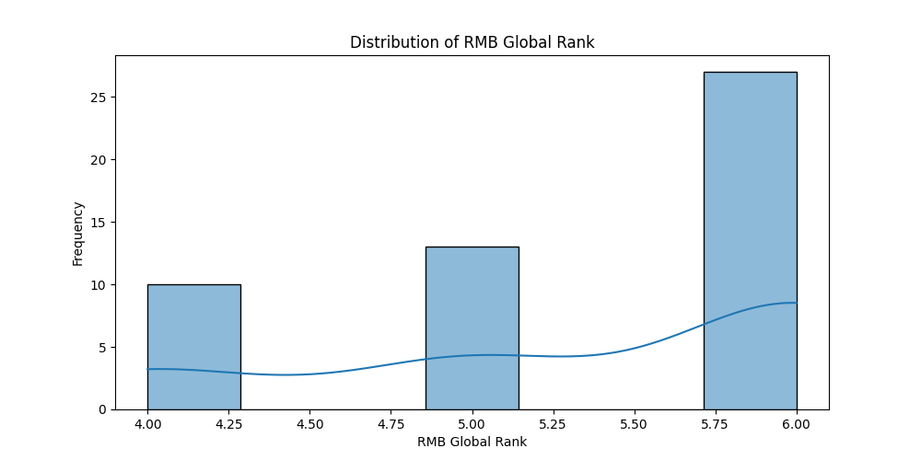

6. Correlation Analysis
Correlation heatmap analysis was used
to identify relationships between
numerical variables in the dataset.
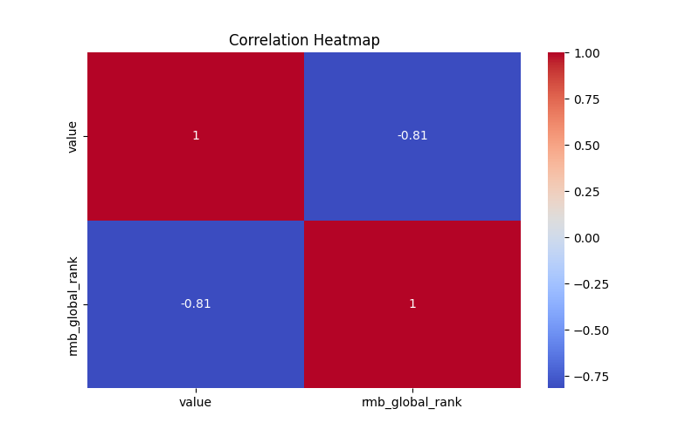

7. Outlier Detection
Outlier detection using the IQR method
identified 38 potential
outliers in the dataset.

8. Key Takeaways
• The dataset was successfully cleaned and analyzed.
• Distribution analysis revealed the spread
and skewness of currency values.
• Correlation analysis highlighted relationships
between numerical variables.
• Outlier detection identified unusual
observations requiring further investigation.
• Visualizations provide insights into
economy rankings and RMB positioning.

9. Open Research Questions
Q1. Are there significant relationships between RMB global rankings
and currency/economy values?
Q2. Which economies consistently exhibit unusually high or low
currency values, and what factors may explain these outliers?
Q3. How can additional macroeconomic indicators improve
future currency and economy analysis?

