AI-Driven Customer Lifetime Value & Retention Prioritization Analysis

- Executive Summary
This report presents a Customer Lifetime Value (CLV) and AI-driven churn risk analysis conducted on transactional data from an online retail business. The objective of the study was to identify high-value customers, assess their churn risk using machine learning, and prioritize retention actions to protect long-term revenue.
The analysis covered 4,338 customers and ₹8.91 million in total revenue. Although customers are evenly distributed across value segments, the results reveal a strong revenue concentration: approximately 84.86% of total revenue is generated by the high-value customer segment, which represents only one-third of the customer base.
By integrating churn risk prediction with customer value, an AI-driven retention prioritization framework was developed. This framework identified 144 high-value customers at elevated churn risk, representing approximately ₹854,950 in revenue at risk. The findings strongly support a targeted, proactive retention strategy rather than uniform engagement across all customers.
- Business Context and Objectives
In competitive retail and digital commerce environments, customer retention plays a critical role in sustaining profitability. Acquiring new customers is often significantly more expensive than retaining existing ones, particularly those who contribute the highest long-term value.
Traditional analytics approaches often analyse customer value and churn risk separately. However, acting on churn signals without considering customer value can lead to inefficient allocation of retention resources. The goal of this project was therefore to combine customer value analysis with AI-driven churn prediction to support decision-focused retention strategies.
Objectives
- Estimate Customer Lifetime Value (CLV) at an individual customer level
- Segment customers based on long-term value
- Identify revenue concentration and risk exposure
- Predict churn risk using explainable machine learning
- Prioritize retention actions based on both value and risk

- Data Overview and Preparation
The dataset consists of historical transaction-level data from an online retail business. Each record represents a product-level transaction made by a customer on a specific date.
Initial Data size
- Raw dataset: 541,909 transaction records
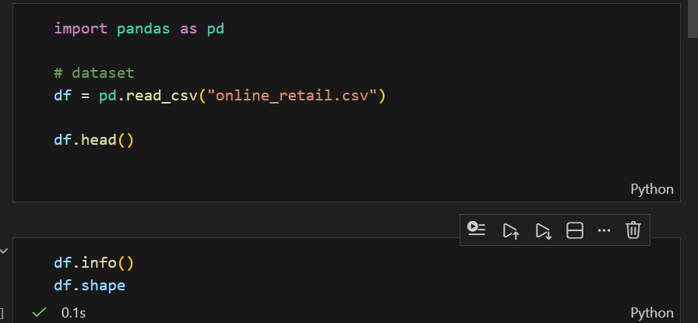
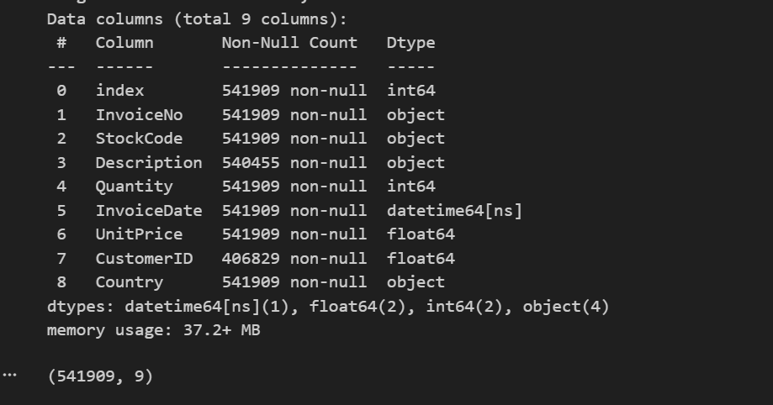
Data Cleaning Decisions
Data cleaning was guided by business relevance and financial accuracy:
- Transactions without a CustomerID were removed, as customer-level analysis requires identifiable customers
- Transactions with negative quantities (returns) were excluded from revenue and CLV calculations
- Records with zero or negative unit prices were removed
- Invoice dates were converted to a standardized datetime format
- A transaction-level Revenue metric was derived
Post-Cleaning Dataset
- Cleaned transactional records: 397,884
- Customer-level analytical dataset: 4,338 customers
These steps ensured that the analysis was based on valid, revenue-generating customer behaviour.
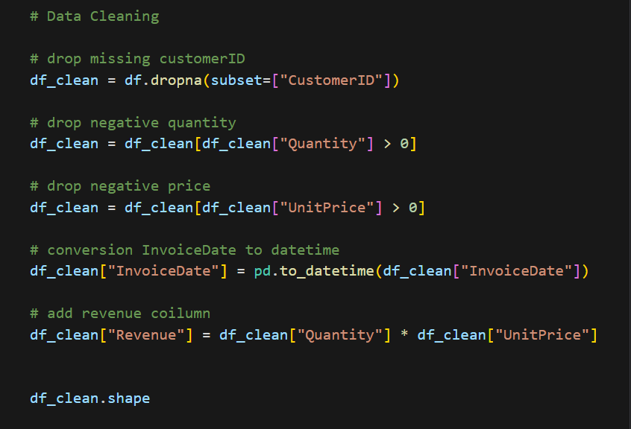
- Feature Engineering and CLV Methodology
To estimate long-term customer value, transactional data was aggregated to the customer level. The following behavioural metrics were engineered:
- Total Revenue: Sum of all transaction revenue per customer
- Total Orders: Number of unique purchase occasions
- Average Order Value (AOV): Revenue per order
- Customer Lifetime: Time between first and last purchase (in days)
- Purchase Frequency: Orders normalized on an annual basis
To avoid distortion caused by one-time buyers, customers with a zero-day observed lifetime were assigned a minimum lifetime of one day.
Customer Lifetime Value (CLV) Calculation
CLV was estimated using a frequency-based, interpretable model:
[CLV = Average Order Value × Purchase Frequency × Customer Lifetime]
This approach was chosen for its transparency, scalability, and suitability for business decision-making.
- CLV Distribution and Customer Segmentation
CLV Distribution Analysis
The CLV distribution is highly right-skewed:
- Median CLV: approximately ₹674
- Mean CLV: approximately ₹2,054
- Maximum CLV: over ₹280,000
This indicates that while most customers generate modest value, a small subset contributes disproportionately to total revenue.
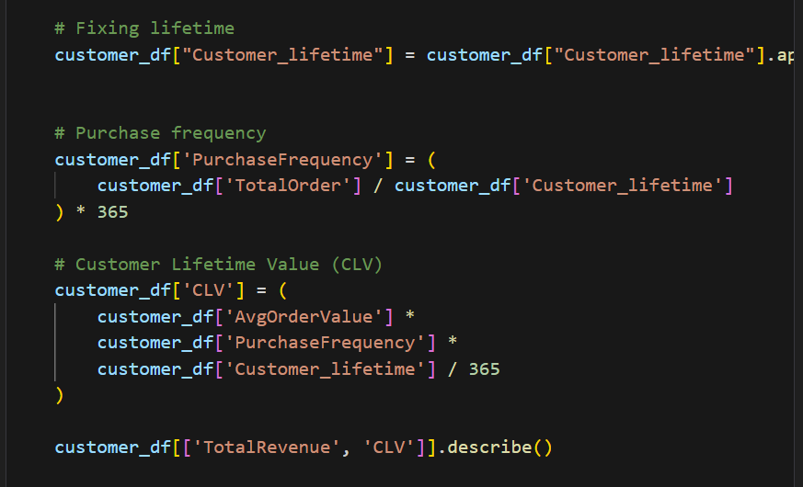
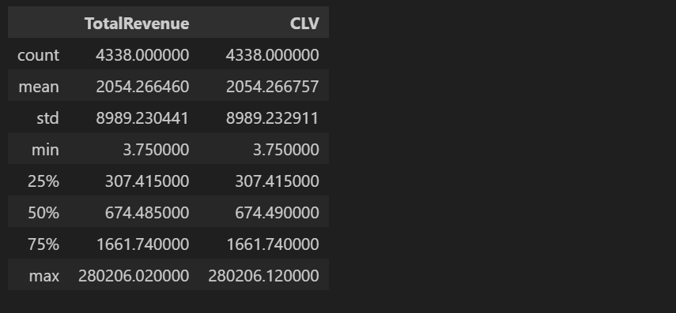
Customer Segmentation
Customers were segmented into three equal-sized groups using CLV tertiles:
- Low Value (1,446 customers)
- Medium Value (1,446 customers)
- High Value (1,446 customers)
Revenue Contribution by Segment
- Low Value: ₹0.32M (~3.6%)
- Medium Value: ₹1.03M (~11.5%)
- High Value: ₹7.56M (~84.9%)
Although customer counts are evenly distributed, revenue contribution is heavily concentrated in the high-value segment. This creates significant revenue exposure if high-value customers churn.

- Churn Definition & AI-Based Risk Modelling
Churn Definition
Churn risk was defined using a practical behavioural rule:
- Customers with no purchases in the last 90 days were classified as at risk
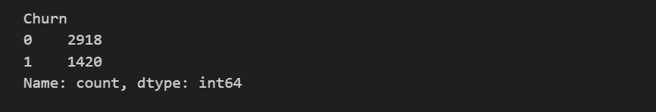
This definition aligns with common retail monitoring practices.
Model Selection
A Logistic Regression model was used to estimate churn probability due to:
- Interpretability
- Stability
- Suitability for business-facing explanations
Features Used
- Days since last purchase
- Total orders
- Average order value
- Purchase frequency
- Customer lifetime
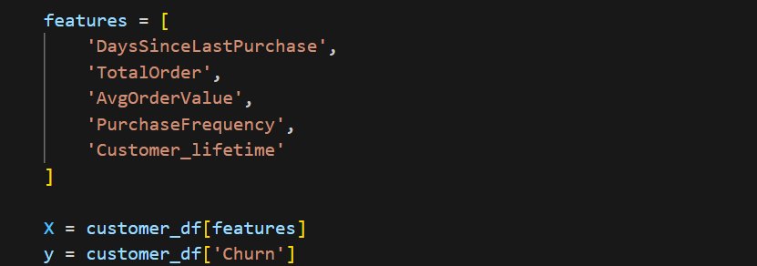
Model Performance
The model demonstrated strong discriminatory power (ROC-AUC ≈ 0.99), indicating clear separation between active and at-risk customers.
[In a production environment, time-based validation and rolling prediction windows would be applied to prevent data leakage and ensure forward-looking predictions.]
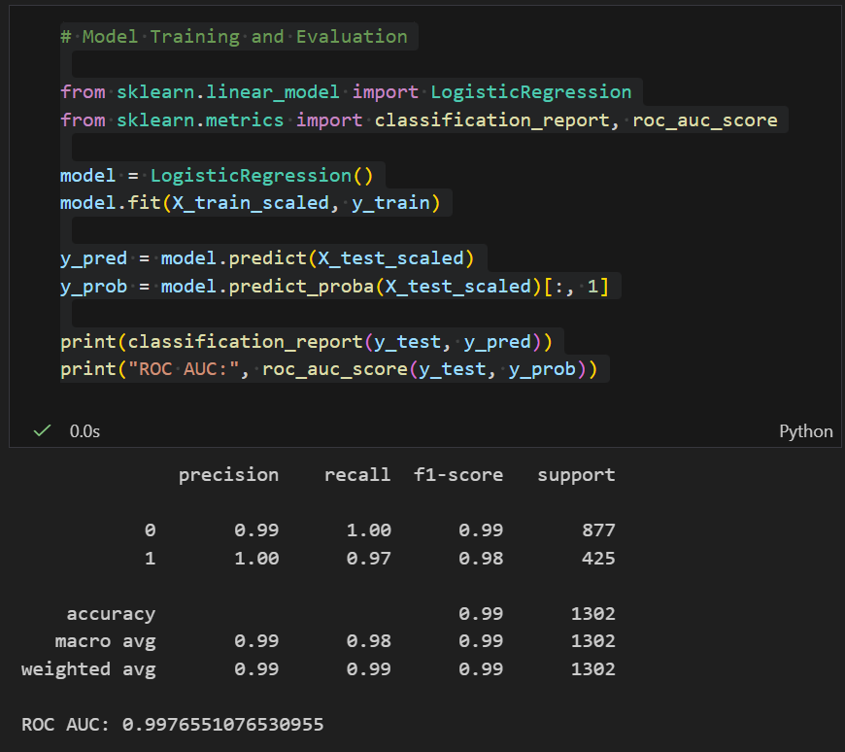
- AI-Driven Retention Priority Framework
Predicting churn alone does not indicate where action should be taken first. To translate AI predictions into business decisions, a Retention Priority Score was created.
Retention Priority Logic
Retention Priority Score = Normalized CLV × Churn Probability
This score highlights customers who are both:
- Highly valuable
- At significant risk of churn

Retention Prioritization Insights
- 144 high-value customers were identified as high-risk
- These customers represent approximately ₹854,950 in revenue at risk
A CLV vs Churn Risk scatter analysis clearly separates customers into four actionable groups:
- High Value & High Risk → Immediate retention action
- High Value & Low Risk → Protect and nurture
- Low Value & High Risk → Cost-controlled engagement
- Low Value & Low Risk → Minimal intervention
This framework enables targeted retention instead of blanket campaigns.
- Strategic Recommendation
High-Value Customers (Retention Focus)
- Implement loyalty and rewards programs
- Offer personalized promotions
- Provide premium customer support
- Proactively engage high-risk customers
Loss in this segment would significantly impact revenue stability.
Medium-Value Customers (Growth Focus)
- Upselling and cross-selling strategies
- Bundled product offerings
- Incentives to increase purchase frequency
This segment offers the strongest potential for migration into the high-value group.
Low-Value Customers (Cost Control Focus)
- Use automated, low-cost engagement channels
- Limit paid acquisition and retention spend
- Avoid aggressive discounting
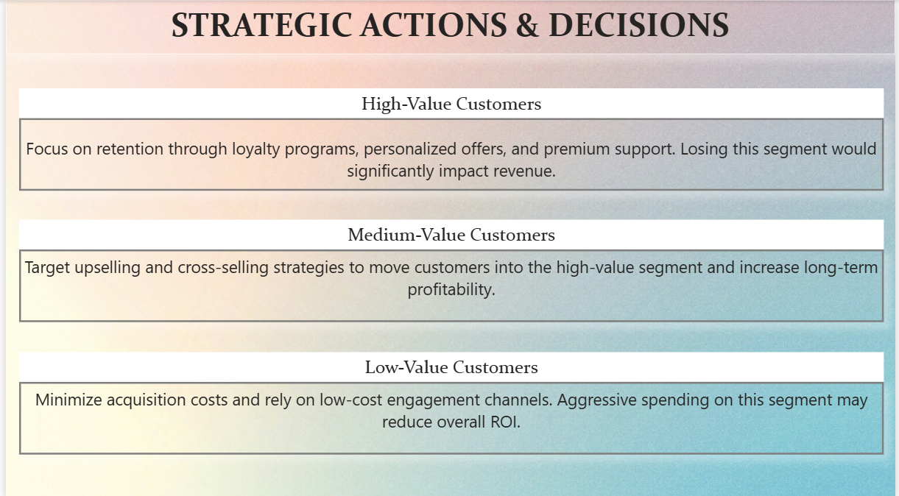
- Business Impact & Value Creation
By integrating customer value with AI-driven churn risk, this analysis enables the business to:
- Identify revenue concentration risk
- Protect approximately ₹0.85M in at-risk revenue
- Optimize retention spending
- Support proactive, data-driven decision-making
This approach aligns analytics directly with measurable financial outcomes.
- Assumptions and Limitations
- Churn defined via purchase inactivity (90-day rule)
- No external customer acquisition cost (CAC) data available
- Single-dataset scope without demographic enrichment
- Model thresholds are illustrative and would be refined in production
These limitations do not reduce the strategic relevance of the findings but define areas for future enhancement.
- Conclusion
This project demonstrates how traditional business analytics can be enhanced with explainable AI to support decision intelligence. By combining Customer Lifetime Value with churn risk prediction, the analysis moves beyond descriptive reporting toward actionable prioritization.
The resulting framework allows businesses to protect revenue, allocate retention resources effectively, and make informed strategic decisions in a competitive environment.

DASHBOARD
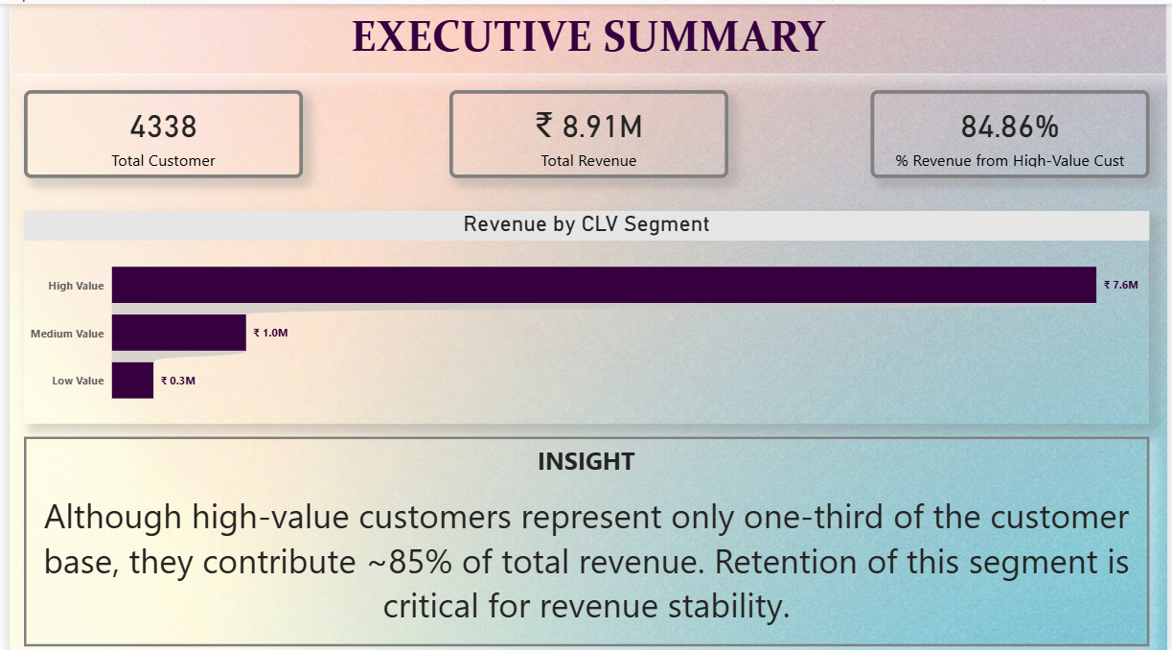
This page summarizes the overall customer base, total revenue, and the proportion of revenue contributed by high-value customers. It highlights the strong concentration of revenue within the high-value segment and sets the context for why targeted retention strategies are critical for revenue stability.
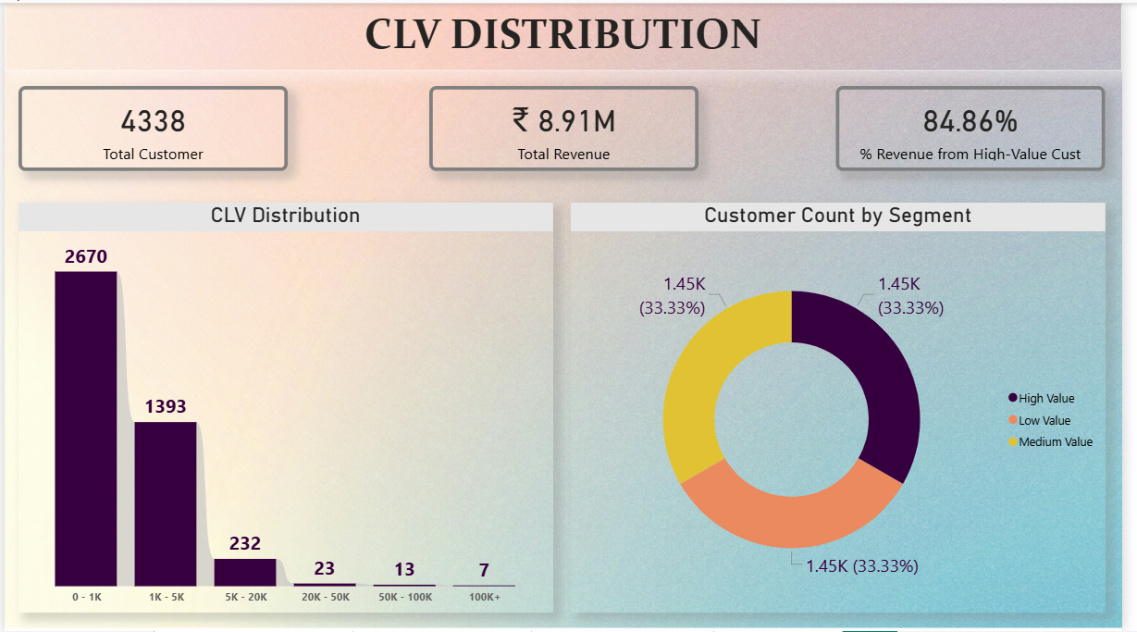
This page visualizes the distribution of Customer Lifetime Value (CLV) across all customers and shows how customers are evenly segmented into low-, medium-, and high-value groups. While customer counts are balanced, the CLV distribution is highly skewed, indicating that a small subset of customers generates disproportionately higher long-term value.
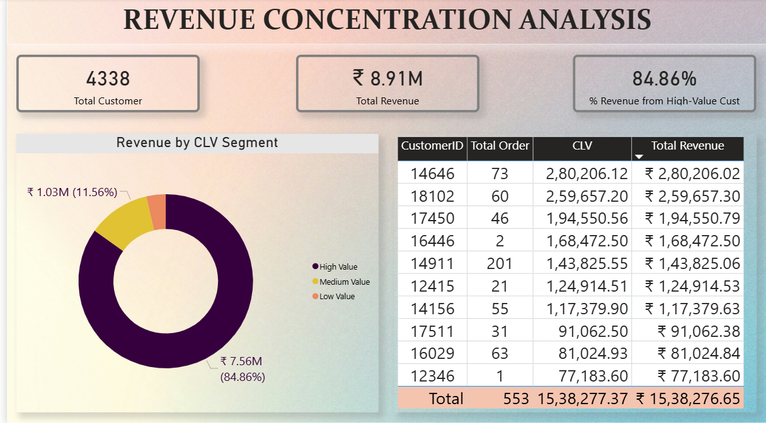
This page analyses revenue contribution by CLV segment and identifies the most valuable customers in terms of total revenue and purchase behaviour. It demonstrates that the high-value segment contributes nearly 85% of total revenue and helps stakeholders understand which customers are most critical to protect.
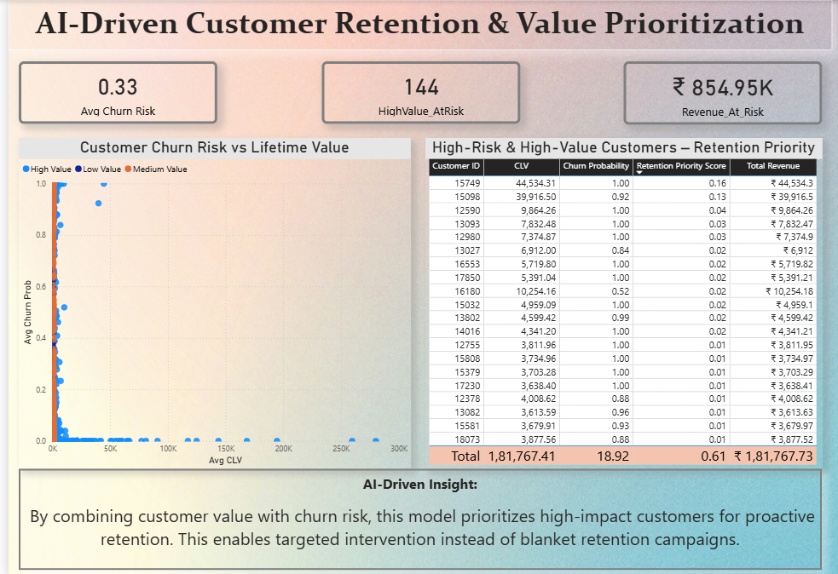
This page combines customer lifetime value with AI-based churn risk to prioritize high-impact customers and focus retention efforts where revenue protection is highest.

