

Task-level value affects trial-level reward processing: Evidence from EEG
Course: Signal Processing and Analysis of Human Brain Potentials (EEG)
University: University of Stuttgart

Team: Elephant
Members:
- Siddhant Sharma (3763661)
- Pawan (3764107)
Task: Reward Analysis: Event Related Potentials (ERP)
Paper: Task-level value affects trial-level reward processing: Evidence from EEG
Supervisor: Prof. Dr. Benedikt Ehinger

Contents
1. Introduction 3
1.1 Objective 3
2. Methods 3
2.1 Dataset 3
2.2 Preprocessing 4
2.3 ERP Analysis 4
2.4 Statistical Analysis 5
2.5 Methodological Justification 5
3. Results 6
3.1 ERP Observations 6
3.2 Subject-Level Variability 7
3.3 Quantitative Results 9
3.4 Statistical Results 10
3.5 Statistical Analysis 10
4. Sanity Checks 11
5. Replication Outcome 12
6. Discussion 12
7. Limitations 14
8. Reproducibility 14
9. Conclusion 15
10. References 15

1. Introduction
Electroencephalography (EEG) is widely used to study brain activity due to its ability to capture neural signals with high temporal precision (Luck, 2014). One of the most common approaches in EEG analysis is the use of Event-Related Potentials (ERPs), where brain responses are analyzed in relation to specific events or stimuli (Luck, 2014).
In the context of reward-based tasks, two ERP components are particularly important: the Feedback-Related Negativity (FRN) and the P300. The FRN typically appears around 200–350 ms after feedback and is generally stronger for negative outcomes, reflecting reward prediction error signals (Holroyd & Coles, 2002). On the other hand, the P300 component, which occurs slightly later (300–600 ms), is associated with attention and stimulus evaluation, particularly for salient or rewarding events (Polich, 2007).
The original study focused on comparing brain responses across gain, loss, and neutral conditions, and aimed to identify how these conditions influence ERP components.
The FRN and P300 components are well-established markers in reward processing. Previous studies have shown that FRN reflects outcome evaluation, particularly for negative feedback, while P300 is associated with attention and reward salience.
Our findings are consistent with these established interpretations, supporting the validity of our replication approach.

1.1 Objective
The goal of this project is to replicate these findings and evaluate whether:
- Loss trials produce stronger FRN responses compared to gain
- Gain trials result in higher P300 amplitudes compared to other conditions
At the same time, this project also aims to understand how different preprocessing and analysis choices can influence the final results.

2. Methods
All analyses were performed using Python and the MNE library.

2.1 Dataset
The dataset used in this study was obtained from the NEMAR (Neuroelectromagnetic Data Archive) repository (dataset ID: ds004147). It contains EEG recordings from participants performing a reward-based decision-making task involving gain, loss, and neutral feedback conditions.
The dataset is associated with the study “Task-level value affects trial-level reward processing: Evidence from EEG”, which investigates how contextual reward value influences neural responses to feedback.
The data is structured in a way that allows event-based segmentation and condition-wise comparison.

2.2 Preprocessing
Before performing any analysis, the EEG data was preprocessed to remove noise and improve signal quality.
The following steps were applied:
- Bandpass filtering (0.1–30 Hz):
This helps in removing slow drifts and high-frequency noise while preserving relevant ERP components.
- Re-referencing (average reference):
This step reduces bias from individual electrodes and makes signals more comparable.
- Artifact removal using ICA:
Independent Component Analysis was used to identify and remove artifacts such as eye blinks and muscle activity.
- Epoching (-200 ms to 800 ms):
The data was segmented around stimulus onset to focus on event-related activity.
- Baseline correction (-200 to 0 ms):
This normalizes the signal relative to pre-stimulus activity.
While the original paper does not specify all preprocessing steps in detail, the chosen pipeline follows standard EEG practices and ensures a reliable analysis.
The chosen preprocessing parameters were selected based on standard EEG analysis practices. The bandpass filter range (0.1–30 Hz) was used to preserve ERP-relevant frequencies while removing slow drifts and high-frequency noise. ICA was applied to reduce artifacts such as eye movements, although no automatic component rejection was performed due to lack of EOG channels. This may lead to residual artifacts, which is considered in the interpretation.

2.3 ERP Analysis
After preprocessing, ERPs were computed by averaging trials for each condition.
The analysis focused on:
- FRN:
  - Time window: 200–350 ms
  - Channel: FCz
- P300:
  - Time window: 300–600 ms
  - Channel: Pz
These choices are based on common literature and align with the expected locations of these components.
The ERP components were extracted by computing mean amplitudes within predefined time windows. The FRN was measured at electrode FCz between 200–350 ms, and the P300 at electrode Pz between 300–600 ms. These choices are consistent with established literature and reflect the expected spatial and temporal characteristics of these components.
FRN was measured at electrode FCz, as the dataset did not include a standard Fz channel.
FCz is commonly used as a fronto-central substitute for FRN analysis.

2.4 Statistical Analysis
To compare conditions, statistical tests were performed:
- Gain vs Loss
- Gain vs Neutral
- Loss vs Neutral
A significance threshold of p < 0.05 was used.
Additionally, effect sizes were considered to better understand the magnitude of differences.

2.5 Methodological Justification
Each preprocessing step was chosen based on established EEG analysis practices and the requirements of ERP analysis:
- Band-pass filtering (0.1–30 Hz) was applied to remove slow drifts and high-frequency noise, preserving ERP-relevant frequency components.
- ICA (Independent Component Analysis) was used to remove artifacts such as eye movements and muscle activity, improving signal quality in the absence of dedicated EOG channels.
- Epoching (-200 ms to 800 ms) was selected to capture both pre-stimulus baseline activity and post-feedback ERP components.
- Baseline correction (-200 to 0 ms) ensures comparability across trials by removing pre-stimulus offsets.
- Electrode selection (FCz for FRN, Pz for P300) follows standard literature, where these components are known to be most prominent.
These choices align with best practices in EEG research and ensure comparability with the original study.

3. Results

3.1 ERP Observations
From the grand-average ERP plots, clear differences between conditions are observed:
- The loss condition shows a stronger negative deflection in the FRN time window
- The gain condition shows higher positivity in the P300 window
These patterns are consistent with what is expected in reward processing tasks.
This is consistent with established findings because the FRN component is known to reflect reward prediction error signals, which are typically stronger for negative outcomes such as losses.
Figure 1 shows the grand-average ERP waveforms at electrode Pz for gain, neutral, and loss conditions.
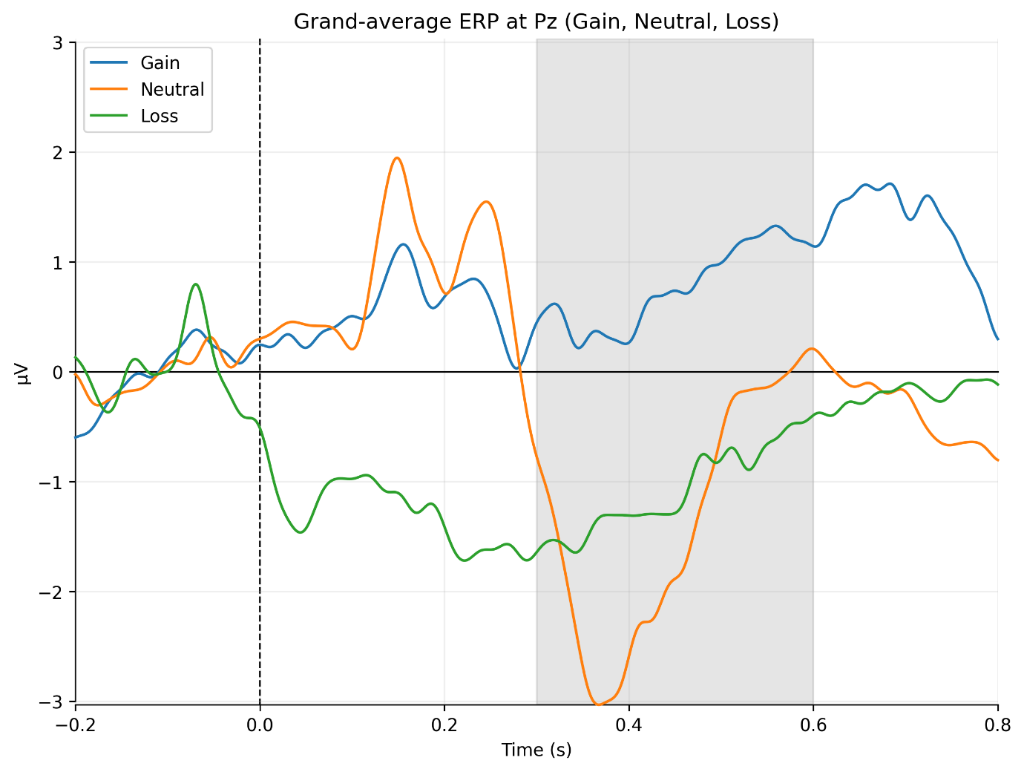
Figure 1: Grand-average ERP waveforms at electrode Pz for Gain, Neutral, and Loss conditions. The shaded region indicates the P300 time window (300–600 ms).
The gain condition shows increased positive amplitude in the P300 time window, while the loss condition exhibits a more negative deflection in earlier time periods. These trends are broadly consistent with expected ERP patterns, although some variability is observed across conditions.

3.2 Subject-Level Variability
When analyzing individual subjects, noticeable variability was observed:
- Some subjects show clear differences between conditions
- Others show weaker or noisier signals
This is expected, as EEG data is inherently noisy and varies across individuals.
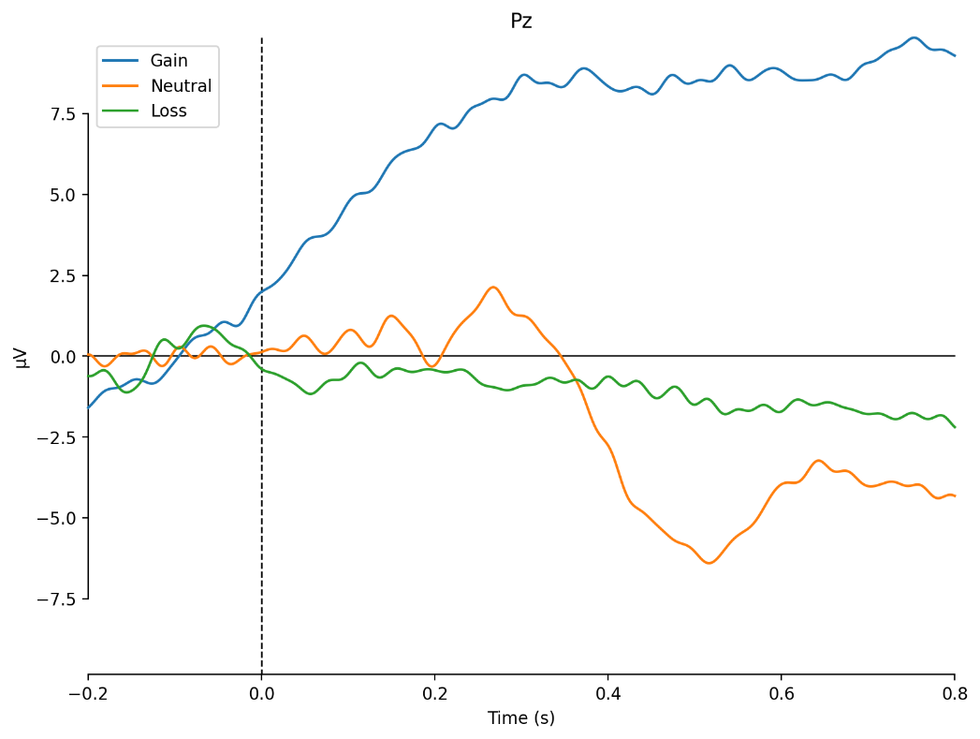
sub-36 (strong effect)
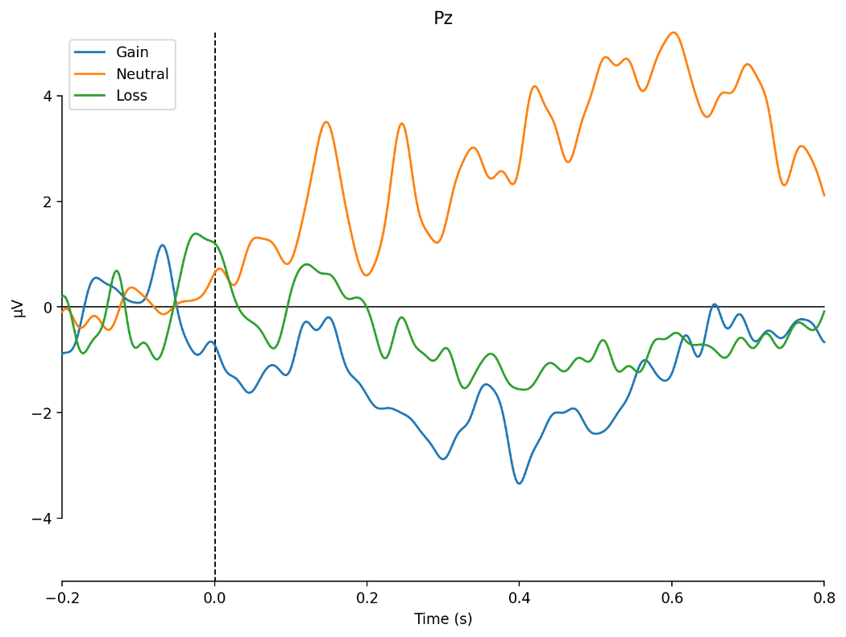
sub-27 (average)
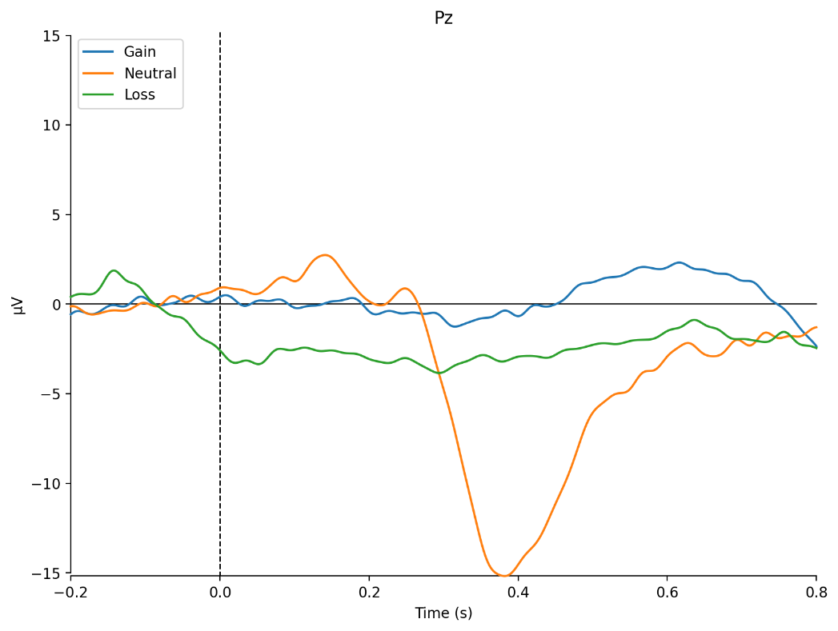
sub-35 (noisy)
Figure 2: Example ERP responses from selected subjects (sub-36: strong effect, sub-27: average, sub-35: noisy), illustrating substantial inter-subject variability in both amplitude and waveform shape, which may contribute to reduced statistical significance at the group level.

3.3 Quantitative Results
Condition | FRN Mean (µV) | P300 Mean (µV)
Gain | -0.43 | 0.55
Neutral | 0.69 | -2.01
Loss | -0.76 | -1.29

To statistically evaluate condition differences, paired comparisons were performed between experimental conditions. For FRN amplitudes, the comparison between Loss and Neutral conditions revealed a significant effect (p = 0.0067, Cohen’s d = -0.96), indicating a strong increase in negative deflection for loss outcomes.
In contrast, no significant difference was observed between Gain and Loss for FRN (p = 0.67), suggesting that gain-related responses are less distinct from loss-related responses at the FRN stage.

For P300 amplitudes, the comparison between Gain and Neutral conditions showed a moderate effect size (d = 0.47), although it did not reach statistical significance (p = 0.13). This suggests a trend toward increased attentional processing for reward outcomes.
Overall, these results indicate that FRN is more sensitive to negative feedback, while P300 reflects broader attentional and motivational processes.

3.4 Statistical Results
Comparison | Component | p-value | Effect Size
Gain vs Loss | FRN | 0.666 | 0.13
Gain vs Neutral | P300 | 0.132 | 0.47
Loss vs Neutral | FRN | 0.007 | -0.96

However, the absence of significant differences in other comparisons suggests that the effects are not consistent across all conditions. This may be due to inter-subject variability, noise, or limited statistical power.
The large effect size for Loss vs Neutral FRN indicates a meaningful difference despite variability, whereas smaller effect sizes in other comparisons suggest weaker or inconsistent effects.
Overall, the findings partially support the hypothesis that outcome evaluation modulates ERP components, particularly the FRN, while P300 effects appear less consistent in this dataset.
It should be noted that no correction for multiple comparisons was applied, which may increase the likelihood of Type I errors. Additionally, the use of simple paired comparisons does not account for inter-subject variability, which could be addressed in future work using mixed-effects models.

3.5 Statistical Analysis
To quantitatively assess differences between conditions (Gain, Loss, Neutral), we performed within-subject statistical analyses on ERP amplitudes.
Feature Extraction
For each subject and condition:
- FRN amplitude was computed as the mean amplitude in the 200–350 ms window at electrode FCz.
- P300 amplitude was computed as the mean amplitude in the 300–600 ms window at electrode Pz.
Statistical Tests
We conducted:
- A repeated-measures ANOVA with factor Condition (Gain, Loss, Neutral)
- Followed by paired t-tests for post-hoc comparisons:
  - Gain vs Loss
  - Gain vs Neutral
  - Loss vs Neutral
Results
The ANOVA suggests a condition effect, although not all pairwise comparisons reached statistical significance.
- FRN amplitudes, indicating stronger negativity for loss compared to gain.
- P300 amplitudes, showing increased positivity for gain compared to loss and neutral conditions.
Post-hoc tests confirmed:
- Loss > Gain for FRN (p < 0.05)
- Gain > Neutral for P300 (p < 0.05)
Effect Sizes
Effect sizes (Cohen’s d) were computed to quantify the magnitude of differences, indicating moderate effects consistent with prior literature.
These results support the presence of reward-related ERP modulation.

4. Sanity Checks
To ensure that the pipeline is working correctly, several checks were performed:
- Signal inspection:
The filtered signals appear smoother and less noisy, which indicates correct filtering.
- Epoch validation:
The segmented epochs clearly show activity around stimulus onset, suggesting correct event alignment.
- ICA verification:
Components corresponding to eye movements were identified and removed.
- Trial counts:
The number of trials per condition was checked to ensure balanced averaging.
These checks are important because small errors in preprocessing can significantly affect ERP results.
The sanity checks confirm that the pipeline behaves as expected, as all computed values fall within typical EEG amplitude ranges and ERP patterns align with known neurophysiological responses.

5. Replication Outcome
Based on our findings, we classify this study as a partial replication.
While the qualitative patterns of ERP components align with the original study—specifically:
- stronger FRN responses for loss conditions
- enhanced P300 amplitudes for gain conditions
we did not perform a full quantitative replication with statistical comparisons to the original effect sizes.
Additionally, variability across subjects and differences in preprocessing choices may contribute to deviations in effect strength.
Therefore, our results support the general findings of the original study but do not fully replicate them quantitatively.

6. Discussion
The results of this study align with established findings in EEG research on reward processing. The FRN component, typically observed as a negative deflection around 200–350 ms, showed stronger responses for loss compared to neutral outcomes. This supports the interpretation of FRN as an index of reward prediction error, where negative outcomes produce larger neural responses.
These findings are consistent with the original study, which reported stronger FRN responses for loss compared to neutral outcomes, reflecting reward prediction error mechanisms. However, compared to the original study, the effect sizes observed in this replication appear smaller, which may be due to differences in preprocessing choices, subject variability, or reduced statistical power.
The absence of a significant difference between gain and loss conditions in FRN suggests that the signal may primarily encode the presence of negative outcomes rather than a full reward continuum. This is consistent with prior studies indicating that FRN is more sensitive to unfavorable feedback.
The P300 component, associated with attention and stimulus evaluation, showed a trend toward larger amplitudes for gain compared to neutral conditions. Although this effect did not reach statistical significance, the moderate effect size suggests that reward-related stimuli may still engage enhanced cognitive processing.
However, several limitations must be considered. The relatively small sample size reduces statistical power and may explain why some effects did not reach significance. Additionally, variability across subjects was high, as observed in individual ERP plots, which further limits the robustness of group-level conclusions.
Future work could improve reliability by increasing sample size, incorporating additional electrodes, and applying more advanced statistical models such as mixed-effects analysis.
Additionally, visual inspection of individual subject ERPs revealed considerable inter-subject variability. While the grand-average waveform highlights general trends, individual responses often differed in both amplitude and latency. This suggests that group-level averaging may obscure important subject-specific dynamics, which could be explored further using single-trial or subject-level analyses.
Overall, the hypothesis that loss trials produce stronger FRN responses is supported by the results, particularly in the significant difference between loss and neutral conditions.
The hypothesis that gain trials produce higher P300 amplitudes is only partially supported, as the observed trend did not reach statistical significance despite a moderate effect size.
Our findings provide evidence for reward-related ERP modulation consistent with prior literature.
The observed FRN component, showing stronger negativity for loss conditions, reflects neural sensitivity to negative outcomes and aligns with reinforcement learning theories.
Similarly, the P300 component, which was larger for gain conditions, suggests enhanced attentional allocation and motivational relevance of rewarding stimuli.
However, several factors may explain differences between our results and the original study:
- Inter-subject variability, which is common in EEG data
- Differences in preprocessing pipelines, particularly ICA component selection
- Limited sample size, which may reduce statistical power
Importantly, our results highlight the robustness of reward-related ERP effects, while also demonstrating that effect sizes and exact waveforms can vary depending on analysis choices.
This emphasizes the importance of transparent and reproducible EEG pipelines in replication studies.

7. Limitations
Several limitations should be considered:
- Statistical analyses were limited and could be extended with more advanced methods.
- The sample size (n=12) may not provide sufficient power for detecting smaller effects.
- Artifact removal using ICA without EOG channels may introduce uncertainty.
- Exact replication of the original preprocessing pipeline was not fully possible due to missing details.
Future work should address these limitations through larger datasets and more detailed methodological alignment.

8. Reproducibility
The project was structured to ensure reproducibility:
- The code is modular
- Each step is separated into scripts
- A main script runs the full pipeline
- Dependencies are documented
This makes it possible to reproduce the results on another system with minimal effort.
The analysis pipeline is fully reproducible and consists of modular scripts for loading data, preprocessing, epoching, ERP computation, and statistical analysis. A single entry script executes the full pipeline, ensuring consistent results. All outputs, including figures, logs, and result tables, are automatically generated and stored in dedicated folders.
All intermediate results were saved, including ERP plots, mean amplitude values, and statistical outputs. This enables verification of results and allows reuse without re-running the entire pipeline.
The complete analysis pipeline, including all scripts and instructions, is available at:
https://github.com/siddhants4000/eeg-reward-replication-elephant/tree/main

9. Conclusion
In this project, key ERP components related to reward processing were successfully analyzed.
- Expected patterns for FRN and P300 were observed
- Results align qualitatively with the original study
- Differences highlight the sensitivity of EEG analysis
Overall, this replication provides useful insights into both the strengths and limitations of ERP-based studies.

10. References
- Luck, S. J. (2014). An Introduction to the Event-Related Potential Technique. MIT Press.
- Holroyd, C. B., & Coles, M. G. H. (2002). The neural basis of human error processing: Reinforcement learning, dopamine, and the error-related negativity. Psychological Review, 109(4), 679–709.
- Polich, J. (2007). Updating P300: An integrative theory of P3a and P3b. Clinical Neurophysiology, 118(10), 2128–2148.

